Lesson 1
Exercise 1 Look and write
stand up | make a line | sit down | be quiet | hands up | hands down

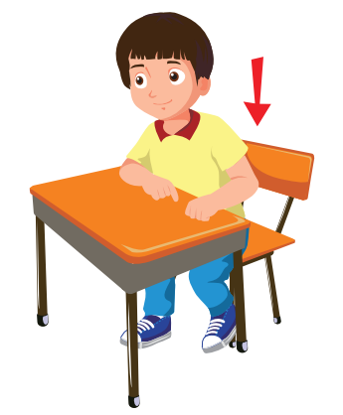 |  | 
………………………………… | ………………………………… | …………………………………
 |  | 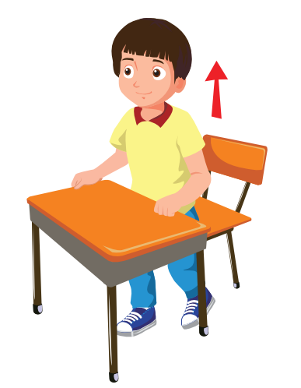
………………………………… | ………………………………… | …………………………………
Exercise 2 Match the halves of the instructions.
1) Be up
2) Hands down
3) Sit a line
4) Make your book
5) Stand quiet
6) Open up

Exercise 3 Read and match
- Sit |  | - up, please!
- Stand |  | - down, please!
- Be |  | - a line , please!
- Hands up |  | - quite, please!
- Make |  | - , please!
Exercise 4 Look and read . Put a tick () or cross () in the box.
a) Stand up , please! b) Hands up , please ! c) Make a circle , please !
d) Hands down , please! e) Be quiet , please ! f) Sit down, please !

Exercise 5 Look at the pictures. Complete the missing words
line - please – down
Hands – Be - Stand

a) Sit ………….,please ! b) ………….quiet , please! c) Hands up, ………….!
d) ………….up, please ! e) ………….down, please ! f) Make a …………, please!
Lesson 2
Exercise 1 Look and answer
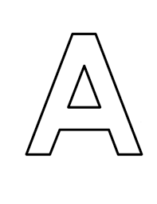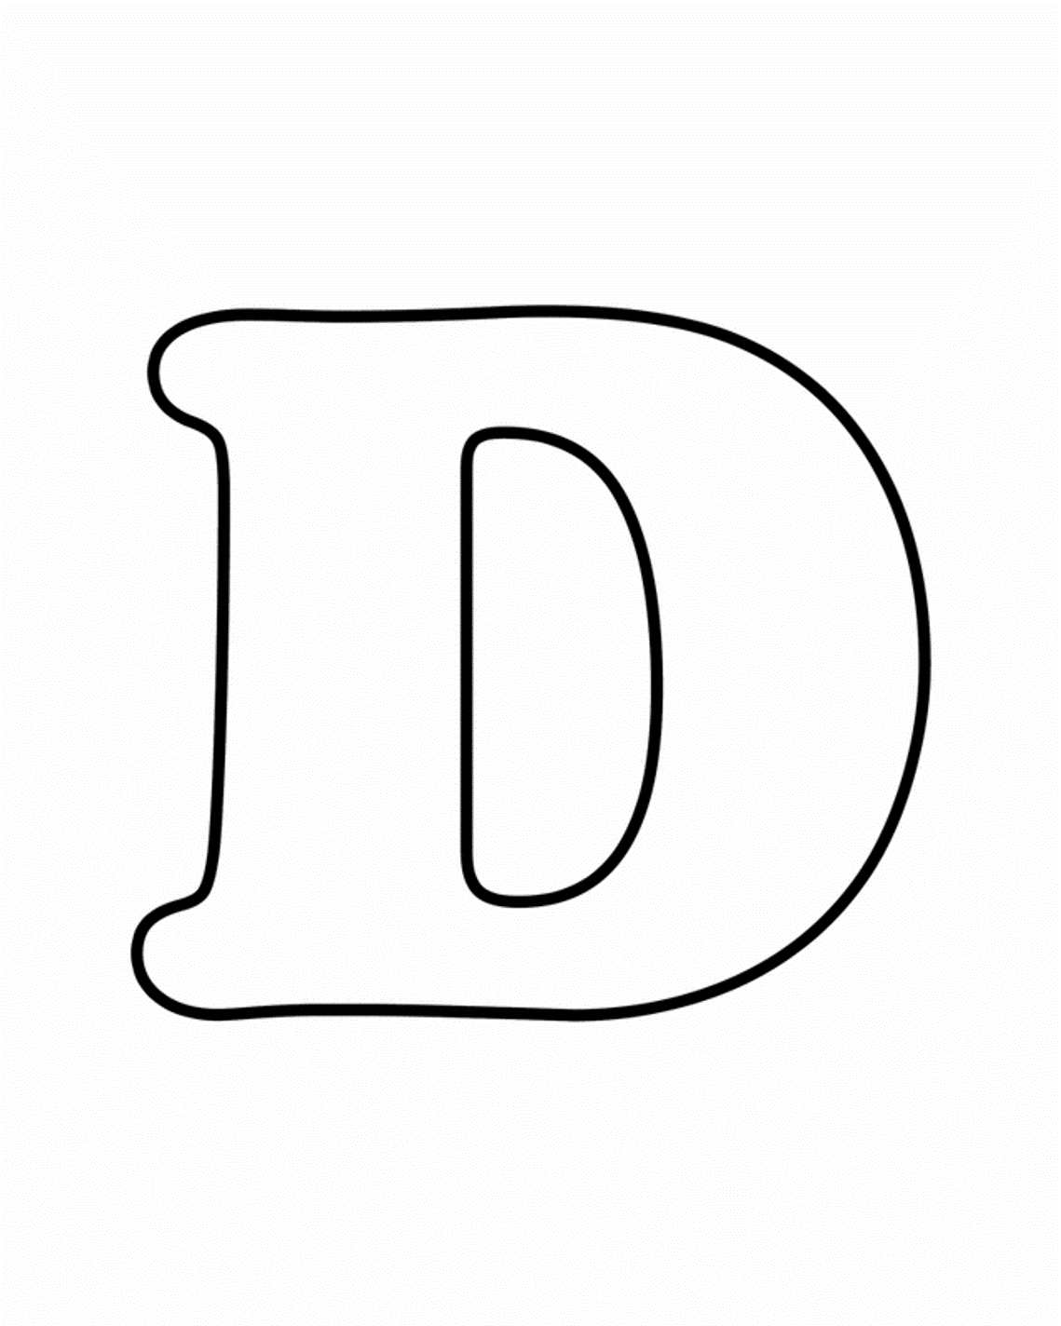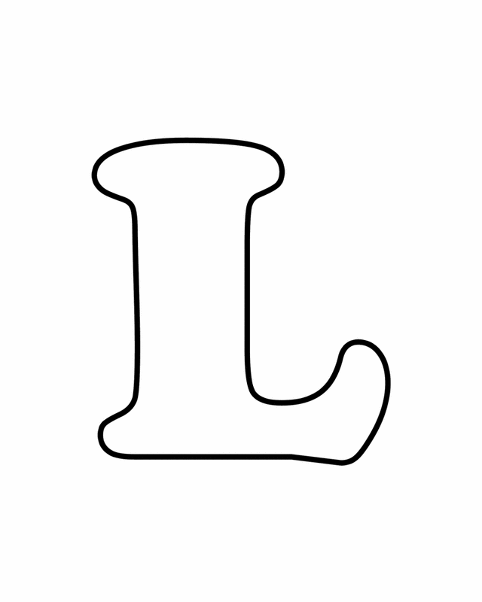
a) What letter is this ? b) What letter is this ? c) What letter is this ?
……………………………… ……………………………… ………………………………
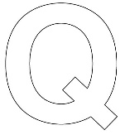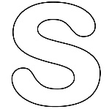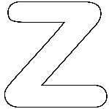
e) What letter is this ? f) What letter is this ? g) What letter is this ?
……………………………… ……………………………… ………………………………
Exercise 2 What letter is missing ?
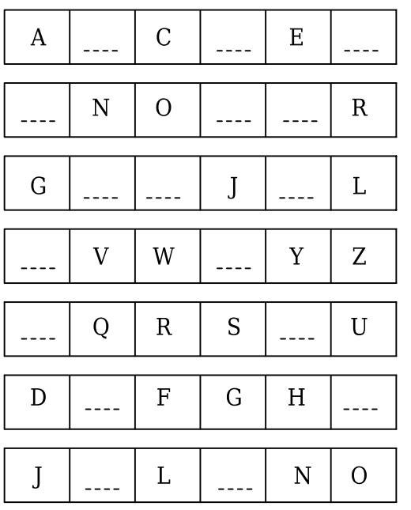

Lesson 3
Exercise 1 Look and circle the right name

a) Mary b) Mai
a) Mary b) Mai
a) Tom b) Alfie
a) Tony b) Tom

Exercise 2 Read and complete
a) What is your name ? b) What is his name ?
My name ………..Mai. His name is ……….
b) What is …………..? c) ……….is his name ?
His name is Nick. His name is Alfie.

Exercise 3 Look and read . Put a tick () or cross () in the box.
a) Her name is Hoa. b) His name is Tom.
c) His name is Nick. d) His name is Mike.
Lesson 4
Exercise 1 Look and write the missing letters

a) Greenw _ _ d
d) ho _ _
c)Ri _ _ _ Town
b) _ _ pha

Exercise 2 Look and write
a) Where are you from ? b) Where is he from ? c) Where is she from ?

……………………………… ……………………………… ………………………………
Exercise 3 Make questions for these answers
a) I am from Alpha. b) She is from Greenwood.
Where are you from ? ………………………………………
c) He is from River Town. d) He is from Alpha.
……………………………………… ………………………………………
e) He is from Greenwood. f) I am from River Town.
……………………………………… ………………………………………
Exercise 4 Put the words in the correct order
A) are – Where – from – you ?
……………………………………………………………………………..
b) He – River Town – is – from.
……………………………………………………………………………..
c) from – I – Alpha – am
……………………………………………………………………………..
d) Greenwood – She – from – is
……………………………………………………………………………..
e) Where – Tom – from – is ?
……………………………………………………………………………..
f) from – Alpha – He – is.
……………………………………………………………………………..
g) she – Where – from – is ?
……………………………………………………………………………..
h) He – from – Greenwood – is.
……………………………………………………………………………..

Lesson 5
Exercise 1 Look and write
ten | five | seven | two | six
three | one | nine | eight | four

1 | 2 | 3 | 4 | 5
……………….. | ……………….. | ……………….. | ……………….. | ………………..
6 | 7 | 8 | 9 | 10
……………….. | ……………….. | ……………….. | ……………….. | ………………..
Exercise 2 Look and write
 |  |  |  | 
Anna / 10 | Ben /6 | Bella / 8 | Alex / 7 | Lily /5
a) My name is Anna . I am ten years old.
b) ……………………………………………………………………………………
c) ……………………………………………………………………………………
d) ……………………………………………………………………………………
e) ……………………………………………………………………………………

Exercise 3 Look , read and complete

9
7
8
a) How old are you ? b) How old are you ? d) …………… is she ?
I am ……………. years old. I am seven ……………. She is nine years old.

10
5
6
d) How old is he ? e) How old is ………? f) How old is she ?
………is six years old. She is five years old. She is ……. years old.
Exercise 4 Look and read . Put a tick () or cross () in the box.

9
4
a) I am seven years old. b) She is nine years old.

8
9
c) She is ten years old. d) He is eight years old.

Lesson 6
Exercise 1 Look and match
- What is your name ? | - She is from Greenwood.
- What letter is this ? | - My name is Tom.
- What is his name ? | - She is seven years old.
- How old are you ? | - It’s letter K.
- Nice to meet you. | - I am from Alpha .
- Where are you from ? | - His name is Alfie.
- How old is she ? | - Nice to meet you, too.
- Where is she from ? | - I am nine years old.
- Is this letter E ? | - He is from River Town.
10. Where is he from ? | - Yes, it is.
Exercise 2 Look and read. Complete the sentences.
8
a) Be ………….. , please. b) Where are you from ? c) How old is she ?
I am from…………….. She is ………. years old.

6
d) What letter is this ? e) …………up , please. f) How old are you ?
It’s ……… ……………………………..

