Exercise 1: Look and read . Put a tick () or a cross () in the box.
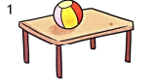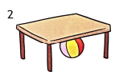
a) Put the ball on the table, please. b) Put the ball next to the table, please.

c) My favorite subject is english. d) I have Math on Tuesday.
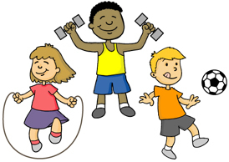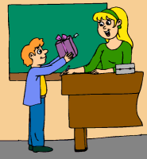
e) We read books in PE. f) I want to give a gift to my teacher.
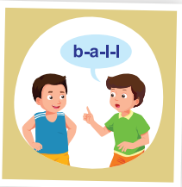
g) I spell words in English. h) Put the cat in front of the box.
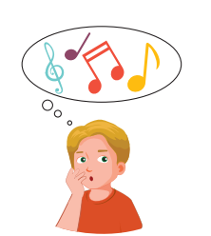
i) His favorite subject is art. j) I want to make a card for Teacher’s day.
Exercise 2 : Look, read and write.
between | in | on | under | next to

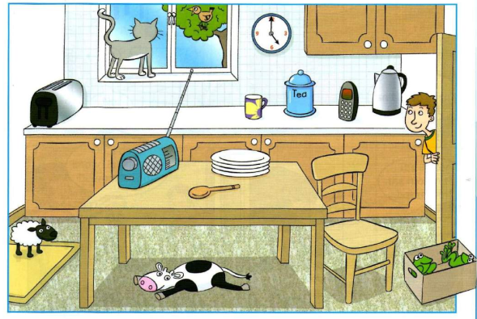
- Where is the bird ? | The bird is ……………… the tree.
- Where is the radio ? | The radio is ……………… the table.
- Where is the clock ? | The clock is……………… the window and the cupboard.
- Where is the chair? | The chair is ……………… the table.
- Where is the sheep ? | The sheep is ……………… the mat.
- Where is the cow ? | The cow is ……………… the table.
- Where are the frogs ? | The frogs are ……………… the box.
- Where are the plates ? | The plates are ……………… the table.
Exercise 3 : Read and match.
- Where is the dog ? | - My favorite subject is music.
- What is your favorite subject ? | - It’s behind the door.
- When do you have Vietnamese ? | - They are sixteen years old.
- Do you like English ? | - It’s Friday.
- What do you do in PE ? | - Yes, I love English.
- What do you want to do for Teacher’s day ? | - I have Vietnamese on Wednesday.
- What day is it today ? | - No, it’s on the table.
- How old are they ? | - I do exercise in PE.
- Is the ball under the table ? | - I want to give a gift to my teacher.
- What’s your phone number? | - It’s 546746453
Exercise 4 : Choose the correct answer.
- What (am/is/are) your phone number? It’s 0362-424-535
- My sister ( wants / want ) to give a gift her teacher.
- Tony ( like/likes ) PE and English.
- Where is the ball ? It ( are / is ) on the desk.
- How (much/many) rectangles can you see? I can see three rectangles.
- She ( have / has ) English on Monday and Thursday.
- 40 plus 16 (am/is/are) 56.
- We( draw pictures / spell words) in English.
- What is (your/my/her) favorite subject? I like P.E.
10. (Where/When/What) do you have Math? I have Math on Tuesday.
11. What do you do in (English/Math/art)? I draw some pictures.
12. I (do exercise / sing a song) in Music
Exercise 5 : Look , read and write : yes or no
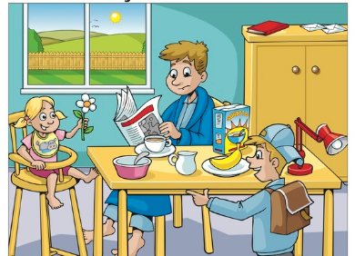 | - The children’s dad is reading.  - There’s a lamp on the cupboard.  - You can see a pear on the table.  - The boy’s hat is on his head.  - The girl is holding a flower.  - There’s a book on the cupboard.
Exercise 6: Put the words in the correct order to make complete sentences.
A) please. / Put / on / the bag / the table ,/
……………………………………………………………………………………………………..
B) the doll / please./ Put / in / the cupboard,/
……………………………………………………………………………………………………..
C) Vietnamese ./ is / favorite / My / subject/
……………………………………………………………………………………………………..
D) on / I / music / have / Tuesday / Friday ./and/
……………………………………………………………………………………………………..
E) to / I / a gift / give / want / teacher. / to /my
……………………………………………………………………………………………………..
F) I / in / draw / art./pictures/
……………………………………………………………………………………………………..
G) Pat’s / is / subject / favorite/ music./
……………………………………………………………………………………………………..
Exercise 7 : Read and fill in the blanks.
My favorite Subject

art | sings | pictures | Friday | plays | reads
At school , my favorite subject is (1) ___________ . I draw (2) _____________ in art. I have art on Tuesday. Tony’s favorite subject is music. He has music on (3) ______________ He (4) ___________ songs and (5) __________________ the piano.
He loves it !
Exercise 8 : Make questions for these answers
a) The book is on the table. b) The box is next to the cupboard.
Where is the book ? …………………………………………?
c) The backpack is under the desk. d) My favorite subject is Vietnamese.
…………………………………………? …………………………………………?
e) She has music on Monday. f) I draw pictures in art.
…………………………………………? …………………………………………?
g) I want to make a card for Teacher’s day. h) His favorite subject is English.
…………………………………………? …………………………………………?
I) My phone number is 036 -242-4535. J) The cat is behind the door.
…………………………………………? …………………………………………?
K) I have English on Tuesday and Friday. L) She likes art and music.
…………………………………………? …………………………………………?
M) The pens are in the pencil case. N) Toby has math on Thursday.
…………………………………………? …………………………………………?

Exercise 9 : Find the mistakes and correct them.
- She have Art on Monday and Friday.
…………………………………………………………………………………………..
- How much circles can you see? 4 circles
…………………………………………………………………………………………..
- I has math on Friday and Tuesday.
…………………………………………………………………………………………..
- I wants to sing a song for Teacher’s Day.
…………………………………………………………………………………………..
- Lucy like music and math.
…………………………………………………………………………………………..
- What do you have vietnamese? I have vietnamese on Wednesday.
…………………………………………………………………………………………..
Exercise 10: Look , read and circle.
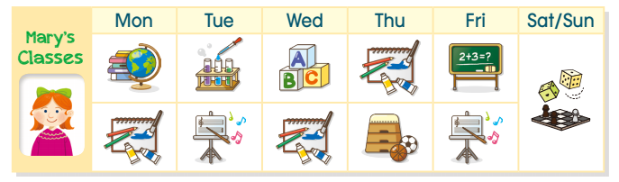
- She has science and P.E on Tuesday. | 
- She has English and art on Wednesday.
- She has art and music on Thursday.
- She has math and music on Friday.
5) She has music and art on Monday.
Exercise 11 :Read this. Choose a word from the box below. Write the correct word next to number 1 – 5 . There is one example.

Schools  Schools are buildings where children go to learn. Children have lessons with (1) ………….. in classrooms.  In a classroom there are (2) ………….., chairs , blackboards , a teacher’s desk , doors and windows. Many schools have a (3) ………….. room too. Lots of them have a (4) ………….. where children can play outside . School are open in the morning and close at (5) …………………... | 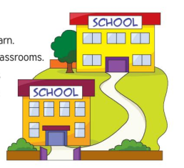
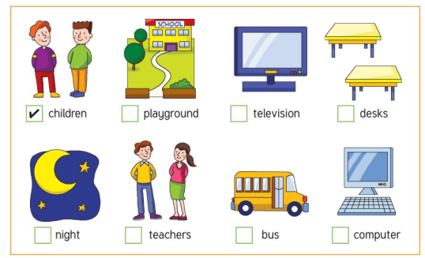

Exercise 12 : Circle the odd one out:
 | math | art | music | Thursday
 | next to | under | is | behind
 | July | Friday | Monday | Tuesday
 | buy | cupboard | sing | make
 | draw | listen | spell | beautiful
 | What | Are | When | How many
 | small | big | nice | read
 | yellow | sixty | nine | eighteen
Exercise 13 : Answer these questions about yourself
a) What is your name ?
………………………………………………………………………..
b) How old are you ?
………………………………………………………………………..
C) How old is your mother ?
………………………………………………………………………..
D) How old is your father ?
………………………………………………………………………..
E) What color do you like ?
………………………………………………………………………..
F) What is your favorite subject ?
………………………………………………………………………..
G) When do you have Vietnamese ?
………………………………………………………………………..
H) What do you want to do for Teacher’s day ?
………………………………………………………………………..

