Lesson 1
Exercise 1 Look and write
board | desk | camera | door | cupboard | chair

 | 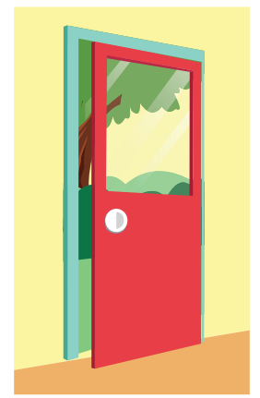 | 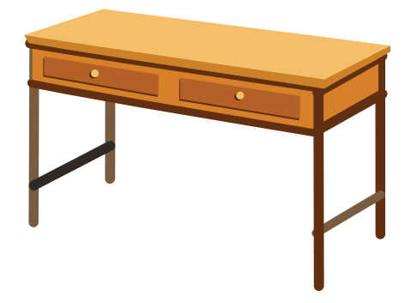
………………………………… | ………………………………… | …………………………………
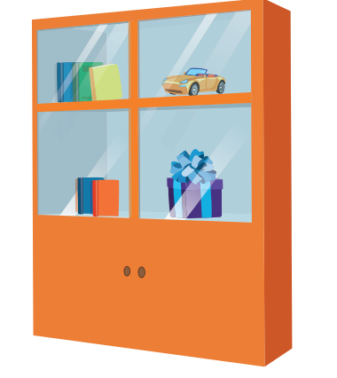 | 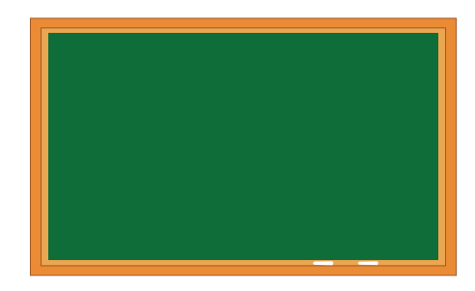 | 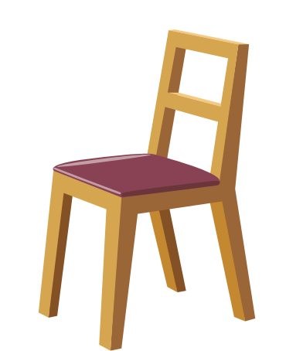
………………………………… | ………………………………… | …………………………………
Exercise 2 Look and read . Put a tick () or cross () in the box.
a) It’s a desk. b) It’s a camera. c) It’s a chair.

d) It’s a board. e) It’s a window. f) It’s a cupboard.

Exercise 3 Read and write
Yes, it is. | No, it isn’t.

a) Is this a board ? b) Is this a desk ? c) Is this a camera ?
……………………… ……………………… ………………………
d) Is this a cupboard ? e) Is this a chair ? f) Is this a door ?
……………………… ……………………… ………………………
Exercise 4 Look and write
a) What is this ? b) …………………………. c) ………………………….

It’s a camera. …………………………. ………………………….
d) …………………………. e) …………………………. f) ………………………….

…………………………. …………………………. ………………………….
Exercise 5 Look , read and write
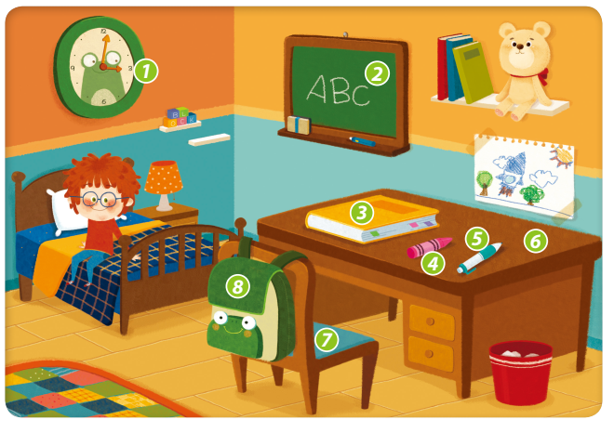
1) Is this a clock ? ……………………………………………..
2) What is this ? ……………………………………………..
3) Is this a ruler ? ……………………………………………..
4) Is this a desk ? ……………………………………………..
5) What is this ? ……………………………………………..
6) What is this ? ……………………………………………..
7) What is this ? ……………………………………………..
8) Is this a backpack ? ……………………………………………..
Lesson 2
Exercise 1 Look and write the missing letters
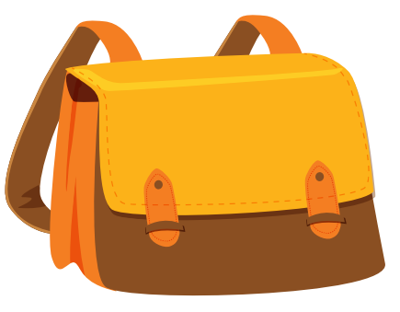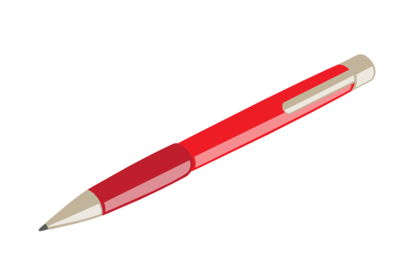
b _ _ k
_ _ n
b _ g


cray _ _
_ _ _ cil
era _ _ _

Exercise 2 Read and complete the sentences.
a) What is this ? b) Is this a ……………? c) Is this a board ?
It’s a …………… Yes, it is. ……………………..
d) Is this a bag ? e) Is this a pencil ? f) What is this ?
No, it isn’t . It’s an………… ……………………… ………………………

Exercise 3 Look , read and write
Yes, it is. | No, it isn’t.
a) Is this an eraser ? b) Is this a pen ? c) Is this a pencil ?
………………………… ………………………… …………………………
d) Is this a crayon ? e) Is this a book ? f) Is this a camera ?
………………………… ………………………… …………………………
Exercise 4 Make questions for these answers
a) …………………………..? b) …………………………..? c) …………………………..?
Yes, it is. It’s an eraser. No, it isn’t . It’s bag.
d) …………………………..? e) …………………………..? f) …………………………..?
It’s a book. Yes, it is. No, it isn’t . It’s chair.
Lesson 3
Exercise 1 Look and circle the correct words
 | 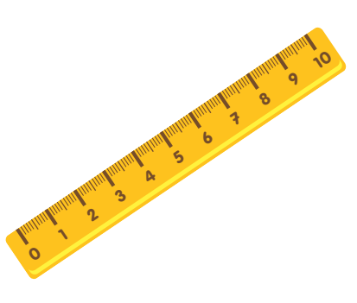 | 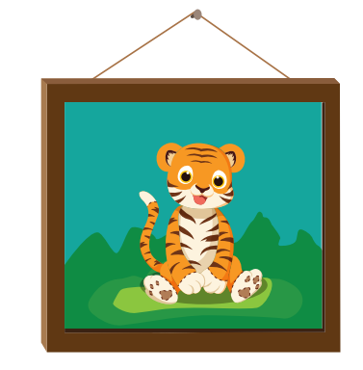 | 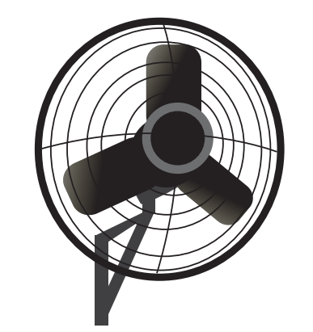 | 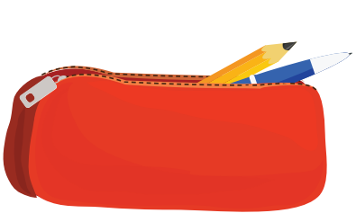
a) ruler  b) letter  c) eraser | a) book  b) pen  c) ruler | a) picture  b) chair  c) desk | a) board  b) picture  c) fan | a) pencil  b) pencil case  c) bag

Exercise 2 Look and circle
1) | It’s a ruler / book. | 6) | Is it a fan / picture ?  Yes, it is.
2) | Is it a desk / picture ? Yes, it is. | 7) | It’s a bag / book.
3) | Is it a pencil ?  Yes, it is / No, it isn’t . | 8) | Is it a pen ?  Yes, it is / No , it isn’t.
4) | It’s a / an bag. | 9) | It’s a desk / chair.
5) | Is it a desk ?  Yes, it is / No, it isn’t. | 10) | It’s a / an eraser.
Exercise 3 Look and write
a) What is it ? | b) Is it a pencil ? | c) What is it ?
It’s a ……………………… | ……………………………. | …………………………….
d)……………………………. | e) What is it ? | f) Is it a pencil case ?
It’s a picture. | ……………………………. | …………………………….
Exercise 4 Find the mistakes and correct them
A) It’s a picture. B) Is it a picture? C) It’s a pencil .
No, it isn’t
………………………… …………………………. ……………………….
D) Is it a pencil case ? E) What is this ? F) Is it a eraser ?
Yes, it is. It’s a ruler. Yes, it is.
………………………. ………………………. ……………………….
Lesson 4
Exercise 1 Look and number
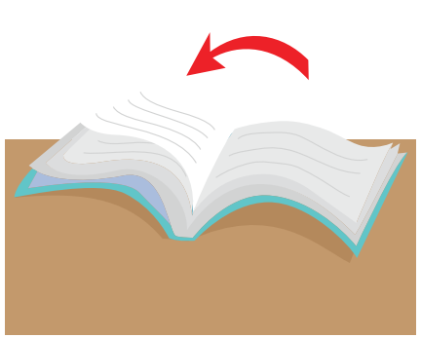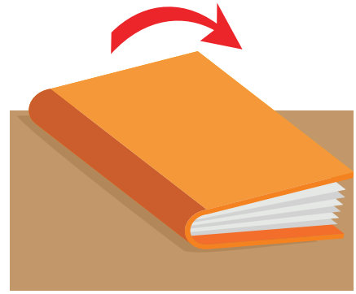

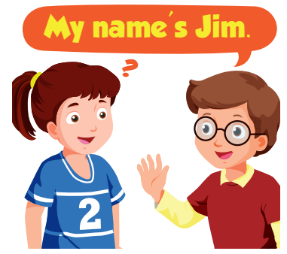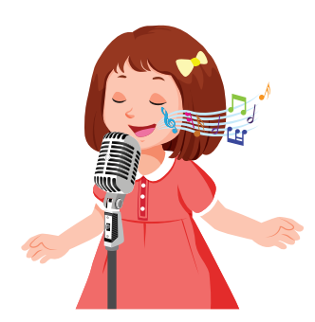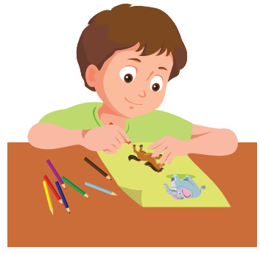

- draw | - open | - sing | - close | - answer | - ask

Exercise 2 Read and match
- Sit |  | - up, please.
- Stand |  | - down, please.
- Be |  | - a line , please.
- Open |  | - quite, please.
- Make |  | - your book, please.
- Draw |  | - a song , please.
- Ask |  | - a picture , please.
- Sing |  | - a question , please .
Exercise 3 Read and complete the sentences.
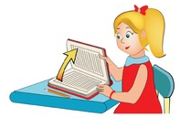 | 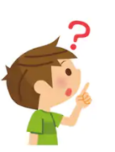
a) ……........ your book , please. | b) ………a question, please. | c) …………… a song, please.
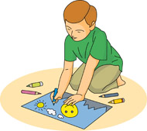 | 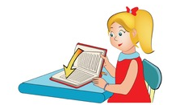
c) Draw a …………., ………... | d) Close your ………..., please. | e) ………..a question, please.
Exercise 4 Put the words in the correct order
A) please – Make – line – a,
…………………………………………………………
B) please – Close – book , – your
…………………………………………………………
C) a – please – Ask – question,
…………………………………………………………
D) Draw – please – a – picture ,
…………………………………………………………
E) your – Open – please – book,
…………………………………………………………
F) up , – please - Hands
…………………………………………………………
G) a song – Sing - please
…………………………………………………………
Exercise 5 Look and read . Put a tick () or cross () in the box.
a) Close you book,please. b) Open you book , please. b)Ask a question, please

d) Answer a question, please . e) Draw a picture , please. f) Sing a song , please.
Lesson 5
Exercise 1 Look and write the missing letters
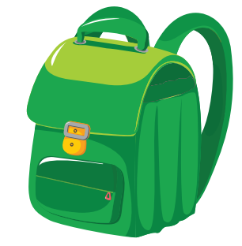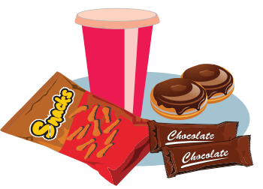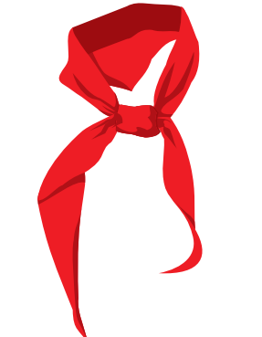
sca _ _
_ _ acks
backp _ _ _


_ _ ter bottle
school _ _ _ _

Exercise 2 Read and complete the sentences.
a) Remember your …………………….!
b) ……………………. your snacks !
c) Remember your …………………….!
d) ……………………. water bottle !
Lesson 6
Exercise 1 Read and match
- What is your name ? | - I’m nine years old.
- How old are you ? | - Yes, teacher.
- What is this ? | - Yes, it is.
- Is it a picture ? | - It’s a camera.
- Open your book, please . | - My name is Tom.
- Where is she from ? | - It’s letter G.
- What letter is this ? | - She is from Greenwood.
- What is his name ? | - She is seven years old.
- How old is she ? | - His name is Alfie.
Exercise 2 Read and complete the sentences.

a) What is this ?
…………………………………….
c ) Is this a bag ?
………………………….
b) ………………………
It’s a chair.

f) ………………a question , please.

e ) ……………………?
Yes, it is.
d) What is it ?
It’s ………eraser.

g) sing a …….please.

g) ………..…….your book , please.

g) Remember your ………..…….!

Exercise 3 Odd one out
a) sing | b) draw | c) ask | d) ruler
a) pencil case | b) ten | c) book | d) pencil
a) three | b) nine | c) picture | d) five
a) water bottle | b) chair | c) desk | d) board
a) where | b) what | c) how old | d) is

