Lesson 1
Exercise 1 Look and write
green | red | blue | colors | yellow

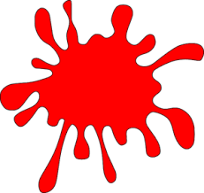 | 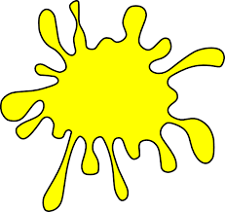 |  | 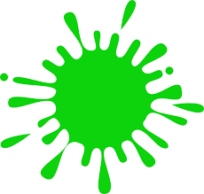 | 
……………… | ……………… | ……………… | ……………… | ………………
Exercise 2 Look and write
a) What color is this ? b) What color is this ?
………………………………………. ……………………………………….
c) What color is this ? d) What color is this ?
………………………………………. ……………………………………….

Exercise 3 Look and write :
Yes, it is. | No, it isn’t.
a) Is it red ? b) Is it red ? c) Is it blue ? d) Is it yellow ?
………………….. ………………….. ………………….. …………………..
Lesson 2
Exercise 1 Look, read and write the missing letters
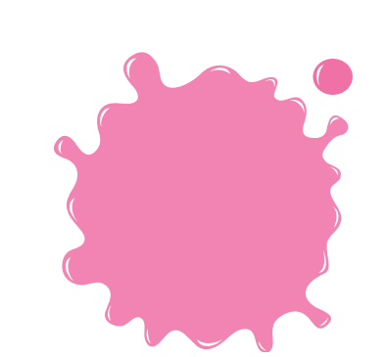

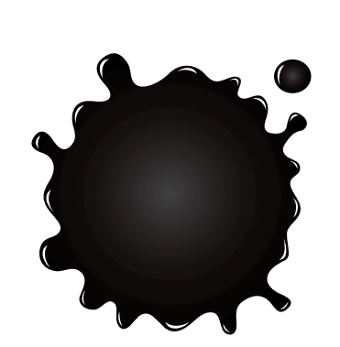

bl _ _ _
_ _ ey
p _ nk

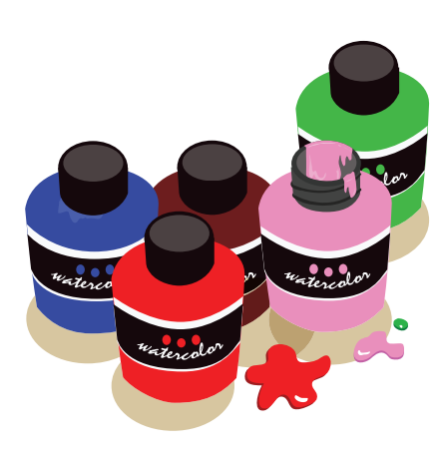
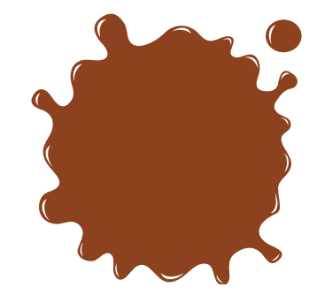
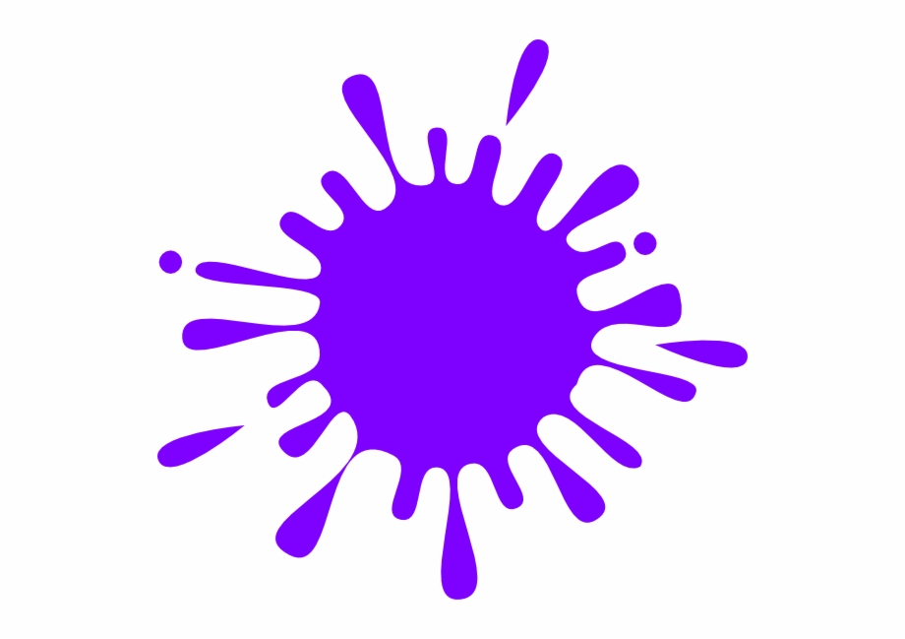

p _ _ nts
purp _ _
_ _ own

Exercise 2 Read and complete the sentences.

a) What color do you want ? b) What ……………do you want ?
………………, please ! Blue, please !

c) What color do you want ? d) …………color do you want ?
Red, ………………! Grey , please !
Exercise 3 Read and color
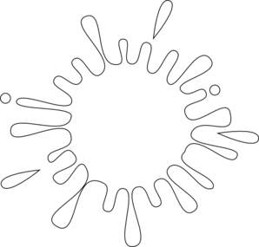

It’s black
It’s red.
It’s blue.

It’s yellow.
It’s white.
It’s green.
Lesson 3
Exercise 1 Look and write
rock | flower | butterfly | leaf | balloon

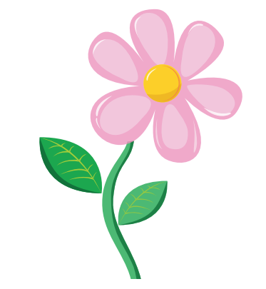 | 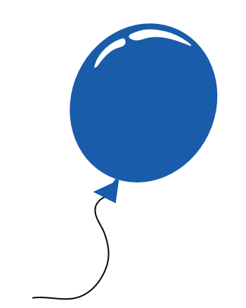 | 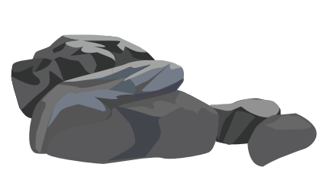 | 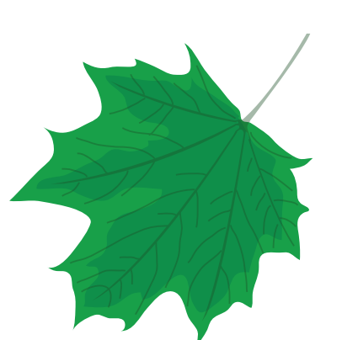 | 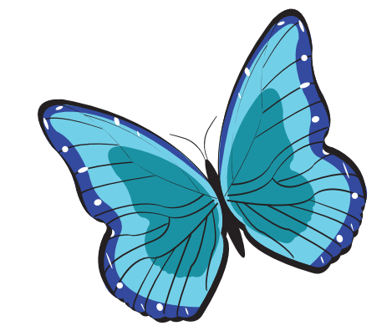
…………….. | …………….. | …………….. | …………….. | ……………..
Exercise 2 Look, read and match

- There are two blue balloons.
- There is a rock.
- There is a flower. |  | 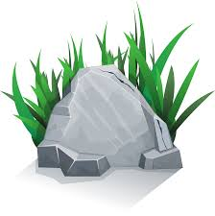
- There is a butterfly.
e) There are two green leaves.

Exercise 3 Look and write
There is | There are

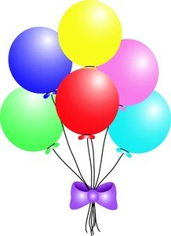
a) ……………a rock. b) …………… six balloons. c) ……………a leaf.
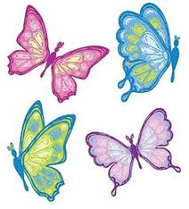
d) ………… four butterflies. e) ……………a flower. f) …………a butterfly.
Exercise 4 Look and answer these questions
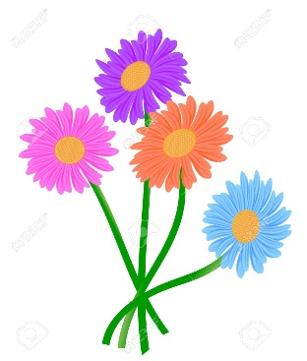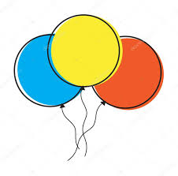
a) How many flowers are there ? b) How many balloons are there ?
…………………………………….. ……………………………………..
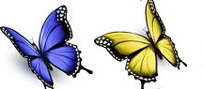
c) How many leaves are there ? d) How many butterflies are there ?
…………………………………….. ……………………………………..
Lesson 4
Exercise 1 Look and number
- white | - purple | - orange | - light blue | - dark blue



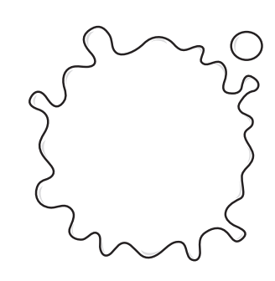


Exercise 2 Look and write
Colors

Name
Tony
Linda
Bella
Alex
Rose

a) What is your favorite color, Tony ? I like white.
b) What is your favorite color, Linda ? ……………………………………….
c) What is your favorite color, Bella ? ………………………………………
d) What is your favorite color, Alex ? …………………………………………
e) What is your favorite color, Rose ? …………………………………………

Exercise 3 Read and match
- What color is this ? | - Pink, please !
- What color do you want ? | - It’s green.
- How many flowers are there ? | - My school bag is purple.
- What is your favorite color ? | - Yes, I do.
- How many balloons are there ? | - There are five flowers.
- Do you like blue ? | - There is a balloon.
- What color is your school bag ? | - I like light blue.
- How many rocks are there ? | - He’s Tom’s father.
- Who is he ? | - There is a rock.
Lesson 5
Exercise 1 Look and write
coconut | papaya | noodles soup | sticky rice | lychee

 | 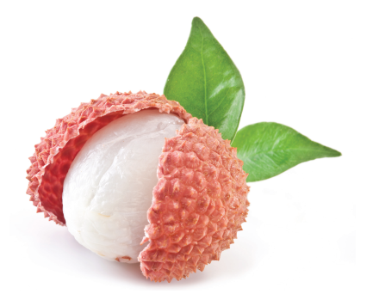 | 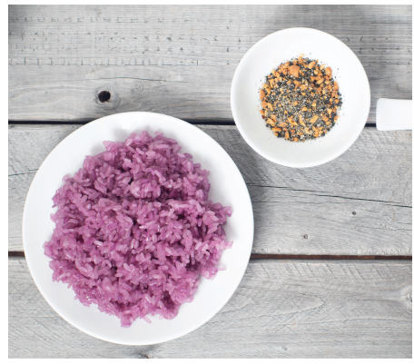 | 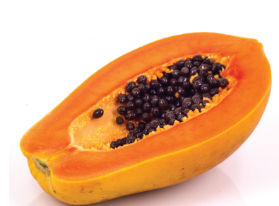 | 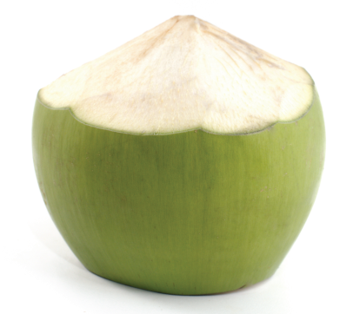
………………………. | ………………………. | ………………………. | ………………………. | …………………….

Exercise 2 Look and complete the sentences.
a) “ What’s that orange thing ?”
“ That’s a papaya . Try it !”
b) “ What’s that green thing ?”
“ That’s a ……………………………………………………………..!”
c) “ What’s that purple thing ?”
“ That’s a ……………………………………………………………..!”
d) “ What’s that red thing ?”
“ That’s a ……………………………………………………………..!”
Lesson 6
Exercise 1 Put the words in the correct order
a) What – is – color – this ? – is – It - green
……………………………………………………………………………
b) color – do – What – want – you ? – please ! - Pink
……………………………………………………………………………
c) There – three – balloons - are
……………………………………………………………………………
d) is – There – a – green - leaf
……………………………………………………………………………
e) What – color – your – is – favorite ? like – dark blue - I
……………………………………………………………………………
f) that – What – is – orange – thing ? papaya – That – is – a - Try - it !”
……………………………………………………………………………

Exercise 2 Look and read . Write Yes or No
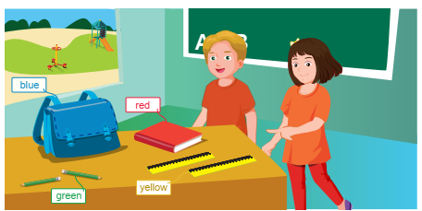
- There is a board in the classroom.
- There are two boys in the classroom.
- There is a blue book on the table.
- There are two yellow rulers on the table.
- There’s a blue bag.
- There are three green pencils.
Exercise 3 Look, read and write
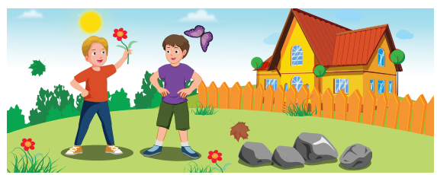
red flowers
purple butterfly
gray rocks
green leaf
Toby and Adam are is in the garden . There are three red flowers. There is one purple (1)……………….and four gray (2) ……………….
Exercise 4 Make questions for these answers
a) There is a book on the table.
How many books are there on the table ?
b) It is yellow.
……………………………………………………………
c) I like light blue.
……………………………………………………………
d) Tony wants green.
……………………………………………………………
e) Anna likes pink and gray.
……………………………………………………………
f) “ That’s a papaya . Try it !”
……………………………………………………………
g) There are two flowers in the garden.
……………………………………………………………
Exercise 5 Odd one out
a) book | b) flower | c) rubber | d) pencil
a) pink | b) green | c) light blue | d) eight
a) boy | b) father | c) mother | d) grandfather
a) sit down | b) stand up | c) open your book | d) camera
a) He | b) She | c) his | d) I
a) nine | b) four | c) six | d) black
a) dark blue | b) yellow | c) rock | d) gray
a) like | b) short | c) pretty | d) tall
a) desk | b) board | c) picture | d) leaf

