Lesson 1
Exercise 1 Look and write
doll | kite | ball | robot | big | small

 |  |  |  |  | 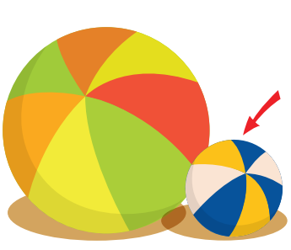
……………… | ……………… | ……………… | ……………… | ……………… | ………………
Exercise 2 Look , read and match
- I can see a small robot.
- I can see a big kite.
- I can see a small doll.
- I can see a big ball.
e) I can see a small ball.

Exercise 3 Look and circle the right option.

a) I can see a small kite. a) I can see a big ball. a) I can see a big ball.
b) I can see a big kite. b) I can see a small ball. b) I can see a small ball.

a) I can see a big doll. a) I can see a small robot. a) I can see a big doll.
b) I can see a small doll. b) I can see a big robot. b) I can see a small doll.
Exercise 4 Look and write

a) What can you see ? b) What can you see ? c) What can you see ?
…………………………….. …………………………….. ……………………………..

d) What can you see ? e) What can you see ? f) What can you see ?
…………………………….. …………………………….. ……………………………..
Lesson 2
Exercise 1 Look and write the missing letters
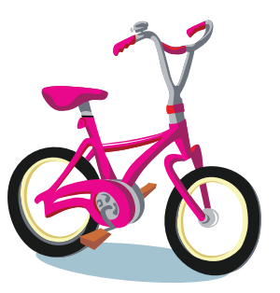 |  |  | 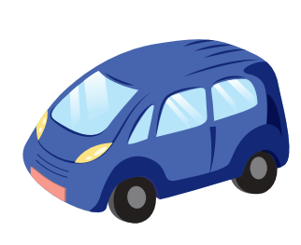 | 
b _ _ e | mons _ _ _ | b_ _ _ | _ ar | tra _ _

Exercise 2 Look and read . Put a tick () or cross () in the box.

c) It’s a car.
b) It’s a boat.
a) It’s a ball.

f) It’s a monster.
e) It’s a train.
d) It’s a bike.

Exercise 3 Look and write
 Anna
 Dad
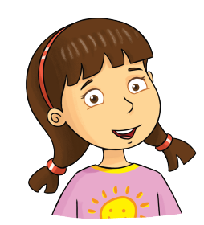Rosy
Grandpa 
 Billy 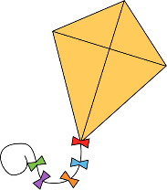
 Linda
Bella

a) What is this ?
It’s Anna’s ball.
b) What is this ?
……………………………………………..
c) What is this ?
……………………………………………..
d) What is this ?
……………………………………………..
e) What is this ?
……………………………………………..
f) What is this ?
……………………………………………..
g) What is this ?
……………………………………………..

a

b

c

d

e

f

g

Exercise 4 Use the words from the box and write.
1 : David | 2: Sarah | 3: Rose | 4 : Anna | 5 : Peter | 6: John

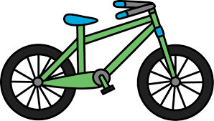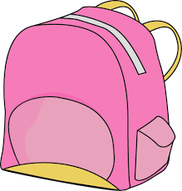
a) It’s David’s bike. b) …………………………… c) ……………………………
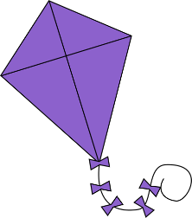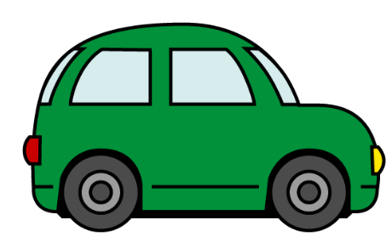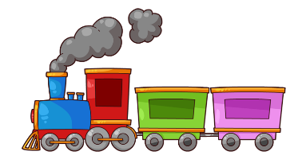
d) ………………………… e) ………………………… f) …………………………
Exercise 5 Look and write : Yes or No
Alfie
Jill
Tom
Lucy

a) This is Lucy’s bike.
b) This is Jill’s kite.
c) This is Alfie’s train.
d) This is Tom’s car.
Lesson 3
Exercise 1 Look and circle the right option
 |  | 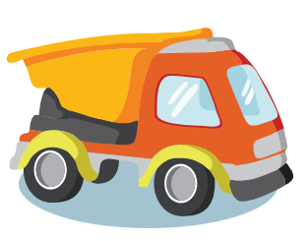
a) plane  b) car | a) truck  b) helicopter | a) plane  b) truck
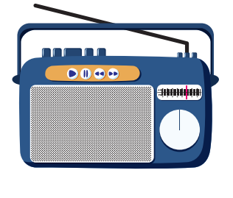 |  | 
a) radio  b) picture | a) doll  b) teddy bear | a) box  b) ball
Exercise 2 Look and write “ in” or “ on”
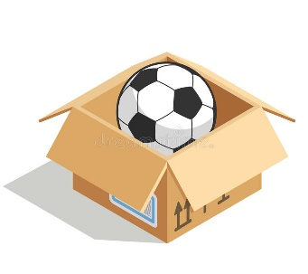 |  | 
a) The ball is ……….the box. | b) The doll is……….the chair | c)The teddy bear is …….the box.
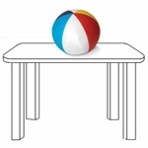 |  | 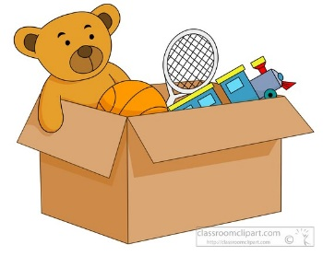
d) The ball is ….…...the table. | e) The robot is ….….the box. | f) The train is ….….the box.
Exercise 3 Look, read and answer
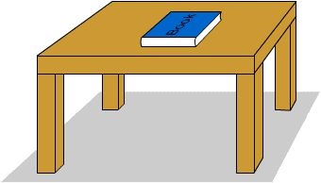
a) Where is the teddy bear ? b) Where is the book ?
……………………………………… …………………………………
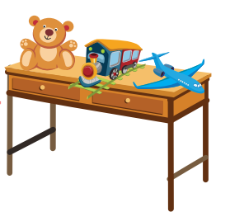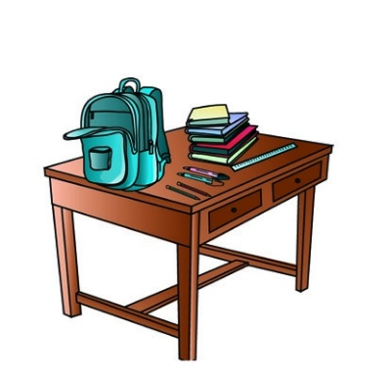
c) Where is the helicopter ? d) Where is the bag ?
………………………………… …………………………………
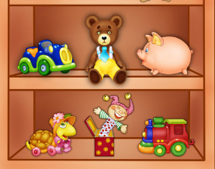
e) Where is the ball ? f) Where is the train ?
………………………………… …………………………………
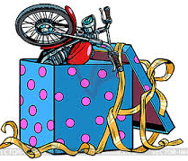
g) Where is the robot ? h) Where is the bike ?
………………………………… …………………………………
Exercise 4 Look and read . Put a tick () or cross () in the box.

a) The teddy bear is in the cupboard. b) The train is on the desk.
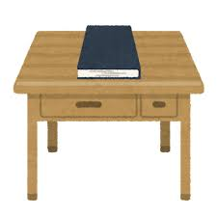
c) The book is on the desk. d) The car is in the box.
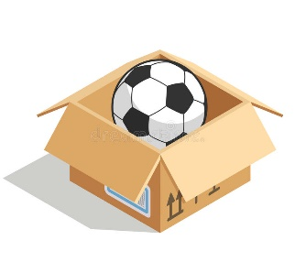
e) The ball is on the box. f) The book is on the chair.
Exercise 5 Put the words in the correct order
A) Where – the – plane – is ?
…………………………………………………………….
B) The – is – plane – in – the cupboard.
…………………………………………………………….
C) robot – Where – is – the ?
…………………………………………………………….
D) the chair – is – The - robot – on
…………………………………………………………….
E) The bag - the desk – on - is
…………………………………………………………….
Lesson 4
Exercise 1 Look and write
picture | soccer ball | basketball | football | baseball

 |  |  |  | 
Exercise 2 Put the words in the correct order
a) the football – Put – in – box – the
………………………………………………………………………………..
b) photo – Put – the – the table – on
………………………………………………………………………………..
c) basketball – the box – Put – in – the
………………………………………………………………………………..
d) the cupboard – Put – the - soccer ball - in
………………………………………………………………………………..
e) baseball – the – Put – on – the chair
………………………………………………………………………………..
f) the pen – Put – on – the desk
………………………………………………………………………………..
g) Put – the desk – the bag - on
………………………………………………………………………………..

Exercise 3 Read this . Choose a word from the box. Write the correct word next to numbers 1 – 2 . There is one example.
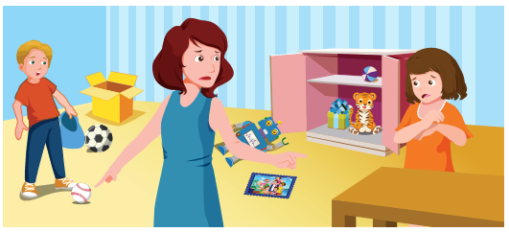

The toys are everywhere . Mom is not happy. She wants Toby to put the baseball in the box. The (1) __________ should be in the cupboard . She asks Lisa to put the photo on the (2) ________________ . Now , the house is clean.
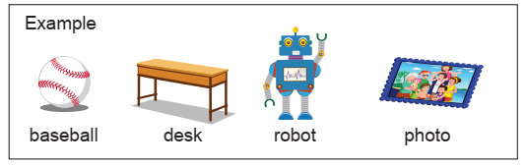

Lesson 5
Exercise 1 Look and write
house | bathroom | kitchen | dining room | living room | bedroom

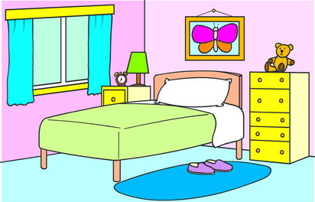 | 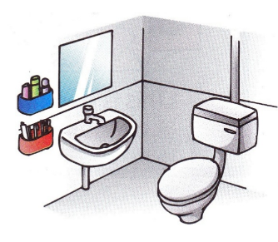 | 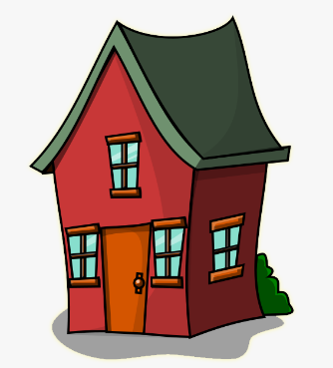
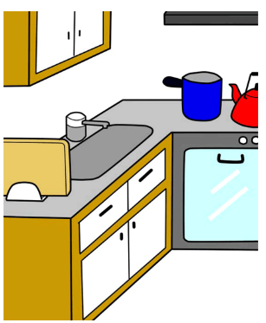 | 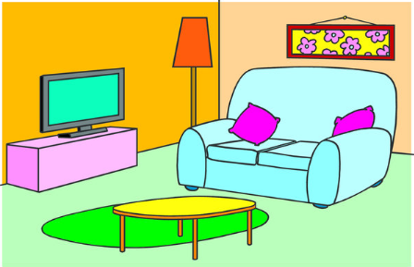 | 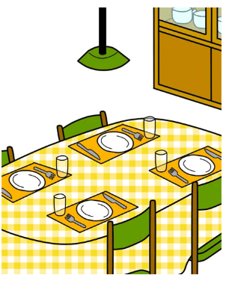
Exercise 2 Number the rooms in the picture above.
1. bathroom | 2. bedroom | 3. dining room | 4. kitchen | 5. living room
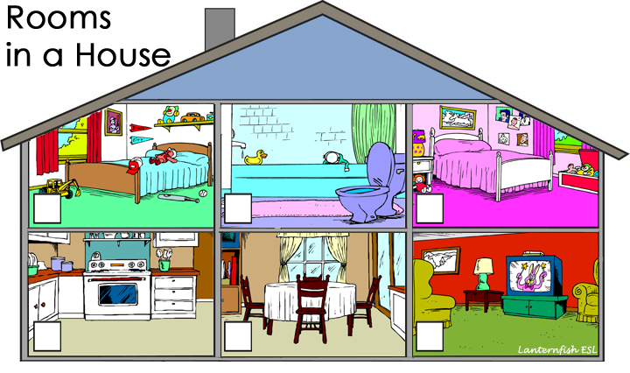

Exercise 3 Look and complete the sentences.

a) There are …………..rooms in the house.
b) There are ………….bedrooms in the house.
c) There is ……………bathroom in the house.
d) ……………a kitchen in the house.
e) There is a living room in the…………
f) …………a dinning room in the house.
Exercise 4 Look and write : There is or There are
a) ………………….. cars in the bedroom.
b) ………………….. one big living room in the house.
c) ………………….. two bedrooms in the house.
d) ………………….. a table in the kitchen.
e) ………………….. four chairs in the living room.
f) ………………….. a picture in the living room.
g) ………………….. three robots in the living room.
h) ………………….. three robots in the living room.
Exercise 5 Read and answer these questions
a) How many pictures are there on the wall ?  …………………………………………………………………  b) How many computers are there on the desk ?  …………………………………………………………………  c) How many chairs are there in the living room ?  …………………………………………………………………  d) How many pillows are there on the sofa ?  …………………………………………………………………  e) How many oranges are there on the table ?  …………………………………………………………………  f) How many boys are there in the living room ?  …………………………………………………………………  h) How many sofas are there in the living room ?  ………………………………………………………………… | 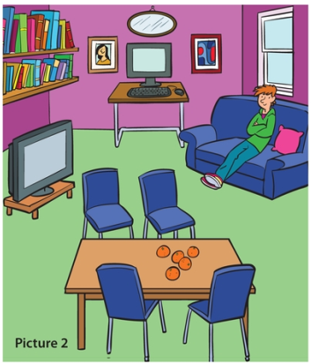
Lesson 6
Exercise 1 Make questions for these answers
A) This is my helicopter.
What is this ?
B) The teddy bear is in the box.
………………………………………………………………..
C) The ball is on the chair.
………………………………………………………………..
D) There are three bedrooms in the house.
………………………………………………………………..
E) There is two cars in the bedroom.
………………………………………………………………..
F) The truck is on the floor.
………………………………………………………………..
Exercise 2 Look and write
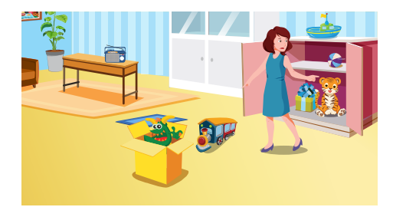
a) Where is the radio ? ………………………………………………..
b) Where is the monster ? ……………………………………………..
c) Where is the boat ? ………………………………………………….
d) Where is the ball ? …………………………………………………..
e) How many trains are there in the room ?
……………………………………………………………………………..
Exercise 3 Read and tick ()
Hi! My name is Mary .This is my house. It’s big. There is a garden in front of the house. There are trees in the garden. The living room is big ,but the kitchen small. There are four bedrooms, two bathrooms in my house. There is a pond behind the house. Around the pond, there are many trees and flowers. They are very beautiful.
 | Yes | No
- Mary’ s house is small.
- The garden is behind the house.
- The living room is large.
- There are many rooms in Mary 's house.
- There is a pond in front of her house.

