Exercise 1 : Look and read . Put a tick () or a cross () in the box.
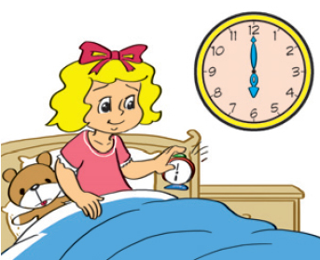
B) I get up at six o’clock.

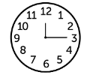
A) It’s twelve o’clock.
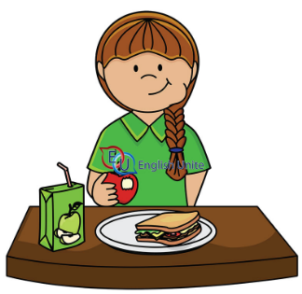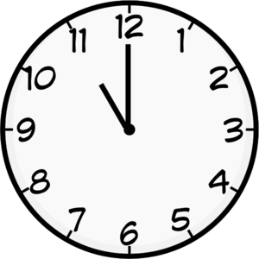
C) She eats lunch at ten o’clock

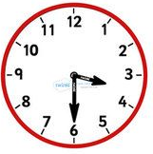
D) It’s half past four.

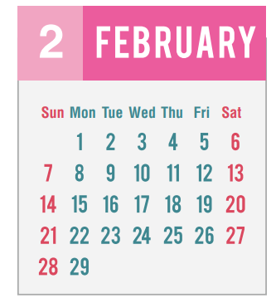
F) My birthday is in September.
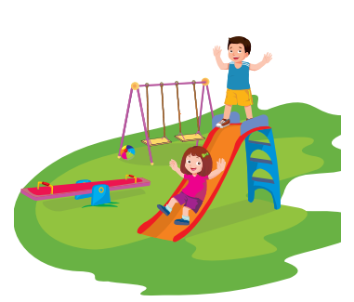
E) I want to go the playground in the afternoon.
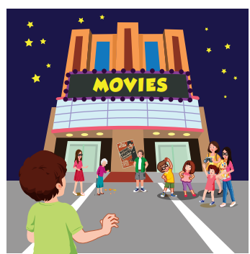
G) He wants to go the movies in the morning.

H) I’m going to watch the
fireworks in the Lunar new Year.

Exercise 2 : Read and match.
1) What time is it ? | A) Toby’s birthday is in April.
2) What do you want to do in the afternoon ? | B) It’s half past eight.
3) What time do you eat dinner ? | C) I’m going to watch a lion dance.
4) When is Toby’s birthday ? | D) She gets at six o’clock.
5) What are you going to do in the Lunar  New Year ? | E) Yes, I do.
6) What time does she get up ? | F) I eat dinner at 7:00 p.m.
7) Do you want to go to the movies in the evening ? | G) I want to go to the park.
Exercise 3 : Read and circle the correct words.
A) What time ( do / does ) you go to bed ?
B) My sister ( get / gets ) up at half past six.
C) What time does he (eat / eats) dinner ?
D) What does your brother ( wants/ want ) to do in the evening ?
E) Henry wants to ( go/ going ) to the playground in the afternoon.
F) My sister usually ( does/ do ) homework at half past eight.
G) My birthday is ( on / in ) October.
H) I’m going to ( visits/ visit ) my family in the Lunar New Year .
I) Lucy’s going to visit ( her / my ) teacher in the Lunar New Year .
J) What is she wearing ? She is ( wear / wearing ) a purple skirt.
K) ( What / When ) is Jenny’s birthday ? It’s in January.
L) What time ( do / does ) they go to school ?
M) My favorite ( day / month ) of the week is Saturday.
Exercise 4 : Read and complete the sentences.
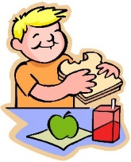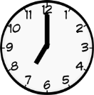 | 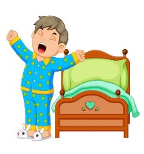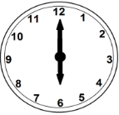 | 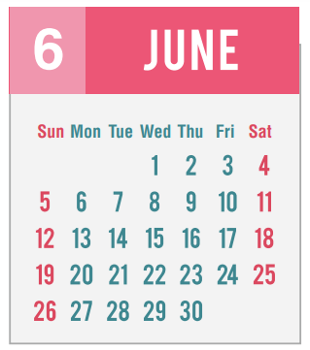
a) He eats breakfast at…..…………………........ | b) He…………………………... at six o’clock. | c) Lucy’s birthday is in  ……………………………..…
 | 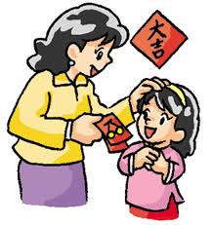 | 
d) I …………………… at  4:00 p.m | e) I’m going to…………………… in the Lunar New Year . | f) I want to …………………….. in the evening.
Exercise 5 : Make questions for these answers.
a) ………………………………………………….….? | It’s half past eleven .
b) ………………………………………………….….? | I get up at half past six.
c) ………………………………………………….….? | My sister goes to bed at 10:00 pm.
d) ……………………………………………….…….? | I want to go swimming in the morning.
e) ………………………………………………….….? | Peter’s birthday is in January.
f) ………………………………………………….….? | I’m going to visit my family in the Lunar New Year.
Exercise 6 : Look ,read and answer these questions
 | get up | eat breakfast | go to school | go home
  Anna | 6 :00 | 6:30 | 7:00 | 4:00
  Tony | 5 :00 | 6:00 | 7:30 | 5:00
a) What time does Anna get up ?
She gets up at six o’clock.
b)What time does Tony eat breakfast ?
…………………………………………………………..………
c) What time does Anna go to school ?
…………………………………………………………..………
d) What time does Tony get up ?
…………………………………………………………..………
e) What time does Anna eat breakfast ?
…………………………………………………………..………
f) What time does Tony go home ?
…………………………………………………………..………
g) What time does Anna go home ?
…………………………………………………………..………
h) What time does Tony go to school ?
…………………………………………………………..………
Exercise 7 : Find the mistakes and correct them.
a) My mother get up at six o’clock every morning.
………………………………………………………………………..
b) What time does you eat dinner ?
………………………………………………………………………..
c) What time is it ? It’s past half twelve.
………………………………………………………………………..
d) My sister want to go to the park in the morning.
………………………………………………………………………..
e) Jenny’s birthday is on October.
………………………………………………………………………..
f) When is Peter’s birthday ? Her birthday is in April.
………………………………………………………………………..
g) I’m going to watching the fireworks in the Lunar New Year.
………………………………………………………………………..
Exercise 8 : Circle the odd one out.
 | - Sunday | - April | - May | - December
 | - breakfast | - get up | - dinner | - lunch
 | - morning | - evening | - afternoon | - birthday
 | - beautiful | - get up | - go to school | - go home
 | - park | - playground | - zoo | - night
 | - tall | - go | - short | - thin
 | - he | - his | - your | - her
 | - Monday | - January | - Saturday | - Thursday

Exercise 9 : Read and answer the questions.
This is John . He’s a teacher. He’s old and a little fat. He has short black hair. He works at the school. He teaches English.
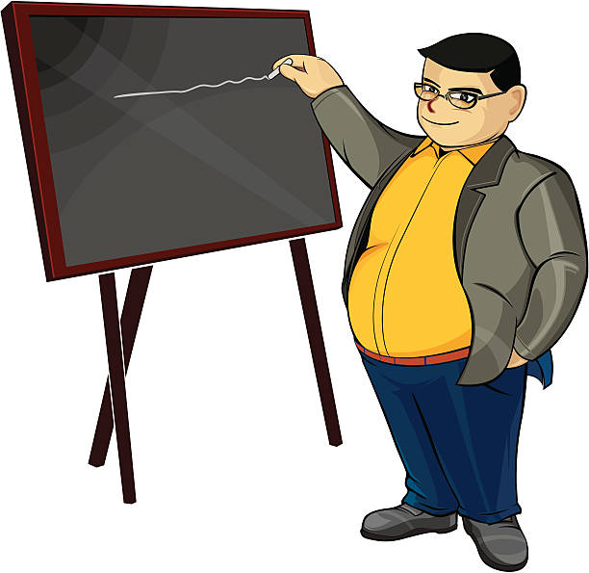
Every day he gets up at half past six in the morning. He takes a shower and puts on a shirt and tie. Then he eats breakfast at seven o’clock. At half past seven, he rides his motorcycle to school.
Tony starts work at eight o’clock. He cleans the classroom. Then, he talks with his students’ parents. He starts teaching at nine o’clock. At twelve o’clock, he eats lunch. He teaches again in the afternoon. He goes home at half past four.
In the evening, he feeds his goldfish and he watches TV. He eats dinner at half past six. Then he corrects students’ homework. At ten o’clock, he goes to bed.
1. What’s his name?
……………………………………………………………………..
2. What does he look like ?
……………………………………………………………………..
3. What time does he get up ?
……………………………………………………………………..
4. What time does he eat breakfast ?
……………………………………………………………………..
5. What time does he go home ?
……………………………………………………………………..
6. What time does he eat dinner?
……………………………………………………………………..
7. What time does he go to bed?
……………………………………………………………………..
8. What does he do in the evening ?
……………………………………………………………………..
Exercise 10 : Read and fill in the blanks with :
What | How old | Whose | Where | Who | When

- ………….is your father ? He is thirty years old.
- …………..time does your father get up ? He gets up at half past five.
- …………. skirt is this ? It’s Mary’s skirt.
- …………. is your best friend ? Tony is my best friend.
- …………. is Peter from ? He’s from the USA.
- …………. is she wearing ? She is wearing a blue dress.
- …………. do you want to do in the morning ?
- …………. is Lucy’s birthday ? It’s in August.
- …………. gloves are these ? They’re Jenny’s gloves.
- …………. color is you sweater ? It’s purple.
- …………. is your favorite subject ? I like English.
- ……….. are you going to do this Saturday ?I’m going to go to the cinema.
Exercise 11 : Look , read and answer these questions
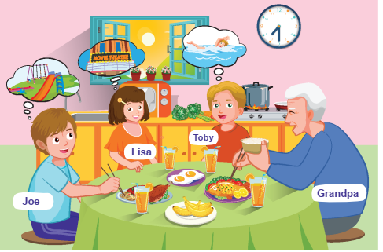 | a) What time do they eat breakfast ?  ………………………………………………………..  b) What does Joe want to do in the morning ?  ……………………………………………………………  c) What does Lisa want to do in the morning ?  ……………………………………………………………  d) What does Toby want to do in the morning ?  …………………………………………………………..  e) How many glasses of orange juice are there on the table?  …………………………………………………………..
Exercise 12 : Put the words in the correct order.
A) past/ half / It’s / eleven./
…………………………………………………………………………………….
B) go / I / at / ten / o’clock ./to / bed/
…………………………………………………………………………………….
C) What / does / eat / she / breakfast ? / time /
…………………………………………………………………………………….
D) party /My /sister /wants / to / go /to /a /the/in/evening./
…………………………………………………………………………………….
E) What / do / want / you /in / to / do / morning ?/the
…………………………………………………………………………………….
F) is / When / his / birthday ? & /in/It’s/March./
…………………………………………………………………………………….
G) I’m/ to / eat/going / Tet cake /the / in/ Lunar/ Year. /New/
…………………………………………………………………………………….
H) is / my / The / Lunar/ favorite /New Year /holiday./
…………………………………………………………………………………….
Exercise 13 :Find the word which has a different sound in the part underlined
 | a) clean | b) clown | c)black | d) clock
 | a) bread | b) weather | c) breakfast | d) beach
 | a) funny | b) lunch | c) sun | d) computer
 | a) subject | b) club | c) lunch | d) student
 | a) come | b) month | c) mother | d) open
 | a) why | b) when | c) who | d) where
 | a) breakfast | b) sea | c) beach | d)read
 | a) road | b) shoes | c) coat | d) goat

Exercise 14 : Use the words in the box to fill in the blanks please.
breakfast | dinner | lunch | short | goes
past | does | seven | morning | studies
evening | brushes | games | watches | cartoons

 | This is Bob. He’s (1) ………….. years old. He’s short and thin. He has (2) ………….. blond hair and big blue eyes. He gets up at seven o’clock in the (3) …………...He takes a shower and (4)………….. his teeth. He eats (5) ………….. at half past seven. At quarter to eight he goes to school with his brother. Bob studies at half (6) ………….. eight. At ten o’clock, he plays (7)………….. with his friends. He eats (8) ………….. at eleven o’clock. Then he (9) ………….. again. At four o’clock he (10) ………….. home. He (11)eats ………….. at six o’clock in the(12)………….. . Then, he takes a shower. He (13)…………. his homework at seven o’clock and then he(14)………….. TV. He likes (15) ………….. .At half past nine, he goes to bed.
Exercise 14 : Read the text again and tick True or False
 | True | False
- Bob gets up at half past six.
- He eats breakfast at seven o’clock.
- He goes to school at quarter to eight.
- He eats lunch at eleven o’clock.
- He goes home at half past four.
- He eats dinner at six o’clock.
- He goes to bed at half past nine.

