Lesson 1
Exercise 1 Look and write
bread | eggs | chicken | rice | cereal | fish

 | 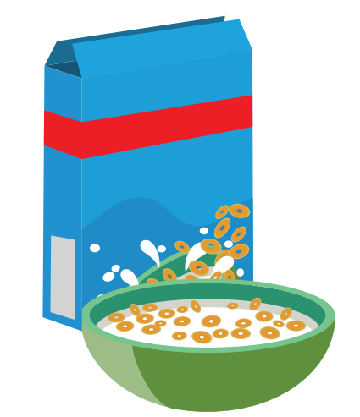 | 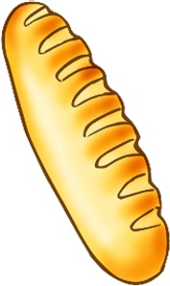
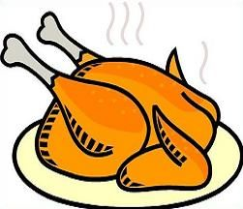 | 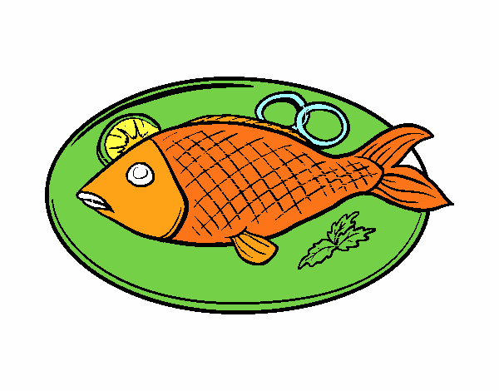 | 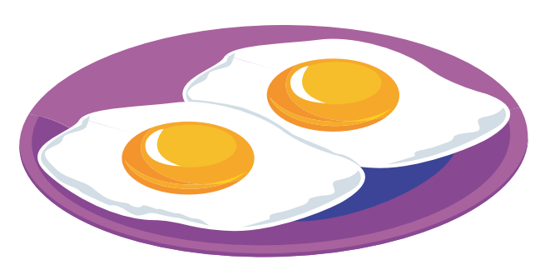
Exercise 2 Find the following words
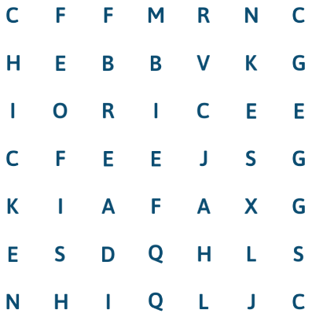
- cereal
- bread
- fish
- eggs
- chicken
- rice

Exercise 3 Read and circle
a) What do you want to eat ? b)What do you want to eat ?
May I have ……………………. ? May I have ……………………. ?
 | - fish  - chicken  - eggs |  |  | 1) rice  2) bread  3) cereal

c) What do you want to eat ? d)What do you want to eat ?
May I have ……………………. ? May I have ……………………. ?
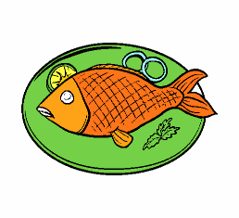 | 1) fish  2) bread  3) eggs |  |  | 1) cereal  2) rice  3) eggs

e) What do you want to eat ? f)What do you want to eat ?
May I have ……………………. ? May I have ……………………. ?
 | 1) bread  2) cereal  3) chicken |  | 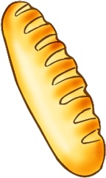 | 1) cereal  2) rice  3) bread
Exercise 4 Read and complete the sentences
a) What do you want to eat ?.................. I have eggs ?
b) What is your favorite food ? My favorite food ..............chicken.
c) What do you want to..................? May I have cereal ?
d) Do you like bread ? ................., I do.
e) What do you want to eat ? May I .......... chicken?
Lesson 2
Exercise 1 Look and write the missing letters
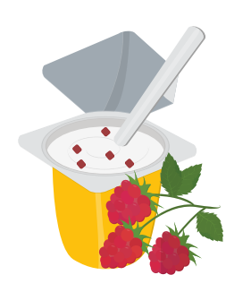 | 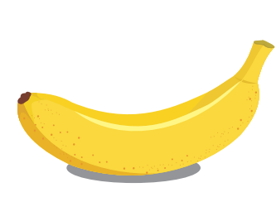 |  | 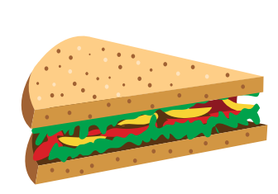 | 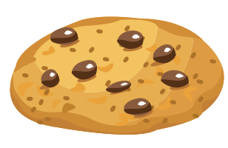
yo _ _ rt | _ _ nana | cup _ _ _ _ | _ _ _ _ wich | cook _ _
Exercise 2 Read and tick ( ) the correct answers
a) Can I eat a sandwich ?

Yes , you can.
b) Can I eat a cupcake ?

Yes, you can.
c) Can I eat a banana ?

Yes, you can.
d) Can I eat a cookie ?

Yes, you can.
e) Can I eat an apple ?  Yes, you can. | 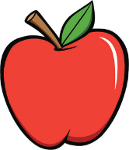

Exercise 3 Read and complete the sentences.
a) Can I eat a ………….. ? Yes, you can.
b) Can I eat a sandwich ? ……., you can.
c) ………. I eat an apple ? Yes, you can.
d) Can I eat a …………..... ? Yes, you can
e) ………. I eat an apple ? ………., you can.
Lesson 3
Exercise 1 Look and match
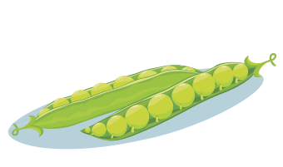
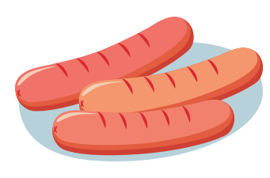
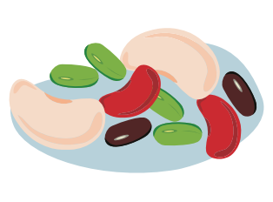
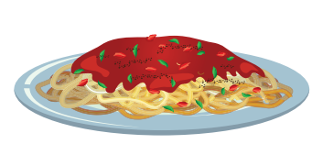
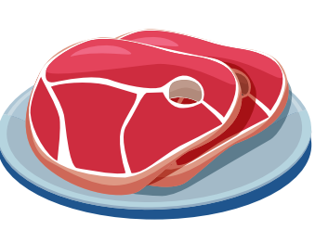
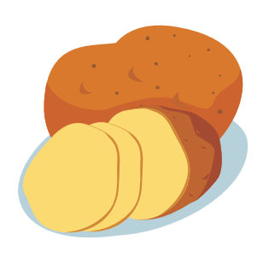

meat
beans
spaghetti
potatoes
sausages
peas

Exercise 2 Read and match
a) Do you like potatoes ?  Yes, I do. |  | 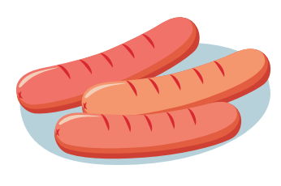
b) My brother likes sausages. |  | 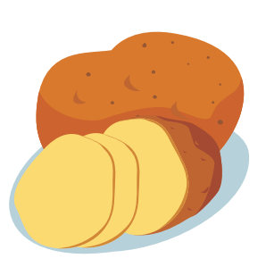
c) What do you want to eat ?  May I have spaghetti ? |  | 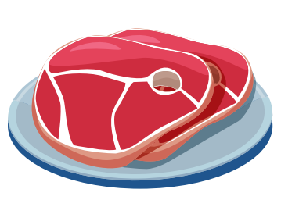
d) I like meat. |  | 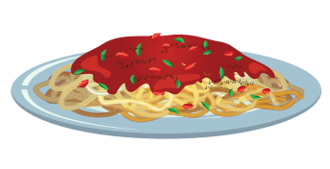
e) I don’t like peas. |  | 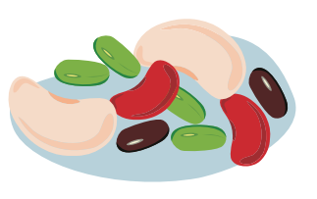
f) These are beans. |  | 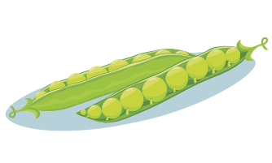

Exercise 3 Look and read . Circle the correct words.
sausages and eggs
potatoes and peas
a) Can I have some , please ?

peas and potatoes
beans and potatoes
b) Can I have some , please ?

sausages and spaghetti
sausages and eggs
c) Can I have some , please ?

 | chicken and rice  chicken and bread  d) Can I have some , please ?
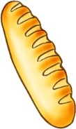 | bread and eggs  bread and milk  e) Can I have some , please ?
Exercise 4 Look and write
a) Can I have some spaghetti and eggs , please ?
Yes , here you are .
Thank you
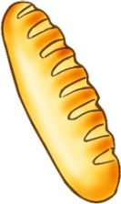 | b) Can I have some …………….and……………. , please ?  Yes , ……………………………..  Thank you
c) Can I have some …………….and……………. , please ?
Yes , ……………………………..
…………………………………….
Lesson 4
Exercise 1 Look and circle
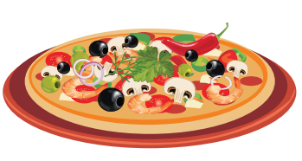 |  | 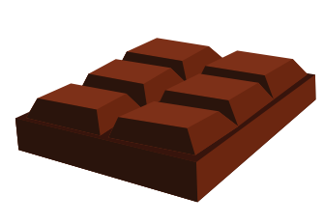
a) pizza  b) sandwich | a) cookie  b) ice cream | a) chocolate  b) chicken
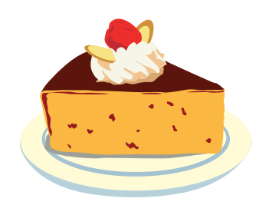 | 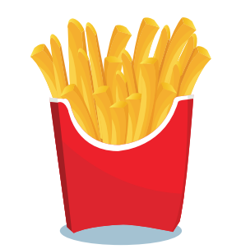 | 
a) bread  b) cake | a) fries  b) spaghetti | a) milk  b) juice
Exercise 2 Ask and answer
 |  | a) Would you like some pizza ? Yes, please.
 |  | b) …………………………………………………….
 |  | c) …………………………………………………….
 |  | d) …………………………………………………….
 |  | e) …………………………………………………….
 |  | f) …………………………………………………….
Exercise 3 Read and complete
 |  | a) Would you like some spaghetti? ………………
 | 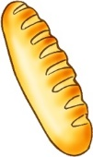 | b) Would you like some ……………? No, thanks
 |  | c) …………you like some cake ? ………………
 | 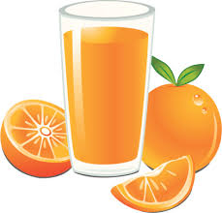 | d) Would you like some ……………? Yes, please.
 |  | e) ) Would you like some chocolate ? ………………
 | 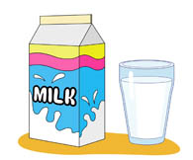 | f) Would you like some ……………? No, thanks.
Exercise 4 Read and match
- Would you like some pizza ? | - Yes, you can.
- Can I have some spaghetti and eggs , please ? | - Yes, please.
- What do you want to eat ? | - Yes , here you are . Thank you
- Can I eat a cupcake ? | - I like pizza.
- What food do you like ? | - May I have cereal ?

Lesson 5
Exercise 1 Look and write the missing letters
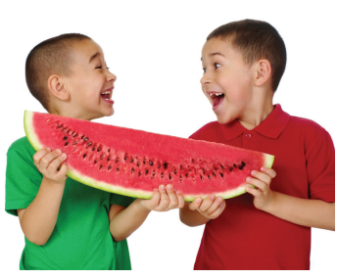 | 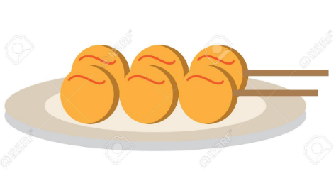 | 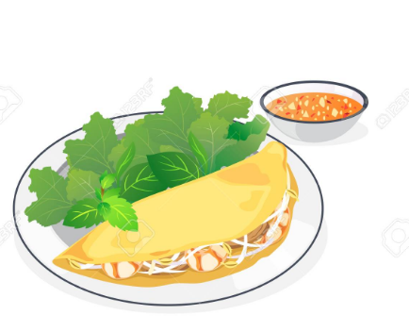
sha _ _ | _ _ _ _ balls | pan _ _ _ _
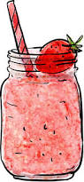 | 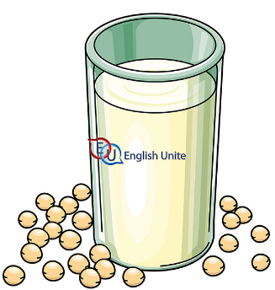
_ _ oothie | soya _ _ _ _
Exercise 2 Look the pictures and complete the sentences
a) Have some fish balls.
b) ……………………………………………………….
c) ……………………………………………………….
d) ……………………………………………………….

Exercise 3 Look and write
a) Have some soya milk.

Thank you.

You’re welcome.

b) ……………………………………….

……………………………………….

……………………………………….

c) ……………………………………….

……………………………………….

……………………………………….

d) ……………………………………….

……………………………………….

……………………………………….

e) ……………………………………….

……………………………………….

……………………………………….

f) ……………………………………….

……………………………………….

……………………………………….

Lesson 6
Exercise 1 Look, circle the right option.
0. What do you want to eat ? 1. Can I eat a ………………?
May I have ………………? Yes, you can.
a. eggs b. chicken c. cereal a. cookie b. sandwich c. cupcake
2. Can I have some …………please ? 3. Can I have some …………please ?
Yes , here you are . Yes , here you are .
Thank you Thank you
a. eggs and beans b. sausages and eggs a. beans and peas b. beans and potatoes.
4. Would you like some………………? 5. Would you like some juice ?
Yes, please. ………………………….
a. chips b. chocolate c. bread a. Yes, please. b. No, thanks
6) Have some ………………. 7) Have some ……………….
Thank you. Thank you.
You’re welcome. You’re welcome
a. juice b. soya milk c. smoothie a. smoothie b. soya milk
Exercise 2 Look and read. Write Yes or No
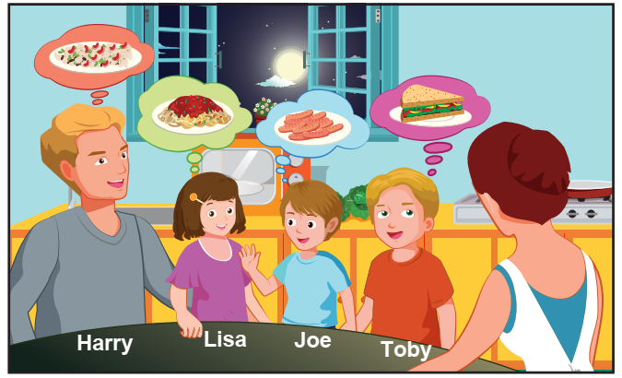
- Harry would like some beans . ___________________
- Toby would like some ice cream. ___________________
- Lisa would like some chocolate. ___________________
- Joe would like some sausages. ___________________
Exercise 3 Look, read and answer
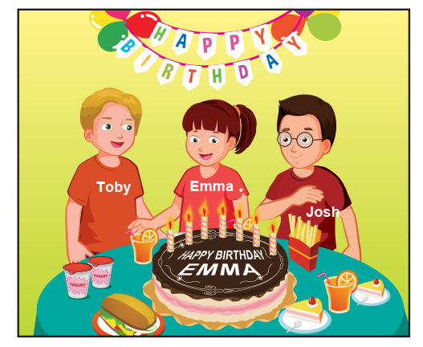 | a) What drink do they have ?  …………………………………………..  b) How old is Emma ?  …………………………………………..  c) What food does John have ?  …………………………………………..  d) How many yogurts are there on  the table ?  …………………………………………..

