Lesson 1
Exercise 1 Look and write
lake | bakery | park | sport shop | supermarket

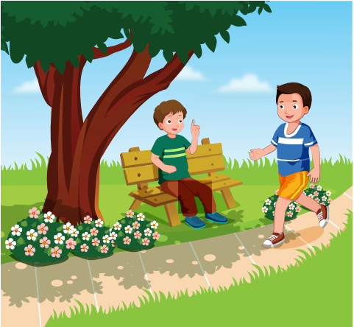 | 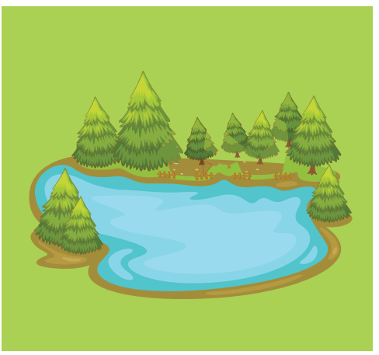 | 
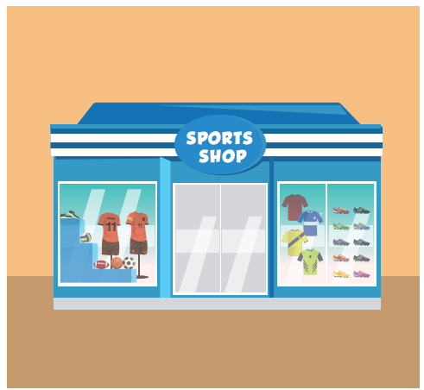 | 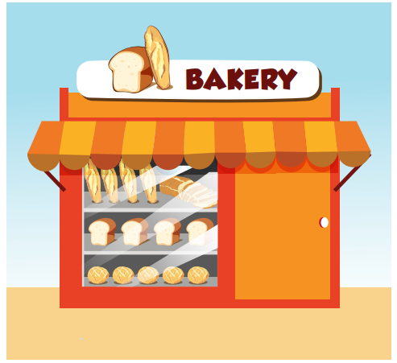 | 
Exercise 2 Look , read and match
- He’s going to the park. |  | 
- She’s going to the supermarket. |  | 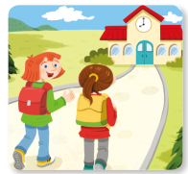
- They’re going to school. |  | 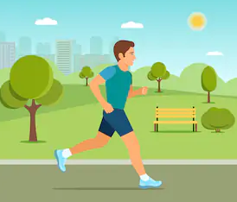
Exercise 3 Look, read and match
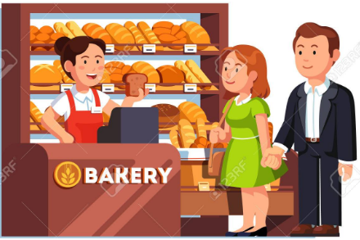 | a) Where are they going ? | …………………………………………
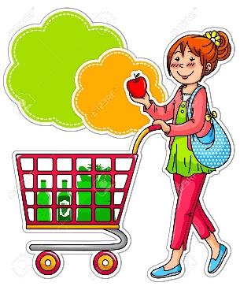 | b) Where is she going ? | …………………………………………
 | c) Where are you going ? | …………………………………………
 | d) Where are they going ? | …………………………………………
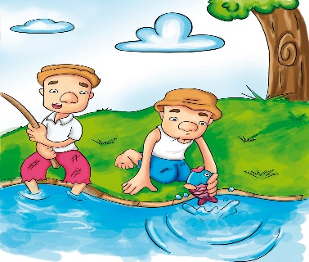 | d) Where are they going ? | …………………………………………
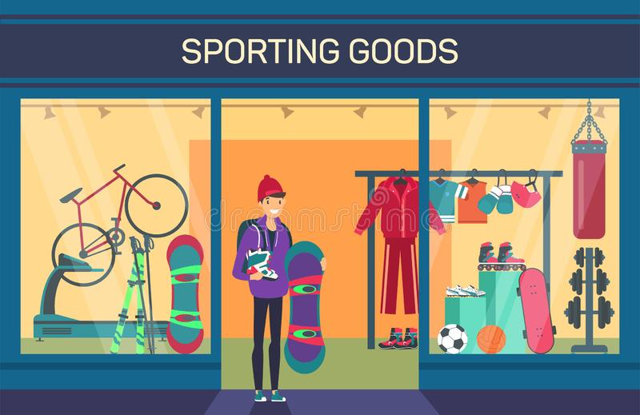 | e) Where is he going ? | …………………………………………
Exercise 4 Make questions for these answers
A) He is going to the sports shop.
…………………………………………………………………………..
B) She is going to the supermarket.
…………………………………………………………………………..
C) They are going to the park.
…………………………………………………………………………..
D) I am going to the lake.
…………………………………………………………………………..
E) They are going to school.
…………………………………………………………………………..
Lesson 2
Exercise 1 Look and number
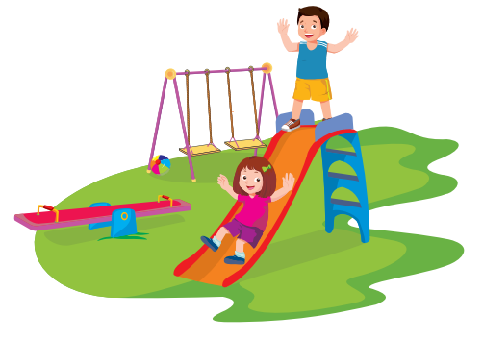



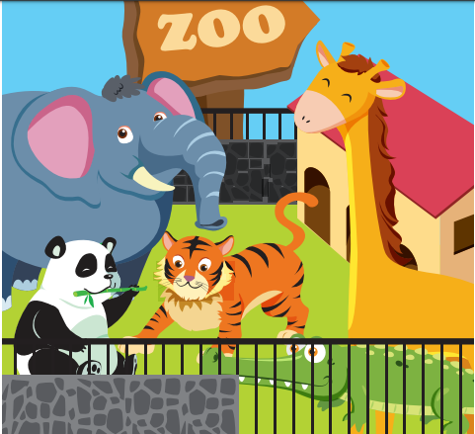

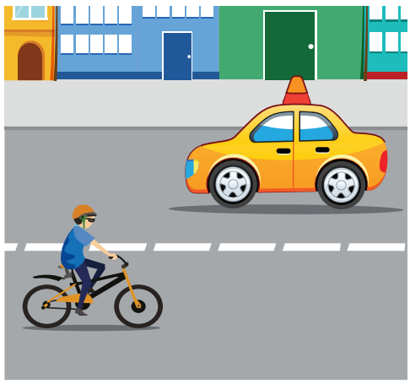

- street | - playground | - zoo | - bookshop | - ice cream shop

Exercise 2 Look and write
 | OAK Street | A) Where is the ice cream shop ?  ……………………………………………..
 | MAIN Street | B) Where is the bookshop ?  ……………………………………………..
 | KING Street | C)Where is the playground ?  ……………………………………………..
 | PINE Street | D)Where is the supermarket ?  ……………………………………………..
 | WATER Street | D)Where is the sports shop ?  ……………………………………………..
 | OAK Street | E)Where is the zoo ?  ……………………………………………..

Exercise 3 Read and complete the sentences
- Where is the ice cream shop ? It’s ………………. Oak Street.
- ………………. are you going ? I’m going the park.
- Where is the supermarket ? It ………………. on PINE Street.
- Where is he going ? ………………is going to the sports shop.
- Where are they going ? They are ………………to school.
- Where is she ………………? She’s going to the supermarket.
- Is he going to the sports shop ? ………………, he is.
- Where are you going ? ………………going the bakery.
- Are they going to school ? Yes, they ………………
- Where is the playground ? It is on KING ……………….
Lesson 3
Exercise 1 Look and match
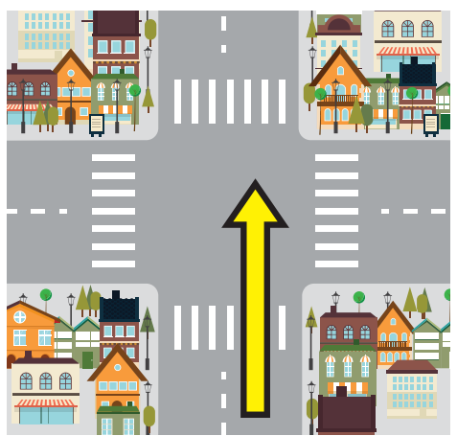 | 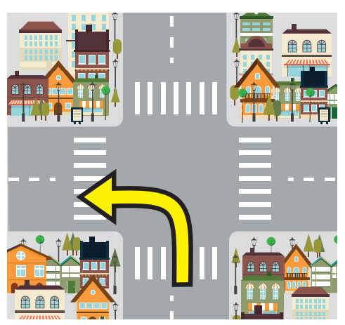 | 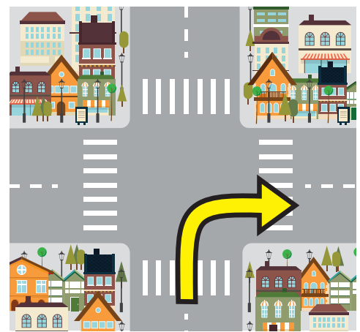 |  | 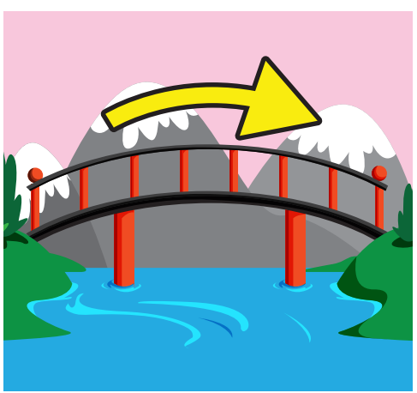
turn left | go over | go straight | turn right | bridge

Exercise 2 Look and circle
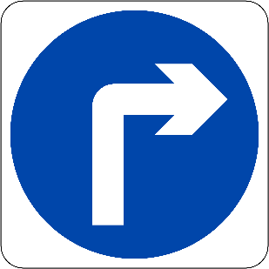 | 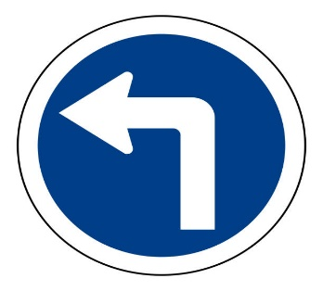 | 
- turn right  - turn left | A. turn right  B. turn left | A. go straight  B. turn left | A. go straight  B. go over the bridge
Exercise 3 Look and write
 | 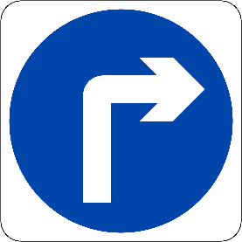 | a) How do I get to the lake ? | ……………………….
 | 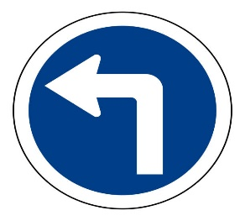 | b) How do I get to the playground ? | ……………………….
 |  | c) How do I get to the bakery ? | ……………………….
 |  | d) How do I get to the park ? | ……………………….

Exercise 4 Read and complete
 |  | a) How do I get to the ……………..? Turn left.
 |  | b) How do I get to the bookshop ?...............................
 |  | c) .............. do I get to the........................? Turn right.
 |  | d) How do I get to the..................? .............................
 |  | e)...................................................? Turn left.

Lesson 4
Exercise 1 Look and write
reading | fishing | campsite | eating | shopping | market

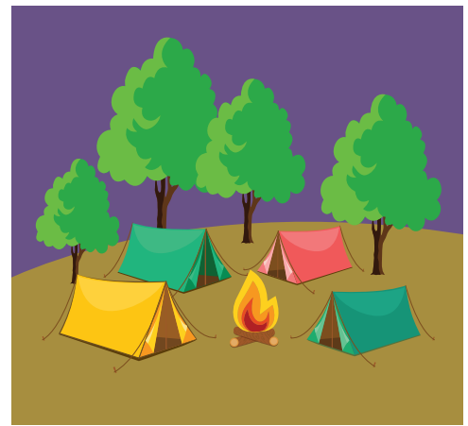 |  | 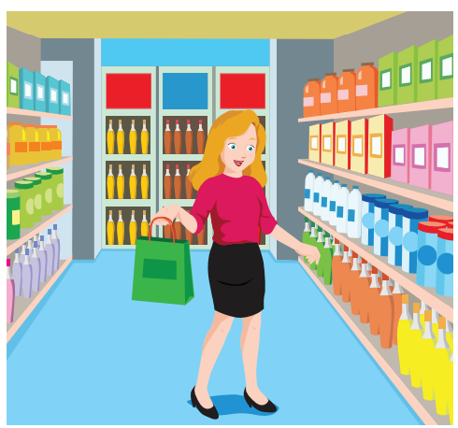
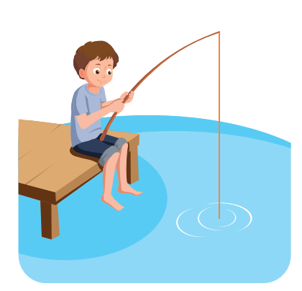 |  | 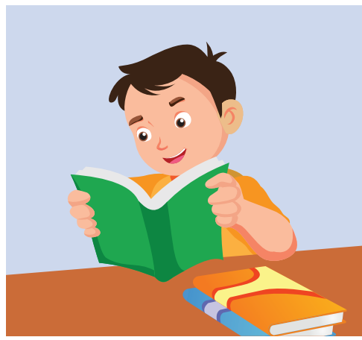
Exercise 2 Look and circle the right option.
 | 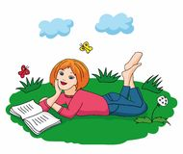 | 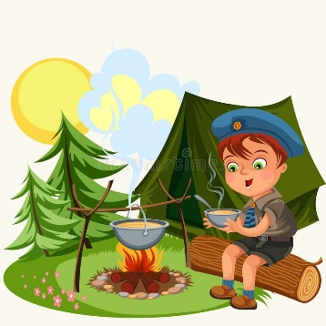
a) He’s fishing at the lake.  b) He’s reading at the park.  c) He’s eating at the campsite. | a) She’s shopping at the market.  b) She is reading at the park.  c) She’s fishing at the lake. | a) He’s eating at the campsite.  b) He’s fishing at the lake.  c) He is reading at the park.
Exercise 3 Look and write
a) What is he doing ? | b) What is she doing ?
……………………………………………. | …………………………………………….
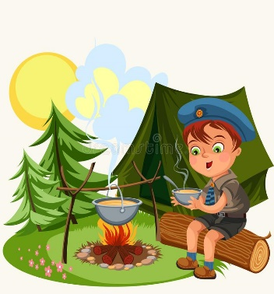

c) What is he doing ? | d) What is she doing ?
……………………………………………. | …………………………………………….
Exercise 4 Read and complete the sentences.
a) What is he doing ? …………is fishing at the lake.
b) ………………… she doing ? She’s shopping at the market.
c) What is he doing ? He is reading ………… the park.
d) What is she …………? She’s eating at the campsite.
e) Is he fishing at the lake ? Yes, …………is.
f) …………are they doing ? They are reading at the park.
g) Is she shopping at the market ? …………, she isn’t.
Lesson 5
Exercise 1 Look and write the missing letters
 |  | 
gr _ _ n light | red li _ _ _ | _ _ _ _ hands
 | 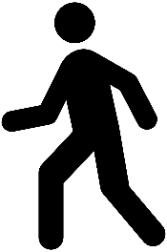 | 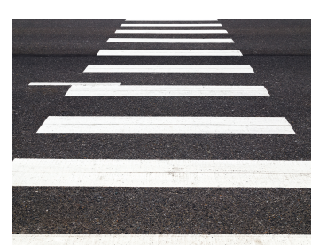
st _ _ | _ o | cross _ _ _ _
Exercise 2 Look and complete
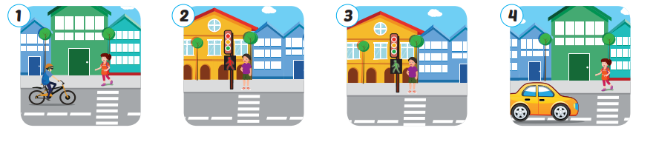
1) There is a bike . Let’s stop.
2) There is a red light . ………………………………………..
3) ………………………………………… . Let’s go.
4) There is a car. ………………………………………..
Exercise 3 Read and match
a) There is a crosswalk . | a) _ | 1) Let’s stop.
b) There is a red light. | b) _ | 2) Let’s hold hands.
c) There is a green light, | c) _ | 3) the street
d) Hold hands and cross | d) _ | 4) Let’s go.

Lesson 6
Exercise 1 Look and Read . Write Yes or No
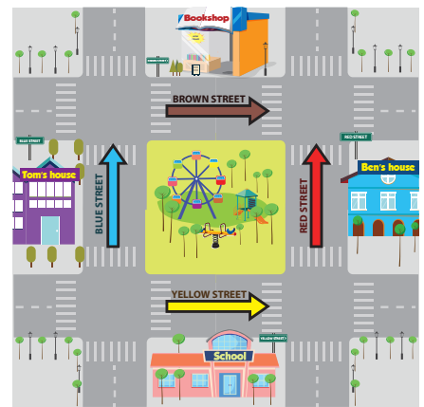 | a) Is Ben’s house on Brown Street ?  ________________________  b) Is the school on Yellow Street ?  ________________________  c) Is the bookshop on Red Street ?  ________________________  d) Is Tom’s house on Blue street ?  ________________________  e) Is the park on Red Street?  ________________________

Exercise 2 Look and write
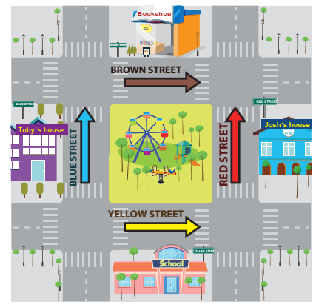
- Where is Toby’s house ?
…………………………………………………………………..
- Where is the school ?
…………………………………………………………………..
- Where is josh’s house ?
…………………………………………………………………..
- Where is the book shop ?
…………………………………………………………………..
Exercise 3 Look at the pictures and read the questions. Write one – word answers.
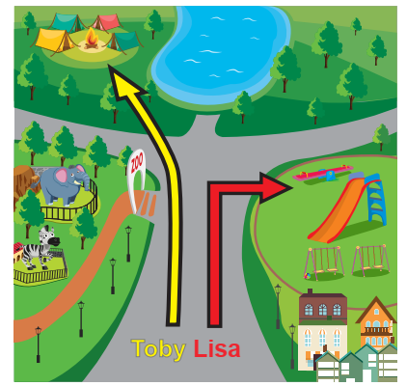 | a) Where’s Tony going ?  To the ______________.  b) How do you get the lake ?  Go ____________________ .  c) Where is Lisa going ?  To the ______________.  d) How do you get to the zoo ?  Turn _______________ .
Exercise 4 Read and match
- Where are you going ? | - Yes, she is.
- Is she going to the supermarket? | - I’m going to the park.
- How do I get to the lake ? | - No, he isn’t.
- What is she doing ? | - Turn right.
- Is he reading a book at the park ? | - She’s fishing at the lake.
- What is he doing ? | - It’s on Oak Street.
- Where is the ice cream shop ? | - Let’s stop.
- There is a red light . | - He’s eating at the campsite.

Exercise 5 Read this. Choose a word from the box. Write the correct word next to numbers 1 – 2. There is one example.
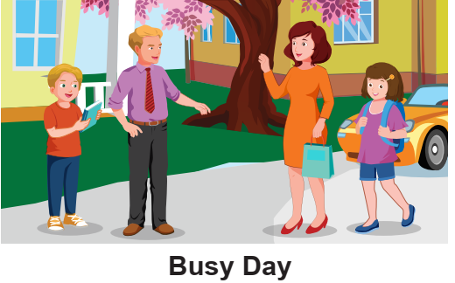
Today is a busy day. My family are all going out. My father is going to the
sport shop. He wants a new football. My mother is going to the (1) ____________ . She needs to buy for dinner . My sister is going to the (2) ________________ buy comics . I’m going to Adam’s house to study with him.
