Exercise 1 Look , read and tick () or cross () in the box.
  a) He is from the UK. | 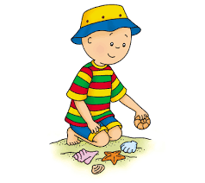  b) He wants to swim. |   c) We want to have a picnic.
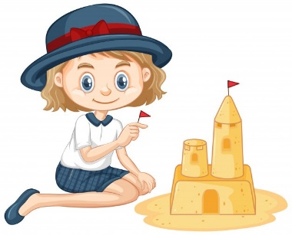  d) I want to make a sandcastle. |   e) He is from Canada. |   f) He wants to fly a kite.
  g) I watered the plants yesterday. | 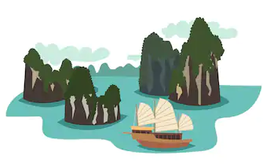  h) My brother wants to go to Ha Long Bay and see the big rocks. |   i) They cleaned the pond yesterday afternoon.
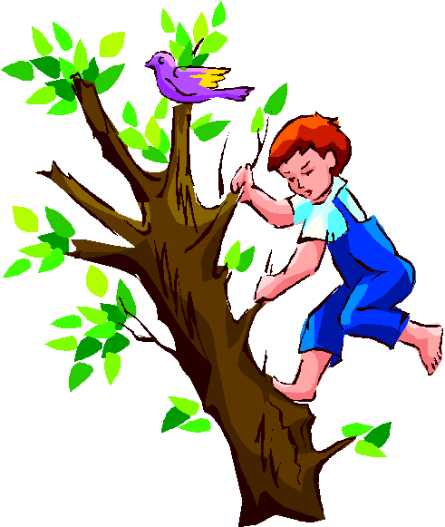 |  | 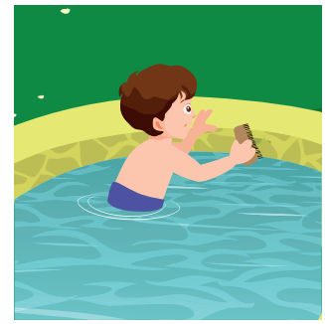
j) He wants to play badminton. | l) They are from Vietnam. | l) He played chess yesterday.

Exercise 2 : Read and match.
- Where is he from ? | - Yes, she is.
- Is she from China ? | - He is from the USA.
- What do you want to do ? | - She watered plants yesterday.
- Do you want to have a picnic ? | - I want to play the guitar.
- What did you do yesterday ? | - No, I didn’t.
- Where do you want to go ? | - I cleaned the pond yesterday.
- Did you go to school yesterday ? | - Sure, Ok.
- What did she do yesterday morning ? | - They are from the UK.
- Where are they from ? | - I want to go to Sa Pa and see the mountains.
Exercise 3 : Read and complete the sentences.
a) Where is Lucy from ? She ……………. from Australia.
b) Are you from Canada ? Yes, I …………….
c) This is Jack . He’s…………….the USA. Hello , Jack .………to meet you.
d) What do you want to do ? I ……………. to make a sandcastle.
e) My sister wants to ……………for shells.
f) Do you want to have a picnic ? No, ……………
g) What can he do ? He……………climb the tree.
h) Do you want to ……………to the park ? Sure ,OK.
i) What did you do yesterday ? I ………….. up the trash.
j) Did you clean the pond yesterday ? No , ……………
k) ……………do you want to go ? I want to go to Da Lat and see the waterfalls.
l) Do you want to go to Da Lat ? ……………, I do.
m) What did she do yesterday morning ? ……………helped her dad.
Exercise 4 : Look, read and complete the sentences.
 | 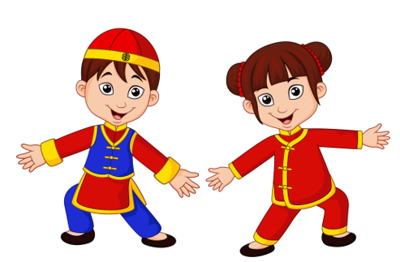
a) This’s Lucy. She’s from  ……………………………………..  Hello Lucy. Nice to meet you | b) Where are they from ?  ………………………………………….. | c) What can he do ?  ………………………………………..
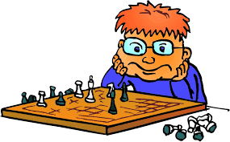 |  | 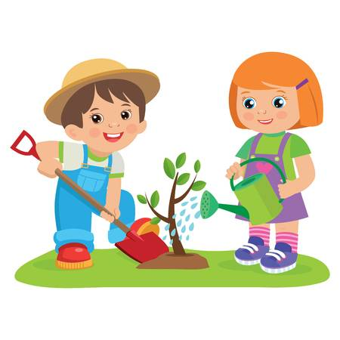
d) What do you want to do ?  ………………………………………. | e) ………………………………  Sure ,Ok. | f)What did they do yesterday?  ……………………………………..
 | 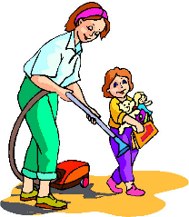 | 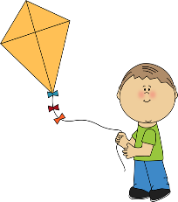
g) Where do you want to go ?  ………………………………………….  and see……………………………. | h) What did she do yesterday?  ………………………………………. | i)……………………………………….  He likes flying a kite.
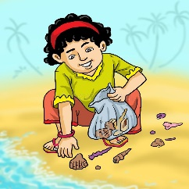 | 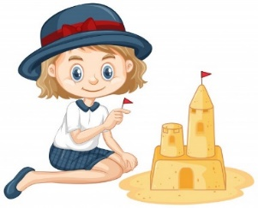 | 
j) what does he want to do ?  He wants…………………………. | k) Can she make a sandcastle?  Yes,……………………………… | l) This is Mai . She is from  ………………………………….
Exercise 5 : Make questions for these answers.
a) …………………………………………………………………..?
+ Peter is from Australia.
b) …………………………………………………………………..?
+ No, she is from the UK.
c) …………………………………………………………………..?
+ I want to look for shells.
d) …………………………………………………………………..?
+ My sister wants to make a sandcastle.
e) …………………………………………………………………..?
+ Toby and Peter want to play tag.
f) …………………………………………………………………..?
+ She went to school yesterday.
g) …………………………………………………………………..?
+ My brother played basketball yesterday afternoon.
h) …………………………………………………………………..?
+ I picked up the trash yesterday morning.
i) ……………………………………………………….?
+ Lucy wants to go to Hue and see the pagodas.
j) ……………………………………………………….?
+ My mother wants to go to Ha Long Bay and see the big rocks.
k) ……………………………………………………….?
+ Peter and Alex can play badminton.
l) ……………………………………………………….?
+ Linda likes playing the piano.
m) ……………………………………………………….?
+ They are from the USA.
Exercise 6 : Read and circle the correct words.
a) This is Jack . (She / He) is from the USA.
b) What do you want to do ? I ( want / wants ) play volleyball.
c) Is she from Canada ? Yes , ( she is / she isn’t)
d) My brother ( want/ wants ) to look for shells.
e) Do you want to have a picnic ? ( Yes / No ) , thanks.
f) What can Tony do ? He can ( fly/ flying ) a kite.
g) What ( did / do ) your brother do yesterday morning?
h) My father ( watch /watched ) TV yesterday evening.
i) Did you go to school yesterday ? Yes , ( I did / I didn’t)
j) My dad wants to ( going / go ) to Sa Pa and see the mountains.
k) ( What / Where ) does your mother want to go ? She wants to go to Hoi An.
l) They ( went / go ) to the party yesteday.
Exercise 7 : Find the mistakes and correct them.
a) What did she do yesterday ? She help her grandma.
……………………………………………………………………………
b) Do you want to flying a kite ? Sure , Ok.
……………………………………………………………………………
c) When is Sarah from ? She is from Australia.
……………………………………………………………………………
d) What do your brother want to do ? He wants to climb a tree.
……………………………………………………………………………
e) Did you picked up the trash yesterday afternoon ? Yes, I did.
……………………………………………………………………………
g) Where do you want to go ? I wants to go to Da Lat and see the waterfalls.
……………………………………………………………………………

Exercise 8 : Look at the picture and read the story . Write some words to complete the sentences about the story . You can use 1,2 or 3 words.
The birthday pirate
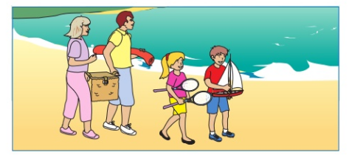
Last weekend , Bill , Jane and their parents went to the sea for Bill’s birthday . It was sunny at the beach. The children played badminton with their father . Mum put a picnic on a red blanket. The family sat on the blanket and ate their lunch . They gave Bill a cake and they sang a birthday song . After their food , Mum and Dad slept
1) On the day that the family went to the beach , the weather was ……………..
2) Bill, Jane and ……………….. played badminton.
3) When they ate their picnic at the beach , they sat on ……………..
4) ………………………..went to sleep after lunch.
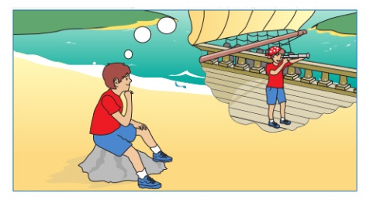
The children were not tired. They wanted to play in the sea. Jane jumped and ran in the water and Bill played with his toy boat. He though, I’d like to sail on a big boat.
Then they saw a pirate ! He had a green parrot on his shoulder.
5) Jane and Bill played in ……………………….
6) ……………………….had a toy boat.
7) Bill wanted to ……………………….on a boat.
8) The pirate had a ……………………….with him.
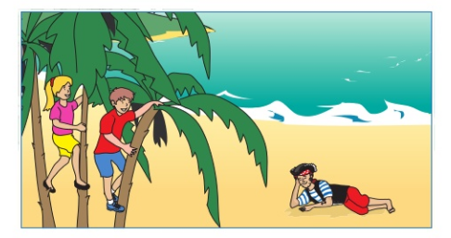
The pirate said , ‘ Hello ! Would you like a ride in my boat ?’ The children said, ‘Yes, please!’
The pirate took them to an island . They climbed trees and played. The pirate gave them some coconuts , which they ate at the top of the trees. Then he said , ‘I must take you back to your parents’ Bill said, ‘ That was the best birthday ! Thank you !’
When they went back to the beach , their parents were awake .They talked to the pirate and gave him a cup of tea.

9) Bill and Jane went in the boat with the pirate to …………………
10) They ate …………………up the trees.
11) On the beach their mum and dad were …………………
12) The pirate had some …………………with Mum and Dad.
Exercise 9 : Read and complete
watered | watched | kitchen | played | were
Last Saturday evening Linda and her parents (1) ……………. in her grandma’s house . Her father (2) ……………. the flowers in the garden . Her mother cooked nice meals in the (3) …………….. Her grandma (4) ……………. TV in the living room . Linda (5) ……………. hide – and – seek with a dog. They really had a good time.
Exercise 10 : Read the text again and answer the questions.
a) Where were Linda and her parents last Saturday evening ?
…………………………………………………………………………………
b) What did Linda do ?
…………………………………………………………………………………
c) What did her grandma do ?
…………………………………………………………………………………
d) What did her father do ?
…………………………………………………………………………………
e) What did her mother do ?
…………………………………………………………………………………
Exercise 11 : Circle the odd one out.
 | - China | - The UK | - Australia | - American
 | - play | - swim | - read | - beautiful
 | - mountains | - waterfalls | - park | - rocks
 | - hot | - weather | - cold | - warm
 | - When | - What | - Where | - the
 | - time | - speak | - swim | - climb
 | - beautiful | - wonderful | - interesting | - pagodas

