Unit 11

PRESENT SIMPLE ( HIỆN TẠI ĐƠN)

GRAMMAR BOARD
POSTITIVE ( KHẲNG ĐỊNH)
S+ V ( s,es)
I watch TV every day.
He watches TV every day.
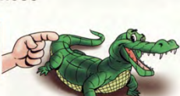


PRESENT SIMPLE

USAGE ( CÁCH SỬ DỤNG)
- Sự thật hiển nhiên
- Thói quen, sở thích ở hiện tại.

NEGATIVE ( PHỦ ĐỊNH)
S+ don’t/doesn’t+ V.
I don’t watch TV every day.
He doesn’t watch TV every. day.

QUESTIONS ( CÂU HỎI)
( Wh) + do/does+ S+ V?
Do you watch TV every day?
Does he watch TV every day?

Complete the sentences with possessive adjectives.
TIME EXPERESSIONS ( DẤU HIỆU THỜI GIAN)
never- hardly – ever-rarely- seldom – sometimes –often –usually -always-in the morning -in the afternoon -in the evening -at the weekend -on Mondays- on Sundays -every day -once a week -twice a week…………

In

- Jame and Alice have a car. _Their___car

86
I/YOU/WE/THEY/CHỦ NGỮ SỐ NHIỀU
POSITIVE ( KHẲNG ĐỊNH)

Nếu động từ kết thúc bằng “ y” chuyển thanh “ ies” Nhưng trước “ y” là nguyên âm “ u,e,o,a,i” thì thêm “ s” bình thường
cry- cries, try-tries
Nhưng: play-plays, enjoy-enjoys
Nếu động từ kết thúc bằng “ o,ch,x.sh,z,s,ss” thì thêm “ es”
go- goes, watch-watches, fix=fixes,
wash-washes, miss-misses

Vs/Ves ( ĐỘNG TỪ THÊM “S” HOẶC “ES”
HE/SHE/IT/CHỦ NGỮ SỐ ÍT
V ( ĐỘNG TỪ NGUYÊN THỂ)

he eats
she eats
it eats
My dog eats.

I eat
You eat
They eat
My parents eat.

Change the verbs form.


1
He/she/it
He/she/it
I/you/we/they
I/you/we/they
wakes up
_______________
______________
_____________
___________
5.watch
7. drink
6. cry
_______________
_____________
___________
4.brush
3.study
2.walk
1.wake up

87
8. play
_______________
_______________
15.tidy
14.sit
_______________
_______________
9.fly
10.do
_______________
_______________
18.work
_______________
_______________
16.enjoy
_______________
_______________
11.read
12.write

17.try
13.give

2
Choose the verbs and complete the sentences.

1
2
4
5
3

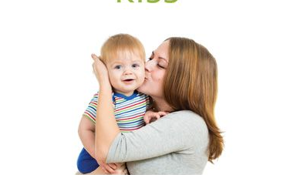




brush
fly
have
do
kiss
- Nick brushes his teeth every day.
- We ___________science lesson on Mondays.
- He ______________his kite very afternoon.
- My mom __________me every day.
- Peter ___________his homework after dinner.

3
Change and complete the sentences.

- I get up at six o’clock.
He gets up at six o’clock
Mr Brown___________________
- I have breakfast every day.
- I brush his teeth at 7a.m
Sam______________________
My brother___________________
- I go to school at 8 a.m
She__________________________
- I study hard at school.
88
Complete the text with the correct form of the verbs.

4
LOVELY SUNDAY
love
I (love)____________Sundays. My brother, Nick (love)________________Sundays too. I (get up) _______________at 6 o’clock, but Nick_________(sleep) until 10 a.m. I (have)________ breakfast in the kitchen with mum and dad. Mum _______(drink) coffee or tea, and I
( drink) ________hot coffee. My dad (drink) ________________tea or milk.
Choose and complete the text.

5
have x2
meet
walk
get up
go x2
start

catch
take

MY DAY

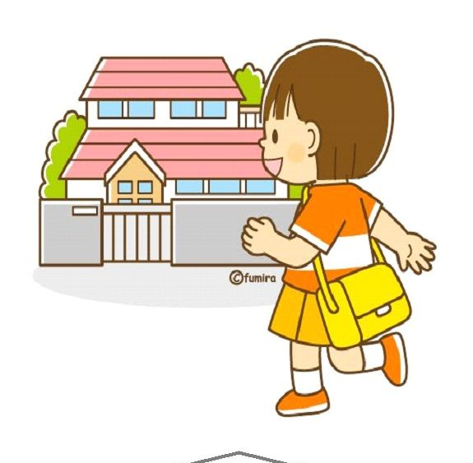
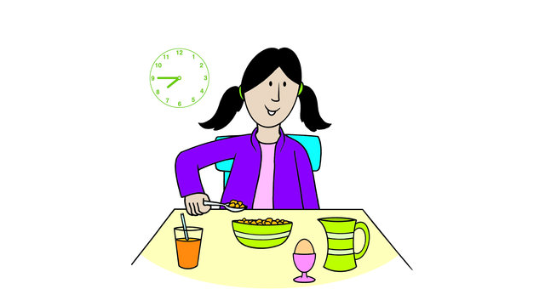

Marry (1)____________ every day at 6 o’clock. She ( 2) __________a shower, then ( 3)____________breakfast. She ( 4)___________to the bus stop and ( 5) ____________a bus to school.
At school, she (6) _________her friends and they ( 7) _________class together. They all ( 8) _____________lunch during recess time at 10 a.m. After recess, lessons ( 9)______a gain. After school, Marry (10) ______home.

gets up

89
88
NEGATIVE ( PHỦ ĐỊNH)
S+ don’t/doesn’t+ V
do not
= don’t
I/YOU/WE/THEY/CHỦ NGỮ SỐ NHIỀU
V ( nguyên thể)
+ +

I don’t go to school on Sundays
You don’t go to school on Sundays
We don’t go to school on Sundays
They don’t go to school on Sundays.
My brothers don’t go to school on Sundays.

+

does not
= doesn’t
+ +
He doesn’t go to school on Sundays.
She doesn’t go to school on Sundays
Marry doesn’t go to school on Sundays
It doesn’t rain much in winter.

V ( nguyên thể)
HE/SHE/IT/CHỦ NGỮ SỐ ÍT

6
Change and complete the sentences in negative forms

1. I wash my hair at night. I don’t wash my hair at night.
2. Mary works on Saturdays. _____________________________________
3. We exercise every day. _____________________________________
4.My parents enjoy skiing. _____________________________________
5. David studies hard. _____________________________________
90
Look and write.

7
2.

C
1.

C
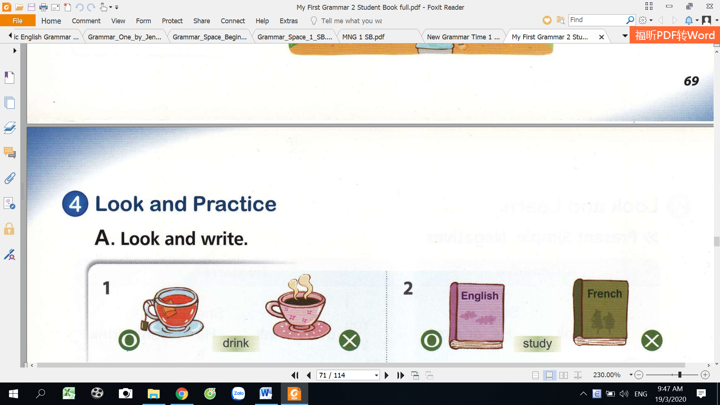
8.

C
7.

C
6.

C
5.

C
4.

C
3.

C
I_____________ my homework.
I ______________ the dishes.
Sam _____________in a department
He ______________in a house.
We _________a computer.
We _______________ a typewriter.
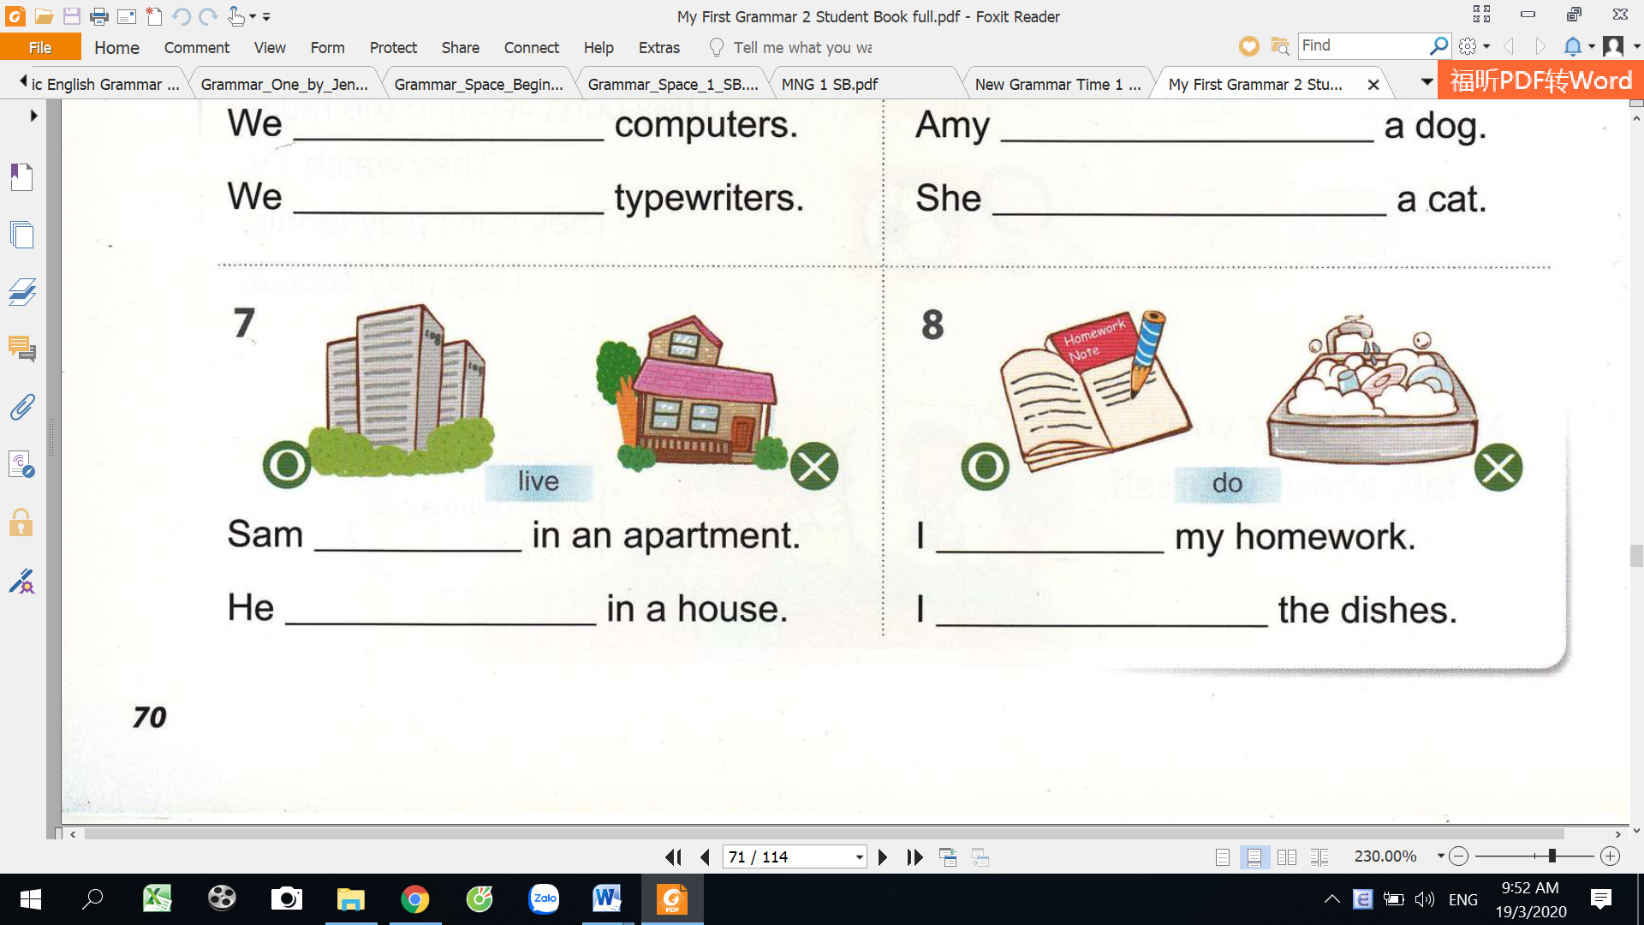
Amy _________a dog
She_______________a cat..
We ___________________English.
We ____________________French.

My mum drinks tea.
She doesn’t drink coffee.
John _________to school on Mondays.
He_______________to school on Sundays.
The students ________soccers.
They ___________________tennis.
We ____________________French.

go
study
drink
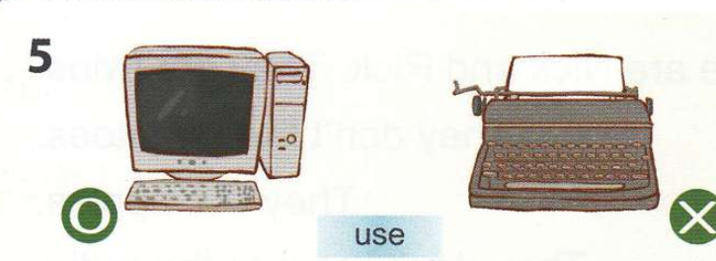
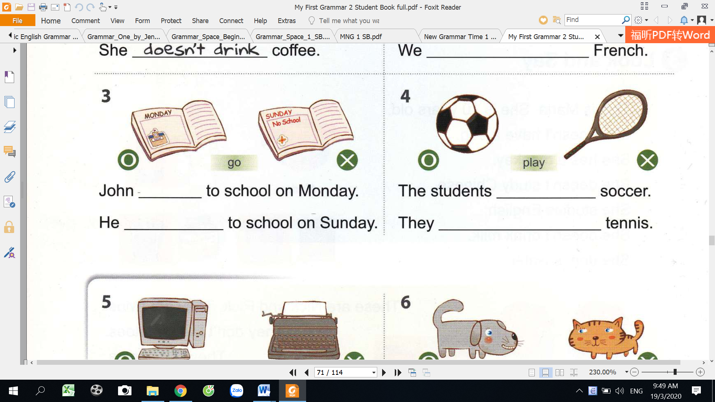

play

use
have

do
live

91

8
Underline the correct words.

- I speak/speaks French.
- They eat/eats Turkey on Christmas day.
- She go/goes jogging every afternoon.
- Bats sleeps/sleep during the day.
- She don’t/doesn’t have a younger sister.
- They don’t/doesn’t watch T.V on weekdays.
- Penguins don’t/doesn’t fly.
- Kate don’t/doesn’t eat anything at night.
- It don’t/doesn’t snow much in Africa.
- I play/plays football.
- We eat/eats fish.

9
Write the correct form of the verbs.

- They go/goes to school.
- She read/reads magazines.
- Jack watch/watches DVDs.
- You listen/listens to the rock music.
- Peter and Milly play/plays the basketball.
- My sister live/lives in a big house.
- I watch/watches an old film.
- It rain/rains much in summer.
- I like/likes chocolate.

5. not live
Maria___________homework at night.
They____________shopping on Mondays.
My grandma doesn’t live in a house.
He _______________apples
She __has____a pet.
I __________to school by bus
My sister_________ tomatoes
My father __________at 7a.m
1.have
2.wake up
3.go
4.like

6.not like
7.not go

8. not do
92
QUESTIONS ( CÂU HỎI)


DO + I/YOU/WE/THEY/ SỐ NHIỀU + V?
DOES+ HE/SHE/IT/ SỐ ÍT + V?

WH-QUESTION
YES/NO QUESTION

(WH)DO + I/YOU/WE/THEY/ SỐ NHIỀU + V?
(WH)DOES+ HE/SHE/IT/ SỐ ÍT + V?
Where do you live?
Where does she live?
DO/DOES + S+ V(NGUYÊN THỂ)

(WH)+ DO/DOES+ S+ V( NGUYÊN THỂ)

Do I read?
Do you read?
Do they read? Do we read?

Does he read…?
Does she read?
Does it read?
Does Mary read?
Do my brothers read?

10
Write the words to the correct order to make questions.

Do you study Maths?
- study Maths/ do/you/?
____________________________
- watch TV/she/does/?
____________________________
- they/ live/America/do/in/?
____________________________

- do/get up/ 7 a.m/you/at/?
____________________________
- you/listen to music/do/?
____________________________
- does/ read books/Cathy/?
____________________________
- Your parents/eat /fish/do/?
93

11
Write the question and negations forms of the sentences.

- Tom lives in England.
Tom doesn’t live in England.
_______________________________________________
Does Tom live in England?
_______________________________________________
- Susan teaches chemistry at a secondary school.
________________________________________________
________________________________________________
- You like playing computer games.
___________________________________________________
___________________________________________________
- John and Sue work in a café.
__________________________________________________
__________________________________________________
- We do the shopping on Saturdays.
________________________________________________
_______________________________________________
- The babies cry all the time.
_________________________________________________
_________________________________________________
- He does his homework every evening.
________________________________________________
________________________________________________
- Joan washes her hair every day.
_____________________________________________
_____________________________________________

94
ADVERBS OF FREQUENCY ( TRẠNG TỪ CHỈ TUẦN XUẤT)
How often do you drink coffee?
Đứng trước động từ thường
She can sometimes swim fast.
Đứng sau “ can”
Đứng giữa “ don’t, doesn’t” và động từ
They don’t often go to the cinema on weekdays.
Đứng sau “ tobe”


Always

He is never late for school
I sometimes drink coffee in the morning.
Usually
Often

Sometimes
Occasionally

Seldom
Rarely
never

12
Complete the chart with the words.( 0%-100%)

sometimes usually always hardly ever often never rarely occasionally

1____never____2_______________ 3_____________ 4__________
5__________ 6 ______________7_____________________8__________

95

13
Put the words to the correct order to make sentences.

- go swimming / sometimes / on Sundays / I
I sometimes go swimming on Sundays.
- in our house / cold / it’s / often/.
______________________________________________________________
- usually / is / hungry / Sam / after school/.
_____________________________________________________________
- goes / never / my cousin / cycling/.
_____________________________________________________________
- Mark and Ted / books / hardly ever / read/.
_____________________________________________________________
- I / my homework / in my room / do / always/.
______________________________________________________________
- snows / in this area / rarely / it /.
______________________________________________________________

14
Rewrite the sentences. Use the adverbs of frequency in brackets.

1. I’m late for school in the morning. (rarely)
I’m rarely late for school in the morning.
_________________________________________
2. Sam goes out with his friends. (occasionally)
__________________________________________
3. Ann surfs the Net in the evening. (usually)
__________________________________________
4. My best friend takes photos at school. (never)
_____________________________________________________
96
- He listens to the radio. (often)
___________________________________________________________
6. They read a book. (sometimes)
___________________________________________________________
7. Peter gets angry. (never)
___________________________________________________________
8. Tom is very friendly. (usually)
___________________________________________________________
9. I take sugar in my coffee. (sometimes)
___________________________________________________________
10. Ramon and Frank are hungry. (often)
___________________________________________________________
11. My grandmother goes for a walk in the evening. (always)
___________________________________________________________
12. Walter helps his father in the kitchen. (usually)
___________________________________________________________
13. They watch TV in the afternoon. (never)
___________________________________________________________
14. Christine smokes. (never)
___________________________________________________________
15. They are happy ( always)
___________________________________________________________
16. You study for the exam. ( rarely)
____________________________________________________________
17. She doesn’t help her mother. ( often)
_____________________________________________________________

97

SPEAKING
Ask your partner “How often do you……..?
A: How often do you………..?
B: I often/sometimes……….











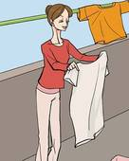

water the flowers

clean

iron
cook

wash the dishes

go to the supermarket.

hang up the
clothes

cut the
lawn

do laundry

walk the dog

take out the trash.

make
the bed


Write a short text about your daily routine.
…………………………………………………………………………………………………………………………………………………………………
………………………………………………………………………………………………………………………………………………………………….
…………………………………………………………………………………………………………………………………………………………………
………………………………………………………………………………………………………………………………………………………………….
…………………………………………………………………………………………………………………………………………………………………
………………………………………………………………………………………………………………………………………………………………….
…………………………………………………………………………………………………………………………………………………………………
………………………………………………………………………………………………………………………………………………………………….
…………………………………………………………………………………………………………………………………………………………………………………………………………………………………………………………………………………………………………………………………….
…………………………………………………………………………………………………………………………………………………………………………………………………………………………………………………………………………………………………………………………………….

98
MY VOCABULARY


No | Words | Vietnamese meanings.
1
2
3
4
5
6
7
8
9
10
11
12
13
14
15
16
17
18
19
20
22
23
24
25 |  | 99

V-E TRASLATION-DỊCH VIỆT ANH

No | Vietnamese | English
1 | Tôi thường ngủ dậy lúc 6 giờ mỗi sáng. | I often get up at 6 ‘clock every morning.
2 | Anh ấy chơi đàn piano hai lần một tuần.
3 | Mẹ tôi không bao giờ xem Tivi vào buổi sáng.
4 | Chúng tôi hiếm khi đi học vào chủ nhật.
5 | Bố tôi đi làm từ 9 giờ sáng đến 5 giờ chiều mỗi ngày.
6 | Peter đánh răng hai lần một ngày.
7 | Mẹ tôi thường đi siêu thị vào cuối tuần.
8 | David thường chơi bóng đá vào buổi chiều.
9 | Tôi không bao giờ đi học muộn.
10 | Bố tôi thường uống café vào buổi sáng.
11 | Em trai tôi và tôi thường xuyên nghe nhạc vào buổi tối.
12 | Cô ấy không bao giờ đi ra ngoài vào ban đêm.
13 | Chúng tôi đến thăm ông bà một tuần một lần.  100
14 | Mary không bao giờ đi bộ vào buổi tối.
15 | Bố mẹ tôi luôn luôn uống trà vào mỗi buổi sáng.
16 | Linda thường đi ngủ vào 10 giờ tối.
17 | Chị gái tôi không bao giờ làm bài tập về nhà vào thứ bẩy.
18 | Peter và Mary hiếm khi giúp đỡ mẹ của họ.
19 | Cô ấy không ăn vào buổi tối.
20 | Họ không thích táo.
21 | Ông tôi thi thoảng đi bộ vào cuối tuần.
22 | Bố tôi không bao giờ đi làm vào chủ nhật.
23 | Họ thường xem tivi vào buổi tối.
24 | Chúng tôi có môn tiếng anh hai lần một tuần.
25 | Chúng tôi làm bài tập về nhà mỗi ngày.
26 | Bố bạn đi làm bằng ô tô không? Không. | Does your father go to work by car? No, he doesn’t
27 | Bạn thích Toán không? Có.
28 | Họ đi học vào chủ nhật không? Không.  101

