PRESENT CONTINUOUS (HIỆN TẠI TIẾP DIỄN)

Unit 12

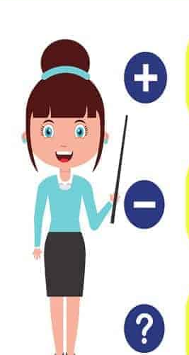

- Nói về hành động đang diễn ra ở hiện tại , hoặc tại thời điểm nói.
We are learning English now ( Bây giờ chúng tôi đang học tiếng anh)
- Nói về hành động trái với hoạt động thường ngày.
We often walk to school, today we are going to school by bike.
( Hằng ngày chúng tôi đi bộ đi học, hôm nay chúng tôi đi xe đạp.)
- Nói về một hành động chắc chắn xảy ra trong tương lai, có kế hoạch trước.
He is visiting his grandparents next week.
( Anh ấy sẽ đến thăm ông bà tuần tới. )

GRAMMAR BOARD
S+ am/is are + V-ing.
He is playing football now.
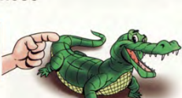
S+ am not/isn’t/aren’t + V-ing
He isn’t playing football now.
(Wh)Am/is/are + S+ Ving?
Is he playing football now?


USAGE ( CÁCH DÙNG)

Complete the sentences with possessive adjectives.
- Jame and Alice have a car. _Their___car
TIME EXPRESSIONS (now, at the moment, at present, look!, listen! today, next week…..)
102


POSITIVE ( +)
S+ am/is/are + Ving

You are drinking coffee=you’re
They are drinking coffee=they’re
We are drinking coffee=we’re
My brothers are drinking coffee.

I am drinking coffee=I’m
He is drinking coffee=He’s
She is drinking coffee= she’s
It is eating= it’s
My father is drinking coffee.

CÁCH THÊM “ING”
- Nếu động từ kết thúc bằng “ e” – bỏ “ e” thêm “ ing”
Make- making, take- taking.
- Nếu động từ 1 âm tiết, 1 nguyên âm kẹp giữa 2 phụ âm thì gấp đôi phụ âm phụ âm cuối và thêm “ing “ stop= stopping, sit-sitting
- Nếu động từ kết thúc bang “ ie” thì chuyển “ ie” thành “ y”, rồi thêm “ ing”
lie=lying .

Add “ing” before the verbs below.
brackets.


1

…having……………..
………………..
………………..
1.have
17.catch
9.eat
………………..
………………..
………………..
3.take
2.swim
18.sit
10.help
………………..
………………..
………………..
………………..
………………..
………………..
4.stop
20.hit
19.rain
12.get
11.read
………………..
………………..
………………..
………………..
………………..
………………..
………………..
………………..
………………..
………………..
………………..
8.make
7.use
6.speak
5.fly
24.carry
23.walk
22.go
21.look
16.learn
15.come
14.study
13.watch

………………..
103

2
Look at the picture and use the verbs in bracket to complete the sentences.
brackets.

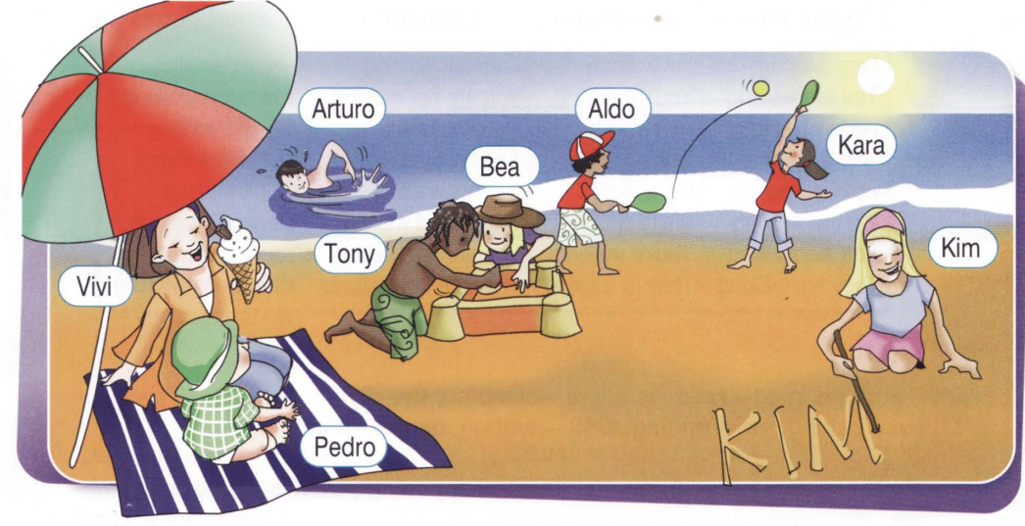

- Bea and Tony are making ( make) a sandcastle.
- _________________________________ ( wear) red T-shirt.
- _________________________________ ( eat) an ice-cream.
- _________________________________ ( sit) under the beach umbrella.
- ________________________________ ( swim).
- _________________________________ ( write ) her name on the sand.
Fill in “ am, is or are”
the sentences.
brackets.

3

- He ____is______ eating banana.
- It _____________flying
- I _____________ reading
- They ___________dancing
- We ____________walking
- She _____________cooking.
- My grandparent ________________drinking tea.
104

4
Choose, look and write.
the sentences.
brackets.

3
4
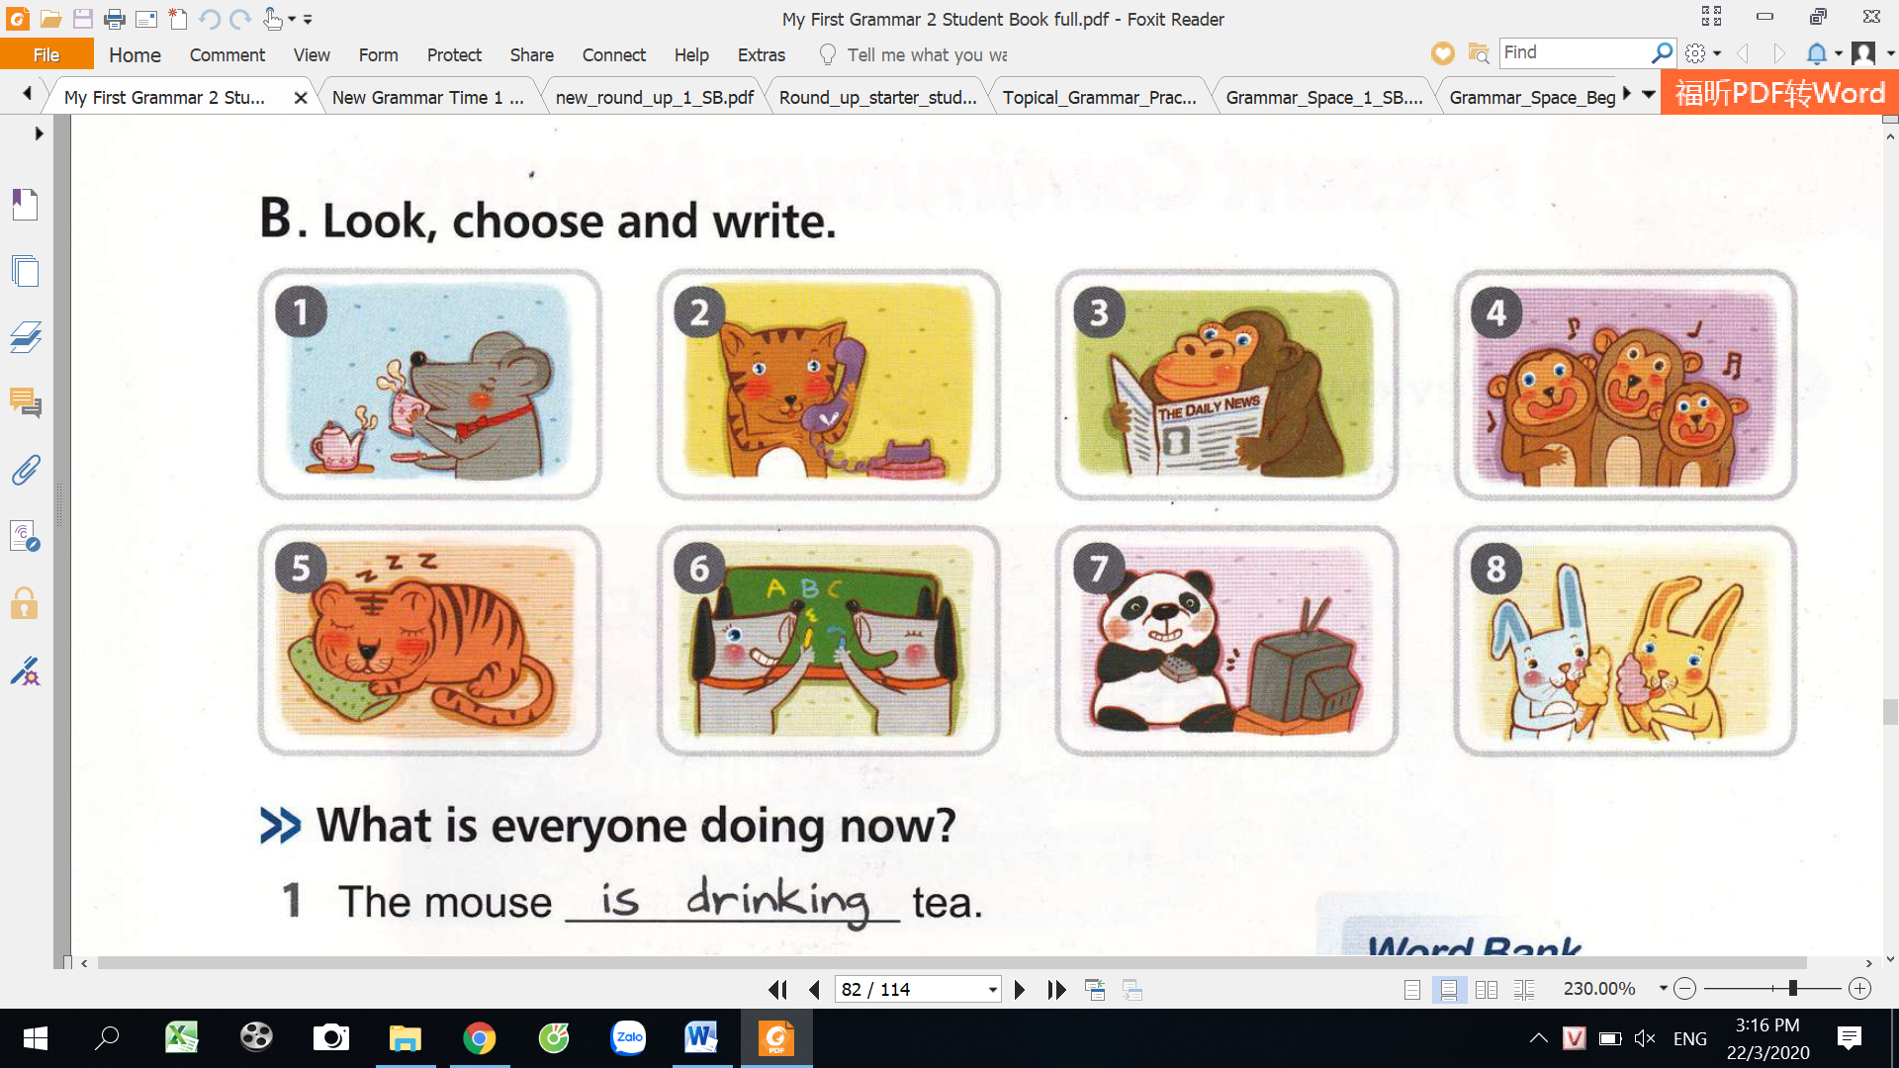
1
2

5
8
7
6

- The mouse is drinking tea.
- The cat ___________________________ on the phone.
write
drink
- The gorilla ________________________newspaper.
- The monkeys __________________________________.
sing
read
eat
- The tiger ______________________________________.
- The dogs _____________________________ABC
talk
sleep
- The panda ___________________________TV
watch
- The rabbits ____________________________ice-creams.
Correct the underline words and rewrite the sentences.
the sentences.
brackets.

5
They are sitting quietly.
_________________________________________

- They are siting quietly.
_________________________________________
- She does studying hard.
_________________________________________
- They are runing on the ground.
_________________________________________
- We are makeing our kites.
_________________________________________
- He is read a newspaper.
_________________________________________
- We is eating ice-creams.
_________________________________________
- The boy are playing football now.
105
NEGATIVE ( -)
S+ am not/is not/ are not+V-ing

TOBE  Subject ( S) | tobe | V-ing  V-ING
I | am not= I’m not | playing
He/she/it/số ít | is not= isn’t | playing
You/we/they/số nhiều | are not= aren’t | playing

6
Change the sentences into the negative form.
the sentences.
brackets.

- We are studying English.
We aren’t studying English.
________________________________________________________
- They are talking with their friends now.
_______________________________________________________
- My mum and dad are working in the garden.
________________________________________________________
- You are listening to the teacher.
_____________________________________________________
- They are drinking orange juice.
___________________________________________________
- He is reading a magazine.
___________________________________________________
- The baby is sleeping at the moment.
_____________________________________________________
- Her mother is writing a letter right now.
106
______________________________________________________

7
Look at the picture and fill in the blanks the sentences.
brackets.

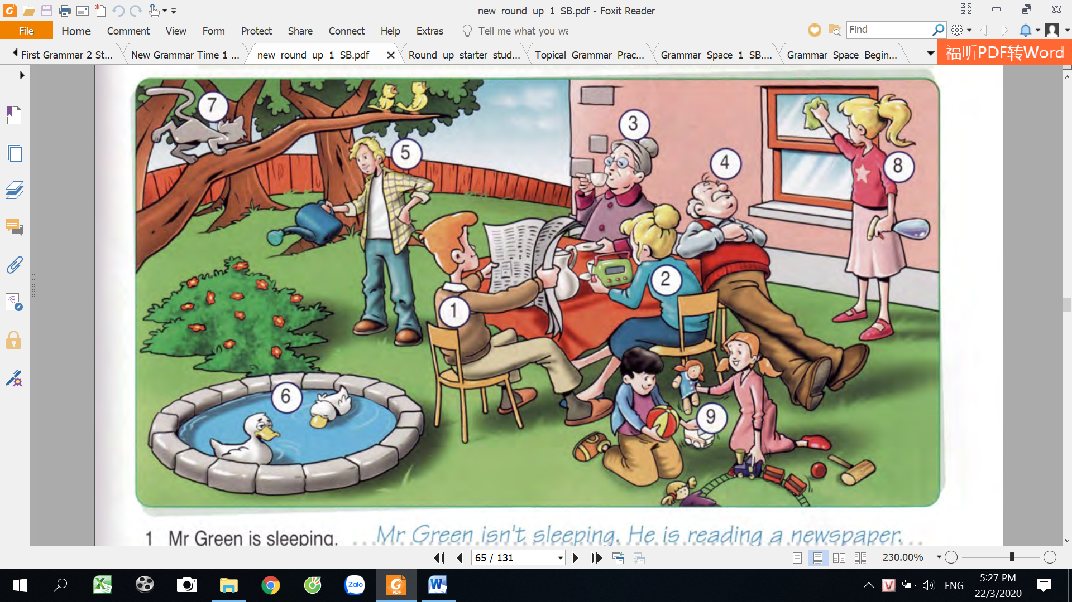

- Mr Green isn’t sleeping. He is reading a newspaper.
- Mrs Green ______________swimming. She’s_________________________.
- Grandmother ____________________singing. She ‘s___________________.
- Grandfather _____________________eating. He’s_______________________.
- Jame ____________washing the dishes. She’s ________________________.
- The ducks _________________running. They’re_______________________.
- The cat ___________________drinking. It’s ____________________________.
- Karen _____________________reading books. She’s ___________________.
- The children ________________drawing. They’re _____________________.
climb a tree listen to the radio drink tea.
clean the window read a newspaper.
swim water the flowers
sleep play with toys

Droini

107
QUESTION ( ?)
(WH)am/is/are + S+ V-ing?

Answer
Yes/no question

be | Subject | V-ing | Yes | No
Am | I | singing? | Yes, you are | No, you aren’t
Is | He/she/it/số ít | singing? | Yes,he/she/it is | No, he/she /it isn’t
Are | /we/they/số nhiều | singing? | Yes, we/they are | No, we/they aren’t
Are | you | singing? | Yes,I am | No, I am not

Answer
Wh- question

I am singing a song.
He is going to the cinema.

(Wh) + is he/she/it + V-ing?
(Wh) are you/they /we/ + V-ing?
What are you doing?
Where is he going?

8
Match the questions with the correct answers brackets.

- Are you watching TV? Yes, he is
- Is he reading a book? No, I’m not.
- Is she cooking? Yes, they are.
- Are they swimming? No, she isn’t.
108

9
Read and complete the sentences.

Helen: Look at this photo.
Tom: What’s dad doing?
Helen: (1)_He’s__cleaning the table.
Tom: Of course. And what (2) _____ you and Sue doing?
Helen: (3)__________playing football.
Tom (4)______the dog playing football too?
Helen: No, it(5)_______. It is running after the cat.
Tom: I think Mum (6)_______drinking coffee.
Helen: Yes, and she (7)_____reading the news.
Tom: oh, ok. What (8)_______grandpa doing?
Helen: (9)_________sleeping
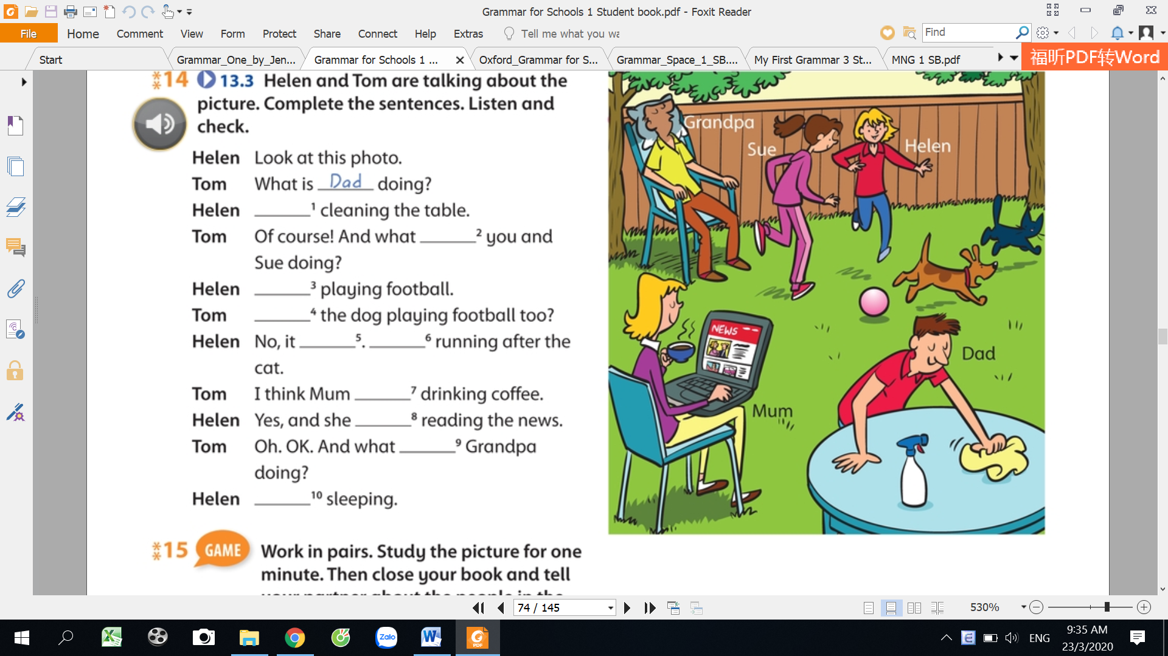

10
Making sentences using present continuous.

It’s raining at the moment.
_____________________________________
It/rain/at the moment.
_____________________________________
- Mushrooms/grow/in the woods.
_____________________________________
- The wind/blow/this week.
_____________________________________
- The sun/shine/now.
_____________________________________
- The birds/fly/now.
_____________________________________
- I/singing/at the party/tonight .
_____________________________________
- We/walk/in the park/now.
_____________________________________
- She/play/with her sister/now.
- They/hop/in the yard/at the moment.
_____________________________________
_____________________________________
- He/hunt/with his Dad/on Friday.
_____________________________________
- My mum/eat/an apple/ now.
109

11
Write the sentence in the present continuous tense.

?
: question.
: negative

: postitive

Mr John isn’t working.
________________________________________
- Mr John/work.
2.Mike/ eat breakfast.
________________________________________
________________________________________
?
3. You/talk on the phone.
________________________________________
4. They/run in the park.
5. It/ snow.
________________________________________
6. She/ speak Chinese.
________________________________________
?
________________________________________
7. Amy/paint.
________________________________________
8. He/ sit on the floor.

________________________________________
9. Mary/smile.
?
________________________________________
10. You/read a newspaper.

12
Answer the questions.

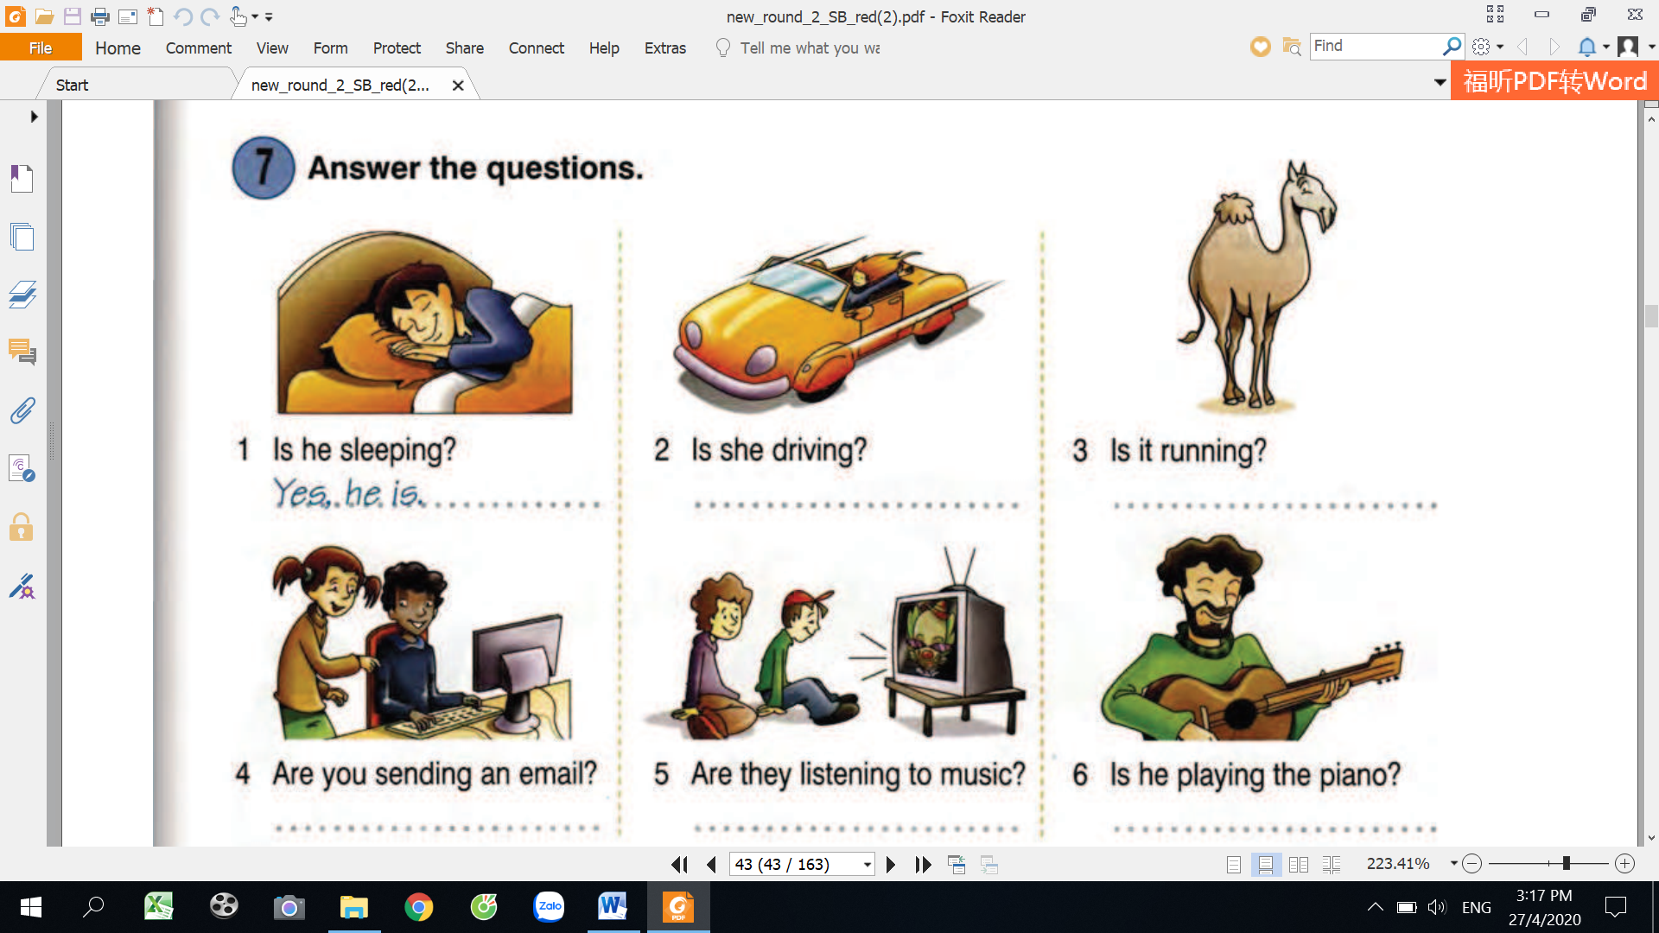
3
2
1

Are they sending an email?
_________________________________________
_________________________________________
Yes, he is
Is he playing the piano?
Is he sleeping?
6
5
4

110
_________________________________________
Are they listening to music?
_________________________________________
Is she driving?
_________________________________________
Is it running?
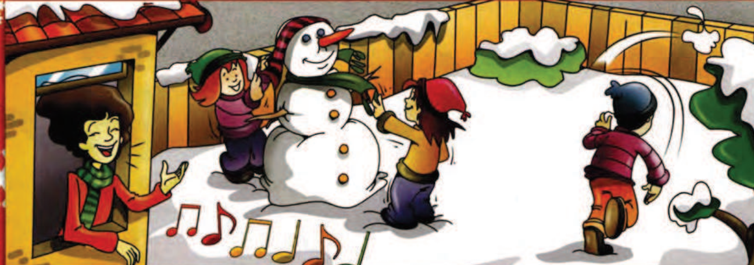
Fill the correct form of the verbs and circle the time expressions.

13

It’s winter, but it_________________________1.( not/snow) today. The children _______________________2.( not/play) in the house now. They’re in the garden. At the moment, Ben _________________3.( not/ride) his bike. He __________________4.( throw) snowballs. The girls ___________________5.( make) a snowman. Look! The girls________________6.( not/wear) their scarves. Their scarves are on the snowman! Can you see Mum? Listen! She ____________________7.( sing)

isn’t snowing

14
Look at the pictures, write and match the correct sentences.

1
Sally/cry
Jane and Nora/dance
father/dig in the garden
Grandpa/sleep.
Lucy/listen to music.
Anna and Peter /cook.


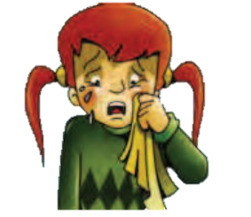

3
2
1
1

________________________________
________________________________
Grandpa is sleeping.
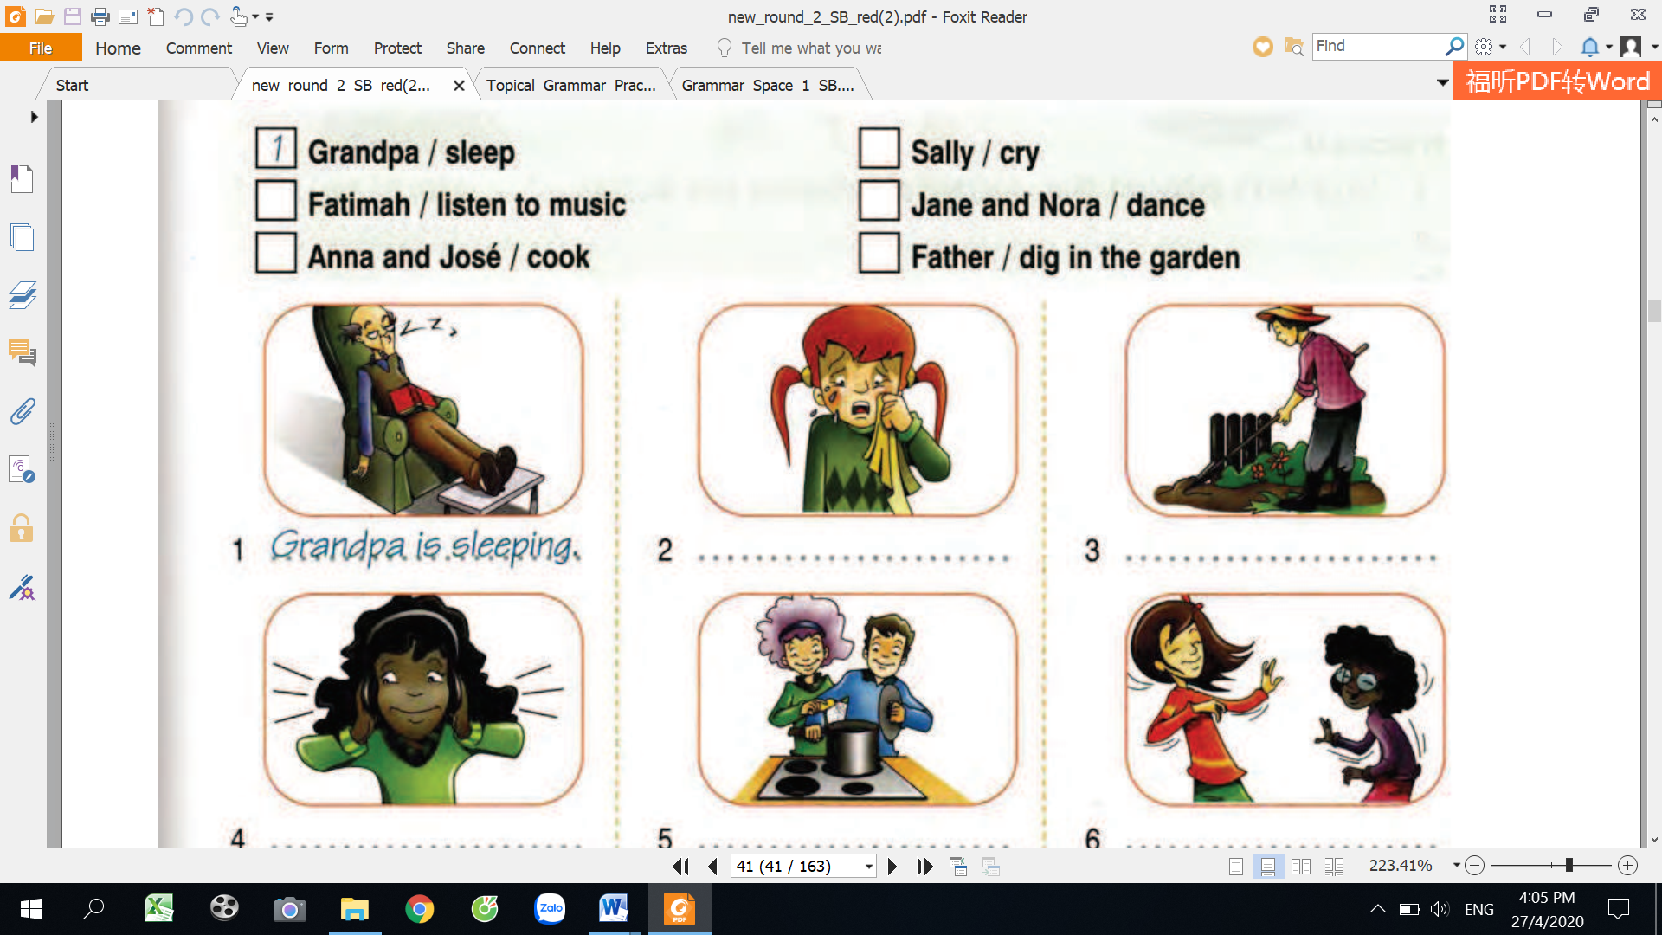
6
5
4
111
________________________________
________________________________
________________________________

15
Complete the text using present continuous.

Hi everyone. We’re on holiday in Germany but the weather is
bad today. It’s raining. We (1)______________in the café at the moment. I’ve got my computer and I (2)_____________my blog. My sister(3) ____________to music. My brothers aren’t in the café. They(4)______________football in the rain. My mum (5)____________to her friends on the phone. And my dad, He (6)____________newspaper. Oh yes, my grandparents are here too. They (7)__________cakes. I haven’t got a cake but I (8)_____________ fruit juice. I like it. We (9)__________a good time.
See you soon.

play
listen
have
eat
drink
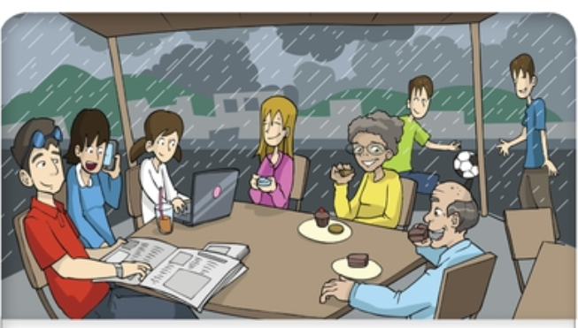
write
talk
sit
read
rain


WRITING

Imagine you are on your holiday with your family. Write your own blog.
…………………………………………………………………………………………………………………………………………………
……………………………………………………………………………………………………………………………………………
.………………………………………………………………………………………………………………………………………………
……………………………………………………………………………………………………………………………………………….
…………………………………………………………………………………………………………………………………………………
…………………………………………………………………………………………………………………………………………….
…………………………………………………………………………………………………………………………………………………
…………………………………………………………………………………………………………………………………………….
……………………………………………………………………………………………………………………………………………………………………………………………………………………………………………………………………………………………….

112

SPEAKING
Describe the picture to your partner and your partner corrects your mistakes.
PICTURE A PICTURE B
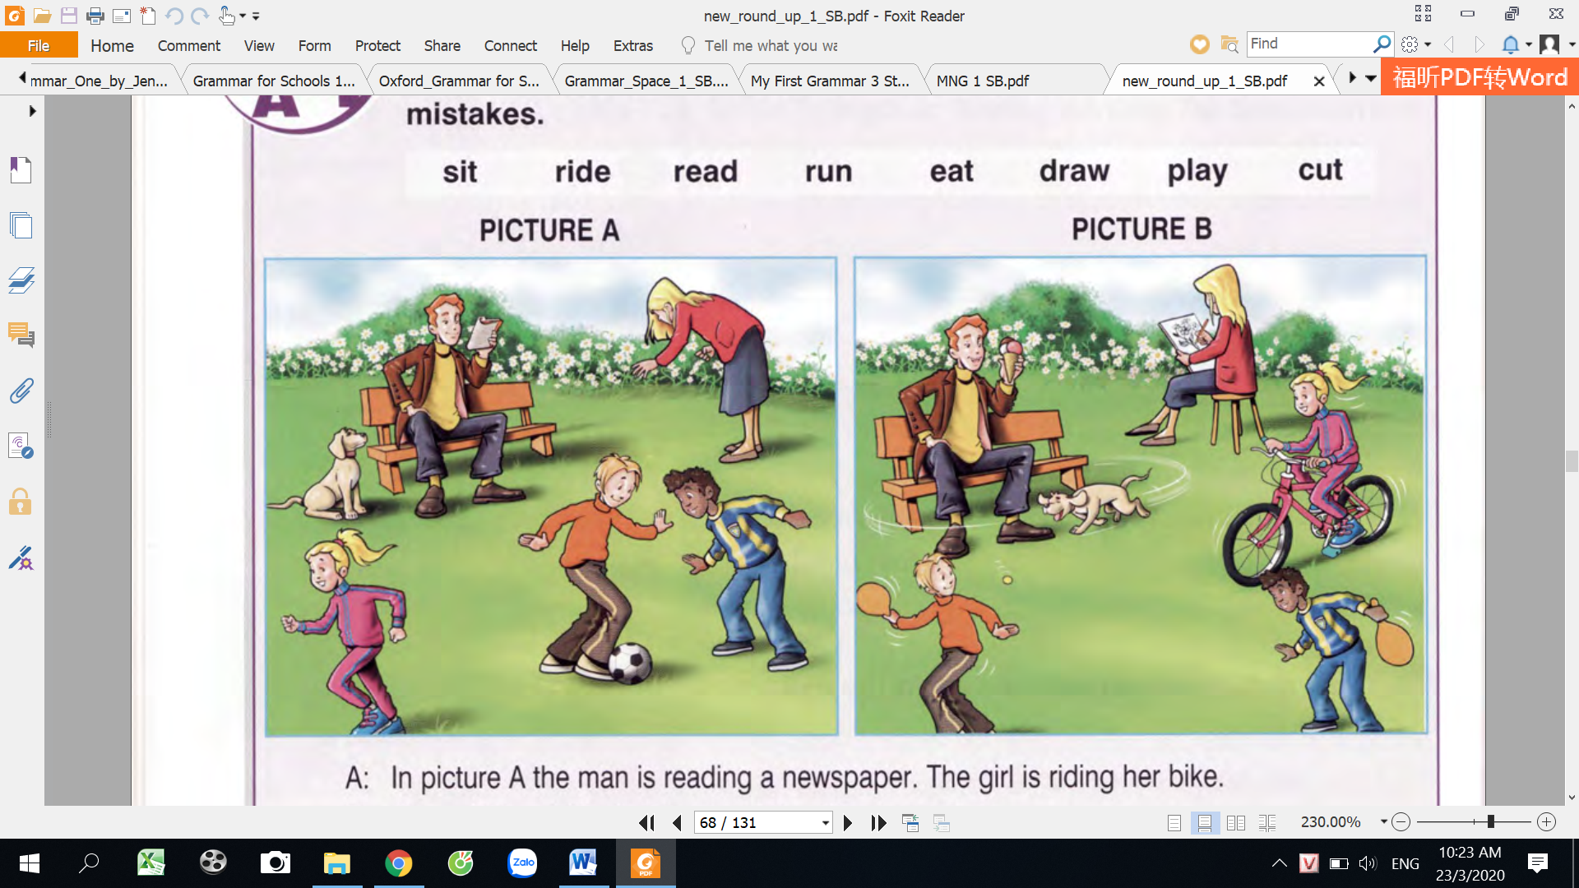
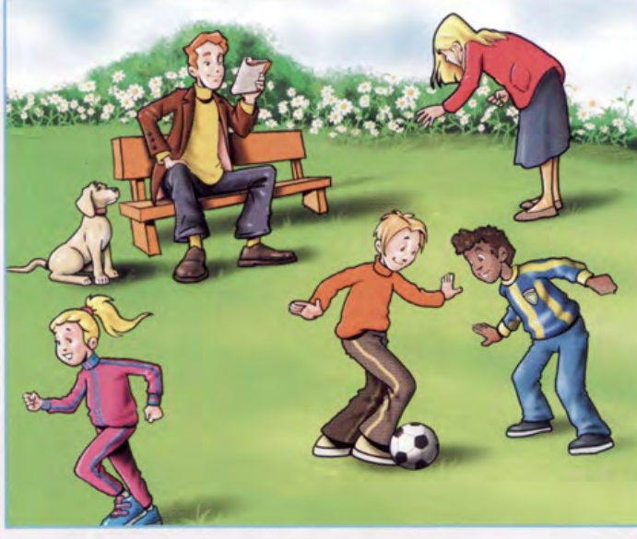

Example:
A: In picture A, a man is reading a newspaper. A girl is riding her bike.
B: Wrong! The girl isn’t ride a bike. She’s running.

113
MY VOCABULARY

No | Words | Vietnamese meanings.
1
2
3
4
5
6
7
8
9
10
11
12
13
14
15
16
17
18
19
20
22
23
24
25
114
V-E TRASLATION-DỊCH VIỆT ANH

No | Vietnamese | English
1 | Bây giờ mẹ tôi đang uống cà phê. | My mother is drinking coffee now.
2 | Những bạn trai đang không chơi bóng đá vào lúc này.
3 | Cô ấy đang không nghe nhạc. Cô ấy đang làm bài tập về nhà.
4 | Bố bạn đang làm gì vậy?  Ông ấy đang xem tivi | What is your father doing?  He’s watching TV.
5 | Những đứa trẻ đang chơi ở công viên.
6 | Anh ấy đang nghe nhạc phải không? Không. Anh ấy đang đọc báo.
7 | Bây giờ trời đang mưa.
8 | Bây giờ mẹ tôi đang nấu ăn trong bếp.
9 | Nhìn này! Em bé đang ngủ trên giường.
10 | Nghe này, những những chú chim đang hót ( sing: hát, hót)
11 | Bạn đang ăn táo phải không? Đúng vậy.
12 | Em trai bạn đang làm gì vậy?  Nó đang chơi đá bóng trong vườn.  115
13 | Nhìn kìa, con khỉ đang đi xe đạp.
14 | Peter đang không làm bài tập. Anh ấy đang đọc báo.
15 | Trong lúc này Mary và Linda đang nói chuyện điện thoại.
16 | Họ đang không ăn tối ở nhà. Họ đang ăn tối ở nhà hàng.
17 | Họ đang làm gì vậy? Họ đang học tiếng anh.
18 | Mary đang làm gì vậy? Cô ấy đang đánh răng trong phòng tắm.
19 | Lucy đang ngủ phải không? Không, cô ấy đang đi siêu thị. | Is Lucy sleeping? No, she isn’t. She is going to the supermarket.
20 | Bố đang đọc báo phải không? Đúng vậy.
21 | Ông tôi đang không tưới hoa. Ông đang cho mèo ăn.
22 | Bà bạn đang làm gì vậy? Bà đang nấu ăn.
116

