PAST SIMPLE ( QUÁ KHỨ ĐƠN)

Unit 17

POSTITIVE

he was at home yesterday.
They were at home yesterday.
S+ was/were
Động từ
“ TOBE”

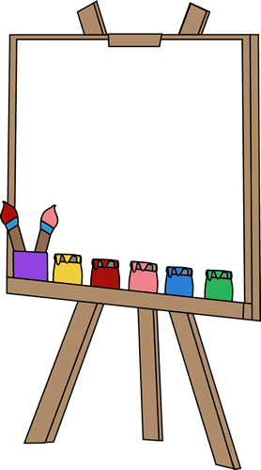
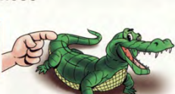
S+ Ved
Động từ có quy tắc

I visited this village last year.


He went to school yesterday.
go-went
S+ V( b.qy tắc)
bất quy tắc
quy tắc

was/were
Động từ
quy tắc

was/were

QUESTION
NEGATIVE
Was/were+ S…?
S+ wasn’t/weren’t

Was he at home yesterday?
Were they at home yesterday?
he wasn’t at home yesterday.
They weren’t at home yesterday.

Did+ S+ V(o)?

S+ didn’t+V(o)
Did you visit this village last year.

I didn’t visit this village last year?

Did+ S+ V(o)?

S+ didn’t+V(o)

Did he go to school yesterday?
He didn’t go to school yesterday.

Complete the sentences with possessive adjectives.
TRẠNG TỪ CHỈ THỜI GIAN:
Yesterday ( hôm qua)
Last (last year, last month, last year),
ago ( one month ago, two hours ago.)
ago

A
- Thì quá khứ đơn dùng để nói về hành động, sự việc đã xảy ra và chấm dứt ở quá khứ.

- Jame and Alice have a car. _Their___car
156

You were
We/They were
My mum and dad were

I was
He/she/it was
Mary was

+
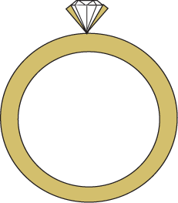

TO BE
WAS/WERE

Were you?
Were we/they?
Were mum and dad?

Was I?
Was he/she/it?
Was Mary..?

You weren’t
We/They weren’t
My mum and dad weren’t

I wasn’t
He/she/it wasn’t
Mary wasn’t

?
-

Choose the correct items.


1

9. It was/were sunny last week.
8. You and Admed was/were at school last Monday.
14. David was/were hungry last night.
13. It was/were cold last night.
12. She was/were at home all day today.
11. My parents were/was at the supermarket this morning.
10. We was/were at the cinema last night.
7. The dog was/were in the garden yesterday.
6. Mark and Anna was/were bored last Saturday.
5. Sam was/were tired last night.
4. You was/were late for school yesterday.
3. Grandma was/were at the supermarket two hours ago.
- The girls were/was happy last week.
- I was/were at my friend’s house yesterday.

157

2
Change “ am, is, are” to “ was/were”
YESTERDAY
TODAY

Fill “was” or “were”
1.They are at the cinema.
2.I’m not happy
3. The film is scary.

They were at the cinema.
6
8
7
5
4
3
2
1

4. Is he in London?
5. What is for lunch?
6. Peter isn’t very friendly
7. Are they happy?
8. It’s very hot.

3

- It _______hot last summer.
- There ______two cakes in the fridge yesterday.
- The boys _________at the library last Wednesday.
- Mum ________at work yesterday.
- There _______a cat at the window an hour ago.
- My friends __________at school yesterday.
- James ________at my party last night.
- There ________a lot of people at the park yesterday.
- It _______foggy yesterday.
- He _________a basketball player.
- Ken’s parents ________in Paris last week.
158

4
Look and write “was, were, wasn’t, weren’t”
1
Amy wasn’t at the library yesterday

She was at home.

_________________________________________________________________________________________________________________________
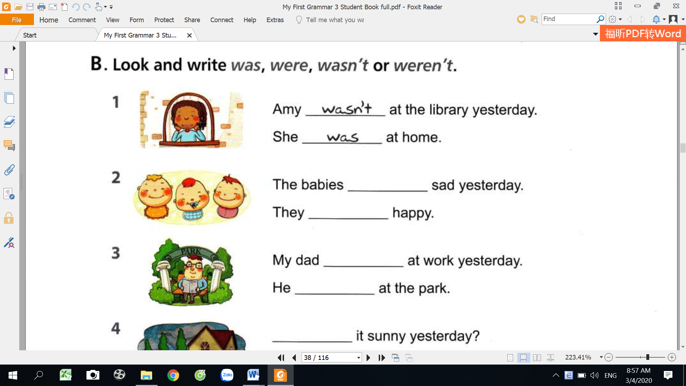

There many people on the bus yesterday.

_________________________________________________________________________________________________________________________

2
There only two people.

The babies sad yesterday.

_________________________________________________________________________________________________________________________
3
They happy.

My dad at work yesterday.

_________________________________________________________________________________________________________________________

44
He at the park.


54
There a soccer game yesterday?

Yes, there

_________________________________________________________________________________________________________________________

It sunny yesterday?
_________________________________________________________________________________________________________________________

No, it . It was cloudy.

64

There a class yesterday.

_________________________________________________________________________________________________________________________
74

159
There a party.

5
Read and write “was, were, wasn’t, weren’t”
ANNE THE PRINCESS
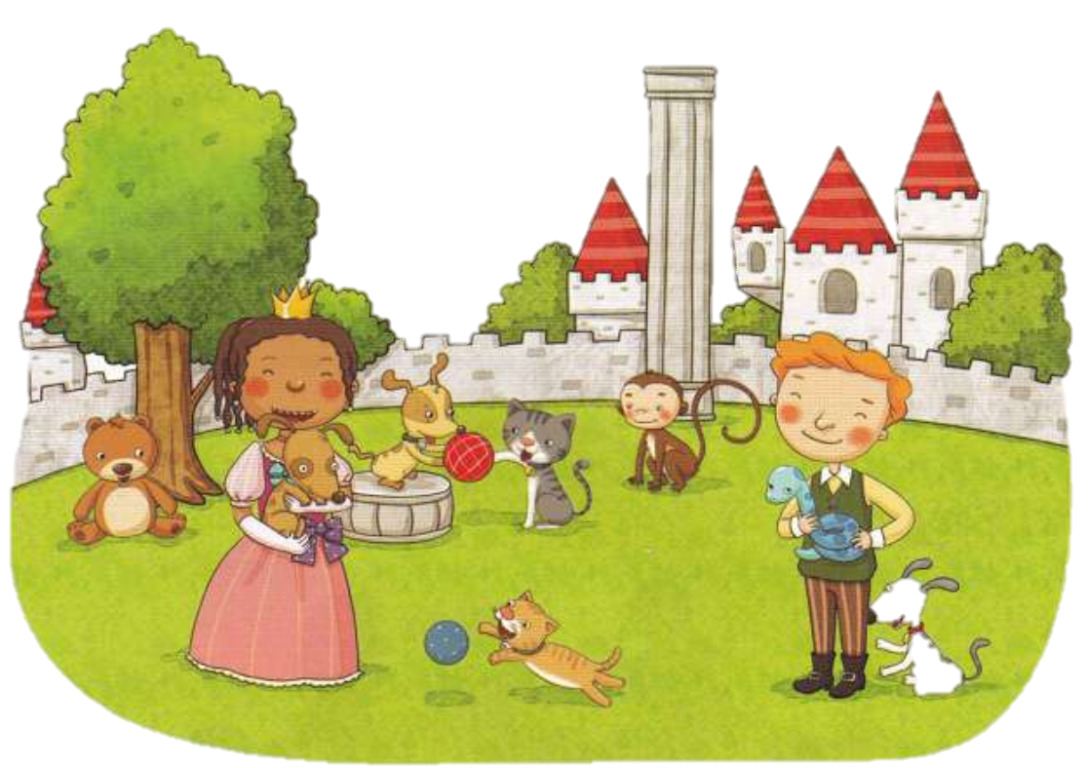

was
A long time ago, there_(1)________ a castle in Fantasy Village. The castle_(2) ______ small but beautiful. A pretty girl lived in the castle. Anne (3)_________ her name. She (4)________ the princess. There(5) ________any other children in the castle. She didn’t have any friends. She (6) ___________a happy princess. She cried every day. One day, a boy came to the castle. His name (7)_______John. He had many animals. They(8) _______ good animals. Princess Anne and John played with the animals in the garden. She (9)__________sad any more. They (10) ________ all happy together.
Write the question form.

6
- Were you at the library yesterday?
1. You were at the library yesterday.nb;h7mhe, bytntmgh,=lk9o-‘
_________________________________________________
2. It was cloudy yesterday.
4. There was a school concert yesterday.
_________________________________________________
_________________________________________________
3.Ken was at school yesterday.
160
_________________________________________________
5. Amy was sick yesterday.

7
Put the words to make questions and answer.
No, they________
Yes, they________
No, I_________
Yes, it________
No, he_______
No, they_______
Yes, I was
Were you at your friend’s house last night?
______________________________________________________
______________________________________________________
2. your parent/at home/yesterday/were/?
7. the shops/were/ open/last Sunday/?
______________________________________________________
6. they/at the party/were/last night/?
______________________________________________________
5. in the team/last week/you/were/?
______________________________________________________
4. it/was/sunny/last Saturday/?
______________________________________________________
3. Tom/this morning/was/on the bus/?
______________________________________________________
1.you/at/your friend’s house/last night/were/?

8
Choose the correct answers.
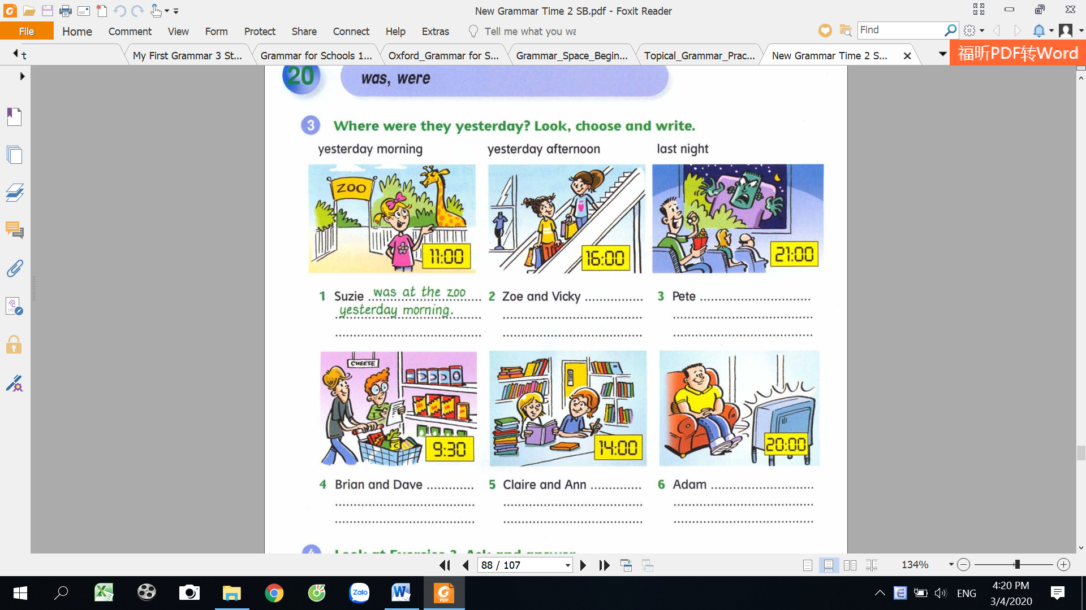

last night.
yesterday morning
yesterday afternoon.
1
at the zoo
at the cinema
at the library
at home
shopping mall
…………………………………….
……………….
Pete…………………………..
……………….
…………………………………….
……………….
Claire and Ann……………
……………….
…………………………………….
……………….
Brian and Dave……………
……………….
3
2
…………………………………….
……………….
Adam…………………………..
……………….
…………………………………….
……………….
Zoe and Vicky……………
……………….
Sue was at the zoo yesterday morning.
at the supermarket
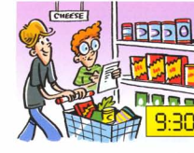

7
6
5
161
S+ didn’t + V(o)
He didn’t play football yesterday morning.

S+ Ved
He played football yesterday morning.

(Wh) did+ S+ V(o)..?
Did he play football yesterday morning?

?
+
-
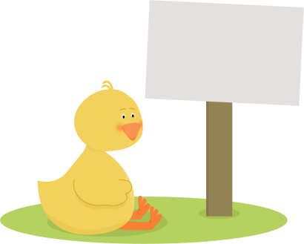
REGULAR VERBS
ĐỘNG TỪ CÓ QUY TẮC

QUY TẮC THÊM “ ED” VÀO SAU ĐỘNG TỪ.
answer- answered
open- opened
enjoy-enjoyed
Hầu hết cá động từ có quy tắc ta thêm “ ed” vào sau động từ khi muốn chuyển sang dạng quá khứ

Nếu động từ kết thúc bằng “ e” ta chỉ cần thêm “ d” vào sau động từ đó.
Nếu động từ 1 âm tiết có 1 nguyên âm kẹp giữa hai phụ âm thì gấp đôi phụ âm cuối.
cry-cried
fry-cried
study-studied
stop- stopped
plan-planned
mop-mopped
arrive-arrived
hope-hoped
invite-invited
Nếu động từ kết thúc bằng “ y” và trước “ y” là một phụ âm thì chuyển thành “ ied”

162

9
Write the past simple of the following verbs.
watched
21.finish……………
22. close…………….
23. dance…………….
24. carry…………….
25. decide…………….
26. laugh………………
27. continue…………..
28. explain……………
29.live………………….
30.arrive………………

11. cry…………………..
12. water ……………..
13. drop……………….
14. call…………………..
15. stay………………….
16. study………………..
17. play………………….
18.help………………….
19. wash………………
20. climb……………....

1.watch ………………..
2. clean …………………
3. return………………
4. stop………………….
5. stay………………….
6. walk…………………..
7. shop………………….
8. tidy……………………
9. smile………………….
10. look………………..

10
Complete the sentences with the past simple form of the verbs

played
- Jack and I ( play)_______________badminton yesterday.
2. My sister ( cook) _____________dinnner last night.
3. Josie ( carry) ____________her mum’s bag for her.

4. Jo and Sam( help)___________ the teacher yesterday afternoon.

9. My parents ( enjoy)______________the party last night.
8. We ( stay)________________ with our grandparents last week.
7. My dad ( stop) _____________the car and ( look) __________at the map.
6. I ( like) ___________the film last night.
5. We ( tidy)____________our rooms yesterday.

10. It ( rain) __________ a lot last month.

163
11

Circle the correct words.
Khoảng thời gian+ ago
two hours ago: hai giờ trước
three month ago: hai tháng trước
two years ago: Hai năm trước

Last+ thời gian
last night: tối hôm trước
last Sunday: chủ nhật trước
last week: tuần trước

Khoảng thời gian+ ago

11
Circle the correct words.

6. I walked the dog three hours ago/last.
- I talked to Jane an hour ago/last.
- I talked to Jane an hour ago/last.
5. they travelled by plane last/ago month.
10. Tim cooked breakfast last/ago Sunday.
9. We played tennis yesterday/ago
8. He worked in London last/ago year.
7 .I listened to music last/ago night.
4. It rained last/yesterday.
3. He phoned me two hours last/ago.
2. We played tennis last/ ago Sunday.

12
Complete the text with the past simple.
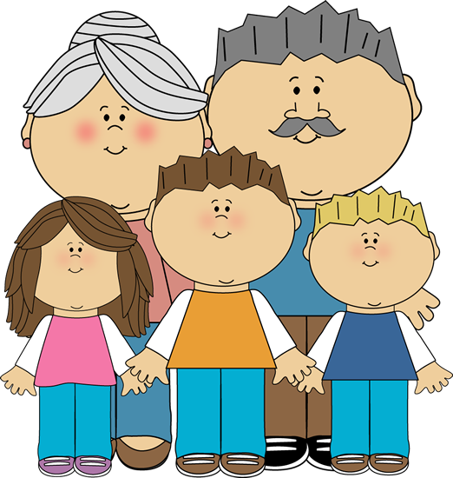

visited
Yesterday, my family and I visit __________my grandparents My mum help ____________my grandma with the house work. My dad clean ____________the windows. My brother and I watch __________cartoon on TV. Later, we play_______ outside in the garden. We climb ________up the tree to get to the treehouse. We stay ___________there all afternoon. Then our mom call ___________us because it was time to go. Our grandparents kiss ___________us goodbye and we return ___________home.

164

13
Mum usually does the house work, but yesterday dad did the housework. Write the sentences.
usually
yesterday

- clean /the house
My mum usually cleans the house. Yesterday, dad cleaned the house.
………………………………………………………………………
……………………………………………………………………….
……………………………………………………………………………………………………………………………………………….


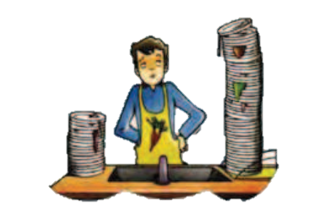
2. wash/the dishes
………………………………………………………………………
……………………………………………………………………….
……………………………………………………………………………………………………………………………………………….

3. cook/dinner
………………………………………………………………………
……………………………………………………………………….
……………………………………………………………………………………………………………………………………………….


4. iron/the clothes
………………………………………………………………………
……………………………………………………………………….
……………………………………………………………………………………………………………………………………………….


5. walk/the dog
………………………………………………………………………
……………………………………………………………………….
……………………………………………………………………………………………………………………………………………….

- clean /the house

165

14
Change the sentences in the negative.
We didn’t study in the library yesterday.
______________________________________________
______________________________________________
______________________________________________
______________________________________________
______________________________________________
______________________________________________
______________________________________________
8. Peter tidied his room two hours ago.
7. He smiled at me.
6. It rained last week.
5. The cat climbed the tree yesterday.
4. Aya listened to music yesterday evening.
3. I watched TV last night.
2. Pedro played football last Sunday.
- We studied in the library yesterday.

15
Read and circle the correct answers.

Yes, he did / yes, she did.

- Did Sue play badminton last Sunday?
No, it didn’t/ Yes, they did.
- Did it snow last winter?
No,she didn’t/ Yes, they did.
- Did mum and dad finish work late last night?
- Did Mark watch TV last night?
Yes, they did/ Yes, we did.
Yes, he did/ yes, she did.
- Did the children walk to school yesterday?
Yes, I did /Yes, she did.
- Did you visit your friend last week?
No, we didn’t/ No, they didn’t
- Did the boys watch the film last night?
Yes, she did/ No, he didn’t
- Did mum lean the house yesterday?
Yes, we did/ Yes, they did.
- Did you and Steve clean your rooms yesterday?
166
S+ V (PI)
V(o)=go, PI= went
He went to school yesterday.
P
-went
+
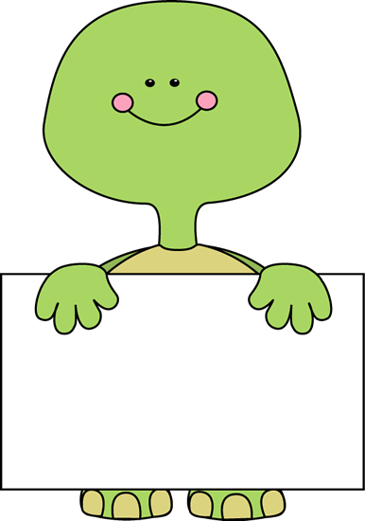

S
( Wh) + did+ S+ V(o)?
What did you do yesterday?
Did you do your homework yesterday?

S+ didn’t + V(o)
He didn’t go to school yesterday

-
?
IRREGULAR VERB
ĐỘNG TỪ BẤT QUY TẮC

Look at the irregular verbs list and complete the table.

16
was/were

- ride…………….
17.run……………..
18.see………………..
19.sit…………………
20.swim………………
21.sleep……………….
22.take…………………
23.give………………….
24.do…………………….
25.know……………........
26.hear…………………..
27. say………………….
28. speak………………..
29. tell…………………..
30. write………………..

29

- is/are……………………
- break……………………
- buy……………………….
- come……………………
- cut………………………
- cost……………………
- drink…………………..
- drive………………….
- eat…………………….
10.get……………...........
11.go………………………
12. make……………….
13. meet………………..
14. put…………………..
15.read…………………..




167

17
Write the verbs in the past simple tense.
ate
eat
- We __________cereal for breakfast this morning.
take
2. Sandy ______________a shower last night.
see
3. They _______________elephants at the zoo yesterday.
go
4. My family _________________the beach last week.
sleep
5. John ___________for twelve hours last Sunday.
read
6. I _____________five books last month.
drive
7. My dad _____________a new car to work this morning.
find
8. Amy _____________ a wallet on the stress this morning.
drink
9. Andy ___________five glasses of milk yesterday morning.
10. I _______________my name on the book yesterday.
write

18
Rewrite the sentences in the past tense.
Katie had breakfast at 7 o’clock.
…………………………………………………………………….
- Katie has breakfast at 7 o’clock.
…………………………………………………………………….
9. My sister buys a lot of dresses.
…………………………………………………………………….
…………………………………………………………………….
…………………………………………………………………….
…………………………………………………………………….
…………………………………………………………………….
…………………………………………………………………….
…………………………………………………………………….
…………………………………………………………………….
6. We take the dog to the shops.
10. I drink a lot of water.
8. Jessica sees us from the window.
7. I do my homework in the kitchen
5. They come to school by bus
4. We get a lot of homework.
3. Mum makes nice cakes
2. I go swimming with my brother.

168

19
Complete the sentences with a verb below in the past simple.
write
make
drink
have
buy
break







1




3
2
did
Cave people

Many, many years ago, people (do) _____not have houses. They lived caves. They (get)______their food from animals and collected fruit from the plants around them. They (eat) ______the food raw. Later on, they (know) _________how to make fire, they cooked the meat and plants. Their water (come) _________from rivers. They (wear) ________animal skin to keep themselves warm. There (be) ______no cars and people (go) ________everywhere on foot. These cave people (tell) _________stories and (draw)_________pictures on the walls of their caves.
made
She _________ a hat
last week.
Juan ____________ a letter
yesterday.
She_______________a cake
an hour ago.
He_________a shower
two minutes ago.

They_________a lot of cola
last night.
She ______________her arm
last week.
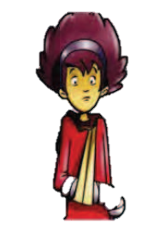




4
6
5

Fill the gaps with the past simple for of the verbs.

20

169

21
Write the sentences in the negative.

- I went to the cinema yesterday.
I didn’t go to the cinema yesterday.
…………………………………………………………………………………………………
13. I had breakfast at 9 o’clock last Sunday.
12. I saw many people on the stress yesterday morning.
…………………………………………………………………………………………………
…………………………………………………………………………………………………
11. They did a lot of homework yesterday.
…………………………………………………………………………………………………
10. Our parents sent us an email last week.
…………………………………………………………………………………………………
9. Dad drove to work yesterday morning.
…………………………………………………………………………………………………
8. You and Jim made sandwiches for lunch yesterday.
…………………………………………………………………………………………………
7. The cat ate a fish last night.
…………………………………………………………………………………………………
6. Emma told me a joke yesterday.
…………………………………………………………………………………………………
5. I swam in the sea last summer.
…………………………………………………………………………………………………
…………………………………………………………………………………………………
4. You bought a new CD yesterday.
3. My friends came to my house last weekend.
…………………………………………………………………………………………………
…………………………………………………………………………………………………
2. John read a comics book yesterday afternoon.

170

22
Write what Marita did or didn’t do yesterday.
1…………………………………………
2………………………………….........
3………………………………………..
4……………………………………….
5………………………………………
6………………………………………
7………………………………………
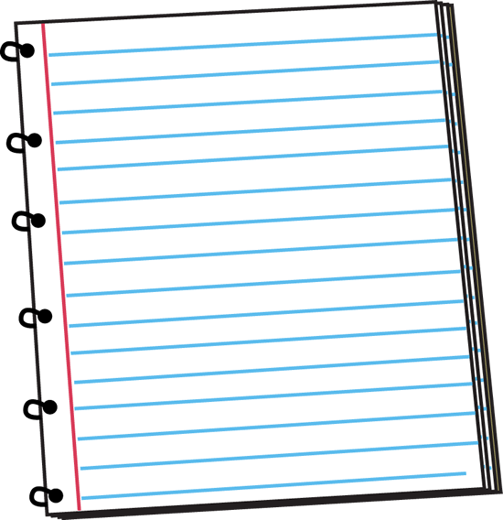

6. visit her grandparents
Marita didn’t go shopping







- go shopping
2. clean the house
3. feed the cat
4. phone Mary
5. watch a film on TV
7. buy her sister a cake

23
Write the questions for the underline words.

6. Carol invited Tim to her party.
7. I spent 20 dollars for a T-shirt.
8. My brother woke up at 9 a.m last Sunday.
9. Alan made a lot of food for dinner.
10. My father returned to Vietnam last week.
When did Pam come home?
…………………………………………………………
…………………………………………………………
…………………………………………………………
……………………………………………………..
………………………………………………………….
5. Paul travelled to Paris by plane.
4. Susan slept seven hours yesterday.
3. Mary ate a lot of sweets.
2. We went to the park after school.
- Pam came home yesterday.
………………………………………………
………………………………………………
………………………………………………
………………………………………………
………………………………………………

171
MY VOCABULARY


No | Words | Vietnamese meanings.
1
2
3
4
5
6
7
8
9
10
11
12
13
14
15
16
17
18
19
20
22
23
24
25 |  | 172
V-E TRASLATION-DỊCH VIỆT ANH

No | Vietnamese | English
1 | Tôi đã ăn một chút bánh bánh và nhảy ở bữa tiệc sinh nhật tối qua. | I danced and ate some cake at the birthday party last night.
2 | Bố tôi đã mua cho tôi một chiếc cặp sách ở hiệu sách ngày hôm qua.
3 | Năm ngoái, mẹ tôi không đi London vào mùa đông.
4 | Bạn đã làm gì ngày hôm qua?  Tôi đã tới thăm ông bà và chơi bóng đá.
5 | Chủ nhật tuần trước, tôi đã đi dã ngoại với gia đình mình.
6 | Em trai tôi không phải tới trường ngày hôm qua.
7 | Tuần trước, chúng tôi đã làm một chiếc bánh.
8 | Hôm qua tôi đã ngủ 12 tiếng.
9 | Hè năm ngoái, chúng tôi đã đi biển. Tôi đã bơi và chụp rất nhiều ảnh.
10 | Chúng tôi không ở nhà ngày hôm qua. Chúng tôi đi học ở thư viện.
173

