FUTURE TENSE: BE GOING TO -WILL

Unit 18

NEAR FUTURE
Tương lai gần

(+) S+ am/is/are+ going to + V(o)

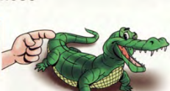
He is going to visit his parents next week.
(-) S+ am not/isn’t/aren’t+ going to + V(o)

STRUCTURE
Cấu trúc
He isn’t going to visit his parents next week.

Are you going to visit your parents next week?
USAGE

Hành động có dự định trước, chắc chắn xảy ra ở tương lai
(?) (Wh)+ am/is/are+ S+ going to + V (o)?

cách dùng

SIMPLE FUTURE
Tương lai đơn

(+) S+ wiil+ V(o)

I will visit you one day.
(-) S+ wiil not+ V(o).

I will not eat that cake.
(?)( Wh)+ will + S+ V(o)?

Will you go with me?
Hành động không dự định trước, quyết định ngay lúc nói.

Complete the sentences with possessive adjectives.
Hành động chưa chắc chắn xảy ra trong tương lai
Phỏng đoán ở tương lai có căn cứ, dấu hiệu
- Jame and Alice have a car. _Their___car
TIME EXPRESSIONS:
tomorrow, tonight,next month, next week, next year…
Thường đi với các động từ sau: hope, think, expect, believe, I’m sure, promise,I’m a fraid, perhaps,…
174
Plans and intentions: Nói về hành động có đự định trước, chắc chắn sẽ xảy ra trong tương lai.
She is going to come your party tonight.
( Cô ấy sẽ tới bữa tiệc của bạn tối nay)
- Prediction:Phỏng đoán về hành động sẽ xảy ra dựa vào dấu hiệu, bằng chứng có thể nhìn thấy hoặc cảm thấy.
It’s cloudy. It’s going to rain.
( Trời nhiều mây. Trời sẽ mưa)
NEAR FUTURE- BE GOING TO



LƯU Ý: Ta có thể dùng thì hiện tại tiếp diễn để thay thế thì tương lai gần” be going to” khi nói về hành động chắc chắn sẽ xảy ra trong tương lai có dự định trước.

QUESTION
NEGATIVE
POSITIVE
I am not going to..
He is not going to..
She is not going to..
It is not going to…
You are not going to…
They are not going to..
We are not going to…

You are= you’re
They are= they’re
We are= we’re
She is= she’s
I am= I’m
He is= he’s
She is= she’s
I am going to..
He is going to..
She is going to..
It is going to..
You are going to..
They are going to..
We are going to..
Am I going to…?
Is he going to…?
Is she going to…?
Is it going to…..?
Are you going to…?
Are they going to….?
Are we going to….?

You are not= you aren’t
They are not= they aren’t
We are not= we aren’t
She is= she’s
I am not= I’m not
He is not= he isn’t
She is not= she isn’t
175

1
Put the words in the correct order to make sentences.

- isn’t/play/tennis/Tom/going/to/./

Tom isn’t going to play tennis.
_______________________________________________________
- tonight/going/we/watch/to/TV/are/./
_________________________________________________________
- going /to/visit/I /am/grandma/my/next week/./
_________________________________________________________
- to/isn’t/cook/he/going/dinner/tonight/./
_________________________________________________________
- Emily/is/that/going/read/to/?/

_________________________________________________________
- play/he/’s/to/going/the/piano/./
________________________________________________________
- They/to/going/’re/the wall/paint/./
_______________________________________________________
- pick/going/we/some fruit/’re/to/./
______________________________________________________
- Tom and Peter/catch/aren’t/to/going/the bus/./

_______________________________________________________
- You/answer/your phone/to/are/going/./
_________________________________________________________
- I/am/to/eat/going/not/ today/chocolate/./
________________________________________________________
- rain/it/going/to/tonight/./is
_________________________________________________________
- parent/my/give/going/me/a/present/are/to/./
_________________________________________________________________
176

2
Look at the pictures and write the sentences.

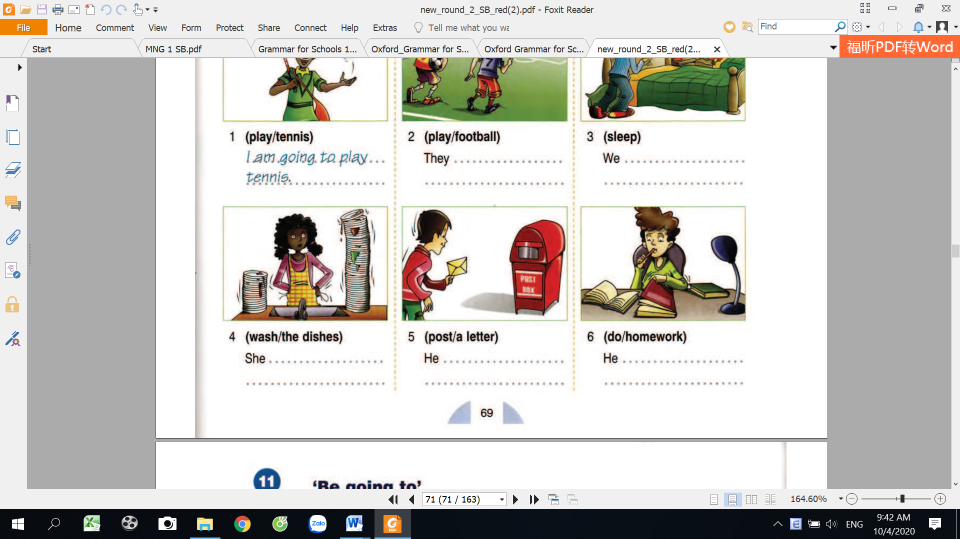

4. do/homework
They……………………………
We……………………………
He……………………………
He……………………………..
She………………………………..
I’m going to play tennis.


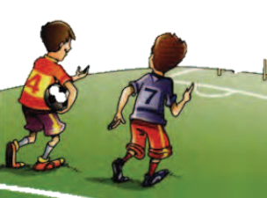
6. sleep
5. play/football
2. wash/the dishes
3. post/the letter.
- play/tennis

3
Look, read and write “ T” for true and “ F” for false sentences.
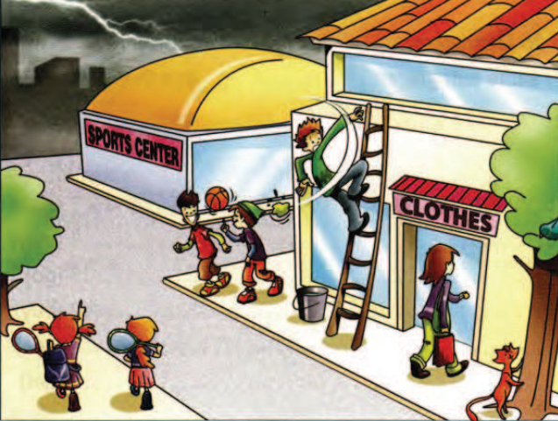
T
- The man is going to fall.
4. It’s going to rain.
2. The girls are going to play basketball.
3. The woman is going to buy a cake.
5. The boys are going to play tennis.
6. The cat is going to climb the tree.

177

4
Look at the Daisy’s dairy and write what her plans are next week.
1…………………………………………………
2…………………………………………………
3…………………………………………………
4………………………………………………
5………………………………………………..
6……………………………………………….
7……………………………………………….


Daisy is going to meet Jane on Monday.
Sunday: have dinner with friends
Saturday: go to the cinema
Friday: visit my grandma
Thursday: buy new shoes
Wednesday: clean the house
Tuesday: stay at home
Monday: meet Jane
My next week’s plans

5
Write the correct form of the verbs in brackets.

do
is going to do
- Julia _______________________the washing up today.
win
visit
10. They _______________________the volley ball team.

9. We __________________a week in London.

8. That train _________________ the station in a few minutes.

7. My mother ____________________the baby.

6. My uncle _________________ some gardening.

5. The girls _______________________some food to the party.

4. We ______________________ these exercises tomorrow.

3. Philip and you _____________________the football match tomorrow.

2. Martha _____________________her grandparents in the country.

practice
buy
do
feed
leave
stay
join
178

6
Complete the gaps and fill “ P” for prediction and “ I” for intensions.

P
I
I

break
miss
take
She ________________
to the beach.
burn
rain
laugh
win
build
buy
eat
jump
call
spend
fall
make
go
‘s going to go
16. He ________________
his girlfriend.
15. She ________________
a few pills
14. I ________________
my piggy bank.
13. He ________________
himself again.
12. It________________
cats and dogs.
11. He________________
when he sees you.
7 .I________________
this delicious meal.
10. We________________
this race
9. They ________________
a house for us.
6. I ________________now.
5. She ________________
her friend Nancy
8. We________________
lot of presents.

4. We ________________
our holiday in Spain
3. He ________________
and spill the coffee.
2. I ________________
a delicious cake.

179

7
Use the words to make questions.

Who is going to cook at next party?
- cook / at next party / who?
- you / study / what / next period?
- where / your sister / tomorrow / go?
- Vanessa / work / when / late ?
- I / why / do / homework?
- speak to / Who / the principal ?
- Olguita / buy / what / ?
- play /they / what / at school?


WRITING
What are you going to do next week?

_______________________________________________________________________________________________________________________________________________________________________________________________________________________________________________________________________
________________________________________________________________________________________________________________________________________________________________________________________________________________________________________________________________________________________________________________________________________________________________
___________________________________________________________________________________________________________________________________________________________________________________________________________________________________________________________

180
SIMPLE FUTURE: TƯƠNG LAI ĐƠN
- Hành động quyết định ngay tại thời điểm nói.
There aren’t any milk in the fridge.
Ok, I will go to the supermarket to buy.
( Không còn chút sữa nào trong tủ lạnh. Được rồi, tôi sẽ đi siêu thị mua)
- Hành động chưa chắc chắn xảy ra ở tương lai.
Đi với các động từ : think ( nghĩ ), hope ( hy vọng), expect ( mong đợi), promise ( hứa), perhaps ( có lẽ), I’m afraid ( e rằng), sure, doubt ( nghi ngờ)

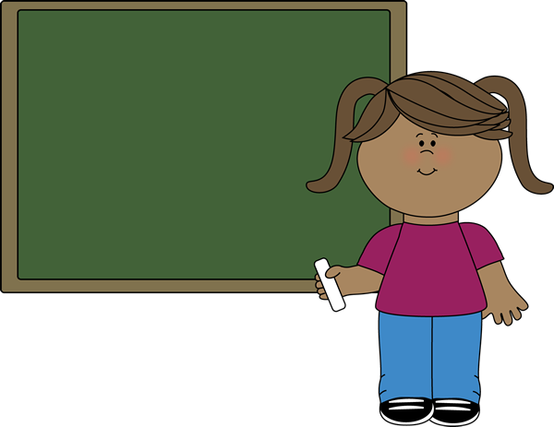

LƯU Ý: Với thì tương lai đơn tất cả các chủ ngữ có thể đi cùng với “ will” , còn với “ I” và “ We” có thể đi với “ shall”=sẽ
Shall not= shan’t.

QUESTION
NEGATIVE
POSITIVE
I will……
He will……
She will…..
It will……
You will…..
They will….
We will…..

I will not
He will not
She will not
It will not
You will not
They will not
We will not

Will I…?
Will he…….?
Will she……?
Will it……?
Will you……?
Will they....?
Will we….?

Yes, I will/ No, I won’t
Yes, he will/ No, he won’t

Yes, she will/ No,s he won’t
Yes,it will/ No,it won’t
Yes, I will/ No,I won’t

Yes, they will/ No,they won’t
181
will= ‘ll
will not= won’t
Yes, we will/ No, we won’t

8
Put the verbs in brackets into Simple Future Tense.
will go
go

1. Jack……………… to the cinema.
write

2. Sandy……………… a novel.
become

3. I………………… a famous singer.
have

4. My friends……………… an exam next week
go

5. Jane……………….to school tomorrow.
do

6. In 2100 robots…………… the housework.
be

7. Dad……………home at 4 o’clock.
iron

8. Mum………………. the clothes.

9
Change the sentences into the negative form.
We won’t travel to the Mars
_______________________________________
1. We will travel to the Mars.
_______________________________________
2. Bob will have lunch with me tomorrow.
_______________________________________
3. I will play football with you.
______________________________________
4. Mr Green will work in a library.
______________________________________
5. They will have a party next week.
______________________________________
6. Sam will go to the disco tonight.
______________________________________
7. I’ll travel to Antarctica.
______________________________________
8. The party will start at 7.30.
______________________________________
9. My parents will go to the disco next week.
______________________________________
10. Peter and Mary will visit you some day.
182

10
Look at the picture and write the sentences in simple future.

1

3

2
Nicol____________(go)
swimming.
Angela____________(drink)
coffee
She____________(wear)
mum’s hat.
Frank____________(eat)
the jam.
I____________(go)
to the doctor.
15

14

13


He____________(take)
a bath.
12

11
10
John______________(go)
bed early.
Greg_______________(fly)
to the moon.
Brian__________________(write) a letter to his grandma.
Frank______________(play) the guitar.
Jack_________________(be) a pilot one day.
Oliver___________________(help) his mum.
9

8

7

6

5

4
2
It___________________(rain)
tomorrow.
Janet_______________
(dance) at the party.
Mary___________(wear) her dress.
2

183

11
Put the words into the correct order.
Will you go out tonight?
______________________________________
1. go out / will / you / tonight ?
______________________________________
2. Ben / tomorrow /go dancing / will ?
______________________________________
3. in June / get married / they / will .
______________________________________
4. next week / won’t / it / be cold .
______________________________________
5. by car / she / travel / will ?
______________________________________
6. live / on the Mars / won’t / people .
______________________________________
7. Gary / move / will / to New York .
______________________________________
8. London/ to/ go/ Joe / will/ when?

12
Answer the following questions. ( = yes, = no)

Yes, he will.
______________________________________
1. Will John be famous?
______________________________________
2. Will you go to the disco?
3. Will Jenny do the washing-up?
______________________________________
4. Will your friends come tonight?
______________________________________
______________________________________
5. Will it snow tomorrow?
______________________________________
6. Will you have a party this Friday?
______________________________________
7. Will we have English tomorrow?
______________________________________
8. Will Peter travel to Rome?
184

13
Circle the correct answers.

1. Oh look! It is going to/ will snow soon.
2. Next summer I am going to/ will backpack around Europe.
3. Ring! Ring! I am going to/ I’ll answer it.
4. I think our team is going to/ will win the match.
5. In 2055 robots are going to/ will be our teachers.
6. Tonight we are going to have/ will have a birthday party for my brother.
7. Sponge Bob is going to/ will work at the Crabby Patty tonight.
8. My friends are going to/ will go to the movies tonight.
9. I doubt that he is going to/ will pass the English test.
10. He is going to/ will study for the test tomorrow.
11. Be careful! You are going to/ will drop the dishes.
12. During summer vacation we are going to/ will go swimming every day.
13. I’m sure that you are going to/ will find your lost ring.
14. I am going to/ will help you carry your books.
15. Look out! That dog is going to/ will bite you if you get near him.
16. Watch out! You are going to/will fall.
17. We will/ are going to meet at 8 p.m.
18. My car broke. I will/am going to fix it this afternoon.
19. Perhaps, I will/am going to go to Spain one day.
20. The phone is ringing. I will/am going to get it.







185
- I ______________to New York tomorrow.

14
Fill in the blanks with “ be going to” or “ will”


Will
am going
- _____________you please get me a coffee?
3._________ you answer the phone? Yes, I________.
4. Watch out for the hole! You______________fall.
5. There are clouds. It’s____________________rain.
6. I think Jim ____________________be back soon.
7. Sam is____________________the doctor’s tomorrow.
He has an appointment.

8. Sue__________________be at the party tomorrow.
10. I_____________________to be a lawyer one day.
12. Maybe, I__________________buy a computer soon.
13. I____________________to my brother’s house now
14. Where are you going? I__________________home.
15. ____________________you walk to school with me?
16. Are you______________________ Paris tomorrow?
17. It_______________________be a few minutes before we arrive.

18. I_________________________ back to the office. I have lots of work to do.
19. I_________________________type the letter for you.
20. I________________make an appointment for you.
21. Obamah________________be the next president.
22. I_____________________to a concert tonight. I
have my ticket.
23. I think the next bus_____________be here soon.
24. Jane_________________________be a mother soon.
186
MY VOCABULARY


No | Words | Vietnamese meanings.
1
2
3
4
5
6
7
8
9
10
11
12
13
14
15
16
17
18
19
20
22
23
24
25 |  | 187
V-E TRASLATION-DỊCH VIỆT ANH

No | Vietnamese | English
1 | Tôi sẽ đến thăm ông bà tôi vào tuần tới. | I’m going to visit my grandparents next week.
2 | Trời nhiều mây. Trời sẽ mưa.
3 | Tôi sẽ tới bữa tiệc sinh nhật của bạn tôi tối nay.
4 | Điện thoại đang reo ( ring: reo). Tôi sẽ nghe nó.
5 | Có lẽ trời sẽ mưa vào ngày mai.
6 | Tôi hy vọng anh ấy sẽ vượt qua kỳ thi.
7 | Bạn định làm gì vào ngày mai?  Tôi sẽ đi bơi. | What are you going to do tomorrow? I’m going to swim.
8 | Gia đình bạn định đi đâu vào mùa hè tới? Chúng tôi sẽ đi biển
9 | Tôi tin rằng đội tuyển Việt Nam sẽ chiến thắng.
10 | Tôi đói. Tôi sẽ ăn một chút cơm.
11 | Tôi và bạn tôi sẽ đến rạp chiếu phim vào 8 giờ tối nay.
12 | Năm tới, chúng tôi sẽ mua một chiếc máy tính mới.
13 | Có lẽ chúng tôi sẽ mua một chiếc TV mới vào năm tới.
188

