THIS/THAT-THESE/THOSE

Unit 5
GRAMMAR BOARD

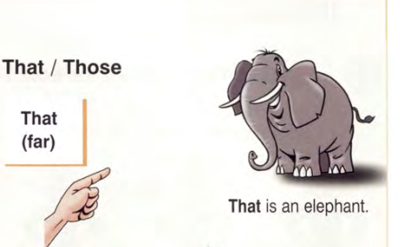
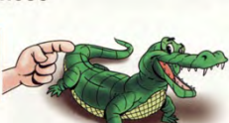

That is an elephant.
This is an alligator.
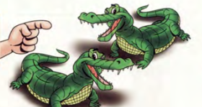

Those are elephants.
These are alligators.

That is: Kia là một….
( Chỉ một người, vật ở xa)

This is: Đây là một…..
( Chỉ một người, 1 vật ở gần)

These are: Đây là những…..
(Chỉ hai người, vật ở gần)

Those are: Kia là những….
( Chỉ hai người, vật trở lên ở xa.

xa)

33
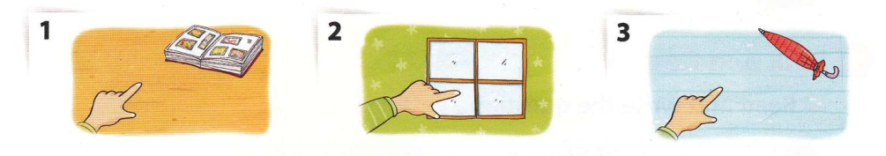

1
Look and write “ This”/ “ That”.


- That is an album.
3.………..is an umbrella.
2……..is a window.

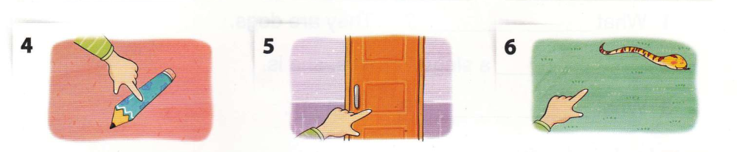
6……………. is a snake.
4……………. is a pencil.
5…………….is a door.

2
Look and write “ These”/ “ Those”.

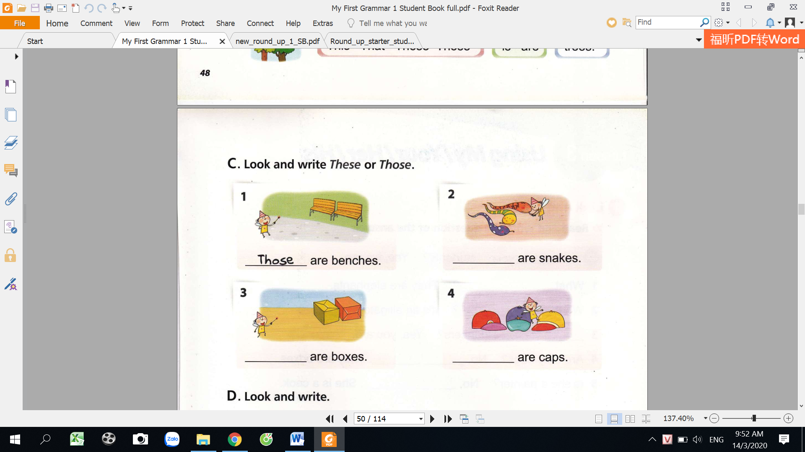
2……………. are snakes.
1.Those are benches.

3……………. are boxes.
4……………. are caps.

34
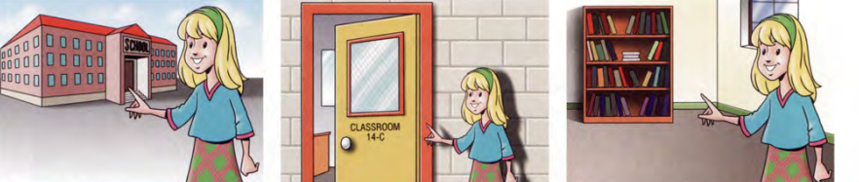
Write “ This” “ That” These” “ Those”.

3
3.……………. is a bookcase.
2.……………. is my classroom
1.…That…is my school.

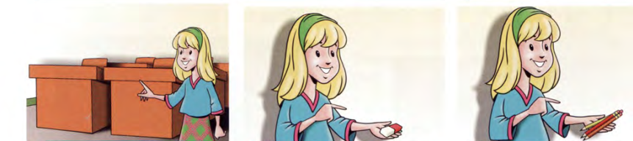
6.……………. are pencils
4.……………. are desks.
5.……………. is an eraser. .
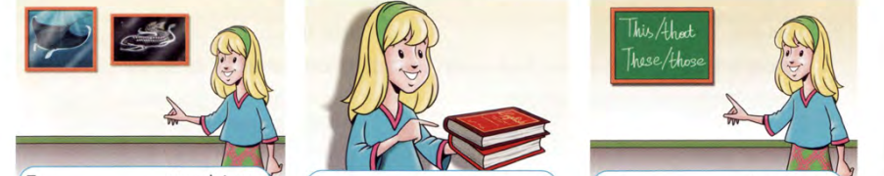
9……………. is a board.

8……………. are books.
7……………. are pictures.
Circle the correct words.

4

- Is this/these a pencil?

- This/these are my shoes.
- That/those book is old.
- This/these pens are red.
- That/Those shoes are beautiful.

- This/these is a nice shoe.
- That/those is Jack.
- Are this/those photos.
35

5
Look and write.

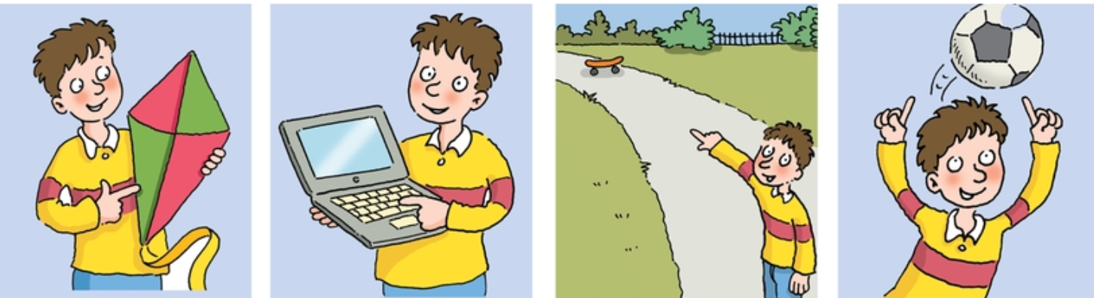
ball
skateboard
computer
kite

7
1
5
3

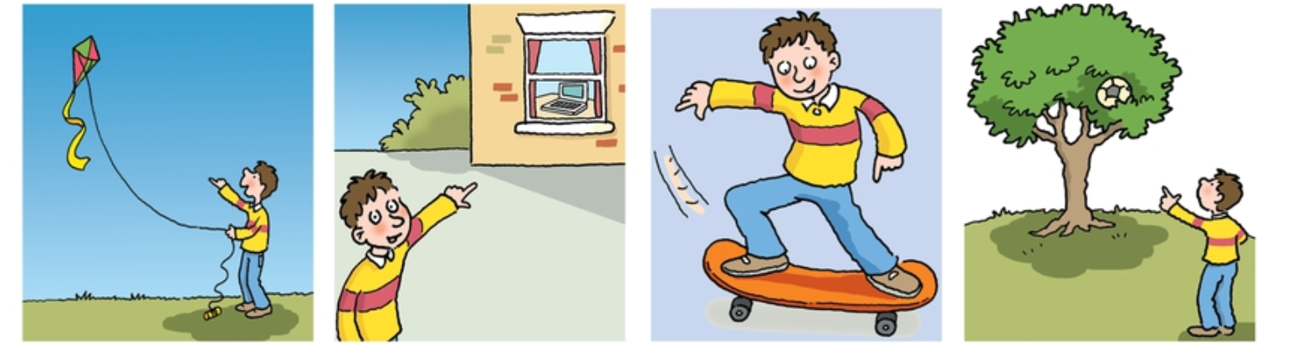
8
6
4
2

This is my kite
- ……………………………………………………………
That is my kite
- ………………………………………………………….
- ………………………………………………………….
- …………………………………………………………..
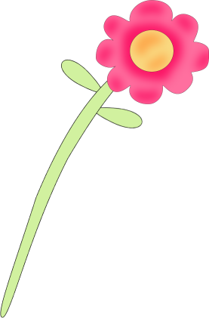
- …………………………………………………………..
- ………………………………………………………….
- ………………………………………………………….
- ………………………………………………………….

36

6
Complete the sentences with “ this, that, these, those”

- What’s________?
- What’s________?
- What’s________?
- What’s________?
- What’s________?
- What are________?
- What are________?
- What are________?
- What are________?
4. What are________?
3.What are________?
- What’s_that_______?
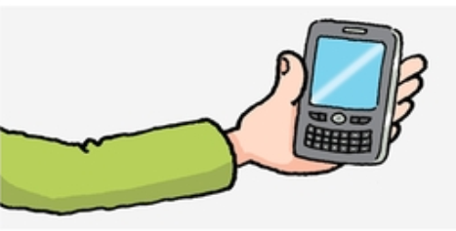
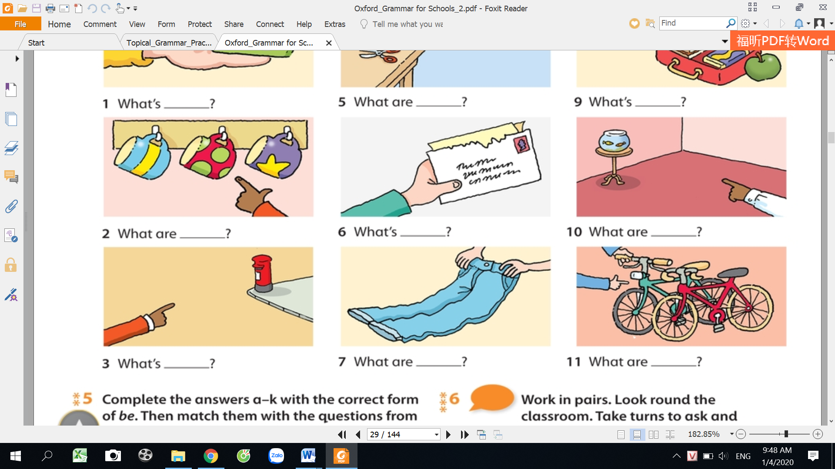

7
Make the sentences plural.

These mice are grey.
_____________________________________
- This mouse is grey.
_____________________________________
- That child is very cute.
_____________________________________
- This pencil is not mine.
_____________________________________
- That cherry is sweet and red.
_____________________________________
- That baby is sleeping.
_____________________________________
- This is a teacher.
_____________________________________
_____________________________________
- That isn’t a box.
_____________________________________
- That glass is empty.
_____________________________________
- This book isn’t good.
_____________________________________
- That window isn’t clean.
37

8
Fill in this, that, these, those and answer the questions.

- What’s _____that______?
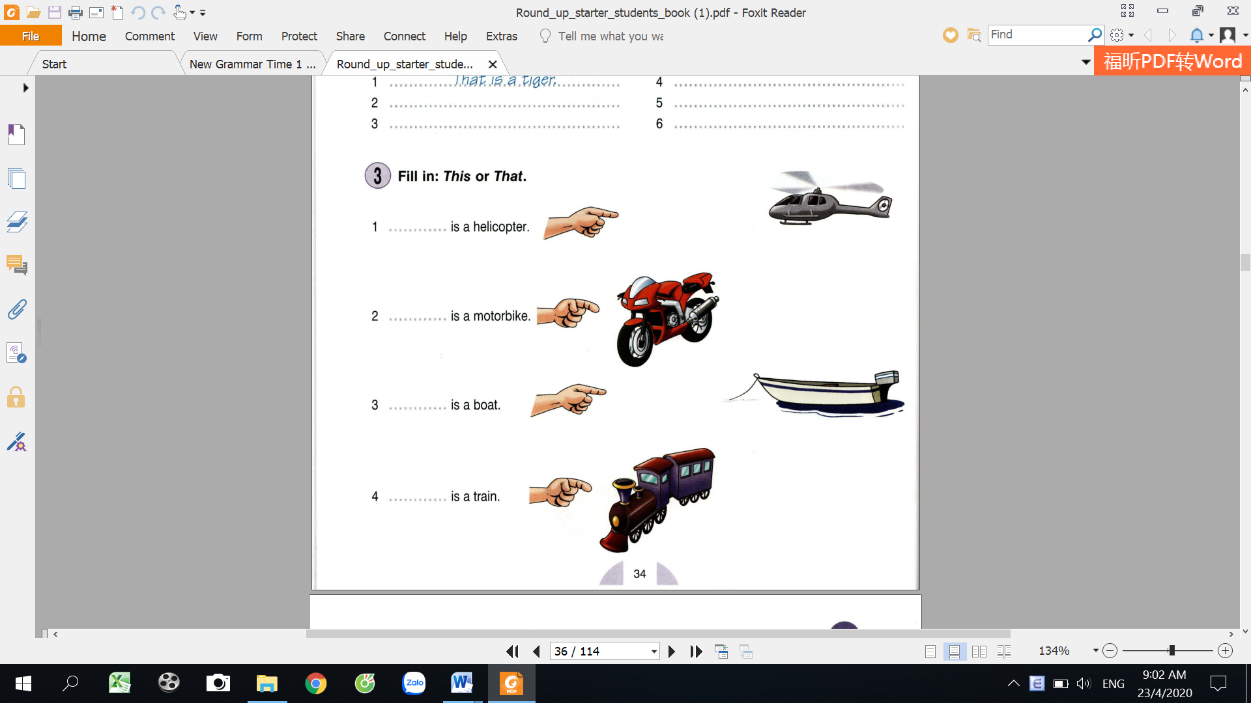
helicopter
train
car
boat
bus
bike
motorbike
plane


That is a helicopter.
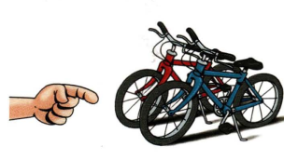
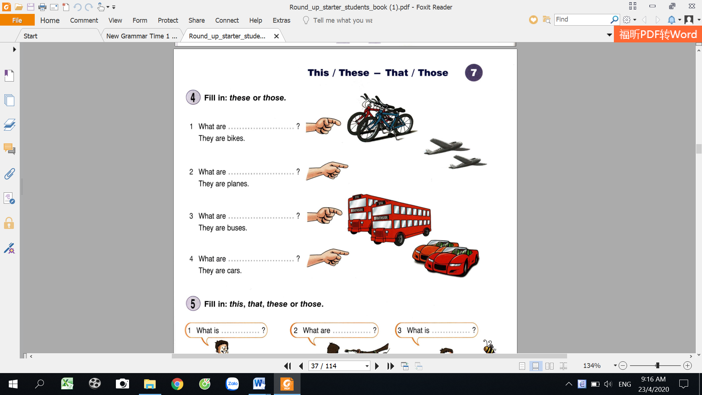
8. What’s___________?
________________________________________
________________________________________
________________________________________
________________________________________
________________________________________
________________________________________
________________________________________
________________________________________
7. What are___________?
6 What’s___________?
5. What are___________?
4. What are___________?
3. What are___________?
2. What’s ___________?

9
Look and circle the correct words.

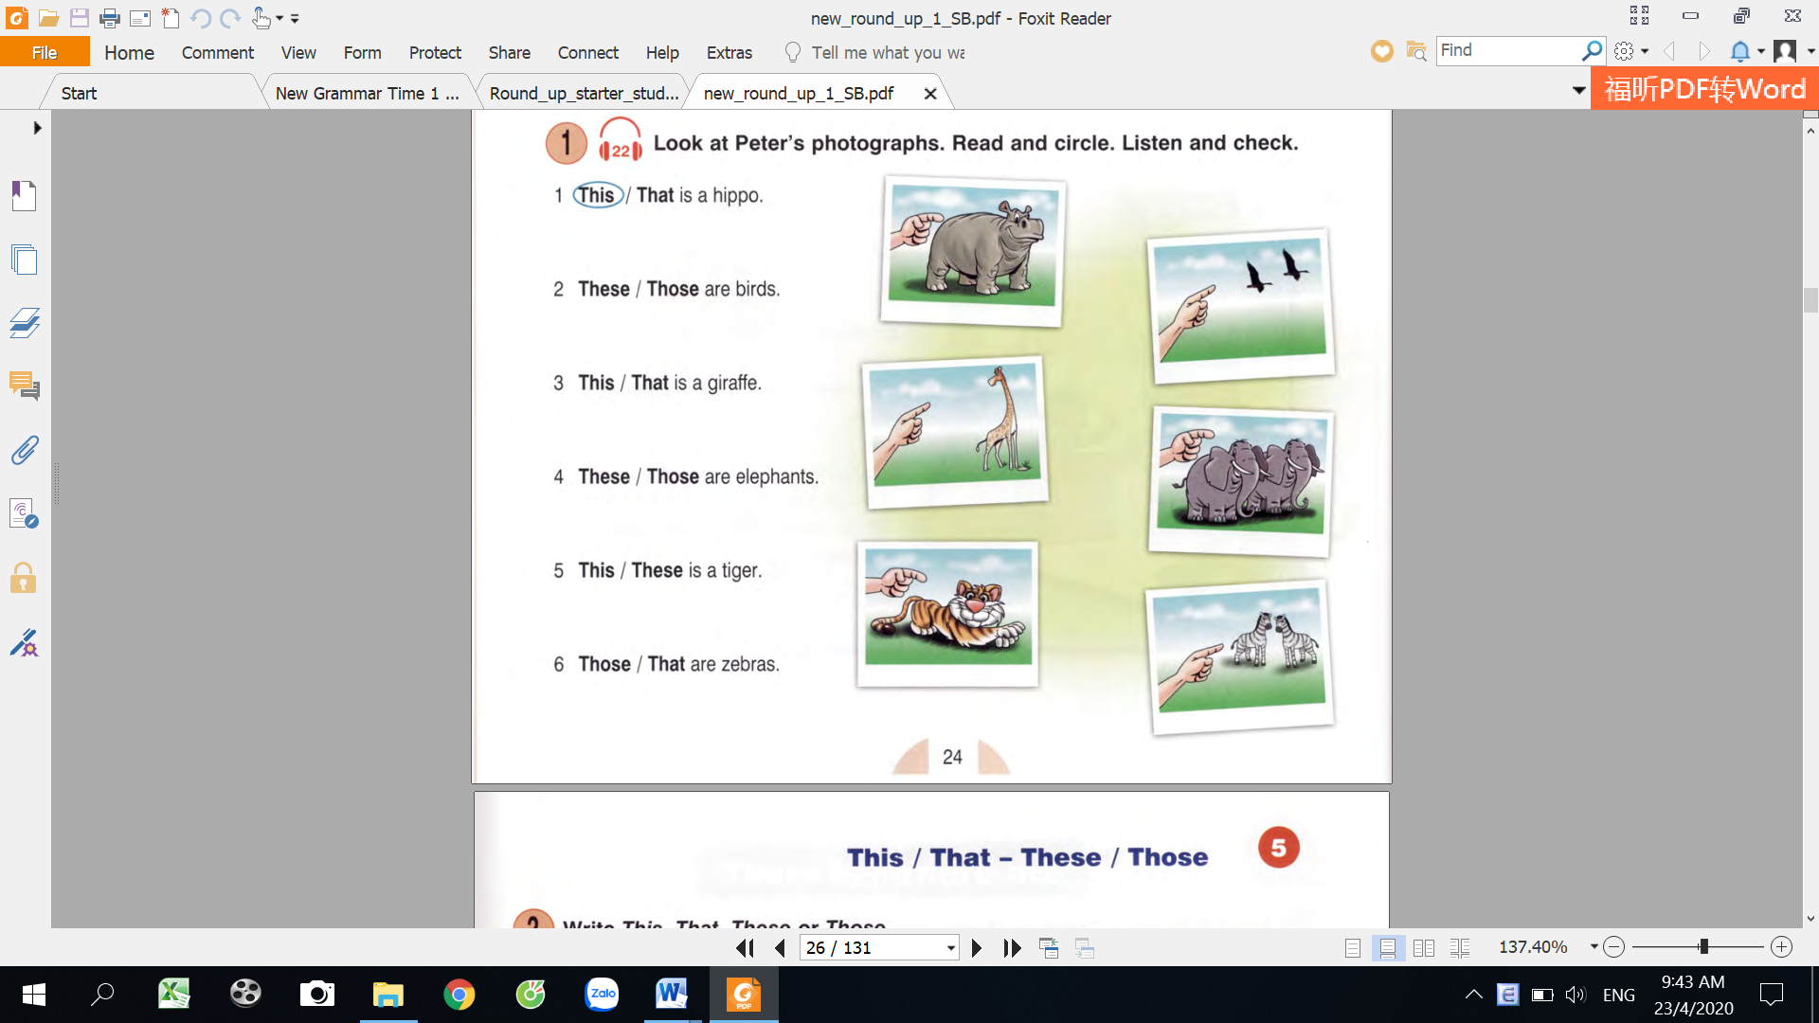

- These/those are birds
3. This/that is a giraffe.
- This/that is a hippo
38
6. These/those are elephants.
5. This/that is a tiger.
4. These/those are zebras
MY VOCABULARY


No | Words | Vietnamese meanings.
1
2
3
4
5
6
7
8
9
10
11
12
13
14
15
16
17
18
19
20
22
23
24
25 |  | 39

V-E TRASLATION-DỊCH VIỆT ANH
No | Vietnamese | English
1 | Đây là một chiếc xe đạp. | This is a bike.
2 | Kia là một con mèo.
3 | Đây là những chiếc máy bay.
4 | Kia là những cái cây.
5 | Cái gì đây? Đây là một cái máy tính.
6 | Những cái gì kia?
7 | Kia là những cái xe máy.
8 | Đây là một cái bút.
9 | Kia là những cái thuyền.
10 | Đây là cái bút đúng không? Đúng. | Is this a pen? Yes, it is
11 | Kia là những bông hoa đúng không? Không, Chúng là những cái cây. | Are those flowers? No, they aren’t.  They are trees.
12 | Đây là một chiếc xe máy. Kia là những chiếc xe máy.
13 | Kia là những con chim.
14 | Đây là những đứa trẻ.
15 | Kia là 10 người đàn ông.
16 | Đây là những con ngỗng.
17 | Cái gì đây?
18 | Cái gì kia?
19 | Những cái gì đây?  40

