THERE IS/THERE ARE

Unit 6

GRAMMAR BOARD

There is a book on the desk.
There are two pens on the desk.
There are three notebooks on the desk.
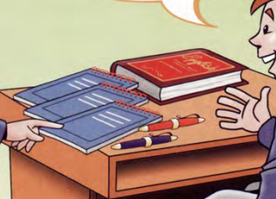
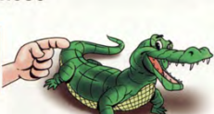
POSITIVE (KHẲNG ĐỊNH)
There is= there’s
There are
NEGATIVE ( PHỦ ĐỊNH)
There is not= There isn’t
There are not= There aren’t
QUESTIONS ( CÂU HỎI)
Is there……….?
Are there……….?

There are: Có ( Số nhiều từ 2 trở lên)
There is: Có ( số ít)

There aren’t : Không có ( số nhiều từ 2 trở lên)

xa)
There isn’t…: Không có ( số ít)

41

1
Look at the picture and circle the correct the items.


clock
mirror
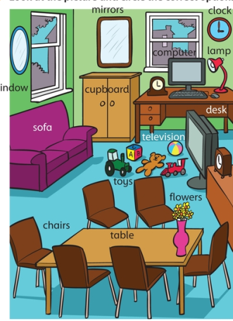
6. There are/there aren’t two mirrors.
7.There are/there aren’t some toys.

8.There is/there isn’t a ball.

5.There’s/there isn’t any phone.
4. There are/there aren’t any books.
desk
3.There’s/there isn’t a guitar.
2.There’s/there isn’t a desk.
1.There is/there isn’t a sofa.
lamp
window
chairs
tables
flowers
toys
television
sofa
cupboard
computer

2
Look at the picture again and fill “ There is” “ There are”, “ There isn’t” , “ There aren’t.

There are
1. _______________some chairs.
2.____________________a bag.
3.____________________any children.
4. ____________________a lamp.
42

5. ____________________two windows.
6. _____________________any shoes.
7. ______________________a cupboard.
8. ______________________a computer.

Look at the picture, read and cross If the sentences are wrong, tick if the sentences are right.

3


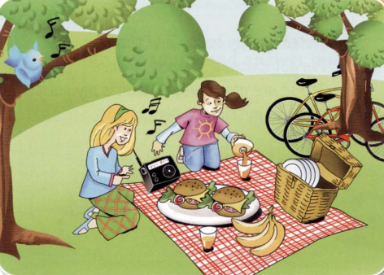


6. There are two sandwiches.
5. There is a radio.
4. There are five bananas.
1.There are two children in the pictures.
3. There isn’t a dog.
2. There are four bikes.

Complete the text about Ann’s room with “there is”, “there isn’t”, “ there are”, there aren’t.

4

In my room, there’s a bed, and (1) ______________________a wardrobe for my clothes. (2) ____________________any chairs, and (3)____________________a desk, (4) ______________________ a small table. ( 5) _______________two clocks ( on the table and on the wall). On the wall, (6) _______________ a mirror and ________________ (7 ) some pictures. There are some other things in my rooms.
( 8)_____________ a cupboard and ( 9)______________ some books and toys in it. But ( 10) ______________ a computer and ( 11) _________________ a television.

5
Write the plural form of the sentences.

There are cupboards.
_______________________________
- There is a cupboard.
_______________________________
- There isn’t a book on the shelf.
_______________________________
- There is a banana.
_______________________________
- Is there a mirror in the room?
43

Look at the pictures and write the questions and answers.

6

Look at the pictures and write
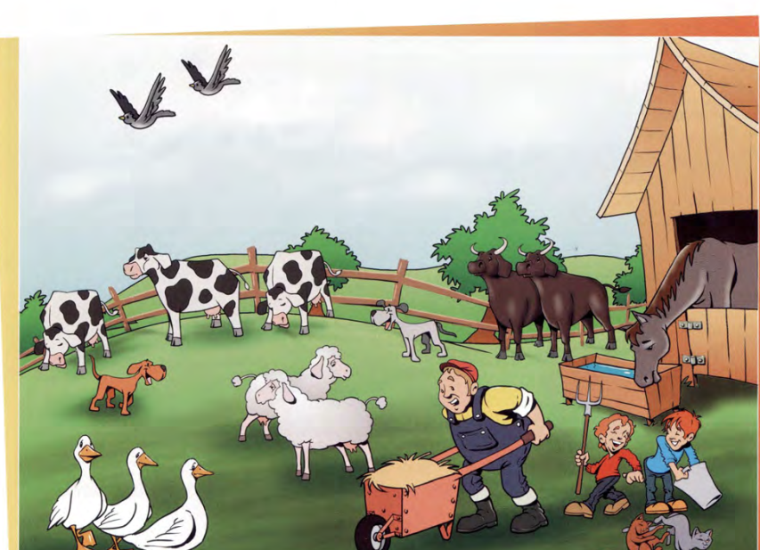
the q

n

- Are there three sheep?
No, there aren’t. There are two sheep
6 ................................. one horse?
……………………………………………………….

- .................................. three geese?
……………………………………………………….

3. ..................................one cat?
……………………………………………………….

4. ..................................two dogs?
……………………………………………………….
5. ..................................two cows?
……………………………………………………….

7 ................................ .one man?
……………………………………………………….

8 .................................three trees?
……………………………………………………….
9. ................................. two children?
……………………………………………………….

10. .................................one bird?
……………………………………………………….

44
Complete the questions “Is there” or “Are there?

7
Are there
- __________________________any computers in your rooms?
- ___________________________ a desk in your bedroom?
- ___________________________ any flowers in your classroom?
- ___________________________ a phone in your bag?
- ___________________________ any books in your bedroom?
- ___________________________ a sofa in your house?
- ___________________________ any pictures in your bedroom?
- ___________________________ a pencil in your bag?
- ___________________________ any spiders in your house?
- _______________________ a mirror in your classroom?
Look at the picture, read the questions and give the short answer.

8
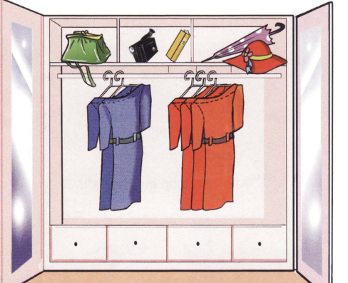
Is there a hat?
Yes, there is.

______________________________________
- Are there three books?
______________________________________
- Are there any dolls?
_____________________________________
- Are there four red dresses?
______________________________________5. Is there an umbrella?
______________________________________

45
Fill in “ is” or “ are”

9
- There _________ three apples in the fridge.
10. There _________a bed in my room.
11. There________many students at school.
12.There _________two pictures on the wall.
13.There _________three children in the room.
14.There ________a cupboard in the kitchen.
- There _________a bird in the cage.
- There __________five bikes in the park.

- There _________ a ball on the floor.
- There _________toys on the floor.
- There________a cat at the wall.
- There _________a photo on the wall.
- There _________parents on the photo.
- There ________curtains on the window.
- There _________a flower pot under the window.
- There __________five dolls on the floor.

is

Circle the mistakes and correct them in the sentences.

10
is
________________
1. There are a library round the corner.
________________
2. There is two cats under the tree.
________________
3. There are a flower pot on the floor.
________________
4. There are many flower in the room.
________________
5. There is three cars in the yard.
________________
6. There is two birds on the tree.
________________
7. There are a boy and a girl there.
________________
8. There is a lot of students at the conference.
________________
9. There are two portrait on the wall.
________________
10. There is three umbrellas in the corner.
________________
11. There are some cake on the table.
________________
12. There is two apples on the plate.
________________
13. There are many potato in the basket.
________________
14. There is two tomatoes on the plate.
46
Writing
………

……………………………………………………………………………………………………………………………………………………………………….
…………………………………………………………………………………………………………………………………………………………………………
…………………………………………………………………………………………………………………………………………………………………………
…………………………………………………………………………………………………………………………………………………………………………
…………………………………………………………………………………………………………………………………………………………………………
…………………………………………………………………………………………………………………………………………………………………………
…………………………………………………………………………………………………………………………………………………………………………
…………………………………………………………………………………………………………………………………………………………………………
…………………………………………………………………………………………………………………………………………………………………………
…………………………………………………………………………………………………………………………………………………………………………
…………………………………………………………………………………………………………………………………………………………………………
…………………………………………………………………………………………………………………………………………………………………………
…………………………………………………………………………………………………………………………………………………………………………
…………………………………………………………………………………………………………………………………………………………………………
…………………………………………………………………………………………………………………………………………………………………………
…………………………………………………………………………………………………………………………………………………………………………
…………………………………………………………………………………………………………………………………………………………………………
…………………………………………………………………………………………………………………………………………………………………………
…………………………………………………………………………………………………………………………………………………………………………
…………………………………………………………………………………………………………………………………………………………………………
…………………………………………………………………………………………………………………………………………………………………………
…………………………………………………………………………………………………………………………………………………………………………

Write a short text about your favorite room in your house using
“There is” or “There are”, there isn’t”, “ there aren’t”

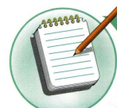

NOTE: GHI CHÚ
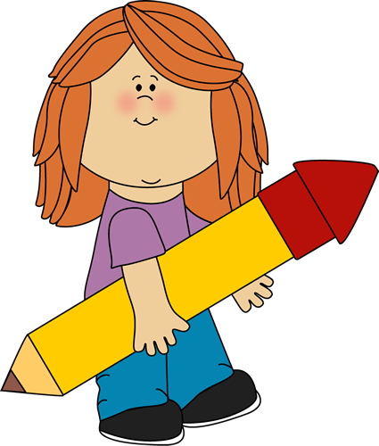

THERE IS/THERE ARE = HAVE/HAS
I/YOU/WE/THEY/ CHỦ NGỮ SỐ NHIỀU + HAVE ( GOT)
HE/SHE/IT/CHỦ NGỮ SỐ ÍT + HAS ( GOT)
Ví dụ: There are five chickens in my garden.
= My garden has five chickens

Vườn của tôi có 5 con gà
47
MY VOCABULARY

No | Words | Vietnamese meanings.
1
2
3
4
5
6
7
8
9
10
11
12
13
14
15
16
17
18
19
20
22
23
24
25
48
V-E TRASLATION-DỊCH VIỆT ANH
No | Vietnamese | English
1 | Có một con mèo trong phòng ngủ. | There is a cat in the bedroom.
2 | Có 5 người trong gia đình của tôi.
3 | Nhà tôi có 7 phòng. | There are 7 rooms in my house/ My house has 7 rooms.
4 | Có ba con chim trên cây.
5 | Có một chiếc đồng hồ trên tường.
6 | Không có một cái TV trong phòng khách. | There isn’t a TV in the livingroom.
7 | Không có những đứa trẻ ở công viên.
8 | Có 4 cái ô tô trên sàn nhà.
9 | Không có một con gà trong vườn.
10 | Có 5 cái bánh trên bàn.
11 | Có một con mèo trên ghế.
12 | Có 3 con lợn trên trang trại.
13 | Có một người phụ nữ trong phòng.
14 | Có 10 người trong phòng.
15 | Không có con trai trong lớp của tôi.
16 | Lớp tôi có 12 bạn nữ.
17 | Có 10 cái bút chì trong cắp sách.
18 | Có 2 quả cà chua trong hộp.
19 | Không có những bức tranh trên tường.  49

