Exercise 1 Look and write
honey | mother | gloves | son

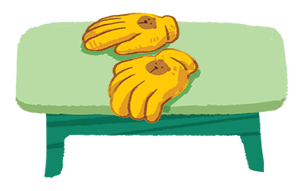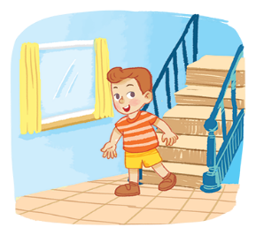

Exercise 2 Look and match
a) Can you see the son ?
b) Can you see the mother ?
c) Can you see the honey ?
d) Can you see the gloves?

Exercise 3 Read and complete the sentences
a)  Can you see the ………………….? Yes, I can.
b) ………………… you see the honey ? Yes, I can.
c) 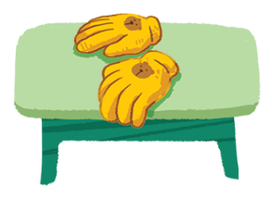 Can you see the hat ? ………………, I can’t.
d) 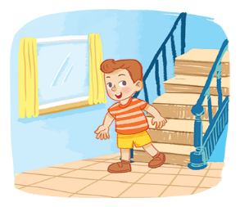 Can you see the …………………? Yes, I can.
Exercise 4 Put the words in the correct order
a) the – gloves – Can – you – see ?
………………………………………………………………………..
b) Can – see – the – mother – you ?
………………………………………………………………………..
c) honey – the – you – Can – see ?
………………………………………………………………………..
d) the – son – see – you – Can ?
………………………………………………………………………..
e) hat – Can – you – see – the ?
………………………………………………………………………..

Exercise 5 Find the word which has a different sound in the part underlined
a) hen | b) umbrella | c) egg | d) he
a) son | b) mother | c) foot | d) gloves
a) nine | b) fish | c) milk | d) chips
a) pot | b) box | c) mop | d) honey
a) bag | b) hat | c) mop | d) cake
a) sun | b) truck | c) fruit | d) bus
a) feet | b) green | c) sheep | d) bed
a) leg | b) beach | c) red | d) egg
Exercise 6 Look and tick () or ()

a) I can see the son . b) I can see the honey .
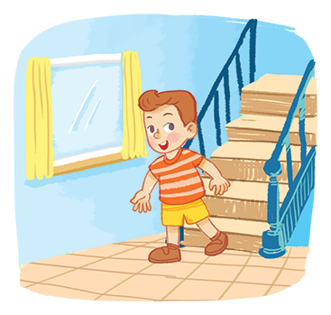
c) I can see the gloves . d) I can see the mother .

Exercise 7 Look and circle the best answer

0. Can you see the ……………..? 1. Can you see the ……………….?
a. honey b. water a. father b. mother
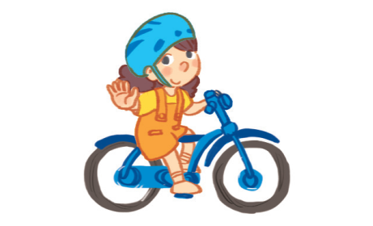
2. She is riding a ……………. 3. I can see a ……………..
a. car b. bike a. kite b. kitten
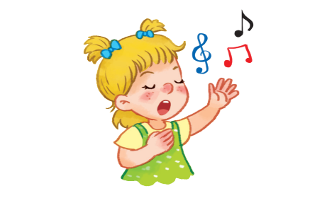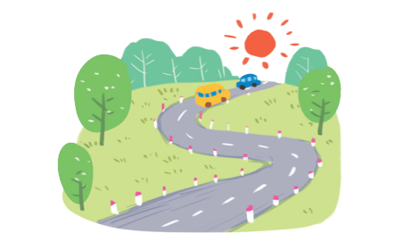
4. She is ……………. 5. I can see a ……………..
a. swimming b. singing a. road b. river

6) Can you see the ……………..? 7. What can you see ?
Yes, I can. I can see a ……………..
a. hat b. gloves a. rainbow b. rabbit

