UNIT 4: DID YOU GO TO THE PARTY
PART I: THEORY
I. VOCABULARY
English | Pronunciation | Vietnamese
Birthday party | /'bə:θdeipɑːti / | Tiệc sinh nhật
Today | /tə'dei/ | Ngày hôm nay
End | /end/ | Kết thúc
Have fun | /hæv fʌn/ | Vui vẻ
Anything else | /'eniθiɳ els/ | Còn cái gì khác nữa
Different | /'difrənt/ | Khác biệt
Festival | /'festivəl/ | Lễ hội
Week | /wi:k/ | Tuần
Month | /mʌnθ/ | Tháng
Day | /dei/ | Ngày
Present | /'preznt/ | Món quà
Robot | /'roubɔt/ | Con rô bốt / người máy
Teddy bear | /'tedi,beə/ | Gấu bông
Picnic | /'piknik/ | Chuyến đi chơi
Book fair | /buk feə/ | Hội chợ sách
Story book | /'stɔ:ri buk/ | Sách truyện
Comic book | /'kɔmik buk/ | Truyện tranh
Enjoy | /in'dʤɔi/ | Thưởng thức, thích
Food | /fu:d/ | Đồ ăn
Drink | /driɳk/ | Đồ uống
Cake | /keik/ | Bánh ngọt
Sweet | /swi:t/ | Ngọt
Fruit | /fru:t/ | Hoa quả
Cream | /kri:m/ | Kem
Fruit juice | /fru:t kri:m/ | Nước hoa quả
Go on a picnic | /gou ɔn ə 'piknik/ | Đi chơi/ đi picnic
Go to the party | /gou tə ðə 'pɑ:ti/ | Tham dự tiệc
Watch TV | /wɔtʃ ti vi/ | Xem TV
Go to the zoo | /gou tə ðə zu:/ | Đi vườn thú
Stay at home | /stei æt houm/ | ở nhà
Play hide and seek | /plei haid ænd si:k/ | Chơi trốn tìm
Chat with friends | /tʃæt wið frendz/ | Nói chuyện với bạn bè
Cartoon | /kɑ:'tu:n/ | Phim hoạt hình
Take part in | /teik pɑ:t in/ | Tham gia/ tham dự
Invite someone to | /in'vait ˈsʌmwʌn tə/ | Mời ai tới
Sing | /siɳ/ | Hát
Dance | /dɑ:ns/ | Nhảy múa, khiêu vũ
Play the guitar | /plei ðəgi´ta:/ | Chơi ghi ta
Play the piano | /plei ðə 'pjænou/ | Chơi piano

II. GRAMMAR
1. Hỏi xem ai đó có làm việc gì hay không
(?) Did + S + V – inf?
(+) Yes, S + did
(-) No, S + didn’t
Ví dụ:
- Did you go to the party last night? Tối qua bạn có đi dự bữa tiệc đó không?
Yes, I did Có, tớ đã đi
- Did she go to the zoo yesterday? Chị ấy có đi vườn thú hôm qua không?
No, she didn’t Không, chị ấy không đi.
2. Hỏi xem ai đó làm gì ở bữa tiệc.
(?) What did + S+ do at the party? Ai đã làm gì ở bữa tiệc?
(+) S + V – ed Ai đã ...
Ví dụ:
What did you do at the party? Bạn đã làm gì ở bữa tiệc?
I played hide and seek. Tớ chơi trốn tìm.
What did they do at the party? Họ đã làm gì ở bữa tiệc
They ate cakes and fruits. Họ ăn bánh và hoa quả.
III. PHONICS Track 13
Đối với từ có 2 âm tiết, trọng âm có thể rơi vào âm tiết thứ nhất hoặc âm tiết thứ 2. Các em hãy nghe và thực hành phát âm chính xác các âm dưới đây.
Listen and practice these words. Pay attention to the stress of words.
‘water ‘flower in’vite re’peat
‘party com’plete ‘comic ‘grammar
PART III. LANGUAGE: VOCABULARY: GRAMMAR – PHONICS
I. VOCABULARY
1. Look at the picture and list all things in it.

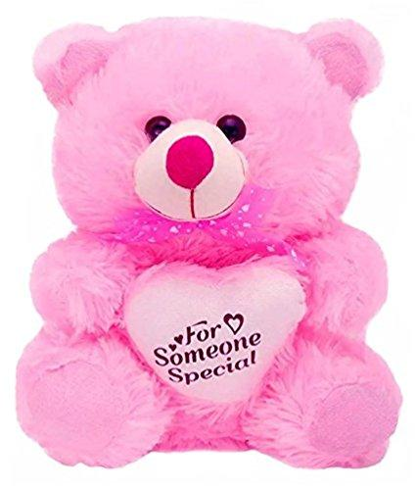









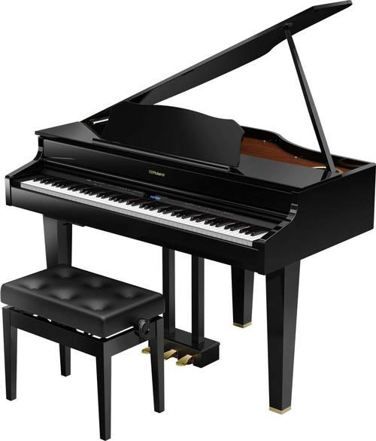

.................................................... ..............................................................
.................................................... ..............................................................
.................................................... ..............................................................
.................................................... ..............................................................
.................................................... ..............................................................
2. Complete each phrase with a suitable verb
Invite have go to take join
1. _______________ part in 4.________________the funfair
2._______________someone to 5. _____________fun
3. _______________ ________________ the zoo.
3. Look at the picture and complete each phrase
  1........................... | 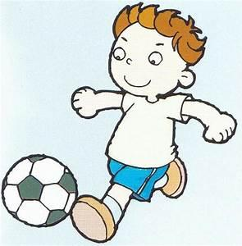  2............................ | 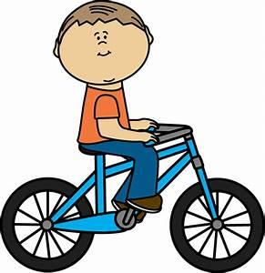  3............................ |   4...................................
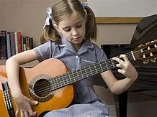  5............................ | 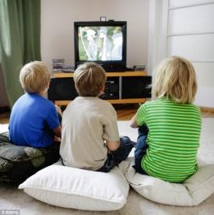  6.............................. | 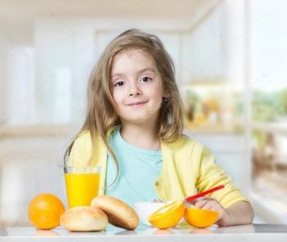  Giaoandethitienganh.info  7................................. |   8...............................
  9......................................... |  |   10..........................................
II. GRAMMAR
1. Make each question with each answer.
1. What did you invite to the birthday party? | A. Yes, of course
2. What did you do at the party? | B. No. On Thursday and Friday I go to school in the afternoon
3. Do you always go to school in the morning? | C. My classmates and some other friends
4. Did you invite Mai to your birthday party? | D. Tug of war ( trò kéo co)
5. What games did you play at the party? | E. We played games and enjoyed good food.

Your answer:
1........................2..........................3...........................4.......................5........................
2. Circle the correct answer.
1. Last night, I go/ went to Hoa’s birthday party.
2. We played many games and did/worked some sports, too.
3. Hoa invited all of her classmates to/ for her birthday party.
4. We played/ sang “Happy birthday” and danced, too.
5. We had lots of funny/ fun at the party last night.
5. Circle the redundant word then rewrite the correct sentence.
1. Did you go to the Lan’s party last week?
________________________________________________________________
2. Yesterday was my name little sister Nana’s birthday.
________________________________________________________________
3. I am going to invite all my friends to come my birthday party next week.
________________________________________________________________
4. I think yesterday was Hung’s party birthday.
________________________________________________________________
5. We played lots of many games and ate nice food.
________________________________________________________________
4. Write answer for the question.
1. Where did you go last week?
________________________________________________________________
2. Did Mina invite you to her birthday party?
________________________________________________________________

3. How did you get to your home town?
________________________________________________________________
4. Did you enjoy the party?
________________________________________________________________
5. What games did you play at the party?
________________________________________________________________
III. PHONICS
1. Mark the stress of the following words. The number 1 has been done for you as an example. Track 14.
1. Car’toon 2. Repeat 3. Garden 4. Complete
5. Birthday 6. Invite 7. Party 8. Notebook
2. Mark the stress of the underlined words then say the sentence aloud.
Track 15
1. Listen and repeat this sentence!
2. Do you like going to picnic?
3. There are lots of beautiful pictures in his room.
4. Did you invite Phong to your birthday party yesterday?
5. I have a new ruler and two notebooks.
PART III. SKILLS: LISTENING – SPEAKING – READING – WRITING
I. LISTENING
Listen and do the tasks followed. Track 16
1. Listen and decide if each statement is True ( T) or False (F)
Statements T/ F
1. Today is the birthday of Mary’s mother ______________________
2. Mary and her mother are going to buy something ______________________
such as sweet candles, etc.
3. Mary is going to have a new pair of shorts. ______________________
4. There is going to be a round cake at home. ______________________
5. Mary’s father is decorating the sitting room. ______________________
2. Listen again and complete the text.
MARY’S BIRTHDAY
Today is Mary’s birthday. She’s preparing for the (1)__________________________ with her mother. They are going to buy sweets, (2) _______________________ candles and a roll of film for Mary’s camera. They’re also going to buy a new (3) ______________________ for Mary.
At home, Mary’s mother is making a big round cake, some (4) _________________ and orange juice. Mary is calling her friends to invite them to the party. Her father is also busy. He’s decorating the living room with (5) ______________ and flowers.
II. SPEAKING
Complete the conversation with available sentences. Then practice it with your friend.
- What present did you give him
- After that, we enjoyed the food and drink
- So, what did you and Hoang do at the party
- It was October 5th
- He gave Hoang a dictionary
Quynh: What was the date yesterday?
Nana: (1) __________________________. It was Hoang’s birthday
Quynh: Really? Oh, I missed it. So, did you go to the party?
Nana: Yes, I did.
Quynh: (2) ________________________?
Nana: I gave him a new book of Maganet Mitchell.
Quynh: That was great. And did Tung go to the party, too?
Nana: Of course! (3) __________________________
Quynh: That was great. (4) ______________________?
Nana: Well, Hoang made a wish, we sang Happy birthday to him, then be blew out the candles. (5) __________________________________
Quynh: It was fantastic.

III. READING
Read and do the tasks followed
CHRISTINA’S BIRTHDAY PARTY
Last week, I had a birthday party at home. My parents and I prepared for this day. I invited my friends and relatives to the party. My father and I went to the shop to buy some things for the party. My mother stayed at home. She cleaned the flat, made cakes and set the table.
At four o’clock, my relatives came to my house. I was very happy to see them. They brought me lots of nice presents. Then we enjoyed food, danced and sang together. After that, we told stories and funny jokes. It was a happy day.
1. Read and decided if each statement is True (T) or False (F)
Statements T/ F
1. Christina had a birthday party in a hotel ______________________
2. Her mother cleaned the flat, made cakes and set the table ______________________
3. Christina was happy to see her friends and relatives ______________________
4. They didn’t bring her any gifts ______________________
5. They told stories and funny jokes. ______________________
2. Read and answer the question
Giaoandethitienganh.info

1. What did Christina do to prepare for the birthday party?
....................................................................................................................................
2. Did Christina’s mother stay at home and prepare the cake?
....................................................................................................................................
3. What time did Christina’s friends and relatives come?
....................................................................................................................................
4. Did her friends and relatives bring presents?
....................................................................................................................................
5. Was Christina happy at the party?
....................................................................................................................................
IV. WRITING
1. Write question for the underlined part.
1. Long had a birthday party yesterday.
....................................................................................................................................
2. We had nice food and drink at the party.
....................................................................................................................................
3. My birthday is on the second of October.
....................................................................................................................................
4. The party began at eight p.m last night.
....................................................................................................................................
5. The party was so wonderful
....................................................................................................................................
2. Write sentences basing on available words. The first one has been done for you as an example.
0. Nam’s birthday party/ played hide and seek.
Did you go to Nam’s birthday party?
Yes, we did
What did you do at his party?
We played hide and seek.
1. Jame’s birthday party/ enjoyed food and drink
....................................................................................................................................
....................................................................................................................................
....................................................................................................................................
....................................................................................................................................
2.Your friend Mai Ngan’s birthday party/ sang and danced
....................................................................................................................................
....................................................................................................................................
....................................................................................................................................
....................................................................................................................................
3. His sister’s birthday party/ sang the song “ Happy birthday”
....................................................................................................................................
....................................................................................................................................
....................................................................................................................................
....................................................................................................................................
4. Minh Trang’s birthday party/ ate good food
....................................................................................................................................
....................................................................................................................................
....................................................................................................................................
....................................................................................................................................
5. Julia’s birthday party/ played some games.
....................................................................................................................................
....................................................................................................................................
....................................................................................................................................
....................................................................................................................................

