Exercise 1 Look and write
tree | sweets | sheep | bee

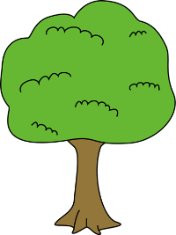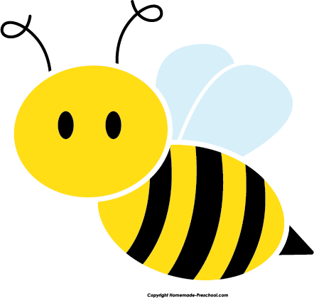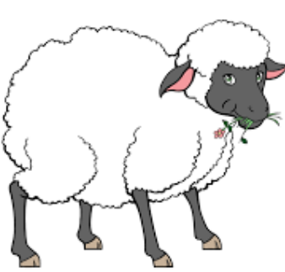

Exercise 2 Read and match
a) I can draw a sheep. |  | 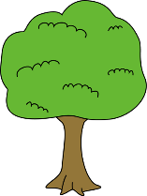
b) I can draw a tree.
c) There are sweets in the bowl.
d) These are my feet.
e) I can draw a bee. |  | 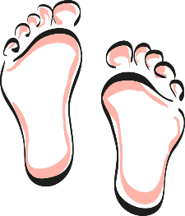
Exercise 3 Look , read and write
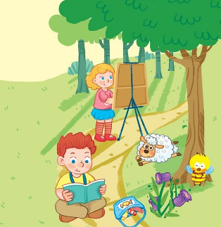 | a) Where is the bee ?  The bee is near the ……………  b) Where is the sheep ?  The sheep is …………the grass.  c) Where are the sweets ?  The sweets are in the ……………  d) The boy is ……………book.
Exercise 4 Put the words in the correct order
a) bee – I – draw – can - a | b) I – can – a – draw - tree | c) sheep – can – a – I - draw
……………………………………….. | …………………………………….. | …………………………………….
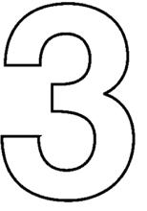
d) three – It – is - number | c) I – sweets - like | d) These – feet – my - are
……………………………………….. | …………………………………….. | ……………………………………..
Exercise 5 Look and circle the best answer
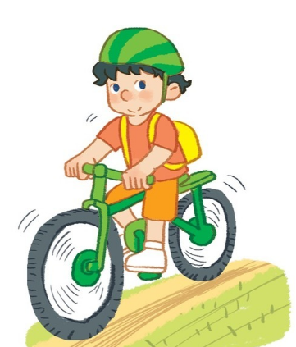
0.There’s a …… by the river. 1. He’s riding a ……….
a. house b. garden c. gate a. car b. scooter c. bike
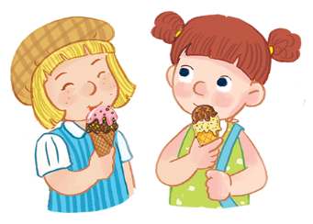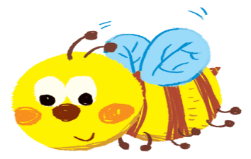
2.They are having………. 3. I can draw a ……….
a. peaches b. ice cream c. chips a. bee b. sheep c. cat
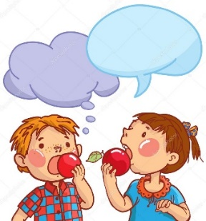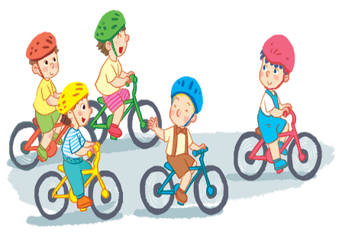
4. They are having………. 5. Five ………. are riding bikes.
a. apples b. peaches c. sweets a. boys b. girls c. women
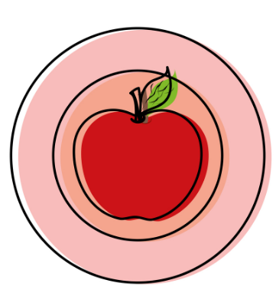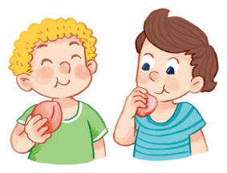
6. The apple is on the ………. 7. ……….are having peaches.
a. table b. plate c. bowl a. he b. she c. they
Exercise 6 Look and tick ()
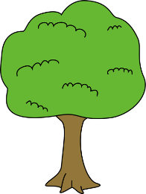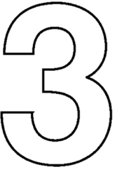
a) I can see a bee. a) I can draw a sheep. a) It’s number five.
b) I can see a tree. b) I can draw a deer. b) It’s number three.
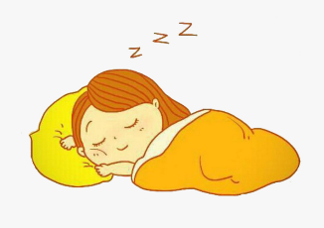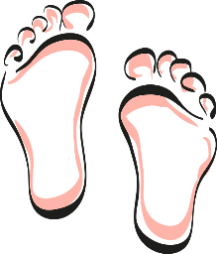
a) She’s sleeping. a) I like peaches. a) These are my feet.
b) She’s singing. b) I like sweets. b) This is my head.
Exercise 7 Find the word which has a different sound in the part underlined
a) tree | b) bee | c) sweets | d) head
a) egg | b) green | c) feet | d) three
a) bread | b) see | c) tree | d) queen
a) ice cream | b) teacher | c) read | d) bear
a) lake | b) face | c) cake | d) peach
a) kite | b) nine | c) fish | d) bike
a) egg | b) hen | c) bed | d) tree
a) hat | b) bag | c) read | d) apple
a) hot | b) honey | c) box | d) mop

