Name: ...............................................TEST Date: Friday, December 15, 2017
Class:4^{A1} Mrs. Dung Phone: 01664.409.436
Question 1.Listen and tick
1.
a.  b.  c. 

2.
a. . b.  c.

3.
a.  b.  c.


Question 2.Listen and number
a. b. 
c.  d.
Question 3: Listen and match
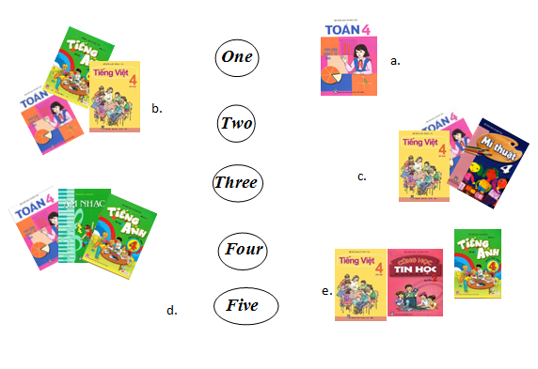

Question 4 : Listen and circle. (1 pt)
1. a. I’m very well. b. I’m fine. c. I’m well.
2. a. English b. Japanese c. Vietnamese
3. a. Monday b. Tuesday c. Sunday
4. a. Nguyen Trai Street b. Nguyen Hue Street c. Nguyen Du Street
5. a. reading b. swimming c. cooking
Question 5: Listen and complete (1pt)
Peter: What (1) ___ is it today, Tom?
Tom: It’s Monday
Peter: Do you have (2) ________ today?
Tom: Yes, I do.
Peter: What (3) ________ do you have today?
Tom: I have Vietnamese, Maths and (4) ________.
Peter: Oh, we’re (5) ________ for school!
Tom: Let’s run
Part II/ Reading and Writing (15 minutes)
Question 6 : Read and complete (1pt)
My name is Nga. I go to school from Monday to Friday. I have Vietnamese and Maths every day. I have English on Mondays, Tuesdays, Thursdays and Fridays. On Wednesdays and Thursdays, I have Science. I have PE on Mondays and Wednesdays. I have Music on Tuesdays and Art on Friday.

Timetable
Monday | Tuesday | Wednesday | Thursday | Friday
 |  | Vietnamese | Vietnamese
Maths | Maths |  |  | Maths
English |  | Science | English
 | Music |  |  | English
Question 8: Look at the pictures and the letters. Write the right words (1 pt)
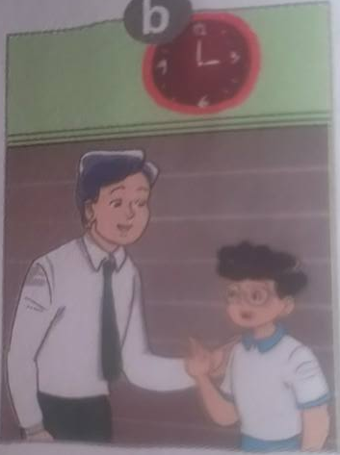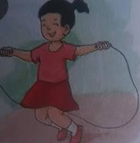
She is from J_ _ _ _ Good _ _ _ _ _ __ She can _ _ _ _ She like _ _ _ _
Question 8 : Look and read. Put a tick ( ) or cross (X) in the box(1pt)
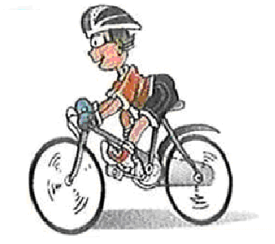He can dancing
It’s on the sixteen of October

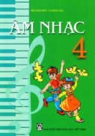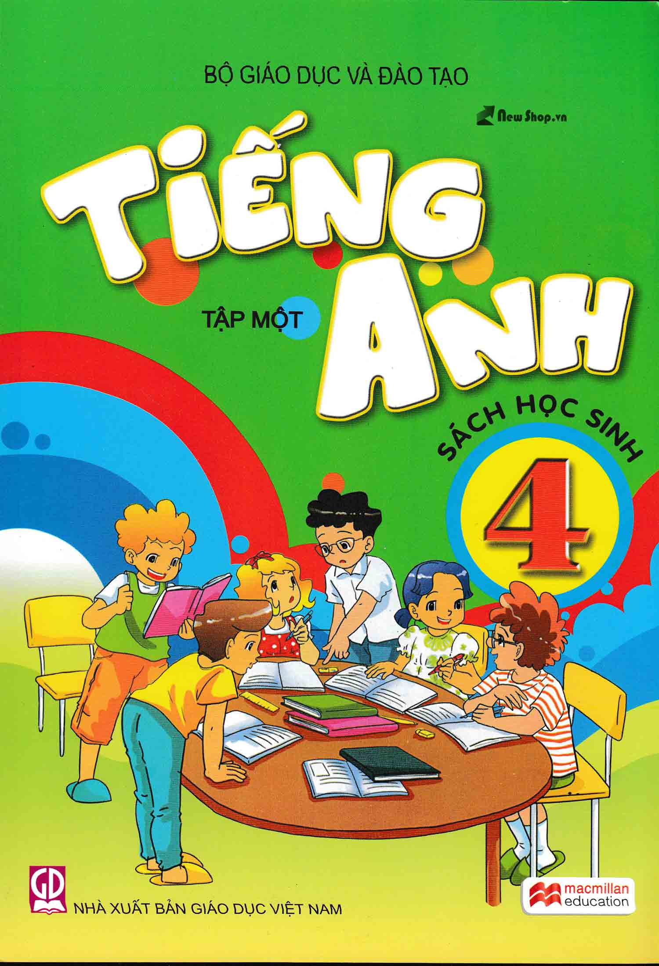 I have Maths, Vietnamese and Music

 I am from England
Question 9 : Reorder the words(1pt)
1. is/birthday /when/ your _____________________________________
2. what/doing/she/is _____________________________________
3. subjects/do/have/what/today/you _____________________________________
4. I/Australia/from/ am _____________________________________
5./piano/I/played/the/yesterday _____________________________________
6. are/you/where/from _____________________________________
7./am/play/guitar/I/the _____________________________________
8. meet/to/you/nice _____________________________________
9. swim/you/can _____________________________________
10. class/4B/am/I/in _____________________________________
PART III : SPEAKING (5 minutes)
Question 10.
1. Listen and repeat | 2. Point, ask and answer
3. Listen and comment | 4. Interview

----------The end----------

