ĐỀ THI GIỮA HỌC KÌ 1 LỚP 3 SỐ 1
Full name:…………………………
Class: 3
I. Circle the correct answer.
1/ Hello, my ………………… is Linda.
A. name
B. is
C. I am
2/ What is ………………. name?
A. you
B. my
C. your
3/ How do you …………………. your name?
A. what
B. is
C. spell
4/ …………………. that Phong? - Yes, it is.
A. Who
B. is
C. are .
5/ Sit ………… , please.
A up
B. down
C. at.
6/ ………………. are you? I’m nine years old .
A. How
B. How old
C. What
7/ I’m fine, …………….
A. thank
B. thanks you
C. thanks
8/ They are my ……………..
A. friend
B. friends
C. teacher
9/ Linda is my ……………..
A. friend
B. friends
C. brother
10/ ………….. , it is.
A. No
B. Yes
C. Thanks
II. Circle the odd one out.
1. A. Peter B. name C. Mai D. Mary
2. A. hi B. hello C. spell D. good morning
3. A. that B. what C. who D. how
4. A. he B. she C. you D. my
III. Read and match.
Example 0. How old are you? | a. My name’s Linda
1. Hello. I’m Mai | b. My name’s Quan. Nice to meet you too.
2. What’s your name? | c. It’s Miss Hien
3. My name’s Linda. Nice to meet you. | d. I’m ten years old
4. Who’s that? | e. Hi, Mai. I’m Peter.
Answers:
0 - d | 1 - ...... | 2 - ...... | 3 - ..... | 4 - .....
IV. Reorder the words to make a meaningful sentences.
1. friend./ This/ my/ is/ new
- ……………………………………………………………………………
2. thank/ I/ you./ am/ fine/ ,
- ……………………………………………………………………………
3. that/ Nam/ Is/ ?
- ……………………………………………………………………………
4. Peter/ are/ They/ Linda/ and
- ……………………………………………………………………………
V. Put the words in order. Then read aloud.
1. That/ Mai./ is
2. You?/ old/ how/ are
3. nine/ old./ I’m/ years
4. Mai?/ how/ is/ old
VI. Read and complete sentences with old, that, no, are.
1. A: Is that Linda?
B: (1) ....................................., it isn’t.
A: Who’s (2) .....................................?
B: It’s Mary.
2. A: How old (3) ..................................... you?
B: I’m ten years (4) ..................................... .

ĐỀ KIỂM TRA GIỮA HỌC KỲ I SỐ 2
I. Odd one out.
1 | A. my | B. her | C. he | D. his
2 | A. hello | B. how | C. what | D. who
3 | A. nine | B. fine | C. six | D. eight
4 | A. are | B. am | C. you | D. is
5 | A. Bye | B. Hello | C. Goodbye | D. Good night
6 | A. boy | B. girl | C. teacher | D. school
7 | A. how | B. is | C. what | D. how old
8 | A. Hello | B. Bye | C. Hi | D.Good morning
9 | A. I | B. she | C. they | D. his
10 | A. Tony | B. Linda | C. Mary | D. friends

II. Choose the correct answer.
1. Is that Linda? – No, it__________
A. is B. not C. isn't D. are
2. Are they your friends? – Yes, they ______
A. are B. aren't C. am D. is
3. How do you spell________name? – C-U-O-N-G
A. you B. they C. your D. he
4. Pleased to ___________you.
A. it B. old C. meet D. this
5. How old are you? – I'm ________ years old.
A. fine B. nine C. friend D. nice
6. Tony and Linda are my ___________
A. friend B. name C. these D. friends
7. She _________________ my friend.
A. Am B. is C. are D. it
8. ___________________________? – It's Nga.
A. Who are they? B. How are you?
C. Who's that? D. How old are you?
9. Peter and Quan are my _________________.
A. friend B. friends C. best friend D. name
10. That ______________is Linda.
A. boy B. boys C. girl D. girls
III. Read and complete.
Thanks | Who | name’s | this | name | you | friend
Nam: Hello, Mai.
Mai: Hi, Nam. How are (1)..............?
Nam: I'm fine, (2).................. And you?
Mai: I'm fine, too. Thank you.
Nam: (3).............. is Tony.
Mai: Hi, Tony. How do you spell your (4).............?
Tony: T-O-N-Y.
Mai: (5)...................'s that?
Tony: It's my (6).............. Her (7).................. Linda.
IV. Reorder the words.
1. spell / how/ his/ name/ do /you?
...............................................................................................................
2. That/ my / is / teacher.
...............................................................................................................
3. your/ is/ friend / Nam?
...............................................................................................................
4. name/ what/ is / her /?
...............................................................................................................
5. your/ are / they / friends?
...............................................................................................................
V. Make the questions.
1. My name's Jack.
..............................................................................................................?
2. I am not well.
..............................................................................................................?
3. His name's Peter.
..............................................................................................................?
4. It's my friend, Quan.
..............................................................................................................?

5. She is seventeen years old.
..............................................................................................................?
6. Her name's Nga.
..............................................................................................................?
7. No, they aren't. They aren't my friends.
..............................................................................................................?
8. No, it isn't. It's Linda.
..............................................................................................................?
VI. Read and do the tasks.
Hello. My name is Nam. I'm eight years old. I'm in class 3A. I am a pupil at Nguyen Trai primary school. This is my best friend Mai. She is eight years old too. They are Peter and Linda. Peter is seven and Linda is nine. They're my friend too.
A. TICK TRUE (T) OR FALSE (F)
0. He is Nam.
1. Nam is eight years old.
2. His best friend is Linda.
3. Linda is ten years old.
4. Peter is nine years old.
5. Peter and Linda are Nam's friend.

B. ANSWER THE QUESTIONS
1. How old is Nam?
...............................................................................................................
2. What class is Nam in?
................................................................................................................
3. How old is Mai?
................................................................................................................
4. Are Peter and Linda his friends?
................................................................................................................
5. How old is Linda?
................................................................................................................

ĐỀ KIỂM TRA GIỮA KỲ I SỐ 3

I. Chọn và khoanh tròn từ khác loại với những từ còn lại
1 | A. you | B. father | C. mother
2 | A. old | B. nice | C. ten
3 | A. his | B. she | C. he
4 | A. how | B. who | C. too

II. Nối các câu hỏi ở cột A với các câu trả lời ở cột B.
A | B
1. What’s your name? | a. I’m fine, thank you.
2. May I go out? | b. My name’s Hue.
3. How are you? | c. Nice to meet you, too
4. Nice to meet you | d. Sure

Đáp án:
1 - | 2 - | 3 - | 4 -

III. Đọc và nối.
1. Nam: This is my school
Mai: What’s its name?
Nam: It’s Kim Đồng School
Mai: Oh, it’s big

A

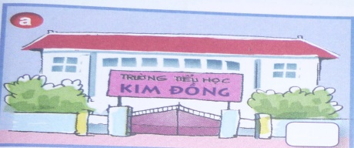
2. Alan: Look. This is my eraser
Li Li: Is it big?
Alan: No, it isn’t. It’s small

B

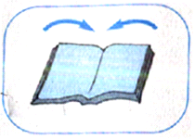
3. This is my library.
It’s big
C

4. Close your book, please
D
Đáp án:
1 - | 2 - | 3 - | 4 -

IV. Sắp xếp lại các từ để tạo thành câu đúng.
1. name / is / Lily / My /. /
___________________________________________________________________
2. your / please / book / Open / , /
___________________________________________________________________
3. in / May / out / I / ? /
___________________________________________________________________
4. This / school / my / is / . /
___________________________________________________________________

V. Nhìn vào tranh và viết các từ thích hợp.

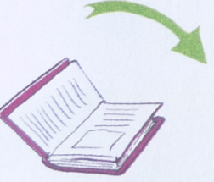 | 1.…………...your book, please.
 | 2. They are my ………………
 | 3. A: Is your………… big ?  B: Yes, it is.
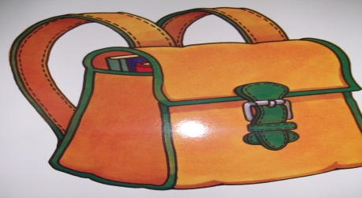 | 4. This is a ……………..

ĐỀ KIỂM TRA GIỮA KỲ I SỐ 4
I. VIẾT TIẾNG ANH CHO CÁC SỐ SAU
- 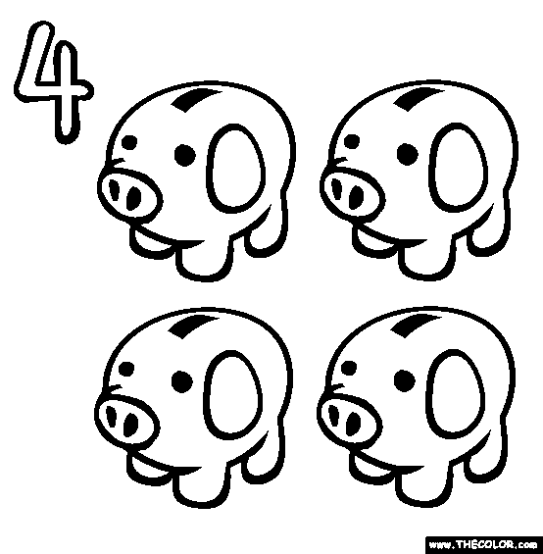

- 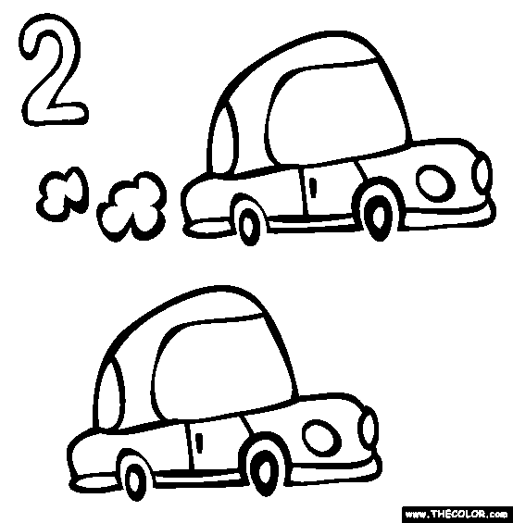

- 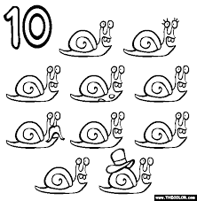

- 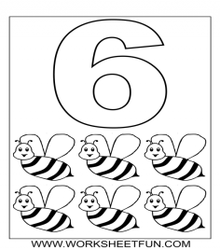

- 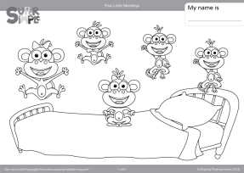

II. ĐIỀN CHỮ CÁI CÒN THIẾU VÀ VIẾT TIẾNG VIỆT
- H__L__ __: _________________________________
- G__ __D__Y__: _____________________________
- __IN__: ____________________________________
- H__ __ OL__: _______________________________
- N__ C__: ___________________________________
III. SẮP XẾP LẠI CÁC CHỮ CÁI SAU
- SEY: _________________________________________________
- LUBE: _______________________________________________
- XSI: _________________________________________________
- THERFA: _____________________________________________
- ESE: _________________________________________________

IV. ĐIỀN TỪ CÒN THIẾU
- Hello. __________ Phong. What __________ your __________?
- Hi, Phong. __________ name __________ Nga. Nice __________ __________ you.
- How __________ you __________ __________ name?
- __________ N – G – A, Nga.

V. TRẢ LỜI CÂU HỎI
- How do you spell your name?
______________________________________________________
- How old are you?
______________________________________________________
- Is this Luna? (Yes)
______________________________________________________
- Is that your mother? (No)
______________________________________________________
- Who is that? (friend, Huong)
______________________________________________________

ĐỀ KIỂM TRA GIỮA KỲ I SỐ 5
I. VIẾT TIẾNG ANH CHO CÁC SỐ SAU

- 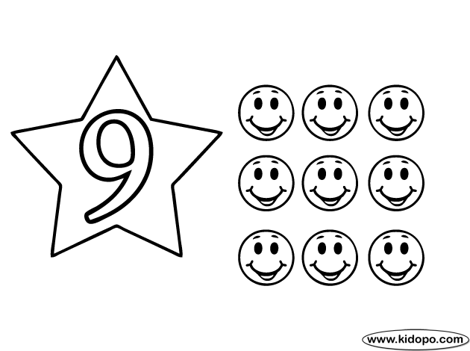

- 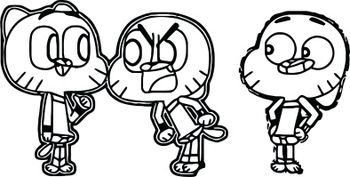

- 

- 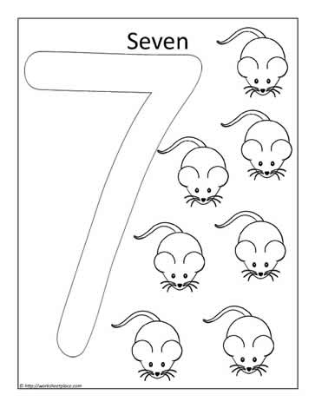

- 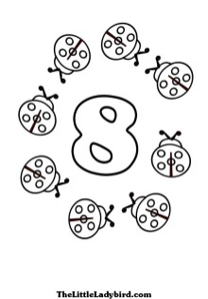

II. ĐIỀN CHỮ CÁI CÒN THIẾU VÀ VIẾT NGHĨA TIẾNG VIỆT
- A__D Y__ __: _______________________________
- G__A__DM__ __HE__: _______________________
- G__EE__: __________________________________
- F__I__ __D: ________________________________

III. SẮP XẾP LẠI CÁC CHỮ CÁI SAU
- VELTWE: ____________________________________________
- HETY: _______________________________________________
- HATT: _______________________________________________
- PELSL: _______________________________________________

IV. ĐIỀN TỪ CÒN THIẾU
- __________ are you? - __________ very well, __________.
- __________ is that? - __________ my friend, Long.
- Hello, Long. __________ to meet __________.
- How __________ __________ you, Long?
- I’m seven __________ __________.
- Are __________ your __________? – Yes, __________ ________.

V. TRẢ LỜI CÂU HỎI
- How do you spell your name?
______________________________________________________
- How old are you?
______________________________________________________
- Is this Luna? (Yes)
______________________________________________________
- Is that your mother? (No)
______________________________________________________
- Who is that? (friend, Huong)
______________________________________________________
- Are they your friends? (No)
______________________________________________________

ĐỀ KIỂM TRA HỌC KỲ I SỐ 1
I. Khoanh tròn từ khác loại
1. One Book Eraser Map
2. Circle Star Waste basket Diamond
3. Yellow Purple Ruler Orange
4. Desk Chair Globe Red
5. Crayon Board Fine Poster
6. Fine Green Great Ok
II. Gạch chân những chỗ sai rồi sửa lại
- How is you? I’m fine
__________________________
- What is you name?
_____________________
- It is an pencil
_______________________
- How are your?
________________________
- What are this?
________________________

III. Viết câu bằng tiếng anh
- Bạn tên là gì?:
- Tôi tên là Nam:
- Bạn có khỏe không?:
- Đây có phải là cục tẩy không?:
- Nó là cái bút chì:
IV. Hoàn thành đoạn hội thoại sau
you How fine thanks Hi

A: Hello, Hanh. (1) ………………are you?
B: (2) .…………, Huong.
I’m (3).…………, thanks.
B: How about (4) ………………?
A: I’m fine, (5) ………………
V. Trả lời câu hỏi sau dựa vào từ gợi ý trong ngoặc
- What’s your name? (Long)
………………………………………………………………
- What’s this? (a bag)
………………………………………………………………
- Is this a book? (yes)
……………………………………………………………..
- Is this a pencil? (No)
…………………………………………………………….

ĐỀ KIỂM TRA HỌC KỲ I SỐ 2
I. Find the odd one out.
1. A. how | B. what | C. Peter
2. A. my | B. name | C. your
3. A. Linda | B. meet | C. Tony
4. A. am | B. is | C. spell
5. A. how | B. hello | C. hi
II. Reorder the words to make correct sentences.
1. my/ is/ name/ Nam./
____________________________________________
2. your/ what/ name/ is/ ?/
____________________________________________
3. later/ you/ Bye./ see/.
____________________________________________
4. you/ are/ how/ ?/
____________________________________________

5. am/ I / fine/ you/ thank/,/./
____________________________________________
6. do/ how/ spell/ name/ your/ ?/
____________________________________________
7. O-/ P-/ H-/ N-/ G-/.
____________________________________________
8. am/ I / in/ 3D/ class/./
____________________________________________
III. Match the sentence in column A with the correct response in column B.
A | B
1. What’s your name? | A. Bye. See you later.
2. How are you? | B. My name is Nga.
3. Goodbye. | C. I’m fine, thank you.
4. Hello, I am Linda. | D. Nice to meet you, too.
5. Nice to meet you. | E. Hi. I’m Quan.
6. How do you spell Tony? | F. T-O-N-Y
Your answer:
1. _________ 2. _________ 3. _________
4. _________ 5. _________ 6. _________

ĐỀ KIỂM TRA HỌC KỲ I SỐ 3
I. Reorder the letters to have the correct word then rewrite it.
WRONG WORD | CORRECT WORD
1. HLOSCO
2. RIBAYRL
3. AEMN
4. PELSL
5. THWA
6. ASSCL
7. AETK
8. ODG

II. Put the words in the correct order to make correct sentence.
1. is/ my/ This/ friend./ new/
________________________________________________
2. are/ How/ Linda?/ you,/
________________________________________________

3. is/ my/ This/ Miss Hien./ teacher,/
________________________________________________
4. spell/ do/ name?/ you/ How/ your/
_______________________________________________
III. Complete the sentence.
1. Is your school new? – _________ , it is.
2. Is your classroom large? - No, _________.
3. This _________ my school.
4. The gym _________ old.

ĐỀ KIỂM TRA HỌC KỲ I SỐ 4
I. Chọn từ khác loại
1. | name | she | he | they
2. | classroom | library | it | book
3. | small | It’s | big | new
4. | book | that | pen | pencil
5. | my | your | brother | his
II. Chọn đáp án đúng
1. How _________ you?
A. am | B. is | C. are | D. it
2. Good bye. _________ you later.
A. What | B. See | C. How | D. Are
3. ____________ it a pen?
A. Is | B. See | C. Am | D. Bye
4. It is ___________ table.
A. is | B. a | C. an | D. you
5. __________. I am Linda
A. Hello | B. Bye | C. It | D. You

6. How _________ she?
A. am | B. is | C. are | D. it
7. Hello. Nice to ______ you.
A. what | B. see | C. how | D. are
8. It ________ a dog.
A. is | B. see | C. am | D. not
9. It is ___________ apple.
A. is | B. an | C. a | D. she
10. __________. I am Linda.
A. Hi | B. Fine | C. Yes | D. No

III. Sắp xếp những từ dưới đây thành câu hoàn chỉnh.
1. name’s / Ricky/ my.
___________________________________
2. I’m/ ,thank/ you/ fine.
___________________________________
3. your/ please/ book/ open.
___________________________________
4. in/ may/ out/ I/ ?
___________________________________
5. this/ school/ my/ is.
___________________________________

ĐỀ KIỂM TRA HỌC KỲ I SỐ 5
I. Khoanh tròn chữ cái a, b hoặc c trước câu trả lời đúng nhất
1. Hello, My ______ is Linda.
a. name b. is c. I am
2. What is ______ name?
a. name b. my c. your
3. Nó là một cây bút chì.
a. It's a pen. b. It's a pencil. c. It's a rubber.
4. How do you ______ your name?
a. what b. is c. spell
5. ______ this a library? - Yes, it is.
a. Is b. who c. What
6. What is this?

a. It's a book. b. It's a computer. c. It's a ruler.
7. Is this a school bag?

a. No. b. Yes, it is. c. it is not
8. Sắp xếp từ theo trật tự đúng: Queen priryma soochl.
a. Queen primary school b. Primary Queen c. school Queen
II. Thêm vào một chữ cái để tạo thành một từ hoàn chỉnh.
a. comp_ter b. Li_rary
c. _encil d. fr_end
III. Nối những từ tiếng Việt ở cột A phù hợp với những từ tiếng anh tươn ứng với chúng ở cột B.
A | B
1) cây viết mực | a/ apple
2) quả táo | b/ pencil
3) cây viết chì | c/ pen
4) đồ chuốt viết chì | d/ School bag
5) cái cặp | e/ rubber
6) cây thước kẻ | f/ book
7) cục tẩy | g/ Pencil sharpener
8) quyển sách | h/ ruler
Đáp án:
1 - | 2 - | 3 - | 4 -
5 - | 6 - | 7 - | 8 -

IV. Sắp xếp các từ thành câu hoàn chỉnh.
1. fine./ Thank/ I/ you/ am.
=> _______________________________
2. do/ spell/ name/ how/ your/ you?
=> _______________________________
3. Mai/ am/ I/ .
=> _______________________________
4. are/ How/ you /?
=> _______________________________
V. Trả lời câu hỏi về bản thân em.
1. What's your name?
_______________________________
2. How are you?
_______________________________

