ĐỀ KIỂM TRA GIỮA KỲ TIẾNG ANH LỚP 3 SỐ 1

I. Odd one out.
1 | A. she | B. he | C. jump
2 | A. bedroom | B. sister | C. brother
3 | A. ground | B. run | C. swim
4 | A. doll | B. garden | C. teddy bear
5 | A. cleaning | B. climbing | C. children

II. Complete the sentences.
seventy – coat – grandfather – cupboards - wardrobe

- Who’s that man?
- He’s my _________________________.
- That’s my grandmother.
- How old is she?
- She’s ____________________________.
- Is there a _________________?
- No, there isn’t.
- Where is my _________________, Mum?
- I don’t know, dear. Look in your schoolbag.
- How many _____________ are there?
- There are two.

III. Look and read. Put a tick (√) or a cross (x).
1. My brother is nine years old. | 
2. Is there a kite? - Yes, there is | 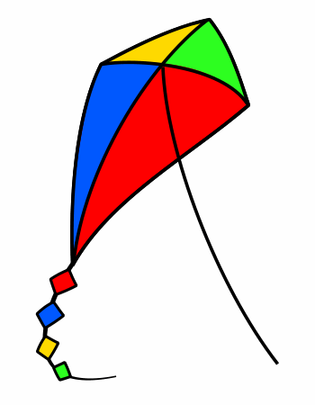
3. The picture is under the table. | 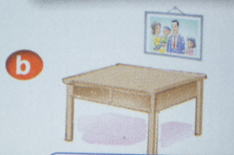
4. There are four cups. | 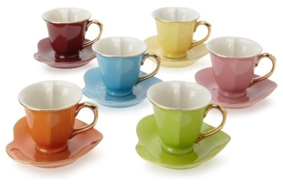

IV. Choose the correct words or phrases to complete the sentences.
1. ................. two apples on the table.
A. There is | B. There are
2. ................. is your father? – He’s 45.
A. How old | B. How
3. Peter .......... a puzzle.
A. has | B. have
4. This is my new friend. His name ........ David.
A. am | B. is
5. The picture is ........ the wall.
A. on | B. in
6. Nice to ....... you.
A. meet B. say

V. Complete the text.

  house | 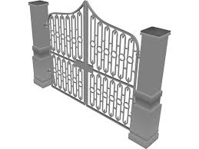  gate | 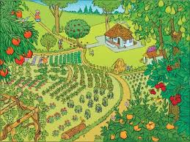  garden |   pond | 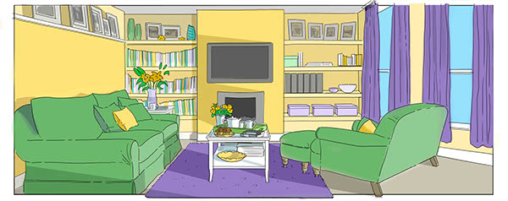living room

Hi, my name is Nga. This is my (1) ______________. It is large. The (2) __________ of the house is brown. There is a beautiful (3) _________________ in front of the house. And there is a small (4) ________________ in the garden. You can see the (5) ________________________ in the house. It is quite big.

VI. Put the words in the right order.
1. this/ ?/ Who/ is/ - my/ ./ This/ sister / is/
____________________________________________________________
2. is/ ./ This/ house/ my/ - is/./ dining/ a/ room/ There/
____________________________________________________________
3. the/ ?/ is/ Where/ poster/ - on/ ./ It’s/ wall/ the/
____________________________________________________________
4. many/ ?/ there/ fans/ How/ are/ - six/./ There/ are/
____________________________________________________________
5. a/ ?/ have/ Do/ car / you/ - I / ,/ No/ ./ don’t/
____________________________________________________________

ĐỀ KIỂM TRA GIỮA KỲ TIẾNG ANH LỚP 3 SỐ 2

I. Odd one out.
1 | A. mother | B. teacher | C. father | D. brother
2 | A. family | B. father | C. mother | D. sister
3 | A. bathroom | B. house | C. kitchen | D. bedroom
4 | A. classroom | B. dining room | C. kitchen | D. living room
5 | A. pond | B. yard | C. fence | D. mirror

II. Read and match.
1. Who’s that? | a. Yes, there is one
2. Where’s the cat? | b. It is near the TV
3. Are there any tables in the kitchen? | c. No, there isn’t
4. Is there a pond in his garden? | d. Yes, he does
5. Does Alan have a robot? | e. That’s my mother

1 - ..... | 2 - ..... | 3 - ..... | 4 - ...... | 5 - .....

III. Choose the correct words to complete the sentences.
1. Be quiet, ..............
A. his | B. is | C. this | D. please
2. A: Is that ............ pen? – B: No, it is not.
A. you | B. your | C. my | D. me
3. There are six chairs ...... my living room
A. at | B. next | C. in | D. out of
4. Goodbye. See you ............
A. behind | B. later | C. before | D. morning
5. This is my .............. Her name is Mary.
A. sister | B. brother | C. father | D. grandfther

IV. Complete the paragraph.
bathroom | house | There | They | small | bedrooms

This is my (1) ________. It is big. There is a living room, a kitchen, three (2)__________ and a garden in it. There is a (3)_____________ inside each bedroom. This is my bedroom. It’s small. There is a bed, a desk, a chair, and a bookcase. (5)_________ is a big poster on the wall. Look! I have three balls. (6)_______ are under the bed.

V. Look at the picture and the letters. Write the words.

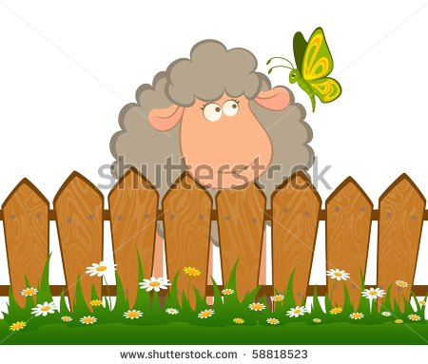  enfec____________________ | 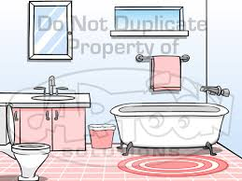  tboarmho _____________________
  eplan _______________________ | 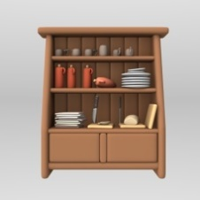  brpcadou _______________________

VI. Read the passage and write Yes or No.
This is my living room. There are many things in the room. There are three windows and a door. There is a table, six sofas and two chairs. There is a lamp on the table and a TV on the cupboard. There are two pictures, a fan and a clock on the wall.
 | Yes | No
1. This is the living room.
2. There are two windows.
3. There is a sofa.
4. The lamp is on the table.
5. The fan is above the wall.

ĐỀ KIỂM TRA GIỮA KỲ LỚP 3 SỐ 3

I. Look at pictures. Look at the letters. Write the words.
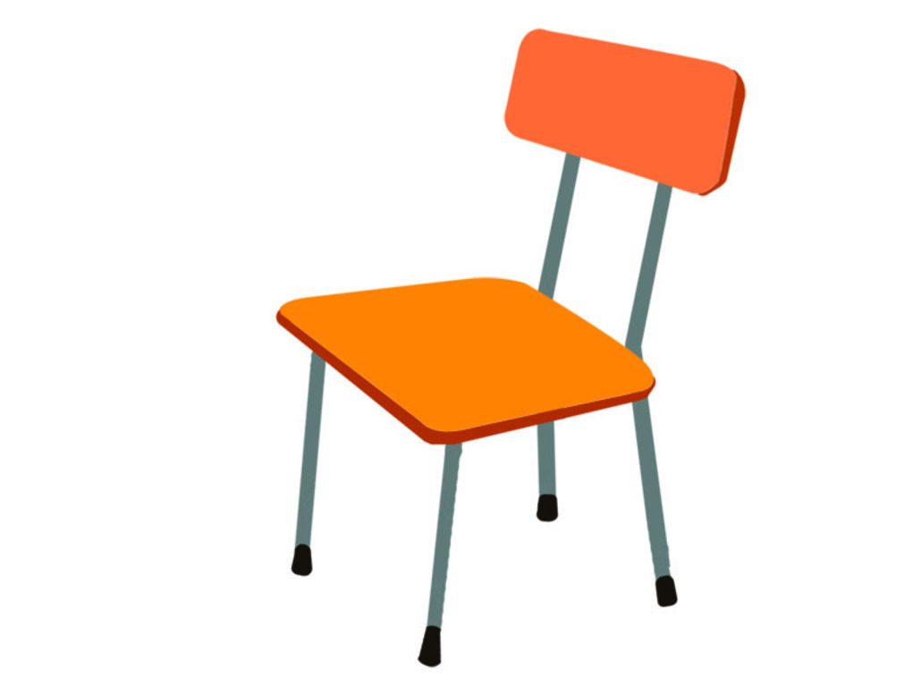 c a h i r  .....……………… |  b t o l o f a  …………………….
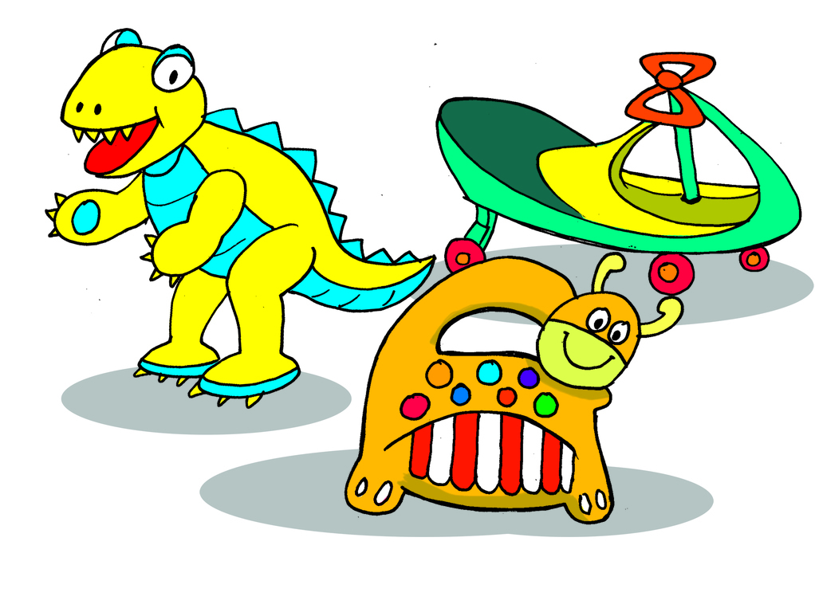  y o t s …………..........  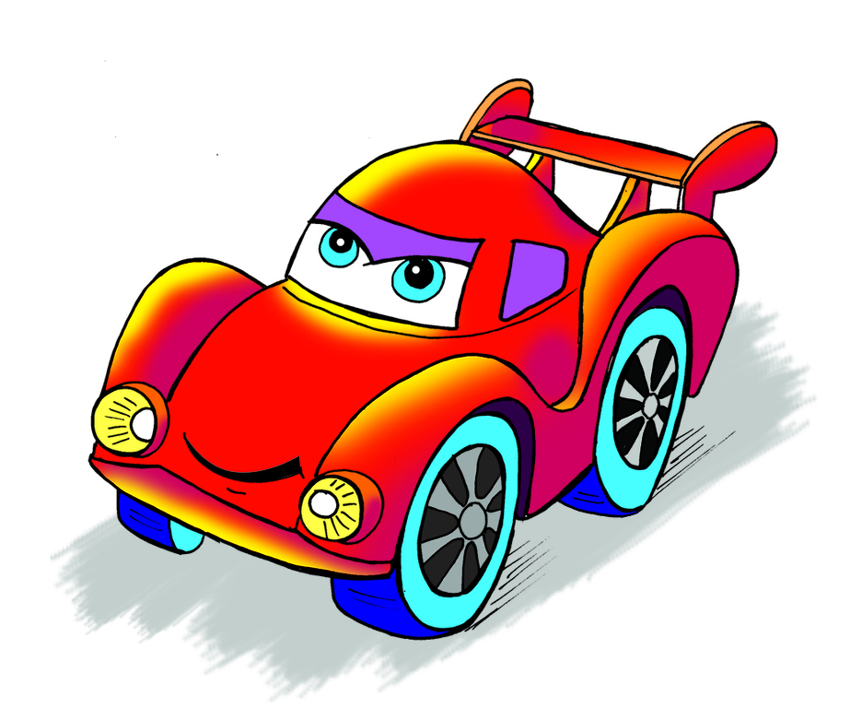  a r c ............................... | 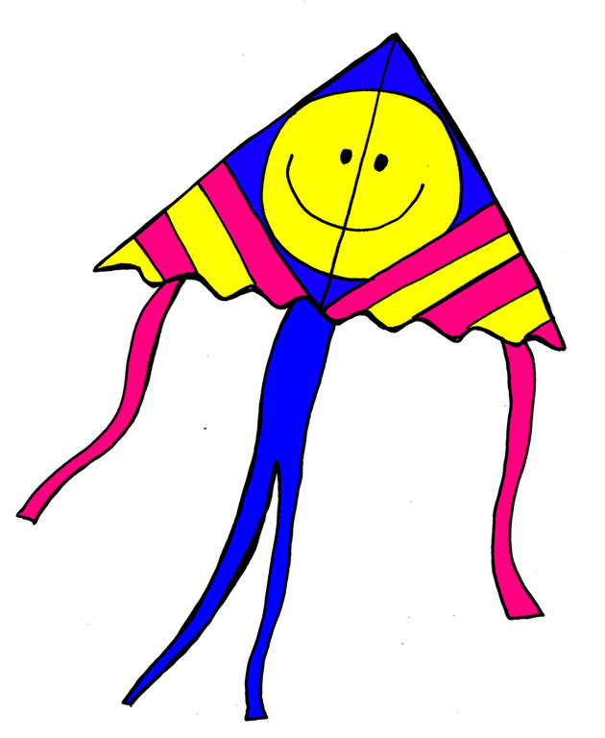  t i k e  …………………........  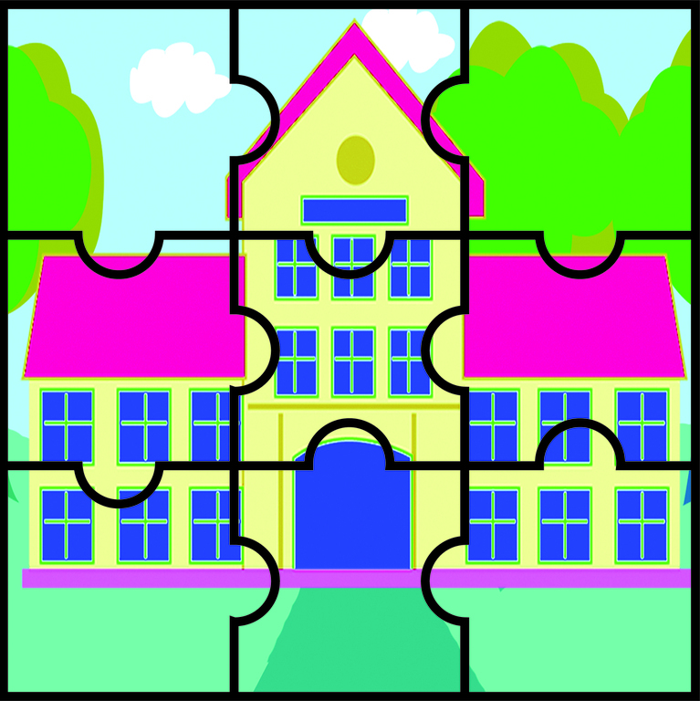  u z l z e p .................................
II. Odd one out.
1 | A. classroom | B. living room | C. dining room | D. kitchen
2 | A. pond | B. yard | C. schoolyard | D. fence
3 | A. behind | B. in | C.for | D. in front of
4 | A. poster | B. wall | C. picture | D. map
5 | A. chair | B. desk | C. room | D. table
III. Choose the correct answer
1. ……………is that man? - He is my father.
A. Who | B. What | C. He | D. His
2. My brother is twelve years ………
A. age | B. how | C. old | D. new
3. There ……..a garden in my house.
A. be | B. is | C. are | D. aren’t
4. There is a pond ……….. front of my house.
A. in | B. off | C. to | D. of
5. …… there a garden in your house?
A. Are | B. Is | C. What | D. Where
6. The gate ………. the house is blue.
A. of | B. for | C. to | D. in
7. ……… are my books? - They’re on the desk.
A. What | B. Where | C. When | D. How
8. There are two pictures ………..the wall.
A. in | B. above | C. on | D. to
9. There is a chair between the table……… the wardrobe.
A. and | B. in | C. on | D. or
10. How……….. chairs are there in the classroom?
A. old | B. much | C. many | D. long

IV. Matching each question to its right answer.
1. Are there any posters on the wall? | a. Yes, there are
2. Who’s that? | b. She is sixty years old
3. Do you have a robot? | c. That is my friend, Alan
4. How many beds are there in the bedroom? | d. There is just only one bed
5. How old is your grandmother? | e. No, I don’t
Answer:

V. Complete the dialogue.
room | two | many | near | wardrobe | any

Linda: Is there a mirror in the (0) room?
Mai: Yes. There is one. It’s (1) …………………….. the window.
Linda: What about pictures? How (2) …………………….. pictures are there?
Mai: There are (3) ………………… pictures.
Linda: Oh, I see. Are there (4) …………….. cupboards?
Mai: No, there are not. But there is a big (5) ……………………………. for my clothes.

VI. Read the passage and answer the following questions.
Hello. I’m Linh. I’m living with my family in Hanoi. Today is Sunday. Now, I am playing games in my bedroom. My mother is cooking in the kitchen. My sister is playing badminton in the garden. My father is reading a magazine in the living room.
1. What is her name?
………………………………………………………………………………………
2. Where is she living?
………………………………………………………………………………………

3. What’s she doing now?
………………………………………………………………………………………
4. What’s her mother doing?
………………………………………………………………………………………
5. Where’s her sister playing badminton?
………………………………………………………………………………………

ĐỀ KIỂM TRA GIỮA KỲ SỐ 4

I. Circle odd one out.
table
milkshake
pizza

noodles
- _______________________
seventeen
shelf
cabinet
bed
- _______________________
one hundred
eighty
drawer
forty
- _______________________
fifteen
noodles
thirteen
twenty
- _______________________
rug
blanket
pillow
twenty
- _______________________

II. Write T (true) or F (false).
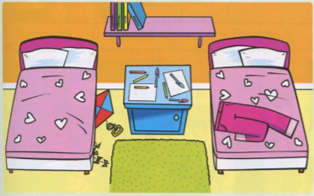
- There are three beds. ______
- There is a kite on the bed . ______
- There are books on the shelf. ______
- There are pants on the rug. . ______
- There are pens under the cabinet. . ______

III. Look and write.
This That These Those

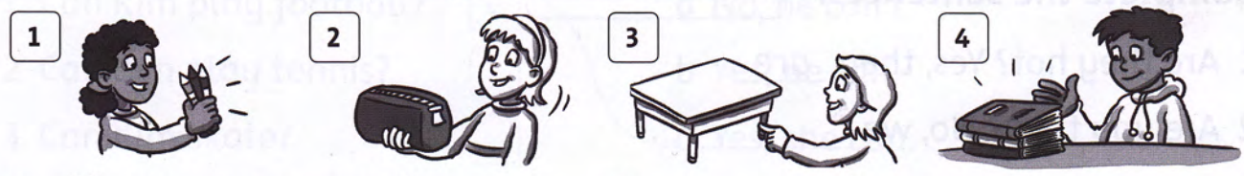

- __________ are my pencils.
- __________ is my pencil case.
- __________ is my table.
- __________ are my books.

IV. Choose the correct answer.
1. Are there any chairs in the room? - No, there …………….
A. are | B. is | C. aren’t | D. isn’t
2. ……….you have any toys?
A. Are | B. Do | C. Can | D. Does
3. Does your brother have a robot? - Yes, he ...........
A. does | B. has | C. are | D. have
4. My sister ………….a doll.
A. is | B. have | C. are | D. has

V. Read
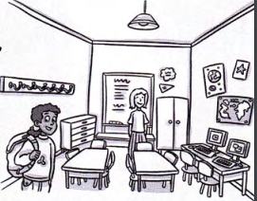
Hello! My name is Daisy. I’m eight. This is my classroom. There are three tables and eight chairs. That is my teacher, Miss Green. She is in front of the board. There are two computers in my class room. There are pictures in on the wall. There are four drawers. There are lots of coat hooks. My coat hook is blue. This is my bag, it is brown.

Circle the correct answer.

- How many tables are there? three / four
- How many chairs are there? nine / eight
- How many computers are there? three / two
- What color is Daisy’s coat hook? blue / brown

VI. Reorder the sentences

1. the / lamp/ There/ a /is / on / desk.

=> …………………………………………………

2. sister / Does/ doll?/ your/ have/ a

=> …………………………………………………

3. is / the / between / table / The/ chair / the / and/ wardrobe

=> ………………………………………………..

4. any / Are / chairs/ there / room? / the / in

=> …………………………………………………

ĐỀ KIỂM TRA LỚP 3 GIỮA KỲ SỐ 5
I. Rearrange the letters and write the complete words.
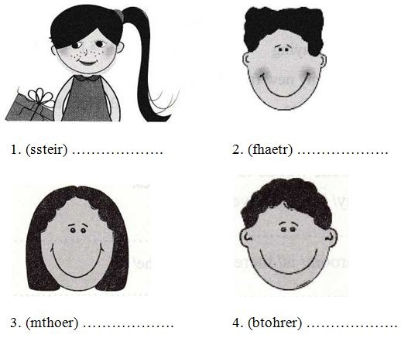
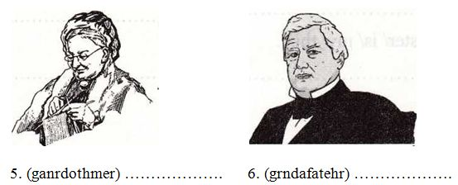

II. Choose the correct words or phrases to complete the sentences.
1. ………………. two apples on the table.
A. There is
B. There are
2………………. is your father? – He’s 45.
A. How old
B. How
3. Peter ………………. in the school yard.
A. are playing
B. is playing
4. This is my new friend ………………. is David.
A. His name
B. Her name
5. The picture is ………………. the wall.
A. in
B. on
III. Odd one out.
1.
A. skip | B. garden | C. skate

2.
A. bedroom | B. sister | C. brother

3.
A. she | B. he | C. jump

4.
A. cleaning | B. climbing | C. children

5.
A. ground | B. run | C. swim

IV. Match the suitable sentences together.
1. Which is your school? | A. Wow. It’s big.
2. How do you spell your name? | B. No, it isn’t
3. This is my school. | C. Yes, he is
4. Is this your friend? | D. This one
5. Is that boy new? | E. It is N-G-O-C

Answer:

V. Rearrange the words to make a correct sentence and
1. Thomas/ name’s/ His/.
=> …………………………………………………………………………………
2. old/ he/ How/ is/?
=> …………………………………………………………………………………
3. twenty/ He/ years/ old/ is/.
=> …………………………………………………………………………………
4. are/ two books/ There/ the table/ on/.
=> …………………………………………………………………………………

ĐỀ KIỂM TRA HỌC KỲ II SỐ 1
I. Read and complete.
near | playing | watching | reading | dog | living room

My family is in the (0) living room. My father is (1) __________ a book. My mother and I are (2) __________ TV. My sister is (3) __________ with her cat (4) __________ the TV. My (5) __________ is under the table.

II. Read and match.
1. Where’s Hue? | a. He’s cleaning the floor.
2. How many toys do you have? | b. Yes, I do.
3. What’s your brother doing? | c. I have three kites and two robots.
4. Do you have any goldfish? | d. A map and a picture.
5. What are those on the wall? | e. It’s in central Viet Nam.

Answer:
1 - | 2 - | 3 - | 4 - | 5 -

III. Put the words in the correct order.
1. for a go walk let’s | _______________________________.
2. let’s a book read | _______________________________!
3. doing are they what | _______________________________?
4. music is Nini to listening | _______________________________.
5. sunny is Hue it’s in today | _______________________________.
IV. Match the rhyming words.
1. cold | a. late
2. wait | b. know
3. walk | c. stay
4. play | d. old
5. hello | e. talk

Answer:
1 - | 2 - | 3 - | 4 - | 5 -

V. Read and write.
Chit: | Hello, Doris. How (1) ______ ?
Doris: | I’m (2) ________. Thank you. And you?
Chit: | Fine, thanks. Do you (3)_______ skating?
Doris: | Yes, (4)_______. Do you?
Chit: | No, (5)________.

ĐỀ KIỂM TRA HỌC KỲ II SỐ 2
I. Odd one out.
1 | A. globe | B. map | C. desk | D. these
2 | A. forty | B. thirteen | C. sixty | D. twenty
3 | A. sun | B. snowy | C. cloud | D. wind
4 | A. teddy bear | B. kite | C. cake | D. puzzle
5 | A. picture | B. pencils | C. notebooks | D. markers

II. Choose the correct answer.
1. What’s it? – It’s ........ inkpot.

A. an | B. a | C. some
2. How many ......... are there? – There is a desk.

A. desk | B. a desk | C. desks
3. The weather is ............. today.

A. cold | B. ok | C. too
4. ......... is Nam from? He’s from Haiphong.

A What | B. Who | C. Where
5. Who is he? – ....... is my friend.

A. He | B. I | C. She

III. Fill in the blanks.
1……. name is Peter.
2. My mother is thirty ……… old.
3. Mai is ……... Vietnam.
4. ………. you want a banana?
5. How many crayons ……. you have?

IV. Read and write.
Hi! My name is Nam. I have a lot of pets. This is my cat. It is on the bed. And that is my dog. It is there, under the table. I also have two parrots and a rabbit. They are all in the garden.
1. Nam has a lot of ________.
2. He has a _______. It is on the bed.
3. He has a ________. It is under the table.
4. He has two _______ and a _________. They are in the _________.
V. Reorder the sentences.
1. friend/ is/ my/ Hien/ new | ______________________________.
2. is/ that/ classroom/ her | _______________________________.
3. your/ write/ let’s/ name | _______________________________.
4. has/ two/ he/ rabbits | _______________________________.

ĐỀ KIỂM TRA HỌC KỲ II SỐ 3
I. Odd one out.
1 | A. classroom | B. teacher | C. library | D. school
2 | A. I | B. she | C. our | D. they
3 | A. his | B. her | C. my | D. it
4 | A. rice | B. bread | C. cake | D. milk
5 | A. house | B. ruler | C. book | D. eraser

II. Choose the correct answer.

1. What is Mai doing? – She _______.

A. play cycling | B. is cycling | C. cycles
2. How old is your _______? – He’s thirty four.

A. sister | B. mother | C. father
3. What is the ________ today? – It’s sunny.

A. activity | B. color | C. weather
4. __________ many cats do you have? – There are 5.

A. Why | B. How | C. What
5. What _________ are your dogs? – They are black and white.

A. color | B. yellow | C. sunny

III. Fill in the blanks.
1. The weather is often __________ in summer.
2. We go to school _______ bike.
3. There _______ six books on the table.
4. This ______ a schoolbag. It is _____ the table.
5. Hello, my name _______ Hoa. I _______ 8 years old.

IV. Match.
1. How many goldfish do you have? | a. It’s behind the door.
2. What colors are your roses? | b. I have three.
3. Who’s sitting in the garden? | c. Yellow, red and blue.
4. Where is your cat? | d. My teacher, Miss Hoa.

Answer:
1 - | 2 - | 3 - | 4 -

V. Read and complete the table:
Her house is in the town. There are eight rooms. There are three bedrooms, two living rooms and two bathrooms in the house. There is one kitchen in the house. It is large.
Rooms of the house | Number
Living room | 2

VI. Read and write.
Hi. My name is Nam. I am in the playroom with my friends. I like planes. Mai likes dolls. Quan and Phong like ships. Linda likes kites. Peter and Tony like trucks. We have a lot of fun in the playroom.
1. The children are in the ________________________.
2. Nam likes _________________________.
3. Mai likes _________________________.
4. Quan and Phong like ____________________.
5. Linda likes ________________________.
6. Peter and Tony like _______________________.
ĐỀ KIỂM TRA HỌC KỲ II SỐ 4

I. Odd one out.

1 | A. dog | B. sunny | C. windy | D. cloudy
2 | A. six | B. seven | C. school | D. ten
3 | A. cat | B. fish | C. bird | D. pet
4 | A. bedroom | B. she | C. bathroom | D. kitchen
5 | A. she | B. that | C. he | D. I
6 | A. book | B. pen | C. TV | D. ruler

II. Circle the right answer.

1. _______ am ten.

A. He | B. I | C.She
2. ________ is the weather today?

A. What | B. Where | C. How
3. I have a _______.

A. cat | B. cats | C. cates
4. How old _______ you?

A. is | B. are | C. am
5. _________ rainy in Hanoi today.

A. They’re | B. She’s | C. It’s
6. ________ is your name?

A. Where | B. What | C. When

III. Fill in the table.

Hello, this is the weather forecast. It’s rainy in Ha Noi today. But in Hue, the weather is very fine, it’s windy softly. It’s cloudy in Da Nang today. There are many clouds. It’s sunny in Ho Chi Minh City. There are no clouds.

Cities | Weather
Ha Noi
Hue
Da Nang
Ho Chi Minh city

IV. Look and reorder the words.
Example:  NPE PEN

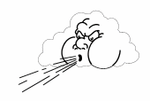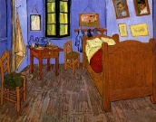

1. WNIYD _____________ 2. BDEROMO __________

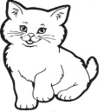

3. COKONIG ______________ 4. ACT ____________

V. Look and read. Put a tick ( : TRUE) or cross (x: FASLE) in the box.

Example  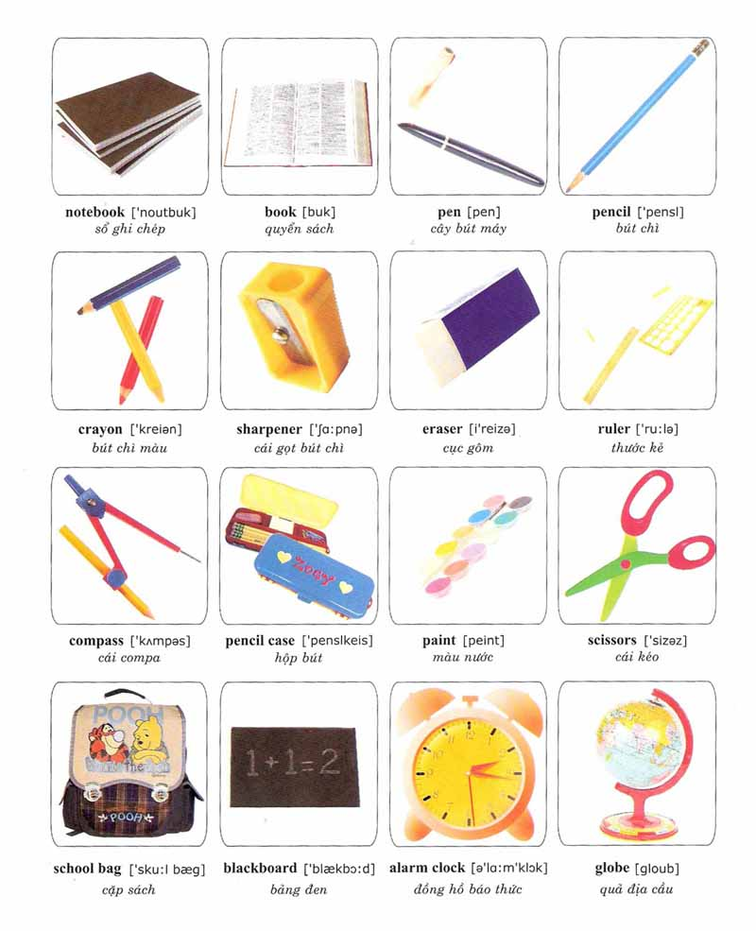
X xxxxxx
1. This is my pen. 2. That is my school bag.

1. 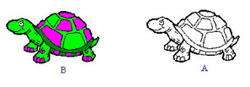
Nam has got a goldfish.

2. 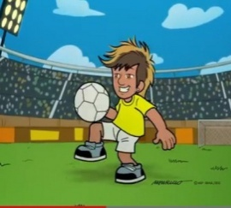
Jack is playing football.

3. 

It is cloudy today.

4. 

My brother is cooking.

VI. Read the passage and select the correct answers.

It is our break time. We are playing in the schoolyard. Many boys are playing football. Some girls are playing skipping. Three boys are running on the grass ground. Two girls are sitting on a bench. Some girls and boys are chatting.

1. The students are playing in .
A. classroom B. schoolyard C. playground

2. are playing football.
A. Boys B. Girls C. Boys and girls

3. girls are sitting on a bench.
A. Three B. Some C. Two

4. Some are chatting.
A. girls B. boys C. boys and girls

ĐỀ KIỂM TRA HỌC KỲ II SỐ 5
I. Odd one out.
1. A. puzzle B. rabbit C. robot D. truck

2. A. wardrobe B. cupboard C. table D. those

3. A. fish B. rabbits C. bird D. goldfish

4. A. teddy bear B. rainy C. cloudy D. sunny

5. A. thirty B. forty C. thirteen D. seventy

II. Circle the best answer A, B, C or D.
1. Where _________ the posters? – They’re on the wall.
A. do | B. does | C. is | D. are
2. What is the weather like in Hanoi? – It’s ________ and windy.
A. happy | B. big | C. cloudy | D. long
3. How many ________ are there in your house?
A. rooms | B. room | C. kitchen | D. bedroom
4. Are there ______ pictures on the wall?
A. some | B. any | C. a | D. an
5. _______ he like birds? – Yes, he does.
A. Is | B. Do | C. Does | D. Are

III. Read and tick Yes or No.
Hi. My name is Nam. I have a lot of toys. I have a red plane, a blue car, a green ship and a yellow ball. Dong is my brother. He also has many toys. He has two robots. They are black and red. He has a red ship, a green car and a yellow yo-yo. We always play together. We have much fun.
Yes No
1. Nam and Dong have many toys.
2. Nam has a yellow ball and a blue car.
3. Dong is Nam’s friend.
4. Dong has a red ship and a green car.
5. They always play together.

IV. Read the passage and write the correct words in the blanks.
room | on | nine | is | near

Hi, I am John. I am (1)______ years old. This (2)___________ my sister. Her name is Mary. This is our (3)____________. There is a cupboard (4)________ the door. There are two posters (5)____________the wall. There is a table and two chairs.

V. Rewrite the following sentences using given words.

1. have?/ How/ do/ you/ many/ notebooks | __________________________________?
2. like/ I/ and/ cats./ dogs/ | ___________________________________.
3. are Linda and Tony/ classroom./ in/ the | ___________________________________.
4. hane/ you/ any/ Do/ pets? | __________________________________?
5. are/ the living room./ watching TV/ They/ in | __________________________________.

