Unit 1:
Part 1 Listen and number the picture, there is one example.
1. I’m Minh
Can you see number 1. Now listen and number the picture.
2. This is Marry.
3. Hello, I’m Lucy.
4. Good bye.
5. Hi, my name is Ben.
Part 2: Listen and circle. There is one example:
1. Hi, I’m Marry. Nice to meet you.
Can you see the circle, now listen and circle A or B.
2. Hello, my name is Mai. It's nice to meet you.
3. I'm sorry. What is your name again? My name is Lucy.
4. Hello, I’m Ben.
Hi, Ben. I’m Mai.
5. Hi, how are you?
I’m fine, thank you.
Unit 2:
Part 1: Listen and draw line, there is one example:
1. I’m seven years old
Can you see the line, now listen and draw line.
2. I’m ten years old.
3. I’m six years old.
4. I’m nine years old.
5. I’m eight years old.
6. I’m five years old.
Part 2: Listen and write a name or a number, there is one example:
1. I’m six years old.
Can you see number six. Now listen and write:
2. What’s your name?
My name is Linda
How do you spell your name?
L-I-N-D-A.
3. How old are you?
I’m 8 years old. It’s my birthday today.
4. Are you 7 years old?
No, I’m 9 years old.
5. Is your name Quan?
No, my name is Minh- M-I-N-H.
6. Hi, I’m Lucy. How old are you?
Hi Lucy, I’m ten years old.

Unit 3:
Part 1: Listen and tick. There is one example:
1. This is Lucy
Can you see the tick. Now listen and tick:
2. That is Bill
3. That is Marry
4. This is Ben
5. This is Mr Long
Part 2: Listen and draw line. There is one example:
Can you see the line. Now listen and draw line
1 This is Mai -d |  | a. 
2 That is Bill - f |  | b. 
3 Is this Marry?  No, it isn’t. This is Lucy- i |  | c. 
4. This is Ms Hoa.- g |  | d. 
5. Who is this?  It’s Ben.- h |  | e. 
6. This is Marry.- b |  | f. 
7 Is that Mai?  No, it isn’t. That is Linh- e |  | g. 
8. Is that Mr Long?  Yes, it is. - c |  | h. 
9. Look, that is Nam. He is my new friend.- a |  | i. 

Unit 4:
Part 1: Listen and circle, question 1 is done for you.

1. It’s a nose
Can you see the circle? Now listen and circle A or B
2. It’s an eye- B
3. It’s an ear. A
4. It’s a hand. B
5. It’s my hair B
6. It’s my face A
7. It’s my mouth B

Part 2: Listen and number. There is one example.

1 Touch your ears
Can you see number 1? Now listen and number.
2. Touch your nose
3. Open your mouth
4. Open your eyes
5. Touch your hair
Unit 5:
Part 1: Listen and complete the following sentences, sentence 1 is done for you.
1. My name is Ben. I like singing
Can you see the underlined word: singing. Now listen and complete the sentences:
2. Hi, I’m Bill. I like swimming
3. What is your hobby?
I like (a)running. What’s your hobby?
It’s (b)dancing
4. Hello, my name is Mai. I like cooking.
5. Hi, I’m Marry. I’m (a)eight years old. I like (b)drawing.
6. I don’t like (a)walking, I like (b)swimming
7. Hello. My name is Lucy. I like painting.
Part 2: Listen and circle, there is one example:
1. I like drawing.
Can you see the circle? Now listen and circle A or B.
2. What is your hobby?
I like singing ( A)
3. Is your hobby swimming?
No, it isn’t. I like dancing. (B)
4. I like painting. (A)
5. Do you like cooking?
Yes, I do. I like cooking (B)
6. Do you like dancing?
No, I don’t. I like swimming( B)
7. What is your hobby?
It’s walking(A)
8. I don’t like cooking, I like painting(B)
Unit 6:
Part 1: Listen and draw line, there is one example:
Can you see the line? Now listen and draw lines:
1. It’s our music room (f)
2. It’s our library (e)
3. It’s our art room (b)
4. It’s our school (h)
5. It’s our class room (g)
6. It’s our computer room (a)
7. It’s our playground (c)
8. It’ our gym (d)
Part 2: Listen and tick. The first sentence is done for you.
1. Let’s go to the gym (A)
2. Let’s go to the music room.
No, I like painting. Let’s go to the art room. (B)
3. Let’s go to the playground.
No, It’s time to learn. Let’s go to the classroom. (B)
4. Is this your school? Yes, it is. (A)
5. Do you like reading? Yes, I do.
Let’s go to the library (B)
6. Let’s go the playground. Ok! (A)
7. What is your hobby? I like singing. Let’s go to the music room (A)
8. Is this our art room?
No, it isn’t. It’s our computer room. (A)
Unit 7:
Part 1: Listen and circle. There is one example:
1. Open the book, please! (B)
2. May I come in? Yes, you can. (A)
3. Sit down, please! (A)
4. May I go out? Yes, you can. (B)
5. Close your book! (A)
6. Our teacher is coming. Class, stand up! (B)
7. Good morning, class. Good morning, teacher( A)
Part 2: Listen and complete the following sentences, the first sentence is done for you.
1. Hello, my name is Jack. I’m ten years old.
Can you see the underlined word: ten?
Now listen and complete the sentences.
2. What is your hobby? I like dancing.
3. Open your eyes please?
4. Is your hobby walking? No, it isn’t. I like swimming.
5. Stand up, please!
6 Is that our computer room? Yes, it is.
7. May I come in, please!
8. Open your book.

Unit 8:
Part 1: Listen and tick  or cross . There are two examples.
1. I have two pens (X)
2. I have a school bag(v)
3. I have an eraser (v)
4. I have four books(X)
5. I have two pencils and three rulers( V)
6. Do you have a pencil case? No, I don’t.(X)
7. I have five pencils. (X)
8. I have four notebooks(v)
9. How many erasers do you have? I have three erasers. (V)
10. I have one note books and one pen(X)
Part 2: Listen and circle, there is one example:
1. I have a pencil. (A)
2. Do you have an eraser? Yes, I do (B)
3. Do you have a pen. No, I don’t. I have a ruler (A)
4. Do you have a school bag? Yes, I do. (B)
5. Do you have a pencil? No, I don’t. I have a pencil case.(A)
6. I have a pen and a ruler( B)
7. Do you have a notebook? Yes, I do. (A)
8. Do you have a notebook? No, I don’t. I have a book (A)

Unit 9:
Part 1: Listen, number and color. There is one example:
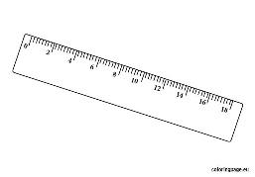 | 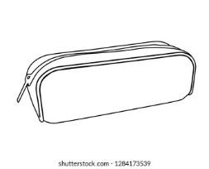 | 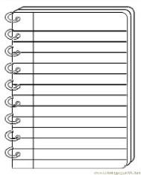 | 
5 | 2 | 8 | 1
 |  | 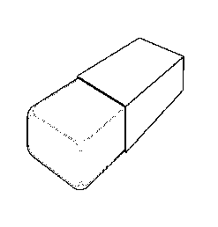 | 
6 | 4 | 8 | 3

1. I have a red school bag.
2. I have an orange pencil case.
3. I have a green pen
4. I have a black book
5. I have a blue ruler.
6.I have a yellow pencil.
7. I have a white eraser
8. I have a brown notebook.

Part 2: Listen and complete the sentences. There is one example:
1. I have a pen. It’s black
Can you see the underlined word: black? Now listen and complete the following sentences:
2. I have five pencils. They’re orange
3. I have a ruler. It’s yellow
4. I have three erasers. They’re brown
5. Do you have a note book? Yes, I do. I have four. They are white
6. I have a green school bag. What color is your school bag? It’ red
7. I have six books. They are blue and black
8. Is your pencil case red?
No, it isn’t. It’s yellow.

Unit 10:
Part 1: Listen and draw line. There is one example:
1. What do you do at break time?  - I play football. (d) |  | a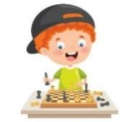
2. What do you do at break time?  I play badminton.(g) |  | b
3. Do you play basketball at break time?  No, I don’t. I play volleyball.(c) |  | c
4. What do you do at break time?  I play table tennis.(h) |  | d
5. I like singing. I sing at break time.(b) |  | e
6. What do you do at break time?  I do word puzzles(i) |  | f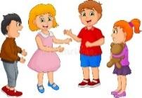
7. I play basketball at break time.(e) |  | g
8. At break time I play football. How about you?  I play chess(a) |  | h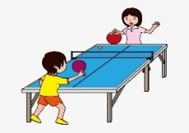
9. What is your hobby?  I like painting. I paint at break time(j) |  | i
10. I don’t like playing chess. I chat with friends at break time.(f) |  | j

Part 2: Listen and complete the text, the first one is done for you:
My name is Ben. I’m nine years old. I have many school things: two blue school bags, six books, five erasers, three yellow pencils, a pencil case, four pens and two red rulers. I like cooking and swimming. At break time I play badminton and chat with my friends. I also do word puzzles and play table tennis with my brother.
Unit 11:
Part 1: Listen and circle. There is one example:
1. It’s my brother( B)
2. It’s my sister (A)
3. It’s my father( A)
4. It’s my mother (B)
5. Is that your brother? No, it’s my sister(B)
6. Who’s this? It’s my father(A)
Part 2: Listen and complete the text: 
My name is Lucy. I’m ten years old.
I like dancing. There are four people
in my family. My father, my mother,
my brother and I. My father is thirty- nine
years old. He likes playing basketball.
My mother is thirty- six years old. She likes
cooking. My brother is seven years old. He
likes playing football. I love my family.

Unit 12:
Part 1: Listen and tick or cross . The first sentence is done for you:
1. She is a teacher (V) 2. He is a famer( X)
3. What is her job? She is a doctor. (X) 4. Is she a singer? Yes, she is. (V)
5. What is his job? He is a worker. (V)
6. Is he a farmer? No, he isn’t. He is a driver.(X)
7. My father is a cook(V) 8. Is she a teacher? No, she is a doctor(V)
Part 2: Listen and complete the sentences. There is one example:
1. She is a cook
2. He is a doctor.
3. My father is a driver
4. This is my mother. She is a nurse.
5. What is his job? He is a worker.
6. Is she a doctor? No, she isn’t. She is a teacher.
7. She is a singer.
8. He isn’t a driver. He is a farmer.
Unit 13:
Part 1: Listen and fill in the blanks
1. The chairs are in the bedroom.
2. The books are on the chair.
3. The lamp is on the table.
4. The table is in the living room
5. Where are the chairs? They’re in the kitchen.
6. Is the ruler on the table? No, it’s in the pencil case.
7. Where is your mother? She is in the bathroom.
8. The pencil isn’t in the school bag. It’s on the notebook.

Part 2: Listen draw line. There is one example:
1. Where is the house?  It’s there.( h) |  | a.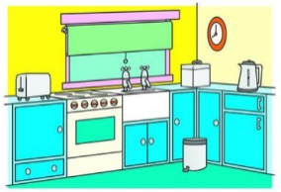
2. Where is the bedroom?  It’s there (d) |  | b.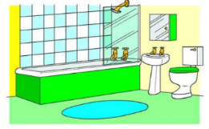
3. Where is the table?  It’s here.(f) |  | c.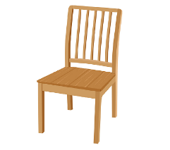
4. Where is the kitchen?  It’s here(a) |  | d.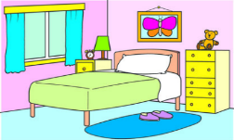
5. Where is the living room?  It’s here (g) |  | e.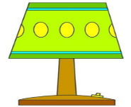
6. Where is the chair?  It’s here.(c) |  | f.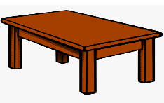
7. Where is the bathroom?  It’s there.(b) |  | g.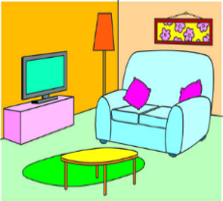
8. Where is the lamp?  It’s there.(e) |  | h.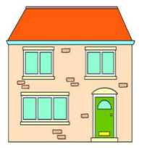

Unit 14:
Part 1: Listen and circle. There is one example:
1. There are two beds in the bedroom (B)
2. There is a window in the kitchen(A)
3. There are two chairs in the living room (B)
4. There is a small door in the bedroom ( A)
5. There are three pillows on the bed.(A)
6. There is a desk in the bedroom. (B)
Part 2: Listen and tick or cross . There are two examples
1. The chair is small(X)
2. The bed is big(V)
3. The school bag is old(x
4. The window is small(v)
5. The door is small(x)
6. The desk is new(x)
7. The lamp is old(v)
8. There is a red pillow(x)
9. The table is big(v)
10. The chair is new(x)
Unit 15:
Part 1: Listen and circle. There is one example:
1. I’d like some bread and eggs, please? (A)
2. I’d like some rice and chicken, please? (B)
3. I’d like some rice and fish, please? (B)
4. What would you like to eat? I’d like some beans and meat, please? (A)
5. What would you like to drink? I’d like some milk, please? (B)
6. Would you like some juice? No, thanks. I’d like some water, please?(A)
7. Would you like some bread and chicken? Some bread and meat, please? Ok (A)
Part 2: Listen and write, the first one is done for you.
Name | Food/ drinks
1. Nam, what would you like to eat?  I’d like some fish and eggs, please? | Fish, eggs
2. Ben, what would you like to eat?  I’d like some bread, meat and beans, please? | …………………………………………………………………….
3. Anna, what would you like to eat?  I’d like some rice and chicken, please? | …………………………………………………………………….
4. Marry, what would you like to eat and drink?  I’d like some eggs, meat and water, please? | …………………………………………………………………….
5. Minh, would you like some bread and milk?  Yes, please. | …………………………………………………………………….
6. Linda, what would you like to drink?  I’d like some juice, please? | …………………………………………………………………….
7. I’d like some rice and meat. How about you, Bill?  I’d like some fish, beans and water. | …………………………………………………………………….

Unit 16:
Part 1: Listen and tick ( ✔) or cross (🗶) . There are two examples:
1. I have some dogs(X)
2. I have two rabbits(V
3. I have three pens(V)
4. I have a dog(X)
5. I have two parrots. (V)
6. I have five cats(X)
7. I have some birds(V)

8. I have many birds(X)
9. I have many pencils(V)
10. I have some goldfish(X)
11. I have many cats.(X)
12. I have some birds(X)
Part 2: Listen and rewrite the following sentences:
1. I have a dog and two cats | -> I have two dogs and two cats.
2. I have a goldfish | -> I have some goldfish
3. I have many birds | -> I have many rabbits
4. I have a bird and many parrots | -> I have some birds and a parrot
5. I have two goldfish and a dog | -> I have many goldfish and some dogs
6. Do you have any cats? No, I don’t | -> Do you have any cats? Yes, I do. I have three cats
7. How many parrots do you have? | -> How many rabbits do you have?
8. I have a goldfish and some birds | -> I have some goldfish and many birds.

Unit 17:
Part 1: Listen and complete the following sentences:
1. I have a teddy bear.
2. She has a new kite.
3. My sister has a plane and a doll.
4. They have two boats.
5. He has a yellow doll and a red bus.
6. She has a truck and three cars
7. Lucy has a big train.
8. They have two old dolls and a small ship.
Part 2: Listen and number the picture. There is one example:
1. They have a car and a kite.
2. She has a big teddy bear and a small doll
3. He has a bus and two trucks.
4. They have a red car and two planes
5. My brother has a blue train and a bus
6. My sister has a green plane and two dolls
7. I have a big ship and two kites.
8. They have three cars.

Unit 18:
Part 1: Listen and number the picture, there is one example:
4 | 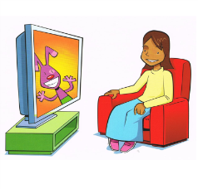2 |  5 | 8
7 |  3 | 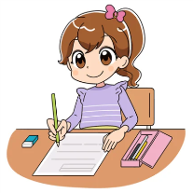 | 6

1. I’m writing.
2.What are you doing? I’m watching TV
3. I’m reading.
4. Are you dancing? No, I’m listening to music.
5. I’m drawing a picture.
6. What are you doing? I’m playing basketball.
7. I’m singing.
8. I am not singing, I’m dancing.

Part 2: Listen and write. There is one example:
1.Ben, what are you doing?  I’m listening to music | listening to music
2. Anna, what are you doing?
I’m singing and dancing
3. Lucy, what are you doing?
I’m drawing and painting a picture
4. Jill, are you playing table tennis?
No, I’m playing basketball
5. What are you doing, Marry?
I’m reading and writing
6. I’m watching TV, what are you doing, Mai?
I’m cooking and listening to music.
7. Linh, are you drawing a picture? Yes, I am. And I’m singing, too
8. Jim, what are you doing?
I’m watching TV.

Unit 19:

Part 1: Listen and complete the following text:
My name is Linh. I am eleven years old. I like dancing. I am singing and painting in my bedroom. My father is a driver. He likes reading. He is walking and running. My mother is a teacher. She likes playing badminton. She is cooking in the kitchen. My brother is eight years old. He likes cycling. He is flying kite in the garden. My sister is six years old. She likes skating. She is skipping with her friends. We are a happy family.

Part 2: Listen and draw line. There is one example:

1. What’s he doing?  He’s running |  | a. 
2. Is he walking?  No, he isn’t. He’s cycling(g) |  | b. 
3. What’s she doing?  She’s painting(f) |  | c. 
4. Is he flying a kite or skating?  He’s flying a kite(h) |  | d. 
5. What’s she doing?  She’s playing badminton(b) |  | e. 
6. He is not walking, he’s skating(a) |  | f. 
7. What is she doing?  She is skipping( c) |  | g. 
8. Is he walking?  Yes, he is.(e) |  | h 

Unit 20:
Part 1: Listen and number the picture. There is one example:

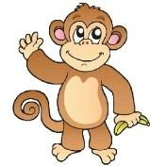
1. What can you see? I can see a monkey
2. What can you see? I can see a parrot
3. Can you see a tiger. No, I can see a peacock
4. I can see a monkey. What can you see? I can see a horse.
5. Can you see an elephant or a tiger? I can see an elephant
6. wow, I can see a tiger. It’s big
Part 2: Listen and circle, there is one example:
1. What is the bird doing? It’s flying.(B)
2. What is the monkey doing? It’s climbing (A)
3. What is the parrot doing? It’s singing.(A)
4. What is the tiger doing? It’s running(B)
5. Is the parrot flying? No, it isn’t. It’s counting (A)
6. What is the el ephant doing? It’ dancing (B)
7. I can see a horse. It’s not running, it’s walking (B)
8. Is the monkey swinging? Yes, it is. (A)
9. I can see a peacock. It’s dancing. (B)

