UNIT 8: TALKING TO THE WORLD
Period 74: Lesson 8.3: Reading and Vocabulary

I. OBJECTIVES
By the end of the lesson, students are expected to achieve the following objectives:
1. Knowledge:
a. Vocabulary: Learning languages (ethnic language, illiterate, basic sentences, words, foreign language, learn a language, speak a little Vietnamese, communicate, native language)
b. Grammar: Present Simple and Past Simple revision
2. Competencies:
a. General competencies: Strengthen group work and independent working, pair work, linguistic competence, cooperative learning and communicative competence.
b. Specific competencies: Improve communicative competencies related to reading skills and use of language (vocabulary, phonetics, grammar)
* For a language lesson: Students are expected to know the meaning of the keywords and phrases used to talk about learning languages, and understand the main grammatical points, then do the tasks assigned in the textbook.
* For a skills lesson: Students are expected to find specific details in an article and talk about their experience in learning languages.
Qualities:
Being hard-working and attentive in class
Being collaborative while doing in-class exercises
II. PREPARATIONS
Teacher: Textbooks, paper, TV, projector, loudspeaker, extra boards.
Students: Textbooks, notebooks

III. PROCEDURE
ACTIVITY 1: WARM-UP (5’)
Aim: To attract Ss’ attention to the lesson and lead in the new lesson.
Content: Ss work into teams to play the game under instruction of T.
Products: Ss are able to make the sentences relating to the words using have to, don’t have to and must/mustn’t
Implementation:
TEACHER AND STUDENTS’ ACTIVITIES | CONTENTS
Step 1: Task delivering  - T explains how to play the game  - T divides the class into two teams (team A and team B)  T tells students that there are 8 cards on the screen containing words/phrases. For each word/phrase, they have to make sentences with the word/phrase by using “have to, don’t have to and must/ mustn’t”.  With each right sentence, you will get 2 points. The team with the highest points will be a winner.  Step 2: Task performance  - Students from each team work together, choose numbers on the cards to make sentences with each word/phrases using “have to, don’t have to and must/ mustn’t”  Step 3: Judgment  Check with the result of the two teams and gives compliments.  The team with the most correct sentences will be the winner.  When opening all the cards, there is a picture about Sa Pa,T leads in the new lesson. | Play a game called “Turn over the cards”  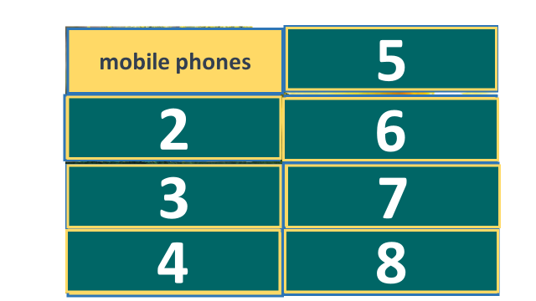  - Card 1 – mobile phones  Ex: You mustn’t use mobile phones in class.  ……………
ACTIVITY 2: KNOWLEDGE FORMATION (3’)
Aim: To introduce the objectives of the lesson with a can-do statement.
Content: The objective of the lesson is listed as below
I can find specific details in an article and talk about learning languages.
Products: Ss acknowledge the lesson’s objectives.
Implementation: T introduces objectives to Ss.
ACTIVITY 3: PRE-READING (10’)
Aim: To get Ss’ interest in space stations and teach some related vocabulary.
Content: Ss work in pairs with the guidance from T to answer the questions about ethnic minorities in Vietnam and T to prepare for the reading exercise and do the assigned exercise in the textbook
Products: Ss are able to give the appropriate answers regarding the given photo, as well as grasp the meaning of related vocabulary.
Implementation:
TEACHER AND STUDENTS’ ACTIVITIES | CONTENTS
Pre – teach Vocabulary  T –Ss :  - Pre teach vocabulary  - Teacher use different techniques to teach vocab (video, situation, explanation, synonym…..)  - Repeat in chorus and individually  - Copy all the words  * Checking vocabulary by doing exercise 5 (page 83)  - T uses the vocabulary box in exercise 4 and asks Ss to do exercise 5 by choosing the best answer  - T asks Ss to work individually to complete the sentences.  - Ask ss to point out keywords in each sentence.  - T remarks and give compliments  Pre – reading  Set the scene  Step 1: Task delivering  T shows the photo of an ethnic minority girl in SB p.83 and some questions.  Step 2: Task performance  Ss listen and answer the questions.  Step 3: Judgment  T checks the answers with Ss.  And then T introduces the lesson: To day Ss are going to learn an article about H’mong children in Sa Pa learning English. And we are going to know who she is and where she lives and how she is successful in her life. | * Vocabulary  - native language (n): tiếng mẹ đẻ  /ˈneɪ.t̬ɪv ˈlæŋ.ɡwɪdʒ/  - ethnic language (n): tiếng dân tộc  /ˈeθ.nɪk ˈlæŋ.ɡwɪdʒ/  - illiterate (a): mù chữ  /ɪˈlɪt̬.ɚ.ət/  - basic sentences: những câu cơ bản  /ˈbeɪ.sɪkˈ ˈsen.tənsiz/  - communicate (v): giao tiếp  /kəˈmjuː.nɪ.keɪt/  - set up (v.p): thành lập  /set ʌp/  *Checking: Exercise 5 (page 83)  Exercise 5. Complete the sentences below by choosing the best answer A, B, C or D.  1. Your _______is the language that you learn at home when you’re a child.  A. ethnic language B. native language  C. foreign language D. basic sentences  2. Some children in mountainous areas are still _______ as they are not able to read or write.  A. illiterate B. ethnic language  C. words D. communicate  3. After five years of learning English as a ________ the little girl is now able to use English to ________ with foreign visitors.  A. words/illiterate  B. ethnic language/communicate  C. foreign language/communicate  D. illiterate/communicate  4. John: “Hoa, help me! I don’t understand what Nam is saying because I could only ________________”.  A. learn a language  B. illiterate  C. speak a little Vietnamese  D. communicate  5. All the in this sentence are new to me. I cannot understand what it means.  A. native language B. basic sentences  C. illiterate D. words  Suggested questions and answers.  Do you know about the girl?  Do you know where she lives?  → No, we don’t
ACTIVITY 4: WHILE-READING (20’)
Aim: To help students practice scanning and skimming skills.
Content: Ss work individually, in groups and in pairs under the instruction from T to do the given reading-related exercises respectively.
Products: Ss are able to accomplish the given exercises as much as they can.
Implementation:
Step 1: Task delivering  T lets Ss open SB p. 83 and look at Exercise 1.  T asks Ss to read all the headings carefully and then T show some tips for reading, guides Ss how to do this exercise.  Step 2: Task performance  Ss work in pairs to complete the task.  T and Ss elicit the keywords.  Step 3: Judgment  T and Ss check the correct answers.  Step 4: Report and discussion  T develops further discussion if needed. | Exercise 1. Read through Part 1 and part 2 of the text. Choose the best heading for each part. There are more headings than you may need.  Answers:  Part 1: D (set up a company called ‘Thank you, Sa Pa’ to train poor children as tour guides)  Part 2: A (At the age of 11, Chee often joined …. a spot in front of a rock church. She decided to learn English. She could communicate in English.)
Step 1: Task delivering  T tells Ss to read Part 1 in SB page 83 again.  T shows some tips for reading  for specific information and guides Ss how to do the task 2.  Step 2: Task performance  Ss work in groups to complete Exercise 2. T tells Ss to underline the key phrases for the answers.  Step 3: Judgment  T and Ss check the correct answers. T tells Ss to read the key phrases for the answers.  Step 4: Report and discussion  T develops further discussion if needed. | Exercise 2. Read Part 1 again. In pairs, mark the sentences ✓ (right), x (wrong) or ? (doesn’t say).  Answers:  ✓ 1. (Chee, a 28-year-old woman in Sa Pa, set up a company called ‘Thank you, Sa Pa’ )  ? 2. (nothing in the text says ‘free’)  ✓3. (Many H’mong people believe that daughters should work and go to school only for their sons.)
Step 1: Task delivering  T asks Ss to read Part 2 again.  T gets Ss to play a game “who is luckier?” to answer the following questions.  T asks Ss to work in teams.  T explains the rules of the game.  Step 2: Task performance  Ss to read Part 2 in SB p. 83 again.  Ss work in teams to answer the questions.  Ss choose the boxes to answer the question and open the box to get points from it.  Step 3: Judgment  T and Ss check the correct answers.  Step 4: Report and discussion  T develops further discussion if needed. | Exercise 3. Read Part 2 again. Take turns to ask and answer the following questions.  * Play a game “Who is luckier?”  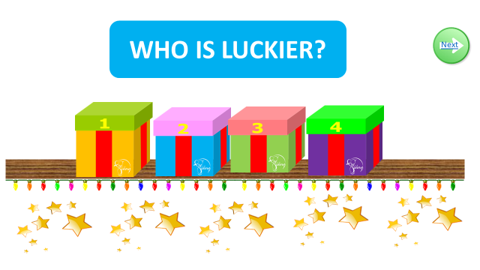  Suggested answers:  1. At the beginning of the 2000s.  2. Because the tourists didn’t understand her.  3. No, she couldn’t  4. She learnt English from foreign visitors.
ACTIVITY 5: POST READING (5’)
Aim: To help Ss know more about how their friends have learned languages
Content: Ss work in groups of 2 to practice to ask and answer the given questions in Exercise 6.
Products: Ss are able to get the idea of how to develop a short speech about sports in general.
Implementation:
Step 1: Task delivering  T models with a student: T asks and Ss answer all the sentences.  T has Ss work in pairs to ask and answer the questions in the table and explain if they don’t know how to answer in full sentences.  Step 2: Task performance  Ss practice asking and answering the questions  Step 3: Report and discussion  T calls some volunteers to practise in front of the class.  Step 4: Judgment  Check corrects and remarks | Exercise 6. Use the questions below to interview at least three friends.  Suggested conversation:  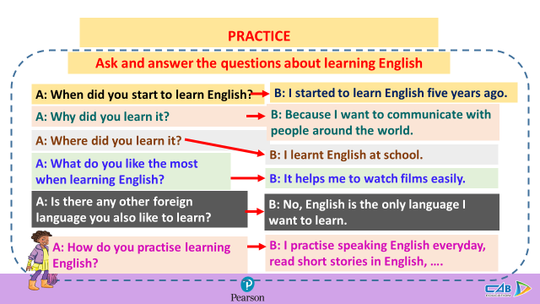
CONSOLIDATION AND HOME ASSIGNMENT (2’)  - T asks Ss to tell what they have learnt in the lesson.  - T shows the slide to consolidate the lesson.  - T assigns the home assignments.  - Ss copy their home assignments.  - T explains it carefully. | 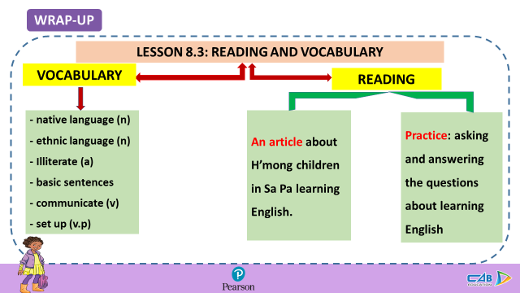  Do exercises on Workbook page 72.  Prepare Unit 8 Lesson 4 – Grammar 2.

