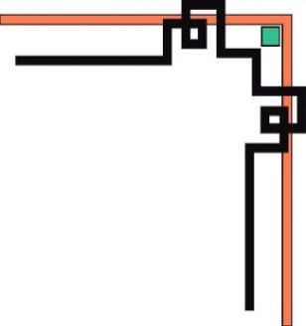

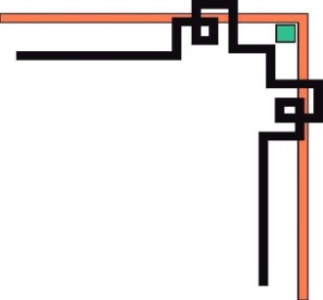
PHÒNG GD & ĐT QUẬN THANH XUÂN
TRƯỜNG THCS NGUYỄN LÂN

LESSON PLAN ENGLISH 7
UNIT 7: SHOPPING AROUND
Lesson 7.3: Reading and Vocabulary

Teacher: Vũ Thị Thu Giang
Class: 7A3
Date of teaching: 7/3/2023

School year: 2022 - 2023

UNIT 7: SHOPPING AROUND
Lesson 3: Reading and Vocabulary

A. Class Description
1. Class: 7A3
2. No of Ss: 33 Male: 8 Female: 25
3. Level of Ss: A majority of Ss are in average level of proficiency and rather passive in their English learning, so the designed lesson in the textbook has to be adapted to fit their level.
B. Lesson
I. OBJECTIVES: By the end of the lesson, Ss will be able to:
1. Knowledge
- Get to know some new words relating to markets in Vietnam (overlook, variety
catalogue, reasonable price, be satisfied with…)
- Identify specific details about shopping in Hội An, Việt Nam.
- Describe one shop or one market students know based on T’s model.
2. Competences:
- General competences: form and / or improve such competencies as group work, independent working, pair work, linguistic competence, and cooperative learning.
- Specific competences:
- Improve communicative competence related to the use of language (vocabulary, phonetics, grammar):
- For a language lesson: Ss are expected to know the meaning of the keywords used to talk about one shop or one market in Vietnam.
- For a skills lesson:
- Ss are expected to locate information and find specific details in a text (scanning skill).
3. Quality/Behavior
- Being hard-working and attentive in class
- Have a positive attitude towards the lesson
- Know more and respect the family time together.
II. TEACHING AIDS:
- T: textbooks, lesson plan, board, projector, laptop, loudspeaker, worksheets, teaching aids.
- Ss: textbooks, notebook, assigment.
III. PROCEDURES
1. Oral checking: No
2. New lesson:
1. WARM-UP (5’)
* Aim:
- To make learning atmosphere.
- To lead into the next activity.
* Content: Watch a video of a place
* Outcome: Ss guess the place and say something about it.
* Organisation: T-Ss, Ss-T.
Teacher’s & Student’s activities | Content
Set the scene:  - Let’s watch a video, then answer the question: “Tell anything you see?”  Activity 1: Guessing place  - T ask Ss to watch a video of a place, then answer the question.  - Ss raise their hands if they have the answer.  - T aks:  + Where is it?  + Have you ever bought something in Hoi An?(What is it?/ How do you fell about it?)  - T tells students that they are going to read about shopping in Hoi An, Vietnam.  - T writes the title for the new lesson:  Unit 7: Shopping around  Lesson 3: Reading and vocabulary. | Watching video:  - colourful lanterns, old street……  - It’s Hoi An.  - Yes./No.
2. PRE-READING (13’)
* Aim:
- To activate Ss’ background knowledge of the topic.
- To provide active words.
* Content: Ss describe photos and get to know related vocabulary.
* Outcome: Ss provide simple facts about Hội An, Việt Nam.
* Organisation: T-Ss, Ss-T, Pair work.
Teacher’s & Student’s activities |  | Content
Activity 2: Exercise 1 – SB p.73  In pairs, look at the photos. What do you know about this place?  Set the scene:  - Look at the pictures.  What can you see in the picture? (lanterns, shoes)  What are they? (lantern / shoe shops)  What do you know about these places?  - Ask Ss to work in pairs to discuss the question, then share their answers.  - T collects Ss answer and check.  Set the scene: To understand better about these places, let’s study some new words.  Activity 3:  - T shows Ss sound.  - T asks Ss to repeat after the radio.  - T shows Ss stress, word form, the meaning of new words. (Direction: Where’s stress? What’s word form?)  - T uses different techniques to teach other new words (picture, explanation, translation, example).  - Ss answer.  - Ss listen and repeat (chorus twice/ individual)  - T corrects Ss’ pronunciation.  - Ss write down.  * Check vocabulary: Exercise 4 – SB p.73  Choose the words to complete the sentences. Make changes to the words if necessary?  - T guides Ss to read the sentences, underline key words, and guess the parts of speech of the words that need to be filled in each blank.  - Ss work individually to finish Exercise 4  - T checks Ss answers by playing game “ Change the ball”  Now let’s play a game to check your answers. Change the ball with the music, not let the ball fall into the floor. When the music stops, Ss having the ball will give the answer. |  | * Describing the photos.  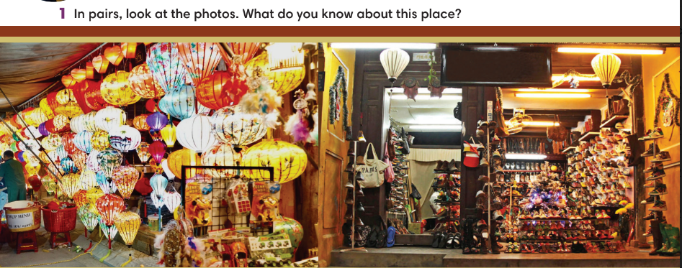  - There are many lanterns shop in Hoi An ancient town. They sell many colorful lanterns with beautiful patterns such as flowers, people, or wishes. Moreover, they have many different sizes and shapes.  - There are many shoe stores which sells many kinds of shoe for both men and women. The sellers can speak English very fluently so it is very easy for foreigners to buy things there.  * I.Vocabulary  - overlook (v) /ˌəʊvəˈlʊk/: quan sát, nhìn (you can see the place  from the building)    - variety (n) /vəˈraɪəti/ : sự đa dạng (several different kinds of  the same thing)    - reasonable (adj) /ˈriːznəbl/ : giá cả phải chăng, hợp lý (of prices) not too expensive)    - be satisfied with ... /ˈsætɪsfaɪd/: hài lòng, thỏa mãn (feel pleased because you have achieved something)    - catalogue (n) /ˈkætəlɒɡ/: bảng liệt kê sản phẩm (a list of items for people can look at or buy)  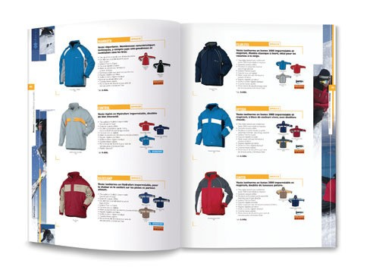  * Check vocabulary.  1. A noun/nounphrase : reasonable price  2. a verb: overlooks  3. A noun: catalogue  4. A noun/nounphrase: variety  5. An adjective: satisfied  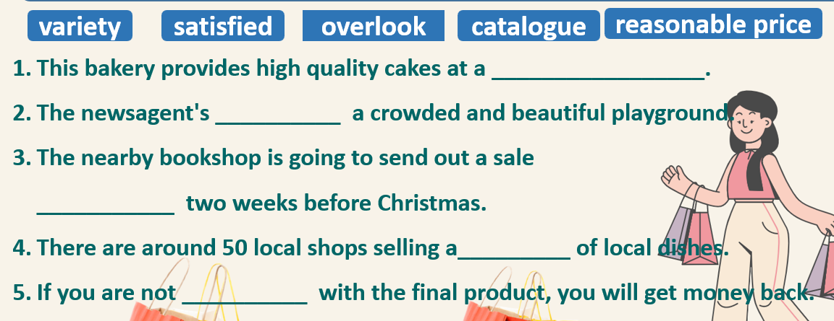
3. WHILE-READING (14’)
ACTIVITY 4 + 5:
*Aim:
- To read two texts and do reading tasks.
- To help students practice finding main ideas of the text.
- To help students practice reading for specific information in a text.
* Content: Ss read the texts and answer the questions.
* Outcome: Ss can identify specific information in the texts and learn more about Hội An, Việt Nam.
* Organisation: T-Ss, Ss-T.
Set the scene: Look at the sentence 5, Ex4: “ If you are not satisfied with the final product, you will get money back.” Do you know any shops having the same rule?  I will introduce to you an interesting shop with this rule in Hoi An.  Activity 4: Exercise 2 – SB p.73  Read the text. Where most likely can you find the information in the text?  - T asks Ss to look at Exercise 2 (SB page 73).  - T explains to Ss that they need to do skimming and find main ideas.  - T sets time limit for Ss to find main ideas and finish exercise 2.  - T asks Ss to check answers with partner before checking with the whole class and explain reasons for their answers. |  | Answer keys:  c. in a travel guide
Activity 5: Exercise 3 – SB p.73  Set the scene:  Read the text again and write N for the night market and S for the shoe shop or B for both places.  - T asks Ss to read the statements, underline the key words first.  - T makes model, then asks Ss to read the text again to find the informtion and answer  ( write N for the night market, S for the shoe shop, B for both).  - T asks students to underline the evidence for their answers.  - Ask Ss to share answers in pairs and explain their choices to their partner before checking the answer with the whole class.  * Summary  - T asks Ss to close the book and answer some questions about the text basing on memory.  1. Where is Hội An night market?  2. What does Hội An night market sell?  3. When can you get 100% money back? |  | Answer keys:  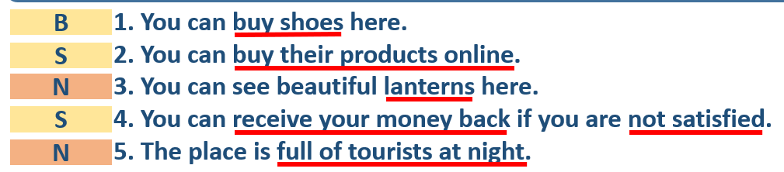  1.The centre of Hoi An ancient town.  2. variety of local snacks, closes, footwear, food and drink.  3. when I am not satisfied with the final product.
4. POST-READING (10’)
ACTIVITIES 6:
* Aim: To use the vocabulary and ideas from the text to develop speaking skill.
* Content: Talk about a shop/ market.
* Outcome: Ss can talk about a shop/ market.
* Organisation: T-Ss, Ss-T, Ss-Ss, Group work, Pair work.
Set the scene: What about a market or a shop in your hometown? Let’s talk about it.  Exercise 5 – SB p.73  Work in groups. Describe one shop or one market in your hometown. Then present to the class.  - T asks Ss to look at exercise 5 (SB page 73).  - T calls a student to read the instruction then checks Ss’ understanding of it.  - T provides one example for Ss to understand.  - Ss work in groups of 4.  - T invites some volunteers to present in front of the class and notes down useful or interesting sentences.  - T asks the rest to give comments on their classmates’ performance and then provides teacher’s feedback. |  | 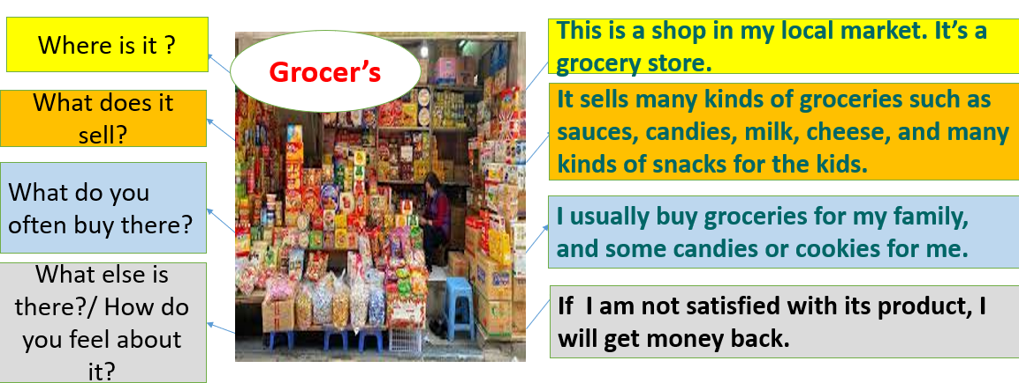
5. WRAP-UP & HOME WORK (3’)
* WRAP-UP
- Words relating to markets in Vietnam (overlook, variety, catalogue, reasonable price, be satisfied with…)
- Identify specific details about shopping in Hội An, Việt Nam.
- Describe one shop or one market in students’ hometown.
* HOME WORK
- Learn the new words by heart.
- Practice talking about one shop or one market.
- Do exercises in the workbook page 62.
- Prepare for Lesson 7.4: Grammar 2.

