TRƯỜNG THCS HẠ ĐÌNH ĐỀ THI KHẢO SÁT TIẾNG ANH 8 - THÁNG 1/2023
NĂM HỌC 2022-2023
(Thời gian làm bài: 60 phút)

Mã đề 123
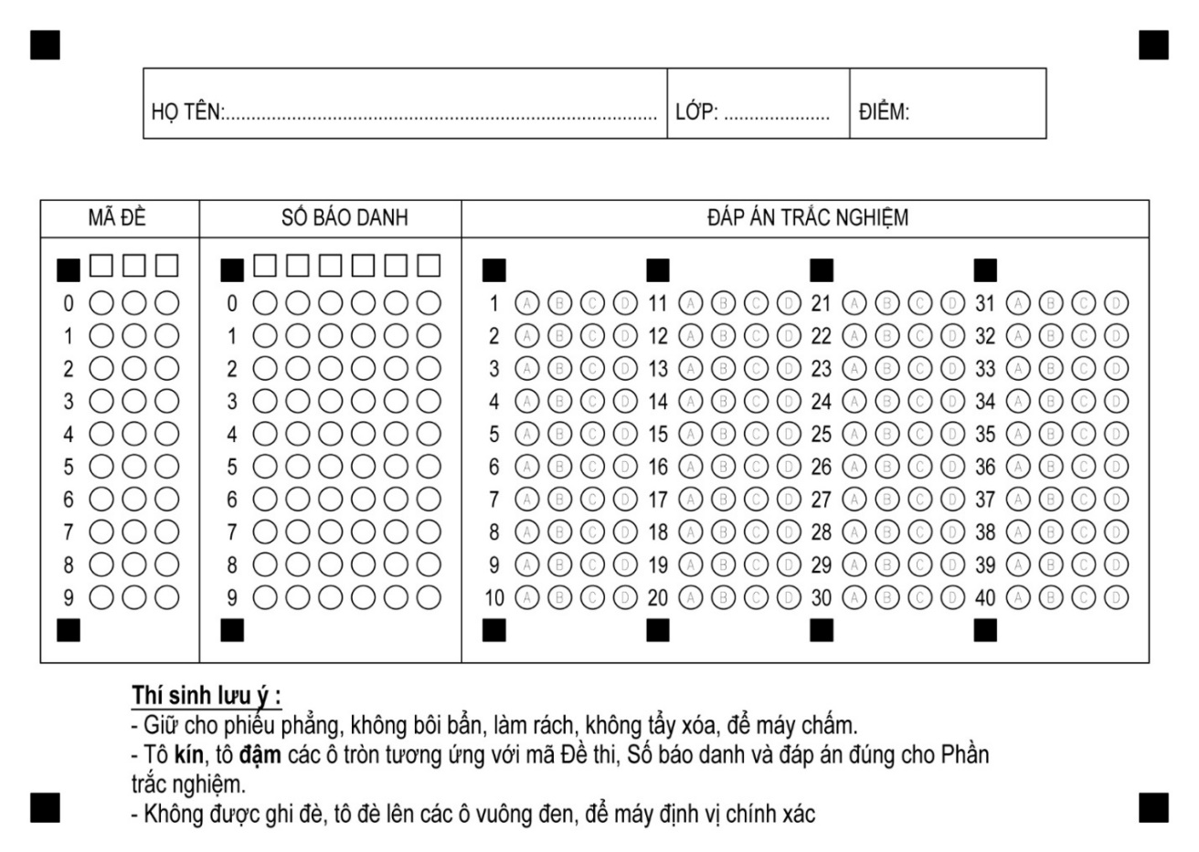

Find the word which has a different sound in the underlined part.
1. A. one B. bottle C. coffee D. pot
2. A. cooked B. stayed C. lived D. smiled
Choose a word in each line that has different stress pattern.
3. A. scientist B. dramatic C. athletic D. domestic
4. A. national B. chemical C. medical D. informal
Choose the correct option for each gap in the sentences.
5. Mi and Nick like ______________ back Mi’s home village on holiday.
A. comes B. come C. came D. coming
6. If the factory____________ dumping poison into the lake, all the fish and other aquatic animals will die.
A. continues B. to continue C. continued D. will continue
7.Many aquatic animals and plants have died _______the oil spill.
A. because B. due to C. since D. as
8.If the air wasn’t dirty, I ________________ so much.
A. wouldn’t sneeze B. sneeze C. would sneeze D. to sneeze
9.Water pollution is the ________________ in the lake has made the fish die.
A. contaminating B. contaminate C. contaminated D. contamination
10. The famous Sydney Opera House as an arts center since 1973.
A. serves B. served C. have served D. has served
11. If you the president, what would you do to help the environment?
A. would be B. are C. had been D. were
12. Don’t drink that water. It’s .
A. polluted B. pure C. damaged D. dumped
13. Do you know that the telephone, the TV and penicillin are Scottish ______.
A. inventors B. inventor C. inventions D. invention
14. Polluted air in the city made Bob_______ ill.
A. become B. became C. to become D. becoming

15. Have you come _______ solutions to this problem?
A. up to B. to with C. up with D. on to
16. The roof of the building _____________ in a storm a few days ago.
A. damaged B. was damaged C. has damaged D. has been damaged
Mark the letter A, B, C or D to indicate the most suitable response to complete the following exchanges.
17. Son: ’Why don't we go fishing this afternoon?" Father: “……………”
A. That’s a good idea B. Glad you enjoyed it
C. The traffic is not too bad, I think. D. Yes, let’s go
18. Linh: Mai has won the first prize. - Ha: ..................!
A. That's awesome B. Oh dear C. How terrible D. That's shocking
Mark the letter A, B, C or D to indicate the word(s) CLOSET in meaning to the underlined words.
19. If we know English very well, we will not find it hard to understand what people say.
A. easy B. simple C. difficult D. wonderful
20. Reading books, listening to radio and watching films are better ways to memorize words.
A. remember B. forget C. learn D. communicate
Find ONE mistake in each sentence.
21. The fish are dead because the polluted water.
A B C D
22. Ships spill oil in oceans and rivers led to the die of many aquatic animals.
A B C D
Reading comprehension
Read the following passage and choose the most suitable answer to fill in each blank.
Rivers are one of the world’s most important natural ………….……. (23). Many cities are on large rivers, and almost every country has at least one river that …………………..... (24) an important part in the lives of its people.
Besides transportation, rivers …………..… (25)food, water for crops, water to drink, and opportunities for recreation for people who live along their banks. And in order to get water for crops, engineers sometimes build a dam across a river and let the water become a lake behind the dam. Then people use their water not only to irrigate fields …….…(26) to make electricity for home and industries.
However, the water often becomes polluted when cities on river banks ………. (27) in size and the number of industries increases. We are learning that it is necessary to keep rivers clean if we want to enjoy the benefits of the natural resources.
23. A. resources B. goods C. possessions D. materials
24. A. makes B. plays C. does D. comes
25. A. give B. send C. get D. provide
26. A. but as well B. and C. as well as D. but also
27. A. get B. become C. plant D. grow
Read the text and choose the correct answer:

Ethnic Groups
Vietnam is a multi-nationality country with 54 ethnic groups. The Viet (Kinh) people account for 87% of the country’s population and mainly inhabit the Red River delta, the central coastal delta, the Mekong delta and major cities. The other 53 ethnic minority groups, totaling over 8 million people, are scattered over mountain areas (covering two-thirds of the country’s territory) spreading from the North to the South.
Among ethnic minorities, the most populated are Tay, Thai, Muong, Hoa, Khmer, Nung... with a population of around 1 million each, while the least populated are Brau, Roman, Odu with several hundred people each.

A number of ethnic minorities had mastered some farming techniques. They grew rice plants in swamped paddy fields and carried out irrigation. Others went hunting, fishing, collecting and lived a semi-nomadic life. Each group has its own culture, diverse and special. Beliefs and religions of the Vietnamese ethnic minority groups were also disparate from each other.
28. Why Vietnam is a multi-nationality country?
A. Because there are 54 nationalities in Vietnam.
B. Because the Kinh is the most major ethnic group in Vietnam.
C. Because there are many people in Vietnam.
D. Because there are 54 peoples in Vietnam.
29. Who is the more populated people in Vietnam?
A. The Kinh B. The Thai C. The Tay D. The Khmer
30. Where do ethnic minority groups mainly live?
A. In lowland areas B. In major cities
C. In mountainous areas D. In the Mekong delta
31. Which of the following statements is true of minor ethnic peoples?
A. They account for 87% of the country's population.
B. Many were good at farming methods.
C. The least populated are Tay, Thai, Muong, Hoa, Khmer.
D. All groups have the same culture.
32. Which of the following statements is not true?
A. The least populated are Brau, Roman, Odu.
B. The (Kinh) people mainly inhabit the Red River delta, the central coastal delta, the Mekong delta and major cities.
C. Beliefs and religions of the Vietnamese ethnic minority groups were the same.
D. Some minor groups went hunting, fishing, collecting and lived a semi- nomadic life.
WRITING SENTENCES

Choose the best sentence that can be made from the cues given:
33. When/1/ wander/ the castle/1/ see/ old servant/ spin.
A. When I were wandering through the castle, I saw an old servant spinning.
B. When I was wandering through the castle, I saw an old servant spinning.
C. When I wandered through the castle, I was seeing an old servant spinning.
D. When I am wandering through the castle, I had seen an old servant spinning.
34. The custom/ we/ have/ cook/ new dish/ each year.
A. The custom is that we have cooked a new dish each year.
B. The custom is we have cook the new dish each year.
C. The custom is that we have to cook the new dish each year.
D. The custom is that we have to cook a new dish each year.
Rearrange the words to form complete sentences:
35. Pauline/ to/ loves/ go/ to/ beach/ the/ and/ spend/ days/ her/ sunbathing.
_____________________________________________________________
36. this/ time/ at/ yesterday, I/ homework/ my/ doing/ was.
_____________________________________________________________

Combine each pair of sentences into one, using the words in brackets:
37. Tam worked hard. Her stepmother never treated her kindly. (BUT)
_____________________________________________________________
38. I have a wish. I will wish every poor but hard-working girl a happy life. (IF)
_____________________________________________________________
39. Tam was working hard. Cam was sleeping. (WHILE)
_____________________________________________________________
40. In Japan, bowing is so important. It is a way to show respect. (BECAUSE)
_____________________________________________________________

TRƯỜNG THCS HẠ ĐÌNH ĐỀ THI KHẢO SÁT TIẾNG ANH 8 - THÁNG 1/2023
NĂM HỌC 2022-2023
(Thời gian làm bài: 60 phút)

Mã đề 216
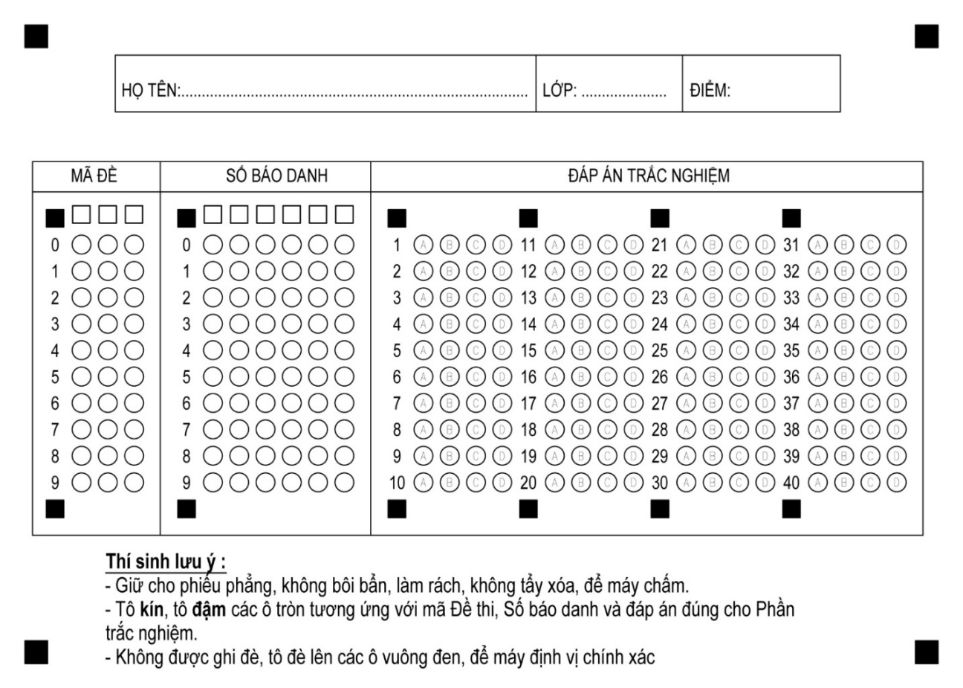

Mark the letter A, B, C or D to indicate the word(s) CLOSET in meaning to the underlined words.
1. If we know English very well, we will not find it hard to understand what people say.
A. easy B. simple C. difficult D. wonderful
2. Reading books, listening to radio and watching films are better ways to memorize words.
A. remember B. forget C. learn D. communicate
Choose the correct option for each gap in the sentences.
3. Mi and Nick like ______________ back Mi’s home village on holiday.
A. comes B. come C. came D. coming
4. If the factory____________ dumping poison into the lake, all the fish and other aquatic animals will die.
A. continues B. to continue C. continued D. will continue
5.Many aquatic animals and plants have died _______the oil spill.
A. because B. due to C. since D. as
6. Don’t drink that water. It’s .
A. polluted B. pure C. damaged D. dumped
7. Do you know that the telephone, the TV and penicillin are Scottish ______.
A. inventors B. inventor C. inventions D. invention
8. Polluted air in the city made Bob_______ ill.
A. become B. became C. to become D. becoming
9. Have you come _______ solutions to this problem?
A. up to B. to with C. up with D. on to
10. The roof of the building _____________ in a storm a few days ago.
A. damaged B. was damaged C. has damaged D. has been damaged
11. If the air wasn’t dirty, I ________________ so much.
A. wouldn’t sneeze B. sneeze C. would sneeze D. to sneeze

12.Water pollution is the ________________ in the lake has made the fish die.
A. contaminating B. contaminate C. contaminated D. contamination
13. The famous Sydney Opera House as an arts center since 1973.
A. serves B. served C. have served D. has served
14. If you the president, what would you do to help the environment?
A. would be B. are C. had been D. were
Mark the letter A, B, C or D to indicate the most suitable response to complete the following exchanges.
15. Son: ’Why don't we go fishing this afternoon?" Father: “……………”
A. That’s a good idea B. Glad you enjoyed it
C. The traffic is not too bad, I think. D. Yes, let’s go
16. Linh: Mai has won the first prize. - Ha: ..................!
A. That's awesome B. Oh dear C. How terrible D. That's shocking
Find the word which has a different sound in the underlined part.
17. A. one B. bottle C. coffee D. pot
18. A. cooked B. stayed C. lived D. smiled
Find ONE mistake in each sentence.
19. The fish are dead because the polluted water.
A B C D
20. Ships spill oil in oceans and rivers led to the die of many aquatic animals.
A B C D
Choose a word in each line that has different stress pattern.
21. A. scientist B. dramatic C. athletic D. domestic
22. A. national B. chemical C. medical D. informal
Reading comprehension
Read the text and choose the correct answer:

Ethnic Groups
Vietnam is a multi-nationality country with 54 ethnic groups. The Viet (Kinh) people account for 87% of the country’s population and mainly inhabit the Red River delta, the central coastal delta, the Mekong delta and major cities. The other 53 ethnic minority groups, totaling over 8 million people, are scattered over mountain areas (covering two-thirds of the country’s territory) spreading from the North to the South.
Among ethnic minorities, the most populated are Tay, Thai, Muong, Hoa, Khmer, Nung... with a population of around 1 million each, while the least populated are Brau, Roman, Odu with several hundred people each.

A number of ethnic minorities had mastered some farming techniques. They grew rice plants in swamped paddy fields and carried out irrigation. Others went hunting, fishing, collecting and lived a semi-nomadic life. Each group has its own culture, diverse and special. Beliefs and religions of the Vietnamese ethnic minority groups were also disparate from each other.
23. Why Vietnam is a multi-nationality country?
A. Because there are 54 nationalities in Vietnam.
B. Because the Kinh is the most major ethnic group in Vietnam.
C. Because there are many people in Vietnam.
D. Because there are 54 peoples in Vietnam.
24. Who is the more populated people in Vietnam?
A. The Kinh B. The Thai C. The Tay D. The Khmer
25. Where do ethnic minority groups mainly live?
A. In lowland areas B. In major cities
C. In mountainous areas D. In the Mekong delta
26. Which of the following statements is true of minor ethnic peoples?
A. They account for 87% of the country's population.
B. Many were good at farming methods.
C. The least populated are Tay, Thai, Muong, Hoa, Khmer.
D. All groups have the same culture.
27. Which of the following statements is not true?
A. The least populated are Brau, Roman, Odu.
B. The (Kinh) people mainly inhabit the Red River delta, the central coastal delta, the Mekong delta and major cities.
C. Beliefs and religions of the Vietnamese ethnic minority groups were the same.
D. Some minor groups went hunting, fishing, collecting and lived a semi- nomadic life.
Read the following passage and choose the most suitable answer to fill in each blank.
Rivers are one of the world’s most important natural ………….……. (28). Many cities are on large rivers, and almost every country has at least one river that …………………..... (29) an important part in the lives of its people.
Besides transportation, rivers …………..… (30)food, water for crops, water to drink, and opportunities for recreation for people who live along their banks. And in order to get water for crops, engineers sometimes build a dam across a river and let the water become a lake behind the dam. Then people use their water not only to irrigate fields …….…(31) to make electricity for home and industries.
However, the water often becomes polluted when cities on river banks ………. (32) in size and the number of industries increases. We are learning that it is necessary to keep rivers clean if we want to enjoy the benefits of the natural resources.
28. A. resources B. goods C. possessions D. materials
29. A. makes B. plays C. does D. comes
30. A. give B. send C. get D. provide
31. A. but as well B. and C. as well as D. but also
32. A. get B. become C. plant D. grow
WRITING SENTENCES

Choose the best sentence that can be made from the cues given:
33. When/1/ wander/ the castle/1/ see/ old servant/ spin.
A. When I were wandering through the castle, I saw an old servant spinning.
B. When I was wandering through the castle, I saw an old servant spinning.
C. When I wandered through the castle, I was seeing an old servant spinning.
D. When I am wandering through the castle, I had seen an old servant spinning.
34. The custom/ we/ have/ cook/ new dish/ each year.
A. The custom is that we have cooked a new dish each year.
B. The custom is we have cook the new dish each year.
C. The custom is that we have to cook the new dish each year.
D. The custom is that we have to cook a new dish each year.

Combine each pair of sentences into one, using the words in brackets:
35. Tam was working hard. Cam was sleeping. (WHILE)
_____________________________________________________________
36. In Japan, bowing is so important. It is a way to show respect. (BECAUSE)
_____________________________________________________________
37. Tam worked hard. Her stepmother never treated her kindly. (BUT)
_____________________________________________________________
38. I have a wish. I will wish every poor but hard-working girl a happy life. (IF)
_____________________________________________________________
Rearrange the words to form complete sentences:
39. Pauline/ to/ loves/ go/ to/ beach/ the/ and/ spend/ days/ her/ sunbathing.
_____________________________________________________________
40. this/ time/ at/ yesterday, I/ homework/ my/ doing/ was.
_____________________________________________________________

