PHÒNG GD&ĐT QUẬN THANH XUÂN ĐỀ THI THÁNG 1 - MÔN TIẾNG ANH - KHỐI 9
TRƯỜNG THCS HẠ ĐÌNH NĂM HỌC: 2022 - 2023
(Đề thi gồm có 04 trang) Thời gian làm bài: 60 phút
Mã đề thi: 009
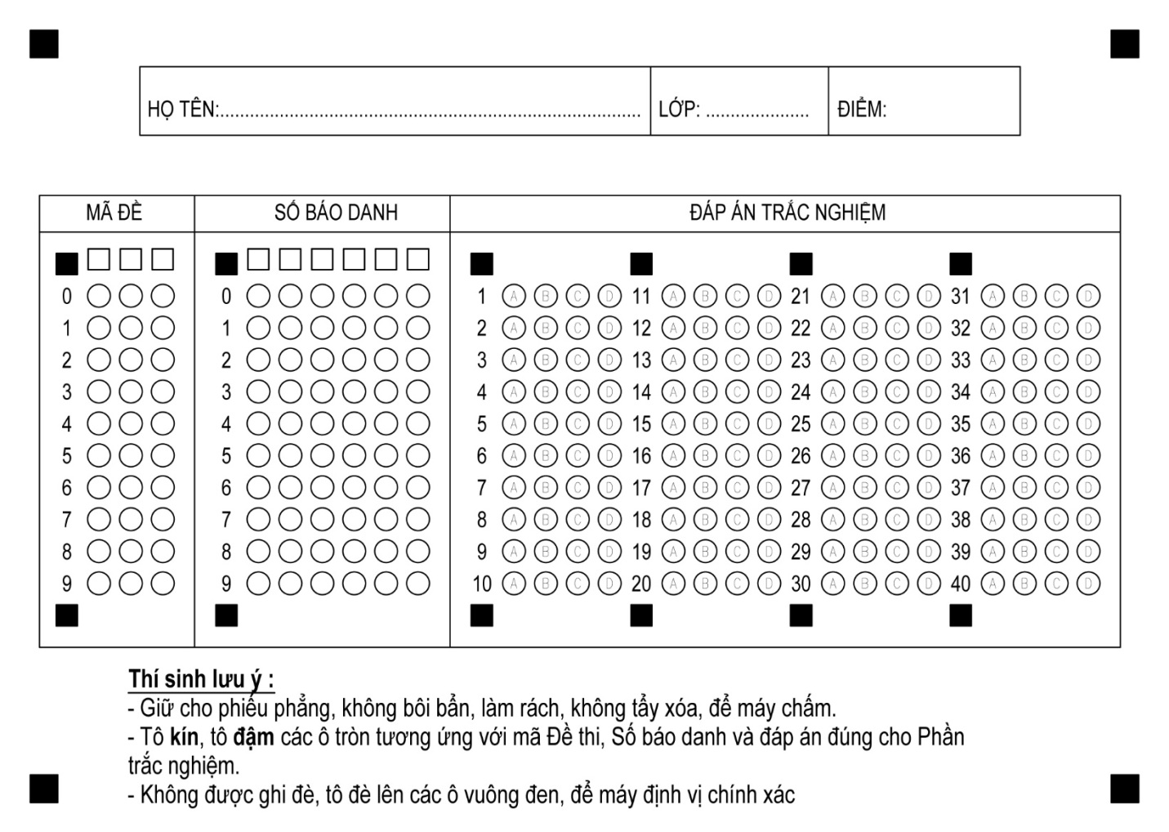

Mark the letter A, B, C, or D on your answer sheet to indicate the word whose underlined part differs from the other three in pronunciation in each of the following questions
1.A. complex B. wonder C. proper D. backdrop
2.A. cooked B. weighed C. washed D. stopped
Mark the letter A, B, C, or D on your answer sheet to indicate the word that differs from the other three in the position of primary stress in each of the following questions.
3.A. member B. village C. picture D. begin
4.A. decide B. modern C. arrive D. reduce
Mark the letter A, B, C or D on your answer sheet to indicate the correct answer to each of the following questions.
5. My brothers__________signs to communicate with each other at this time yesterday.
A. used B. are using C. were using D. using
6. Tom was impressed by the _______________of dishes on offer.
A. various B. vary C. varied D. variety
7. _______ a small population, Japanese people consume more than 10% of the world’s fish.
A. Despite B. In spite C. Despite of D. Although
8.If we go on _________ the water, there will be a shortage of fresh water in the near future.
A. pollute B. pollution C. polluting D. polluted
9. Are you thirsty? Would you like ___________ glass of water?
A. a B. an C. some D. any
10. Susan’s uncle has worked hard _____________ he can have a better life.
A. so that B. so as to C. in order to D. in order
11. The senior level entrance examination will be held _________ July 10th, 2030.
A. in B. on C. at D. to
12. Crime affects everyone in the city, ______________?
A. didn’t it B. doesn’t it C. don’t they D. do they
13. | He lives happily in a very village in Hue.
 | A. picture | B. pictures | C. picturesque | D. picturesquely
14.Hannah came____________a fantastic idea for the school trip.
A. down to B. down with C. over to D. up with
Mark the letter A, B, C or D on your answer sheet to indicate the word(s) CLOSEST in meaning to the underlined word(s) in each of the following questions.
15. NASA has recently discovered something new about Mars.
A. narrowed down B. got into C. lived on D. found out
16. What has been the most challenging experience in your life as an astronaut, Mr. Tuan?
A. easy B. dangerous C. lucky D. difficult
Mark the letter A, B, C or D on your answer sheet to indicate the word(s) OPPOSITE in meaning to the underlined word(s) in each of the following questions.
17. Some areas of the country are just too cold to be habitable.
A. livable B. unable to live in
C. have enough conditions for living D. capable of being inhabited
18. To be honest, I go to the museums once in a blue moon.
A. once in a while B. from time to time
C. very often D. seldom
Mark the letter A, B, C or D on your answer sheet to indicate the option that best completes each of the following exchanges.
19. Quang and Nam are talking about the way to save electricity.
- Quang: “I think we should use energy-saving bulbs to save electricity." - Nam: “______”
A. That’s a good idea. B. Great! Don’t do that.
C. Good but I don’t want to. D. Well done.
20.Two friends are talking to each other at a class reunion
- Mai: “_________” - Lan "I work at a bank."
A. What do you do for a living, Lan’ B. Where did you work Lan?
C. How do you do, Lan? D. How are you going. Lan?
Read the following passage and mark the letter A, B, C or D to indicate the correct word or phrase that best fits each of the numbered blanks.
Alexander Mc Queen
Alexander McQueen is one of the world’s most famous clothes designers, He stated working in an expensive clothes shop in London where he made clothes for people like Prince Charles and the Russian leader Mikhail Gorbrachev. (21) ________ the 1990s, he decided to work on his own and he (22) ________ his own fashion business.
Many rich and famous people became his customers and the clothes (23) ________ he made for them were often unusual. Magazines and newspaper liked to write (24) ________ about his clothes and about him. However, he wasn’t always pleasant to journalists so they didn’t always write nice things about him. But McQueen never cared what anyone said about him.
Unfortunately, he (25) ________ in 2010 when he was only 41 years old.
21. A. In B. On C. At D. For
22. A. closed B. opened C. sold D. set
23. A. whose B. who C. which D. whom
24. A. books B. films C. programs D. articles
25. A. dies B. died C. die D. dying
Mark the letter A, B, C or D on your answer sheet to indicate the underlined part that needs correction in each of the following questions.
26. She doesn’t know why her father finds horse-riding very excited.
A. know B. her father C. horse-riding D. excited
27. Now that the stress of examination are over, we can go somewhere for our holiday.
- the B. are C. can go D. for our holiday
28. If your son were old enough, he could be able to take the competition next week.
A. were B. old enough C. could D. to take
Read the following passage and mark the letter A, B, C or D on your answer sheet to indicate the best option to answer each of the following questions
Plastic is a material we use every day. The first plastics were made more than 100 years ago from parts of plants. Plastics are now made from oil, coal and natural gas. We are using up these things so fast that the Earth's supplies may run out. Because of this, scientists are investigating new ideas for making plastics from plants such as sweet potato, bamboo and flax.
Things made from plastic can be useful for people but bad for the planet. Some plastics can last for a long time without wearing out, and can be difficult to get rid of when they are not needed. They can remain in rubbish dumps for hundreds of years.
Recycling is a good way to solve the problems of unwanted plastics. Recycled waste materials can be used again to make new products. This can be difficult as different types of plastic need to be recycled in different ways. Some kinds of plastics can be melted down and used to make new things such as bags and bottles. Others can be made into fibres for clothing.
Another way to protect the environment is to use canvas bags for shopping instead of plastic ones. A lot of plastic objects can also be reused. Plastic bottles can be refilled many times, rather than thrown away once they are empty. Unwanted plastic goods such as CDs and toys can be sold or given away to charity shops.
29. What is the passage mainly about?
A. Plastic effects and solutions to the problem. B. Plastic history and its usefulness.
C. The ways to reduce the harm of plastic. D. Materials that plastic is made of.
30. The phrase "get rid of" in paragraph 2 is closest in meaning to
A. remove B. create C. keep D. make
31. According to the passage, things made from plastic are bad for our environment because
A. they are dangerous to marine life
B. they are very useful for people
C. plastics can remain for a long time without decomposing
D. people reuse plastic objects before recycling them
32. The word "they” in paragraph 4 refers to
A. objects B. canvas bags C. toys D. plastic bottles
Mark the letter A, B, C or D to indicate the sentence that is closest in meaning to each of the following questions.
33. Charlie said, "Nora and Jim are getting married tomorrow ”
A. He said that Nora and Jim are getting married tomorrow
B.. He said that Nora and Jim were getting married the next day.
C. He said that Nora and Jim were getting married tomorrow.
D. He said that Nora and Jim are getting married the next day.
34. I have never seen a UFO before.
A. This is the first time I have seen a UFO.
B. I used to see a UFO when I was small.
C. I have already seen a UFO.
D. The first time I saw a UFO was a year ago.
35. The Government sent medical supplies to victims of the flood immediately.
A. Medical supplies sent to victims of the flood immediately by the Government.
B. Medical supplies were sent to victims of the flood immediately by the Government.
C. Medical supplies was sent to victims of the flood immediately by the Government.
D. Medical supplies being sent to victims of the flood immediately by the Government.
36. My father cooks better than me.
A. I cook not better than my father.
B. I don’t cook as good as my father.
C. I cook worse as my father.
D. I don’t cook as well as my father.
Mark the letter A, B, C, or D on your answer sheet to indicate the sentence that best combines
each pair of sentences
37. woman/say/not be responsible/the accident
A. The woman said not to be responsible for the accident.
B. The woman said that she wasn't responsible of the accident.
C. The woman said that she isn't responsible for the accident.
D. The woman said that she wasn't responsible for the accident.
38. I wish /can/go camping/you/ tomorrow
A. I wish I can go camping with you tomorrow.
B. I wish I can go to the camp with you tomorrow.
C. I wish I could go camping with you tomorrow.
D. I wish I could going to camp with you tomorrow.
39. What /you/use to do/your free time/a child?
A. What did you use to do in your free time as a child?
B. What did you use doing in your free time as a child?
C. What do you used to do in your free time when a child?
D. What were you used to do in your free time as a child?
40. She/ suggest/ take/ plane today/ or/ go/ train tomorrow.
A. She suggested taking the plane today or go by train tomorrow.
B. She suggested to take the plane today or to go by train tomorrow.
C. She suggested taking the plane today or going by train tomorrow.
D. She suggested that we should take the plane today or going by train tomorrow.

PHÒNG GD&ĐT QUẬN THANH XUÂN ĐỀ THI THÁNG 1 - MÔN TIẾNG ANH - KHỐI 9
TRƯỜNG THCS HẠ ĐÌNH NĂM HỌC: 2022 - 2023
(Đề thi gồm có 04 trang) Thời gian làm bài: 60 phút
Mã đề thi: 018

Mark the letter A, B, C, or D on your answer sheet to indicate the sentence that best combines
each pair of sentences
1. I wish /can/go camping/you/ tomorrow
A. I wish I can go camping with you tomorrow.
B. I wish I can go to the camp with you tomorrow.
C. I wish I could go camping with you tomorrow.
D. I wish I could going to camp with you tomorrow.
2. She/ suggest/ take/ plane today/ or/ go/ train tomorrow.
A. She suggested taking the plane today or go by train tomorrow.
B. She suggested to take the plane today or to go by train tomorrow.
C. She suggested taking the plane today or going by train tomorrow.
D. She suggested that we should take the plane today or going by train tomorrow.
3. woman/say/not be responsible/the accident
A. The woman said not to be responsible for the accident.
B. The woman said that she wasn't responsible of the accident.
C. The woman said that she isn't responsible for the accident.
D. The woman said that she wasn't responsible for the accident.
4. What /you/use to do/your free time/a child?
A. What did you use to do in your free time as a child?
B. What did you use doing in your free time as a child?
C. What do you used to do in your free time when a child?
D. What were you used to do in your free time as a child?

Mark the letter A, B, C or D on your answer sheet to indicate the word(s) CLOSEST in meaning to the underlined word(s) in each of the following questions.
5. What has been the most challenging experience in your life as an astronaut, Mr. Tuan?
A. easy B. dangerous C. lucky D. Difficult
6. NASA has recently discovered something new about Mars.
A. narrowed down B. got into C. lived on D. found out
Mark the letter A, B, C, or D on your answer sheet to indicate the word whose underlined part differs from the other three in pronunciation in each of the following questions
7.A. cooked B. weighed C. washed D. stopped
8.A. complex B. wonder C. proper D. backdrop
Mark the letter A, B, C or D on your answer sheet to indicate the correct answer to each of the following questions.
9. Tom was impressed by the _______________of dishes on offer.
A. various B. vary C. varied D. variety
10.If we go on _________ the water, there will be a shortage of fresh water in the near future.
A. pollute B. pollution C. polluting D. polluted
11. Are you thirsty? Would you like ___________ glass of water?
A. a B. an C. some D. any
12. Susan’s uncle has worked hard _____________ he can have a better life.
A. so that B. so as to C. in order to D. in order
13. Crime affects everyone in the city, ______________?
A. didn’t it B. doesn’t it C. don’t they D. do they
14.Hannah came____________a fantastic idea for the school trip.
A. down to B. down with C. over to D. up with
15. My brothers__________signs to communicate with each other at this time yesterday.
A. used B. are using C. were using D. using
16. ______ a small population, Japanese people consume more than 10% of the world’s fish.
A. Despite B. In spite C. Despite of D. Although
17. The senior level entrance examination will be held _________ July 10th, 2030.
A. in B. on C. at D. to
18. | He lives happily in a very village in Hue.
 | A. picture | B. pictures | C. picturesque | D. picturesquely
Mark the letter A, B, C or D on your answer sheet to indicate the word(s) OPPOSITE in meaning to the underlined word(s) in each of the following questions.
19. To be honest, I go to the museums once in a blue moon.
A. once in a while B. from time to time
C. very often D. Seldom
20. Some areas of the country are just too cold to be habitable.
A. livable B. unable to live in
C. have enough conditions for living D. capable of being inhabited
Mark the letter A, B, C or D on your answer sheet to indicate the option that best completes each of the following exchanges.
21. Quang and Nam are talking about the way to save electricity.
- Quang: “I think we should use energy-saving bulbs to save electricity." - Nam: “______”
A. That’s a good idea. B. Great! Don’t do that.
C. Good but I don’t want to. D. Well done.
22.Two friends are talking to each other at a class reunion
- Mai: “_________” - Lan "I work at a bank."
A. What do you do for a living, Lan’ B. Where did you work Lan?
C. How do you do, Lan? D. How are you going. Lan?

Mark the letter A, B, C or D to indicate the sentence that is closest in meaning to each of the following questions.
23. I have never seen a UFO before.
A. This is the first time I have seen a UFO.
B. I used to see a UFO when I was small.
C. I have already seen a UFO.
D. The first time I saw a UFO was a year ago.
24. My father cooks better than me.
A. I cook not better than my father.
B. I don’t cook as good as my father.
C. I cook worse as my father.
D. I don’t cook as well as my father.
25. Charlie said, "Nora and Jim are getting married tomorrow ”
A. He said that Nora and Jim are getting married tomorrow
B.. He said that Nora and Jim were getting married the next day.
C. He said that Nora and Jim were getting married tomorrow.
D. He said that Nora and Jim are getting married the next day.
26. The Government sent medical supplies to victims of the flood immediately.
A. Medical supplies sent to victims of the flood immediately by the Government.
B. Medical supplies were sent to victims of the flood immediately by the Government.
C. Medical supplies was sent to victims of the flood immediately by the Government.
D. Medical supplies being sent to victims of the flood immediately by the Government.
Read the following passage and mark the letter A, B, C or D to indicate the correct word or phrase that best fits each of the numbered blanks.
Alexander Mc Queen
Alexander McQueen is one of the world’s most famous clothes designers, He stated working in an expensive clothes shop in London where he made clothes for people like Prince Charles and the Russian leader Mikhail Gorbrachev. (27) ________ the 1990s, he decided to work on his own and he (28) ________ his own fashion business.
Many rich and famous people became his customers and the clothes (29) ________ he made for them were often unusual. Magazines and newspaper liked to write (30) ________ about his clothes and about him. However, he wasn’t always pleasant to journalists so they didn’t always write nice things about him. But McQueen never cared what anyone said about him.
Unfortunately, he (31) ________ in 2010 when he was only 41 years old.
27. A. In B. On C. At D. For
28. A. closed B. opened C. sold D. set
29. A. whose B. who C. which D. whom
30. A. books B. films C. programs D. articles
31. A. dies B. died C. die D. dying
Mark the letter A, B, C, or D on your answer sheet to indicate the word that differs from the other three in the position of primary stress in each of the following questions.
32.A. decide B. modern C. arrive D. reduce
33.A. member B. village C. picture D. begin
Mark the letter A, B, C or D on your answer sheet to indicate the underlined part that needs correction in each of the following questions.
34. If your son were old enough, he could be able to take the competition next week.
A. were B. old enough C. could D. to take
35. Now that the stress of examination are over, we can go somewhere for our holiday.
- the B. are C. can go D. for our holiday
36. She doesn’t know why her father finds horse-riding very excited.
A. know B. her father C. horse-riding D. excited

Read the following passage and mark the letter A, B, C or D on your answer sheet to indicate the best option to answer each of the following questions
Plastic is a material we use every day. The first plastics were made more than 100 years ago from parts of plants. Plastics are now made from oil, coal and natural gas. We are using up these things so fast that the Earth's supplies may run out. Because of this, scientists are investigating new ideas for making plastics from plants such as sweet potato, bamboo and flax.
Things made from plastic can be useful for people but bad for the planet. Some plastics can last for a long time without wearing out, and can be difficult to get rid of when they are not needed. They can remain in rubbish dumps for hundreds of years.
Recycling is a good way to solve the problems of unwanted plastics. Recycled waste materials can be used again to make new products. This can be difficult as different types of plastic need to be recycled in different ways. Some kinds of plastics can be melted down and used to make new things such as bags and bottles. Others can be made into fibres for clothing.
Another way to protect the environment is to use canvas bags for shopping instead of plastic ones. A lot of plastic objects can also be reused. Plastic bottles can be refilled many times, rather than thrown away once they are empty. Unwanted plastic goods such as CDs and toys can be sold or given away to charity shops.
37. What is the passage mainly about?
A. Plastic effects and solutions to the problem. B. Plastic history and its usefulness.
C. The ways to reduce the harm of plastic. D. Materials that plastic is made of.
38. The phrase "get rid of" in paragraph 2 is closest in meaning to
A. remove B. create C. keep D. make
39. According to the passage, things made from plastic are bad for our environment because
A. they are dangerous to marine life
B. they are very useful for people
C. plastics can remain for a long time without decomposing
D. people reuse plastic objects before recycling them
40. The word "they” in paragraph 4 refers to
A. objects B. canvas bags C. toys D. plastic bottles

