Date of planning:  Date of teaching: | ENGLISH 7
Period 1 - INSTRUCTIONS FOR USING TEXTBOOKS, STUDYING MATERIALS
I. OBJECTIVES:
1. Knowledge:
- To introduce new Tieng Anh 6 textbooks. Student’s book and Workbook
- Tell students something about Great Britain; England and English. Students learn how to study English well and know the way to learn English.
*Vocabulary: Use lexical items related to text book, and the way to learn English in class; at home... some classroom languages.
* Grammar: to be; possessive adjectives….
2. Competence:
- By the end of the lesson, students will be able to know how to study English effectively and how to use new Tieng Anh 7 (English Discovery 7 ) textbooks and know the methods to study new Tieng Anh 7 textbooks.
3.Quality/Behavior: To teach Ss the love of English; the love of their new school. The awareness about importance of learning English. Ss have the good attitude to working in groups, individual work, pairwork, cooperative learning and working.
II. TEACHING AIDS:
- Teacher: Text book, laptop, louspeaker, projector…
- Students: Text books, studying equipments….
- Method: T-WC; group works; individual ……
III. PROCEDURE:
1. WARM UP & INTRODUCTION ( 3’- 5’)
Aims:
- To create a friendly and atmosphere in the class before the lesson;
- To give T and Ss a chance to introduce themselves;
- To lead into the unit
* Content: Have some warm-up activities to creat a friendly and relaxed atmosphere to inspire Ss to warm up to the new class.
* Organisation: Teacher’s instructions…
Teacher’s & Student’s activities |  | Content
+ Greeting  + Chatting  - Teacher (T) introduces himself/ herself  - T may introduce some warm-up activities to creat a friendly and relaxed atmostphere to inspire Ss to warm up to the new class…  - Have Ss to introduce themselves.  - Students (Ss) listen and learn how to introduce themselves.  - T encourages Ss to talk in English as much as possible  - T leads to the first unit of the new school yearl.  - Students (Ss) listen and learn how to do the tasks.  - Ss answer the teacher’s questions  - T writes the unit title on the board and ask Ss guest what they are going to learn this unit …  - T asks Ss to open their book and introduce what they are going to study….  - Ss open their book and write. |  | + Greeting  + Chatting. T_Ss    - Introduce themselves (name; age;address; likes; dislikes ….friends… )
2. NEW LESSON (12’-15’)
ACTIVITY 1+ 2:
Aims: - To set the context for the introductory;
- To introduce the topic of the unit, the vocabulary, the sounds, and the grammar points to be learned.
* Content: Some brief notes; Some things about England, English. Introduce New Tieng Anh 7(English Discovery 7 )
* Outcome: Know something about England, English; Learn how to use New Tieng Anh 7 (English Discovery 7 )
* Organisation: Teacher’s instructions….

Teacher’s & Student’s activities | Content
1& 2. T. asks sts some questions about England and English.  - T. gives sts something about England and English.  - Ss listen carefully and read aloud.  - Ss fulfil teacher’s requirements  - Ss give the answers  - Ss answer if possile  - Ss listen carefully and read aloud.  - Ss find out the words related to the topic.  * Introduction:  - T introduces: English is an international language. Hundreds of million people speak English in the world. 400 million people speak English as their first language, 600 million people speak English as their second language or first foreign language. 4/5 of the world’s computers use program in English. ¾ of all international correspondence is in English.  3/ English Discovery 7 text book:  - T asks:  + How many units are there in English 7 text book?  + What are they about?  - SS answer  T: There are 10 units .  T: English is not too difficult but it requires you working hard.  - Sts need learn by heart all vocabulary and their usage.  - Ss review the lesson everyday.  - Ss learn English everyday. |   1. England.  - What do you know about England?  - It located in North-west coast of Europe with very mild weather not too hot but not too cold.  - It consists of four parts: England, Wales, Scotland and Ireland.  - It’s official name is the UK  - Each part has its own flag of UK.  2. English:  - How many people speak English as their mother tongue?  - How many people speak English as their first language?  - How many people speak English as their second language or first foreign language?  - Why do you learn English?  - Is it important? Difficult? Useful? Interesting?  => It’s very important, useful, interesting. It is the means of communication to one another.  * Introduction  3/ English Discovery 7 has 10 Units  + 5 CLIL  - Unit 0 has 5 lessons.  - From Unit 1 to Unit 9: each unit has 9 lessons  Leson 1: Vocabulary  Leson 2: Grammar  Leson 3: Reading and Vocabulary  Leson 4: Grammar  Leson 5: Listening and Vocabulary  Leson 6: Speaking  Leson 7: English in use  Leson 8: Vocabulary in action and Pronunciation  Leson 9: Revision  - 5 CLIL
3. PRACTICE (15’)
ACTIVITY 3:
Aims: To help Ss understand the lesson. Class room language
* Content: Some brief notes; Something about England, English . Classroom language…
* Outcome: Know something about England, English; Classroom language…
* Organisation: Teacher’s instructions….
Teacher’s & Student’s activities | Content
3. How to learn English best?  - T tells us how you learn best?  - T tells us how you can learn English best?  - T tell Ss how to improve your English :  - SS listen to the teacher carefully, learn E. from many sources, always enrich your vocabulary, do exercises carefully, practice speaking, listening, writing, reading everyday. …  - Ss listen carefully  - SS practice saying classroom languages  - Ss should work hard everyday to improve their English.  “ Hard work is the key to success” | * Some useful classroom languages:  - Who is the monitor?  - Who is absent today?  - Who is on duty today?  - May I go out?  - May I come in?.......  
4. PRODUCTION/ FURTHER PRACTICE (8’)
ACTIVITY 4:

Aims: To revise / teach classroom languages.
* Content: Some brief notes; Some things about England, English . Classroom language…
* Outcome: Know something about England, English; Classroom language…

* Organisation: Teacher’s instructions…..
Teacher’s & Student’s activities | Content
- T_Ss  - T gives some questions to introduce the class expressions.  - Have Ss listen and repeat.  - Teacher says “ go out, please” Go out  - Teacher says “No” Don’t go out  - Call on some pairs to practice in front of the class. | - The greetings : - Goodmorning  - Good afternoon  - Good evening  - Good bye ….  - We can say “ May I go out, please ?”  - You can say “Stand up, please”  - Listen, please  - Read after me  - Repeat please…..
IV. WRAP-UP & HOME WORK (2’)
- Instruct students to do their homework.
- Prepare textbook, workbook, exercise book,
- Prepare new lesson Unit one .
* HOME WORK
- Learn classroom languages.
- Prepare new lesson Unit one .

Date of planning:  Date of teaching: | ENGLISH 7  Period 2 - UNIT 0: WELCOME  Lesson 1: Introducing Nam
I. OBJECTIVES:
By the end of the lesson, students will be able to:
- use the vocabulary and grammar points to talk about their family members.
1. Knowledge:
- To practice listening and speaking.
* Vocabulary:
- name the family members in Nam’s family.
- pronounce the vocabulary of family members correctly.
* Grammar:
- remember the forms of possessive adjectives and possessive’s.
- use possessive adjectives and possessive’s to talk about family members.
2. Competence:
To know how to use vocabulary to talk about family members, and understand the main grammatical points, then do the tasks assigned in the textbook.
3. Quality/Behavior: To teach Ss to be hard-working and attentive in class. Ss have a positive attitude to working in groups, individual work, pair work, cooperative learning and working.
II. TEACHING AIDS:
- Teacher: Grade 7 textbook, Unit 0 (SB p. 4-5), laptop/computer connected to the Internet, loudspeaker, projector / TV, PPT slides…
- Students: Text books, studying equipment…
- Method: Active teach, T-WC; group works; individual…

III. PROCEDURE:
1. WARM UP (10’)
ACTIVITY 1:
* Aims:
- To set the context for the introductory;
- To introduce the topic of the unit, the vocabulary, the sounds, and the grammar points to be learned;
- To lead into the unit.
* Content: Some brief notes; something about family, family members, family names... Introduce Nam’s family members.
* Organization: Teacher’s instructions…

Teacher’s & Student’s activities | Content
1. (4’) Listen and read the text. Find the people in the photos.  (Ex 1, p. 4)  - T asks Ss to open their SB page 4, look at exercise 1.  - T calls a student to read the instruction then checks Ss’ understanding of it.  - T plays the audio and lets Ss listen.  - T calls some Ss to give answers then shows the answers on the slide.  2. (6’) Mark the sentences T (true), F (false). In pairs, correct the false sentences.  (Ex 2, p. 4)  - T asks Ss to open their SB page 4, look at exercise 2.  - T calls a student to read the instruction then checks Ss’ understanding of it.  - T asks Ss to work in pairs to complete the activity.  - T calls some pairs to give answers then shows the answers on the slide. | Answer keys:  1. Mrs. Hien  2. Mr. Phong  3. Lan  4. Nam  Answer keys:  2. T  3. F (brother => sister)  4. F (hasn’t got a job => is a policeman)  5. F (Đà Nẵng => Huế)
2. PRACTICE 1 (6’)
EXTRA ACTIVITY:
* Aims: To helps Ss review family vocabulary
* Content: Some brief notes; something about family, family members, family names...
* Outcome: Know something about family, family members, family names...
* Organisation: Teacher’s instructions….
Teacher’s & Student’s activities |  | Content
Lucky Star Game (Extra activity)  - T explains the game rules then checks instructions.  - Ss join in the game individually.  - T corrects Ss’ pronunciation if any. |  | Game rules:  ✔ Choose stars for questions.  ✔ Read the sentence carefully.  ✔ Fill in the blank with one word.  ✔ 1 correct answer => get points.
3. PRESENTATION (12’)
ACTIVITY 3:
* Aims:
- To present possessive adjectives in context.
- To present possessive’s in context.
* Content: Some brief notes; something about family, family members, family names...
* Outcome: Know something about family, family members, family names...
* Organisation: Teacher’s instructions….
Teacher’s & Student’s activities | Content
3. (6’) Look at Nam’s family tree. Complete the sentences below with the correct possessive adjectives. Write the name of the person.  (Ex 3, p. 5)  - T asks Ss to open their SB page 5, look at exercise 3.  - T calls a student to read the instruction then checks Ss’ understanding of it.  - T explains the grammar box.  - T asks Ss to work in groups to complete the activity.  - T calls some groups to give answers then shows the answers on the slide.  4. (6’) Add apostrophes (’s) to the sentences about Nam’s family.  (Ex 4, p. 5)  - T asks Ss to open their SB page 5, look at exercise 4.  - T calls a student to read the instruction then checks Ss’ understanding of it.  - T explains the grammar box.  - T asks Ss to work in groups to complete the activity.  - T calls some groups to give answers then shows the answers on the slide. | Answer keys:  Answer keys:  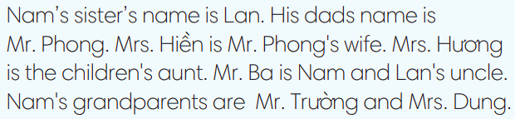
  2. Nam; Her | 4. Mrs. Huong; My
  3. Mrs. Huong; Mrs. Hien | 5. Mrs. Huong; Our
4. PRACTICE 2 (7’)
EXTRA ACTIVITY:
* Aims: To help Ss practice grammar points.
* Content Some brief notes; something about family, family members, family names...
* Outcome: Know something about family, family members, family names...
* Organisation: Teacher’s instructions…..
Teacher’s & Student’s activities | Content
Street Game  (Adapted from ex 2&3 WB p.2)  - T explains the game rules then checks instructions.  - Ss join in the game individually.  - T corrects Ss if any. | Game rules:  ✔ Read the sentence carefully.  ✔ Choose a word to fill in the blank.  ✔ 1 correct answer = 3 points.
5. FURTHER PRACTICE (7’) SPEAKING
ACTIVITY 5:
* Aims: To encourage Ss to apply vocabulary and grammar points they have learnt to talk about their family..
* Content Some brief notes; something about family, family members, family names...
* Outcome: Know something about family, family members, family names...
* Organisation: Teacher’s instructions…..
Teacher’s & Student’s activities | Content
5. In pairs, ask and answer about your family members. Then tell the class about partner’s family.  (Ex 5, p.5)  - T asks Ss to look at exercise 5 (SB page 5).  - T calls a student to read the instruction then checks Ss’ understanding of it.  - T divides Ss into new pairs, then sets a time limit for them to complete the activity.  - T asks pairs to talk about their family members.  - T walks around to listen and notes down common mistakes for delayed feedback.  - T calls some pairs to come to the front of the class, and make conversations.  - T asks the rest to give comments on their classmates’ performance.  - T gives feedback on Ss’ work. | Game rules:  ✔ Read the sentence carefully.  ✔ Choose a word to fill in the blank.  ✔ 1 correct answer = 3 points.
WRAP-UP & HOME WORK (3’)
- T asks Ss to talk about what they have learnt in the lesson.
✔ Nam’s family members.
✔ Possessive adjectives.
✔ Possessive ’s
* HOME WORK
- Do exercises in the workbook page 2.
- Prepare for Lesson 0.2: Introducing Mai.

Date of planning:  Date of teaching: | Period 3 - UNIT 0: WELCOME  Lesson 2: Introducing Mai
I. OBJECTIVES:
By the end of the lesson, students will be able to:
- use the vocabulary and grammar points to talk about activities in their free time.
1. Knowledge:
- To practice listening and speaking.
* Vocabulary:
- name favourite activities in their free time.
- tell key information about Mai.
* Grammar: use useful expressions to talk about free time.
2. Competence: To know how to use vocabulary to talk about free time, and understand the main grammatical points, then do the tasks assigned in the textbook.
3. Quality/ behavior: To teach Ss to be hard-working and attentive in class. Ss have a positive attitude to working in groups, individual work, pair work, cooperative learning and working.
II. TEACHING AIDS:
- Teacher: Grade 7 textbook, Unit 0 (SB p. 6), laptop/computer connected to the Internet, loudspeaker, projector/TV, PPT slides …
- Students: Text books, studying equipment….
- Method: Active teach, T-WC; group works; individual ……
III. PROCEDURE:
1. INTRODUCTION ( 19’)
ACTIVITY 1+ 2 + 3:
* Aims:
- To introduce Mai.
- To present vocabulary of hobbies and interests in context.
* Content: Some brief notes; something about hobbies and interests... Introduce Mai and her favourtie activities in her free time.
* Outcome: Know something about Mai and her hobbies.
* Organisation : T_ Ss , …
Teacher’s Student’s activities | Content
1. (6’) Read the text. In pairs, ask and answer questions below.  (Ex 1, p. 6)  - T asks Ss to open their SB page 6, look at exercise 1.  - T calls a student to read the instruction then checks Ss’ understanding of it.  - T sets a time limit and asks Ss to work in pairs to complete the activity.  - T calls some pairs to give answers then shows the answers on the slide. | Answer keys:  1. Yes, they are.  2. Yes, they are.  3. Yes, she is. – swimming, cycling.
2. (5’) Read the text about Mai again. What are her hobbies and interests?  (Ex 2, p. 6)  - T asks Ss to open their SB page 6, look at exercise 2.  - T calls a student to read the instruction then checks Ss’ understanding of it.  - T sets a time limit and asks Ss for answers.  - T calls some Ss to give answers then shows the answer on the slide. | Answer keys:  She likes surfing the Internet, taking photos, swimming, and in summer, cycling.
3. (8’) Listen and check. If you understand the words below.  (Ex 3, p. 6)  - T asks Ss to open their SB page 6, look at exercise 3.  - T calls a student to read the instruction then checks Ss’ understanding of it.  - T lets Ss listen once then elicits the meaning of phrases from Ss through the picture cues on the slide.  - T confirms the meaning of phrases then drills them. | 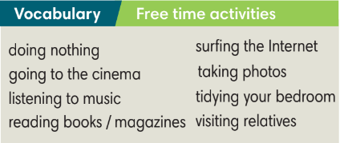
2. PRACTICE 1 ( 6’) VOCABULARY
EXTRA ACTIVITY:
* Aims: To help Ss practice using vocabulary in context.
* Content: Play Gift Box Secret Game to know how to use the new words in the sentence.
* Outcome: Understanding the meaning of the new words and how to use them correctly.
* Organisation : T_ Ss, …
Teacher’s Student’s activities |  |  | Content
Gift Box Secret Game (Adapted from ex.2 WB p.3)  - T explains the game rules then checks instructions.  - Ss join in the game individually.  - T corrects Ss if any. |  |  | Game rules:  ✔ Read the sentence carefully.  ✔ Fill in the blank with a word.  ✔1 correct answer = the candles in the gift box.
3. PRESENTATION ( 4’)
ACTIVITY 4:
* Aim: To present expressions to talk about hobbies and interests in context.
* Content: Listen and read the conversation. Understand the conversation; grammar points; present simple tense..
* Outcome: Know more new words. Understand the conversation; the topic of the lesson, Vocab, grammar points…
* Organisation: T_ Ss .…..
Teacher’s Student’s activities |  |  |  | Content
4. Listen to Mai and Nam. What is Nam’s free time activity? Choose the correct answer.  (Ex 4, p. 6)  - T asks Ss to look at exercise 4 (SB page 6).  - T calls a student to read the instruction then checks Ss’ understanding of it.  - T plays the audio, lets Ss listen and answer the question.  - T elicits answers from Ss then checks as the whole class. |  |  |  | Answer keys:  C. Doing nothing.
4. PRACTICE 2 ( 5’)
EXTRA ACTIVITY:
*Aim: To help Ss practice building sentences about hobbies and interests.
* Content: Play Hard Working Ants Game to make correct sentences.
* Outcome: Understand the grammar points to make correct sentences.
* Organisation: T_Ss…
Teacher’s Student’s activities |  | Content
Hard Working Ants Game (Adapted from ex4 WB p.3)  - T explains the game rules then checks instructions.  - Ss join in the game individually.  - T corrects Ss if any. |  | Game rules:  ✔ Reorder the given words to make correct sentences.  ✔ 1 correct answer = 2 points.
3. PRODUCTION (8’)
ACTIVITY 5:
* Aim: To help Ss apply what they have learnt to talk about favourite activity in their free time.
* Content: Review vocabulary and grammar points about activities in your free time.
* Outcome: Talk about Ss’s favourite activities in their free time.
* Organisation : T_ Ss .…..
Teacher’s Student’s activities |  |  |  | Content
5. Work in groups of three. Ask and answer about each other’s interests. Complete the table below then report to the class.  (Ex 5, p. 6)  - T asks Ss to look at exercise 5 (SB page 6).  - T calls a student to read the instruction then checks Ss’ understanding of it.  - T asks a student to read the sample report.  - T divides Ss into groups of three, then sets a time limit for them to complete the activity.  - T walks around to listen and notes down common mistakes for delayed feedback.  - T calls some groups to come to the front of the class and report.  - T asks the rest to give comments on their classmates’ performance.  - T gives feedback on Ss’ work. |  |  |  | Report:
  Names | Hobbies and interests
WRAP-UP & HOME WORK (3’)
- T asks Ss to talk about what they have learnt in the lesson.
✔ Mai’s information.
✔ Free time activities.
* HOME WORK
- Do exercises in the workbook page 3.
- Prepare for Lesson 0.3: Mai’s Home.

Date of planning:  Date of teaching: | Period 4 - UNIT 0: WELCOME  Lesson 3: Mai’s Home
I. OBJECTIVES:
By the end of the lesson, students will be able to:
- use the vocabulary and grammar points to talk about their possessions.
1. Knowledge:
* Vocabulary:
- Identify key information about Mai.
- Name possessions.
* Grammar: use there is / there are with some / any to talk about their possessions.
2. Competence: Understand and use vocabulary to talk about possessions, and understand the main grammatical points, then do the tasks assigned in the textbook.
3. Quality/ behavior: To teach Ss to be hard-working and attentive in class. Ss have a positive attitude to working in groups, individual work, pair work, cooperative learning, and working.
II. TEACHING AIDS:
- Teacher: Grade 7 textbook, Unit 0 (SB p. 7), laptop/computer connected to the Internet, loudspeaker, projector/TV, PPT slides …
- Students: Text books, studying equipment….
- Method: Active teach, T-WC; group works; individual ……
III. PROCEDURE:

1. WARM UP (4’)
* Aim: To help Ss review information about Mai that they have learnt in the previous lesson.
* Content: Rewind correct information about Mai.
* Outcome: Ss choose 5 correct sentences about Mai.
* Organisation : T_ Ss …
Teacher’s &Student’s activities | Content
Read and tick 5 correct sentences about Mai.
(Extra activity)
- T asks Ss to read the instruction on the slide then check their understanding.
- T calls students to read the sentences about Mai.
- T sets a time limit and asks Ss to work in pairs to complete the activity.
- T calls some pairs to give answers then shows the answers on the slide.
2. VOCABULARY( 20’)
2.1 PRESENTATION (10’)
ACTIVITY 1
* Aims: To present vocabulary of possessions in context.
* Content: Read about Mai’s bedroom to mark the sentences T (true), F (false).
* Outcome: Know more some new words, how to combine a verb and a noun.
* Organisation : T_ Ss …
Teacher’s & Student’s activities |  | Content
1. Read about Mai’s bedroom. Mark the sentences T (true), F (false)  (Ex 1, p. 7)  - T asks Ss to open their SB page 7, look at exercise 1.  - T calls a student to read the instruction then checks Ss’ understanding of it.  - T lets Ss read the short text and all the sentences.  - T calls Ss to give answers and asks them to explain their answers.  - T checks as the whole class. |  | Answer keys:  2. F 4. T  3. T 5. T
Guessing Game  (Adapted from ex.1 WB p.4)  - T explains the game rules then checks instructions.  - Ss join in the game individually.  - T corrects Ss if any. |  | Game rules:  ✔ Look at the picture.  ✔ Guess the thing.  ✔ Choose 1, 2 or 3 then read the word  ✔ 1 correct answer = 1 point
2.2 PRACTICE ( 10’)
ACTIVITY 2 + 3
*Aim: - To help Ss identify and name possessions.
- To help Ss correct their pronunciation of target vocabulary.
- To provide Ss with a chance to talk about their possessions.
* Content: To use the possessions to do the exercises. Pronounce new words correctly.
* Outcome: To understand more about using possessions in contexts;
* Organisation : T_ Ss …

2. Listen and underline the things you can see in the photo.  (Ex 2, p. 7)  - T asks Ss to open their SB page 7, look at exercise 2.  - T calls a student to read the instruction then checks Ss’ understanding of it.  - T lets Ss listen and underline things they see in the photo.  - T calls Ss to give answers.  - T correct Ss’ pronunciation if any. |  | Answer keys:
  book, camera, dictionary, headphones, helmet, keys, laptop, photo, poster, sports bag, sunglasses, trainers.
3. In pairs, use vocabulary box to tell your partner three things you have / haven’t got / would like to have.  (Ex 3, p. 7)  - T asks Ss to open their SB page 7, look at exercise 3.  - T calls a student to read the instruction then checks Ss’ understanding of it.  - T sets time limit and asks Ss to work in pairs to complete the activity.  - T calls some pairs to practice speaking in front of the class.  - T correct Ss’ pronunciation if any. |  | 
3. GRAMMAR (12’)
3.1 PRESENTATION ( 5’)
ACTIVITY 4:
* Aim: To present the use of there is / there are with a / an / some / any.
* Content: To use there is / there are with a / an / some / any to write sentences about bedrooms..
* Outcome: Use there is / there are with a / an / some / any correctly.
* Organisation: T_ Ss ….
4. Study the grammar box. Use there is / there are with a / an / some / any to write sentences about your bedrooms.  (Ex 4, p. 7)  - T asks Ss to look at exercise 4 (SB page 7).  - T calls a student to read the instruction then checks Ss’ understanding of it.  - T lets Ss work in groups, study the grammar box, read the model sentences then make some new sentences about their bedrooms.  - T elicits answers from groups then shows some suggestions. |  | 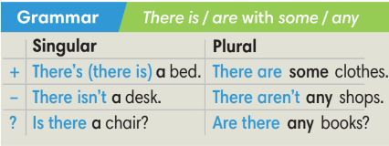
3.2 PRACTICE (7’)
EXTRA ACTIVITY:
*Aim: To help Ss practice building sentences about hobbies and interests.
* Content: Play Bomb Stars Game to understand the structure of the sentences about hobbies and interests.
* Outcome: Use grammar points correctly in the sentences
* Organisation: T_ Ss …
Teacher’s &Student’s activities |  |  |  | Content
Bomb Stars Game  (Adapted from ex4 WB p.4)  - T explains the game rules then checks instructions.  - Ss join in the game individually.  - T corrects Ss if any. |  |  |  | Game rules:  ✔ Make sentences with There is / There are  ✔ 1 correct answer => choose a star for point(s).
4. PRODUCTION (7’)
ACTIVITY 5
* Aim: To help Ss apply what they have learnt to talk about their possessions.
* Content: Work in pairs to ask and answer questions about your bedrooms.
* Outcome: Students use the items from the vocabulary box or their own ideas to talk about their bedrooms.
* Organization:
5. In pairs, ask and answer questions about your bedrooms. Use the items from vocabulary box or your own ideas.  (Ex 5, p. 7)  - T asks Ss to look at exercise 5 (SB page 7).  - T calls a student to read the instruction then checks Ss’ understanding of it.  - T asks a student to read the sample dialogue.  - T divides Ss into new pairs, then sets a time limit for them to complete the activity.  - T walks around to listen and notes down common mistakes for delayed feedback.  - T calls some pairs to come to the front of the class and make conversations.  - T asks the rest to give comments on their classmates’ performance.  - T gives feedback on Ss’ work. |  |  | 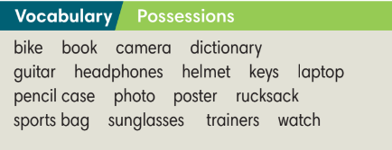  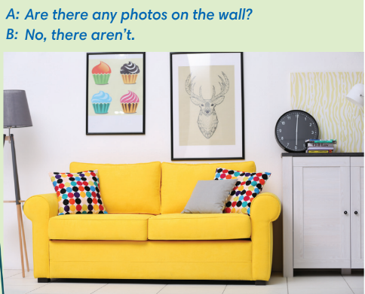
WRAP-UP & HOME WORK (2’)
- T asks Ss to talk about what they have learnt in the lesson.
✔ Possessions.
✔ There is / There are with some / any.
* HOME WORK
- Do exercises in the workbook page 4.
- Prepare for Lesson 0.4: Introducing Kim.

Date of planning:  Date of teaching: | Period 5 - UNIT 0: WELCOME  Lesson 4: Introducing Kim
I. OBJECTIVES:
By the end of the lesson students will be able to:
- use the vocabulary and grammar points to talk about their skills / abilities.
1. Knowledge:
* Vocabulary:
- remember key information about Kim.
- name school subjects.
* Grammar:
- make sentences with can / can’t to talk about skills / abilities.
2. Competence: Understand and use vocabulary to talk about skills / abilities, and understand the main grammatical points, then do the tasks assigned in the textbook.
3. Quality/ behavior: To teach Ss to be hard-working and attentive in class. Ss have a positive attitude to working in groups, individual work, pair work, cooperative learning and working.
II. TEACHING AIDS:
- Teacher: Grade 7 textbook, Unit 0 (SB p. 8), laptop/computer connected to the Internet, loudspeaker, projector/TV, PPT slides …
- Students: Text books, studying equipment….
- Method: Active teach, T-WC; group works; individual ……
III. PROCEDURE:
1. INTRODUCTION (5’)
ACTIVITY 1
* Aim: - To introduce Kim.
- To activate Ss’ knowledge of school subjects and teach them.
* Content: Some brief notes; something about school subjects, school activities…
* Outcome: Know something about Kim’s favourite subjects in school.
* Organisation: T_ Ss ..….

Teacher’s & Student’s activities | Content
1. In pairs, match school subjects 1-6 with A-F. What are Kim’s favourite subjects?  (Ex 2, p. 8)  - T asks Ss to open their SB page 8, look at exercise 2.  - T calls a student to read the instruction then checks Ss’ understanding of it.  - T sets a time limit and asks Ss to work in pairs to complete the activity.  - T calls some pairs to give answers then shows the answers on the slide.  - T drills all the subjects. | Answer keys:  2. A 4. E 6. C  3. F 5. D  Kim’s favourite subjects are English and history.
2. PRACTICE VOCABULARY 1 (5’)
EXTRA ACTIVITY:
*Aim: To help Ss practice vocabulary of school subjects.
* Content: Some brief notes; something about school subjects, school activities…
* Outcome: Know something about Kim’s favourite subjects in school.
* Organisation: T_ Ss ..….

Teacher’s & Student’s activities | Content
Angry Birds Game (Extra activity)  - T explains the game rules then checks instructions.  - Ss join in the game individually.  - T corrects Ss’ pronunciation if any.  - T drills all the subjects. | Game rules:  ✔ Read the definition.  ✔ Choose the correct subject.  ✔ 1 correct answer = 5 points.
3. GRAMMAR (10’)
3.1. PRESENTATION (5’)
ACTIVITY 2:
*Aim: To present the grammar points in context.
* Content: To use can / can’t to answer the questions in pairs.
* Outcome: Use can / can’t correctly.
* Organisation: T_ Ss ..….
Teacher’s & Student’s activities | Content
2. Read the text, answer the questions in pairs.  (Ex 1, p. 8)  - T asks Ss to open their SB page 8, look at exercise 1.  - T calls a student to read the instruction then checks Ss’ understanding of it.  - T sets a time limit and ask Ss to work in pairs to complete the activity.  - T calls some pairs to give answers then checks as the whole class. | Answer keys:  1. She can play the piano.  2. She can’t sing.
3.2. PRACTICE (5’)
ACTIVITY 3
*Aim: To help Ss practice building sentences about hobbies and interests.
* Content: Complete the sentences with can / can’t.
* Outcome: Use can / can’t to complete the sentences correctly.
* Organisation : T_ Ss ..….
Teacher’s & Student’s activities | Content
3. Complete the sentences with can or can’t.  (Ex 3, p. 8)  - T asks Ss to open their SB page 8, look at exercise 3.  - T calls a student to read the instruction then checks Ss’ understanding of it.  - T sets a time limit and asks Ss to work in groups to complete the activity.  - T calls some groups to give answers then checks as the whole class. | Answer keys:
  2. can’t | 4. can’t | 6. can’t
  3. can | 5. can’t
4. VOCABULARY (14’)
4.1. PRESENTATION (7’)
ACTIVITY 4
*Aim: To present vocabulary of skills and abilities in context.
* Content: Some brief notes; something about skills and abilities.
* Outcome: Understanding the meaning of the new words about skills and abilities, and knowing how to use them correctly.
* Organisation : T_ Ss ..….
Teacher’s & Student’s activities | Content
Lead-in:  - T shows the slide and elicits the vocabulary and its meaning from the students.  - T confirms the meaning and tell Ss that they can use these verb phrases to talk about their skills / abilities.  Activity 4: Listen to Kim and underline the things in the Vocabulary box that she can do.  (Ex 4, p. 8)  - T asks Ss to open their SB page 8, look at exercise 4.  - T calls a student to read the instruction then checks Ss’ understanding of it.  - T plays the audio for Ss to complete the activity.  - T calls some Ss to give answers then checks as the whole class.  - T drills the vocabulary.  - T correct Ss’ pronunciation if any. | Answer key:  Play the piano
4.2. PRACTICE (7’)
EXTRA ACTIVITY:
*Aim: To help Ss practice vocabulary of skills and abilities in context.
* Content: Play Mystery Box Game to know how to use the new words in the sentence.
* Outcome: Understanding the meaning of the new words and using them correctly.
* Organisation : T_ Ss ..….

Teacher’s & Student’s activities | Content
Mystery Box Game  (Adapted from ex2 WB p.5)  - T explains the game rules then checks instructions.  - Ss join in the game individually.  - T corrects Ss’ pronunciation if any.  - T drills all the subjects.  - T correct Ss’ pronunciation if any. | Game rules:  ✔ Look at the picture and the given word.  ✔ Make a sentence with can / can’t.  ✔ 1 correct answer => Choose to keep or give the mystery box.
4. PRODUCTION (8’)
ACTIVITY 5
* Aims: To help Ss apply what they have learnt to talk about their skills and abilities.
* Content: Review vocabulary and grammar points about skills/abilities.
* Outcome: Talk about skills/abilities.
* Organisation: T_ Ss , Individual, Pair work, ….

Teacher’s & Student’s activities | Content
5. Work in pairs, ask and answer questions.  (Ex 5, p. 8)  - T asks Ss to look at exercise 5 (SB page 8).  - T calls a student to read the instruction then checks Ss’ understanding of it.  - T asks a pair to read the sample question and answer.  - T divides Ss into new pairs, then sets a time limit for them to complete the activity.  - T walk around to listen and notes down common mistakes for delayed feedback.  - T calls some pairs to come to the front of the class and report.  - T asks the rest to give comments on their classmates’ performance.  - T gives feedback on Ss’ work. | 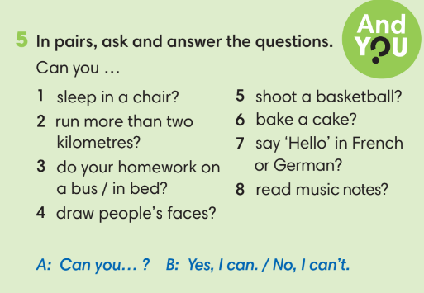
WRAP-UP & HOME WORK (2’)
- T asks Ss to talk about what they have learnt in the lesson.
✔ Kim’s information.
✔ School subjects.
✔ Skills / abilities.
* HOME WORK
- Do exercises in the workbook page 4.
- Prepare for Revision Unit 0.

Date of planning:  Date of teaching: | Period 6 - UNIT 0: WELCOME  Lesson 5: Revision
I. OBJECTIVES:
By the end of the lesson, students are expected to achieve the following objectives:
1. Knowledge:
* Vocabulary:
- key information about Kim, Nam and Mai; questions and answer about personal information.
* Grammar:
- grammar points they’ve learnt in Unit 0.
2. Competence: Understand and use vocabulary to talk about personal information, and understand the main grammatical points, then do the tasks assigned in the textbook.
3. Quality/ behavior: To teach Ss to be hard-working and attentive in class. Ss have a positive attitude to working in groups, individual work, pair work, cooperative learning and working.
II. TEACHING AIDS:
- Teacher: Textbooks, hand-out, TV, projector, loudspeaker
- Students: Text books, studying equipment….
- Method: Active teach, T-WC; group works; individual ……
III. PROCEDURE:
- REVIEW CHARACTERS (8’)
ACTIVITY 1:
* Aim: To help Ss review key information about Nam, Mai and Kim.
* Content: Ss work in groups to play the game called “Spin The Wheel Game” followed the instruction of T.
* Outcome: Ss are able to recall the knowledge about the characters that they have learnt.
* Organisation: T_ Ss …
Teacher’s & Student’s activities | Content
1.In group, do the quiz. Use the texts in lessons 0.1-0.4 to help you  (Ex 1, p. 9)  Spin The Wheel Game:  - T explains the game rules then checks instructions.  - Ss work in groups.  - Which S gets more points will be the winner.  - T corrects Ss’ pronunciation if any. | Game rules:  ✔ Read the questions.  ✔ Give the answers.  ✔ 1 correct answer => spin the wheel for point(s)  Answer keys:  1. She’s Nam’s grandmother. / Mrs. Hương’s mother.  2. He lives in Nam Định.  3. No, she can’t.  4. She’s thirteen.  5. He’s a policeman.  6. No, she hasn’t.
2. REVIEW QUESTIONS (8’)
ACTIVITY 2:
*Aim: To present the grammar points in context.
* Content: Ss work individually to do the exercise 2 given in the textbook under the instruction of T.
* Outcome: Ss are able to make questions and answers using the proper grammatical points of Wh -questions.
* Organisation: T_ Ss …
Teacher’s & Student’s activities | Content
2. Complete the questions with the words below. Then ask and answer the questions in pairs.  (Ex 2, p. 9)  Find The Treasure Game:  - T explains the game rules then checks instructions.  - Ss work in pairs to fill in the blank then ask and answer.  - Which S gets more points will be the winner.  - T corrects Ss’ pronunciation if any. | Game rules:  ✔ Fill in the blanks with question words.  ✔ Ask and answer questions in pairs.  ✔ 1 correct answer => choose a number for point(s)  Answer keys:
  2. How old | 4. What | 6. Who
  3. Where | 5. What | 7. What time
ACTIVITY 3:
*Aim: To review questions of personal information.
* Content: Ss work in pairs to complete the assigned exercises in the textbook.
* Outcome: Ss are able to ask and answers about personal information.
* Organisation: T_ Ss …
Teacher’s & Student’s activities | Content
3. Complete the questions with is, are, can, have, or has. Then ask and answer the questions in pairs.  (Ex 3, p. 9)  - T asks Ss to look at exercise 3.  - T calls a student to read the instruction then checks Ss’ understanding of it.  - T asks Ss to work in groups of three to complete the activity.  - T calls groups to give answers  - shows the answers on the slide to check as the whole class. | Answer keys:
  1 | 2 | 3 | 4 | 5
  Is | Have | have | Can | Are
  6 | 7 | 8 | 9 | 10
  Can | Are | Can | Is | Are
EXTRA ACTIVITY (8’):
*Aim: To help Ss practice building sentences about hobbies and interests.
* Content: Ss work in groups to play the game called “Spin The Wheel Game” under the instruction of T.
* Outcome: Ss are able to understand the usage of there is, there are, can and have got.
* Organisation : T_ Ss …

Teacher’s & Student’s activities | Content
Tom and Jerry Game  (Adapted from Exercise 3)  - T explains the game rules then checks instructions.  - Ss work in pairs to fill in the blank then ask and answer..  - Which S gets more points will be the winner.  - T corrects Ss if any. | Game rules:  ✔ Fill in the blanks with is / are / can / have / has.  ✔ Ask and answer questions in pairs.  ✔ 1 correct answer => help Jerry find the cheese.
PRACTICE SPEAKING (12’)
ACTIVITY 4
*Aim: To provide Ss with a chance to apply what they’ve learnt in Unit 0 to ask and answer about personal information.
* Content: Ss work individually, in pairs or in groups complete the assigned exercises in to the textbook.
* Outcome: Ss are able to use the vocabulary and grammar structures to make a conversation with their classmates …
* Organisation : T_ Ss …
Teacher’s & Student’s activities | Content
4. Choose four questions from exercise 2 and 3 that you think they are very interesting. Then ask as many classmates as you can.
(Ex 4, p. 9)
- T asks Ss to open their SB page 9, look at exercise 4.
- T calls a student to read the instruction then checks Ss’ understanding of it.
- T lets Ss to work individually first, list out four questions that they want to ask their classmate.
- T sets a time limit for Ss to walk around the classroom, ask and answer with as many classmates as they can then take note the results.
- T calls some Ss to report in front of the class.
- T asks the rest to give comments on their classmates’ performance.
- T gives feedback on Ss’ work.

WRAP-UP & HOME WORK (2’)
- T asks Ss to talk about what they have learnt in the lesson.
✔ Information about Nam, Mai and Kim.
✔ Grammar points.
* HOME WORK
- Prepare for Unit 1 – Lesson 1.1: Vocabulary.

Date of planning:  Date of teaching: | ENGLISH 7  Period 7 - UNIT 1: CULTURE INTERESTS  Lesson 1: Vocabulary
I. OBJECTIVES:
By the end of the lesson, students will be able to:
- have an overview of the topic “Culture Interests”.
- use vocabulary and grammar points to talk about cultural activities, like and dislike.
1. Knowledge:
* Vocabulary: an understanding of the meaning of keywords or word collocations below:
Types of films | cartoons, comedies, documentaries, fantasy films, romantic films, science fiction (sci-fi) films, action films, horror films.  watching cartoons / comedies / documentaries / fantasy films, romantic films / science fiction (sci-fi) films / action films / horror films.
Things to read | comics, novels, short stories.  reading comics / novels / short stories.
Types of dance | ballet, salsa, zumba.  dancing ballet / salsa / zumba.
Musical instruments | drums, guitar, piano, violin.  playing drums / the guitar / the piano / the violin.
Types of music | classical music, hip-hop, pop, traditional rock.  listening to classical music / hip-hop / pop / traditional rock.

* Grammar: expressions to talk about likes and dislikes:

LIKES | DISLIKES
I like /  I’m interested in /  I love /  I really like /  I’m into | I hate /  I’m not into / I don’t like | + N / V-ing
2. Competence:
To know the meaning of the keywords used to talk about cultural activities, and understand the main grammatical points, then do the tasks assigned in the textbook.
3. Quality/Behavior: To teach Ss to be hard-working and attentive in class. Ss have a positive attitude to working in groups, individual work, pair work, cooperative learning and working.
II. TEACHING AIDS:
- Teacher: Grade 7 textbook, Unit 1 (SB p.14, WB p.6-7) , laptop/computer connected to the Internet, loudspeaker, projector/TV, PPT slides…
- Students: Text books, studying equipment…
- Method: Active teach, T-WC; group works; individual ……
III. PROCEDURE:
 | 1. WARM UP( 3’)
* Aims:
- To activate Ss’ prior knowledge and get students involved in the lesson.
- To set the context for introducing new words.
* Content: Play Guessing game to get students involved in the lesson and to set the context for the lesson.
* Outcome: Students name some types of cultural activities they’ve already known.
* Organisation: Teacher’s instructions…
 | Teacher’s & Student’s activities |  | Content
 | Guessing game  - T explains the game rules then checks instructions.  - T sets the context for the lesson: Write the title on the board Unit 1: Cultural interests / Lesson 1.1: Culture.  - T asks Ss to name some types of cultural activities they’ve already known. |  | Game rules:  - Look at the pictures.  - Guess the activities.  - Choose 1, 2 or 3 then read the words.  - 1 correct answer = 1 point.
2. Presentation 1 (5’) VOCABULARY
(Types of cultural activities)
ACTIVITY 1:
* Aims:
- To reinforce the types of cultural activities that students have already known.
- To teach five types of cultural activities.
- To lead into the next activity.
* Content: Some brief notes; Some things about cultural activities.
* Outcome: Know new words about cultural activities.
* Organisation: Teacher’s instructions….
 | Teacher’s & Student’s activities |  |  | Content
 | 1. What can you see in the photos. In pairs, match photos 1-5 with phrase a-e.  (Ex 1, p.10)  - T asks Ss to open their SB page 10, look at exercise 1.  - T calls a student to read the instruction then checks Ss’ understanding of it.  - T quickly checks Ss’ understanding of vocabulary in this by asking the question about each picture  Prompts:  (1) What’s he / she doing in picture ...?  (2) What are they doing in picture ...?  (3) In which picture, the girl / boy is ...?  (4) In which picture, the people are ...?  - T gives and check instructions for exercise 1 (SB page 10) then sets a time limit for Ss to complete it.  - Ss work in pairs to complete the matching.  - T checks as the whole class.  - T drills the vocabulary:  (1) dance  (2) reading  (3) musical instruments  (4) music  (5) cinema  Further discussion:  - T asks more questions to encourage Ss to think and speak.  (1) What types of dance / music / films / musical instruments do you know?  (2) Name some things you often read.  - T tells Ss that they are going to know more types of cultural activities in the next activity. |  |  | Answer keys:  a-4 / c-2 / d-5 / e-3
3. PRESENTATION 2 (9’)
(Cultural activities)
ACTIVITY 2:
* Aims:
- To pre-teach vocabulary of cultural activities.
- To introduce the vocabulary of cultural activities to Ss.
- To help Ss classify cultural activities and into types.
- To let Ss work cooperatively.
* Content: Some brief notes; Some things about cultural activities.
* Outcome: Know new words about cultural activities and classify them into types.
* Organisation: Teacher’s instructions …
 | Teacher’s & Student’s activities |  | Content
 | Extra activity 2 (4’): Balloon game  - T gives and checks instructions for the game.  - T waits 10 seconds for Ss to read each definition before clicks to show the balloons.  - T corrects Ss’ pronunciation if any.  2. (5’) Add the words below to the correct category. Listen and check.  (Ex 2, p.10)  - T asks Ss to look at excersise 2 (SB page 10).  - T calls a student to read the instruction then checks Ss’ understanding of it.  - T sets a time limit and asks Ss to work in groups of five to complete the exercise.  - T calls groups to give answers then checks as the whole class.  - T drills the vocabulary and corrects Ss’ pronunciation if any. |  | Game rules:  - Look at the pictures.  - Read the definitions.  - Choose the correct answer.  - 1 correct answer = 2 points.  Answer keys:  (2) horror films (3) short stories (4) zumba  (5) violin (6) rock
 | 4. PRACTICE (14’)
ACTIVITY 3:
* Aims:
- To provide Ss with chances to practice pronouncing new words.
- To help Ss use the new vocabulary in collocations.
- To review and reinforce the expressions to talk about likes and dislikes.
* Content:
* Outcome:
* Organisation: Teacher’s instructions….
 | Teacher’s & Student’s activities |  | Content
 | 3. (7’) Complete the sentences with the words below.  (Ex 3, p.11)  - T asks Ss to look at exercise 3 (SB page 11).  - T calls a student to read the instruction then checks Ss’ understanding of it.  - T asks Ss to read the given words aloud, checks their understanding of the words by asking them to do the corresponding actions.  - T sets a time limit and asks Ss to work in groups of four to complete the exercise.  - T calls groups to give answers then checks as the whole class.  - T corrects Ss’ pronunciation if any.  Further discussion:  - T asks Ss to underline the expressions to talk about likes and dislikes in exercise 3.  - T calls some volunteers to give answers then confirms with the whole class.  - T tells Ss that they are going to use those structures to talk about what they like and don’t like.  - T drills the structures. |  | Answer keys:  (2) listening (3) playing (4) taking  (5) acting (6) drawing (7) reading (8) watching
 | (7’) Extra activity 3: Pokemon game (Adapted from exercise 2 – Workbook p.6)  - T gives and checks instructions for the game.  - T monitors Ss while they are playing then confirms to answers.  - Ss work individually, rearrange words to make sentences, choose A, B or C.  - Ss raise their hand to give answers.  - T corrects Ss’ grammar and pronunciation if any. |  | Answer keys:  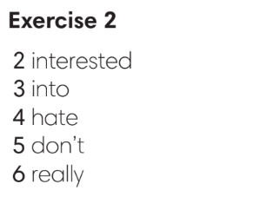
 | 4. PRODUCTION (11’)
ACTIVITY 4:
* Aims: To help Ss practice applying the vocabulary items and grammar points related to the topic in speaking.
* Content: Ss work in groups to talk about their likes and dislikes.
* Outcome: Ss talk about their likes and dislikes using vocabulary and grammar points.
* Organisation: Teacher’s instructions….

 | Teacher’s & Student’s activities |  | Content
 | 4. In groups of four, talk about likes and dislikes. Use exercise 3 to help you.  (Ex 4, p.11)  - T asks Ss to look at excersise 4 (SB page 11).  - T calls a student to read the instruction then checks Ss’ understanding of it.  - T asks a pair to read the sample dialogue then asks some new pairs to make new dialogues to ask and answer about likes and dislikes.  - T divides Ss into groups of four, models the activity in front of the class then asks groups to make conversations about their likes and dislikes.  - T sets a time limit and monitors Ss while they are working in groups.  - T notes down common mistakes for delayed feedback.  - T calls some groups to come to the front of the class, make conversations to talk about their likes and dislikes.  - T asks the rest to give comments on their classmates’ performance.  - T gives feedback on Ss’ work. |  | 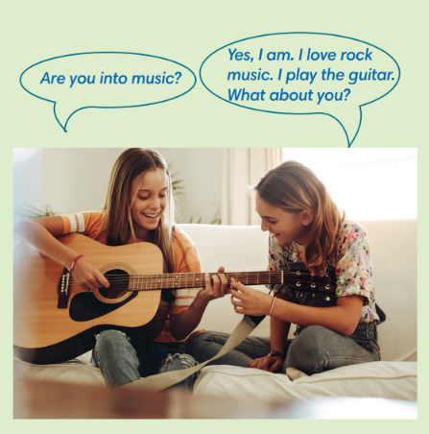
WRAP-UP & HOME WORK (3’)
- T asks Ss to talk about what they have learnt in the lesson.
- Vocabulary of types of cultural activities.
- Vocabulary of cultural activities.
- Grammar points: Expressions to talk about likes and dislikes.
* HOME WORK
- Do exercises in the workbook page 6-7.
- Prepare for Lesson 2: Grammar 1.

 | Date of planning:  Date of teaching: | Period 8 - UNIT 1: CULTURE INTERESTS  Lesson 2: Grammar
I. OBJECTIVES:
By the end of the lesson, students will be able to:
- use Present Simple to talk about habits, likes and dislikes.
1. Knowledge:
* Grammar:
- write affirmative and negative forms of the Present Simple tense correctly.
- use the Present Simple tense to talk about habits and routines.
2. Competence: Students know to use vocabulary about habits and routines, and understand the main grammatical points, then do the tasks assigned in the textbook; use the affirmative and negative forms in the present simple tense correctly to talk about habits and routines.
3. Quality/ behavior: To teach Ss to be hard-working and attentive in class. Ss have a positive attitude to working in groups, individual work, pair work, cooperative learning and working.
II. TEACHING AIDS:
- Teacher: Grade 7 textbook, Unit 1 (SB p. 12), laptop/computer connected to the Internet, loudspeaker, projector/TV, PPT slides…
- Students: Text books, studying equipment…
- Method: Active teach, T-WC; group works; individual ……
III. PROCEDURE:
1. WARM UP ( 4’)
* Aims:
- To activate students’ prior knowledge and get students involved in the lesson.
- To set the context for introducing new structures.
* Content: Play Guessing game to get students involved in the lesson and to set the context for the lesson.
* Outcome: Students know the context of the lesson.
* Organisation : T_ Ss , …

Teacher’s Student’s activities | Content
Extra activity 1: Guessing Game  - T divides Ss into 2 teams. Team boys and team girls.  - T explains the game rules then checks instructions.  - T corrects Ss if necessary.  - T set the scene for the new lesson: T tells Ss that these are activities we do regularly. Today we are going to learn the affirmative and negative forms in the Present Simple tense.  - T writes the title on the board Unit 1: Cultural interests / Lesson 1.2: Grammar | Game rules:  ✔ Look at the pictures.  ✔ Fill in the gap with the suitable words  ✔ 1 correct answer = 1 point.
2. LEAD-IN ( 3’)
* Aims: To lead into the new lesson.
* Content: Differentiate the people in the picture on the slide.
* Outcome: Make guesses about the picture then give answers.
* Organisation : T_ Ss , …
Teacher’s Student’s activities | Content
Extra Activity 2: See – think – wonder.  - T shows a picture on the slide then asks students four questions.  (1) What do you see in the picture?  (2) Do they look the same?  (3) Do you have brothers or sisters?  - T sets a time limit for Ss’ quick discussion.  - Ss work in pairs to make guesses about the picture then give answers.  - T calls some Ss to give answers then note them down on the board.  - T tells Ss that they’re going to read Rose’s blog in exercise 1 (SB p.12) to check all the answers. | 
3. PRESENTATION (9’)
(Questions and answers in the Present Simple tense)
ACTIVITY 1 + 2:
Aims:
- To present the grammar point in context.
- To lead into the next activity.
- To help Ss recognize the form of affirmative and negative in the Present Simple form.
- To provide Ss with chances to work cooperatively.
- To explain the grammar point for Ss.
* Content: Read Rose’s blog and find out new words. Learn the Present Simple.
* Outcome: Know more new words. Understanding the reading document; the topic of the lesson, grammar points…
* Organisation: T_ Ss , …
Teacher’s Student’s activities |  |  | Content
1. (5’) Read Rose’s blog. How are Rose and her sister, Violet different?  (Ex 1, p.12)  - T asks Ss to open their SB page 12, look at exercise 1.  - T calls a student to read the instruction then checks Ss’ understanding of it.  - T asks Ss to read the blog and fill in the gap with the missing information.  - Ss work individually.  - T calls some Ss to give answers then shows the answers on the slide.  - T asks Ss to look at the sentences and elicits the tense of those for Ss (affirmative and negative forms in the Present Simple tense). |  |  | Answer keys:  1. Violet studies classical music, but Rose studies art.  2. Violet reads novels and poems, but Rose doesn’t read much.  3. Violet watches TV, but it doesn’t interest Rose.  4. Violet writes poems, but Rose paints pictures.  5. Rose loves hip hop, but hip hop annoys Violet.
2. (4’) Find more examples of Present Simple in the text in Exercise 1.  (Ex 2, p.12)  - T asks Ss to look at exercise 2.  - T calls a student to read the instruction then checks Ss’ understanding of it.  - T asks Ss to work in groups of three to complete the activity.  - T calls groups to give answers then shows the answers on the slide to check as the whole class.  - T shows the affirmative and negative forms of the Present Simple tense then elicits information from Ss.  - T explains the grammar points and tells Ss that they’re going to use the Present Simple tense to talk about habits and routines.  - T circles and tells the class information about adverbs of frequency (use, position)  - T shows the grammar notes, then Ss can read aloud. |  |  | 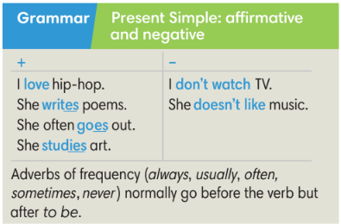
3. PRACTICE (19’)
ACTIVITY 3 + 4:
Aim:
- To help students practice completing the correct forms of the verbs with corresponding singular/plural subjects.
- To help students identify the correct form of the verbs in the present simple tense.
- To help students put adverbs of frequency in the correct positions
* Content: Complete the text/sentences with the correct form of the verbs.
Understand the text; grammar points; present simple tense..
* Outcome: Know how to form a sentence with the correct form of the verbs. Understand the conversation; the topic of the lesson, vocabulary, grammar points…
* Organisation : T_ Ss .…..
Teacher’s Student’s activities |  |  |  | Content
(6’) Extra activity 3: Minion game.  - T explains the game rules then checks instructions.  - Ss join in the game individually.  - T corrects Ss if any. |  |  |  | Game rules:  ✔ Read the sentence  ✔ Put the correct verbs in the brackets.  ✔ Raise your hand to give answers.  ✔ Get points.
3. (4’) Bookwork: Complete the text with the correct form of the verbs in the brackets.  (Ex 3 SB p.12)  - T asks Ss to look at exercise 3.  - T calls a student to read the instruction then checks Ss’ understanding of it.  - T asks Ss to work in individually.  - T calls students to give answers then shows them on the slide to check as the whole class.  - T corrects Ss if any. |  |  |  | Answer keys:  1. live  2. don’t go  3. watches  4. prefer  5. wins  6. doesn’t win  7. don’t play  8. play
4. (5’) Correct the information in the following sentences.  (Ex 4 SB p.12)  - T asks Ss to look at exercise 3.  - T asks Ss to correct the information in the following sentences.  - T corrects Ss if any. |  |  |  | Answer key:  2. One Direction don’t play classical music. They play pop music.  3. Director Tim Burton doesn’t make documents. He makes films.  4. J.K Rowling doesn’t act in films. She writes books.  5. Daniel Radcliffe and Emma Watson don’t paint pictures. They act in film.
(4’) Extra activity 4: Order the words to make sentences.  (Ex 5 WB p.8)  - T asks Ss to look at exercise 5.  - T asks Ss to order the words to make sentences.  - T corrects Ss if any. |  |  |  | Answer key:  2. I often play computer games with my friends.  3. I don’t understand Spanish.  4. I usually buy clothes online.  5. Our teacher doesn’t drive a car.  6. Tom is never late for class.
4. PRODUCTION ( 7’)
ACTIVITY 5:
*Aim: To help students applying the vocabulary items and grammar points related to the topic in communicating.
* Content: Ss describe themselves and their partners (what they like and dislike).
* Outcome: Ss know how to express themselves and describe others.
* Organisation: T_Ss…
Teacher’s Student’s activities |  | Content
5. In pairs or groups: Tell your class about you and your partner (what you like and dislike)  (Ex 5, p.12)  - T asks Ss to look at exercise 5 (SB page 12).  - T calls a student to read the instruction then checks Ss’ understanding of it.  - T models the activity in front of the class.  - T divides Ss into new pairs, asks them to make conversations to ask and answer about habits and routines.  - T walks around to listen and notes down common mistakes for delayed feedback.  - T calls some groups to come to the front of the class, and make conversations.  - T asks the rest to give comments on their classmates’ performance.  - T gives feedback on Ss’ work. |  | 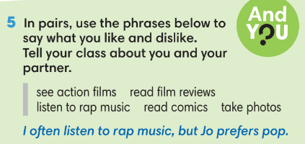
WRAP-UP & HOME WORK (2’)
- T asks Ss to talk about what they have learnt in the lesson.
✔ The present simple tense: affirmative and negative
✔ The adverbs of frequency
* HOME WORK
- Do exercises in the workbook page 8.
- Prepare for Lesson 1.3: Reading.

Date of planning:  Date of teaching: | Period 9 - UNIT 1: CULTURE INTERESTS  Lesson 3: Reading and Vocabulary
I. OBJECTIVES:
By the end of the lesson ss will be able to:
- find specific detail in an article and talk about age groups.
1. Knowledge:
* Vocabulary: an understanding of the vocabulary on age groups.
New words | Pronunciation | Definition | Vietnamese meaning
1. adults (n) | /ˈæd.ʌlt/ /əˈdʌlt | People that have grown to full size and strength. | Người lớn
2. kids (n) | /kɪd/ | Children | Trẻ con
3. middle-aged (adj) | /ˌmɪd.əlˈeɪdʒd/ | Being of the age intermediate between youth and old age, roughly between 45 and 65. | Trung tuổi
4. pensioners (n) | /ˈpen.ʃən.ər/ | People who receive a pension, especially the government pension given to old people. | Người được hưởng tiền trợ cấp/tiền dưỡng lão
5. teenagers (n) | /ˈtiːnˌeɪ.dʒər/ | Young people between 13 and 19 years old. | Thanh thiếu niên
* Grammar:
- Reading skills: the ability to find specific details in an article (scanning skill).
2. Competence: Understand know the meaning of the keywords used to talk about cultural activities, and understand the main grammatical points, then do the tasks assigned in the textbook; locate information and find specific details in an article (scanning skill); identify the main ideas of the paragraphs in the text or the text itself (skimming skill).
3. Quality/behavior: To teach Ss to be hard-working and attentive in class. Ss have a positive attitude to working in groups, individual work, pair work, cooperative learning and working.
II. TEACHING AIDS:
- Teacher: Grade 7 textbook, Unit 1 (SB p.13, WB p.9), laptop/computer connected to the Internet, loudspeaker, projector/TV, PPT slides …
- Students: Text books, studying equipment …
- Method: Active teach, T-WC; group works; individual …
III. PROCEDURE:
1. WARM-UP (5’)
* Aim:
- To help Ss review the use of adverbs of frequency in the Present Simple tense they have learnt in lesson 1.2.
- To lead into the next activity.
* Content: Game: Lucky Stars Game ( about watching habits)
* Outcome: Ss use adverbs of frequency in the Present Simple tense to talk about their watching habits.
* Organisation: T_ Ss …
Teacher’s &Student’s activities | Content
Extra activity 1: Lucky Stars Game  - T explains the game rules then checks instructions.  - T asks Ss the question “ Do you often watch TV?” after the last question of the game.  - Ss raise their hands if the answer is “Yes”.  - T will ask Ss to tell more about their watching habits in the next activity. | Game rules:  - Look at the timetable.  - Choose A, B or C to fill in the blank.  - Open the star to get point(s).
2. PRE-READING (3’)
ACTIVITY 1:
* Aim:
- To activate Ss’ background knowledge of the topic.
- To make students to move.
- To provide Ss with reasons for reading the text in the next stage.
- To lead in to the topic of the reading text.
* Content: To discuss Ss’s watching habits by reading, and answering T’s questions.
* Outcome: Know new words, and grammar points when talking about one’s habits.
* Organisation: T_ Ss …
Teacher’s & Student’s activities |  | Content
1. How many hours of TV do you usually watch after school?  (Ex 1, p.13)  - T shows the slide, reads aloud the question “How many hours of TV do you usually watch after school?”  - T asks a student to read the four options then model the corresponding poses on the slide.  - I never watch TV.  - Under one hour.  - One or two hours.  - More than two hours.  - T asks all Ss to stand up, give answers by doing the corresponding poses when the teacher mentions to.  - T sets the context for the lesson: Write the title on the board Unit 1: Cultural interests / Lesson 1.3: Reading and Vocabulary.  - T asks Ss to base on the answer to the above question and look at the title of the reading text, elicits from Ss what are they going to read about.  - T notes down Ss’ ideas on the board to check later. |  | 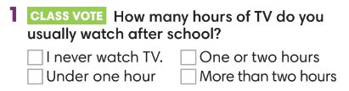
2. WHILE-READING (12’)
ACTIVITY 2 + 3:
*Aim: teach vocabulary in context:
- To encourage Ss to guess the meaning of new words in context.
- To teach topic-related vocabulary in context.
- To help Ss pull out tips for guessing the meaning of new words in the reading text.
* Content: To use the present simple to do the exercises.
* Outcome: To know more new words about habits. Understand more about using the words in contexts.
* Organisation: T_ Ss …
2. (5’) Read the first paragraph of the text. What do you think these phrases mean?  (Ex 2, p.13)  - T asks Ss to look at excersise 2 (SB page 13).  - T calls a student to read the instruction then checks Ss’ understanding of it.  - T sets a time limit and asks Ss to work in pairs to complete the activity.  - T elicits the ideas from Ss, asks them in which line of the paragraph they see the answers.  - T confirms the answers then drills the pronunciation of the phrases and corrects Ss’ pronunciation if any.  Further discussion:  - T and students discuss tips for guessing the meaning of new words in the reading text. |  | Answer keys:  a. a couch potato (n): someone who spends a lot of time sitting or lying on the sofa (or a couch) watching TV.  b. to have square eyes (v): to watch a lot of TV.
3. Find the following words in the text. What do they mean?  (Ex 3, p.13)  - T asks Ss to look at excersise 3 (SB page 13).  - T calls a student to read the instruction then checks Ss’ understanding of it.  - T guides Ss to find the words in the text.  - T sets a time limit and asks Ss to work in groups of three to complete the exercise.  - T calls groups to give answers then checks as the whole class.  - T confirms the answers then drills the vocabulary and corrects Ss’ pronunciation if any.  Further discussion:  - T and students may discuss the ages each word corresponds to. For example, a teenager is any age ending in-teen, but when does middle age start and finish, and do you become an adult at eighteen, twenty-one or some other age? |  | Answer keys:  1. adults (n): People that have grown to full size and strength.  2. kids (n): Children  3. middle-aged (adj): Being of the age intermediate between youth and old age, roughly between 45 and 65.  4. teenagers (n): Young people between 13 and 19 years old.  5. pensioners (n): People who receive a pension, especially the government pension given to old people.
3. PRACTICE (15’)
ACTIVITY 4 + 5:
* Aim:
- To help Ss practice reading for the main idea of each paragraph and matching the correct headings with the paragraph.
- To help Ss practice reading for specific information.
* Content: To match correctly the headings and the paragraphs by understanding the subject and the content of the given texts.
* Outcome: Understanding and explaining the meaning of the given texts. Using scanning skills for reading.
* Organisation: T_ Ss …
4. (7’) Read the rest of the text. Match headings a-e with paragraphs 1-4. There is one extra heading.  (Ex 4, p.13)  - T asks Ss to look at exercise 3 (SB page 13).  - T calls a student to read the instruction then checks Ss’ understanding of it.  - T asks Ss to read the given headings aloud, checks Ss’ understanding of them (by eliciting the ideas of what the headings could refer to. For example, a global change  could refer to a new TV habit taken up by people all over  the world, such as watching TV over the internet.  - T sets a time limit and asks Ss to work individually to complete the exercise.  - T calls Ss to give answers then checks with the whole class.  - T corrects Ss’ pronunciation if any.  Further discussion:  - T asks Ss to explain their answers by referring to the clues in the text.  Further discussion:  - T and students discuss tips for identifying the main idea of each paragraph in the long text. (This should be done after Ss complete paragraph 1). |  | 4. Answer keys:  1d / 2b / 3a / 4e
5. (5’) Cross The River Game.  (Adapt from Ex 5, p.13)  - T explains the game rules then checks instructions.  - T corrects Ss’ pronunciation if any.  Further discussion:  - T asks Ss to explain their answers. |  | Game rules:  - Choose numbers for questions.  - Choose A, B or C to answer.  - 1 fish = 1 correct answer  Answer keys:  1. 🗸  2. 🗸  3. x (They watch six hours a day.)  4. x (They spend the time on the internet.)  5. ? (It says they use the internet in their bedrooms but doesn’t mention TVs.)
(3’) Extra activity 3 – Gist Task: Look at the title of the reading text “Where are all the couch potatoes?”. Answer the question.  - T call a student to read the instruction on the slide then check the student’s understanding of it.  - T asks Ss to discuss in groups of five in 1 minute then volunteer to give answers.  - T accepts Ss’ answers and asks them to explain by giving clues from the reading text.  Further discussion:  - T tells Ss that they can use the tips as in doing exercise 5 to find the general idea of the text. |  | Answer:  - They are just back in their bedrooms surfing the internet.
4. PRODUCTION (7’)
ACTIVITY 6:
* Aim: To encourage Ss to talk about the watching habits of their family members using the topic-related vocabulary.
* Content: To discuss the SS’s family member’s watching habits.
* Outcome: Making sentences to talk about their family members’ watching habits. Commenting about the sentences of others.
* Organization: T, Ss...
6. The survey shows British people watch a lot of TV. What about you and your family?  (Ex 6, p.13)  - T asks Ss to look at exercise 6 (SB page 13).  - T calls a student to read the instruction then checks Ss’ understanding of it.  - T asks a student to read the example then models the activity in front of the class.  - T elicits more information on kinds of programs and favorite programs that different family members watch.  - T asks Ss to work in pairs and talk about their family members’ watching habits.  - Ss may use the result in class vote activity (activity 1) and adverbs of frequency they have learnt.  - T sets a time limit and monitors Ss while they are working in pairs.  - T notes down common mistakes for delayed feedback.  - T calls some pairs to come to the front of the class, make sentences to talk about their family members’ watching habits.  - T asks the rest to give comments on their classmates’ performance.  - T gives feedback on Ss’ work. |  |  | 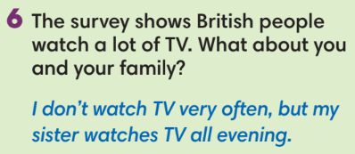
WRAP-UP & HOME WORK (3’)
- T asks Ss to talk about what they have learnt in the lesson.
- Vocabulary of age groups.
- Reading text about watching habits of different age groups.
* HOME WORK
- Do exercises in the workbook page 9.
- Prepare for Lesson 1.4: Grammar 2.

Date of planning:  Date of teaching: | Period 10 - UNIT 1: CULTURE INTERESTS  Lesson 4: Grammar 2
I. OBJECTIVES:
By the end of the lesson students will be able to:
- ask and answer questions about habits and routines.
1. Knowledge:
* Vocabulary: about habits and routines.
* Grammar:
- write the questions and answers of the Present Simple tense correctly.
- use the Present Simple tense to ask and answer about habits and routines.
2. Competence: Understand and use vocabulary about habits and routines, and understand the main grammatical points, then do the tasks assigned in the textbook. Use the questions and answers in the present simple tense correctly to talk about habits and routines.
3. Quality/ behavior: To teach Ss to be hard-working and attentive in class. Ss have a positive attitude to working in groups, individual work, pair work, cooperative learning and working.
II. TEACHING AIDS:
- Teacher: Grade 7 textbook, Unit 1 (SB p. 14), laptop/computer connected to the Internet, loudspeaker, projector/TV, PPT slides…
- Students: Text books, studying equipment…
- Method: Active teach, T-WC; group works; individual ……
III. PROCEDURE:
1. WARM UP (5’)
* Aim:
- To create a positive classroom atmosphere to start a new lesson.
- To help Ss review the Present Simple tense they have learnt in Lesson 1.2.
* Content: Game: Tom & Jerry (with the simple present)
* Outcome: Ss use the correct form of the verb in the Present Simple tense.
* Organisation: T_ Ss ..….
Teacher’s & Student’s activities |  | Content
Extra activity 1: Tom & Jerry Game  - T asks Ss to prepare 3 letter cards A, B and C (T may ask Ss to prepare them before the lesson.)  - T explains the game rules then checks instructions.  - Ss join in the game individually.  - T corrects Ss if necessary.  - T set the scene for the new lesson: T tells Ss that they are going to learn the questions and answers in the Present Simple tense.  - T writes the title on the board Unit 1: Cultural interests / Lesson 1.4: Grammar 2. |  | Game rules:  - Read the sentence  - Put the verb into the correct verb form in the Present Simple tense.  - Show the letter card A, B or C to give answers.  - 1 correct answer = 1 point.  - 1 wrong answer => Tom catches Jerry.
2. LEAD-IN (15’)
*Aim:
- To lead into the new lesson.
- To provide Ss with reasons for listening to the dialogue in exercise 1 (SB p.14).
* Content: Ss answer the questions about the habits.
* Outcome: Get the right answers on time.
* Organisation: T_ Ss …

Teacher’s & Student’s activities | Content
Extra activity 2: See – think – wonder.  - T shows a picture on the slide then asks students four questions.  (1) What can you see in the picture?  (2) What are they doing?  (3) Can the boy play the guitar?  (4) Do you like playing the piano or the guitar in your free time?  - T sets a time limit for Ss’ quick discussion.  - Ss work in pairs to make guesses about the picture then give answers.  - T calls some Ss to give answers then note them down on the board.  - T tells Ss that they’re going to read the conversation in exercise 1 (SB p.14) to check all the answers. | 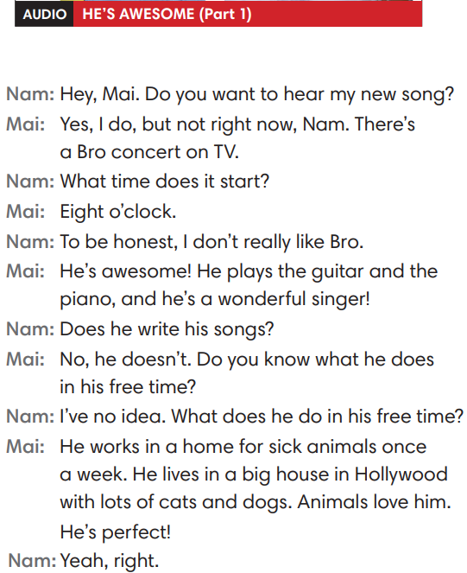
3. PRESENTATION (14’)
ACTIVITY 1 + 2:
*Aim:
- To present the grammar point in context.
- To lead into the next activity.
- To provide Ss with chances to spot the questions and answers in the Present Simple tense.
- To help Ss recognize the form of questions and answers in the Present Simple form.
- To provide Ss with chances to work cooperatively.
- To explain the grammar point for Ss.
- To introduce the everyday phrases and expressions pulled out from the conversation shortly.
* Content: To practice using the present simple in context, practice using adverbs of frequency in context by choosing the correct answer.
* Outcome: Practicing the use of the present simple by writing the correct form of the verbs, using adverbs of frequency in context.
* Organisation: T_Ss …

Teacher’s & Student’s activities | Content
1. Listen to part 1. Answer the questions below.  (Ex 1, p.14)  - T asks Ss to open their SB page 14, look at exercise 1.  - T calls a student to read the instruction then checks Ss’ understanding of it.  - T calls four students to read for questions.  - T tells Ss that they are going to listen to a conversation between Mai and Nam.  - Ss work individually, listen and note down the answers to the given questions.  - T calls some Ss to give answers then shows the answers on the slide.  - T asks Ss to look at the highlighted verbs in the above answers and elicits the tense of those from Ss (in the Present Simple tense). | Answer keys:  (1) It starts at eight o’clock.  (2) Mai thinks that Bro is awesome.  (3) He plays the guitar and the piano.  (4) He works in a home for sick animals once a week.
2. Find more Present Simple questions and answers in the dialogue.  (Ex 2, p.14)  - T asks Ss to look at exercise 2.  - T calls a student to read the instruction then checks Ss’ understanding of it.  - T asks Ss to work in groups of three to read the complete the activity.  - T calls groups to give answers then shows the answers on the slide to check as the whole class.  - T shows the interrogative form of the Present Simple tense (short questions / WH- questions) with missing words then elicits information from Ss.  - T explains the grammar points and tells Ss that they’re going to use the questions and answers in the Present Simple tense to talk about habits and routines. | 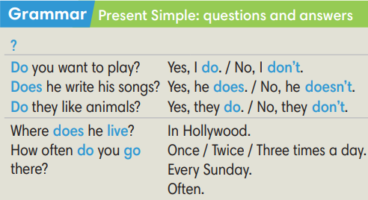
Extra activity 3: Read the phrases aloud. What do they mean? Use the dialogue to help you.  (Out of class box)  - T asks Ss to look at the Out of class box, find and underline the phrases in the dialogue.  - T calls students to read the phrases and asks for meaning based on the conversation.  - T corrects Ss’ pronunciation if any.  - T confirms the answers. | 
4. PRACTICE (13’)
ACTIVITY 3:
* Aims:
- To help Ss identify singular/plural subjects and use auxiliary verbs (do/does) correctly.
- To help students practice making questions and answers in the Present Simple tense for habits and routines.
* Content: Making questions; Listen to the audio track partners to answer the questions.
* Outcome: Making questions correctly. Then listen to choose the correct answers.
* Organisation: T_ Ss , Individual, Pair work, …

Teacher’s & Student’s activities | Content
Extra activity 4: Lucky stars game.  (Adapted from ex3 WB p.10)  - T explains the game rules then checks instructions.  - Ss join in the game individually.  - T corrects Ss if any. | Game rules:  - Read the sentence  - Fill in the blank with “do / does / don’t / doesn’t.”  - Raise your hand to give answers.  - 1 correct answer => choose a lucky star for points.
3. Make questions in the Present Simple. Listen to part 2 to answer the questions.  (Ex 3 SB p.14)  - T asks Ss to look at exercise 3.  - T calls a student to read the instruction then checks Ss’ understanding of it.  Step 1:  - T asks Ss to work in individually to read the written questions.  - T calls students to give answers then shows them on the slide to check with the whole class.  - T corrects Ss if any.  Step 2:  - T asks Ss to listen to part 2 of the dialogue to answer questions.  - T asks Ss to work in pairs, compare their answers with their partners.  - T calls students to give answers then shows the answers on the slide to check with the whole class.  - T corrects students if any. | 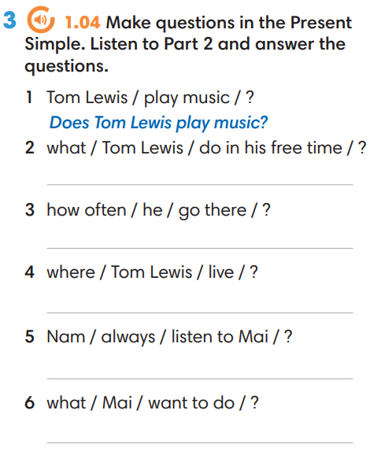
4. Production (7’)
ACTIVITY 4:
* Aims: To let Ss make conversations to ask and answer about habits and routines.
* Content: Making questions; Interview partners using the cues words.
* Outcome: Making questions correctly. Then Interview partners.
* Organisation: T_ Ss , Individual, Pair work, …
Teacher’s & Student’s activities | Content
4. In pairs, ask and answer questions about the activities below.  (Ex 4, p.14)  - T asks Ss to look at excersise 4 (SB page 14).  - T calls a student to read the instruction then checks Ss’ understanding of it.  - T models the activity in front of the class.  - T divides Ss into new pairs, asks them to make conversations to ask and answer about habits and routines.  - T gives a signal for Ss to change partners after every 3 minutes.  - T walk around to listen and notes down common mistakes for delayed feedback.  - T calls some groups to come to the front of the class, make conversations.  - T asks the rest to give comments on their classmates’ performance.  - T gives feedback on Ss’ work. | 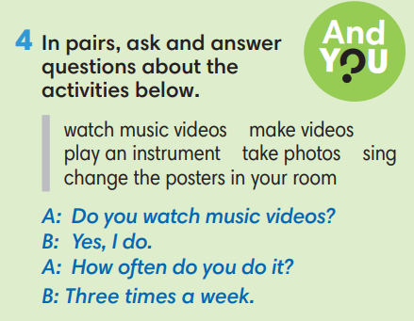
WRAP-UP & HOME WORK (3’)
- T asks Ss to talk about what they have learnt in the lesson.
✔ The present simple tense: questions and answers.
* HOME WORK
- Do exercises in the workbook page 10.
- Prepare for Lesson 1.5: Listening and vocabulary.

Date of planning: Date of teaching: | Period 11 - UNIT 1: CULTURE INTERESTS  Lesson 5: Listening and Vocabulary
I. OBJECTIVES:
By the end of the lesson student will be able to:
- identify specific details in a conversation and talk about media habits.
1. Knowledge:
* Vocabulary: use vocabulary of types of media to talk about media habits.
* Grammar: make sentences in the Present Simple with different personal pronouns correctly.
2. Competence: Understand and use the vocabulary of types of media and TV programs, do the tasks assigned in the textbook. Listen and identify specific details in a conversation and talk about media habits.
3. Quality/ behavior: To teach Ss to be hard-working and attentive in class. Ss have a positive attitude to working in groups, individual work, pair work, cooperative learning and working.
II. TEACHING AIDS:
- Teacher: Grade 7 textbook, Unit 1 (SB p. 15, WB p.11), laptop/computer connected to the Internet, loudspeaker, projector/TV, PPT slides …
- Students: Text books, studying equipment …
- Method: Active teach, T-WC; group works; individual …
III. PROCEDURE:
1. WARM UP + LEAD-IN (7’)
ACTIVITY 1:
* Aim:
- To create a positive classroom atmosphere to start a new lesson.
- To lead into the topic.
- To get students to think about the topic.
- To provide Ss with reasons for more discussions
* Content: Ss do the survey about the type of media that they’re using.
* Outcome: Name some types of media. Know more information about the media habits.
* Organisation: T_ Ss …
Teacher’s &Student’s activities | Content
1. (4’) Class Vote (SB p.15 - Ex 1)  - Set the scene: T tells Ss to look at the girl in Student book page 15. T asks some questions to elicit that the girl is going to do an interview about types of media.  - Teacher introduces the Vote and the survey questions in the student book.  - T explains How-to-vote steps then checks instructions.  - Ss join in the survey in pairs or in small groups.  - T sets the scene for the new lesson: T tells Ss that they are going to learn more words of media by doing a listening task.  - T writes the title on the board Unit 1: Cultural interests / Lesson 1.5: Listening and Vocabulary | How to vote:  - Read the questions  - Ask your classmates questions from 1-6  - Put a dot next to the type of media that you hear  - Answer your classmate questions if you are asked
Extra activity 1: (3’) Count and Announce  - T writes 4 types of media on the board: Newspaper, The Radio, The TV, and The Internet  - T asks students to count the number of the dots next to the name of media in their book.  - Ss work in pairs to count and tell teacher the answer.  - T asks some students to help with working out the most popular type of media in the class.  - T tells Ss that they’re going to learn more words of media in the next steps of the lesson. | 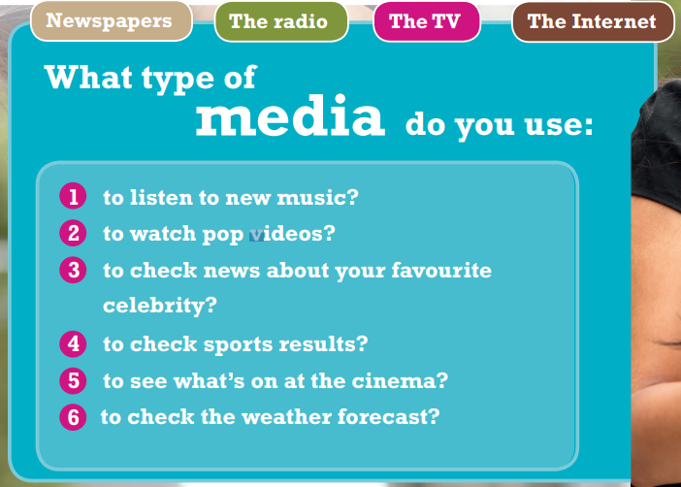
2. PRE-LISTENING (20’)
ACTIVITY 2 + 3:
*Aim:
- To activate Ss’ prior knowledge of the topic.
- To pre-teach words of news and entertainment
- To check Ss’ answers in “Think and Share” activity.
- To reinforce words of programs
* Content: Some brief notes; vocabulary about news and entertainment. Use them to complete the exercise.
* Outcome: Know some more new words about news and entertainment. Chose the correct words to answer the questions.
* Organisation: T_ Ss …
Teacher’s &Student’s activities | Content
Extra activity 2: (10’) Multiple Choice Game  (pre-teach vocabulary)  - Teacher introduces that Ss will learn more words of media by joining a game.  - T explains the game rules then checks instructions.  - Ss join the game in team. Ss take turns to answer each question.  - Teacher leads the game and asks students to read aloud each word or phrase.  - When the game ends, teacher shows all the new words again for students to read. | How to play:  - Look at the pictures and read the definitions  - Read the words of programs  - Choose 1, 2, or 3 to match the word with the picture  - 1 correct answer = 1 point
2. (4’) Think and Share.  (SB p.15 – Ex 2)  - T asks Ss to look at exercise 2.  - T calls a student to read the instruction then checks Ss’ understanding of it.  - T asks Ss to work in groups of three to read then complete the activity.  - T calls groups to give answers to check as the whole class. | 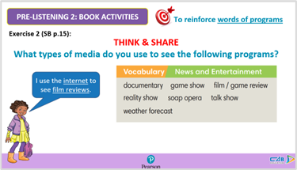
3. (3’) Use the Vocabulary box to complete the sentences. Change the words if necessary.  (SB p.15 - Ex 3)  - T asks Ss to look at exercise 3.  - T calls a student to read the instruction then checks Ss’ understanding of it.  - T asks Ss to work in pairs to read then complete the activity.  - T checks as the whole class. | Answer keys:  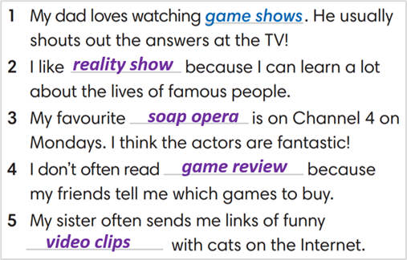
Extra activity 3: (3’) Match comments 1-6 with the types of media.  (WB p.11 - Ex 2)  - T asks Ss to look at exercise 2 in workbook page 11.  - T calls a student to read the instruction then checks Ss’ understanding of it.  - T asks Ss to work in pairs to read then complete the activity.  - T checks as the whole class. | Answer keys:  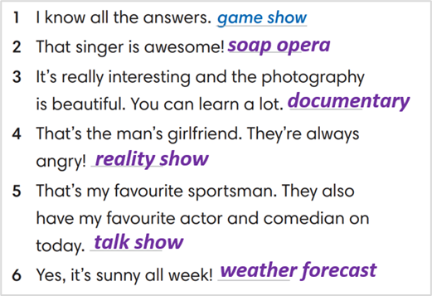
3. WHILE-LISTENING (8’)
ACTIVITY 4:
* Aim:
- To help Ss identify specific details in a conversation
- To provide Ss with chances to think and talk about personal media habits
* Content: Listen and understand to the audio track and complete the exercise.
* Outcome: Understanding the types of radio programs by matching the correct answers.
* Organisation : T_ Ss …
Teacher’s &Student’s activities | Content
4. Listen and match speakers 1-4 with the type of program they like a-e.  (SB p.15 - Exercise 4)  - T asks Ss to look at exercise 4 in student book page 15.  - T calls a student to read the instruction then checks Ss’ understanding of it.  - T asks students to look at the different kinds of programs and think of reasons why people might like these kinds of show.  - T asks Ss to work in pairs to listen then complete the activity and peer check for the first listening.  - T plays the audio again and checks as the whole class.  - Teacher asks students to give the evidence that they hear from the audio track to prove their answer. | Answer keys: 1-c, 2-e, 3-b, 4-a
4. POST-LISTENING (6’)
ACTIVITY 5:
*Aim: To help students applying the vocabulary items related to the topic in communicating.
* Content: Complete the sentences about the specific habits of each student. Share with partners their habits.
* Outcome: Think and share about individual habits.
* Organisation : T_ Ss ..
Teacher’s &Student’s activities | Content
5. Complete the following sentences to make them true for you. Then share with your partner  (SB p.15 - Exercise 5a & 5b)  - T asks Ss to look at exercise 5a in student book page 15.  - T calls a student to read the instruction then checks Ss’ understanding of it.  - T asks Ss to work in pairs to read then complete the activity.  - T sets a time limit for student.  - Students work in pair to think and share.  - Teacher invites different students to talk about their partner. | 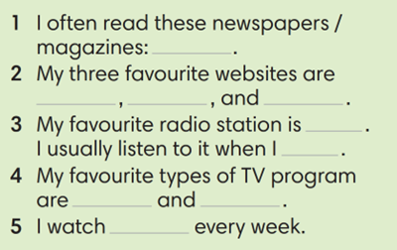
WRAP-UP & HOME WORK ( 2’)

- T asks Ss to talk about what they have learnt in the lesson.
- Vocabulary of types of media
* HOME WORK
- Do exercises in the workbook page 11.
- Prepare for Lesson 1.6: Speaking.

Date of planning:  Date of teaching: | Period 12 - UNIT 1: CULTURE INTERESTS  Lesson 6: Speaking
I. OBJECTIVES:
By the end of the lesson student will be able to:
- improve speaking skills by practicing say cinema expression to buy tickets.
1. Knowledge:
* Vocabulary: use vocabulary of types of films, time expression.
* Grammar: make dialogue in the Present Simple with cinema expressions.
2. Competence: Ss understand and use the vocabulary of types film and other related topics to the lesson content, do the tasks assigned in the textbook. Listen for comprehension and say cinema expression to buy tickets.
3. Quality/behavior: To teach Ss to be hard-working and attentive in class. Ss have a positive attitude to working in groups, individual work, pair work, cooperative learning and working.
II. TEACHING AIDS:
- Teacher: Grade 7 textbook, Unit 1 (SB p. 16, WB p.12), laptop/computer connected to the Internet, loudspeaker, projector/TV, PPT slides…
- Students: Text books, studying equipment…
- Method: Active teach, T-WC; group works; individual ……
III. PROCEDURE:
1. WARM UP + LEAD-IN (5’)
* Aim:
- To create a positive classroom atmosphere to start a new lesson.
- To review types of films
- To lead into the topic
* Content: Do mind-map for “Types of films”. Present their idea in front of the class.
* Outcome: Students share their knowledge about films, types of films…
* Organization of implementation: T- Ss …
Teacher’s & Student’s activities |  | Content
Extra activity 1: Mind-map  - T writes the words “TYPES OF FILMS” on board and asks students to work in pairs/small group.  - Students discuss and list out all words they remember from previous lesson.  - Students use a mind-map to present their ideas.  - Teacher encourages students to stand up and share their answers in front of the class.  - Teachers explains that students will use their knowledge about types of film to complete some tasks of the new lesson.  Unit 1 – Lesson 6: Speaking (At the cinema) |  | 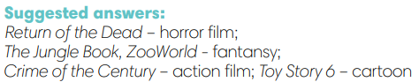
2. PRE-LISTENING (15’)
ACTIVITY 1 + 2:
* Aim:
- To activate Ss’ prior knowledge of the topic.
- To reinforce types of film
- To start a class discussion
- To listen and identify specific information to answer the questions
* Content: Some vocabularies related to films, and types of films. Listen to the conversation to answer the questions about Nam and Mai’s plan.
* Outcome: Knowledge about types of films. Understand the conversation.
* Organisation: Teacher’s instructions …
Teacher’s & Student’s activities |  |  | Content
1. (5’) Class vote  (SB p.16 – Ex 1)  - Set the scene: T tells Ss to look at the cinema program in Student book page 16. T asks some questions to elicit that the program tell students about the titles or the movies and when they start.  - Teacher introduces the Class Vote task in student book.  - T explains How-to-vote steps then checks instructions.  - Ss join in the survey in pairs or in small groups.  - T sets the transition for the next step of the lesson: “Now, let’s do a listening task to know Nam and Mai’s plan.” |  |  | How to vote:  - Read the program  - Say what types of films are on  - Answer the question for yourself “Which ones would you like to see”  - Use the given expression: “I think the … is a/an … film. I’d like to see it.”
2. (10’) Listen and answer the questions.  (SB p.16 – Ex 2)  - T asks students to look at the cinema program again and elicits some information about the program, tickets, seats and rows. (pre-teach the words if needed)  - T asks Ss to look at exercise 2.  - T calls a student to read the instruction then checks Ss’ understanding of it.  - T asks Ss to work in groups of three to listen for the first time  - Students works in pair to listen, answer, and compare their answers.  - T allows students to listen again, read the dialogue to double-check their answers.  - T calls groups to give answers to check with the whole class.  - T tells students to practice reading the dialogue again in a limited time. |  |  | Answer keys:  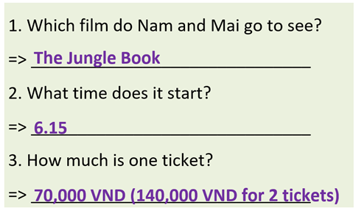
3. WHILE-SPEAKING (10’)
ACTIVITY 3:
* Aim:
- To reinforce the cinema expressions
- To practice the “buy ticket” dialogue
* Content: Complete the dialogue about buying tickets.
* Outcome: Understanding more about cinema expressions. Knowing the dialogue to buy movie tickets.
* Organisation: T_ Ss …
Teacher’s & Student’s activities |  |  |  | Content
3. Complete the dialogue below with one word in each gap. Listen again and check.  (SB p.16 - Exercise 3)  - T asks Ss to look at exercise 3.  - T goes through the Speaking box with students.  - T calls a student to read the instruction then checks Ss’ understanding of it  - Students find examples of the phrases in the dialogue.  - T asks Ss to work in pairs to read then complete the activity.  - T checks as the whole class.  - T sets a limit for students to work in pairs to practice the dialogue as a role play.  - T invites some pairs of students to act out the roleplay in front of the class.  - Ss work in pairs, practice the dialogue, then act out. |  |  |  | Answer keys:  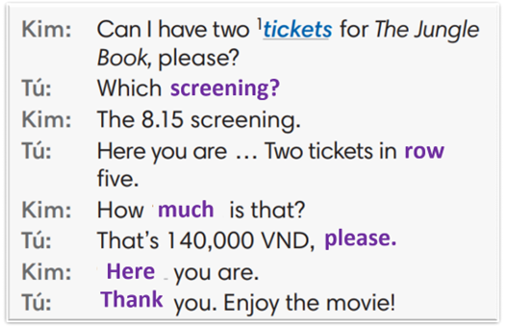
4. POST-SPEAKING ( 8’)
ACTIVITY 4:
*Aims: To help students applying the new language and skills related to the topic in communicating.
* Content: Ask and answer the questions to buy tickets for a film.
* Outcome: To practice speaking by asking and discussing the choices of films, and “buy ticket” related…
* Organisation: T_ Ss …
Teacher’s & Student’s activities | Content
4. In pairs, ask and answer to buy tickets for a film.  (Adaptation for Exercise 4 - SB p.16)  - T tells student to look at the speaking box in their student book again and prepare for the task.  - T gives students time to think about what they are going to say in their roleplays.  - T encourages stronger students to introduce a problem into their role play, e.g. the film is sold out, the only seats leaf are in the front row, there are two tickets left but they aren’t seated together.  - Students work in the same pairs from the last activity and practice their role plays, focus on using the correct intonation.  - Teacher invites pairs to act out their roleplays in front of the class. | 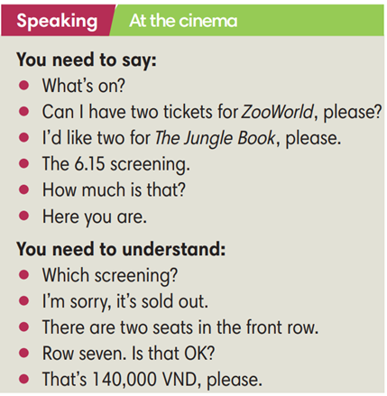
WRAP-UP & HOME WORK (2’)
- T asks Ss to talk about what they have learnt in the lesson.
Cinema expression
* HOME WORK
- Do exercises in the workbook page 12.
- Prepare for Lesson 1.7: Writing.

Date of planning:  Date of teaching: | Period 13 - UNIT 1: CULTURE INTERESTS  Lesson 7: Writing
I. OBJECTIVES:
By the end of the lesson, Ss are able to:
- write a personal introduction to a webpage.
1. Knowledge:
* Vocabulary: use vocabulary of common topics (age / school / places / subjects / foods, etc.) to write about personal information.
* Grammar: make sentences in the Present Simple tense correctly.
2. Competence: Ss understand and use the vocabulary of common topics (age / school / places / subjects / foods, etc.), do the tasks assigned in the textbook. Write a personal introduction for a webpage.
3. Quality/behavior: To teach Ss to be hard-working and attentive in class. Ss have a positive attitude to working in groups, individual work, pair work, cooperative learning and working.
II. TEACHING AIDS:
- Teacher: Grade 7 textbook, Unit 1 (SB p. 17, WB p.13), laptop/computer connected to the Internet, loudspeaker, projector/TV, PPT slides …
- Students: Text books, studying equipment …
- Method: Active teach, T-WC; group works; individual …
III. PROCEDURE:
1. WARM UP (4’)
* Aim:
- To create a positive classroom atmosphere to start a new lesson.
- To lead into the sample writing.
* Content: Game: Telepathy Game (about friends)
* Outcome: Ss guess and choose the correct picture.
* Organization of implementation:
Teacher’s & Student’s activities |  | Content
Extra activity 1: Telepathy Game  - Set the scene: T tells Ss that she / he’s going to give some sentences about her / his friends. Ss are going to play this game to find which friend she / he is talking about.  - T explains the game rules then checks instructions.  - Ss join in the game individually.  - T set the scene for the new lesson: T tells Ss that they are going to read and write about personal information in this lesson.  - T writes the title on the board Unit 1: Cultural interests / Lesson 1.7: Writing. |  | Game rules:  - Read the sentence  - Make guesses and choose A or B as the correct picture.  - 1 correct answer = 1 point.
2. LEAD-IN (3’)
* Aim:
- To get students to think about the topic.
- To provide Ss with reasons for reading the sample writing in exercise 1 (SB p.17).
* Content: Discuss groups and give the answer about the boy in the picture.
* Outcome: Guess the correct answers to the questions.
* Organisation: T_ Ss ..….
Teacher’s & Student’s activities |  | Content
Extra activity 2: See – think – wonder.  - T shows a picture of a boy on the slide then asks students four questions.  (1) How old is he?  (2) Which grade is he in?  (3) Where is he from?  (4) What’s his favorite subject?  - T sets a time limit for Ss’ quick discussion.  - Ss work in pairs to make guesses about the picture then give answers.  - T calls some Ss to give answers then note them down on the board for checking later.  - T tells Ss that they’re going to read the conversation in exercise 1 (SB p.17) to check all the answers. |  | 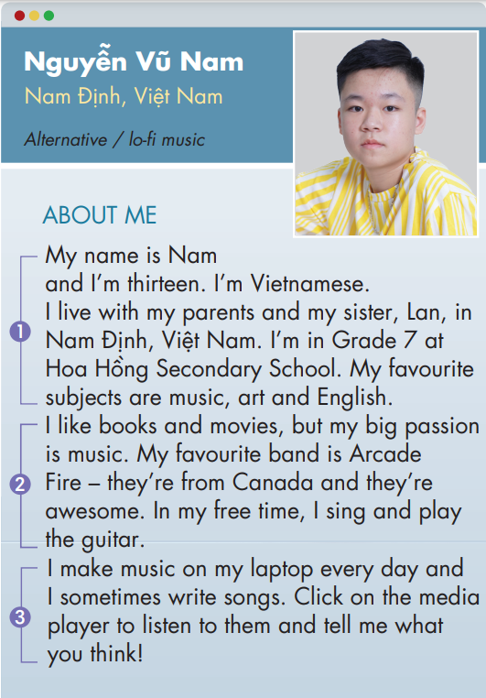
3. PRE-WRITING (13’)
ACTIVITY 1 + 2 + 3:
Aim:
- To activate Ss’ prior knowledge of the topic.
- To lead into the next activity.
- To check Ss’ answers in the “See – think – wonder” activity.
- To help Ss understand the sample writing.
- To help Ss focus on personal information while reading the sample.
- To provide Ss with useful expressions for writing a personal introduction.
* Content: Read Nam’s webpage to get used to writing skills
* Outcome: Do the exercise to improve writing skills.
* Organisation: T_ Ss ..….
Teacher’s & Student’s activities |  | Content
1. (3’) Class vote. Have you got a personal webpage?  (Ex 1, p.17)  - T calls a student to read the instruction then checks Ss’ understanding of it.  - T asks Ss if they’ve got a personal webpage.  - T shows slides to provide Ss with some clues.  - T names some types of social media and asks Ss to raise their hands if they’ve got accounts on one or some of them.  - T encourages Ss to name more webpages that they’ve joined.  - T tells Ss that they are going to look at Nam’s personal webpage in the next activity. |  |   Some types of social media:  
2. (4’) Read Nam’s webpage.  Step 1: Check your answers.  (Extra activity 3)  - T asks Ss to look at Nam’s webpage, read and compare with their answers in “See – think – wonder” activity.  - T checks with the whole class on the board.  Step 2: Which of the sentences are true. Write T.  (Ex 2, p.17)  - T asks Ss to look at exercise 2.  - T calls a student to read the instruction then checks Ss’ understanding of it.  - T asks Ss to work in groups of three to read then complete the activity.  - T calls groups to give answers then shows the answers on the slide to check as the whole class. |  | 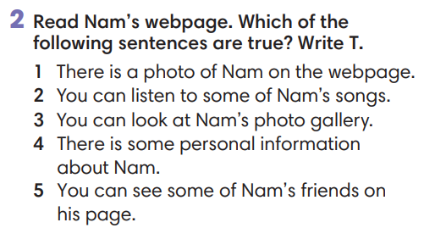
3. (3’) In pairs, read Nam’s personal information. Tick the things he writes about.  (Ex 3, p.17)  - T asks Ss to look at exercise 3.  - T calls a student to read the instruction then checks Ss’ understanding of it.  - T asks Ss to work in pairs to read then complete the activity.  - T checks as the whole class. |  | 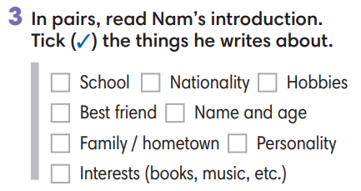
Extra activity 4: Look at the writing box. Which structures did Nam use? Underline.  - T asks Ss to look at the writing box and the sample writing again.  - T asks Ss to work individually, underlined the useful structures Nam used in his writing.  - T sets a time limit for the activity.  - T shows the slide and check as the whole class.
  Writing a personal introduction
  1. Personal details | My name is ….  I’m … years old.  I come from … [place] / I’m … [nationality]  I live with my family. / My hometown is …  I’m in Grade … at … school.
  2. Interests / Hobbies | I like / I’m into / I’m a big fan of ...  I’m interested in ... / My big passion is ...  My favorite is ...  In my free time, I ... / After school, I ...  I often ...
  3. Routines | I often / sometimes / usually ...  I ... once a week / every day.
4. WHILE-WRITING (17’)
ACTIVITY 4:
Aim:
- To help Ss identify correct personal information.
- To provide Ss with chances to think and write about their personal information.
- To help student practice writing a personal introduction for a webpage.
* Content: Use the writing box and Nam’s page to practice writing skills.
* Outcome: Write a personal introduction.
* Organisation: T_ Ss.. ….

Teacher’s & Student’s activities |  | Content
Extra activity 5: (4’) Mole hunt game.  (Adapted from ex3 WB p.13)  - T explains the game rules then checks instructions.  - Ss think and write individually then check sentences in pairs.  - T corrects Ss if any. |  | Game rules:  - Read the sentence  - Fill in the blank with A, B or C.  - Write the sentence in your notebook.  - 1 correct answer = 2 points.  - Check answers in pairs.
Extra activity 6: (5’) Write about you. Complete the sentences about you.  - T calls a student to read the instruction on the slide then checks Ss’ understanding of it.  - T asks Ss to work individually to complete the exercise.  - T sets a time limit for the task.  - T asks students to sit in pairs, compare their answers with partners.  - T calls some Ss to read their sentences.  - T corrects Ss if any. |  | 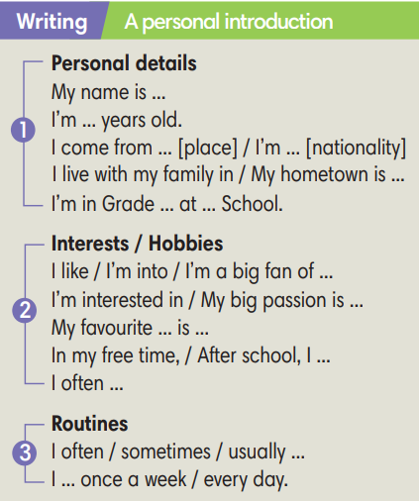
4. (8’) Write a personal introduction (60-80 words) for a webpage. Use the writing box and Nam’s page to help you.  (Ex 4 SB p.17)  - T asks Ss to look at exercise 4.  - T calls a student to read the instruction then checks Ss’ understanding of it.  - T asks Ss to work individually to write basing on the writing box and Nam’s page.  - T sets a time limits and walk around as a monitor while Ss are writing. |  | 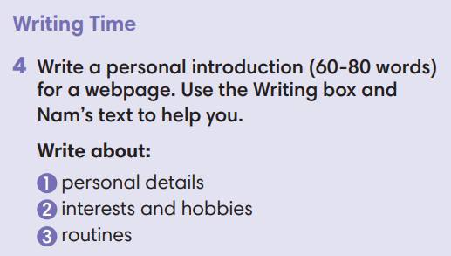
5. POST-WRITING (6’)
*Aim:
- To let Ss do peer-check.
- To give general comments on Ss’ writing pieces.
* Content: Ss swapping their writing in pairs.
* Outcome: Cross-check writing pieces and follow the writing rubric.
* Organisation: T_ Ss .…….

Teacher’s & Student’s activities |  | Content
Extra activity 7: In pairs, swap your writing then check.  (Ex 4, p.14)  - T explains the writing rubric before checking.  - T asks Ss to swap their writing pieces, use the given writing rubric then do cross-check.  - T gives feedback on common mistakes of Ss’ work.  - T may collect Ss’ writing for detailed comments. |  | Writing rubric:  (1) Does the writing include personal details, interests and hobbies, routines?  (2) Does the writing meet word limit (60-80 words)?  (3) Does the writing make any vocabulary and grammar mistakes?
WRAP-UP & HOME WORK (2’)
- T asks Ss to talk about what they have learnt in the lesson.
- A personal introduction for a webpage.
* HOME WORK:
- Do exercises in the workbook page 13.
- Prepare for Lesson 1.8: Self-check.

Date of planning:  Date of teaching: | Period 14 - UNIT 1: CULTURE INTERESTS  Lesson 8: Vocabulary In Action and Pronunciation
I. OBJECTIVES:
By the end of the lesson student will be able to:
1. Knowledge:
* Vocabulary: review vocabulary
- The lexical items related to hobbies: types of film, types of radio/TV programs, type of music, things you can read.
- Verbs of liking and disliking
* Pronunciation: Correctly pronounce words that contain the sounds /ɪ/ and /i:/
2. Competence: Students develop communication skills, presentation skills, and creativity; being collaborative and supportive in pair work, teamwork, and actively join in class activities.
3. Quality/behavior: To teach Ss the love of talking about their hobbies, and develop self-study skills. Ss have a good attitude to working in groups, individual work, pairwork, cooperative learning, and working
II. TEACHING AIDS:
- Teacher: Grade 7 textbook, Unit 1 (SB p.18, WB p.14), laptop/computer connected to the Internet, loudspeaker, projector/TV, PPT slides… .
- Students: Text books, studying equipment…
- Method: Active teach, T-WC; group works; individual ……
III. PROCEDURE:
1. WARM UP + LEAD-IN (4’)
*Aims:
- To create an active atmosphere in the class before the lesson.
- To lead into the new lesson.
* Content: Game: NAME 3 THINGS CHALLENGE (culture interests)
* Outcome: Students say words relating to the given topic quickly.
* Organisation : Teacher’s instructions…
Teacher’s & Student’s activities | Content
Extra activity 1: NAME 3 THINGS CHALLENGE  * Teacher asks students to spend 1 minutes to quickly review all vocabulary they have learnt in Unit 1 before they play a warm-up game.  - T tells students that they are going to play a game called NAME 3 THINGS CHALLENGE  - T explains the game rules then checks instructions.  - Teacher uses the slides to show the challenge  - Ss join in the game pairs or in small groups.  - Teacher listens to the Ss answers and calls several Ss to check for the whole class.  - T tells Ss that they can remember better with Glossary Table and asks Ss to open their Student Book page 18 – Exercise 1. | Game rules:  - Choose a number to get the challenge  - Read the topic word  - Say 3 words relating to that topic quickly.
2. REVIEW VOCABULARY (9’)
ACTIVITY 1 + 2 + 3:
*Aim:
- To introduce the glossary and its uses.
- To give further practice with verbs of liking / disliking.
* Content: Revise what they have learnt during the unit. Glossary and its uses.
* Outcome: Remember the new words and use liking / disliking.
* Organisation: Teacher’s instructions…
Teacher’s & Student’s activities | Content
1. Use the Glossary to find.  (Exercise 1 – Student Book page 18)  - Teacher introduces the Glossary Table.  - T asks Ss to look at exercise 1 in student book page 18  - T has students use the glossary to find the words which belong to the correct category  - T asks students to work in pairs and quickly do the task.  - T allows students to peer check first.  - T checks and confirms the answers | Answer key:  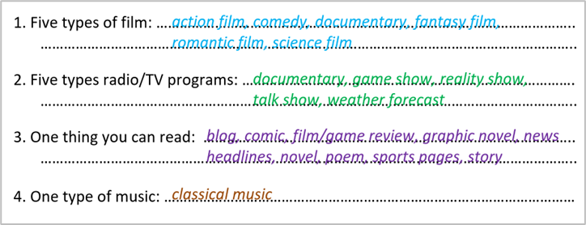
2. In pairs, say which three things you prefer in each category in activity 1.  (Exercise 2 – Student Book page 18)  - T reminds students about the form of verbs of liking / disliking.  - T asks students to do this activity individually. Have students read all the sentences carefully to make sure they understand the sentences.  - T lets them share their answers in pairs. Invite some students to give the answers.  - T writes the correct answers on the board. | e.g.  I prefer horror films, comedies and ….
3. Complete the Word Friends. In pairs, say if the sentences are true for you.  (Exercise 3 – Student Book page 18)  - T asks students to complete the sentences with suitable words.  - T asks students to work individually and check in pairs.  - T invites students to share their answers.  - T confirms the correct answers. | Answer key:  1. into  2. take  3. about  4. happy  5. check  6. in
3. PRONUNCIATION (14’)
3.1. Presentation ( 4’)
* Aims:
- To present new sounds
- To help students identify how to pronounce the sounds /ɪ/ and /i:/
* Content: Game: HEAR AND CLAP to practice pronunciation.
* Outcome: Pronoun some sounds after each play.
* Organisation: Teacher’s instructions …
Teacher’s & Student’s activities | Content
Extra activity 2: HEAR AND CLAP GAME  - T tells students that they are going to play a game called HEAR AND CLAP  - T explains the game rules then checks instructions.  - Teacher uses the slides to lead the game  - Ss join in the game pairs or in small groups.  - T listens to the Ss answers and calls several Ss to check for the whole class.  - T asks students to say the word again to practice some sounds after each play. | Game rules:  - Hear the sound  - Read the words  - Clap your hands 1 or 2 times to choose the word you hear.
3.2. Practice (10’)
ACTIVITY 4:
* Aims:
- To help students practice pronouncing these sounds in words.
- To help students pronounce the sounds /ɪ/ and /i:/ correctly in sentences.
- To help students identify the sounds /ɪ/ and /i:/ correctly in words
* Content: Listen to the sample pronunciation to choose the correct answer.
* Outcome: Read and write the words correctly.
* Organisation: Teacher’s instructions…

Teacher’s & Student’s activities | Content
4a. Listen to the underlined vowel(s) in each word and describe which sound you hear. Write the word in the correct column.  (Exercise 4a– Student Book page 18)  - T calls some students to read out the words first.  - T plays the recording for them to listen and underline vowel(s) in each word.  - T asks Ss to write the word in the correct column.  /ɪ/ and /i:/  - T invites some students to share their answers.  - T confirms the correct ones.
  /i:/ | /ɪ/
  media  reading  seat  teenagers | interest  middle-aged  sing  video
4b. Listen, check and repeat.  (Exercise 4b– Student Book page 18)  - T plays the recording for them to listen and repeat the words they hear.  - T asks Ss to pay close attention to the two sounds.  - T plays the recording again if needed.  - T explains to students the difference between the two sounds if needed.  - T invites some students to say some words they know that include the two sounds.  - T confirms the correct answers. | (Teacher can play the pronunciation guide video of this unit for students to watch and learn).
4. FURTHER PRACTICE (5’)
* Aim: To reinforce the student's recognition of the targeted sounds.
* Content: Game: ODD ONE OUT - practice the pronunciations by choosing the word that has a different sound.
* Outcome: Differentiate the sounds to practice the pronunciations. Saying the sounds correctly.
* Organisation: Teacher’s instructions….

Teacher’s & Student’s activities | Content
Extra activity 3: ODD ONE OUT  - T explains the game rules then checks instructions.  - Teacher uses the slides to lead the activity  - Ss join the activity in pairs or in small groups.  - T listens to the Ss answers and calls several Ss to check for the whole class.  - T asks students to say the word again to practice some sounds after each question. | Game rules:  - Read and choose A, B or C to odd out one word  - Explain by correctly saying the sounds
WRAP-UP & HOME WORK ( 3’)
- Teacher asks students to talk about what they have learnt in the lesson.
* HOME WORK
- Find 3 more words relating to hobbies that have the sounds /ɪ/ and /i:/

Date of planning:  Date of teaching: | Period 15 - UNIT 1: CULTURE INTERESTS  Lesson 9: Revision
I. OBJECTIVES:
By the end of the lesson, Ss are able to:
1. Knowledge:
* Vocabulary: revise words related to cultures, cultural activities, likes and dislikes, age groups, news and entertainment
* Grammar: review present simple tense to talk about habits and routines, likes and dislikes, media habits.
2. Competence: Ss understand and use the vocabulary of the unit, do the tasks assigned in the textbook. Write a personal introduction for a webpage.
3. Quality/ behavior : To teach Ss to be hard-working and attentive in class. Ss have a positive attitude to working in groups, individual work, pair work, cooperative learning and working.
II. TEACHING AIDS:
- Teacher: Grade 7 textbook, Unit 1 (SB p. 17, WB p.13), laptop/computer connected to the Internet, loudspeaker, projector/TV, PPT slides …
- Students : Text books, studying equipment …
- Method: Active teach, T-WC; group works; individual …
III. PROCEDURE:

- WARM-UP (4’)
*Aims:
- To create a positive classroom atmosphere to start a new lesson.
- To lead into the review lesson.
* Content: Game: SUPER EYES
* Outcome: Ss understand that they are going to review Unit 1.
* Organisation: Teacher’s instructions …
Teacher’s & Student’s activities | Content
Extra activity 1: SUPER EYES  - Set the scene: T asks students to do quick exercises for eyes such as look up and down, look left and right, row the eyes  - T tells students that they are going to play a game called SUPER EYES  - T explains the game rules then checks instructions.  - Teacher uses the slides to show the collages  - Ss join in the game in pairs or in small groups.  - Teacher shows the collage again with displayed answers to check for the whole class.  - T tells Ss that they are going to review Unit 1 | Game rules:  - Look carefully at a collage of different small pictures  - The collage will disappear in a few seconds  - Recall as many words about the collage as you can remember.
- REVIEW VOCABULARY (15’)
ACTIVITY 1 + 2 + 3:
* Aims:
- To help students reviews topic words and word friends from the unit
- To review vocabulary in context
* Content: Do the exercise to revise the vocabulary of Unit 1.
* Outcome: Understand the vocabulary to do the exercise correctly.
* Organisation : Teacher’s instructions….
Teacher’s & Student’s activities | Content
Extra activity 2: (5’) SUPER MIND  - T tells students to open the Glossary box in student book page 18  - T introduces the SUPER MIND game and rules  - T shows the slides of the game  - Ss take turns to choose the numbers for their teams.  - Ss discuss and list out all words related to the topic they get.  - T calls some Ss to give answers and confirms the winner. | How to play:  - Play in team  - Choose a number to open a block  - Read the topic word  - Write as many words related to the topic as you can  - The faster finisher gets points
1. (3’) Write the correct word for each definition  (Exercise 1 – Student Book page 19)  - T asks Ss to look at exercise 1 in student book page 19  - T calls a student to read the instruction then checks Ss’ understanding of it.  - T asks Ss to work in pairs to read then complete the activity.  - T checks as the whole class. | Answer keys:  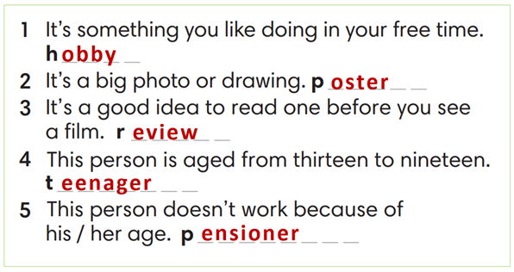
2. (4’) Complete the word friends in the text. Then ask and answer the questions in pairs.  (Exercise 2 – Student Book page 19)  - T asks Ss to look at exercise 2 in student book page 19  - T calls a student to read the instruction then checks Ss’ understanding of it.  - T asks Ss to work in pairs to read then complete the activity.  - Ss work in pairs to complete the task and compare the answers.  - T checks as the whole class. | Answer keys:  1-news / 2- forecast / 3-soap / 4-talk / 5-game / 6-reality / 7-magazines
3. (3’) Complete the poem with the words below.  (Exercise 3 – Student Book page 19)  - T asks Ss to look at exercise 3 in the student book on page 19  - T calls a student to read the instruction and then checks Ss’ understanding of it.  - T asks Ss to work in pairs to read and then complete the activity.  - Ss work in pairs to complete the task and compare the answers.  - T checks as the whole class. | Answer keys:  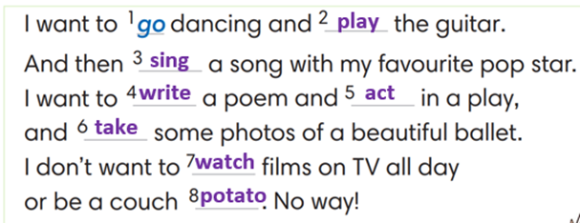
3. REVIEW GRAMMAR ( 15’)
ACTIVITY 4 + 5 + 6:
*Aim:
- To help students practice the present simple.
- To help students practice the present simple in a communicative activity
- To help students practice writing a personal introduction for a webpage.
* Content: Use the present simple tense to complete the exercises.
* Outcome: Use the present simple tense for communication and writing.
* Organisation: Teacher’s instructions….
Teacher’s & Student’s activities | Content
4. Complete the sentences with Present Simple form of verbs in brackets  (Exercise 4 – Student Book page 19)  - T asks Ss to look at exercise 4 in student book page 19  - T calls a student to read the instruction then checks Ss’ understanding of it.  - T asks Ss to work in pairs to read then complete the activity.  - Ss work in pairs to complete the task and compare the answers.  - T checks as the whole class. | Answer keys:  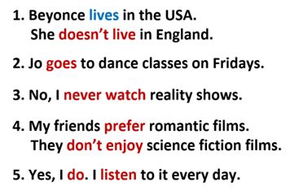
5. In pairs, use the words in A and B to write five sentences about a classmate. Then ask your classmate questions with How often to check.  (Exercise 5 – Student Book page 19)  Step 1: Time to write  - T tells students to read words in part A and B.  - T reminds them that they belong to 2 groups: Adverbs of frequency and verbs.  - T elicits the form of the sentence and gives an example.  - Ss work in pairs to write.  Step 2: Time to talk  - T calls a pair of strong students to demonstrate the dialogue in front of the class.  - Ss work in pairs to practice asking and answering.  - T encourages some pairs to roleplay the dialogue in front of the class. | Step 1:  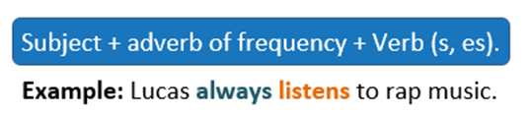  Step 2:  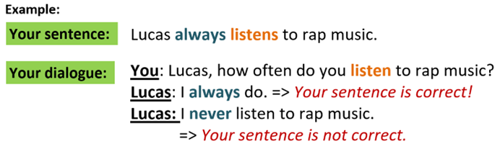
6. Your class has a new webpage. Write a text (60-80 words) to introduce a member from your class and post it on the webpage.  (Exercise 6 – Student Book page 19)  - T asks Ss to look at exercise 6.  - T calls a student to read the instruction then checks Ss’ understanding of it.  - T asks Ss to work individually to write based on the writing box in the student book page 17  - T sets a time limit and walks around as a monitor while Ss are writing.  - T asks Ss to swap their writing pieces for peer check.  - Ss work in pairs to write and give feedback for their partner’s writing product.  - T may collect Ss’ writing for detailed comments. | 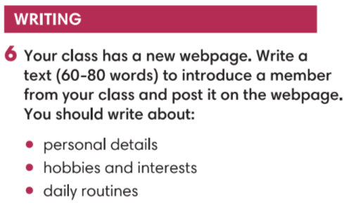
WRAP-UP & HOME WORK ( 2’)
- T asks Ss to talk about what they have learned in the lesson.
- Review Unit 1 vocabulary and grammar.
- Write a personal introduction for a webpage.
* HOMEWORK
- Do exercises in the workbook page 13.
- Prepare for Unit 2/Lesson 2.1: Vocabulary

Date of planning:  Date of teaching: | PERIOD 16 - UNIT 2: FAMILY AND FRIENDS  Lesson 1: Vocabulary
I. OBJECTIVES:
By the end of the lesson, students will be able to:
- have an overview of the topic “Family and Friends”.
- use vocabulary and grammar points to talk about clothes and appearance.
1. Knowledge:
*Vocabulary: an understanding of the meaning of keywords or word collocations below:
Type of clothes and footwear | Boots, dress, hoodie, jacket, jeans, pyjamas, shirt, shoes, shorts, T-shirt, tracksuit, trainers
Accessories | Baseball cap, glasses, handbag, necklace, scarf
Describing words | Size/Shape: baggy, tight  Material: leather, woolly, cotton  Colour/Pattern: plain, checked, striped, logo

* Grammar: expressions to talk about clothes and appearance, preference
I prefer ___.
I often wear pyjamas when I go to bed.
2. Competence:
To know the meaning of the keywords used to talk about clothes, and understand the main grammatical points, then do the tasks assigned in the textbook. To use the vocabulary about clothes to practice talking about preference and do a class survey about what the other classmates often wear.
3.Quality/Behavior: To teach Ss to be hard-working and attentive in class. Ss have a positive attitude to working in groups, individual work, pair work, cooperative learning and working.
II. TEACHING AIDS:
- Teacher: Grade 7 textbook, Unit 2 (SB p.20-21, WB p.15-16), laptop/computer connected to the Internet, loudspeaker, projector/TV, PPT slides…
- Students: Text books, studying equipment…
- Method: Active teach, T-WC; group works; individual ……
III. PROCEDURE:
 | 1. WARM UP( 3’)
* Aims:
- To activate Ss’ prior knowledge and get students involved in the lesson.
- To set the context for introducing new words.
* Content: Play Super Eyes game to get students involved in the lesson and to set the context for the lesson.
* Outcome: Students name some types of clothes they’ve already known.
* Organisation: Teacher’s instructions…
 | Teacher’s & Student’s activities |  | Content
 | Extra activity 1: Super Eyes game  - T explains the game rules then checks instructions.  - T uses the PPT slides to lead the game.  - T tells students that they are learning more words of clothes in today lesson.  - T sets the context for the lesson: Write the title on the board Unit 2: Family and Friends / Lesson 2.1: Vocabulary  - T asks Ss to name some more types of clothes they’ve already known. |  | Game rules:  - Look at the pictures.  - Remember as many clothing items as you can  - Recall the words you remember  - 1 correct words = 1 point.
 | 2. PRESENTATION 1 (11’) VOCABULARY
ACTIVITY 1:
* Aims:
- To reinforce the words of clothes that students have already known.
- To teach more new words
- To lead into the next activity.
- To reinforce the meaning and spelling of the words
* Content: Some brief notes; Some things about types of clothes.
* Outcome: Know new words about clothes.
* Organisation: Teacher’s instructions….

 | Teacher’s & Student’s activities |  |  |  | Content
 | 1. (8’) What clothes can you see in the picture?  Exercise 1 (SBp20)  - T asks Ss to open their SB page 20, look at exercise 1.  - T calls a student to read the instruction then checks Ss’ understanding of it.  - T elicits the meaning of words in the Vocabulary Box and quickly checks Ss’ understanding of vocabulary by asking them to look at the picture in SB and say all the clothing items they see.  - T plays the audio track 2.01 for students to listen and repeat.  - T asks students to work in pairs to find two things from the vocabulary list that are NOT in the picture. |  |  |  | Prompts:  What clothes can you see in the picture?  I see ….  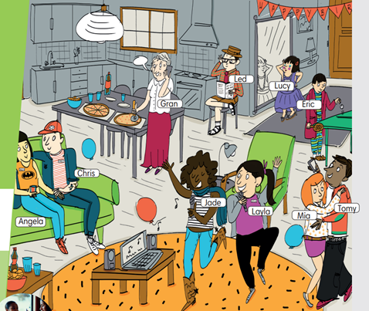  
 | Extra activity 2 (3’): Look and Say  - T asks Ss to look at the slide, slowly displays the vocabulary  - T tells Ss to say the words one by one  - Ss join the activity as the whole class.  - T tells Ss to remember the words using 3 groups: Clothes, Footwear, Accessories. |  |  |  | 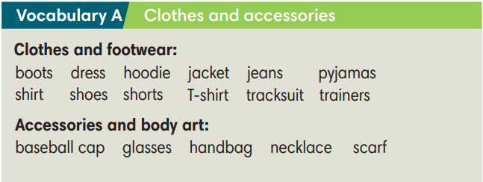
 | 3. PRACTICE 1 (9’)
ACTIVITY 2:
* Aims:
- To provide students with chances to practice pronouncing new words.
* Content: Some brief notes; Some things about types of clothes.
* Outcome: Know new words about clothes and classify them into types.
* Organisation: Teacher’s instructions…

 | Teacher’s & Student’s activities |  | Content
 | Extra activity 3 (5’): Find Someone Who  - T models the activity with the whole class by saying: “Look at the picture in your SB, find someone wearing boots.”  - T divides class into pairs/small groups.  - T gives and checks instructions for the game.  - Ss play the game in pairs/small groups  - T corrects Ss’ pronunciation if any. |  | Game rules:  - Look at the pictures.  - Student A says: “Find someone wearing…..”  - Student B finds and says the name.  - 1 correct answer = 2 points.
 | 2. (4’) Write the items under each picture (2-6)  (Exercise 2 – SB p.20)  - T asks Ss to look at exercise 2 (SB page 20).  - T calls a student to read the instruction then checks Ss’ understanding of it.  - T sets a time limit and asks Ss to work in groups of five to complete the exercise.  - T calls groups to give answers then checks as the whole class.  - T drills the vocabulary and corrects Ss’ pronunciation if any. |  | Answer keys:  (1) tracksuit (2) hoodie (3) necklace  (4) trainers (5) pyjamas (6) boots
 | 4. PRACTICE 2 (11’)
ACTIVITY 3 + 4:
* Aims:
- To help Ss use the new vocabulary in collocations.
- To practice the vocabulary and models related to the topic in communication
* Content: Some brief notes about the exercise; some keywords about clothes, type of clothes, preferences; some note about pronunciation.
* Outcome: Have a vocabulary about clothes; know how to talk about clothes and preferences.
* Organisation: Teacher’s instructions…

 | Teacher’s & Student’s activities |  |  | Content
 | 3. (4’) Complete the sentences with the words below.  (Ex 3, p.11)  Activity 6: Exercise 3 – SB p.21  Look at the photos. Choose the correct word.  - T asks Ss to look at exercise 3 (SB page 21).  - T calls a student to read the instruction then checks Ss’ understanding of it.  - T asks Ss to read the given words aloud, checks their understanding of the words.  - T sets a time limit and asks Ss to work in groups of four to complete the exercise.  - T calls groups to give answers then checks as the whole class.  - T corrects Ss’ pronunciation if any. |  |  | Answer keys:  a. plain T-shirt  b. striped shirt  c. baggy jeans  d. woolly hat
 | 4. (7’): In pairs, do the Fashion Quiz. Then look at page 101 and check how similar or different you are.  (Exercise 4 – SB p. 21)  - T asks students to look at their SB p.21 – Exercises 4  Step 1:  - T writes the heading words on board:  Size/Shape – Material – Colour/Pattern  - T asks Ss to find the words in the text that match the heading words.  - Ss work individually, find the words.  - Ss raise their hand to give answers.  - T confirms the answers, corrects Ss’ pronunciation if any.  Step 2:  - T presents the Quiz prompts:  - T asks students to do the quiz individually first, then compare  their answers in pairs.  - Ss work individually, find the words.  - Ss raise their hand to share the answers in pairs.  - T checks grammar, corrects Ss’ pronunciation if any. |  |  | 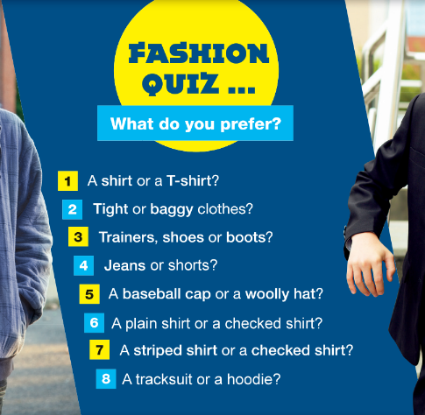  Correct headings:  
  Student A: What do you prefer? A shirt or a T-shirt?
  Student B: I prefer a T-shirt. What about you?
 | 4. PRODUCTION (7’)
ACTIVITY 5:
* Aims: To help Ss practice applying the vocabulary items and grammar points related to the topic in speaking.
* Content: Ss work in groups to talk about their clothes and appearance.
* Outcome: Ss talk about their clothes and appearance using vocabulary and grammar points.
* Organisation: Teacher’s instructions…..
 | Teacher’s & Student’s activities |  | Content
 | 5. Work in group of three. Interview two friends and complete the table.  (Exercise 5 – SB p.21)  - T asks Ss to look at exercise 5 (SB page 21).  - T calls a student to read the instruction then checks Ss’ understanding of it.  - T asks students to work in groups of three to interview each other and complete the table.  - T invites some students to report their results to the class using the present simple statements (i,e., Lan usually goes to bed at 9.30 pm.)  - T asks the rest to give comments on their classmates’ performance. T gives feedback on Ss’ work. |  | 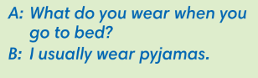  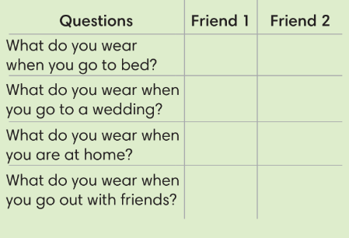
WRAP-UP & HOME WORK (3’)
- T asks Ss to talk about what they have learnt in the lesson.
- Vocabulary of types of clothes and accessories.
- Grammar points: Expressions to talk about preference and daily outfit.
* HOME WORK
- Do exercises in the workbook page 15-16.
- Prepare for Lesson 2: Grammar 1.

 | Date of planning:  Date of teaching: | PERIOD 17 - UNIT 2: FAMILY AND FRIENDS  Lesson 2: Grammar
I. OBJECTIVES:
By the end of the lesson, students will be able to:
- use Present Continuous to talk about present activities.
1. Knowledge:
* Grammar:
- write affirmative, negative and question forms of the Present Continuous tense correctly.
- use the Present Continuous tense to talk about present activities and describe friends in class.
2. Competence: Students know to use vocabulary about activities, and understand the main grammatical points, then do the tasks assigned in the textbook; use the Present Continuous tense to talk about present activities and describe friends in class.
3. Quality/ behavior: To teach Ss to be hard-working and attentive in class. Ss have a positive attitude to working in groups, individual work, pair work, cooperative learning and working.
II. TEACHING AIDS:
- Teacher: Grade 7 textbook, Unit2 (SB p. 22), laptop/computer connected to the Internet, loudspeaker, projector/TV, PPT slides…
- Students: Text books, studying equipment…
- Method: Active teach, T-WC; group works; individual ……
III. PROCEDURE:

1. WARM UP (4’)
* Aims:
- To activate students’ prior knowledge and get students involved in the lesson.
- To set the context for introducing new structures.
* Content: Play Guessing game to get students involved in the lesson and to set the context for the lesson.
* Outcome: Students know the context of the lesson.
* Organisation : T_ Ss , …
Teacher’s Student’s activities | Content
Extra activity 1: Guessing Game  - T divides Ss into 2 teams. Team boys and team girls.  - T explains the game rules then checks instructions.  - T corrects Ss if necessary.  - T set the scene for the new lesson: T tells Ss that they can describe what Dr Strange is doing by looking at the pictures.  They will learn more structures to describe people and present activities.  - T writes the title on the board Unit 2: Family and Friends / Lesson 2.2: Grammar | Game rules:  - Look at the pictures.  - Choose A – B - C  - 1 correct answer = 1 point.
2. LEAD-IN (3’)
* Aims: To lead into the new lesson.
* Content: Describe people and their activities in the picture on the slide.
* Outcome: Make guesses about the picture then give answers.
* Organisation : T_ Ss , …
Teacher’s Student’s activities | Content
Extra Activity 2: See – think – wonder.  - T shows a picture on the slide then asks students three questions.  (1) What do you see in the picture?  (2) Who are they?  (3) What are they doing?  - T sets a time limit for Ss’ quick discussion.  - Ss work in pairs to make guesses about the picture then give answers.  - T calls some Ss to give answers then note them down on the board.  - T tells Ss that they’re going to read a dialogue in exercise 1 (SB p.22) to check all the answers. | 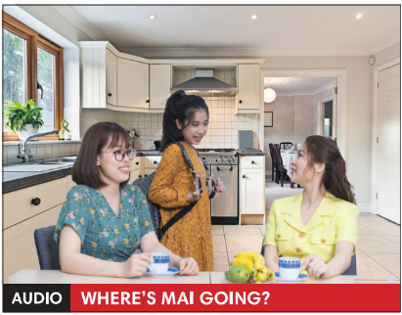
3. PRESENTATION (11’)
(Questions and answers in the Present Continuous tense)
ACTIVITY 1 + 2:
Aims:
- To present the grammar point in context.
- To lead into the next activity.
- To help Ss recognize all the forms of Present Continuous Tense.
- To provide Ss with chances to work cooperatively.
- To explain the grammar point for Ss.
* Content: Read Rose’s blog and find out new words. Learn the Present Simple.
* Outcome: Know more new words. Understanding the reading document; the topic of the lesson, grammar points…
* Organisation : T_ Ss , ..
Teacher’s Student’s activities |  |  |  | Content
1. (4’) Look at the photo. What is Mai doing? Then read and listen to check.  (Exercise 1 – SB p.22)  - T asks Ss to open their SB page 12, look at exercise 1.  - T calls a student to read the instruction then checks Ss’ understanding of it.  - T asks Ss to read the dialogue to find the answer for the question.  - Ss work individually.  - T calls some Ss to give answers then shows the answers on the slide.  - T asks Ss to look at the sentences and elicits the tense of those for Ss (all forms in the Present Simple Continuous). |  |  |  | Answer keys:  Mai is getting ready for school.  Some other sentences in the dialogue:  I’m brushing my hair.  I’m going to school.
2. (7’) Find more examples of Present Continuous in the dialogue in Exercise 1.  (Exercise 2 – SB p.22)  - T asks Ss to look at exercise 2.  - T calls a student to read the instruction then checks Ss’ understanding of it.  - T asks Ss to work in groups of three to complete the activity.  - T calls groups to give answers then shows the answers on the slide to check as the whole class.  THE GRAMMAR NOTES  - T shows the Grammar Notes for all forms of the Present Continuous tense then elicits information from Ss.  - T explains the grammar points and tells Ss that they’re going to use the Present Continuous tense to talk about things that happening now.  - T shows the grammar notes again, then Ss can read aloud. |  |  |  | 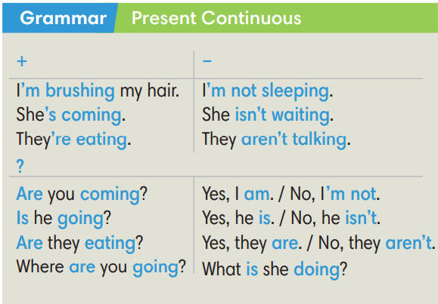
3. PRACTICE (15’)
ACTIVITY 3 + 4:
Aim:
- To help students practice completing the correct forms of the verbs with corresponding singular/plural subjects.
- To help students identify the correct form of the verbs in present continuous tense.
* Content: Complete the text/sentences with the correct form of the verbs.
Understand the text; grammar points; present continuous tense.
* Outcome: Know how to form a sentence with the correct form of the verbs. Understand the conversation; the topic of the lesson, vocabulary, grammar points…
* Organisation : T_ Ss .…..

Teacher’s Student’s activities |  | Content
Extra activity 3 (6’): Space Mission Game.  - T explains the game rules then checks instructions.  - Ss join in the game individually or in teams.  - T corrects Ss if any. |  | Game rules:  - Read the sentence  - Put the correct verbs in the brackets.  - Raise your hand to give answers.  - Get points.
3. (4’) Make affirmative and negative sentences in Present Continuous.  (Exercise 3 – SB p.22)  - T asks Ss to look at exercise 3.  - T calls a student to read the instruction then checks Ss’ understanding of it.  - T asks Ss to work in individually.  - T calls students to give answers then shows them on the slide to check as the whole class.  - T corrects Ss if any. |  | Answer key:  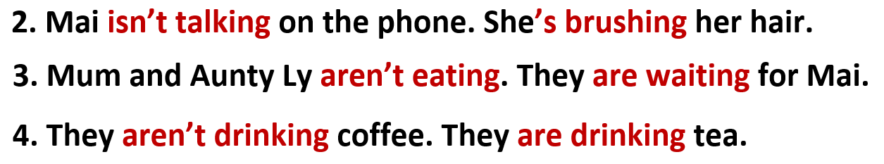
4. (5’) Make questions in Present Continuous. In pairs, look at the photo and answer the questions.  (Exercise 4 – SB p.22)  - T asks Ss to look at exercise 4.  - T calls a student to read the instruction then checks Ss’ understanding of it.  - T asks Ss to work in in pairs.  - T calls some pairs to give answers then shows them on the slide to check as the whole class.  - T corrects Ss if any.  *Extra Activity: Teacher can get some exercises from Workbook page 17 for Ss to practice in class. |  | Answer key:  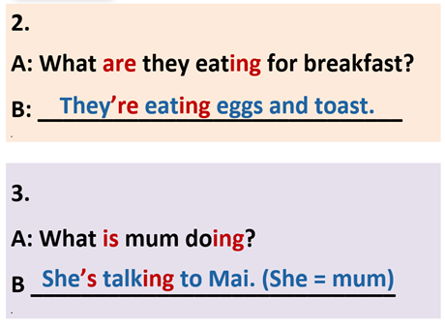
4. PRODUCTION ( 7’)
ACTIVITY 5:
*Aim: To help students applying the vocabulary items and grammar points related to the topic in communicating.
* Content: Ss describe themselves and their partners (what they are doing or wearing).
* Outcome: Ss know how to express themselves and describe others.
* Organisation: T_Ss…

Teacher’s Student’s activities |  |  | Content
5. Ask and answer about what your friends are doing or wearing.  (Exercise 5 – SB p.22)  - T asks Ss to look at exercise 5 (SB page 22).  - T calls a student to read the instruction then checks Ss’ understanding of it.  - T models the activity in front of the class.  - T divides Ss into new pairs, asks them to make conversations to ask and answer about their classmates.  - T walk around to listen and notes down common mistakes for delayed feedback.  - T calls some groups to come to the front of the class, make conversations.  - T asks the rest to give comments on their classmates’ performance.  - T gives feedback on Ss’ work. |  |  | 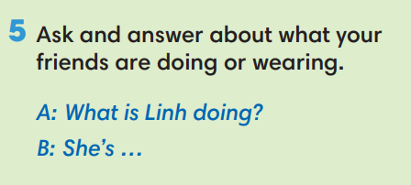
WRAP-UP & HOME WORK (2’)

- T asks Ss to talk about what they have learnt in the lesson.
- The present continuous tense: all forms
* HOME WORK
- Do exercises in the workbook page 17.
- Prepare for Lesson 1.3: Reading.

Date of planning:  Date of teaching: | PERIOD 18 - UNIT 2: FAMILY AND FRIENDS  Lesson 3: Reading and Vocabulary
I. OBJECTIVES:
By the end of the lesson ss will be able to:
- find specific detail in a letter and talk about family activities.
1. Knowledge:
*Vocabulary: an understanding of the vocabulary about family activities and some adjectives.
New words | Vietnamese meaning
- take care of the garden (np) | chăm sóc vườn
- sing karaoke (np) | hát karaoke
- plan for a trip (np) | chuẩn bị cho một chuyến đi
- excited (adj) | cảm thấy hào hứng
- relaxed (adj) | cảm thấy thư thái

* Grammar: Reading skills: the ability to find specific details in a letter.
2. Competence: Understand and know the meaning of the keywords used to talk about family activities, vote for top three exciting activities then do the tasks assigned in the textbook; locate information and find specific details in a letter (scanning skill); identify the main ideas of the paragraphs in the text or the text itself (skimming skill).
3. Quality/ behavior: To teach Ss to be hard-working and attentive in class. Ss have a positive attitude to working in groups, individual work, pair work, cooperative learning and working.
II. TEACHING AIDS:
- Teacher: Grade 7 textbook, Unit 2 (SB p.23, WB p.18), laptop/computer connected to the Internet, loudspeaker, projector/TV, PPT slides…
- Students: Text books, studying equipment…
- Method: Active teach, T-WC; group works; individual ……
III. PROCEDURE:

1. WARM-UP (5’)
* Aim:
- To help Ss review some activities they have known.
- To lead into the next activity.
* Content: Game: Relax Game (about family activities to relax)
* Outcome: Ss can talk about some family activities to relax.
* Organisation: T_ Ss …
Teacher’s &Student’s activities |  | Content
Extra activity 1: Relax Game  - T explains the game rules then checks instructions.  - T uses slide to lead the game.  - T asks Ss the question “What do these families do to relax?” – T elicits the picture and ask student to guess the meaning before they unscramble the word.  - Ss raise their hands if they have the answer.  - T asks students to read aloud the sentence after each play.  - T tells students that they are reading about family activities.  - T writes the title for the new lesson:  Unit 2/Lesson 3: Reading and vocabulary. |  | Game rules:  - Look at the picture  - Unscramble the word to see the activity  - Open the star to get point.
2. PRE-READING (8’)
ACTIVITY 1 + 2:
* Aim:
- To activate Ss’ background knowledge of the topic.
- To get student think about family activities.
- To provide Ss with reasons for reading the text in the next stage.
* Content: To discuss Ss’s family activities by reading and answering T’s questions.
* Outcome: Know new words, and grammar points when talking about one’s family activities.
* Organisation: T, Ss …
Teacher’s & Student’s activities | Content
1. (3’) Look at the photo. What are the family member doing?  (Exercise 1 – SB p.23)  - T shows the slide, reads aloud the questions  1- What are the family members doing?  2- How do they feel?  - T asks a students to look at the photos and find the answers.  - 1- They are doing gardening together.  - 2- They feel happy.  - T emphasizes about the photo “Doing gardening together makes the family members happy.”  - T mentions that doing gardening is one of family activities. | 
2. (5’): Work in pairs. What do family members do to relax? Compare your answers with another pair.  (Exercise 2 – SB p.23)  - T asks students to recall some family activities that they have known from the warm-up game.  - T tells students to work in pairs to talk about what their family.  - Ss can use the list in warm-up game for reference: what family members often do to relax.  - T invites some students to share their answers with the whole class using the given prompts.  A: What do family members do to relax?  B: We often go hiking together. | 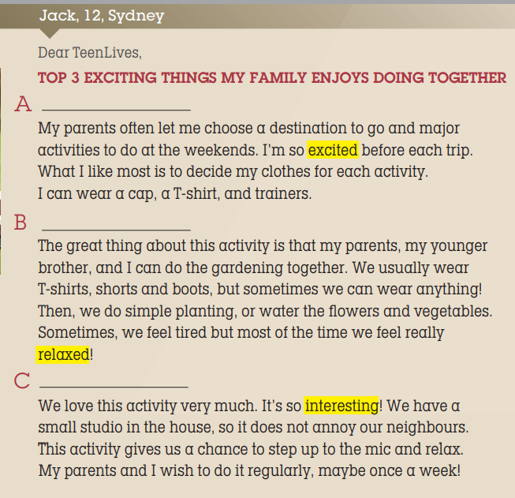
2. WHILE-READING 1 (7’)
ACTIVITY 3:
*Aim:
- To reinforce words of family activities.
- To help students practice identifying the general meaning of each paragraph.
- To help students practice matching the correct heading with each paragraph.
* Content: Read the letter from Jack then choose the best heading for it.
* Outcome: To know more new words about family activities. Understand more about using the words in contexts.
* Organisation: T, Ss …
3. Read the letter from Jack to TeenLives Magazine. Choose the best heading (1-3) for the paragraph (A-C)  (Exercise 3 – SB p.23)  - T asks Ss to look at exercise 3 (SB page 23).  - T calls a student to read the instruction then checks Ss’ understanding of it.  Step 1: Understanding the HEADINGS  - T asks Ss to look at the slide, read and match the heading with the pictures to elicit the Ss’ comprehension.  Step 2: Match the headings  - T and Ss review TIPS for reading and match the headings.  (Ss learnt the TIPS from Unit 1 already)  - T sets a time limit and asks Ss to work in pairs to complete the activity.  - T elicits the ideas from Ss, asks them in which line of the paragraph they see the answers.  - T asks Ss to explain their answers by referring to the clues the text.  - T confirms the answers then drills the pronunciation of the phrases and corrects Ss’ pronunciation if any. | Answer keys: A – B – C stand for the paragraphs.  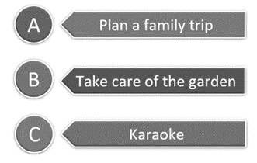
2. WHILE-READING 2 (5’)
ACTIVITY 4:
*Aim: To help students practice reading for specific information in an article.
* Content: To use the vocabulary of family activities grammar points to do the exercises.
* Outcome: To know more new words about family activities to relax. Understand more about using the words in contexts.
* Organisation: T, Ss …
4. Read the letter again. Choose the correct answer.  (Exercise 4 – SB p.23)  - T asks Ss to look at exercise 4 (SB page 23).  - T calls a student to read the instruction then checks Ss’ understanding of it.  - T and Ss review TIPS: reading for specific information.  (Ss learnt the TIPS from Unit 1 already)  - T tells student to read the text again individually to complete Exercise 4.  - When finished, T asks them to compare their answers in pairs and check with them.  - T asks students to point to relevant details in the text. | 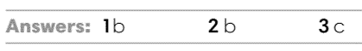
3. WHILE-READING 3 (5’)
ACTIVITY 5:
* Aim:
- To provide more vocabulary in context.
- To help Ss practice reading for specific information.
* Content: Discuss in groups the meanings of the adjectives by understanding the content of the given texts.
* Outcome: Understanding and explaining the meaning of the adjectives about feelings.
* Organisation: T, Ss ….
5. Look at the highlighted adjectives in the text. What do they mean?  (Exercise 5 – SB p.23)  - T asks students to find the highlighted adjectives in the text and discuss in groups of three the meanings of these words.  - T checks the answers with students.  - T uses slide to drill the pronunciations.  - T corrects Ss’ pronunciation if any. | 4. Answer keys:  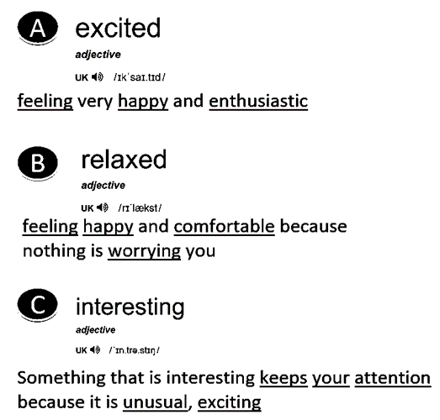
4. POST-READING (7’)
ACTIVITY 6:
* Aim: To encourage students to talk about their family members’ exciting activities.
* Content: To discuss the Ss’s exciting family activities.
* Outcome: Making sentences to talk about their family activities. Commenting about the sentences of others.
* Organization: T, Ss...
6. Work in group of four. Vote for the top three exciting activities that a family can do. Then share with your class.  (Exercise 6 – SB p.23)  - T asks Ss to look at exercise 6 (SB page 23).  - T calls a student to read the instruction then checks Ss’ understanding of it.  - T asks a student to read the example then models the activity in front of the class.  - T asks students to work in groups of four to discuss the  activities a family can do.  - T sets a time limit and monitors Ss while they are working in groups.  - When finished, T asks each group to vote for the three most  exciting activities and share with the class.  - T notes down common mistakes for delayed feedback.  - T asks the rest to give comments on their classmates’ performance.  - T gives feedback on Ss’ work. | 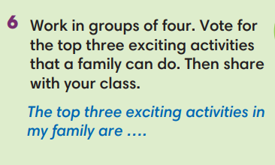
WRAP-UP & HOME WORK (4’)
- T asks Ss to talk about what they have learnt in the lesson.
- Vocabulary of family activities and adjectives.
- Reading a letter about family activities
- Some tips for reading skills
* HOME WORK
- Do exercises in the workbook page 18.
- Prepare for Lesson 2.4: Grammar 2.

Date of planning:  Date of teaching: | PERIOD 19 - UNIT 2: FAMILY AND FRIENDS  Lesson 4: Grammar 2
I. OBJECTIVES:
By the end of the lesson students will be able to:
- use Present Simple and Present Continuous to talk about what usually happens and is happening around now.
1. Knowledge:
* Grammar:
- Identify the Present Simple and Present Continuous (rules and time expressions)
- Talk about what usually happens and is happening around now
2. Competence: Understand and use vocabulary about habits and routines, and understand the rules and time expression of present simple and present continuous, then do the tasks assigned in the textbook; use the correct tense of verbs to form a question about daily routines or things happening at the speaking time or in a period of time.
3. Quality/ behavior: To teach Ss to be hard-working and attentive in class. Ss have a positive attitude to working in groups, individual work, pair work, cooperative learning and working.
II. TEACHING AIDS:
- Teacher: Grade 7 textbook, Unit 2 (SB p. 24), laptop/computer connected to the Internet, loudspeaker, projector/TV, PPT slides…
- Students: Textbooks, studying equipment…
- Method: Active teach, T-WC; group works; individual ……
III. PROCEDURE:

1. WARM UP (5’)
* Aim:
- To create a positive classroom atmosphere to start a new lesson.
- To help Ss review the words of hobbies and interests.
* Content: Game: Tom & Jerry (with the simple present)
* Outcome: Ss use the correct form of the verb in the Present Simple tense and Present Continuous tense.
* Organisation: T, Ss ..….
Teacher’s & Student’s activities |  | Content
Extra activity 1: Tom & Jerry Game  - T asks Ss to prepare 3 letter cards A, B and C (T may ask Ss to prepare them before the lesson.)  - T explains the game rules then checks instructions.  - Ss join in the game individually.  - T corrects Ss if necessary.  - T tells students to talk more about interests and hobbies by asking two questions:  What do you like doing in your free time?  How often do you do these activities? |  | Game rules:  - Read the sentence  - Show the letter card A, B or C to give answers.  - 1 correct answer = 1 point.  - 1 wrong answer => Tom catches Jerry.
2. LEAD-IN (3’)
*Aim:
- To lead into the new lesson.
- To provide Ss with reasons for listening to the text in exercise 1 (SB p.24).
* Content: Ss answer the questions about the activities.
* Outcome: Get the right answers on time.
* Organisation: T_ Ss ..….

Teacher’s & Student’s activities | Content
Extra activity 2: See – think – wonder.  - T shows a picture on the slide then asks students four questions.  (1) What can you see in the picture?  (2) What is the girl doing?  - T sets a time limit for Ss’ quick discussion.  - Ss work in pairs to make guesses about the picture then give answers.  - T calls some Ss to give answers then checks with the whole class.  - T introduces Kim. “This is Kim. She is talking about her routines.” | 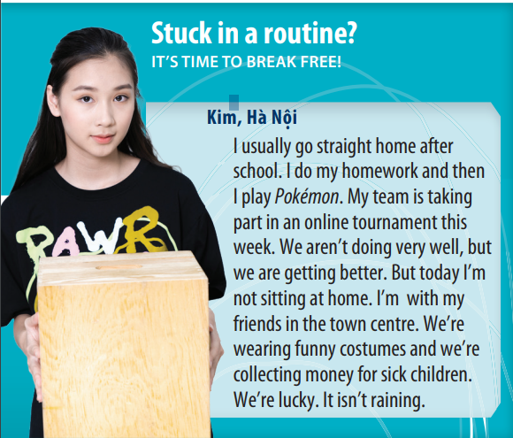
3. PRESENTATION (11’)
ACTIVITY 1 + 2:
*Aim:
- To present the grammar point in context.
- To lead into the next activity.
- To introduce to students the uses and time expressions of the Present Simple and Present Continuous tense.
- To explain the grammar point for Ss.
* Content: To practice using the present simple and present continuous in context by choosing the correct answer.
* Outcome: Practicing the use of the present simple and present continuous by writing the correct form of the verbs.
* Organisation: T, Ss ..….
Teacher’s & Student’s activities | Content
1. (7’) Read the text and answer the questions. (Exercise 1 – SB p24)  - T asks Ss to open their SB page 24, look at exercise 1.  - T calls a student to read the instruction then checks Ss’ understanding of it.  - T calls four students to read for questions.  - T tells Ss that they are going to read the text to find answers.  - Ss work individually, read and note down the answers to the given questions.  - T calls some Ss to give answers then shows the answers on the slide. | Answer keys:  1. Kim usually goes straight home, does her homework and then plays Pokémon.  2. No, they aren’t (but they’re getting better).  3. Today she’s with her friends in the town canter, collecting money for sick children.
2. (4’) Find two more examples in the text for each rule below.  (Exercise 2 – SB p24)  - T goes through the Grammar box with students.  - T asks them which tense we use with adverbs of frequency such as always, usually, often (Present Simple).  - T asks them which tense we use to talk about something happening now, this week, today (Present Continuous).  - T reminds students that we use the Present Continuous not only for things happening exactly now but also for things happening around now, such as “I’m reading a great book.” (I’m not reading at this minute but I’m in the middle of reading the book.).  - T uses slide to show the grammar notes again.  - T asks Ss to look at exercise 2.  - T calls a student to read the instruction then checks Ss’ understanding of it.  - T asks Ss to work in groups of three to read the complete the activity.  - T calls groups to give answers then shows the answers on the slide to check as the whole class. | 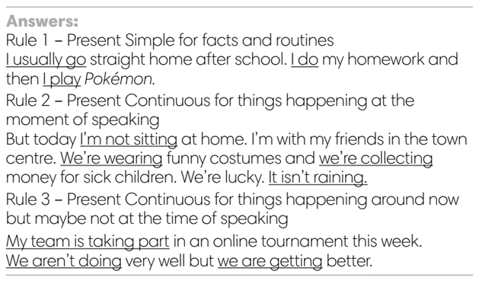
4. PRACTICE 1 (3’)
ACTIVITY 3:
* Aims: To help students identify the use of Present Simple and Present continuous.
* Content: Choose the correct option to complete the sentence.
* Outcome: Choose the option correctly in grammar and use present simple and present continuous to explain their options.
* Organisation: T, Ss, ….
Teacher’s & Student’s activities | Content
3. Choose the correct option  (Exercise 3 – SB p24)  - T elicits the example sentence with students.  - T asks them why the Present Continuous is the correct form to use (because it’s referring only to this semester, not as a permanent fact).  - T encourages students to discuss the other sentences in pairs,  to decide on the correct form and the reasons for this.  - T calls some students to share their answers.  - T corrects Ss’ pronunciation if any.  - T confirms the answers. | Answer keys:  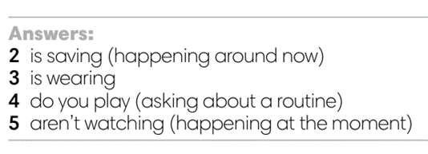
4. PRACTICE 2 (13’)
ACTIVITY 4:
* Aims: To help students practice making sentences in the Present Simple and Present Continuous.
* Content: Making correct sentences.
* Outcome: Making sentences describe someone’s usual life and what they’re doing by using present simple and present continuous.
* Organisation: T, Ss , Individual, Pair work, ….
Teacher’s & Student’s activities | Content
4. Make sentences with but to describe Paula’s usual life and what she’s doing now. (Exercise 4 – SB p.24)  - T asks Ss to look at exercise 4.  - T calls a student to read the instruction then checks Ss’ understanding of it.  - T reminds students that we use but to link two contrasting ideas.  - T explains that in this instance, the contrast is between what usually happens and what is happening at the moment.  - T asks Ss to work in individually to write.  - Students write full sentences in their notebooks.  - T calls students to give answers then shows them on the slide to check as the whole class.  - T corrects Ss if any.  Further practice:  There are two more exercises from workbook.  - T uses the slides to lead the activity if time. | 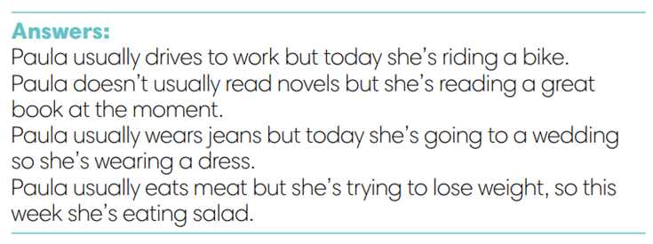
4. Production (7’)
ACTIVITY 5:
* Aims: To help students applying the vocabulary items and grammar points related to the topic in communicating.
* Content: Do class survey; interview partners using the cues words.
* Outcome: Use vocabulary items and grammar points related to the topic to interview partners.
* Organisation: T. Ss , Individual, Pair work, ….
Teacher’s & Student’s activities | Content
5. Class survey. Interview your classmates and write their names to complete the sentences.  (Exercise 5 – SB p.24)  - T asks Ss to look at exercise 5 (SB page 24).  - T calls a student to read the instructions then checks Ss’ understanding of it.  - T explains to the students that they are going to walk around  class and survey their friends.  - T elicits the questions that students may use to ask their friends.  - T models the activity in front of the class.  - T asks students to stand up and walk around the class and  interview other students to complete the sentences.  - T walk around to listen and notes down common mistakes for delayed feedback.  - T invites some students to report their sentences to the class.  - T asks the other students to give comments on their classmates’ performance.  - T gives feedback on Ss’ work. | 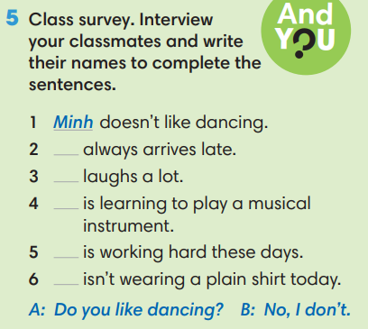
WRAP-UP & HOME WORK (3’)
- T asks Ss to talk about what they have learnt in the lesson.
- The present simple and present continuous tense: rules and time expressions
* HOME WORK
- Do exercises in the workbook page 19.
- Prepare for Lesson 2.5: Listening and vocabulary.

Date of planning: Date of teaching: | PERIOD 20 - UNIT 2: FAMILY AND FRIENDS  Lesson 5: Listening and Vocabulary
I. OBJECTIVES:
By the end of the lesson student will be able to:
- identify specific details in a conversation and talk about personalities.
1. Knowledge:
* Vocabulary: use vocabulary of personalities to describe people.
* Grammar: make sentences in the Present Simple and Present Continuous to describe people’s interest and habit correctly.
2. Competence: Understand and use adjectives of personalities, do the tasks assigned in the textbook. Listen and identify specific details in a conversation and talk about personalities.
3. Quality/ behavior: To teach Ss to be hard-working and attentive in class. Ss have a positive attitude to working in groups, individual work, pair work, cooperative learning and working.
II. TEACHING AIDS:
- Teacher: Grade 7 textbook, Unit 2 (SB p. 25, WB p.20), laptop/computer connected to the Internet, loudspeaker, projector/TV, PPT slides…
- Students: Text books, studying equipment…
- Method: Active teach, T-WC; group works; individual ……
III. PROCEDURE:
1. WARM UP + LEAD-IN (10’)
ACTIVITY 1:
* Aim:
- To activate students’ prior knowledge and get students involved in the lesson.
- To set the context for introducing new words.
- To get students to think about the topic.
- To provide Ss with reasons for more discussions
* Content: Play SONGS game to practice the listening skill.
* Outcome: Know more new words in context. Improve pronunciation.
* Organisation: T, Ss ..
Teacher’s &Student’s activities | Content
Extra activity 1 (5’): SONGS  - T greets students  - T introduces the Warm-up song  - T explains How-to-play steps then checks instructions.  - Ss join the activity as the whole class.  - T uses slides to conduct the activity.  - T introduces that all the words are adjectives of Personalities.  - T elicits the meaning and drill the pronunciation of the words.  - T sets the scene for the new lesson: T tells Ss that they are going to learn more words of personalities by doing a listening task.  - T writes the title on the board Unit 2: Family and Friends / Lesson 2.5: Listening and Vocabulary. | How to play:  - Read the list of given words  - Listen to a song, put a tick next to the word you hear.  - 1 correct answer = 1 point
1. (5’) Tell your partner about the personalities of two people in your family.  (Exercise 1 – SB p.25)  - T asks students to work in pairs to talk about the personalities  of two people in their family.  - Ss work in pairs to think and share.  - T invites some students to share with the class.  - T notes down the adjectives that students used to talk about  personalities on the board.  - T tells Ss that they’re going to learn adjectives in the next steps of the lesson. | 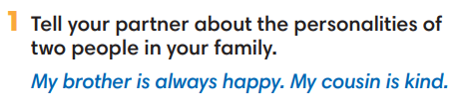
2. PRE-LISTENING (18’)
ACTIVITY 2 + 3:
*Aim:
- To activate Ss’ prior knowledge of the topic.
- To pre-teach words of personalities
- Introduce the Vocabulary Box
- To reinforce words of personalities
- To develop Critical Thinking
- To reinforce words of personalities
* Content: Some brief notes; vocabulary about personalities. Use them to complete the exercise.
* Outcome: Know some more new words about personalities. Chose the correct words to answer the questions.
* Organisation: T, Ss …
Teacher’s &Student’s activities | Content
Extra activity 2 (10’): Multiple Choice Game (pre-teach vocabulary)  - Teacher introduces that Ss will learn more words of personalities by joining a game.  - T explains the game rules then checks instructions.  - Ss join the game in team. Ss take turns to answer each question.  - Teacher leads the game and asks students to read aloud each word or phrase.  - When the game ends, teacher shows all the new words again for students to read. | How to play:  - Look at the slides and read the definitions  - Read the words of personalities  - Choose 1, 2 or 3 to match the word with the definition  - 1 correct answer = 1 point
2. (4’) Tick (V) the positive adjectives and cross (X) the negative ones.  (Exercise 2 - SB p.252)  - T asks Ss to look at exercise 2.  - T calls a student to read the instruction then checks Ss’ understanding of it.  - T elicits the meaning of Positive and Negative  - T asks Ss to work in pairs or small groups to read then complete the activity.  - T calls groups to give answers to check as the whole class.  - T encourages students to make sentences with these adjectives. | 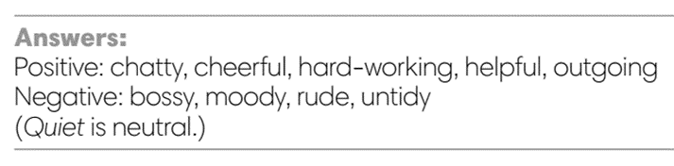
3. (4’) Minh, Nam and Linh are talking about Mai. Read their opinions and complete each gap with a word from the Vocabulary box. Listen and check.  (Exercise 3 - SB p.25)  - T asks Ss to look at exercise 3.  - T calls a student to read the instruction then checks Ss’ understanding of it.  - T asks students to look at the photo of Mai and discuss Mai's  personality in groups of three or four.  - T plays the audio and ask students to complete the gaps.  - T plays the audio again for Ss to check with the answers.  - T checks as the whole class. | Answer keys:  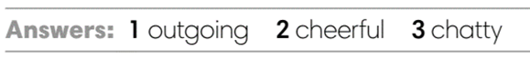
3. WHILE-LISTENING (8’)
ACTIVITY 4:
* Aim:
- To help Ss identify specific details in a conversation.
- To provide Ss with chances to think and talk about personalities.
* Content: Listen and understand the audio track to complete the exercise.
* Outcome: Understanding the personalities by matching the correct answers.
* Organisation: T_ Ss …
Teacher’s &Student’s activities | Content
4. Listen to a talk between Minh and Nam. Mark the sentences V (right), X (wrong), ? (doesn’t say).  (Exercise 4 - SB p.25)  - T asks Ss to look at exercise 4 in student book page 25.  - T calls a student to read the instruction then checks Ss’ understanding of it.  - T tells students to read the statements before listening.  - T asks students to listen and mark the sentences (i.e., v, x, ?).  - T plays the audio and have students do the exercise.  - T tells Ss to check their answers in pairs.  - T plays the audio again and checks the answers with the  whole class.  - Teacher encourages students to give the evidence that they hear from the audio track to prove their answer. | 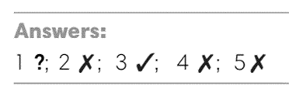
4. POST-LISTENING (6’)
ACTIVITY 5:
*Aim: TTo help students applying the vocabulary items related to the topic in communicating.
* Content: Work in pairs to describe one’s personalities by using adjectives.
* Outcome: Think and share about individual personality.
* Organisation : T, Ss ..
Teacher’s &Student’s activities | Content
5. In pairs, choose three adjectives from the Vocabulary Box to describe.  (Exercise 5 - SB p.25)  - T asks Ss to look at exercise 5 in student book page 25.  - T calls a student to read the instruction then checks Ss’ understanding of it.  - T asks Ss to work in pairs to read then complete the activity.  - T sets a time limit for students.  - Students work in pair to think and share.  - Teacher invites different students to talk about their partner. | 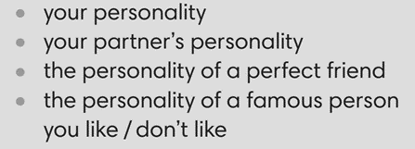
WRAP-UP & HOME WORK ( 2’)

- T asks Ss to talk about what they have learnt in the lesson.
- Vocabulary of personalities
* HOME WORK
- Do exercises in the workbook page 20.
- Prepare for Lesson 2.6: Speaking.

Date of planning:  Date of teaching: | PERIOD 21 - UNIT 2: FAMILY AND FRIENDS  Lesson 6: Speaking
I. OBJECTIVES:
By the end of the lesson student will be able to:
- improve speaking skills by giving and responding to news.
1. Knowledge:
* Vocabulary: use the expressions of giving and responding to news.
* Grammar: make dialogue in the Present Simple, Present Continuous with expressions of giving and responding to news.
2. Competence: Ss understand and use the expressions of giving and responding to news as well as the other related topics to the lesson content, do the tasks assigned in the textbook. Listen and read a dialogue for comprehension and practice in giving and responding news.
3. Quality/ behavior: To teach Ss to be hard-working and attentive in class. Ss have a positive attitude to working in groups, individual work, pair work, cooperative learning and working.
II. TEACHING AIDS:
- Teacher: Grade 7 textbook, Unit 2 (SB p. 26, WB p.21), laptop/computer connected to the Internet, loudspeaker, projector/TV, PPT slides…
- Students: Text books, studying equipment…
- Method: Active teach, T-WC; group works; individual ……
III. PROCEDURE:
1. WARM UP + LEAD-IN (5’)
* Aim:
- To create a positive classroom atmosphere to start a new lesson.
- To review adjectives of personalities.
- To lead into the topic.
* Content: Play Minion Games to recall the vocabulary in previous lessons.
* Outcome: Students choose the correct answers by using the vocabulary in previous lessons.
* Organization of implementation: T- Ss
Teacher’s & Student’s activities |  | Content
Extra activity 1: Minion Games  - T greets students and asks Ss what topic they learnt from last lesson.  - Students discuss and list out all words they remember from previous lesson.  - T introduces the Minion Games and How to play steps  - T uses the slides to lead the game.  - When Ss finish the game, T shows a picture of Mai and reminds students of Mai’s friends’ opinions about her.  - T introduces that Mai and one friend will be the main characters in today lesson.  - T writes the title of new lesson: Unit 2 / Lesson 6 - Speaking |  | How to play:  - Read the sentence carefully.  - Choose A or B to fill in the blank.  - 1 correct answer = 1 point.
2. PRE-SPEAKING (15’)
ACTIVITY 1 + 2:
* Aim:
- To activate Ss’ prior knowledge of the topic.
- To present the prompts of news
- To introduce 3 questions
- To introduce the Speaking Box
- To identify the different news and response
* Content: Listen to the conversation to answer the questions about Kim and Mai’s news.
* Outcome: Know about giving and receiving news. Understand the conversation.
* Organisation: Teacher’s instructions…
Teacher’s & Student’s activities |  |  | Content
1. (5’) Listen. What is the news from Mai and Kim?  (Exercise 1 – SB p.261)  - Set the scene: T tells Ss to look at the picture in their student book page 26. Today, Mai meets Kim, and they are giving each other some news.  - T encourages students to predict what news Mai and Kim may give.  - T asks Ss to read exercise 1 directions and check understanding.  - T plays the audio for students to listen  - Ss listen and note down in their notebooks what they can here.  - T calls some students to share their answers and checks as the whole class.  - T shows the three questions in OUT OF CLASS part  - T introduces that the three questions are asked to update news from our friends.  - T sets the transition for the next step of the lesson: “Now, let’s learn more of expressions to give and respond to the news.” |  |  | Key answers:  Mai: My mum’s sister is staying with us, and we all love her.  Kim:  - My dance class is going well.  - We’ve got a new teacher. She’s great, friendly, and cheerful!
2. (10’) In pairs, complete the Speaking Box with the phrases below.  (Exercise 2 – SB p. 26)  - T asks Ss to look at exercise 2.  - T calls a student to read the instruction then checks Ss’ understanding of it.  - T asks students to read the three expressions of responding, elicits the meaning if needed.  - You’re kidding!  - Cool!  - Poor you!  - T raises the questions: When do we say the phrases?  - T allows students to discuss in pairs or small groups before sharing the answers to teacher.  - T confirms the correct answers.  - T tells students to look at the Speaking Box and complete the missing phrases.  - T calls groups to give answers to check as the whole class.  - T tell students to practice reading aloud the Speaking Box  - T explains that the news we give can be surprising, positive, or negative. So that we respond differently to each type of news.  - T tells students to read the Speaking Box again and say which expression is used for surprising/ positive/ negative news. |  |  | Answer keys:  - You’re kidding! In response to surprising news  - Cool! to say something is positive  - Poor you! if something bad has happened to the others  Answer keys:  1 – Cool!  2 – Poor you!  3 – You’re kidding!
3. WHILE-SPEAKING (13’)
ACTIVITY 3:
* Aim:
- To reinforce expressions of giving and responding to news
- To practice using the new expression in context
- To reinforce expressions of giving and responding to news
* Content: Choose the correct answer to talk about news.
* Outcome: Understand the use of expressions to communicate.
* Organisation: T, Ss ..….
Teacher’s & Student’s activities |  |  |  | Content
3. (10’) Choose the correct option.  (Exercise 3 - SB p.26)  - T goes through the Speaking Box with students again.  - T asks Ss to look at exercise 3.  - T calls a student to read the instruction then checks Ss’ understanding of it  - T asks Ss to work in pairs to read then complete the activity.  - T checks as the whole class.  Pair work task 1  - T sets a limit for students to work in pairs to practice the 4 situations in Exercise 3 as a role play.  - T invites some pairs of students to act out the roleplay in front of the class.  Pair work task 2: Use the Speaking Box and replace the current response by another suitable expression  - Ss work in pair, practice the dialogue, then act out. |  |  |  | Answer keys:  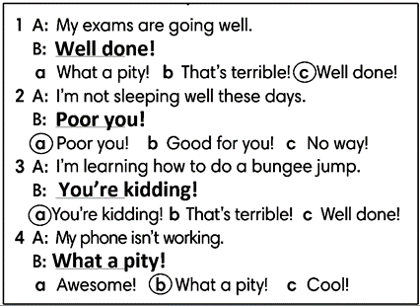
Extra activity 2 (3’): Extended Practice to reinforce the new expressions
- T shows 4 pieces of news with multiple choice responses.
- T asks Ss to read and classify the news as surprising (S), positive (P) or negative (N).
- T tells Ss to choose the correct response for each news.
- Ss read, say, and choose the answers as the whole class.
- T checks and confirms the correct answers.
4. POST-SPEAKING ( 8’)
ACTIVITY 4:
*Aims: To help students applying the new language and skills related to the topic in communicating.
* Content: Give and receive the news from each other’s.
* Outcome: To practice speaking by sharing both bad and good news; use expressions in communicating.
* Organisation : T, Ss .…

Teacher’s & Student’s activities | Content
4. Work in pairs. Student A gives some good and bad news. Student B responds to the news. Use the Speaking box.  (Exercise 4 - SB p.26)  - T tells student to look at the speaking box in their student book again and prepare for the task.  - T gives students time to think about what they are going to say in their roleplays.  - If students have difficulty thinking of true pieces of news, T encourages them to use their imagination.  - T encourages stronger students to give some very first examples.  - Students work in the same pairs from the last activity and practice their role plays, focus on using the correct intonation.  - T tells students to do the activity with their books closed, so that their reactions can be natural, and they don’t just read from the Speaking box.  - Teacher invites pairs to act out their roleplays in front of the class. | 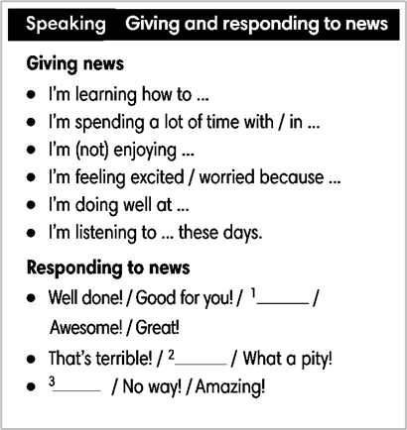
WRAP-UP & HOME WORK (2’)
- T asks Ss to talk about what they have learnt in the lesson.
- Expressions of giving and responding to news
* HOME WORK
- Do exercises in the workbook page 21.
- Prepare for Lesson 2.7: English In Use

Date of planning:  Date of teaching: | PERIOD 22 - UNIT 2: FAMILY AND FRIENDS  Lesson 7: English in Use
I. OBJECTIVES:
By the end of the lesson, Ss are able to:
- use prepositions of time to talk about when something happens.
1. Knowledge:
* Grammar:
- Use correctly prepositions IN – ON – AT in time expressions
- Talk about when something happens
2. Competence: Ss understand and use the vocabulary about after school activities and understand the use of IN – ON – AT in time expressions, then do the tasks assigned in the textbook. use the correct tense of verbs, prepositions of time to form a question and answer to talk about when something happens.
3. Quality/ behavior: To teach Ss to be hard-working and attentive in class. Ss have a positive attitude to working in groups, individual work, pair work, cooperative learning and working.
II. TEACHING AIDS:
- Teacher: Grade 7 textbook, Unit 2 (SB p. 27), laptop/computer connected to the Internet, loudspeaker, projector/TV, PPT slides…
- Students: Text books, studying equipment…
- Method: Active teach, T-WC; group works; individual ……
III. PROCEDURE:
1. WARM UP (5’)
* Aim:
- To create a positive classroom atmosphere to start a new lesson.
- To review after school activities and early introduce IN – ON - AT.
* Content: Game: Space Shuttle Game (about after school activities)
* Outcome: Ss guess and choose the correct picture.
* Organization of implementation

Teacher’s & Student’s activities | Content
Extra activity 1: Space Shuttle Game  - T asks Ss What do they often do after school?  - T tells students that they are playing a game with activities.  - T explains the game rules then checks instructions.  - T uses the slides to lead the game  - Ss join in the game individually.  - T corrects Ss if necessary.  - T tells students to recall all after school activities from the game. | Game rules:  - Look at the picture. Read the sentence  - Guess and choose the correct after school activity.  - 1 correct answer makes the shuttle space move
2. LEAD-IN (3’)
* Aim:
- To lead into the new lesson.
- To provide Ss with reasons for reading the cartoon in exercise 1 (SB p.27).
* Content: Discuss in groups and give the answer about the girl in the pictures.
* Outcome: Guess the correct answers to the questions.
* Organisation: T_ Ss ..….

Teacher’s & Student’s activities | Content
Extra activity 2: See – think – wonder.  - T shows the cartoon pictures on the slide then asks students four questions.  (1) What can you see in the pictures?  (2) Who are in the pictures?  (3) What’s the girl doing in each picture?  (4) Is the girl happy?  - T sets a time limit for Ss’ quick discussion.  - Ss work in pairs to make guesses about the pictures then give answers.  - T calls some Ss to give answers then checks with the whole class.  - T introduces Holly. “This is Holly. She is tired because she has too many extra classes after school.” | 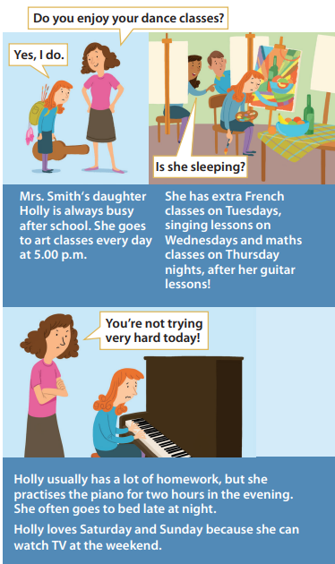
3. PRESENTATION (11’)
ACTIVITY 1 + 2:
* Aim:
- To present the grammar point in context of a cartoon.
- To introduce the Grammar Box through the reading tasks
- To introduce to Grammar Box
- To explain the grammar point for Ss.
* Content: Read the cartoon about Holly to practice grammar.
* Outcome: Do the exercise to improve grammar.
* Organisation : T_ Ss ..….
Teacher’s & Student’s activities | Content
1. (7’) Read the cartoon. How many extra classes does Holly have?  (Exercise 1 – SB p27)  - T asks Ss to open their SB page 27, look at exercise 1.  - T calls a student to read the instruction then checks Ss’ understanding of it.  - T tells Ss that they are going to read the cartoon to find the answers.  - Ss work individually, read, and note down the answers to the given question.  - T calls some Ss to give answers then shows the answers on the slide.  - T tell students that IN – ON – AT are the prepositions of time. | 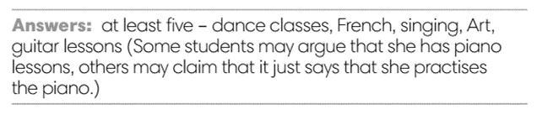
2. (4’) How many examples of prepositions can you find in the cartoon in thirty seconds?  (Exercise 2 – SB p27)  - T asks Ss to open their SB page 27, look at exercise 2.  - T calls a student to read the instruction then checks Ss’ understanding of it.  - T gives students the thirty-second time limit and asks them  how many prepositions they found.  - T elicits the prepositions and the words that come after them the text.  Discuss the Language box with the class  - T uses slide to show the grammar notes again.  - T goes through the Grammar box with students.  - T asks Ss to work in groups of three to read all uses of IN – ON – AT, elicits the meanings if needed. | 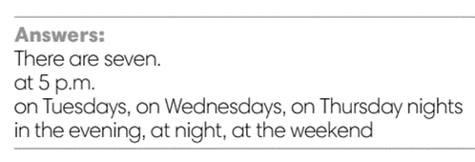  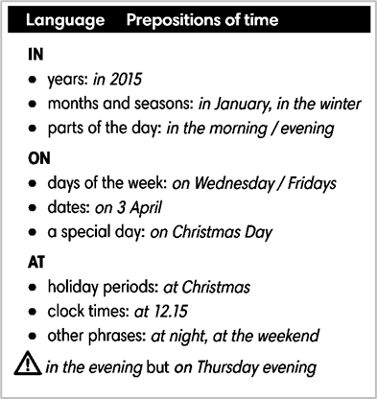
4. PRACTICE 1 (3’)
ACTIVITY 3:
* Aim: To help students identify the use of IN – ON – AT in time expressing.
* Content: Use the prepositions to complete the sentence.
* Outcome: Write correct prepositions using in, at or on.
* Organisation : T_ Ss.. ….
Teacher’s & Student’s activities | Content
3. Write correct prepositions: in, at or on.  (Exercise 2 – SB p27)  - T elicits the example sentence with students.  - T encourages students to discuss the other sentences in pairs,  to decide on the correct form and the reasons for this.  - T calls some students to share their answers.  - T corrects Ss’ pronunciation if any.  - T confirms the answers. | 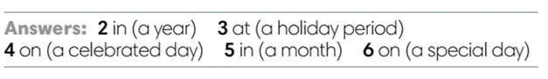
5. PRACTICE 2 (6’)
ACTIVITY 4:
* Aim: To reinforce the use of IN – ON - AT.
* Content: Use the prepositions to complete the sentence.
* Outcome: Write correct prepositions using in, at or on.
* Organisation : T_ Ss.. ….

Teacher’s & Student’s activities | Content
4. Complete the text with in, at or on.  (Exercise 4 – SB p.27)  - T asks Ss to look at exercise 4.  - T calls a student to read the instruction then checks Ss’ understanding of it.  - T asks Ss to work in individually to write.  - Students write the answers in their books.  - T calls students to give answers then shows them on the slide to check as the whole class.  - T corrects Ss if any.  Further practice:  THE STAMP GAME:  How to play:  - Read the sentence  - Fill in the blank with IN, ON or AT  - 1 correct answer gets 2 points | 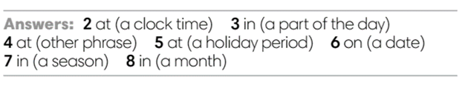
6. PRODUCTION (7’)
ACTIVITY 5:
*Aim: To help students applying the vocabulary items and grammar points related to the topic in communicating.
* Content: Ss ask and answer the questions in pairs.
* Outcome: Cross-check writing pieces and follow the writing rubric.
* Organisation: T_ Ss .…….
Teacher’s & Student’s activities | Content
5. In pairs, ask and answer the questions:  - What do you do after school?  - What do you often do at the weekend?  (Exercise 5 – SB p.27)  - T asks Ss to look at exercise 5 (SB page 27).  - T calls a student to read the instructions then checks Ss’ understanding of it.  - T explains to the students that they are going to work in pair for this task  - T elicits the questions that students may use to ask their friends.  - T models the activity in front of the class.  - T asks some strong students to stand up and recall some after-school activities that they’ve learn from the warm-up game.  - T writes the activities on boards for reference  - Students work in pairs to complete the task.  - T walk around to listen and notes down common mistakes for delayed feedback.  - T invites some students to present their dialogue to the class.  - T asks the other students to give comments on their classmates’ performance.  - T gives feedback on Ss’ work. | 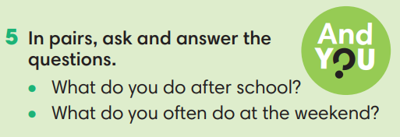
WRAP-UP & HOME WORK (3’)
- T asks Ss to talk about what they have learnt in the lesson.
- Time expressions IN – ON – AT
- Talk about when something happens
* HOME WORK:
- Do exercises in the workbook page 22.
- Prepare for Lesson 2.8: Vocabulary in action and Pronunciation

Date of planning:  Date of teaching: | PERIOD 23 - UNIT 2: FAMILY AND FRIENDS  Lesson 8: Vocabulary in Action and Pronunciation
I. OBJECTIVES:
By the end of the lesson student will be able to:
1. Knowledge:
* Vocabulary: review vocabulary
- The lexical items related to: clothes, accessories and adjectives of personalities to describe people
- Present simple and present continuous
* Pronunciation: Correctly pronounce words that contain the sounds /æ/ and /e/
2. Competence: Students develop communication skills, presentation skills, and creativity; being collaborative and supportive in pair work, teamwork, and actively join in class activities.
3. Quality/ behavior: To teach Ss the love of talking about clothes and describing people, and develop self-study skills. Ss have a good attitude to working in groups, individual work, pairwork, cooperative learning, and working
II. TEACHING AIDS:
- Teacher: Grade 7 textbook, Unit 2 (SB p.27), laptop/computer connected to the Internet, loudspeaker, projector/TV, PPT slides… .
- Students: Text books, studying equipment…
- Method: Active teach, T-WC; group works; individual ……
III. PROCEDURE:
1. WARM UP + LEAD-IN (4’)
*Aims:
- To create an active atmosphere in the class before the lesson.
- To lead into the new lesson.
* Content: Game: NAME 3 THINGS CHALLENGE (family and friends)
* Outcome: Students say words relating to the given topic quickly.
* Organisation : Teacher’s instructions…
Teacher’s & Student’s activities | Content
Extra activity 1: NAME 3 THINGS CHALLENGE  * Teacher asks students to spend 1 minutes to quickly review all vocabulary they have learnt in Unit 2 before they play a warm-up game.  - T tells students that they are going to play a game called NAME 3 THINGS CHALLENGE  - T explains the game rules then checks instructions.  - Teacher uses the slides to show the challenge  - Ss join in the game pairs or in small groups.  - Teacher listens to the Ss answers and calls several Ss to check for the whole class.  - T tells Ss that they can remember better with Glossary Table and asks Ss to open their Student Book page 28 – Exercise 1. | Game rules:  - Choose a number to get the challenge  - Read the topic word  - Say 3 words relating to that topic quickly.
2. REVIEW VOCABULARY (14’)
ACTIVITY 1 + 2 + 3:
*Aim:
- To introduce the glossary and its uses.
- To give further practice in making sentences using the Glossary.
* Content: Revise what they have learnt during the unit. Glossary and its uses.
* Outcome: Remember the new words and describe what a person you know usually wears and what he/she is wearing today.
* Organisation : Teacher’s instructions…
Teacher’s & Student’s activities | Content
1. (5’) Use the Glossary to find.  (Exercise 1 – Student Book page 28)  - Teacher introduces the Glossary Table.  - T asks Ss to look at exercise 1 in student book page 28  - T has students use the glossary to find the words which belong to the correct category  - T asks students to work in pairs and quickly do the task.  - T allows students to peer check first.  - T checks and confirms the answers. | Answer key:  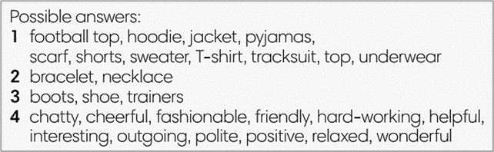
2. (5’) Use the glossary to describe what a person you know usually wears and what he/she is wearing today.  (Exercise 2 – Student Book page 28)  - T reminds students about the model sentences to describe what people are wearing.  - T asks students to do this activity individually. Have students read all the sentences carefully to make sure they check the grammar carefully  - T lets them share their sentences in pairs.  - T invites some students to give the describing sentences.  - T checks the grammar, pronunciation if needed. | e.g.  My best friend usually wears jeans. Today she’s wearing a dress.
3. (4’) Complete the Word Friends..  (Exercise 3 – Student Book page 28)  - T asks students to complete the sentences with suitable words.  - T asks students to work individually and check in pairs.  - T invites students to share their answers.  - T confirms the correct answers.  Extra-Practice  TIME TO TALK: Use the Word Friends and make sentence for you  - T encourage students to make sentences using the word friends in exercise 3  - Ss work in pairs to share true information about themselves | Answer key:  1. well  2. part / money  3. to
3. PRONUNCIATION (14’)
3.1. Presentation (4’)
* Aims:
- To present new sounds
- To help students identify how to pronounce the sounds /æ/ and /e/
* Content: Game: HEAR AND CLAP to practice pronunciation.
* Outcome: Pronoun some sounds after each play.
* Organisation: Teacher’s instructions…
Teacher’s & Student’s activities | Content
Extra activity 2: HEAR AND CLAP GAME  - T tells students that they are going to play a game called HEAR AND CLAP  - T explains the game rules then checks instructions.  - Teacher uses the slides to lead the game  - Ss join in the game pairs or in small groups.  - T listens to the Ss answers and calls several Ss to check for the whole class.  - T asks students to say the word again to practice some sounds after each play. | Game rules:  - Hear the sound  - Read the words  - Clap your hands 1 or 2 times to choose the word you hear.
3.2. Practice (10’)
ACTIVITY 4:
* Aims:
- To help students practice pronouncing these sounds in words.
- To help students pronounce the sounds /æ/ and /e/ correctly in sentences.
- To help students identify the sounds /æ/ and /e/ correctly in words.
* Content: Listen to the sample pronunciation to choose the correct answer.
* Outcome: Read and write the words correctly.
* Organisation : Teacher’s instructions…
Teacher’s & Student’s activities | Content
4a. Listen to the underlined vowel(s) in each word and describe which sound you hear. Write the word in the correct column.  (Exercise 4a– Student Book page 28)  - T calls some students to read out the words first.  - T plays the recording for them to listen and underline vowel(s) in each word.  - T asks Ss to write the word in the correct column.  /æ/ and /e/  - T invites some students to share their answers.  - T confirms the correct ones. | 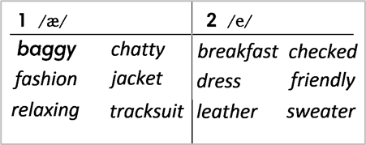
4b. Listen, check and repeat.  (Exercise 4b– Student Book page 28)  - T plays the recording for them to listen and repeat the words they hear.  - T asks Ss to pay close attention to the two sounds.  - T plays the recording again if needed.  - T explains to students the difference between the two sounds if needed.  - T invites some students to say some words they know that include the two sounds.  - T confirms the correct answers. | (Teacher can play the pronunciation guide video of this unit for students to watch and learn).
4. FURTHER PRACTICE (5’)
* Aim: To reinforce the student's recognition of the targeted sounds.
* Content: Game: ODD ONE OUT - practice the pronunciations by choosing the word that has a different sound.
* Outcome: Differentiate the sounds to practice the pronunciations. Saying the sounds correctly.
* Organisation: Teacher’s instructions…
Teacher’s & Student’s activities | Content
Extra activity 3: ODD ONE OUT  - T explains the game rules then checks instructions.  - Teacher uses the slides to lead the activity  - Ss join the activity in pairs or in small groups.  - T listens to the Ss answers and calls several Ss to check for the whole class.  - T asks students to say the word again to practice some sounds after each question. | Game rules:  - Read and choose A, B or C to odd out one word  - Explain by correctly saying the sounds
WRAP-UP & HOME WORK ( 3’)
- Teacher asks students to talk about what they have learnt in the lesson.
* HOME WORK
- Find more words relating to clothes, personalities that have the sounds /æ/ and /e/

Date of planning:  Date of teaching: | PERIOD 24 - UNIT 2: FAMILY AND FRIENDS  Lesson 9: Revision
I. OBJECTIVES:
By the end of the lesson, Ss are able to:
1. Knowledge:
* Vocabulary: revise words related to clothes, accessories, personalities, and time expressions.
* Grammar: review present simple, present continuous tense to describe people, talk about after school activities, give and respond to news.
2. Competence: Ss understand and use the vocabulary of the unit, do the tasks assigned in the textbook. Participate in a guided conversation to give and respond to news using given information.
3. Quality/ behavior : To teach Ss to be hard-working and attentive in class. Ss have a positive attitude to working in groups, individual work, pair work, cooperative learning and working.
II. TEACHING AIDS:
- Teacher: Grade 7 textbook, Unit 2 (SB p. 29, WB p.23), laptop/computer connected to the Internet, loudspeaker, projector/TV, PPT slides…
- Students : Text books, studying equipment….
- Method: Active teach, T-WC; group works; individual ……
III. PROCEDURE:
- WARM-UP (4’)

*Aims:
- To create a positive classroom atmosphere to start a new lesson.
- To lead into the review lesson.
* Content: Game: SUPER EYES
* Outcome: Ss understand that they are going to review Unit 2.
* Organisation: Teacher’s instructions…
Teacher’s & Student’s activities | Content
Extra activity 1: SUPER EYES  - Set the scene: T asks students to do quick exercises for eyes such as look up and down, look left and right, row the eyes  - T tells students that they are going to play a game called SUPER EYES  - T explains the game rules then checks instructions.  - Teacher uses the slides to show the collages  - Ss join in the game pairs or in small groups.  - Teacher shows the collage again with displayed answers to check for the whole class.  - T tells Ss that they are going to review Unit 2. | Game rules:  - Look carefully at a collage of different small pictures  - The collage will disappear in a few seconds  - Recall as many words about the collage as you can remember.
- REVIEW VOCABULARY (17’)
ACTIVITY 1 + 2 + 3:
* Aims:
- To help students reviews topic words and word friends from the unit
- - To review vocabulary with critical thinking
- To review vocabulary in context
* Content: Do the exercise to revise the vocabulary of Unit 1.
* Outcome: Understand the vocabulary to do the exercise correctly.
* Organisation : Teacher’s instructions….
Teacher’s & Student’s activities | Content
Extra activity 2: (5’) SUPER MIND  - T tells students to open the Glossary box in student book page 28  - T introduce the SUPER MIND game and rules  - T shows the slides of the game  - Ss take turns to choose the numbers for their teams.  - Ss discuss and list out all words related to the topic they get.  - T calls some Ss to give answers and confirms the winner. | How to play:  - Play in team  - Choose a number to open a block  - Read the topic word  - Write as many words related to the topic as you can  - The faster finisher gets points
1. (3’) Choose the odd one out  (Exercise 1 – Student Book page 29)  - T asks Ss to look at exercise 1 in student book page 29  - T calls a student to read the instruction then checks Ss’ understanding of it.  - T asks Ss to work in pairs to read then complete the activity.  - T encourages students to give the reason for their answer.  - T checks as the whole class. | Answer keys:  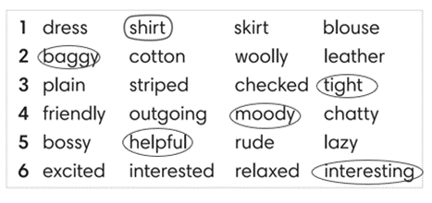
2. (6’) Complete the second sentence so that it means the same as the first one. In pairs, say if the sentences are true for you.  (Exercise 2 – Student Book page 29)  - T asks Ss to look at exercise 2 in student book page 29  - T calls a student to read the instruction then checks Ss’ understanding of it.  - T asks Ss to work in pairs to read then complete the activity.  - Ss work in pair to complete the task and compare the answers.  - T checks as the whole class.  Exercise 2 - Time to talk:  - T asks Ss to work in pairs to share their facts.  - Ss work in pairs to say which statements are true for them. | Answer keys:  2. is boring / 3. annoyed / 4. shocking / 5. Relaxed  Example:  Number 1 is true for me. I’m not into fashion.  Number 4 is not true for me.
3. (3’) Complete Word Friend in the text. Use the words in correct form.  (Exercise 3 – Student Book page 29)  - T asks Ss to look at exercise 3 in student book page 29  - T calls a student to read the instruction then checks Ss’ understanding of it.  - T asks Ss to work in pairs to read then complete the activity.  - Ss work in pair to complete the task and compare the answers.  - T checks as the whole class. | Answer keys:  2. to 5. brushing  3. getting 6. lose  4. annoyed 7. get
3. REVIEW GRAMMAR ( 24’)
ACTIVITY 4 + 5 + 6:
*Aim:
- To help students revise the form and use of the present simple, present continuous. Preposition of time
- To help students practice the present simple and present continuous
- To help students practice the present simple and time expression in a communicative activity
- To help student practice speaking skill in a task: give and respond to news
* Content: Use the present simple and present continuous to complete the exercises.
* Outcome: Use the present simple and present continuous for communication and writing.
* Organisation : Teacher’s instructions….

Teacher’s & Student’s activities | Content
Extra activity 3: (3’) Read the grammar boxes and review the grammar points.  - T asks Ss to look at the grammar box and read the example.  - T shows slides for detail review grammar  - Ss read the review content together before they do some grammar tasks. | 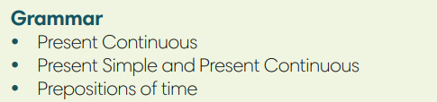
4. (5’) Complete the sentences with Present Simple or Present Continuous form of verbs in brackets.  (Exercise 4 – Student Book page 29)  - T asks Ss to look at exercise 4 in student book page 29  - T calls a student to read the instruction then checks Ss’ understanding of it.  - T asks Ss to work in pairs to read then complete the activity.  - Ss work in pairs to complete the task and compare the answers.  - T checks as the whole class. | Answer keys:  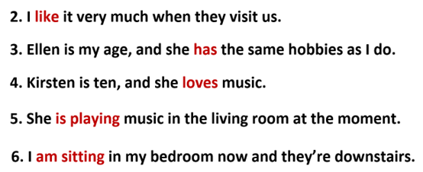
5. (8’) Write answers to the questions.  Use at, in or on with a time expression. Then compare with a partner.  (Exercise 5 – Student Book page 29)  Step 1: Time to write  - T asks Ss to look at exercise 5 in student book page 29  - T calls a student to read the instruction then checks Ss’ understanding of it.  - T elicits an example.  - T sets a time limit for Ss to write sentences  - Ss write their sentences in their notebooks.  Step 2: Time to pair  - T asks Ss to work in pairs and share their sentences by asking and answering.  - T calls a pair of strong students to demonstrate the dialogue in front of the class.  - Ss work in pairs to practice asking and answering.  - T encourages some pairs to roleplay the dialogue in front of the class. | 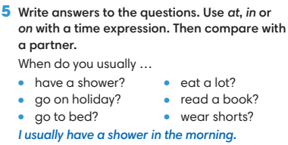
6. (8’) Work in pairs. Student A, use the information below to give and respond to news. Student B, look at page 102.  (Exercise 6 - Student Book page 29)  Student A  1. Greet Student B and ask what’s new in his / her life.  2. Listen and respond to Student B’s news  *you’re learning how to make webpages  *your computer isn’t working at the moment  - T asks Ss to look at exercise 6.  - T calls a student to read the instruction then checks Ss’ understanding of it.  - T asks Ss to work in pairs to prepare for their dialogues  - T sets a time limit and walk around as a monitor while Ss are discussing.  - Ss work in pairs to practice the speaking task  - T moves around and takes notes for any issues that need improving from students work.  - T encourages some strong students to role-play their dialogues in front of the class.  - T gives some general feedback for Ss’ performances. | 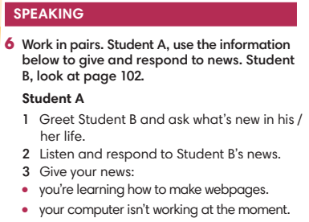
WRAP-UP & HOME WORK ( 2’)
- T asks Ss to talk about what they have learnt in the lesson.
- Review Unit 2 vocabulary and grammar.
- Write a personal introduction for a webpage.
* HOMEWORK
- Do exercises in the workbook page 23
- Prepare for REVIEW 1

Date of planning:  Date of teaching: | Period 25 : REVIEW 1 (UNIT 0 - 1-2)
I. OBJECTIVES:
1. Knowledge: By the end of this review, students will be able to revise the language they have learnt and the skills they have practiced in Units 1 - 2.
a) Vocabulary: Ss revise words related to cultural activities, clothing items, and personality adjectives.
b) Grammar: review present simple and present continuous tense to describe people.
c) Writing: Writing a personal introduction to a webpage.
d) Speaking: talking about cultural activities and types of habits; talking about clothes and appearances; talking about family activities; describing a friend’s personality.
2. Competence: SS can revise the language they have learnt and the skills they have practiced in Units 1 – 2. Use the vocabulary of the units, and do the tasks assigned in the textbook. Participate in a guided conversation to give and respond to the news using the given information.
3. Quality/ behavior: Having a positive attitude towards the lesson and a good relationship with friends. The love of learning English. Hard-working; attentive; cooperative; sociable; good communication in class.
II. TEACHING AIDS:
- Teacher: Textbook, laptop, loudspeaker, projector…
- Students: Grade 7 textbook, Unit 1&2 (SB p. 18, 28), studying equipment….
- Method: T-WC; group works; individual ……
III. PROCEDURE:
1. REVIEW VOCABULARY UNIT 1 (14’)
ACTIVITY 1 + 2:
* Aim:
- To help students reviews topic words and word friends from the unit.
- To review vocabulary in context.
* Content: Glossary of unit 1, Mario Playing Tennis Game: vocabulary of unit 1.
* Outcome: Students’ correct pronunciation and answers.
* Organization of implementation:
Teacher’s & Student’s activities |  | Content
1. (7’) Activity 1:  - T tells students to open the Glossary box in student book page 18.  - T asks Ss to work in pairs: 1 student points to the word, 1 student pronounces it. Then they swap their roles.  - T corrects Ss’ pronunciation if any. |  | 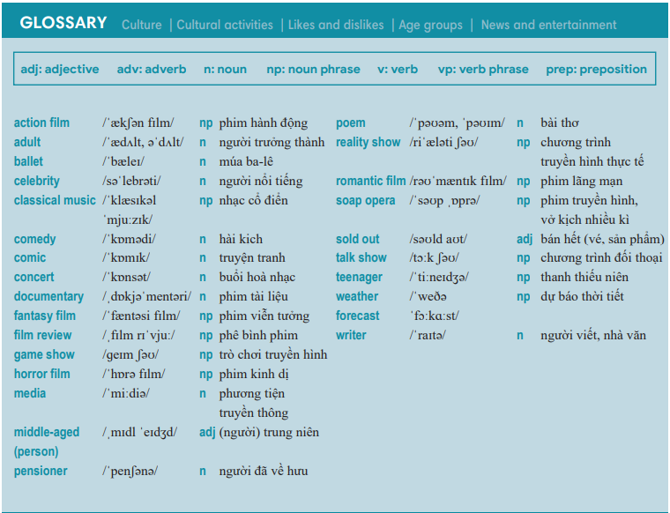
2. (7’) Mario Playing Tennis Game:  - T gives and checks instructions for the game.  - T corrects Ss’ pronunciation if any. |  | How to play:  - Read the sentences.  - Choose A, B or C for answers.  - 1 correct answer = 2 points.
2. REVIEW GRAMMAR UNIT 1 (7’)
ACTIVITY 3:
*Aim: To help students revise the form and use of the present simple.
* Content: Football Game: sentences use present simple.
* Outcome: Complete the sentences correctly.
* Organisation: Teacher’s instructions…..
3. Football Game  - T gives and checks instructions for the game.  - T corrects Ss if any. | How to play:  - Read the sentences.  - Choose A, B, C or D to fill in the blanks.  - 1 correct answer = 2 points.
3. REVIEW VOCABULARY UNIT 2 (14’)
ACTIVITY 4 + 5:
Aim:
- To help students reviews topic words and word friends from the units.
- To review vocabulary in context.
* Content: Glossary of unit 2, Classifying Game: vocabulary have learnt in the unit 2.
* Outcome: Call out the vocabulary. Revision. Do exercises correctly.
* Organisation : Teacher’s instructions…...
4. (7’) Activity 4:  - T tells students to open the Glossary box in student book page 28.  - T asks Ss work in pairs: 1 student points to the word, 1 student pronounces it. Then they swap their roles.  - T corrects Ss’ pronunciation if any. | 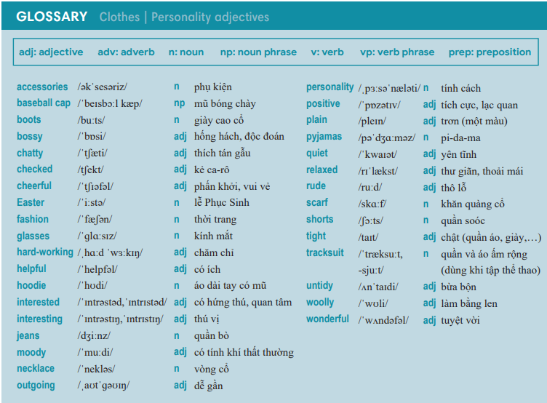
5. (7’) Classifying Game:  - T gives and checks instructions for the game.  - T corrects Ss’ pronunciation if any. | How to play:  - Look at the words.  - Think about which topic the word belongs to.  - Classify them into 2 groups.  - 1 correct answer = 2 points.
4. REVIEW GRAMMAR UNIT 2 (7’)
ACTIVITY 6:
* Aim: To help students revise the form and use of the present simple and present continuous.
* Content: Review grammar elements taught in unit 2; Compare the present simple and the present continuous.
* Outcome: Remember how to form and use them. Do exercises correctly.
* Organisation : Teacher’s instructions…..

Teacher’s & Student’s activities | Content
6. Obstacle Race Game.  - T gives and checks instructions for the game.  - T corrects Ss if any. | How to play:  - Read the sentences.  - Put the verbs in brackets into the correct form.  - 1 correct answer => open the present for points.
WRAP-UP & HOME WORK (3’)
- T asks Ss to talk about what they have learnt in the lesson.
- Review Unit 1 vocabulary and grammar.
- Review Unit 2 vocabulary and grammar.
* HOME WORK
- Prepare for PREPARATION FOR MID-TERM TEST 1.

Date of teaching: …./…/2022 | Period 26 : THE FIRST MID-TERM TEST
A. Objectives: By the end of the lesson, SS can review knowledge from unit 0 to unit 2. They will be able to realize their studying result and know how to learn to improve it.
1. Knowledge:
* Pronunciation: pronounce and stressed syllable
* Grammar - Vocabulary:
- Choose the best answer to complete the sentences.
* Reading: - Read the passage and decide which statement is True (T), False (F) or Not Given (NG).
- Read the passage and choose the best answer.
* Writing:
- Put the words and phrases in the correct order to make complete sentences.
- Use the given words to make complete sentences. (2 points)
- Use the word in capitals to rewrite the sentences. Do not change the given word
2. Competence: SS will develop some competences such as working independently and being determined, using language in the right ways.
3. Behavior: Students are hard-working and serious.
B. Teaching aids:
1. Teacher: Textbooks, teaching plan, loud speakers, paper tests.
2. Students: Notebooks, pens…
C. Procedures:

The content of the test
MATRIX
 | Số câu | Số bài | Dạng bài | Mức độ nhận biết/ câu | Số điểm
Pronunciation | 6 | 2 | MCQ | Nhận biết: 6 | 1.5 pts (0,25 pt for each item)
Vocabulary and Grammar | 8 | 1 | MCQ | Nhận biết: 4  Thông hiểu: 4  Vận dụng: 0 | 2.0 pts (0,25 pt for each item)
Reading | 10 | 2 | T/F, Cloze test | Thông hiểu: 10 | 2.5 pts (0,25 pt for each item)
Writing | 10 | 3 | -Re-order (4)  - complete sentences(4)  sentence transformation (2) | Vận dụng: 8 (re-order, complete sentences)  Vận dụng cao: 2 (sentence transformation) | 4.0 pts  4 x 0,25 pt for each item  6 x 0,5 pt for each item
Total | 34 câu | 8 |  |  | 10.0 pts

D. PRODURE
Content of the test
I. PRONUNCIATION
Choose the word whose underlined part is pronounced differently. (1 point )
- A. action B. fantasy C. cartoon D. ballet
- A. necklace B. interesting C. checked D. sweater
- A. bear B. chair C. cheerful D. there
- A. zoo B. blue C. good D. shoe
Choose the word that has a different stressed syllable from the rest. (0.5 points)
- A. horror B. cartoon C. comics D. concert
- A. baseball B. bedroom C. idea D. chatty
II. GRAMMAR AND VOCABULARY (2 points)
- He is a (an) …………. He just lies around, eating chips and watching TV all day long.
- teenager B. couch potato C. adult D. kid
- My: Why …………………. you ever …………………. to the cinema?
An: Because I like watching films on TV.
- do- go B. does- go C. don't- go D. doesn't- go
- Mai’s parents are ………………….the gardening at the moment.
- making B. changing C. working D. doing
- I like …………………. films on television.
- watch B. watches C. watching D. watched
- I’ve got three children……………………….names are Ali, Lisa and Phil.
A Their B. Your C. They D. Our
- I __________ swim – I want to learn soon.
- haven’t B. can’t C. am not D. don’t
- There isn’t……………..milk in the fridge.
A a B some C any D the
- Don’t switch the TV off, please. - ………………... it.
A I watch B I watching C I’m watching D I’m watch
III. READING (2.5 points)
- Read the passage and decide which statement is True (T), False (F) or Not Given (NG).
Jane lives in a family with her parents and her younger brother. Her father is driving them to their grandparents’ house this weekend. She is very excited about it. Her grandmother is old, but she is very positive about everything. She loves telling stories, such as “The Mermaid” and “Snow White”. She usually wears glasses when she reads the magazine because she can’t see without them. Jane’s grandfather has different hobbies. He is into sports. Next Monday, he is going to watch a football match in the city. He loves drinking tea in the afternoon, but today he is drinking coffee. He always takes care of Jane and her little brother when their parents are busy.
15. Jane is visiting her grandparents this weekend.  16. Jane’s grandmother likes reading the magazine.  - Jane’s grandfather is watching a football match today.  - Jane’s grandfather is not drinking tea today. | _________  _________  _________  _________
- Choose A, B or C to complete the text.
Hi, Everyone! My name’s Sandra and I (0) ………… with my parents and my brother Max in San Francisco in the USA, so I’m (19) ……….. . I love music – I’m mad about hip hop and I play it all the time. Max (20) ……….... hip hop at all – he says it’s really boring! I’m in 10th Grade at Sweet Home High School. My favourite (21) ………….. is Science. Do you like Science? My brother (22) ……….…..like it and thinks that it’s really difficult! As you can see, we aren’t (23) ………….. ..the same things! I like films and music but my big passion is reading. I love (24)…………….. about famous scientists and their work. I sometimes write about them (and lots of other things!) in my blog – click on the link below to have a look. Tell me what you think
- A living B lives C. live
19. A America B American English C American
- A isn’t into B don’t like C hate
- A teacher B subject C classroom
- A doesn’t B don’t C aren’t
- A interested of B interested on C interested in
- A find information B finds information C finding information
IV. WRITING
- Put the words and phrases in the correct order to make complete sentences. (1 points)
25. favorite / is / film / The Jungle Book. / My
=> ………………………………………………………………………………………………
26. time, / In / my / I / free / sing / guitar. / play / the/ and
=> ………………………………………………………………………………………………
- They / are / party / to / have / going / evening. / this / a
=> ……………………………………………………………………………………………..…
28. often / to / Nam / radio? / listen / the / does / weather / the / How / forecast / on
=> ……………………………………………………………………………………………..…
- Use the given words to make complete sentences. (2 points)
29. I / into / listen / pop / music.
=>…………………………………………………………………………………………………
30. My father / interested / read / romantic novels.
=>…………………………………………………………………………………………………
- She / often / go to bed / late / tonight / she / go to bed / early.
=>…………………………………………………………………………………………………
- They / not / take part / tournament / this week.
=>………………………………………………………………………………………………
- Use the word in capitals to rewrite the sentences. Do not change the given word. (1 points)
33. I don’t think listening to classical music is interesting. (INTERESTED)
=> I am …………………………………………………………………………………………
34. I think it is relaxing to go for a walk in the park . (RELAXED)
=> I feel …………………………………………………………………………………………

Teaching date:…/…../2022 | Period 27: THE MID-TERM 45-MINUTE  TEST CORRECTION

A. Objectives
1. Knowledge: By the end of the lesson, SS will be able to understand the test better. They will also develop the skill of doing a test and recognize their errors. They will know how to learn to get better results.
- Vocabulary: lexical items related to unit 0, 1,2,
- Grammar: The present simple and the present continuous.
2. Competence: They can self-evaluate their studying and have good plans to improve it.
3. Behavior: Students are hard-working and attentive. They will try their best to get better results.
B. Teaching aids:
1. Teacher: Textbooks, teaching plan, teacher’s book…
2. Students: Textbooks, notebooks…
C. Procedures:
1. Checking: During the lesson.
2. New lesson: Mid-term test correction (43’)

Teacher’s and Students’ activities | Contents
I. WARM UP (5’)  - Delivers the paper test.  II. PRESENTATION (25’) | - Receive the tests, check the answer.
CÂU | ĐÁP ÁN | ĐIỂM
- PRONUNCIATION  II. GRAMMAR-VOCABULARY  III. READING (2,5 p)  Read 1 :  Read 2 :  IV. WRITING  A. Writing 1 :  B. Writing 2 : 1,5 p  B. Writing 2 | 1- C 2- B 3- C 4- C 5 – B 6 - C  7. B 8.C 9. D 10. C  11. C 12. B 13. C 14. C  - T 16. NG 17. F 18. T  19. C 20. A 21. B 22. A  23. C 24. C  25. My favorite film is The Jungle Book.  26. In my free time, I sing and play the guitar.  27. They are going to / have a party this evening.  28. How often does Nam listen to the weather forecast the on radio?  29. I am into listening to pop music.  30. My father is interested in reading romantic novels.  31. She often goes to bed late but tonight she is going to bed early.  32. They are not taking part in the tournament this week.  33. I am not interested in listening to classical music 34.I feel relaxed to go for a walk in the park./ I feel relaxed when I go for a walk in the park . | 1.5 p : 0.25 p for each correct answer.  2.0 p : 0.25 p for each correct answer.  2.5 pts : 0,25p for each correct answer.  1p : 0.25p for each correct answer  2p : 0. 5p for each correct answer  1.0 p: 0.5 p for each correct answer.
III. REMARK – SOLUTION (8’)
- Strong points :
- Weak point :
IV. SUMMARY & HOMEWORK (2’)
- Do the test again.
Prepare next lesson : Unit 3 – Vocabulary

Date of teaching: …./…../2022 | Period 28 - UNIT 3: ANIMALS’ MAGIC  Lesson 1: Vocabulary
I. OBJECTIVES:
By the end of the lesson, students will be able to:
- have an overview of the topic “Animals’ Magic”.
- use vocabulary and grammar points to talk about animals.
1. Knowledge:
- Vocabulary: an understanding of the meaning of keywords below:
Animal names | Pets: parrot, rabbit, tortoise.
Animal names | Farm animals: chicken, cow, donkey.
Animal names | Wild animals: bear, chimp, elephant, giraffe, kangaroo, tiger, zebra.
Animal names | Insects: bee, butterfly, fly.
Animal body parts | claw, feather, fur, mouth, tail, wing.

2. Competence:
To know the meaning of the keywords used to talk about animals and their body parts, then do the tasks assigned in the textbook. To use the vocabulary about animals to practice talking about them.
3. Quality/Behavior: To teach Ss to be hard-working and attentive in class. Ss have a positive attitude to working in groups, individual work, pair work, cooperative learning and working.
II. TEACHING AIDS:
- Teacher: Grade 7 textbook, Unit 3 (SB p.30-31, WB p.24-25), laptop/computer connected to the Internet, loudspeaker, projector/TV, PPT slides…
- Students: Text books, studying equipment…
- Method: Active teach, T-WC; group works; individual ……
III. PROCEDURE:
 | 1. WARM UP (3’)
* Aims:
- To create a positive classroom atmosphere.
- To activate Ss’ prior knowledge and get students involved in the lesson.
- To lead into the next activity.
* Content: Play What do you see? to get students involved in the lesson and to set the context for the lesson.
* Outcome: Students guess the animals’ name correctly, and name more animals they’ve already known.
* Organisation: Teacher’s instructions…

 | Teacher’s & Student’s activities | Content
 | Extra activity 1: What do you see?  - T explains the game rules then checks instructions.  - T sets the context for the lesson: Write the title on the board Unit 3: Animals’ Magic / Lesson 3.1: Animals.  - T asks Ss to name more animals they’ve already known. | Game rules:  - Look at a part of each picture.  - Guess the animal you see.  - 1 correct answer = 1 point.
 | 2. PRESENTATION 1 (5’)
ACTIVITY 1:
* Aims:
- To activate Ss’ prior knowledge of the topic.
- To present animal names.
* Content: Some brief notes; Some things about animals.
* Outcome: Know new words about animals.
* Organisation: Teacher’s instructions….

 | Teacher’s & Student’s activities |  | Content
 | 1. In pairs, match the animals in the picture with the words below. Listen and check.  (Ex 1, p.30)  - T asks Ss to open their SB page 30, look at exercise 1.  - T calls a student to read the instruction then checks Ss’ understanding of it.  - T sets a time limit for Ss to work in pairs and complete the exercise.  - T plays the audio, lets all Ss listen and check.  - T shows answers on the slide and drills all the animal names.  Further discussion:  - T asks more questions to encourage Ss to think and speak.  (1) Which animal is a pet?  (2) Is zebra a wild animal?  - T tells Ss that they are going to put these animals in groups in the next activity. |  | Answer keys:
  A. butterfly | G. zebra | M. tortoise
  B. fly | H. donkey | N. rabbit
  C. elephant | I. kangaroo | O. tiger
  D. chimp | J. parrot | P. bear
  E. giraffe | K. cow
  F. bee | L. chicken
 | 3. PRACTICE 1 (10’)
ACTIVITY 2:
* Aims:
- To help Ss practice pronouncing new words.
- To help Ss classify animals into different groups.
- To let Ss work cooperatively.
* Content: Some brief notes; Some things about animals.
* Outcome: Know new words about animals and classify them into categories.
* Organisation: Teacher’s instructions….
 | Teacher’s & Student’s activities | Content
 | Extra activity 2 (5’): Work in groups. Classify animals into categories below. Read the words again.  - T calls a student to read the instruction then checks Ss’ understanding of it.  - T sets a time limit and ask Ss to work in groups to complete the activity.  - T calls groups to give answers then checks as the whole class.  - T drills the words and corrects Ss’ pronunciation if any.
  Pets | parrot, rabbit, tortoise
  Farm animals | chicken, cow, donkey
  Wild animals | Bear, chimp, elephant, kangaroo, tiger, zebra, giraffe
  Insects | Bee, butterfly, fly
 | 2. (5’) In groups, think of two or more animals for each category. Then compare with another group.  (Ex 2, p.30)  - T asks Ss to look at exercise 2 (SB page 30).  - T calls a student to read the instruction then checks Ss’ understanding of it.  - T asks Ss to read the given sentences then checks their understanding by asking them to give one example for each category.  - T sets a time limit and asks Ss to work in groups to complete the activity then compare their answers.  - T calls groups to give answers, writes them on the board.  - T shows possible answers on the slide and compliments groups.  - T corrects Ss’ pronunciation if any. | Possible answers:  1. bear, bat  2. cow, pig, sheep, chicken  3. bear, cat, monkey  4. cheetah, horse, dog, deer  5. snake, hippo, polar bear  6. lion, tiger, crocodile, shark
 | 4. PRESENTATION 2 (5’)
ACTIVITY 3:
* Aims:
- To encourage Ss to guess the meaning of words from the picture cues.
- To present vocabulary of animal body parts.
* Content: Some brief notes about the exercise; some keywords about clothes, type of clothes, preferences; some note about pronunciation.
* Outcome: Have a vocabulary about clothes; know how to talk about clothes and preferences.
* Organisation: Teacher’s instructions …
 | Teacher’s & Student’s activities | Content
 | 3. Guessing the animals!  (Adapted from Ex 3, p.30-31)  Stage 1: Eliciting  - T asks Ss to look Vocabulary Box B (SB page 30).  - T calls some Ss to read the given words aloud then elicits the meaning of words from Ss (remember not to confirm right or wrong ideas in this stage).  Stage 2: Presenting  - T shows the instructions of the game on the slide.  - T calls a student to read the instructions then checks Ss’ understanding of it.  - T shows the picture one by one and asks all Ss to give answers at the same time.  - T confirms answers and drills the key words (claw, fur, feather, mouth, tail, wing) on the slide.  - T checks the meaning of key words again (claw, fur, feather, mouth, tail, wing).  - T corrects Ss’ pronunciation if any.  Further discussion:  - T plays the audio, lets Ss listen and repeat the phrases. | Answer keys:  1. The feathers of a duck. 2. The eye of an elephant  3. The mouth of a kangaroo. 4. The claws of a chicken.  5. The wing of a fly. 6. The tail of a monkey.  7. The fur of a rabbit.
 | 4. PRACTICE 2 (13’)
ACTIVITY 4 + 5:
* Aims:
- To help Ss use learnt vocabulary in context.
- To help Ss know more facts about animals.
- To lead into a productive activity.
* Content: Some brief notes about the exercise; some keywords about animals; some facts about animals.
* Outcome: Have a vocabulary about animals; know how to talk about animals.
* Organisation: Teacher’s instructions….
 | Teacher’s & Student’s activities
 | 4. (6’) In pairs, mark the sentences T (true) or F (false). Check your answers on page 101. Which facts do you find surprising?  (Ex 4, p.31)  - T asks Ss to look at exercise 4 (SB page 31).  - T calls a student to read the instruction then checks Ss’ understanding of it.  - T asks some Ss to read the given sentences aloud.  - T sets a time limit and asks Ss to work in pairs to discuss and decide T or F.  - T calls pairs to give answers, writes them on the board.  - T then asks Ss to look for the answers on page 101.  - T corrects Ss’ pronunciation if any.  Further discussion:  - T encourages Ss to discuss the facts they find surprising and give reasons for them. | Answer keys:
  1. T | 3. T | 5. T | 7. T
  2. F | 4. T | 6. T | 7. T
 | 5. (7’) Listen and fill in the blanks. Read the descriptions.  (Adapted from Ex 5, p.31)  - T asks Ss to look through the five descriptions on the slide and read them in their mind.  - T elicits from Ss the type of word that they may fill in each blank then guides them to take notes while listening.  - T plays the audio, lets Ss work individually and listen twice.  - T elicits answers from Ss, write them on the board then checks as the whole class.  - T shows all the answers on the board then asks Ss to read the descriptions one by one.  Further discussion:  - T asks some Yes / No questions about the above animals and calls Ss to give answers.  Possible questions:  (1) Does a tiger eat meat?  (2) Is a chicken good at flying? | Answer keys:  1. This animal eats meat. It’s dangerous. It has a long tail. It lives in India. It’s got striped fur. It’s a tiger.  2. This animal eats grass. It lives in Europe. It’s strong and it works hard. It’s like a small horse. It’s a donkey.  3. This animal is also very dangerous. It’s very good at swimming – and smelling blood. It has very sharp teeth. It lives in the sea. It’s a shark.  4. This animal lives all over the world. It often lives on farms. People keep it for food. It has feathers and wings but it’s not good at flying. It’s a chicken.  5. This animal eats leaves. It lives in Africa. It’s got a long tail and a very long neck. It’s a giraffe
 | 4. PRODUCTION (7’)
ACTIVITY 6:
* Aims:
- To provide Ss with chances to ask and answer about animals.
- To help Ss to apply the vocabulary they have learnt to talk about animals.
* Content: Ss play Guessing game to talk about their animals.
* Outcome: Ss talk about animals using vocabulary and grammar points.
* Organisation: Teacher’s instructions…..
 | Teacher’s & Student’s activities | Content
 | 6. Guessing game. Work in pairs.  (Ex 6, p.31)  - T asks Ss to look at exercise 6 (SB page 31).  - T calls a student to read the instruction then checks Ss’ understanding of it.  - T asks a pair to read the sample dialogue on the slide then asks some new pairs to make new dialogues to ask and answer about other animals.  - T divides Ss into pairs, models the activity in front of the class then asks Ss to make conversations about animals.  - T sets a time limit and monitors Ss while they are working in groups.  - T notes down common mistakes for delayed feedback.  - T calls some pairs to come to the front of the class, make conversations about animals.  - T asks the rest to give comments on their classmates’ performance.  - T gives feedback on Ss’ work. | 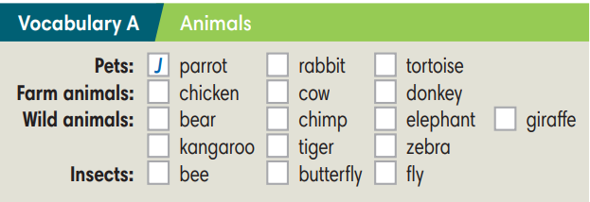  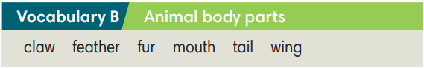
WRAP-UP & HOME WORK (2’)

- T asks Ss to talk about what they have learnt in the lesson.
- Vocabulary of animal names.
- Vocabulary of animal body parts.
* HOME WORK
- Do exercises in the workbook page 24-25.
- Prepare for Lesson 2: Grammar 1.

Date of teaching:  ……/…./2022 | Period 29 - UNIT 3: ANIMALS’ MAGIC  Lesson 2: Grammar
I. OBJECTIVES:
By the end of the lesson, students will be able to:
- use was and were to talk about the past.
1. Knowledge:
* Grammar:
- form correct sentences in past simple with was/were.
- ask and answer questions with was/were.
- use was/were to talk about the past.
2. Competence: Students understand the main grammar point, then do the tasks assigned in the textbook; use was/were to practice talking about the past.
3. Quality/ behavior: To teach Ss to be hard-working and attentive in class. Ss have a positive attitude to working in groups, individual work, pair work, cooperative learning and working.
II. TEACHING AIDS:
- Teacher: Grade 7 textbook, Unit 3 (SB p.32, WB p.26), laptop/computer connected to the Internet, loudspeaker, projector/TV, PPT slides…
- Students: Text books, studying equipment…
- Method: Active teach, T-WC; group works; individual ……
III. PROCEDURE:
1. WARM UP (3’)
* Aims:
- To create a positive classroom atmosphere.
- To help students review the vocabulary they have learnt in the previous lesson.
- To lead into the next activity.
* Content: Play game: Who am I? to get students involved in the lesson and to set the context for the lesson.
* Outcome: Students know the context of the lesson.
* Organisation : T_ Ss , …
Teacher’s Student’s activities | Content
Extra activity 1: Who am I?  - T explains the game rules then checks instructions.  - T sets the context for the lesson: Write the title on the board Unit 3: Animals’ Magic / Lesson 3.2: Grammar. | Game rules:  - Read the descriptions.  - Guess what animal is it. Read aloud.  - 1 correct answer => get points.
2. LEAD-IN (3’)
* Aims:
- To lead into the new lesson.
- To provide students with reasons for listening to the dialogue in exercise 1 (SB p.32).
* Content: Describe the animals and people in the picture on the slide.
* Outcome: Make guesses about the picture then give answers.
* Organisation: T_ Ss , …
Teacher’s Student’s activities | Content
Extra Activity 2: See – think – wonder.  - T shows a picture on the slide then asks students four questions.  (1) What animal do you see?  (2) How are the chimps?  (3) How many people are there?  (4) Are the kids excited?  - T sets a time limit for Ss’ quick discussion.  - Ss work in pairs to discuss then give answers.  - T calls some Ss to give answers then note them down on the board.  - T tells Ss that they’re going to read the conversation in exercise 1 (SB p.32) to check all the answers. | 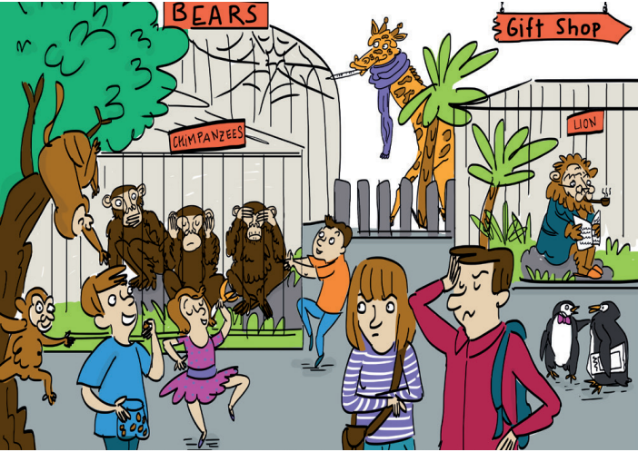
3. PRESENTATION (10’)
ACTIVITY 1 + 2:
Aims:
- To present the grammar point in context.
- To introduce to students the use of TO BE in past simple.
- To lead into the next activities.
- To provide Ss with chances to spot the sentences with was / were.
- To provide Ss with chances to work cooperatively.
- To explain the grammar point for Ss.
* Content: Read the conversation between Kyle and Zadie and find out new words. Learn the Past Simple.
* Outcome: Know more new words. Understanding the reading document; the topic of the lesson, grammar points…
* Organisation: T_ Ss , …
Teacher’s Student’s activities |  |  |  | Content
1. (5’) Read and listen. What does Kyle say about the twins?  (Ex 1, p.32)  - T asks Ss to open their SB page 32, look at exercise 1.  - T calls a student to read the instruction then checks Ss’ understanding of it.  - T plays the audio, let’s all Ss listen and calls Ss to give answers.  Further discussion:  - T asks one more question to encourage Ss to think and speak.  (1) When did Kyle go to the zoo? – Yesterday.  - T tells Ss that they are going to learn more about the past simple tense. |  |  |  | Answer key:  The twins weren’t excited. They were crazy.
2. (5’) Find more example of was / were in the dialogue in exercise 1.  (Ex 2, p.32)  - T asks Ss to open their SB page 32, look at exercise 2.  - T calls a student to read the instruction then checks Ss’ understanding of it.  - T asks Ss to work in groups of three to read the complete the activity.  - T calls groups to give answers then shows the answers on the slide to check as the whole class.  - T shows the grammar notes on the slide then explains the grammar points and tells Ss that they’re going to use was / were to talk about the past in next activities. |  |  |  | 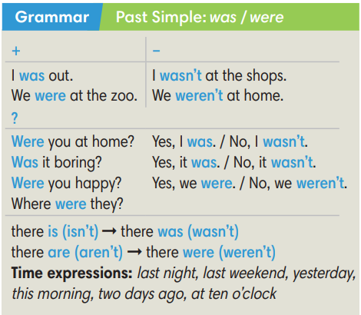
3. PRACTICE (20’)
ACTIVITY 3 + 4:
*Aim:
- To help Ss identify subject-verb agreement.
- To prepare for the next activity.
- To help Ss practice using was / were in context.
- To help Ss prepare for the next activity.
* Content: Complete the text/sentences with the correct form of the verbs.
Understand the text; grammar points; past simple tense.
* Outcome: Know how to form a sentence with the correct form of the verbs. Understand the conversation; the topic of the lesson, vocabulary, grammar points…
* Organisation : T_ Ss …
Teacher’s Student’s activities |  | Content
Extra activity 3 (6’): Ring the Golden Bell Game.  (Adapted from Ex 3, WB p.26)  - T explains the game rules then checks instructions.  - Ss join in the game individually.  - T corrects Ss if any. |  | Game rules:  - Read the sentences carefully.  - Choose a word in brackets to fill in the blank.  - 1 correct answer = 1 point.
3. (4’) Complete the dialogue with was / were / wasn’t / weren’t. Listen and check.  (Ex 3, p.32)  - T asks Ss to look at exercise 3 (SB page 32).  - T calls a student to read the instruction then checks Ss’ understanding of it.  - T asks Ss to underline the subject in each sentence and tell if it is singular or plural.  - T sets a time limit for Ss to work in groups and complete the exercise.  - T calls groups to give and explain their answers.  - T corrects Ss’ pronunciation if any.  - T plays the audio, lets Ss listen and check. |  | Answer key:
  2. was | 4. Were | 6.  Was | 8.  weren’t | 10. was
  3. were | 5. were | 7. wasn’t | 9.  were | 11. was
(5’) Extra activity 4: Lucky Wheel Game.  (Adapted from Ex 4, SB p.32)  - T explains the game rules then checks instructions.  - Ss join in the game individually.  - T corrects Ss if any. |  | Game rules:  - Read the sentences carefully.  - Find a mistake in each sentence then correct it.  - 1 correct answer => spin the wheel for points.
4. (5’) Use the words below to make sentences about the cartoon. Use there was / there were.  (Ex 4, SB p.32)  - T asks Ss to look at exercise 4 (SB page 32).  - T calls a student to read the instruction then checks Ss’ understanding of it.  - T sets a time limit, asks Ss to work in groups to write as many sentences with there was / there were as they can about the cartoon.  - T calls groups to read their sentences then shows possible answers on the slide.  - T corrects Ss’ grammar on the board if any. |  | 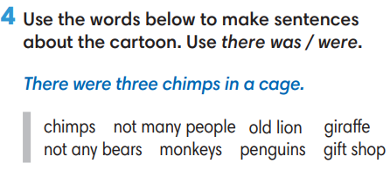
4. PRODUCTION (7’)
ACTIVITY 5:
*Aim: To help Ss to apply the grammar point they have learnt to talk about the past.
* Content: Ss make conversation about animals (where and when they were).
* Outcome: Ss know how to use past simple tense to make a conversations about their place and activities in the past.
* Organisation: T_Ss …
Teacher’s Student’s activities |  |  | Content
5. Complete the table with the places below. In pairs, guess your partner’s answers.  (Ex 5, p.32)  - T asks Ss to look at exercise 5 (SB page 32).  - T calls a student to read the instruction then checks Ss’ understanding of it.  - T asks a pair to read the sample dialogue on the slide then asks some new pairs to make new dialogues to ask and answer about other places and time.  - T divides Ss into pairs, models the activity in front of the class then asks Ss to make conversations about animals.  - T sets a time limit and monitors Ss while they are working in groups.  - T notes down common mistakes for delayed feedback.  - T calls some pairs to come to the front of the class, make conversations about the past.  - T asks the rest to give comments on their classmates’ performance.  - T gives feedback on Ss’ work. |  |  | 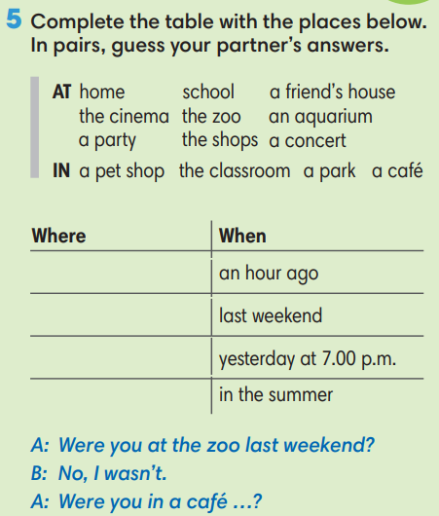
WRAP-UP & HOME WORK (2’)
- T asks Ss to talk about what they have learnt in the lesson.
- Vocabulary of animal names.
- Vocabulary of animal body parts.
* HOME WORK
- Do exercises in the workbook page 26.
- Prepare for Lesson 3: Reading and Vocabulary.

Date of teaching:  ……/……/2022 | Period 30 - UNIT 3: ANIMALS’ MAGIC  Lesson 3: Reading and Vocabulary
I. OBJECTIVES:
By the end of the lesson ss will be able to:
- find specific details in an article and talk about behaviours.
1. Knowledge:
* Vocabulary: an understanding of the vocabulary about family activities and some adjectives.
New words | Pronunciation | Vietnamese meaning
- adolescent (n) | /ˌæd.əˈles.ənt/ | A teenager
- adolescent (a) | /ˌæd.əˈles.ənt/ | Describe a time just before becoming an adult.
- adventure (n) | /ədˈven.tʃɚ/ | An unusual, exciting and possibly dangerous activity.
- aggressive (a) | /əˈɡres.ɪv/ | Behave violently towards other people.
- unthinking (n) | /ʌnˈθɪŋ.kɪŋ/ | Not base on careful thought.
- teenage (a) | /ˈtiːn.eɪdʒ/ | Aged between 13 and 19.

* Grammar: Reading skills:
- the ability to find specific details in a text (scanning skill).
- the ability to guess the meaning of new vocabulary in context.
2. Competence: Understand and know the meaning of the keywords used to talk about teenage behaviours, and understand the main grammatical points, then do the tasks assigned in the textbook; locate information and find specific details in an article (scanning skill); guess the meaning of new vocabulary in context.
3. Quality/ behavior: To teach Ss to be hard-working and attentive in class. Ss have a positive attitude to working in groups, individual work, pair work, cooperative learning and working.
II. TEACHING AIDS:
- Teacher: Grade 7 textbook, Unit 3 (SB p.33, WB p.27), laptop/computer connected to the Internet, loudspeaker, projector/TV, PPT slides…
- Students: Text books, studying equipment…
- Method: Active teach, T-WC; group works; individual ……
III. PROCEDURE:
1. WARM-UP (5’)
* Aim:
- To help Ss review the grammar point they have learnt in lesson 3.2.
- To create a positive classroom atmosphere.
* Content: Game: The Secret Chest Game (about watching habits)
* Outcome: Ss can talk about their watching habits.
* Organisation: T_ Ss …
Teacher’s &Student’s activities |  | Content
Extra activity 1: The Secret Chest Game  - T explains the game rules then checks instructions.  - T asks Ss the question “Do you often watch TV?” after the last question of the game.  - Ss raise their hands if the answer is “Yes”.  - T will ask Ss to tell more about their watching habits in the next activity. |  | Game rules:  - Read the sentences.  - Show fingers for answers.  - A gold coin = 2 points; A silver coin = 1 point.
2. PRE-READING (10’)
ACTIVITY 1:
* Aim:
- To activate Ss’ background knowledge of the topic.
- To pre-teach vocabulary.
- To prepare for the next activity.
- To prepare for the next activity.
* Content: To discuss Ss’s activities by reading and answering T’s questions.
* Outcome: Know new words, and grammar points when talking about teenage behaviours.
* Organisation: T, Ss …
Teacher’s & Student’s activities | Content
Extra activity 2 (5’):  (Extra exercise)  - T explains the game rules then checks instructions.  - T checks Ss’ understanding of each verb phrase after every question.  Further discussion:  - T tells Ss that they are going to read more about teenage behaviours.  - T sets the context for the lesson: Write the title on the board Unit 3: Animals’ Magic / Lesson 3.3: Reading and Vocabulary. | Game rules:  - Read the given word / phrase.  - Choose the correct picture.  - 1 correct answer = 2 points.
1. (5’) In pairs, look at the words and phrases below. Which things do teenagers typically do?  (Ex 1, p.33)  - T asks Ss to look at exercise 1 (SB page 33).  - T calls a student to read the instruction then checks Ss’ understanding of it.  - T sets a time limit and asks Ss to work in pairs to complete the activity.  - T calls some pairs to give ideas then writes them on the board.  - T tells Ss that they are going to find the answers in the reading text in the next activity. | 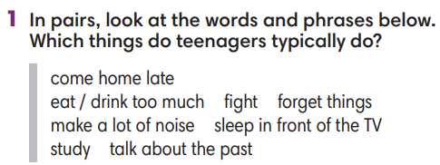
2. WHILE-READING 1 (20’)
ACTIVITY 2 + 3 + 4:
*Aim:
- To help Ss practice scanning skill.
- To teach topic-related vocabulary in context.
- To help Ss pull out tips for finding specific information in a text.
- To help Ss practice finding specific information in a text.
* Content: Read about the teenage behaviours.
* Outcome: To know more new words about teenage behaviours. Understand more about using the words in contexts.
* Organisation: T, Ss …

2. (5’) Which of the activity in exercise 1 does it mention?  (Ex 2, p.33)  - T asks Ss to look at exercise 2 (SB page 33).  - T calls a student to read the instruction then checks Ss’ understanding of it.  - T sets a time limit and asks Ss to work in pairs to complete the activity.  - T elicits the ideas from Ss, asks them in which line of the paragraph they see the answers.  - T confirms the answers then drills the pronunciation of the phrases and corrects Ss’ pronunciation if any.  Further discussion:  - T and students discuss tips for finding specific information in a text. | Answer keys:  1. make a lot of noise / 2. Do dangerous things / 3. Fight
3. (8’) Read the text again. Mark the sentences right, wrong or doesn’t say.  (Ex 3, p.33)  - T asks Ss to look at exercise 3 (SB page 33).  - T calls a student to read the instruction then checks Ss’ understanding of it.  - T elicits from Ss tips to find specific information in the text.  - T sets a time limit and asks Ss to work in groups to complete the exercise.  - T calls groups to give answers and the reasons for them.  - T confirms the answers.  - T corrects Ss’ pronunciation if any.  Further discussion:  - T and students reinforce tips for finding specific information in a text. | Answer keys:  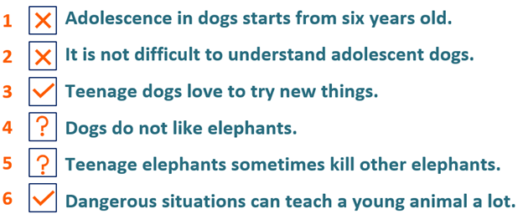
4. (7’) Choose the meaning of the highlighted words in the text.  (Ex 4, p.33)  - T asks Ss to look at exercise 4 (SB page 33).  - T calls a student to read the instruction then checks Ss’ understanding of it.  - T elicits from Ss tips to guessing the meaning of new vocabulary in a text.  - T sets a time limit and asks Ss to work in groups to choose the meaning.  - T calls groups to give answers and the reasons for them.  - T confirms the answers.  - T corrects Ss’ pronunciation if any.  Further discussion:  - T and students discuss on the tips to guess the meaning of new vocabulary in a text. | Answer keys:  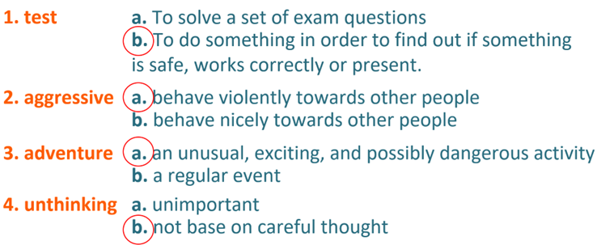
4. POST-READING (7’)
ACTIVITY 5:
* Aim: To encourage Ss to talk about teenage behaviours using the topic-related vocabulary.
* Content: To discuss the teenage behaviours.
* Outcome: Making sentences to talk about a teenager they know. Commenting about the sentences of others.
* Organization: T, Ss...
5. In pairs, tell about a teenager you know. Ask and answer questions using the verbs in exercise 1.  (Ex 5, p.33)  - T asks Ss to look at excersise 5 (SB page 33).  - T calls a student to read the instruction then checks Ss’ understanding of it.  - T asks a student to read the example then models the activity in front of the class.  - T asks Ss to work in pairs and talk about one of the teenagers they know.  - T sets a time limit and monitors Ss while they are working in pairs.  - T notes down common mistakes for delayed feedback.  - T calls some students to come to the front of the class to speak.  - T asks the rest to give comments on their classmates’ performance.  - T gives feedback on Ss’ work. | 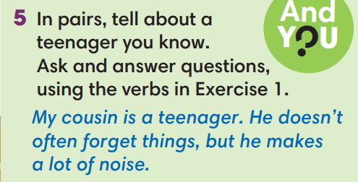
WRAP-UP & HOME WORK (3’)
- T asks Ss to talk about what they have learnt in the lesson.
- Vocabulary of teenage behaviours.
- Reading skills.

* HOME WORK
- Do exercises in the workbook page 27.
- Prepare for Lesson 3.4: Grammar 2.

Date of teaching:  ……/……/ 2022 | Period 31 - UNIT 3: ANIMALS’ MAGIC  Lesson 4: Grammar 2
I. OBJECTIVES:
By the end of the lesson students will be able to:
- use Past Simple of regular verbs to talk about the past.
1. Knowledge:
* Grammar:
- remember the forms of regular verbs in Past Simple.
- write past simple forms of regular verbs.
- use past simple forms of regular verbs to talk about the past.
2. Competence: Understand and use verbs to talk about activities in the past, and understand the main grammatical points, then do the tasks assigned in the textbook; use the questions and answers in past simple correctly to talk about the past.
3. Quality/ behavior: To teach Ss to be hard-working and attentive in class. Ss have a positive attitude to working in groups, individual work, pair work, cooperative learning and working.
II. TEACHING AIDS:
- Teacher: Grade 7 textbook, Unit 3 (SB p. 34), laptop/computer connected to the Internet, loudspeaker, projector/TV, PPT slides…
- Students: Textbooks, studying equipment…
- Method: Active teach, T-WC; group works; individual ……
III. PROCEDURE:

1. WARM UP (4’)
* Aim:
- To create a positive classroom atmosphere to start a new lesson.
- To help Ss review the vocabulary they have learnt in Lesson 3.3.
* Content: Game: Minion Game (with the past simple tense)
* Outcome: Ss use the correct form of the verb in the Past Simple tense.
* Organisation: T, Ss ..….

Teacher’s & Student’s activities |  | Content
Extra activity 1: Minion Game  - T explains the game rules then checks instructions.  - Ss join in the game individually.  - T corrects Ss if necessary. |  | Game rules:  - Read the sentence carefully.  - Choose A or B to fill in the blank.  - 1 correct answer = 1 point.
2. LEAD-IN (2’)
*Aim:
- To lead into the new lesson.
- To provide Ss with reasons for listening to the dialogue in exercise 1 (SB p.34).
* Content: Ss answer the questions about Nam.
* Outcome: Get the right answers on time.
* Organisation: T_ Ss ..….

Teacher’s & Student’s activities | Content
Extra activity 2: See – think – wonder.  - T shows a picture on the slide then asks students four questions.  (1) What do you see in the picture?  (2) What is he doing?  (3) Where is he?  (4) How does he feel?  - T sets a time limit for Ss’ quick discussion.  - Ss work in pairs to make guesses about the picture then give answers.  - T calls some Ss to give answers then note them down on the board.  - T tells Ss that they’re going to read the conversation in exercise 1 (SB p.34) to check all the answers. | 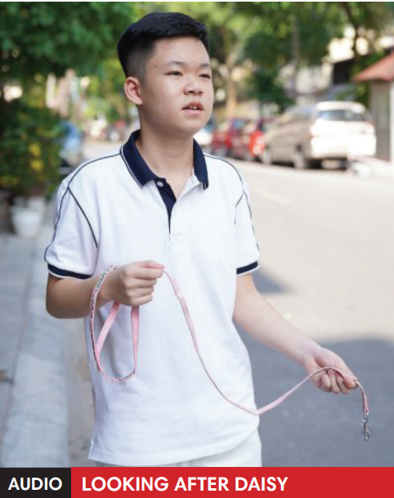
3. PRESENTATION (13’)
(Questions and answers in the Present Simple tense)
ACTIVITY 1 + 2:
*Aim:
- To present the grammar point in context.
- To lead into the next activity.
- To introduce the forms of regular verbs in Past Simple.
- To introduce the everyday phrases and expressions pulled out from the conversation shortly.
* Content: To practice using the past simple in context by choosing the correct answer.
* Outcome: Practicing the use of the past simple by writing the correct form of the verbs.
* Organisation: T, Ss ..….

Teacher’s & Student’s activities | Content
1. (5’) Listen. Why is Nam worried?  (Ex 1, p.34)  - T asks Ss to open their SB page 34, look at exercise 1.  - T calls a student to read the instruction then checks Ss’ understanding of it.  - T tells Ss that they are going to listen to a conversation between Mai and Nam.  - Ss work individually, listen and note down the answers to the given questions.  - T calls some Ss to give answers then shows the answers on the slide.  Answer keys:  Nam is worried because he can’t find Kim’s dog.  - T set the scene for the new lesson: T tells Ss that they are going to read a conversation to see what happened with him in the past.  - T writes the title on the board Unit 3: Animals’ Magic / Lesson 3.4: Grammar 2. | 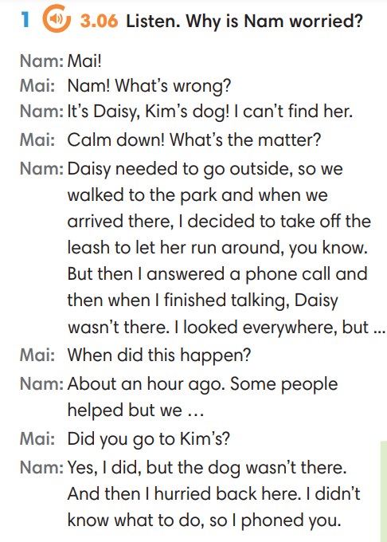
2. (4’) Find more example of the Past Simple in the dialogue.  (Ex 2, p.34)  - T asks Ss to look at exercise 2.  - T calls a student to read the instruction then checks Ss’ understanding of it.  - T asks Ss to work in groups of three to read the complete the activity.  - T calls groups to give answers then shows the answers on the slide to check as the whole class. | 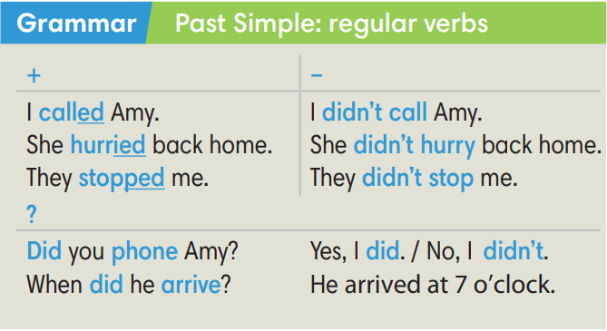
Extra activity 3 (4’): Find and underline the phrases below in the dialogue.  (Out of class box)  - T asks Ss to look at the Out of class box, find and underline the phrases in the dialogue.  - T calls students to read the phrases and asks for meaning basing on the conversation.  - T corrects Ss’ pronunciation if any.  - T shows the grammar notes, explains the grammar points and tells Ss that they’re going to use them to talk about the past. | 
4. PRACTICE (17’)
ACTIVITY 3:
* Aims:
- To help Ss practice writing form of regular verbs in Past Simple.
- To help Ss practice pronouncing verbs with -ed ending then classify them.
- To help Ss practice writing form of regular verbs in Past Simple in context.
* Content: Choose the correct form of the verb in the past simple tense.
* Outcome: Choose the form correctly in grammar and use the past simple to explain their options.
* Organisation: T, Ss, ….
Teacher’s & Student’s activities | Content
Extra activity 4 (6’): Tom and Jerry Game.  (Adapted from ex3 SB p.34)  - T explains the game rules then checks instructions.  - Ss join in the game individually.  - T corrects Ss’ pronunciation if any. | Game rules:  - Read the questions carefully.  - Choose A, B or C.  - Check answers with Tom and Jerry.  - 1 correct answer = 2 points.
3. (7’) Write past simple form of the verb below then put them in the correct column. Listen and check.  (Ex 3 SB p.34)  - T asks Ss to look at exercise 3.  - T calls a student to read the instruction then checks Ss’ understanding of it.  - T sets a time limit for Ss to complete the exercise in groups of four.  - T calls groups to give answers then checks as the whole class.  - T corrects Ss’ pronunciation if any. | Answer keys:  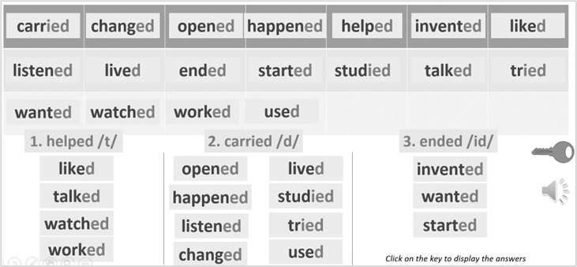
4. (4’) Write past simple form of the verb below then put them in the correct column. Listen and check.  (Ex 4 SB p.34)  - T asks Ss to look at exercise 4.  - T calls a student to read the instruction then checks Ss’ understanding of it.  - T sets a time limit for Ss to complete the exercise in pairs.  - T calls groups to give answers then checks as the whole class.  - T corrects Ss’ pronunciation if any. | Answer keys:
  2. didn’t want | 4. agreed | 6. shouted | 8. walked
  3. needed | 5. decided | 7. suggested | 9. didn’t like
4. PRODUCTION (7’)
ACTIVITY 5:
* Aims: To let Ss make questions and answers about the past.
* Content: Interview partners using the cues words.
* Outcome: Use vocabulary items and grammar points related to the topic to interview partners.
* Organisation: T. Ss , Individual, Pair work, ….

Teacher’s & Student’s activities | Content
5. In pairs, make questions from the promts. The go to page 101 to find answers.  (Ex 5, p.34)  - T asks Ss to look at excersise 5 (SB page 34).  - T calls a student to read the instruction then checks Ss’ understanding of it.  - T divides Ss into new pairs, then sets a time limit for them to complete the activity.  - T asks pairs to ask and answer questions.  - T walk around to listen and notes down common mistakes for delayed feedback.  - T calls some pairs to come to the front of the class, make conversations.  - T asks the rest to give comments on their classmates’ performance.  - T gives feedback on Ss’ work. | 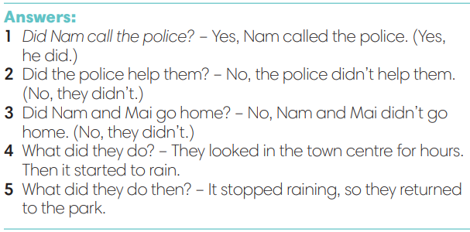
WRAP-UP & HOME WORK (3’)
- T asks Ss to talk about what they have learnt in the lesson.
- The past simple tense with regular verbs.
* HOME WORK
- Do exercises in the workbook page 28.
- Prepare for Lesson 3.5: Listening and vocabulary.

Date of teaching:  ……/…../2022 | Period 32 - UNIT 3: ANIMALS’ MAGIC  Lesson 5: Listening and Vocabulary
I. OBJECTIVES:
By the end of the lesson student will be able to:
- can identify specific details in a conversation and talk about pets.
1. Knowledge:
* Vocabulary: use vocabulary of pets and Word Friends about looking after pets.
* Grammar: make sentences in Present Simple and Past Simple to talk about pets.
2. Competence: Understand and use words about pets and Word Friends about looking after pets, do the tasks assigned in the textbook. Listen and identify specific details in a conversation and talk pets.
3. Quality/ behavior: To teach Ss to be hard-working and attentive in class. Ss have a positive attitude to working in groups, individual work, pair work, cooperative learning and working.
II. TEACHING AIDS:
- Teacher: Grade 7 textbook, Unit 3 (SB p. 35, WB p.29), laptop/computer connected to the Internet, loudspeaker, projector/TV, PPT slides…
- Students: Text books, studying equipment…
- Method: Active teach, T-WC; group works; individual ……
III. PROCEDURE:
1. WARM UP + LEAD-IN (8’)
ACTIVITY 1:
* Aim:
- To create a positive classroom atmosphere to start a new lesson.
- To review what students have learnt from previous lesson
- To lead into the lesson
* Content: Play Hidden Symbols game.
* Outcome: Know more new words in context. Improve pronunciation.
* Organisation: T, Ss ..
Teacher’s &Student’s activities | Content
Extra activity 1 (5’): Hidden Symbols  - Teacher introduces the Hidden Symbols Game  - T explains How-to-play steps then checks Ss’ comprehension  - T uses slides to lead the game.  - Ss join the game in small groups | How to vote:  - Choose a number  - Solve a riddle or do a task  - Raise your hand to answer  - 1 point = 1 star / 1 bomb = no point
Extra activity 2 (3’): Guessing Activity  - T asks student that if they remember the key sentence in slide riddle 6.  - T displays the sentence: Ali wants a pet but what kind to get?  - T shows the picture of Ali and a part of the reading text.  - T allows students to discuss and guess the answer massively  - T encourages Ss to give the reason for their guessing.  - Ss work in pairs to do the task  - T tells Ss that they’re going to learn more words of about having and taking care of a pet in the next step of the lesson. | 
2. PRE-LISTENING (14’)
ACTIVITY 1 + 2:
*Aim:
- To activate Ss’ prior knowledge of the topic.
- To pre-teach word friends of taking care of a pet
- To present Word Friends about having and taking care of a pet.
* Content: Some brief notes; vocabulary about pets. Use them to complete the exercise.
* Outcome: Know some more new words about pets. Chose the correct words to answer the questions.
* Organisation: T, Ss …
Teacher’s &Student’s activities | Content
1. (10’) Read the text and decide which of the pets is good for Ali.  (Exercise 1 – SB p. 35)  - T asks Ss to look at exercise 1.  - T calls a student to read the instruction then checks Ss’ understanding of it.  STEP 1: CLASS VOTE  - T shows the reading text A and B and asks Ss to read and vote A or B.  A – dogs / B - cats  - Ss read and vote by giving their thumb up for A or B  STEP 2: THE ADVANTAGES AND DISADVANTAGES  - T tells Ss to work in small groups to read the text again and find the information to fill in the column displayed in teacher’s slide. The advantages and disadvantages of having a dog or a cat.  - Ss work in groups to read, information and fill in the column  - From the information, T encourages Ss to compare with Ali’s condition to decide which pet is for her.  - T calls volunteers to share the answer and confirm the possible one.  => A cat can be a good idea. | 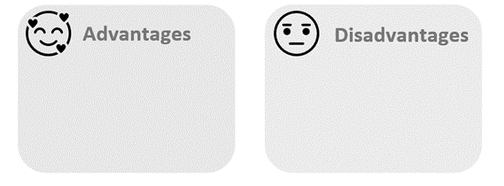
2. (4’) Check if you understand this Word Friends.  Then listen to Ali talking to a friend.  Number the Words Friends in the order you hear them.  (Exercise 2 – SB p.35)  - T asks Ss to look at exercise 2.  - T calls a student to read the instruction then checks Ss’ understanding of it.  STEP 1: Understand the Words Friends  Task: Match the phrases with the corresponding pictures.  - T uses slides to lead the activities  - T asks Ss to work in groups of three to read then match  - T calls groups to give answers to check as the whole class.  STEP 2: Listen and number  - T plays the audio for students to listen and number the phrases.  - T checks the answers with the whole class.  - T displays all the Word Friends again for Ss to read aloud. | Answer keys:  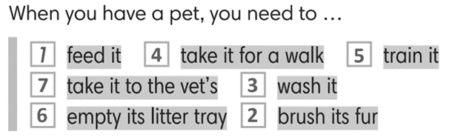
3. WHILE-LISTENING (5’)
ACTIVITY 3:
* Aim:
- To help Ss identify specific details in a conversation
- To provide Ss with chances to think and talk about pets
* Content: Listen and understand the audio track to complete the exercise.
* Outcome: Think and talk about pets by matching the correct answers.
* Organisation: T_ Ss …
Teacher’s &Student’s activities | Content
3. Listen to five dialogues and choose the correct answers.  (Exercise 3 - SB p.35)  - T asks Ss to look at exercise 3 in student book page 35.  - T calls a student to read the instruction then checks Ss’ understanding of it.  - T asks students to read the sentences carefully  - T asks Ss to work in pairs to listen then complete the activity and peer check for the first listening.  - T plays the audio again and checks as the whole class.  - Teacher asks students to give the evidence that they hear from the audio track to prove their answer. | Answer keys: 2-b, 3-b, 4-c, 5-b
4. POST-LISTENING (12’)
ACTIVITY 4:
*Aim: To help students applying the vocabulary items related to the topic in communicating.
* Content: Work in pairs to talk about pets.
* Outcome: Think and talk about pets.
* Organisation: T, Ss ..
Teacher’s &Student’s activities | Content
Extra activity 3 (6’): Fill in the blanks.  Read a dialogue again and fill in the blanks.  - T provides Ss the script of dialogue 1 from exercise 3.  - T tells Ss to read and fill in the blanks.    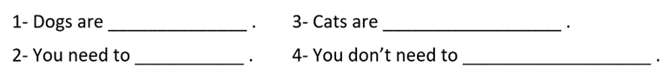  - T explains that they are some criteria students should think of when they choose a pet.  - Ss work individually and raise their hands to answer.  - T listens to Ss’ answer and checks as the whole class | Key answers: 1-fun / 2-train them / 3-quiet and clean / 4-take them for a walk
4. (6’) In groups, say which animal you would like as a pet and why. Use the phrases below to help you.  (Exercise 4 - SB p.35)  - T asks Ss to look at exercise 4 in student book page 35.  - T calls a student to read the instruction then checks Ss’ understanding of it.  - T asks Ss to work in groups to read then complete the activity.  - T sets a time limit for students.  - Students work in groups to think and share.  - Teacher invites different students to talk about their partner. | 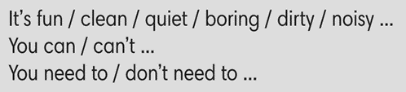
WRAP-UP & HOME WORK ( 2’)

- T asks Ss to talk about what they have learnt in the lesson.
- Word Friends: Have and take care of a pet
* HOME WORK
- Do exercises in the workbook page 29.
- Prepare for Lesson 3.6: Speaking.

Date of teaching:  ……/…../2022 | Period 33 - UNIT 3: ANIMALS’ MAGIC  Lesson 6: Speaking
I. OBJECTIVES:
By the end of the lesson student will be able to:
- make and respond to apologies.
1. Knowledge:
* Vocabulary: review some pet-related actions, learn some apologizing expressions.
* Grammar: make dialogue in the Present Simple with apologizing expressions.
2. Competence: Ss understand and use the vocabulary of apologizing expressions and other related topics to the lesson content, do the tasks assigned in the textbook. Listen for comprehension then make and response to some apologies.
3. Quality/ behavior: To teach Ss to be hard-working and attentive in class. Ss have a positive attitude to working in groups, individual work, pair work, cooperative learning and working.
II. TEACHING AIDS:
- Teacher: Grade 7 textbook, Unit 3 (SB p. 36, WB p.30), laptop/computer connected to the Internet, loudspeaker, projector/TV, PPT slides…
- Students: Text books, studying equipment…
- Method: Active teach, T-WC; group works; individual ……
III. PROCEDURE:
1. WARM UP + LEAD-IN (5’)
* Aim:
- To create a positive classroom atmosphere to start a new lesson.
- To review pet-related actions.
- To lead into the topic.
* Content: Play Mind-map to recall the vocabulary in previous lessons.
* Outcome: Students talk about pets by using the vocabulary in previous lessons.
* Organization of implementation: T- Ss
Teacher’s & Student’s activities |  | Content
Extra activity 1: Mind-map  - T writes the words “all things you need to do when you have a pet” on board and asks students to work in pairs/small group.  - Students discuss and list out all words they remember from previous lesson.  - Students use a mind-map to present their ideas.  - Teacher encourages students to stand up and share their answers in front of the class.  - Teachers explains that students find some of the warm-up words in the new lesson.  Unit 3 – Lesson 6: Speaking |  | 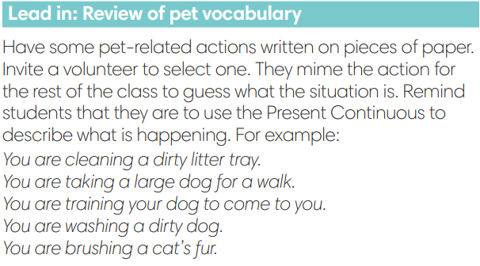
2. PRE-SPEAKING (20’)
ACTIVITY 1 + 2:
* Aim:
- To activate Ss’ prior knowledge of the topic.
- To start a class discussion
- To listen and identify specific information to answer the questions
- To read and identify specific information to answer the questions
- To introduce the Speaking Box
- To reinforce the apologizing expressions
- To classify statements of accepting and not accepting apologies.
* Content: Listen to the conversation to answer the questions about Kim and Nam.
* Outcome: Know about the apologizing expressions. Understand the conversation.
* Organisation: Teacher’s instructions…

Teacher’s & Student’s activities |  |  | Content
1. (5’) Look at the photos. How do you think Nam and Kim are feeling? Why? Listen and read to check your answers.  (Exercise 1 - SB p.36)  - Set the scene: T tells Ss to remember what happened in the dialogue of Unit 3 – Lesson 4.  - T has Ss work in pairs or small groups to discuss and find the answers for the questions.  - Ss do the tasks in pairs or in small groups.  - T calls some volunteer Ss to say aloud the possible answers.  - T plays the audio for Ss to check then confirms the answers.  - T provides information from unit 3-lesson 4: Nam was with Kim's dog, but it disappeared. He looked for it, but he doesn’t know where it is. |  |  | Answer keys:  Nam is feeling sad and embarrassed because he can’t find Kim’s dog.  Kim is feeling shocked and sad because Nam lost her dog.
2. (7’) Tick (v) the words and phrases from the dialogue.  (Exercise 2 – SB p.36)  - T asks students 2 questions then has Ss to discuss in pairs.  Who is doing the apologising?  Why do they feel they need to apologise?  - T confirms the answers:  - Nam is apologising for losing the dog.  - Kim is apologising for being rude.  - T asks Ss to look at exercise 2.  - T calls a student to read the instruction then checks Ss’ understanding of it.  - T sets a time limit for Ss to work in groups  - T calls groups to give answers to check as the whole class.  - T provides explanations and tell the whole class to read aloud the words and phrases from the Speaking Box together. |  |  | Answer keys:  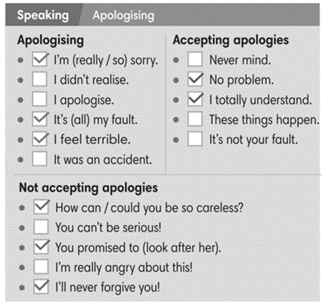
Extra activity 2 (3’): Minion Game  - T has Ss get ready for the game in team and explains the game rules.  - T uses Pptx slides to lead the games  - Ss in each team take turns to play.  - T rewards points for the winner then asks Ss to read the expressions aloud together. |  |  | Game rules:  - Read the sentence carefully.  - Choose A or B to fill in the blank.
3. (5’) Use the Speaking Box to complete the dialogues. Sometimes more than one answer is possible. Listen and check.  (Exercise 3 – SB p.36)  - T asks Ss to look at exercise 3.  - T calls a student to read the instruction then checks Ss’ understanding of it.  - T sets a time limit for Ss to work in groups  - T calls groups to give answers to check as the whole class. |  |  | Answer keys:  2. No problem.  3. It’s not your fault.  4. How can you be so careless?
3. WHILE-SPEAKING (10’)
ACTIVITY 3 + 4:
* Aim:
- To reinforce the apologizing expressions
- To practice the “apologizing” dialogue
* Content: Complete the conversations to express apologies.
* Outcome: Understand the use of apologizing expressions to communicate.
* Organisation: T, Ss ..….

Teacher’s & Student’s activities |  |  |  | Content
3. (5’) Act out the dialogue in exercise 3 – SB p.36 (Exercise 3 - SB p.23)  - T sets a limit for students to work in pairs to practice the dialogue as a role play.  - T invites some pairs of students to act out the roleplay in front of the class.  - Ss work in pair, practice the dialogue, then act out. |  |  |  | 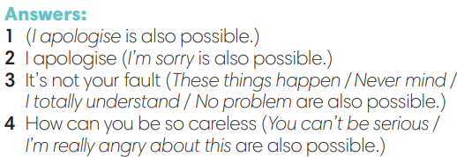
4. In pairs, follow the instructions. Use the  Speaking box to help you.  (Exercise 4 – SB p.36)  - T asks Ss to look at exercise 4.  - T calls a student to read the instruction then checks Ss’ understanding of it.  - T sets a time limit for Ss to work in pairs.  - Ss work in pairs to discuss on the given situation then build up the dialogue.  - T invites some pairs of students to perform in front of the class  - T provides corrections when needed. |  |  |  | 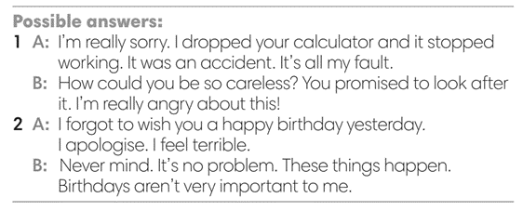
4. POST-SPEAKING (8’)
ACTIVITY 4:
*Aims: To help students applying the new language and skills related to the topic in communicating.
* Content: Express apologies to each other’s.
* Outcome: To practice apologizing expression by create a new situation and act out.
* Organisation : T, Ss .…

Teacher’s & Student’s activities | Content
Extra activity 3: Adaptation for Exercise 4 (SB p.36)  In pairs, create a new situation and act out.  - T tells student to look at the speaking box in their student book again and prepare for the task.  - T gives students time to think about what they are going to say in their roleplays.  - T encourages stronger students to introduce a situation as an example for the whole class, e.g. You lost your friend’s toy. You go home late.  - Students work in the same pairs from the last activity and practice their role plays, focus on using the correct intonation.  - Teacher invites pairs to act out their roleplays in front of the class. | 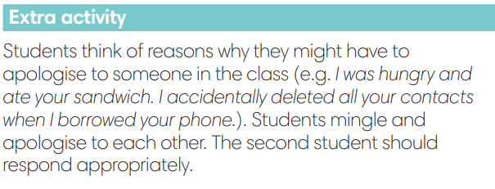
WRAP-UP & HOME WORK (2’)
- T asks Ss to talk about what they have learnt in the lesson.
- Apologizing expressions
* HOME WORK
- Do exercises in the workbook page 30.
- Prepare for Lesson 3.7: Writing.

Date of teaching:  ……./……/ 2022 | Period 34 - UNIT 3: ANIMALS’ MAGIC  Lesson 7: Writing
I. OBJECTIVES:
By the end of the lesson, Ss are able to:
- write a biography.
1. Knowledge:
* Vocabulary: use vocabulary of common topics (age / jobs / places / family, etc.) to write a biography (of a famous person).
* Grammar: make sentences in the Past Simple tense correctly.
2. Competence: Ss understand and use the vocabulary of common topics (age / jobs / places / family, etc.), do the tasks assigned in the textbook. Write a biography of a famous person.
3. Quality/ behavior: To teach Ss to be hard-working and attentive in class. Ss have a positive attitude to working in groups, individual work, pair work, cooperative learning and working.
II. TEACHING AIDS:
- Teacher: Grade 7 textbook, Unit 3 (SB p. 47, WB p.31), laptop/computer connected to the Internet, loudspeaker, projector/TV, PPT slides…
- Students: Text books, studying equipment…
- Method: Active teach, T-WC; group works; individual ……
III. PROCEDURE:
1. WARM UP (4’)
* Aim:
- To create a positive classroom atmosphere to start a new lesson.
- To lead in to the sample writing.
- To early introduce some information about Steve Irwin
* Content: Game: Telepathy Game (about an expert called Steve Irwin)
* Outcome: Ss guess and choose the correct picture.
* Organization of implementation
Teacher’s & Student’s activities | Content
Extra activity 1: Telepathy Game  - Set the scene: T tells Ss that she / he’s going to give some sentences about an expert called Steve Irwin.  - T explains the game rules then checks instructions.  - Ss join in the game individually.  - T set the scene for the new lesson: T tells Ss that they are going to read and write a biography in this lesson.  - T writes the title on the board Unit 3: Animals’ Magic / Lesson 3.7: Writing. | Game rules:  - Read the sentence  - Make guesses and choose A or B as the correct picture.  - 1 correct answer = 1 point.
2. LEAD-IN (3’)
* Aim:
- To get students to think about the topic.
- To provide Ss with reasons for reading the sample writing in exercise 1 (SB p.37).
* Content: Discuss in groups and give the answer about the an expert called Steve Irwin in the picture.
* Outcome: Guess the correct answers to the questions.
* Organisation: T_ Ss ..….
Teacher’s & Student’s activities | Content
Extra activity 2: See – think – wonder.  - T shows a picture of Steve Irwin on the slide then asks students four questions.  (1) How old was he?  (2) Where was he from?  (4) What was his job?  - T sets a time limit for Ss’ quick discussion.  - Ss work in pairs to make guesses about the picture then give answers.  - T calls some Ss to give answers then note them down on the board for checking later.  - T tells Ss that they’re going to read the conversation in exercise 1 (SB p.37) to check all the answers. | 
3. PRE-WRITING (13’)
ACTIVITY 1 + 2 + 3 + 4:
* Aim:
- To activate Ss’ prior knowledge of the topic.
- To lead in to the next activitiy.
- To study the Writing Box.

- To help Ss focus on personal information while reading the sample.
- To provide Ss the localized content to write about.
- To practice sentence building by filling in the blanks before Ss can write a complete text.
* Outcome: Do the exercise to improve grammar.
* Organisation : T_ Ss ..….
Teacher’s & Student’s activities | Content
1. (3’) Read Steve Irwin’s biography and  answer the questions.  (Exercise 1 – SB p.37)  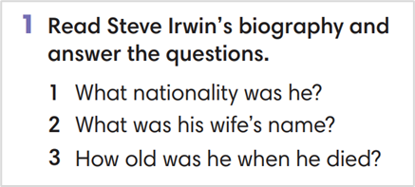  - T calls a student to read the instruction then checks Ss’ understanding of it.  - T has Ss work in pair and find the answers for the questions  - T encourages Ss to underlines the key sentences in the reading.  - T calls some volunteer students to give their answers then checks for the whole class. | Answer key:  1. Australian  2. Terri  3. forty-four years old (although he could have been forty-three if his birthday was after September)
2. (4’) Look at Steve’s biography again.
Find all the examples of Past Simple.
(Exercise 2 – SB p.37)
- T asks Ss to look at exercise 2.
- T calls a student to read the instruction then checks Ss’ understanding of it.
- T asks Ss to work in groups of three to read then complete the activity.
- T calls groups to give answers then shows the answers on the slide to check as the whole class.
3. (3’) Study the Writing box. Which of the phrases can you find in Steve’s biography?  (Exercise 3 – SB p.37)  - T asks Ss to look at exercise 3.  - T calls a student to read the instruction then checks Ss’ understanding of it.  - T asks Ss to work in pairs to read then complete the activity.  - T checks as the whole class. | 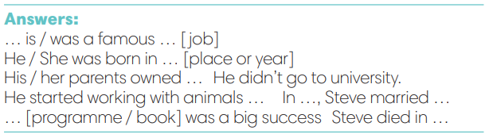
4. (3’) What do you know about Trinh Công Son?  Read the fact box and complete it with Past Simple form of the verbs in brackets.  (Exercise 4 – SB p.37)  - T asks Ss to look at the writing box and the sample writing again.  - T asks Ss to work individually, complete the facts about Trinh Cong Son  - T sets a time limit for the activity.  - T tells Ss to pair, share, and compare the answers.  - T shows the slides and check as the whole class. | 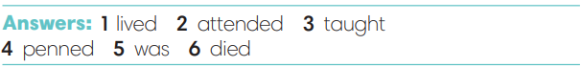
4. WHILE-WRITING (8’)
ACTIVITY 5:
* Aim: To provide students task to apply useful expressions from Writing Box in writing sentences with Past Simple tense.
* Content: Use the past simple tense to write a short biography.
* Outcome: Write a short biography of a famous people using the vocabulary and grammar points of the unit.
* Organisation : T_ Ss.. ….

Teacher’s & Student’s activities | Content
5. Write a short biography (60-80 words) of Trinh Cong Son. Use the fact box and the Writing Box from Exercise 4  (Exercise 5 – SB p.37)  - T calls a student to read the instructions then checks Ss’ understanding of it.  - T asks Ss to work individually to write a biography of Trinh Cong Son base on the Fact box and Writing Box  - T sets a time limit for the task and walk around as a monitor while Ss are writing. | 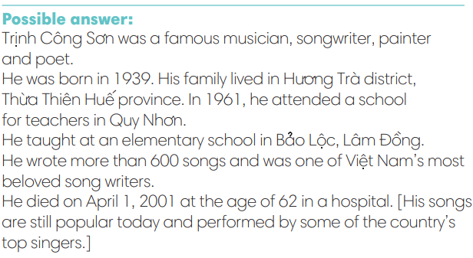
5. POST-WRITING (6’)
* Aim:
- To let Ss do peer-check.
- To give general comments on Ss’ writing pieces.
* Content: Ss swap their writing and check.
* Outcome: Ss’s biography is followed the writing rubric.
* Organisation : T_ Ss.. ….

Teacher’s & Student’s activities | Content
Extra activity 3: In pairs, swap your writing then check.  - T explains the writing rubric before checking.  - T asks Ss to swap their writing pieces, use the given writing rubric then do cross-check.  - T gives feedback on common mistakes of Ss’ work.  - T may collect Ss’ writing for detailed comments. | Writing rubric:  (1) Does the writing include details?  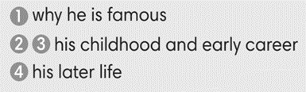  (2) Does the writing meet word limit (60-80 words)?  (3) Does the writing make any vocabulary and grammar mistakes?
WRAP-UP & HOME WORK (2’)
- T asks Ss to talk about what they have learnt in the lesson.
- A biography of a famous person
* HOME WORK:
- Do exercises in the workbook page 31.
- Prepare for Lesson 3.8

Date of teaching:  ……/……/ 2022 | Period 35 - UNIT 3: ANIMALS’ MAGIC  Lesson 8: Vocabulary in Action and Pronunciation
I. OBJECTIVES:
By the end of the lesson student will be able to:
1. Knowledge:
* Vocabulary: review vocabulary about animals, adjectives, looking after pets
- phrasal verbs of pet-looking activities
- word friends and word family
* Pronunciation: Listen and identify the rhyming words
2. Competence: Students develop communication skills, and creativity; be collaborative and supportive in pair work, and teamwork; actively join in class activities.
3. Quality/ behavior: To teach Ss the love of talking about relating topics of unit 3 and using word friends or phrasal verbs in pair work or group work, and develop self-study skills. Ss have a good attitude to working in groups, individual work, pairwork, cooperative learning, and working
II. TEACHING AIDS:
- Teacher: Grade 7 textbook, Unit 3 (SB p.38), laptop/computer connected to the Internet, loudspeaker, projector/TV, PPT slides… .
- Students: Text books, studying equipment…
- Method: Active teach, T-WC; group works; individual ……
III. PROCEDURE:
1. WARM UP + LEAD-IN (5’)
*Aims:
- To create an active atmosphere in the class before the lesson.
- To lead into the new lesson.
* Content: Game: NAME 3 THINGS CHALLENGE (animals)
* Outcome: Students say words relating to the given topic quickly.
* Organisation: Teacher’s instructions…

Teacher’s & Student’s activities | Content
Extra activity 1: NAME 3 THINGS CHALLENGE  * Teacher asks students to spend 1 minutes to quickly review all vocabulary they have learnt in Unit 3 before they play a warm-up game.  - T tells students that they are going to play a game called NAME 3 THINGS CHALLENGE  - T explains the game rules then checks instructions.  - Teacher uses the slides to show the challenge  - Ss join in the game pairs or in small groups.  - Teacher listens to the Ss answers and calls several Ss to check for the whole class.  - T tells Ss that they can remember better with Glossary Table and asks Ss to open their Student Book page 38 – Exercise 1. | Game rules:  - Choose a number to get the challenge  - Read the topic word  - Say 3 words relating to that topic quickly.
2. REVIEW VOCABULARY (18’)
(GLOSSARY TALBE)
ACTIVITY 1 + 2 + 3:
*Aim:
- To introduce the glossary and its uses.
- To give further practice in making sentences using the Glossary.
* Content: Revise what they have learnt during the unit. Glossary and its uses.
* Outcome: Remember the new words and animals’ name.
* Organisation : Teacher’s instructions…

Teacher’s & Student’s activities | Content
1. (7’) In pairs, say the names of there animals that you think are:  1. quiet  2. noisy  3. dangerous  4. cute  5. lively  (Exercise 1 – Student Book page 38)  - Teacher introduces the Glossary Table.  - T asks Ss to look at exercise 1 in student book page 38  - T has students use the glossary to find the words which belong to the correct category  - T asks students to work in pairs and quickly do the task.  - T allows students to peer check first.  - T checks and confirms the answers.  The answers can be variety depends on Ss’ choice. | 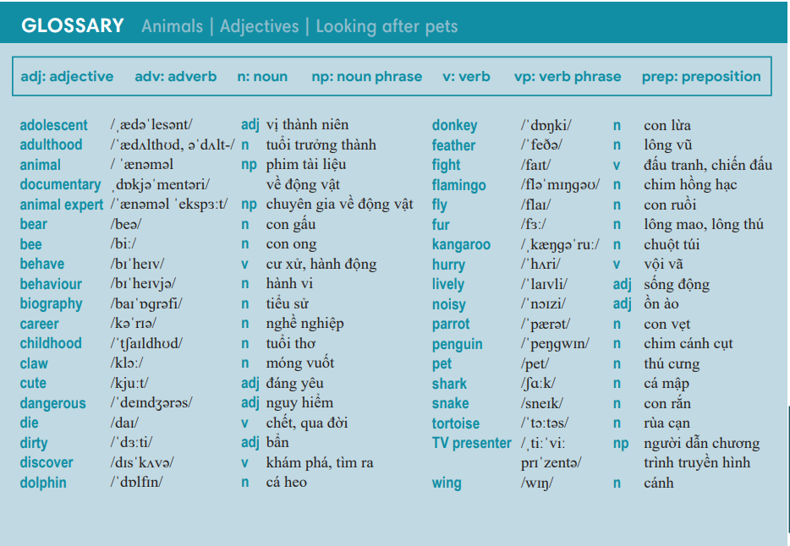
2. (6’) Complete the sentences with the prepositions below.  In pairs, say if you agree with the statements or not.  (Exercise 2 – Student Book page 38)  - T asks students to complete the sentences with suitable prepositions  - T asks students to work individually and check in pairs.  - T invites students to share their answers.  - T confirms the correct answers.  TIME TO TALK:  - Ss work in pairs to share if they agree or disagree to the statements in the exercise. | Answer key:  2. after / 3. for / 4. to / 5. for
3. (5’) Complete the sentences with the correct form of the word in bold.  (Exercise 3 – Student Book page 38)  - T asks Ss to open their SB page 38, look at exercise 3.  - T calls a student to read the instruction then checks Ss’ understanding of it.  - T gives students a time limit to work individually.  - T allows Ss to share their answers massively before checking the final ones as the whole class.  - T provides the meanings, pronunciations of the words in the exercise  Childhood / behaviour / adolescence / presenter  - T has students pronounce the words in pairs. | Answer key:  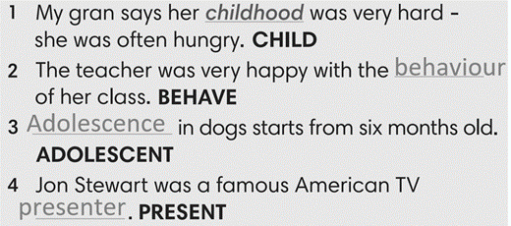
3. PRONUNCIATION (19’)
3.1. Presentation (13’)
ACTIVITY 4:
* Aims:
- To present the list of rhyming words
- To help students identify the rhyming words
- To help students listen and identify rhyming words in pairs.
* Content: Do exercises to practice pronunciation.
* Outcome: Say the rhyming words correctly.
* Organisation: Teacher’s instructions…

Teacher’s & Student’s activities | Content
4. (7’) Complete the sentences. Use the words below that rhyme with the underlined words. There are two extra words.  (Exercise 4 – SB p38)  - Teacher uses the slides to lead the activity  - T calls a student to read the instruction then checks Ss’ understanding of it.  - T gives students a time limit to work individually.  - T allows Ss to share their answers massively before checking the final ones as the whole class.  TIME TO SAY  - T have students say the rhyming words in pairs/ group | Answer keys:  2- wing, 3-hurry, 4-snake, 5-fly, 6-zoo, 7-bear
Extra activity 2 (6’): Defeat The Goalkeeper Game  - T introduces the game and explains the rules.  - T calls some students to read out the words first.  - T plays the audio tracks for them to listen choose.  - T invites some students to share their answers.  - T confirms the answer using the slide and rewards points for the winner team. | Game rules:  - Read the questions carefully.  - Choose the answer A or B to defeat the goalkeeper.  - 1 correct answer = 1 point.
3.2. Practice (6’)
* Aims: To enhance the rhyming words
* Content: Play Phonic Game to practice pronunciation.
* Outcome: Say the words with the correct rhymes.
* Organisation : Teacher’s instructions…

Teacher’s & Student’s activities | Content
Extra activity 3: Phonics Game  - T has Ss to play the game in pairs, explains the rules.  - T sets a time for students to play in pairs, walks around and provides support when needed. | Game rules:  - Student A says a word (from the phonics list)  - Student B says a word that rhymes with Student A’s word  - Swap the role.
WRAP-UP & HOME WORK (3’)
- Teacher asks students to talk about what they have learnt in the lesson.
- Use a Glossary to review
- Identify rhyming words
* HOME WORK
- Find more rhyming words
- Prepare for Unit 3 – Lesson 9: Revision

Date of teaching:  ……./…../ 2022 | Period 36 - UNIT 3: ANIMALS’ MAGIC  Lesson 9: Revision
I. OBJECTIVES:
By the end of the lesson, Ss are able to:
1. Knowledge:
* Vocabulary: revise words related to animals, adjectives, looking after pets
* Grammar: review phrasal verbs of looking after pets and past simple tense to talk about a famous person or write a biography.
2. Competence: Ss understand and use the vocabulary of the unit, do the tasks assigned in the textbook; write a biography.
3. Quality/ behavior : To teach Ss to be hard-working and attentive in class. Ss have a positive attitude to working in groups, individual work, pair work, cooperative learning and working.
II. TEACHING AIDS:
- Teacher: Grade 7 textbook, Unit 3 (SB p. 39, WB p.32), laptop/computer connected to the Internet, loudspeaker, projector/TV, PPT slides…
- Students : Text books, studying equipment….
- Method: Active teach, T-WC; group works; individual ……
III. PROCEDURE:

- WARM-UP (4’)
*Aims:
- To create a positive classroom atmosphere to start a new lesson.
- To lead into the review lesson.
* Content: Game: SUPER EYES
* Outcome: Ss understand that they are going to review Unit 3.
* Organisation: Teacher’s instructions…
Teacher’s & Student’s activities | Content
Extra activity 1: SUPER EYES  - Set the scene: T asks students to do quick exercises for eyes such as look up and down, look left and right, row the eyes  - T tells students that they are going to play a game called SUPER EYES  - T explains the game rules then checks instructions.  - Teacher uses the slides to show the collages  - Ss join in the game pairs or in small groups.  - Teacher shows the collage again with displayed answers to check for the whole class.  - T tells Ss that they are going to review Unit 3. | Game rules:  - Look carefully at a collage of different small pictures  - The collage will disappear in a few seconds  - Recall as many words about the collage as you can remember.
- REVIEW VOCABULARY (12’)
ACTIVITY 1 + 2:
* Aims:
- To help students reviews topic words and word friends from the unit
- To review vocabulary in context
* Content: Do the exercise to revise the vocabulary of Unit 3.
* Outcome: Understand the vocabulary to do the exercise correctly.
* Organisation : Teacher’s instructions….
Teacher’s & Student’s activities | Content
Extra activity 2: (5’) SUPER MIND  - T tells students to open the Glossary box in student book page 39.  - T introduce the SUPER MIND game and rules  - T shows the slides of the game  - Ss take turns to choose the numbers for their teams.  - Ss discuss and list out all words related to the topic they get.  - T calls some Ss to give answers and confirms the winner. | How to play:  - Play in team  - Choose a number to open a block  - Read the topic word  - Write as many words related to the topic as you can  - The faster finisher gets points
1. (3’) Write the names of animals for the definitions.  (Exercise 1 – Student Book page 39)  - T asks Ss to look at exercise 1 in student book page 39  - T calls a student to read the instruction then checks Ss’ understanding of it.  - T asks Ss to work in pairs to read then complete the activity.  - T checks as the whole class. | Answer keys:  2-kitten, 3-spider, 4-tiger, 5-penguin, 6-flamingo, 7-kangaroo, 8-giraffe
2. (4’) Complete sentences. Then in pairs, say if the sentences are true for you.  (Exercise 2 – Student Book page 39)  - T asks Ss to look at exercise 2 in student book page 39  - T calls a student to read the instruction then checks Ss’ understanding of it.  - T asks Ss to work in pairs to read then complete the activity.  - Ss work in pair to complete the task and compare the answers.  - T checks as the whole class. | Answer keys:  2-fur/ empty, 3-takes, 4-make, 5-feed, 6-miss
3. REVIEW GRAMMAR ( 21’)
ACTIVITY 3 + 4 + 5:
*Aim:
- To help students revise the form and use of the past simple.
- To help students practice the past form of to be.
- To help students practice the past form of verbs.
- To help student practice writing a biography
* Content: Use the past simple tense to complete the exercises.
* Outcome: Use the past simple tense for communication and writing.
* Organisation : Teacher’s instructions….

Teacher’s & Student’s activities | Content
Extra activity 3: (3’) Read the grammar box
- T tells Ss to look at the grammar box and read the example.
- T has Ss to work individually to apply the grammar to write some sentences in the notebooks using the grammar boxes.
- Students think and write the sentences
- T sets a time limit for the activity.
- T invites some students to read their sentences and provide corrections when needed.
3. (5’) Complete the sentences with was, wasn’t, were, or weren’t.  (Exercise 3 – Student Book page 39)  - T asks Ss to look at exercise 3 in student book page 39  - T calls a student to read the instruction then checks Ss’ understanding of it.  - T asks Ss to work in pairs to read then complete the activity.  - Ss work in pair to complete the task and compare the answers.  - T checks as the whole class. | Answer keys:  2-was, 3-was, 4-wasn’t, 5-was, 6-Were, 7-were, 8-was
4. (5’) Complete the text with the Past Simple forms of the verbs below.  (Exercise 4 – Student Book page 39)  - T asks Ss to look at exercise 4 in student book page 39  - T calls a student to read the instruction then checks Ss’ understanding of it.  - T asks Ss to work in pairs to read then complete the activity.  - Ss work in pair to complete the task and compare the answers.  - T checks as the whole class. | Answer keys:  2-hurried, 3-needed, 4-changed, 5-studied, 6-called, 7-didn’t want, 8-asked, 9-talked, 10-didn’t answer
5. (8’) Your teacher is organizing a writing contest about famous people. Write a biography (60-80 words) about a famous person who takes great care of animals.  (Exercise 5 – Student Book page 39)  - T asks Ss to look at exercise 5.  - T calls a student to read the instruction then checks Ss’ understanding of it.  - T asks Ss to work individually to write basing on the writing box in student book page 37  - T sets a time limit and walk around as a monitor while Ss are writing.  - T asks Ss to swap their writing pieces for peer check.  - Ss work in pairs to write and give feedback for their partner’s writing product.  - T may collect Ss’ writing for detailed comments. | You should write about:  - why he / she became famous  - his / her childhood and career  - his / her later life
WRAP-UP & HOME WORK (2’)
- T asks Ss to talk about what they have learnt in the lesson.
- Review Unit 3 vocabulary and grammar.
- Write a biography for the class writing contest.
* HOMEWORK
- Do exercises in the workbook page 32.
- Prepare for Unit 4/Lesson 4.1: Vocabulary

Date of teaching:  ……/…./ 2022 | Period 37 - CLIL 1 (ART): Why is street art popular?
I. OBJECTIVES
By the end of the lesson, students are expected to achieve the following objectives:
- read a text about some popular dances: ballet dance, hip-hop dance, tap dance.
- identify keys information about a dance: origin country, movements, and other interesting information.
- use related vocabulary words to talk about popular dances in the country
- write a paragraph about one of popular dances.
- Knowledge:
- Vocabulary: Understand the meaning of the key words or word collocations: ballet dance, hip-hop dance, tap dance, movement, unusual, freestyle etc.
- Grammar: Use the grammar structures presented in the lesson: present simple and past simple tense.
- Competencies:
- General competencies:
Form and/or improve such competencies as group work, independent working, pair work, linguistic competence, and cooperative learning.
- Specific competencies:
Improve competences related to language learning: reading, writing skills and the use of language (vocabulary, phonetics, grammar)
- For a language lesson: Students are expected to know the meaning of the keywords and grammatical structures used to talk about a dance.
- For a skills lesson: Students are expected to
- read for general ideas and for specific information about popular dances
- develop specific and detailed writing
- Qualities:
- Be hard-working and attentive in class
- Have better understanding of the book morals: love nature, friendship, etc.
- Respect the culture and street arts
II. PREPARATIONS
Teacher: Textbooks, worksheet, PowerPoint slides, video clip, TV, projector, loudspeaker
Students: Textbooks, notebooks
III. PROCEDURE
ACTIVITY 1: WARM-UP – SUPER EYES GAME
- Aim: to get students be ready and excited about the lesson
- Content: see, remember, say information about some pictures
- Products: Ss answer the correct information about the pictures
- Implementation:
TEACHER AND STUDENTS’ ACTIVITIES | CONTENTS
Step 1: Task delivering  - T shows and hides the pictures quickly  - T lets students look at some pictures. Try to remember the information then answers for 2 questions.  Step 2: Task performance  - Students say a loud the answers  Step 3: Report and discussion  - Teacher discusses with the students about the dances from the pictures and the events.  Step 4: Judgment  Teacher comments on the answer. Teacher gets students to guess what they are going to learn about. | Pictures of some popular dances        Questions:  How many pictures are there?  What are people doing in the pictures?
ACTIVITY 2: KNOWLEDGE FORMATION
Pre -reading
- Aim: to activate students’ prior knowledge about the topic.
- Content: Students work in pair to ask and answer some questions.
- Products: Students are able to apply their own words to answer the questions.
- Implementation:
TEACHER AND STUDENTS’ ACTIVITIES | CONTENTS
Step 1: Task delivering  - Teacher ask students to work in pairs to ask and answer the questions.  Step 2: Task performance  - Students work in pairs. One student asks and the other answers  Step 3: Report and discussion  - Teacher asks some pairs to act out  Step 4: Judgment  - Teacher comments on the answer. Teacher gets students to guess what they are going to learn about. This will lead to the lesson naturally | Orientation questions  - Have you ever seen these dance before?  - Where and when did you see the dances? Who were the dancers?  - Share what you know about the dances.  - Today, we are reading about popular dances.
Pre-teaching of vocabulary
- Aim: To provide students with some lexical items before reading the text
- Content: Learn some vocab related the topic
- Products: Read and understand the meaning of words
- Implementation:
TEACHER AND STUDENTS’ ACTIVITIES | CONTENTS
Step 1: Task delivering  - Teacher uses different techniques to teach vocab (pictures, situation, explanation, slides)  - Ask students to listen and repeat the words  Step 2: Task performance  - Students listen to the teacher and repeat the words in chorus and individually  - Copy all the words  Step 3: Report and discussion  - Call someone to read aloud all the new words  Step 4: Judgment  - Teacher checks and corrects students’ pronunciation | ballet /ˈbæl.eɪ/ (n) a type of dancing in which controlled movements of the body are designed to express the beauty of physical motion, often while telling a story, or a piece of music for such dancing  tap dance /ˈtæp ˌdɑːns/ (n) to do a type of dance in which a rhythm is formed by the noise of the dancer's shoes on the floor  hip-hop /hɪp.hɒp/ (n) a type of popular music in which the words are spoken rather than sung and the subject of the songs is often politics or society  movement /ˈmuːv.mənt/ (n) a change of position  unusual /ʌnˈjuː.ʒu.əl/  (n) different from others of the same type in a way that is surprising, interesting, or attractive  free-style /ˈfriː.staɪl/ (n) a style of dancing in which there are no particular steps (= movements) that must be performed
ACTIVITY 3: PRACTICE: While – reading
Task 1
- Aim: to provide students with the main idea of the text and give them a reason/ motivation to read.
- Content: Students read the text and match the pictures to the paragraphs.
- Products: Students say names of the dances
- Implementation:
TEACHER AND STUDENTS’ ACTIVITIES | CONTENTS
Step 1: Task delivering  - Teacher asks students to look at Student’s Book page 103, read the text and look at the pictures in Exercise 1 to choose the matching one.  Step 2: Task performance  - Students work individually to read and match.  Step 3: Report and discussion  - Teacher calls some students to answer  Step 4: Judgment  - Teacher checks and corrects students’ pronunciation  - Teacher checks the exercise with the students | Exercise 1  Match the photos A-C with paragraphs 1-3  Answers:  1-A, 2-B, 3-C
Task 2
- Aim: to get students to practice their comprehensive reading skills and help them understand more deeply the content of the text.
- Content: Read the text and choose the correct detail
- Products: Students tick the appropriate column in a table of content
- Implementation:
TEACHER AND STUDENTS’ ACTIVITIES | CONTENTS
Step 1: Task delivering  - Teacher asks students to look at Exercise 2 - SB page 103, read the text again and work in groups of four to decide the answers.  - Teacher ask them to identify the information.  Step 2: Task performance  - Students work in group to read the text again and discuss the information before decide to put a tick.  - Students underline the information they found in the text  Step 3: Report and discussion  - Invite members of some groups to present their answers  Step 4: Judgement  - Teacher checks the answer with the whole class | Exercise 2: Read the article again and tick (v) the appropriate column.  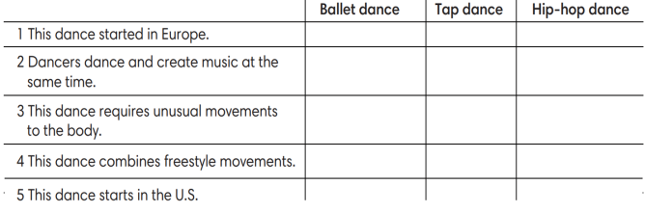  Answers:  1 – ballet dance  2 – tap dance  3 – ballet dance  4 – hip hop dance  5 – hip hop dance
ACTIVITY 4: APPLICATION Post – reading
      - Aim: To help students reflect on what they’ve learnt and what they’ve known about popular types of art in Vietnam
      - Content:
- Use the Internet to collect some information about popular type of art in Vietnam
3. Products: Students can make notes about dances and detail information such as places where it tis popular, some famous artists and fun facts about the dances.
4. Implementation:
Step 1: Task delivering  - Teacher puts students in pairs, has them to find information or think of the answer for some orientation questions about popular dances in Vietnam  - T sets a time limit for students to work in pair, practice asking and answering about the dances  Step 2: Task performance  - Students work in pairs to ask and answer about information about the dances  - Students need to exchange the information they searched and found.  - Teacher goes around the class, provides support when needed and takes note.  Step 3: Report and discussion  - Students volunteer to role play the dialogue in front of the class  Step 4: Judgement  - Teacher gives comment and checks with the whole class. | Exercise 3: Work in pairs. Search the information using orientation questions  Question 1: What dance is it?  Question 2: Where is it popular?  Question 3: What’s the famous dancer’s name?  Question 4: Why do you like that dance?  Question 5: Can you say 3 interesting things about the dance?
ACTIVITY 5: PRODUCTION
1. Aim: to write a text about the dance in Exercise 3
2. Content: use the information from exercise 3 to write
3. Products: write a paragraph about a type of art in Vietnam, your favourite dance and detail information
4. Implementation:
TEACHER AND STUDENTS’ ACTIVITIES | CONTENTS
Task 3.1 and 3.2  Step 1: Task delivering  - Teacher ask students to work individually to review what they’ve got from Exercise 3.  - Set a time limit for students to write a paragraph about their favourite dances.  Step 2: Task performance  - Students work individually to write in their notebook  Step 3: Report and discussion  - Teacher calls some volunteer students to stand up and read aloud their writing  Step 4: Judgement  - Teacher checks and gives feedback  - T invites some sharp students to share their contribution idea.  ***T might ask Ss to prepare this content in advance so their writing can be better and more diverse. | Exercise 4:  Write a paragraph (60-80 words)  about the dance in Exercise 3  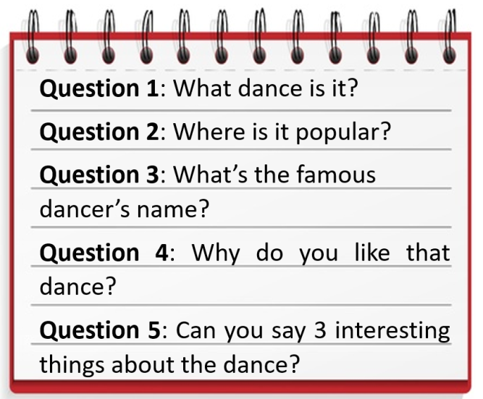
HOME ASSIGNMENT
Students take note of the homework: Students continue with their writing project. Find more information and pictures to illustrate for their writing content.
IV. FEED-BACK:
With class………………………………………………………………………………
With class………………………………………………………………………………
With class………………………………………………………………………………
Notes:
…………………………………………………………………………………
…………………………………………………………………………………

Date of planning:  Date of teaching: | Period 38 - UNIT 4: HEALTH AND FITNESS  Lesson 1: Vocabulary
I. OBJECTIVES:
By the end of the lesson, students will be able to:
- have an overview of the topic “Health and Fitness”.
- use vocabulary and grammar points to talk about the body and keeping fit.
1. Knowledge:
*Vocabulary: an understanding of the meaning of key words or word collocations below:
Body parts | ankle, elbow, eyebrows, finger, knee, lips, neck, shoulder, toes, stomach, skin, heart, brain
Activities to keep fit | play rugby/ football/baseball, do exercise, go to the gym, do weight training, go running, do yoga, have fitness classes, go swimming

*Grammar: expressions to talk about personal routine of keeping fit.
2. Competence:
To know the meaning of the keywords used to talk about body parts and keep – fit activities, and understand the main grammatical points, then do the tasks assigned in the textbook. To use the targeted language to practice talking about body and keeping fit.
3. Quality/Behavior: To teach Ss to be hard-working and attentive in class. Ss have a positive attitude to working in groups, individual work, pair work, cooperative learning and working.
II. TEACHING AIDS:
- Teacher: Grade 7 textbook, Unit 4 (SB p.40-41, WB p.33-34), laptop/computer connected to the Internet, loudspeaker, projector/TV, PPT slides…
- Students: Text books, studying equipment…
- Method: Active teach, T-WC; group works; individual ……
III. PROCEDURE:
1. WARM UP (3’)
* Aims:
- To activate Ss’ prior knowledge and get students involved in the lesson.
- To set the context for introducing new words.
* Content: Play Super Eyes game to get students involved in the lesson and to set the context for the lesson.
* Outcome: Students name the body’s parts correctly.
* Organisation: Teacher’s instructions…
Teacher’s & Student’s activities | Content
Extra activity 1: Super Eyes game  - T explains the game rules then checks instructions.  - T uses the PPT slides to lead the game.  - T tells students that they are learning more words of body parts in today lesson.  - T sets the context for the lesson: Write the title on the board Unit 4: Health and fitness / Lesson 4.1: Vocabulary  - T asks Ss to name some more words of body parts they’ve already known. | Game rules:  - Look at the pictures.  - Remember as many body parts as you can  - Recall the words you remember  - 1 correct words = 1 point.
2. PRESENTATION 1 (8’)
VOCABULARY
ACTIVITY 1:
* Aims:
- To reinforce the words of body parts that students have already known.
- To teach more new words
- To lead in to the next activitiy.
* Content: Some brief notes; Some things body parts.
* Outcome: Know new words about body parts.
* Organisation: Teacher’s instructions….
Teacher’s & Student’s activities |  | Content
1. Match the words below with the parts of the body 1-9 in the photos. Listen and check.  (Exercise 1 - SBp40)  - T asks Ss to open their SB page 40, look at exercise 1.  - T calls a student to read the instruction then checks Ss’ understanding of it.  - T elicits the meaning of words in the Vocabulary Box and quickly checks Ss’ understanding of vocabulary by asking them to look at the picture in SB and say all the body parts they see.  - Then, T asks students to look at exercise 1 and complete.  - Ss can work in pairs or small groups to finish the task.  - T plays the audio for students to check, T may pause the audio for students to listen and repeat if necessary. |  | Answer keys:  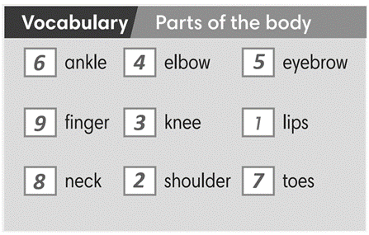
3. PRESENTATION 2 (5’)
ACTIVITY 2:
* Aims: To introduce more new words in a context
* Content: Some brief notes; Some facts about human body.
* Outcome: Know new words about human body and understand the functions of body parts.
* Organisation: Teacher’s instructions….
Teacher’s & Student’s activities | Content
2. Read the text below and follow the instructions.  (Exercise 2 - SBp41)  1. Listen and repeat the highlighted words.  How do you say them in your language  - T asks students to look at the facts on page 41, listen and  repeat the highlighted words.  - Teacher elicits the meaning of 4 new words of body part and may provide further explanations of the words in Vietnamese.  - Ss to look at the slides, slowly displays the vocabulary  - T tells Ss to say the words one by one  - Ss join the activity as the whole class.  2. Which facts do you find interesting?  - T asks Ss to read the fun facts again and put a tick next to the facts they find interesting.  - T encourages Ss to share with their partners.  - T invites some volunteers to express their interests in front of the whole class.  - T checks pronunciation if needed.  - T shows slides of all vocabulary again for Ss to review quickly with focus on the IPA of the words. | 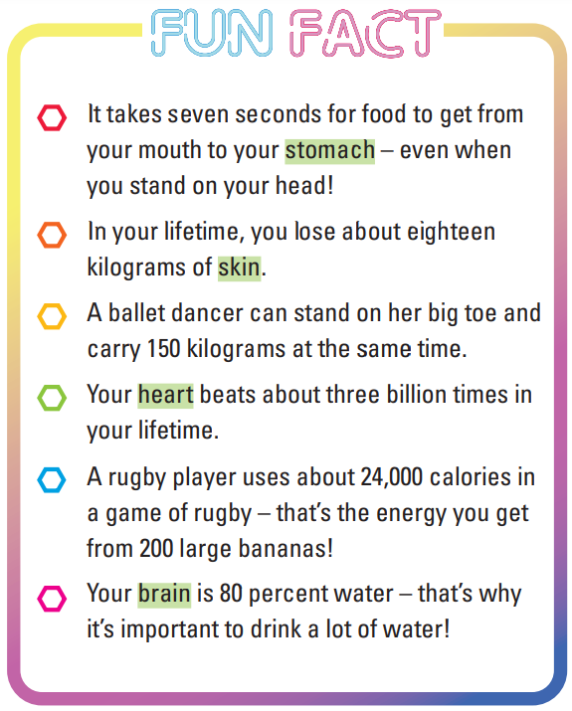
4. PRACTICE 1 (9’)
ACTIVITY 3:
* Aims:
- To provide students with chances to practice pronouncing new words
- To help students use the new vocabulary in context
* Content: Some brief notes about the exercise; some keywords about body parts; some note about pronunciation.
* Outcome: Have a vocabulary about clothes; know how to talk about body parts and preferences.
* Organisation: Teacher’s instructions….
Teacher’s & Student’s activities | Content
3. (5’) Complete the sentences with the correct form of the body parts.  (Exercise 3 – SB p.41)  - T asks Ss to look at exercise 3 (SB page 41).  - T calls a student to read the instruction then checks Ss’ understanding of it.  - T sets a time limit and asks Ss to work in groups of three to complete the exercise.  - T calls groups to give answers then checks as the whole class.  - T drills the vocabulary and corrects Ss’ pronunciation if any. | Answer keys:  (2) heart (3) Hair (4) skin (5) knees
Extra activity 2 (4’): Choose the correct option  (Adapted from exercise 2 – WB p.33)  - T asks Ss to look at excersise 2 (WB page 33).  - T calls a student to read the instruction then checks Ss’ understanding of it.  - T sets a time limit and asks Ss to work in pairs to complete the exercise.  - T calls students to give answers then checks as the whole class.  - T drills the vocabulary and corrects Ss’ pronunciation if any. | Answer keys:  (1) brain (2) skin (3) heart  (4) muscles (5) beard (6) stomach
4. PRACTICE 2 (8’)
ACTIVITY 4:
* Aims:
- To provide more words related to the topic
- To help Ss use the new vocabluary in collocations.
- To practice the vocabulary in present simple tense using adverbs of frequency
* Content: Some brief notes about the exercise; some keywords about fitness activities.
* Outcome: Have a vocabulary about fitness activities; know how to talk about fitness routine.
* Organisation: Teacher’s instructions….
Teacher’s & Student’s activities
4. (4’) Listen and complete the sentences with the words below.  (Exercise 4 – SB p.4)  - T asks Ss to look at excersise 4 (SB page 41).  - T calls a student to read the instruction then checks Ss’ understanding of it.  - T asks Ss to read the given words aloud, checks their understanding of the words.  - T plays the audio for the whole class to listen and do the exercise individually  - T sets a time limit and asks Ss to work in groups of four to compare their answer and complete the exercise together.  - T calls groups to give answers then checks as the whole class.  - T corrects Ss’ pronunciation if any.  - T encourages Ss to say more of activities to keep fit they know. | Answer keys:  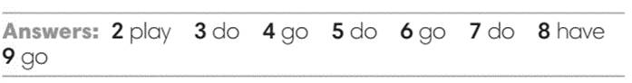
Extra activity 3 (4’): Match the parts of the sentences.  (Adapted from exercise 5 – WB p. 34)  - T asks students to look at their WB p.34 – Exercises 5  - T calls a student to read the instruction then checks Ss’ understanding of it.  - T asks Ss to work in pair to complete the exercise  - T calls volunteers to read aloud the answers.  - Ss raise their hand to give answers.  - T confirms the answers, corrects Ss’ pronunciation if any. | Answer keys:  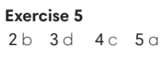
4. PRODUCTION (7’)
ACTIVITY 5:
* Aims: To help Ss practice applying the vocabulary items and grammar points related to the topic in speaking.
* Content: Ss play The truth game to talk about their activities to keep fit.
* Outcome: Ss talk about activities to keep fit using vocabulary and grammar points.
* Organisation: Teacher’s instructions…..
Teacher’s & Student’s activities | Content
5. Let’s play the truth game. Work in pairs. Use the exercise 4 to help you.  (Exercise 5 – SB p.41)  - T asks Ss to look at excersise 5 (SB page 41).  - T calls a student to read the instruction then checks Ss’ understanding of it.  - T asks students to work individually to write the true sentences about keeping fit.  - T display the slide with WAYS TO KEEP FIT content and model sentences:  Example:  I don’t do exercise at home, but I go to the gym once a week.  TIME TO TALK  - T sets a time limit and ask students to share their truth with a partner.  - Then T claps hands, asks Ss to change the partners.  - Ss swap and share their truth to as many friends as they can.  - T moves around to support, takes note the common issues that need to be discussed later.  - T announces when the sharing time finishes and gives feedback to students. | 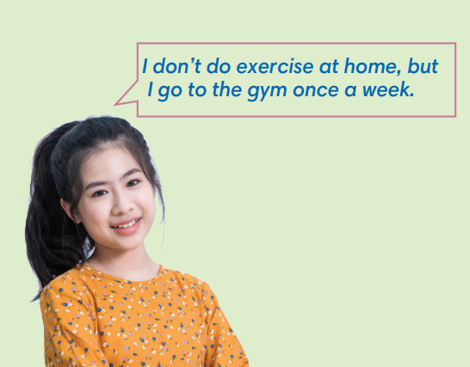

WRAP-UP & HOME WORK (3’)

- T asks Ss to talk about what they have learnt in the lesson.
- Vocabulary of body parts and keep fit activities.
- Grammar points: Present simple and adverbs of frequency to talk about keep fit activities
* HOME WORK
- Do exercises in the workbook page 33-34.
- Prepare for Lesson 2: Grammar 1.

Date of planning:  Date of teaching: | Period 39 - UNIT 4: HEALTH AND FITNESS  Lesson 2: Grammar
I. OBJECTIVES:
By the end of the lesson, students will be able to:
- talk about quantities of food.
1. Knowledge:
* Grammar:
- Identify and understand how to use quantifiers
- Talk about quantifiers of food with countable and uncountable nouns
- Use adverbs of frequency and quantifiers to talk about eating routines
2. Competence: Students use vocabulary about food, quantifiers, and understand the main grammatical points, then do the tasks assigned in the textbook; to use the Present simple, adverbs of frequency to talk about eating routines and quantities of food.
3. Quality/ behavior: To teach Ss to be hard-working and attentive in class. Ss have a positive attitude to working in groups, individual work, pair work, cooperative learning and working.
II. TEACHING AIDS:
- Teacher: Grade 7 textbook, Unit 4 (SB p. 42), laptop/computer connected to the Internet, loudspeaker, projector/TV, PPT slides…
- Students: Text books, studying equipment…
- Method: Active teach, T-WC; group works; individual ……
III. PROCEDURE:

1. WARM UP (4’)
* Aims:
- To activate students’ prior knowledge and get students involved in the lesson.
- To set the context for introducing new structures.
* Content: Play game: Guessing Game to get students involved in the lesson and to set the context for the lesson.
* Outcome: Students know the context of the lesson.
* Organisation : T_ Ss , …
Teacher’s Student’s activities | Content
Extra activity 1: Guessing Game  - T divides Ss into 2 teams. Team boys and team girls.  - T introduces OTTO from the cartoon Minions  - T explains the game rules then checks instructions.  - T uses the slides to lead the game  - Ss raise up to give the guessing. T corrects Ss if necessary.  - T sets the scene for the new lesson: T tells Ss that they’ve just guess what OTTO usually eat at school.  They will learn more of food and models to talk about food.  - T writes the title on the board Unit 4: Health and Fitness / Lesson 4.2: Grammar | Game rules:  - Look at the hint.  - Guess the food  - 1 correct answer = 1 point.
2. REVIEW (4’)
ACTIVITY 1:
* Aims:
- To reinforce the vocabulary of food Ss already know
- To elicit the new words if needed
* Content: Some brief notes about the common snacks.
* Outcome: Have a vocabulary about snacks; know how to talk about their snacks and eating habbits.
* Organisation: T_ Ss , …
Teacher’s Student’s activities | Content
1. Class vote: Which snack do you usually eat at school?  (Exercise 1 – SB p. 42)  - T asks Ss to open their SB page 42, look at exercise 1.  - T calls a student to read the instruction then checks Ss’ understanding of it.  - T plays the audio for the Ss to listen and read the Vocabulary Box.  - T goes through the Vocabulary Box with the whole class, elicits the words if needed.  - Ss work individually to think of their own answer.  - T moderates the class from pair work to group work so that Ss could share their answers to as many friends as they can. | 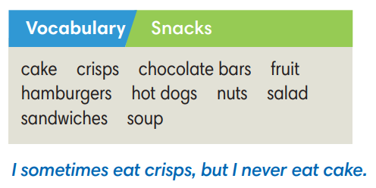
3. LEAD-IN (3’)
* Aims: To lead into the dialogue
* Content: Describe the picture on the slide.
* Outcome: Make guesses about the picture (what are they talking about?) then give answers.
* Organisation: T_ Ss , …
Teacher’s Student’s activities | Content
Extra Activity 2: See – think – wonder.  - T shows a picture on the slide then asks students three questions.  (1) What do you see in the picture?  (2) Who are they?  (3) What are they doing?  - T sets a time limit for Ss’ quick discussion.  - Ss work in pairs to make guesses about the picture then give answers.  - T calls some Ss to give answers then note them down on the board.  - T tells Ss that they’re going to read a dialogue in exercise 2 (SB p.42) to check all the answers. | 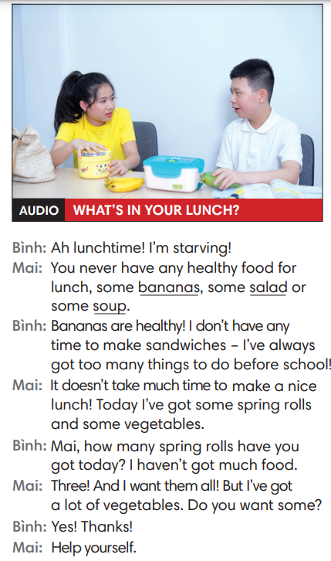
4. PRESENTATION (11’)
ACTIVITY 2 + 3:
Aims:
- To present the grammar point in context.
- To lead into the next activity.
- To introduce the Grammar Box
- To provide Ss with chances to work cooperatively.
- To explain the grammar point for Ss.
* Content: Read the conversation between Kyle and Zadie and find out new words. Learn the Past Simple.
* Outcome: Know more new words. Understanding the reading document; the topic of the lesson, grammar points…
* Organisation: T_ Ss , ..

Teacher’s Student’s activities |  | Content
2. (4’) Listen and answer the questions below  (Exercise 2 – SB p.42)  - T asks Ss to open their SB page 42, look at exercise 2.  - T calls a student to read the instruction then checks Ss’ understanding of it.  - T asks Ss to listen to and read the dialogue to find the answer for the questions.  - Ss work individually.  - T calls some Ss to give answers then shows the answers on the slide.  - T asks Ss to look at the sentences about Mai and elicits SOME – A LOT OF - ANY for Ss. |  | Answer keys:  1. No, he isn’t.  2. Today, Mai’s having some spring rolls and some vegetables.
3. (7’) Find more quantifiers with nouns in the dialogue.  (Exercise 3 – SB p42)  STEP 1: Introduce the Grammar Box  - T goes through the Grammar Box with Ss  - T reminds students that the uncountable nouns refer to things  we can’t count and that they don’t have a plural form.  - T explains to students that the words/ phrases in blue are  quantifiers.  STEP 2: Exercise 3  - T asks Ss to look at exercise 3.  - T calls a student to read the instruction then checks Ss’ understanding of it.  - T asks Ss to work in groups of three to complete the activity.  - T calls groups to give answers then shows the answers on the slide to check as the whole class.  *The grammar note  - T shows the Grammar Notes with all cases of quantifiers.  - T tells Ss to read the notes carefully. |  | 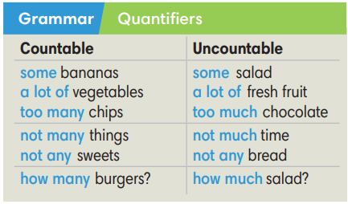
5. PRACTICE (13’)
ACTIVITY 4 + 5:
*Aim:
- To help Ss classify the countable and uncountable nouns
- To provide Ss grammar exercises to practice using quantifiers
* Content: Complete the text/sentences with the suitable quantifiers.
Understand the text; grammar points; quantifiers.
* Outcome: Know how to form a sentence with the suitable quantifiers. Understand the conversation; the topic of the lesson, vocabulary, grammar points…
* Organisation: T_ Ss .…..
Teacher’s Student’s activities |  | Content
4. (4’) Read what Mai and Binh eat for lunch in one week. Complete the sentences with suitable quantifiers. There is often more than one possible answer.  (Exercise 4 – SB p.42)  - T asks Ss to look at exercise 6.  - T calls a student to read the instruction then checks Ss’ understanding of it.  - T asks Ss to work in individually.  - T calls students to give answers then shows them on the slide to check as the whole class. |  | 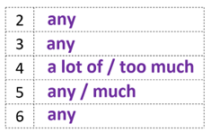
3. (4’) Cross out the incorrect quantifiers in each sentence.  (Exercise 5 – SB p.42)  - T asks Ss to look at exercise 5.  - T calls a student to read the instructions then checks Ss’ understanding of it.  - T asks Ss to work in individually.  - T encourages Ss to provide the reason for their choices.  - Ss read the sentences and think of the possible answers.  - T calls students to give answers then shows them on the slide to check as the whole class.  - T corrects Ss if any. |  | Answer key:  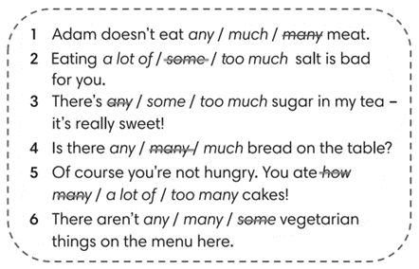
Extra activity 3 (5’): STREET GAME – The mix practice.  - T asks Ss to review quickly the vocabulary and grammar box  - T introduces the game and how to play rules  - T uses slides to lead the game.  - T allows Ss to say their answer massively to encourage the confidence and time challenge.  - T confirms the answers.  - T corrects Ss if any.  *Extra Activity: Teacher can get some exercises from Workbook page 35 for Ss to practice in class. |  | Game rules:  - Read the sentence carefully.  - Choose a word to fill in the blank.  - 1 correct answer = 3 points.
4. PRODUCTION (7’)
ACTIVITY 6:
*Aim: To help students applying the vocabulary items and grammar points related to the topic in communicating.
* Content: Ss make conversation about animals (where and when they were).
* Outcome: Ss know how to use past simple tense to make a conversations about their place and activities in the past.
* Organisation: T_Ss…

Teacher’s Student’s activities |  |  | Content
6. In pairs, say how much of these things you eat/drink.  (Exercise 6 – SB p.42)  - T asks Ss to look at exercise 6 (SB page 42).  - T calls a student to read the instruction then checks Ss’ understanding of it.  - T models the activity in front of the class.  - T divides Ss into new pairs, asks them to make conversations: share – ask - respond  - T walk around to listen and notes down common mistakes for delayed feedback.  - T calls some groups to come to the front of the class, make conversations.  - T asks the rest to give comments on their classmates’ performance.  - T gives feedback on Ss’ work. |  |  | 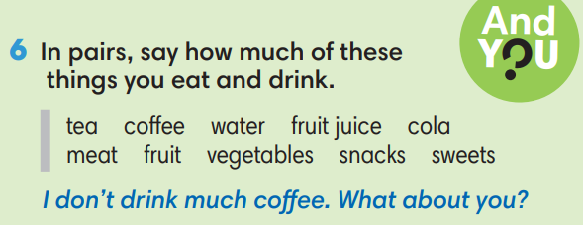
WRAP-UP & HOME WORK (3’)

- T asks Ss to talk about what they have learnt in the lesson.
- Countable and Uncountable nouns, quantifiers
* HOME WORK
- Do exercises in the workbook page 35.
- Prepare for Lesson 4.3: Reading.

Date of planning:  Date of teaching: | Period 40 - UNIT 4: HEALTH AND FITNESS  Lesson 3: Reading and Vocabulary
I. OBJECTIVES:
By the end of the lesson ss will be able to:
- find main ideas and specific details in a text about sleeping habits.
1. Knowledge:
*Vocabulary: an understanding of the vocabulary about sleeping habits.
New words | Vietnamese meaning
1. fall asleep | ngủ gục
2. go to bed/sleep | đi ngủ
3. feel tired | cảm thấy mệt/buồn ngủ
4. get up early/late | thức dậy sớm/ muộn
New words | Vietnamese meaning
5. stay up late | thức khuya
6. have a dream | ngủ mơ
7. get ready for bed | sửa soạn đi ngủ
9. sleep well/badly | ngủ ngon/ không ngon

* Grammar: Reading skills: the ability to find main and specific details in a letter.
2. Competence: Understand and know the meaning of the keywords used to talk about sleeping habits; locate information and find specific details in a letter (scanning skill); identify the main ideas of the paragraphs in the text or the text itself (skimming skill).
3. Quality/ behavior: To teach Ss to be hard-working and attentive in class. Ss have a positive attitude to working in groups, individual work, pair work, cooperative learning and working.
II. TEACHING AIDS:
- Teacher: Grade 7 textbook, Unit 4 (SB p.43, WB p.36), laptop/computer connected to the Internet, loudspeaker, projector/TV, PPT slides…
- Students: Text books, studying equipment…
- Method: Active teach, T-WC; group works; individual ……
III. PROCEDURE:
1. WARM-UP (5’)
* Aim:
- To help Ss review some phrases they have known.
- To lead in to the next activity.
* Content: Game: LUCKY PHOTO GAME (about sleeping habits)
* Outcome: Ss can talk about their sleeping habits.
* Organisation: T_ Ss …
Teacher’s &Student’s activities |  |  | Content
Extra activity 1: LUCKY PHOTO GAME  - T explains the game rules then checks instructions.  - T uses slide to lead the game.  - T asks Ss to Choose the correct phrase  - T elicits the picture and ask student to guess the meaning before they choose.  - Ss raise their hands if they have the answer.  - T asks students to read aloud the phrase after each play.  - T tells students that they’ve just play a game with words about sleeping and they are reading about sleeping today.  - T writes the title for the new lesson:  Unit 4/Lesson 3: Reading and vocabulary. |  |  | Game rules:  - Look at the picture  - Read the given phrases  - Choose randomly to see your luck (you may know the answer already)
2. PRE-READING (6’)
ACTIVITY 1:
* Aim:
- To activate Ss’ background knowledge of the topic.
- To get student think about their sleeping habits
- To provide Ss with reasons for reading the text in the next stage.
* Content: To discuss Ss’s sleeping habits by doing the exercise.
* Outcome: Know new words, and grammar points when talking about sleeping habits.
* Organisation: T, Ss …
Teacher’s & Student’s activities |  |  | Content
1. (3’) CLASS VOTE – Do you agree with statements a – c  a. It’s hard to get up in the morning.  b. I sleep more than my parents.  c. I never want to go to bed before 11.00 p.m.  (Exercise 1 – SB p.43)  - T tells students how to vote  - T shows each of the statements and asks students to read aloud.  - T tells Ss that they to put up their hands if they agree.  - T asks students who don’t raise their hands why they disagree. |  |  | 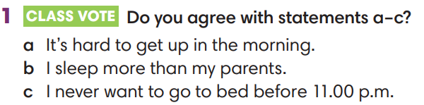
Extra activity 2 (3’): SEE – THINK - WONDER  - T shows the slide, asks Ss to read aloud the questions  - What do you see in the picture?  - What’s the boy problem?  - T asks a students to look at the photos and find the answers.  - 1. A boy, day, night, play on phone, sleep in class, etc.  - 2. He stays up late at night and sleeps at daytime.  - T emphasizes about the photo “This is Karl. He has unhealthy sleeping habits, so he needs some advice.”  - T provides more information about Karl and Polly is the one who replies to Karl’s letter. |  |  | 
3. WHILE-READING 1 (5’)
ACTIVITY 2:
*Aim:
- To read two letters and do some reading tasks.
- To help students practice finding main ideas and specific details in the texts.
- To present word friends of sleeping habits.
* Content: Read about the sleeping habits.
* Outcome: To know more new words about sleeping habits. Understand more about using the words in contexts.
* Organisation: T, Ss …
Teacher’s & Student’s activities |  | Content
2. (5’) Read the text. What’s Polly’s advice  (Exercise 2 – SB p.43)  - T asks Ss to look at excersise 2 (SB page 43).  - T calls a student to read the instructions then checks Ss’ understanding of it.  - T tells Ss to read the text and asks what Karl’s problems are  (He has to go to bed when he isn’t tired. He has to get up when his parents tell him to at the weekend.).  - T asks what they think Polly’s advice might be and allows Ss to continue reading.  - T sets a time limit and asks Ss to work in pairs to complete the activity by sharing the answers.  - T elicits the ideas from Ss, asks them in which line of the paragraph they see the answers.  - T asks Ss to explain their answers by referring to the clues the text.  - T confirms the answers then drills the pronunciation of the phrases and corrects Ss’ pronunciation if any. |  | Answer keys:  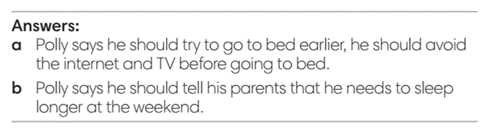
4. WHILE-READING 2 (5’)
ACTIVITY 3:
*Aim: To help students practice reading for specific information in a letter.
* Content: Read about the sleeping habits in the letter.
* Outcome: To know more new words about sleeping habits. Understand more about using the words in contexts.
* Organisation: T, Ss …
Teacher’s & Student’s activities |  | Content
3. (5’) Read the text again. Choose the correct answer.  (Exercise 3 – SB p.43)  - T asks Ss to look at excersise 4 (SB page 43).  - T calls a student to read the instruction then checks Ss’ understanding of it.  - T and Ss review TIPS: reading for specific information.  (Ss learnt the TIPS from Unit 1 already)  - T tells student to read the text again individually to  complete Exercise 4.  - When finished, T asks them to compare their answers in pairs  and check with them.  - T asks students to point to relevant details in the text. |  | 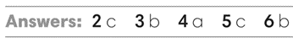
5. POST-READING (15’)
ACTIVITY 4 + 5:
* Aim:
- To provide more word friends and practice talking about sleeping habits.
- To reinforce word friends and practice talking about sleeping habits.
* Content: To discuss the sleeping habits.
* Outcome: Making sentences to talk about their sleeping habits. Commenting about the sentences of others.
* Organization: T, Ss...
Teacher’s & Student’s activities |  | Content
4. (5’) How do you day these phrases in your own language?
(Exercise 4 – SB p.43)
- T asks students to find the highlighted words in the text
and discuss in groups of three the meanings of these
words.
- T tells Ss to work in pair to do the same with phrases in Exercise 4
- T checks the answers with the whole class and elicit the meaning of these phrases in Vietnamese.
- When Ss finish, T asks further questions using phrases.
Eg:
How do you get ready for bed?
Do you put on your pyjamas before or after you clean your teeth?
Extra activity 3 (5’): HAPPY BOB GAME  - T tells Ss that they are play a game to reinforce word friends and practice talking about sleeping habits  - T tells the game rules  - T uses slides to lead the game.  - Ss are allowed to raise hands and share their answers massively  - T checks Ss’ pronunciation if needed |  | Game rules:  - Read the sentences  - Choose a word to complete the sentence  - Click on pic of Bob to see the points
5. (5’) In pairs, read the Sleep Quiz and choose the correct option. Then interview each other.  (Exercise 5 – SB p.43)  - T asks Ss to look at excersise 5 (SB page 43).  - T calls a student to read the instruction then checks Ss’ understanding of it.  - T asks a student to read the example then models the activity in front of the class.  - T asks students to work in pairs to circle the correct option.  - Ss work in pairs and do the task.  - T uses the slides to check the correct answer for the whole class.  Interview time  - T records the Sleep Quiz on board/screen and tell students to pair and interview each other.  - After 1 minute, Ss swap and interview a new classmate.  - T sets a time limit and monitors Ss while they are carrying out their interviews  - T notes down common mistakes for delayed feedback.  - When Ss finish, T invites some volunteers to role play the interview in front of the class.  - T asks the rest to give comments on their classmates’ performance.  - T gives feedback on Ss’ work. |  | 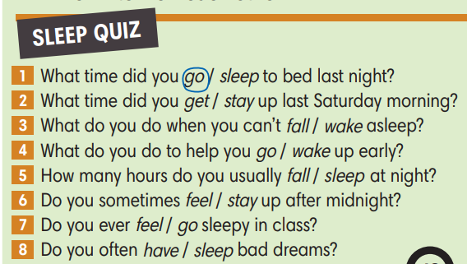
WRAP-UP & HOME WORK 4’)
- T asks Ss to talk about what they have learnt in the lesson.
- Vocabulary of sleeping habits
- Reading a letter about sleeping problems.
- Join a Sleep Quiz
* HOME WORK
- Do exercises in the workbook page 36.
- Prepare for Lesson 4.4: Grammar 2.

Date of planning:  Date of teaching: | Period 41 - UNIT 4: HEALTH AND FITNESS  Lesson 4: Grammar 2
I. OBJECTIVES:
By the end of the lesson students will be able to:
- use Past Simple of irregular verbs to talk about the past.
1. Knowledge:
* Grammar:
- Identify the past form of irregular verbs
- Understand and use the forms of past simple tense
- Use past simple of irregular verbs to talk about the past
2. Competence: Understand and use vocabulary about everyday activities and understand the forms of past simple tense, then do the tasks assigned in the textbook; use the correct tense of verbs to form questions and answers to talk about what happened in the past.
3. Quality/ behavior: To teach Ss to be hard-working and attentive in class. Ss have a positive attitude to working in groups, individual work, pair work, cooperative learning and working.
II. TEACHING AIDS:
- Teacher: Grade 7 textbook, Unit 4 (SB p. 44), laptop/computer connected to the Internet, loudspeaker, projector/TV, PPT slides…
- Students: Textbooks, studying equipment…
- Method: Active teach, T-WC; group works; individual ……
III. PROCEDURE:

1. WARM UP (5’)
* Aim:
- To create a positive classroom atmosphere to start a new lesson.
- To review the past simple of regular verbs.
* Content: Game: Football Game (past simple verbs)
* Outcome: Ss use the correct form of the verb in the Past Simple tense.
* Organisation: T, Ss ..….

Teacher’s & Student’s activities |  | Content
Extra activity 1: Football Game  - T asks Ss to prepare 3 letter cards A, B (T may ask Ss to prepare them before the lesson.)  - T explains the game rules then checks instructions.  - Ss join in the game individually.  - T corrects Ss if necessary.  - T tells students to recall all verbs they see from the warm-up game  - T tells Ss that, today they will learn more of past simple verbs. |  | Game rules:  - Read the questions carefully  - Show the letter card A, B to give answers.  - 1 correct answer = 1 point.
2. LEAD-IN (3’)
*Aim: To lead into the new lesson.
* Content: Describe the picture on the slide.
* Outcome: Guess correctly what the boy is doing do in the picture.
* Organisation: T_ Ss ..….
Teacher’s & Student’s activities | Content
Extra activity 2: See – think – wonder.  - T shows a picture on the slide then asks students four questions.  (1) What can you see in the picture?  (2) Where was the boy?  - T sets a time limit for Ss’ quick discussion.  - Ss work in pairs to make guesses about the picture then give answers.  - T calls some Ss to give answers then checks with the whole class. | Answer keys:  - A boy and a dentist  - The boy was at the dentist’s.
3. PRESENTATION 1 (7’)
ACTIVITY 1 + 2:
*Aim:
- To present the grammar point in context.
- To lead into the next activity.
* Content: To practice changing irregular verbs into past simple form.
* Outcome: Remember the past simple form of some irregular verbs.
* Organisation: T, Ss ..….
Teacher’s & Student’s activities | Content
1. (3’) Read the text and answer the questions.  (Ex 1, p.44)  - T asks Ss to open their SB page 44, look at exercise 1.  - T calls a student to read the instruction then checks Ss’ understanding of it.  - T asks Ss to find the line in the reading that prove their guessing from See – think – wonder activity.  - T uses the slide to confirm the answer. | 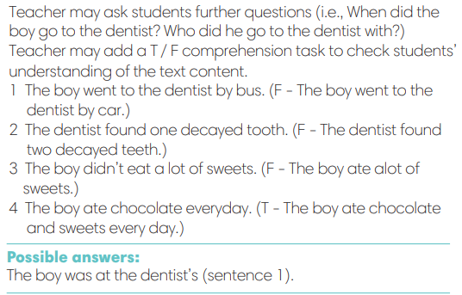
2. (4’) Find the past form of verbs below in the text. Add to the list 5 irregular verbs that you know. Then change them into Past Simple form.  (Ex 2, p.44)  - T calls a student to read the instruction then checks Ss’ understanding of it.  - T tells Ss to work in groups of three to read the text and find the answers.  - Ss work in groups, read, and note down the answers to the given verbs.  - T calls some Ss to give answers then shows the answers on the slide.  - T tells Ss that went, drove, got, found are the past form of irregular verbs.  - T asks Ss to work in groups again and do the second task: Add more of irregular verbs they know.  - T allows Ss to add and share massively in a time limit.  - T asks Ss to look at the Grammar Box in SB p.44. | Answer keys:  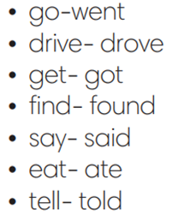
4. PRESENTATION 2 (4’)
ACTIVITY 1 + 2:
*Aim: To introduce the Grammar Notes and explain the grammar point
* Content: Practicing the use of the past simple by writing the correct form of the verbs.
* Outcome: Make sentences in past simple.
* Organisation: T, Ss ..….
Teacher’s & Student’s activities | Content
Extra activity 3:  - T asks Ss to look at the Grammar Box in SB and elicits the forms.  - T uses slide to display the Grammar Note again.  - T encourage Ss to make sentences using the grammar note. | 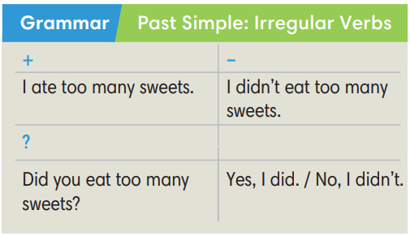
5. PRACTICE 1 (7’)
ACTIVITY 3:
* Aims:
- To help students identify the form of Past Simple tense
- To help Ss practice then new grammar points in context
- To practice solving some types of Grammar exercises
* Content: Choose the correct form of the verb in the past simple tense.
* Outcome: Choose the form correctly in grammar and use the past simple to explain their options.
* Organisation: T, Ss, ….
Teacher’s & Student’s activities | Content
Extra activity 4 (2’): GAME – CHOOSE THE BEST ANSWER  - T explains the game rules then checks instructions.  - Ss join in the game individually.  - T corrects Ss if necessary.  - T tells students to recall all verbs they see from the game. | Game rules:  - Read the questions carefully  - Show the possible answer from some options  - 1 correct answer = 1 point.
3. (3’) Complete then sentences with Past Simple form of the verbs in brackets  (E Exercise 3 – SB p. 44)  - T elicits the direction with students.  - T encourages students to discuss the answers in pairs,  to decide on the correct form and the reasons for this.  - Ss work in pair to complete the exercise.  - T calls some students to share their answers.  - T uses slides to confirm the answer.  - T corrects Ss’ pronunciation if any. | Answer keys:  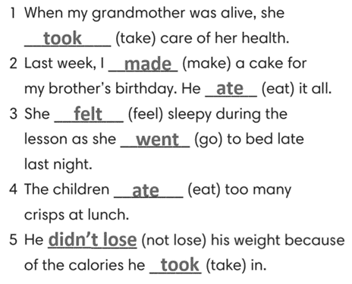
Extra activity 5 (2’):  (Adapted from Exercise 2 – WB p. 37)  - Repeat the steps in Exercise 3 – SB p,44. | Answer keys:  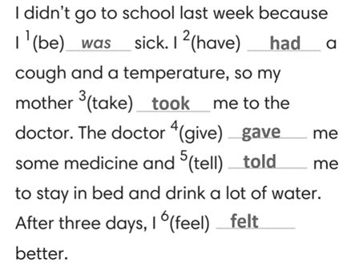
5. PRACTICE 2 (10’)
ACTIVITY 4:
* Aims: To help students practice making sentences in the Past Simple.
* Content: Choose the correct form of the irregular verbs in the past simple tense.
* Outcome: Make sentences correctly in grammar and use the past simple.
* Organisation: T, Ss, ….
Teacher’s & Student’s activities | Content
4. (5’) Write questions in Simple Past for these sentences.  (Exercise 4 – SB p.44)  - T asks Ss to look at exercise 4.  - T calls a student to read the instruction then checks Ss’ understanding of it.  - T asks Ss to work in individually to write.  - Students write full questions in their notebooks.  - T calls students to give answers then shows them on the slide to check as the whole class.  - T corrects Ss if any. | Answer keys:  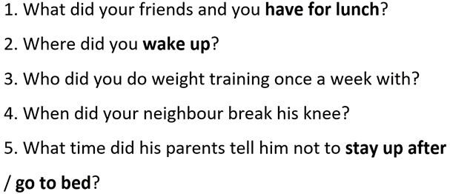
Extra activity 6 (5’): Reorder the words to make complete sentences  (Adapted from Exercise 3 – AB p.37)  - T asks Ss to look at exercise 3 in AB p.37.  - T calls a student to read the instruction then checks Ss’ understanding of it.  - T asks Ss to work in individually to write.  - Students write full questions in their notebooks.  - T calls students to give answers then shows them on the slide to check as the whole class.  - T corrects Ss if any. | Answer keys:  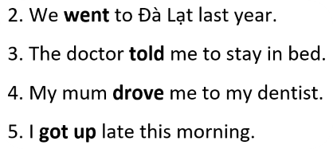
7. PRODUCTION (7’)
ACTIVITY 5:
* Aims: To help students applying the vocabulary items and grammar points related to the topic in communicating.
* Content: Interview partners using the cues words.
* Outcome: Use vocabulary items and grammar points related to the topic to interview partners.
* Organisation: T. Ss , Individual, Pair work, ….
Teacher’s & Student’s activities | Content
5. In pairs, ask and answer about what you often did during Covid-19 lockdown to keep fit and stay healthy.  (Exercise 5 – SB p.44)  - T asks Ss to look at exercise 5 (SB page 44).  - T calls a student to read the instructions then checks Ss’ understanding of it.  - T explains to the students that they are going to do the task in pairs  - T elicits some stay-home-safe-activities  - T models the activity in front of the class.  - T asks students to stand up and walk around the class and choose a new classmate to pair with.  - Ss think, pair, and share.  - T walk around to listen and notes down common mistakes for delayed feedback.  - T invites some students to report their answers to the class.  - T asks the other students to give comments on their classmates’ performance.  - T gives feedback on Ss’ work. | 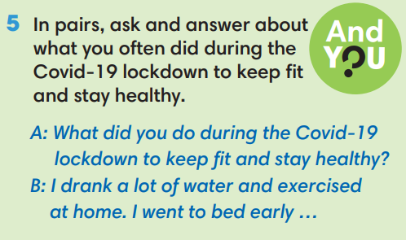
WRAP-UP & HOME WORK (2’)
- T asks Ss to talk about what they have learnt in the lesson.
- The past continuous: irregular verbs.
* HOME WORK
- Do exercises in the workbook page 37.
- Prepare for Lesson 4.5: Listening and vocabulary.

Date of planning: Date of teaching: | Period 42 - UNIT 4: HEALTH AND FITNESS  Lesson 5: Listening and Vocabulary
I. OBJECTIVES:
By the end of the lesson student will be able to:
- identify specific details in a conversation and talk about illnesses.
1. Knowledge:
* Vocabulary: use vocabulary of symptoms and illnesses.
* Grammar: make sentences in the Present Simple and Present Continuous to describe people’s health problems.
2. Competence: Understand and use words of illnesses, do the tasks assigned in the textbook. Listen and identify specific details in a conversation and talk about illnesses.
3. Quality/ behavior: To teach Ss to be hard-working and attentive in class. Ss have a positive attitude to working in groups, individual work, pair work, cooperative learning and working.
II. TEACHING AIDS:
- Teacher: Grade 7 textbook, Unit 4 (SB p. 45, WB p.38), laptop/computer connected to the Internet, loudspeaker, projector/TV, PPT slides…
- Students: Text books, studying equipment…
- Method: Active teach, T-WC; group works; individual ……
III. PROCEDURE:
1. WARM UP + LEAD-IN (5’)
* Aim:
- To activate students’ prior knowledge and get students involved in the lesson.
- To early introduce some words of illnesses
* Content: Play Doctor Pikachu game (about illnesses).
* Outcome: Know more new words in context. Improve pronunciation.
* Organisation: T, Ss ..
Teacher’s &Student’s activities | Content
Extra activity 1: Doctor Pikachu  - T greets students  - T introduces the Warm-up game  - T explains How-to-play steps then checks instructions.  - Ss join the activity as the whole class.  - T uses slides to conduct the activity  - T introduces that all the words are about illnesses  - T elicits the meaning and drill the pronunciation of the words  - T sets the scene for the new lesson: T tells Ss that they are going to learn more words of illnesses and symptoms by doing a listening task.  - T writes the title on the board Unit 4: Health and Fitness Lesson 4.5: Listening and Vocabulary | How to play:  - Look at the picture  - Choose the correct sentence to meet Doctor Pikachu  - 1 correct answer = 1 point
2. PRE-LISTENING (18’)
ACTIVITY 1 + 2 + 3:
*Aim:
- To lead into the topic
- To set the scene for the new content and introduce Vocabulary Box
- To introduce the Vocabulary Box
- To develop critical thinking through a group activity
- To reinforce words of symptoms and illnesses
- To practice using new words in context
* Content: Some brief notes; vocabulary about pets. Use them to complete the exercise.
* Outcome: Know some more new words about pets. Chose the correct words to answer the questions.
* Organisation: T, Ss …
Teacher’s &Student’s activities | Content
1. (10’) Look at the picture. Why is tomorrow a big day for Bridgeton United?  (Exercise 1 – SB p. 45)  - T asks the students to look at the picture and the text and  answer the question.  - T elicits the answer and then asks students if anyone has taken part in the final of a sports competition.  - T asks how they felt and what happened.  - T asks Ss to look at the picture of Bridgeton United football team again and says “LOOK! WHAT’ WRONG WITH THE FOOTBALL TEAM?”  - Then teacher tells Ss to look at the Vocabulary Box in Exercise 2 to find the suitable describing words. | 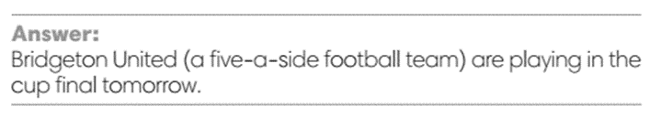
2. (4’) How do you say the phrases below in your language?  (Exercise 2 - SB p.45)  - T asks Ss to look at exercise 2.  - T calls a student to read the instruction then checks Ss’ understanding of it.  - T elicits the meaning of Symptoms and Illnesses.  Example: A high temperature and headache are the usual symptoms of flu.  - T asks Ss to work in pairs or small groups to read the other phrases and work out their meanings.  - T calls groups to give answers and provides the support if needed.  - T encourages students to make sentences with these phrases.  - Critical thinking: T asks students to work in groups and think of the answer for a critical thinking question.  Can you say the symptoms of….?  a hay fever  a flu  a cold  a type of allergy | 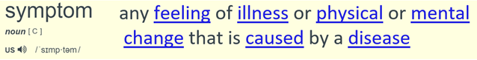  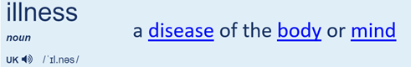
3. (4’) Use the vocabulary box to complete the sentences.  (Exercise 3 - SB p.45)  - T asks Ss to look at exercise 3.  - T calls a student to read the instruction then checks Ss’ understanding of it.  - T asks students to work individually to complete the task  - T calls volunteers to say the answer for each sentence.  - T checks as the whole class.  - T encourages Ss to read aloud the sentences and corrects pronunciation if needed. | Answer keys:  1. sneeze; hay fever  2. high temperature; flu  3. stomachache  4. cough / 5. sore throat
3. WHILE-LISTENING (5’)
ACTIVITY 4 + 5:
* Aim:
- To help Ss identify specific details in a conversation
- To provide practice of using vocabulary in context
- To provide practice of using vocabulary in questions and answers
* Content: Listen and understand the audio track to complete the exercise.
* Outcome: Think and talk about pets by matching the correct answers.
* Organisation: T_ Ss …
Teacher’s &Student’s activities | Content
4. (3’) Listen to five short extracts between the coach and the players. Complete the sentences.  (Exercise 4 - SB p.45)  - T asks Ss to look at exercise 4 in student book page 45.  - T calls a student to read the instruction then checks Ss’ understanding of it.  - T tells students to read the statements before listening.  - T checks that students understand coach (= trainer).  - T checks answers and elicit ideas about how Jerry might cope on his own in the match.  - T plays the audio and have students do the exercise.  - T tells Ss to check their answers in pairs.  - Students work individually then in pairs to complete the task.  - T plays the audio again and checks the answers with the  whole class.  - Teacher encourages students to give the evidence that they hear from the audio track to prove their answer. | Answer keys:  1. ready – 2. high – 3. Sneezing – 4. Terrible – 5. a cough
5. (2’) Listen again and answer the questions  (Exercise 5 - SB p.45)  - T asks Ss to look at exercise 4 in student book page 45.  - T calls a student to read the instruction then checks Ss’ understanding of it.  - Before students listen, T asks them to read the questions and  underline key words.  - T plays the audio once, elicits the answers  and then checks with the whole class. | Answer keys:  - Yes, he can.  - He has got a flu.  - He has got a hay fever.  - He has a stomachache.  - He got on the wrong train.
4. POST-LISTENING (6’)
ACTIVITY 6:
*Aim: To help students applying the vocabulary items related to the topic in communicating.
* Content: Work in pairs to talk about illness.
* Outcome: Think and talk about illness.
* Organisation: T, Ss ..
Teacher’s &Student’s activities | Content
6. In pairs, ask and answer the questions.  1. How often do you have a cold or the flu?  2. Are you allergic to anything?  3. What kind of things can give you a headache?  (Exercise 6 - SB p.45)  - T asks Ss to look at exercise 5 in student book page 45.  - T calls a student to read the instruction then checks Ss’ understanding of it.  - T provides some prompts for this activity.  Example: I have a cold once or twice a year.  I’m allergic to ____  ___ can give me a headache.  - T asks Ss to work in pairs to read then complete the activity.  - T sets a time limit for students.  - Students work in pair to think and share.  - Teacher invites different students to talk about their partner. | 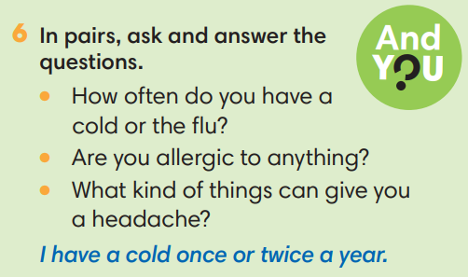
WRAP-UP & HOME WORK ( 2’)

- T asks Ss to talk about what they have learnt in the lesson.
- Vocabulary of illness
* HOME WORK
- Do exercises in the workbook page 38.
- Prepare for Lesson 4.6: Speaking.

Date of planning:  Date of teaching: | Period 43 - UNIT 4: HEALTH AND FITNESS  Lesson 6: Speaking
I. OBJECTIVES:
By the end of the lesson student will be able to:
- talk about illnesses and ask about how someone is feeling.
1. Knowledge:
* Vocabulary: use the phrases to describe symptoms of illnesses and to give advice.
* Grammar: make dialogue in the Present Simple, Present Continuous to talk about health problems and advice.
2. Competence: Ss understand and use the phrases of illnesses and advice, do the tasks assigned in the textbook. Listen and read a dialogue for comprehension. Then practice asking how a classmate is feeling and give some pieces of advice.
3. Quality/ behavior: To teach Ss to be hard-working and attentive in class. Ss have a positive attitude to working in groups, individual work, pair work, cooperative learning and working.
II. TEACHING AIDS:
- Teacher: Grade 7 textbook, Unit 4 (SB p. 46, WB p.39), laptop/computer connected to the Internet, loudspeaker, projector/TV, PPT slides…
- Students: Text books, studying equipment…
- Method: Active teach, T-WC; group works; individual ……
III. PROCEDURE:
1. WARM UP + LEAD-IN (5’)
* Aim:
- To create a positive classroom atmosphere to start a new lesson.
- To review words of illnesses.
- To lead into the topic.
* Content: Play Minion Games to recall the vocabulary in previous lessons.
* Outcome: Students talk about pets by using the vocabulary in previous lessons.
* Organization of implementation: T- Ss
Teacher’s & Student’s activities |  | Content
Extra activity 1: Minion Games  - T greets students and asks Ss what topic they learnt from last lesson.  - Students discuss and list out all words they remember from previous lesson.  - T introduces the Minion Games and How to play steps  - T uses the slides to lead the game.  - When Ss finish the game, T shows a slide of Unit 4 – Lesson 5 vocabulary and asks students to look at them quickly  - T tells Ss that, they are using the vocabulary to do some speaking tasks today.  - T writes the title of new lesson: Unit 4/ Lesson 6 - Speaking |  | How to play:  - Read the sentence carefully.  - Choose A or B to fill in the blank.  - 1 correct answer = 1 point.
2. PRE-SPEAKING (15’)
ACTIVITY 1 + 2 + 3:
* Aim:
- To activate Ss’ prior knowledge of the topic.
- To lead into the topic.
- To present phrases of talking about health problems and giving advice.
- To introduce the Speaking Box.
* Content: Listen to the conversation to answer the questions about Binh.
* Outcome: Know about asking what the problem is and giving advice. Understand the conversation.
* Organisation: Teacher’s instructions…
Teacher’s & Student’s activities |  |  | Content
1. (5’) In pairs, look at the photo. What do you think is happening?  (Exercise 1 – SB p.46)  Set the scene: See – think - wonder  - T tells Ss to look at the picture in their student book page 46.  - T encourages students to predict the information by answering the two questions:  1. What do you see in the picture?  2. What do you think is happening?  - Ss work in pairs to find the answer for the two questions.  - T calls some students to share their answers and checks as the whole class.  - T sets the transition for the next step of the lesson by showing the introduction: “This is Binh. He felt terrible so he went to see the school nurse. Let’s see what happened.” |  |  | Key answers:  - A boy and a nurse  - The boy has a health problem. / The boy is sick.
2. (5’) Listen and read. Why did Binh go to see the school nurse?  (Exercise 2 – SB p.46)  - T asks Ss to look at exercise 2.  - T calls a student to read the instruction then checks Ss’ understanding of it.  - T asks students to listen and read the dialogue to find the answer. T elicits some parts of the dialogue if needed.  - T asks the volunteer students to give the answer then checks as the whole class.  More tasks with Exercise 2  - T tell students to read the text again and answer the other two tasks:  1. What questions did the school nurse ask Binh?  2. Read again and finish the school nurse’s advice.  - Students work in pairs to continue reading and are allowed to give the answer massively.  - T listens to Ss’s answer and checks as the whole class.  - T explains to Ss that the school nurse in the dialogue did 2 main jobs: asking what the problem is and giving advice. |  |  | Answer key:  Because he felt terrible, and he had a really bad stomachache.  Answer keys for extra task:  1. When did you start feeling ill?  What did you have for lunch?  2. You should drink a lot of water  You should make an appointment with your doctor.
3. (5’) Underline the words and phrases from the dialogue.  (Exercise 3 – SB p.46)  - T asks Ss to look at exercise 3.  - T calls a student to read the instruction then checks Ss’ understanding of it.  - T goes through the Speaking box and asks students to find the phrases that are used in the dialogue.  - When they have finished, T asks them to work in pairs to create a short dialogue which includes at least one phrase from each section of the Speaking box.  - T encourages Ss to use their imagination and tell them to make sure that the advice given matches the illness that is described.  - T invites different pairs to act out their dialogues in front of the class. |  |  | 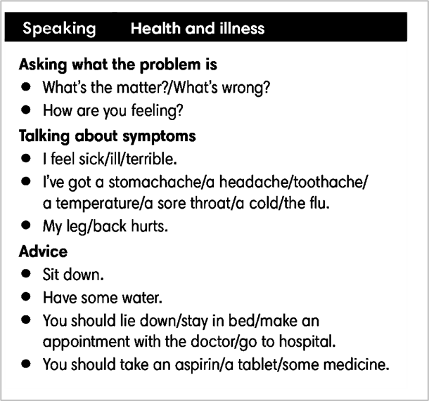
3. WHILE-SPEAKING (10’)
ACTIVITY 4 + 5:
* Aim:
- To reinforce the expressions of asking about health problem and giving advice
- To practice using the new expression in context
* Content: Complete the conversations to make an appointment to see the doctor.
* Outcome: Understand the use of making an appointment to communicate.
* Organisation: T, Ss ..….
Teacher’s & Student’s activities |  |  |  | Content
4. (5’) In pairs, complete the dialogues with one word in each gap. Listen and check.  (Exercise 4 - SB p.46)  - T asks students to work in pairs to complete the exercises.  - T plays the audio for students to check.  - When students have finished, T tells them to discuss each of the following: the last time they had a temperature and what they did; a time when they thought they had broken a bone and how it happened; the last time they made an appointment to see the doctor and why.  Pair work task 1  - T sets a limit for students to work in pairs to practice the 3 situations in Exercise 4 as a role play.  - T invites some pairs of students to act out the roleplay in front of the class.  Pair work task 2: Use the Speaking Box and replace another the response for each situation.  - Ss work in pair, practice the dialogue, then act out. |  |  |  | Answer keys:  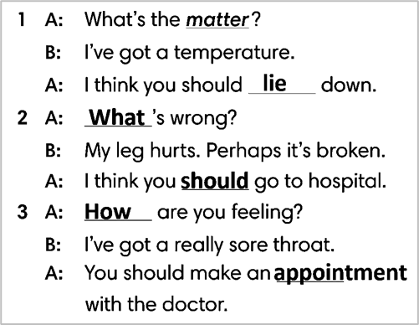
4. POST-SPEAKING (8’)
ACTIVITY 5:
*Aims: To help students applying the new language and skills related to the topic in communicating.
* Content: Describe symptoms of illnesses and to give advice.
* Outcome: To practice describing symptoms of illnesses and to give advice by create a new situation and act out.
* Organisation : T, Ss .…
Teacher’s & Student’s activities | Content
5. In pairs, follow the instructions. Use the Speaking box and Exercise 4 to help you.  (Exercise 5 - SB p.46)  - T tells students to look at the speaking box in their student book again and prepare for the task.  - T gives students time to think about what they are going to say in their roleplays.  - If students have difficulties thinking of true situations, T encourages them to use their imagination.  - T encourages stronger students to give some very first examples.  - Students work in the same pairs from the last activity and practice their role plays, focus on using the correct intonation.  - T tells students to do the activity with their books closed, so that their reactions can be natural, and they don’t just read from the Speaking box.  - Teacher invites pairs to act out their roleplays in front of the class. | 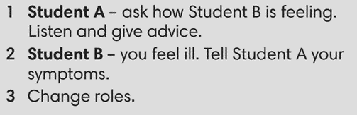
WRAP-UP & HOME WORK (2’)
- T asks Ss to talk about what they have learnt in the lesson.
- phrases to describe symptoms of illnesses and to give advice
* HOME WORK
- Do exercises in the workbook page 39.
- Prepare for Lesson 4.7: English In Use

Date of planning:  Date of teaching: | Period 44 - UNIT 4: HEALTH AND FITNESS  Lesson 7: English in Use
I. OBJECTIVES:
By the end of the lesson, Ss are able to:
- use phrasal verbs to talk about health.
1. Knowledge:
* Grammar:
- Understand and use correctly some phrasal verbs provided in the lesson.
- Talk about health and how to keep fit.
2. Competence: Ss understand and use the vocabulary about illnesses and understand the use of phrasal verbs in context (a cartoon), then do the tasks assigned in the textbook; use the correct tense of verbs, phrasal verbs to talk about health.
3. Quality/ behavior: To teach Ss to be hard-working and attentive in class. Ss have a positive attitude to working in groups, individual work, pair work, cooperative learning and working.
II. TEACHING AIDS:
- Teacher: Grade 7 textbook, Unit 4 (SB p. 47), laptop/computer connected to the Internet, loudspeaker, projector/TV, PPT slides…
- Students: Text books, studying equipment…
- Method: Active teach, T-WC; group works; individual ……
III. PROCEDURE:
1. WARM UP (5’)
* Aim:
- To create a positive classroom atmosphere to start a new lesson.
- To review words of illnesses and giving advice.
* Content: Game: SUPER DOCTOR GAME (about health)
* Outcome: Ss guess and choose the correct advice for the problem.
* Organization of implementation
Teacher’s & Student’s activities |  | Content
Extra activity 1: SUPER DOCTOR GAME  - T asks Ss How are you feeling? Do you remember vocabulary from Unit 4-Lesson 5?  - T tells students that they are playing a game with words of illnesses and giving advice.  - T explains the game rules then checks instructions.  - T uses the slides to lead the game  - Ss join in the game individually.  - T corrects Ss’s pronunciation if necessary.  - T tells students to recall all vocabulary from the game.  - T introduces the new lesson and writes on board:  Unit 4/ Lesson 7: English in use |  | Game rules:  - Look at the picture. Read the sentence  - Guess correct advice for the problem.  - 1 correct answer makes the doctor happy.
2. LEAD-IN (3’)
* Aim:
- To lead into the new lesson.
- To provide Ss with reasons for reading the cartoon in exercise 1 (SB p.47).
* Content: Describe the situation in the cartoon.
* Outcome: Guess the correct answers to the questions.
* Organisation: T_ Ss ..….

Teacher’s & Student’s activities |  | Content
Extra activity 2: See – think – wonder.  - T shows the cartoon pictures on the slide then asks students four questions.  (1) What can you see in the pictures?  (2) Who are in the pictures?  (3) What’s the boys doing in each picture?  (4) Is the boy happy? Why?  - T sets a time limit for Ss’ quick discussion.  - Ss work in pairs to make guesses about the pictures then give answers.  - T calls some Ss to give answers then checks with the whole class.  - T introduces “This boy felt terrible, so he and his friend decided to go home.” |  | 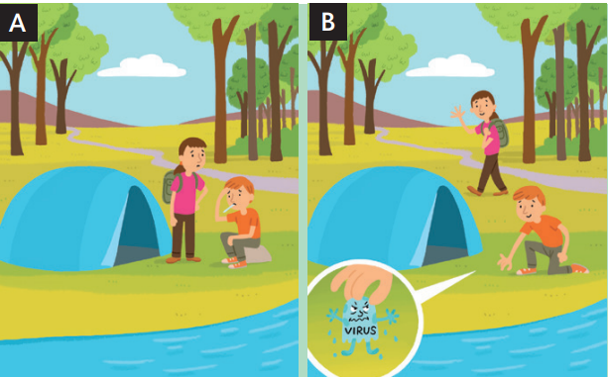
3. PRESENTATION (7’)
ACTIVITY 1:
* Aim:
- To present the new phrasal verbs through a context.
- To introduce the Language Box through the reading tasks.
* Content: Exercises about health and illness.
* Outcome: Do the exercise to improve grammar.
* Organisation : T_ Ss ..….
Teacher’s & Student’s activities | Content
1. (3’) Look at the cartoons. Which version, A or B, matches the text? Read the information about phrasal verbs to check your answer.  (Exercise 1 – SB p.47)  - T asks Ss to open their SB page 47, look at exercise 1.  - T calls a student to read the instruction then checks Ss’ understanding of it.  - T tells Ss that they are going to read the text to find the answers.  - T refers students to the Language box before they read the sentences and answer the question.  - Ss work individually, read, and note down the answers to the given question.  - T calls some Ss to give answers then shows the answers on the slide.  - T elicits the meaning of pick-up using slide.  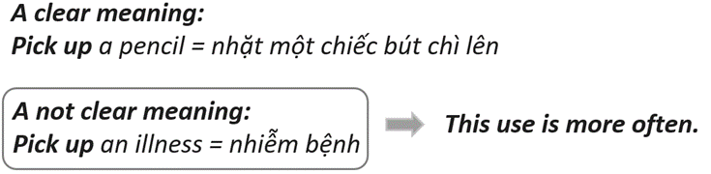  - T provides another cartoon picture for student to practice.  - Ss listen to the teacher carefully and learn another phrasal verb: go off | Answer keys:  Version A matches the text.  Version B show the literal meaning of the words in the phrasal verb, but it doesn’t show the true meaning.
4. PRACTICE (8’)
ACTIVITY 2 + 3:
* Aim: To reinforce the use of phrasal verbs.
* Content: Use the phrasal verbs to do the excercise.
* Outcome: Match and complete sentences crroectly.
* Organisation : T_ Ss.. ….
Teacher’s & Student’s activities |  |  | Content
5. (4’) Match the phrasal verbs in sentences 1 – 7 with meanings a – g.  (Exercise 2 – SB p.47)  - T asks Ss to open their SB page 47, look at exercise 2.  - T calls a student to read the instruction then checks Ss’ understanding of it.  - T gives students a time limit to work individually.  - T allows Ss to share their answers massively before checking the final ones as the whole class.  - T provides the meanings of the phrasal verbs if needed. |  |  | Answer keys: 2-c, 3-a, 4-f, 5-e, 6-d, 7-g
3. (4’) Complete the text with one word in each gap  (Exercise 3 – SB p.47)  - T asks Ss to open their SB page 47, look at exercise 3.  - T calls a student to read the instruction then checks Ss’ understanding of it.  - T gives students a time limit to work individually.  - T allows Ss to share their answers massively before checking the final ones as the whole class.  - T provides the meanings of the phrasal verbs if needed  - T encourages Ss to make sentences using the phrasal verbs they learnt from Unit 2 & 3. |  |  | Answer keys: 1 – look, 2 – up, 3 – give, 4 - find
5. FURTHER PRACTICE (6’)
* Aim: To reinforce the use of phrasal verbs.
* Content: Playing game: STAMP GAME (with the phrasal verbs).
* Outcome: Complete the phrasal verbs correctly.
* Organisation : T_ Ss.. ….
Teacher’s & Student’s activities |  | Content
Extra activity 3: STAMP GAME  - T tells students that they are playing a game with the phrasal verbs  - T explains the game rules then checks instructions.  - T uses the slides to lead the game  - T reminds Ss that sometimes they have to choose a preposition, sometimes a verb.  - Ss join in the game individually.  - T corrects Ss’s pronunciation if necessary.  - T tells students to recall all phrasal verbs from the game. |  | Game rules:  - Look at the picture. Read the sentence  - Fill in the blank to complete the phrasal verbs  - 1 correct answer = 2 points
6. PRODUCTION (7’)
ACTIVITY 4:
* Aim: To help students applying the vocabulary items and grammar points related to the topic in communicating.
* Content: Make sentences about what should you do to keep fit.
* Outcome: Write about keeping fit and use phrasal verbs.
* Organisation : T_ Ss.. ….
Teacher’s & Student’s activities
4. Write four sentences about what should you do to keep fit. Use the phrasal verbs in exercise 2 in your sentences.  (Exercise 4 – SB p.47)  - T asks Ss to look at exercise 4 (SB page 47).  - T calls a student to read the instructions then checks Ss’ understanding of it.  - T lets students work individually to write their sentences first (E.g., I should give up eating sweets/eating chocolate/ drinking coke.)  - Then T pairs students up and asks them to share their sentences with their friends and choose four best sentences from the eight sentences they had.  - Teacher may continue to make groups of four (by joining two pairs together) and asks students to share their pairs’ sentences and choose 4 sentences for their groups.  - Teacher may collect the groups’ sentences to give feedback or ask some groups to share their sentences and give feedback. |  | 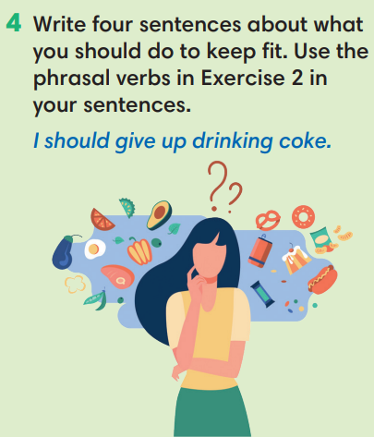
WRAP-UP & HOME WORK (3’)
- T asks Ss to talk about what they have learnt in the lesson.
- Phrasal verbs
- Talk about health & fitness
* HOME WORK:
- Do exercises in the workbook page 40.
- Prepare for Lesson 4.8: Vocabulary in action and Pronunciation

Date of planning:  Date of teaching: | Period 45 - UNIT 4: HEALTH AND FITNESS  Lesson 8: Vocabulary in Action and Pronunciation
I. OBJECTIVES:
By the end of the lesson student will be able to:
1. Knowledge:
* Vocabulary: review vocabulary
- The lexical items related to: parts of the body, accidents and injuries, keeping fit, snacks, sleep, symptoms and illnesses.
- Present simple and present continuous.
* Pronunciation: Listen and identify the silent letters in words then correctly pronounce the words that contain the silent letters.
2. Competence: Students develop communication skills, and creativity; be collaborative and supportive in pair work, and teamwork; actively join in class activities.
3. Quality/ behavior: To teach Ss the love of talking about relating topics to unit 4 and using word friends or phrasal verbs in pair work or group work, and develop self-study skills. Ss have a good attitude to working in groups, individual work, pairwork, cooperative learning, and working
II. TEACHING AIDS:
- Teacher: Grade 7 textbook, Unit 4 (SB p.47), laptop/computer connected to the Internet, loudspeaker, projector/TV, PPT slides… .
- Students: Text books, studying equipment…
- Method: Active teach, T-WC; group works; individual ……
III. PROCEDURE:
1. WARM UP + LEAD-IN (5’)
*Aims:
- To create an active atmosphere in the class before the lesson.
- To lead into the new lesson.
* Content: Game: NAME 3 THINGS CHALLENGE (health and fitness)
* Outcome: Students say words relating to the given topic quickly.
* Organisation: Teacher’s instructions…
Teacher’s & Student’s activities | Content
Extra activity 1: NAME 3 THINGS CHALLENGE  * Teacher asks students to spend 1 minutes to quickly review all vocabulary they have learnt in Unit 4 before they play a warm-up game.  - T tells students that they are going to play a game called NAME 3 THINGS CHALLENGE  - T explains the game rules then checks instructions.  - Teacher uses the slides to show the challenge  - Ss join in the game pairs or in small groups.  - Teacher listens to the Ss answers and calls several Ss to check for the whole class.  - T tells Ss that they can remember better with Glossary Table and asks Ss to open their Student Book page 48 – Exercise 1. | Game rules:  - Choose a number to get the challenge  - Read the topic word  - Say 3 words relating to that topic quickly.
2. REVIEW VOCABULARY (22’)
(GLOSSARY TALBE)
ACTIVITY 1 + 2 + 3:
*Aim:
- To introduce the glossary and its uses.
- To give further practice in making sentences using the Glossary.
* Content: Revise what they have learnt during the unit. Glossary and its uses.
* Outcome: Remember the new words and animals’ name.
* Organisation : Teacher’s instructions…
Teacher’s & Student’s activities | Content
1. (5’) Use the Glossary to find:  - Three items of food or drink that are bad for you.  - Three health problems ending with –ache  - Two things you can take when you are ill.  (Exercise 1 – Student Book page 48)  - Teacher introduces the Glossary Table.  - T asks Ss to look at exercise 1 in student book page 48  - T has students use the glossary to find the words which belong to the correct category  - T asks students to work in pairs and quickly do the task.  - T allows students to peer check first.  - T checks and confirms the answers. | Answer key:  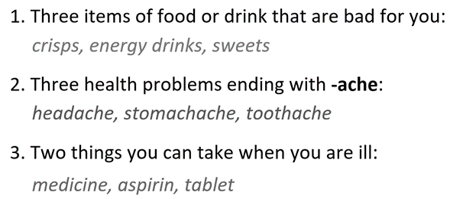
2. (12’) Complete the phrasal verbs.  (Exercise 2 – Student Book page 48)  - T asks students to complete the sentences with suitable words.  - T asks students to work individually and check in pairs.  - T invites students to share their answers.  - T confirms the correct answers.  Extra-Practice  TIME TO TALK: Use the Phrasal Verbs and make sentence for you.  - T encourage students to make sentences using the phrasal verbs in exercise 2.  - Ss work in pairs to share true information about themselves. | Answer key:  1. after / 2. up / 3. up / 4. up
3. (5’) Complete the sentences with the words below. In pairs, say which sentences are true for you.  (Exercise 3 – Student Book page 48)  - T asks Ss to open their SB page 48, look at exercise 3.  - T calls a student to read the instruction then checks Ss’ understanding of it.  - T gives students a time limit to work individually.  - T allows Ss to share their answers massively before checking the final ones as the whole class.  - T provides the meanings of the phrasal verbs if needed  TIME TO TALK  - T pairs students up and asks them to share the sentences which are true about them with their partners. | Answer key:  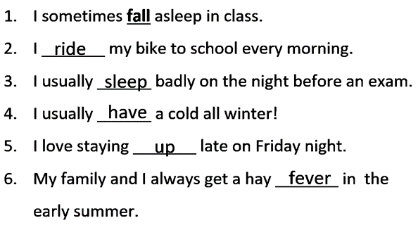
3. PRONUNCIATION (10’)
Presentation and Practice
ACTIVITY 4:
* Aims:
- To present the list of words which contain the silent letters
- To help students identify the silent letters in words
- To help students listen and identify the words which contain silent letters
* Content: Do exercises to practice pronunciation.
* Outcome: Identify and say silent letters in words correctly.
* Organisation: Teacher’s instructions…

Teacher’s & Student’s activities | Content
Extra activity 2: (5’) HEAR AND CLAP GAME  - T tells students that they are going to play a game called HEAR AND CLAP  - T explains the game rules then checks instructions.  - Teacher uses the slides to lead the game  - Ss join in the game pairs or in small groups.  - T listens to the Ss answers and calls several Ss to check for the whole class.  - T asks students to say the word again to practice some sounds after each play. | Game rules:  - Hear the sound  - Read the words  - Clap your hands 1 or 2 times to choose the word you hear.
4. (5’) Listen to the words below and decide if you hear the underlined letter(s). Then listen again and repeat.  (Exercise 4a– Student Book page 48)  - T calls a student to read the instruction of Exercise 4 then checks Ss’ understanding of it.  - T calls some students to read out the words first.  - T plays the audio tracks for them to listen take notes.  - T invites some students to share their answers.  - T confirms the answer using the slide.  Listen again and repeat  - T shows the slide with full words, IPA and individual audio track for Ss to practice listening and pronouncing words. | Answer keys:  All the underlined letters are silent.  => You can’t hear them.
WRAP-UP & HOME WORK (3’)
- Teacher asks students to talk about what they have learnt in the lesson.
- Use a Glossary to review
- Identify silent letters in words
* HOME WORK
- Find more words which contain the silent letters
- Prepare for Unit 4 – Lesson 9: Revision

Date of planning:  Date of teaching: | Period 46 - UNIT 4: HEALTH AND FITNESS  Lesson 9: Revision
I. OBJECTIVES:
By the end of the lesson, Ss are able to:
1. Knowledge:
* Vocabulary: revise words related to parts of the body, accidents and injuries, keeping fit, snacks, sleep, symptoms and illnesses.
* Grammar: review present simple of irregular verbs, quantifiers, phrasal verbs to talk about health, fitness, illnesses and give advice.
2. Competence: Ss understand and use use vocabulary of the unit, do the tasks assigned in the textbook; participate in a guided conversation to talk about illnesses and give advice.
3. Quality/ behavior : To teach Ss to be hard-working and attentive in class. Ss have a positive attitude to working in groups, individual work, pair work, cooperative learning and working.
II. TEACHING AIDS:
- Teacher: Grade 7 textbook, Unit 4 (SB p. 49, WB p.41), laptop/computer connected to the Internet, loudspeaker, projector/TV, PPT slides…
- Students : Text books, studying equipment….
- Method: Active teach, T-WC; group works; individual ……
III. PROCEDURE:

- WARM-UP (4’)

*Aims:
- To create a positive classroom atmosphere to start a new lesson.
- To lead into the review lesson.
* Content: Game: SUPER EYES
* Outcome: Ss understand that they are going to review Unit 4.
* Organisation: Teacher’s instructions…
Teacher’s & Student’s activities | Content
Extra activity 1: SUPER EYES  - Set the scene: T asks students to do quick exercises for eyes such as look up and down, look left and right, row the eyes  - T tells students that they are going to play a game called SUPER EYES  - T explains the game rules then checks instructions.  - Teacher uses the slides to show the collages  - Ss join in the game pairs or in small groups.  - Teacher shows the collage again with displayed answers to check for the whole class.  - T tells Ss that they are going to review Unit 4 | Game rules:  - Look carefully at a collage of different small pictures  - The collage will disappear in a few seconds  - Recall as many words about the collage as you can remember.
- REVIEW VOCABULARY (16’)
ACTIVITY 1 + 2:
* Aims:
- To help students reviews topic words and word friends from the unit.
- To review vocabulary in context.
* Content: Do the exercise to revise the vocabulary of Unit 4.
* Outcome: Understand the vocabulary to do the exercise correctly.
* Organisation : Teacher’s instructions….
Teacher’s & Student’s activities | Content
Extra activity 2: (5’) SUPER MIND  - T tells students to open the Glossary box in student book page 48  - T introduce the SUPER MIND game and rules  - T shows the slides of the game  - Ss take turns to choose the numbers for their teams.  - Ss discuss and list out all words related to the topic they get.  - T calls some Ss to give answers and confirms the winner. | How to play:  - Play in team  - Choose a number to open a block  - Read the topic word  - Write as many words related to the topic as you can  - The faster finisher gets points
1. (5’) Write the correct word for each definition.  (Exercise 1 – Student Book page 49)  - T asks Ss to look at exercise 1 in student book page 49  - T calls a student to read the instruction then checks Ss’ understanding of it.  - T asks Ss to work in pairs to read then complete the activity.  - T encourages students to give the reason for their answer.  - T checks as the whole class. | Answer keys:  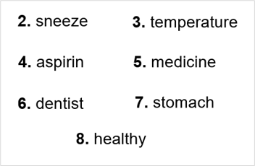
2. (6’) In pairs, read the text and choose the correct option. Do you have any one in your family like Grandpa George?  (Exercise 2 – Student Book page 49)  - T asks Ss to look at exercise 2 in student book page 29  - T calls a student to read the instruction then checks Ss’ understanding of it.  - T asks Ss to work in pairs to read then complete the activity.  - Ss work in pair to complete the task and compare the answers.  - T checks as the whole class.  Exercise 2 - Time to talk:  - T asks Ss to work in pairs to share their facts.  - Ss work in pairs to talk about anyone in the family who is like Grandpa George.  Example:  - My cousin is like Grandpa George. He always talks with food in his mouth. | Answer keys:  1-woke up/ 2-did/ 3-mouth/ 4-elbows/ 5-shoulders/ 6-hair
3. REVIEW GRAMMAR (15’)
ACTIVITY 3 + 4 + 5:
*Aim:
- To reinforce the grammar of unit 4
- To review words of quantifiers
- To help students review past simple tense with irregular verbs
- To provide more practice of Past Simple
* Content: Use the past simple tense to complete the exercises.
* Outcome: Use the past simple tense for communication and writing.
* Organisation : Teacher’s instructions….
Teacher’s & Student’s activities | Content
Extra activity 3: (2’) Read the grammar boxes and review the grammar points.  - T asks Ss to look at the grammar box and read the example.  - T shows slides for detail review grammar  - Ss read the review content together before they do some grammar tasks. | 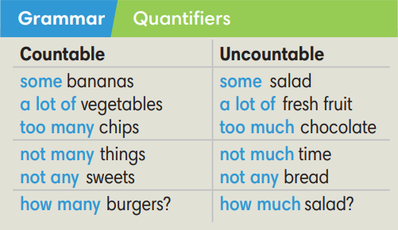  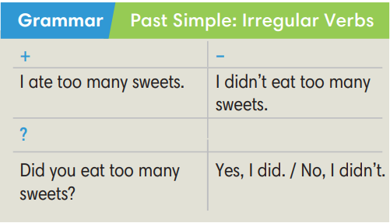
3. (3’ Choose the correct options.  (Exercise 3 – Student Book page 49)  - T asks Ss to look at exercise 3 in student book page 49  - T calls a student to read the instruction then checks Ss’ understanding of it.  - T asks Ss to work in pairs to read then complete the activity.  - Ss work in pairs to complete the task and compare the answers.  - T checks as the whole class. | Answer keys:  2-any / 3-any / 4-some / 5-many / 6-not many / 7-a lot of
4. (5’) Complete the text with the Past Simple form of the verbs in brackets  (Exercise 4 – Student Book page 49)  - T asks Ss to look at exercise 4 in student book page 49  - T calls a student to read the instruction then checks Ss’ understanding of it.  - T asks Ss to work in pairs to read then complete the activity.  - Ss work in pairs to complete the task and compare the answers.  - T checks as the whole class. | Answer keys:  1-heard 2- ran 3- saw 4- told  5- broke 6- did…say 7- didn’t pay 8- fell
Extra activity 4 (5’): Mystery Box Game  - T introduce the Mystery Box Game and rules  - T shows the slides of the game  - Ss take turns to play the game.  - Ss discuss and say out loud their answers.  - T calls some Ss to give answers and confirms.  - Ss decide to KEEP or to GIVE their mystery box. | How to play:  - Play in team  - Answer a question or do a task.  - Choose: KEEP THE BOX or GIVE THE BOX
4. SPEAKING (8’)
ACTIVITY 5:
*Aim: To help student practice speaking skill in a task: talk about illnesses and give advice.
* Content: Talk about feeling ill and complete the exercises.
* Outcome: Practice speaking by talking about illness and give advice/make appointment.
* Organisation: Teacher’s instructions….
Teacher’s & Student’s activities | Content
5. Work in pairs, talk about feeling ill. Student A, look below. Student B, look at page 102.  (Exercise 5 – Student Book page 49)  - T asks Ss to look at exercise 5.  - T calls a student to read the instruction then checks Ss’ understanding of it.  - T asks Ss to work in pairs to prepare for their dialogues  - T sets a time limit and walk around as a monitor while Ss are discussing.  - Ss work in pairs to practice the speaking task  - T moves around and takes notes for any issues that need improving from students work.  - T encourages some strong students to role-play their dialogues in front of the class.  - T gives some general feedback for Ss’ performances. | 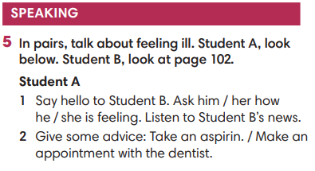
WRAP-UP & HOME WORK (2’)
- T asks Ss to talk about what they have learnt in the lesson.
- Review Unit 4 vocabulary and grammar.
- Talk about illnesses and give some advice
* HOMEWORK
- Do exercises in the workbook page 41
- Prepare for REVIEW 2

Date of planning:  Date of teaching: | Period 47 – CLII 2 : LITERATURE
I. OBJECTIVES
By the end of the lesson, students are expected to achieve the following objectives:
- read a text about “Diary of cricket” a very famous book by To Hoai.
- identify keys information about a fiction (title, author, country of origin, etc.).
- review adjectives and use them to describe main character of the book.
- use book fact file related vocabulary words to talk about other fictions
- write a fact file and a short summary about a book.
1. Knowledge:
- Vocabulary: Understand the meaning of the key words or word collocations: fiction, authors name, title, main characters, country of origin, etc.
- Grammar: Use the grammar structures presented in the lesson: present simple tense, think of, famous about
2. Competencies:
a. General competencies:
Form and/or improve such competencies as group work, independent working, pair work, linguistic competence, and cooperative learning.
b. Specific competencies:
Improve competences related to language learning: reading, writing skills and the use of language (vocabulary, phonetics, grammar)
- For a language lesson: Students are expected to know the meaning of the keywords and grammatical structures used to summarize a book.
- For a skills lesson: Students are expected to
- read for general ideas and for specific information about book information
- develop specific and detailed writing
3. Qualities:
- Be hard-working and attentive in class
- Have better understanding of the book morals: love nature, friendship, etc.
- Love reading books
II. PREPARATIONS
Teacher: Textbooks, worksheet, PowerPoint slides, video clip, TV, projector, loudspeaker
Students: Textbooks, notebooks
III. PROCEDURE
ACTIVITY 1: WARM-UP – SUPER EYES GAME
Aim: to get students be ready and excited about the lesson
Content: see, remember, say information about some book covers
Products: Ss answer the correct information about the pictures
Implementation:
TEACHER AND STUDENTS’ ACTIVITIES | CONTENTS
Step 1: Task delivering  - T shows and hides the pictures quickly  - T lets students look at some book covers. Try to remember the information from the covers the answers for 2 questions.  Step 2: Task performance  - Students say a loud the answers  Step 3: Report and discussion  - Teacher discusses with the students about the books covers and information on the covers.  Step 4: Judgment  Teacher comments on the answer. Teacher gets students to guess what they are going to learn about. | Pictures of some book covers  Questions: How many books are there? What are the books about?
   | 
   | 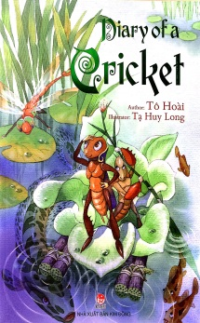
ACTIVITY 2: KNOWLEDGE FORMATION
Pre -reading
Aim: to activate students’ prior knowledge about the topic.
Content: Students work in pair to ask and answer some questions.
Products: Students are able to apply their own words to answer the questions.
Implementation:
TEACHER AND STUDENTS’ ACTIVITIES | CONTENTS
Step 1: Task delivering  - Teacher ask students to work in pairs to ask and answer the questions.  Step 2: Task performance  - Students work in pairs. One student asks and the other answers  Step 3: Report and discussion  - Teacher asks some pairs to act out  Step 4: Judgment  - Teacher comments on the answer. Teacher gets students to guess what they are going to learn about. This will lead to the lesson naturally | Orientation questions  - Have you ever read these books before?  - Share what they know about the books.  - Do you know what fiction is mean?  - Today, we are reading about one of the books (from 4 covers in Warm up game), can you guess which one is?
Pre-teaching of vocabulary
Aim: To provide students with some lexical items before reading the text
Content: Learn some vocab related the topic
Products: Read and understand the meaning of words
Implementation:
TEACHER AND STUDENTS’ ACTIVITIES | CONTENTS
Step 1: Task delivering  - Teacher uses different techniques to teach vocab (pictures, situation, explanation, slides)  - Ask students to listen and repeat the words  Step 2: Task performance  - Students listen to the teacher and repeat the words in chorus and individually  - Copy all the words  Step 3: Report and discussion  - Call someone to read aloud all the new words  Step 4: Judgment  - Teacher checks and corrects students’ pronunciation | fiction /ˈfɪk.ʃən/ (n) the type of book or story that is written about imaginary characters and events and not based on real people and facts  author /ˈɔː.θər/ (n) the writer of a book, article, play, etc.  title /ˈtaɪ.təl / (n) the name of a book, film, painting, etc.  main character /meɪn ˈˈkær.ək.tər/ (n) a central character that acts as the focus of the audience's emotional attachment to the story.  country of origin /kʌntri ɒvˈɒr.ɪ.dʒɪn/ (n) is the country where something or someone comes from.
ACTIVITY 3: PRACTICE While – reading
Task 1
Aim: to provide students with the main idea of the text and give them a reason/ motivation to read.
Content: Students read the text and choose the correct cover of the book
Products: Students say the title of the book and author’s name.
Implementation:
TEACHER AND STUDENTS’ ACTIVITIES | CONTENTS
Step 1: Task delivering  - Teacher asks students to look at Student’s Book page 104, read the text and look at the book cover in Exercise 1 to choose the matching one.  Step 2: Task performance  - Students work individually to read and choose the book cover.  Step 3: Report and discussion  - Teacher calls some students to answer  Step 4: Judgment  - Teacher checks and corrects students’ pronunciation  - Teacher checks the exercise with the students | Exercise 2  Read the text. Which of the books from exercise 1 is the text about?  Answers:  The text is about “Diary of cricket” a very famous book by To Hoai
Task 2
Aim: to get students to practice their comprehensive reading skills and help them understand more deeply the content of the text.
Content: Read the text and complete a fact file
Products: Students fill in the correct information for the fact file
Implementation:
TEACHER AND STUDENTS’ ACTIVITIES | CONTENTS
Step 1: Task delivering  - Teacher asks students to look at Exercise 2 - SB page 104, read the text again and work in groups of four to answer the questions.  - Teacher ask them to identify the information.  Step 2: Task performance  - Students work in group to read the text again and discuss the information to fill in the fact file  - Students underline the information they found in the text  Step 3: Report and discussion  - Invite members of some groups to present their fact file  Step 4: Judgement  - Teacher checks the answer with the whole class | Exercise 3: Read the text again and complete the fact file  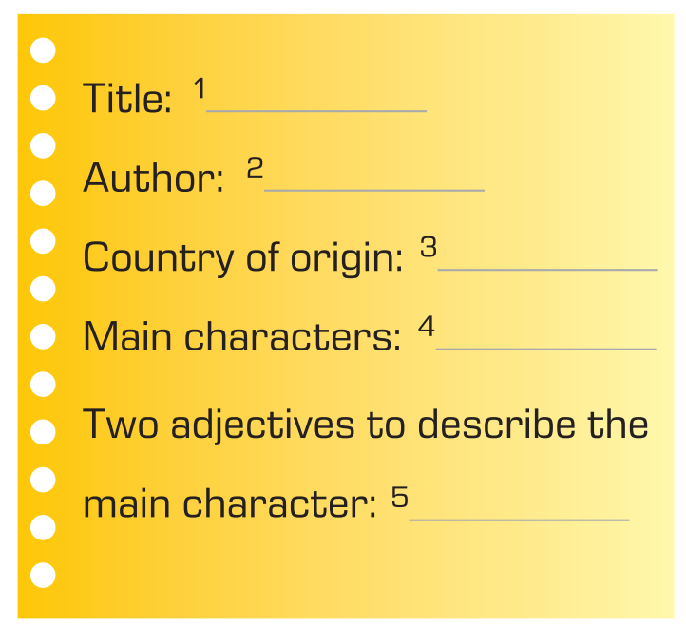  Answers:  1 Diary of a cricket / 2 To Hoai  3 Vietnam / 4 Dế Mèn (a cricket)  5 kind, helpful
Information Exchange:  Step 1: Task delivering  - Teacher puts students in pairs, has them to form a question for each information using their own work.  - T sets a time limit for students to work in pair, practice asking and answering about the book  Step 2: Task performance  - Students work in pairs to ask and answer about information about the book.  - Students need to compare their answer and do peer check  - Teacher goes around the class, provides support when needed and takes note.  - Students do group check after finishing  Step 3: Report and discussion  - Students volunteer to role play the dialogue in front of the class  Step 4: Judgement  - Teacher gives comment and checks with the whole class. | - Exercise 4: Work in pairs. Take turn to ask your teacher questions about the books  - Suggested questions  - Question 1: What is the book title?  - Question 2: Who wrote the book? / What is the author’s name?  - Question 3: Where is the book from?  - Question 4: Who are the main characters? / What are the main characters’ name?  - Question 5: Can you describe the main character using 2 adjectives?
ACTIVITY 4: APPLICATION Post – reading
Aim: - To help students reflect on what they’ve known and what they’ve learnt about “Diary of a cricket”.
- To help apply the learnt knowledge to write a summary of a book about an animal.
Content:
- ask and answer questions related to the book with partner
- write a summary of a book about an animal
Products: Students can recall the name of ethnic groups, national holidays and traditional festivals; Students’ perfect fact file writing.
Implementation:
TEACHER AND STUDENTS’ ACTIVITIES |  | CONTENTS
Task 4  Step 1: Task delivering  - Teacher provides students with simple summaries of story books about animals.  - Teacher asks students to read through all the questions of the task and guides them on how to make notes of key information while reading the given materials by using a graphic organizer.  - Teacher gives an example of the graphic organizer using the summary of "Diary of cricket".  Step 2: Task performance  - Students create their own notes using the given summaries or their own knowledge about their favourite book about an animal.  - Teacher facilitates while students are making notes with the graphic organizer.  - Students exchange their notes with a partner and check their friends’ one.  Step 3: Report and discussion  - Teacher calls some students to present their graphic organizer.  Step 4: Judgement  - Teacher checks and give feedbacks for their notes.  Task 5  Step 1: Task delivering  - Teacher has students complete the task by using their notes in task 4 and the sample summary of "Diary of cricket".  Step 2: Task performance  - Students write a short summary (60 – 80 words) based on the graphic organizer.  - Teacher facilitates while students are writing.  - Students exchange their writing to check their friends’ one.  Step 3: Report and discussion  - Teacher calls some students to show their writing on the board.  Step 4: Judgement  - Teacher checks and give feedbacks for their writing.  ***T might ask Ss to prepare this content in advance so their writing can be better and more diverse. |  | Exercise 4  Graphic organizer illustration
  Diary of cricket
  Author | …
  When | …
  What it’s about
  What you like | …
  Other interesting information | …
HOME ASSIGNMENT
- Students take note of the homework: Write a short summary of another story book about an animal they’ve read or found on the Internet. Encourage them to ask or search for more information to put in the writing.
IV. FEED-BACK:
With class
………………………………………………………………………………
With class
Notes:
…………………………………………………………………………………

Date of planning:  Date of teaching: | Period 48 : REVISION

I. OBJECTIVES:
1. Knowledge: By the end of the lesson, ss will be able to:
- Vocabulary: revise words related to cultural activities, clothes, accessories, personality adjectives.
- Grammar: review present simple and present continuous tense to describe people.
- Pronunciation: review the pronunciation of the following sounds: /æ/ and /e/, /i:/ and /ɪ/.
2. Competence: SS can revise the language they have learnt and the skills they have practiced in Units 1 – 2. Use the vocabulary of the units, and do the tasks assigned in the textbook. Participate in a guided conversation to give and respond to the news using the given information.
3. Quality/ behavior: Having a positive attitude towards the lesson and a good relationship with friends. The love of learning English. Hard-working; attentive; cooperative; sociable; good communication in class.
II. TEACHING AIDS:
- Teacher: Textbooks, laptop, loudspeaker, projector…
- Students: Grade 7 textbook, Unit 1&2 (SB p. 18&28), studying equipment….
- Method: T-WC; group works; individual ……
III. PROCEDURE:
1. WARM UP (7’)
ACTIVITY 1
* Aim:
- To create a positive classroom atmosphere to start a new lesson.
- To lead into the lesson.
* Content: Play game Who’s faster?
* Products: Students’ correct answers
* Organization of implementation:
Teacher’s & Student’s activities |  | Content
1. Who’s faster?  - T gives and checks instructions for the game.  - T corrects Ss’ pronunciation if any. |  | Game rules:  - Read the instructions carefully.  - Think and say the answers aloud.  - 1 correct answer = 1 point.
2. REVIEW VOCABULARY (22’)
ACTIVITY 2 - 5:
*Aim:
- To help students reviews topic words and word friends from the unit 1.
- To help students reviews topic words and word friends from the unit 2.
- To review vocabulary with critical thinking.
- To review vocabulary in context.
* Content: Vocabulary of unit 1 + 2.
* Outcome: get more information and understand the vocabulary in context, do the exercises correctly.
* Organisation: Teacher’s instructions…...
Teacher’s & Student’s activities |  | Content
2. (5’) Activity 2:
- T tells students to open the Glossary box in the student book on page 18.
- T asks Ss to work in pairs: 1 student pronounces the word; 1 student writes it down. Then they swap their roles. Each student has 3 turns to do so. The Ss with more correct words is the winner.
- T corrects Ss’ pronunciation if any.
3. (5’) Activity 3:
- T tells students to open the Glossary box in the student book on page 28.
- T asks Ss to work in pairs: 1 student pronounces the word; 1 student writes it down. Then they swap their roles. Each student has 3 turns to do so. The Ss with more correct words is the winner.
- T corrects Ss’ pronunciation if any.
4. (5’) Circle the odd one out.  - T gives and checks the instruction.  - T set a time limit and asks Ss to work in pairs to read and then complete the activity.  - T encourages students to give the reason for their answers.  - T checks as the whole class. |  | Answer keys:
5. (7’) Fill in the blank with a personality adjective. In pairs, say if the sentences are true for you.  - T calls a student to read the instruction and then checks Ss’ understanding of it.  - T asks Ss to work in groups of four to read and then complete the activity.  - Ss work in groups to complete the task and compare the answers.  - T checks as the whole class.  Exercise 2 - Time to talk:  - T asks Ss to work in groups to share their facts.  - Ss work in groups to say which statements are true for them. |  | Answer keys:  2. cheerful / 3. chatty / 4. quiet / 5. Moody  Example:  Number 1 is true for me. I’m cheerful.  Number 4 is not true for me.
3. REVIEW GRAMMAR (7’)
ACTIVITY 6:
*Aim: To help students revise the form and use of the present simple, present continuous.
* Content: Pac-man game (present simple, present continuous).
* Outcome: Give the correct answers.
* Organisation: Teacher’s instructions...
6. Pac-man game:  - T gives and checks instructions for the game.  - T corrects Ss if any. | Game rules:  - 2 teams take turns to answer questions.  - 1 correct answer = 10 points.  - The winning team = the team with a higher point.
4. REVIEW PRONUNCIATION (6’)
ACTIVITY 7:
*Aim: To help students review the sounds: /æ/ and /e/, /i:/ and /ɪ/.
* Content: Words with sounds /æ/ and /e/, /i:/ and /ɪ/.
* Outcome: Discuss and choose the correct word.
* Organisation: Teacher’s instructions…...
7. Circle the word which has the underlined part pronounced differently.  - T asks Ss to work in pairs, discuss and give answers.  - Ss work in pairs to discuss and answer.  - T corrects Ss’ pronunciation if any. |  | Answer keys:  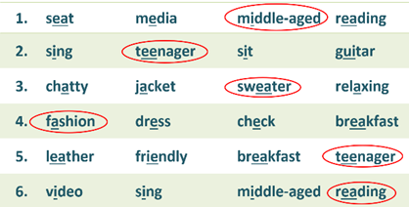
WRAP-UP & HOME WORK (3’)
- T asks Ss to talk about what they have learnt in the lesson.
- Review Unit 1 & 2 vocabulary and grammar.
- Review Unit 1 & 2 pronunciation.
HOME WORK
- Prepare for MID-TERM TEST 1.

Date of planning:  Date of teaching: | Period 49: REVISION

I. OBJECTIVES:
1. Knowledge: By the end of the lesson, ss will be able to:
- Vocabulary: revise the vocabulary which students have learnt from unit 1 to unit 4.
- Grammar: review the grammar points which students have learnt from unit 1 to unit 4.
- Pronunciation: review the pronunciation of the following sounds: /æ/ and /e/, /i:/ and /ɪ/, rhythming words and word stress.
2. Competence: SS can revise the language they have learnt and the skills they have practiced in Units 1 – 4. Use the vocabulary of the units, and do the tasks assigned in the textbook. Participate in a guided conversation to give and respond to the news using the given information.
3. Quality/ behavior: Having a positive attitude towards the lesson and a good relationship with friends. The love of learning English. Hard-working; attentive; cooperative; sociable; good communication in class.
II. TEACHING AIDS:
- Teacher: Textbooks, laptop, loudspeaker, projector…
- Students: Grade 7 textbook, Unit 1, 2, 3&4 (SB p. 18, 28, 38 & 48), studying equipment….
- Method: T-WC; group works; individual ……
III. PROCEDURE:
1. WARM UP (7’)
ACTIVITY 1
* Aim:
- To create a positive classroom atmosphere to start a new lesson.
- To lead into the lesson.
* Content: Play game Who’s faster?
* Products: Students’ correct answers
* Organization of implementation:
Teacher’s & Student’s activities | Content
1. Who’s faster?  - T gives and checks instructions for the game.  - T corrects Ss’ pronunciation if any. | Game rules:  - Read the instructions carefully.  - Think and say the answers aloud.  - 1 correct answer = 1 point.
2. REVIEW VOCABULARY UNITS 1 – 4 (19’)
ACTIVITY 2 - 4:
*Aim:
- To help students reviews topic words and word friends from the units 1 – 4.
- To review vocabulary with critical thinking.
- To review vocabulary in context.
* Content: Vocabulary of unit 1 – 4.
* Outcome: get more information and understand the vocabulary in context, do the exercises correctly.
* Organisation: Teacher’s instructions…...
Teacher’s & Student’s activities | Content
2. (7’) Activity 2:
- T tells students to open the Glossary box in the student book on page 18.
- T asks Ss to work in pairs: 1 student pronounces the word; 1 student writes it down. Then they swap their roles. Each student has 3 turns to do so. The Ss with more correct words is the winner.
- T corrects Ss’ pronunciation if any.
3. (5’) Circle the odd one out.  - T gives and checks the instruction.  - T set a time limit and asks Ss to work in pairs to read then complete the activity.  - T encourages students to give the reason for their answer.  - T checks as the whole class. | Answer keys:  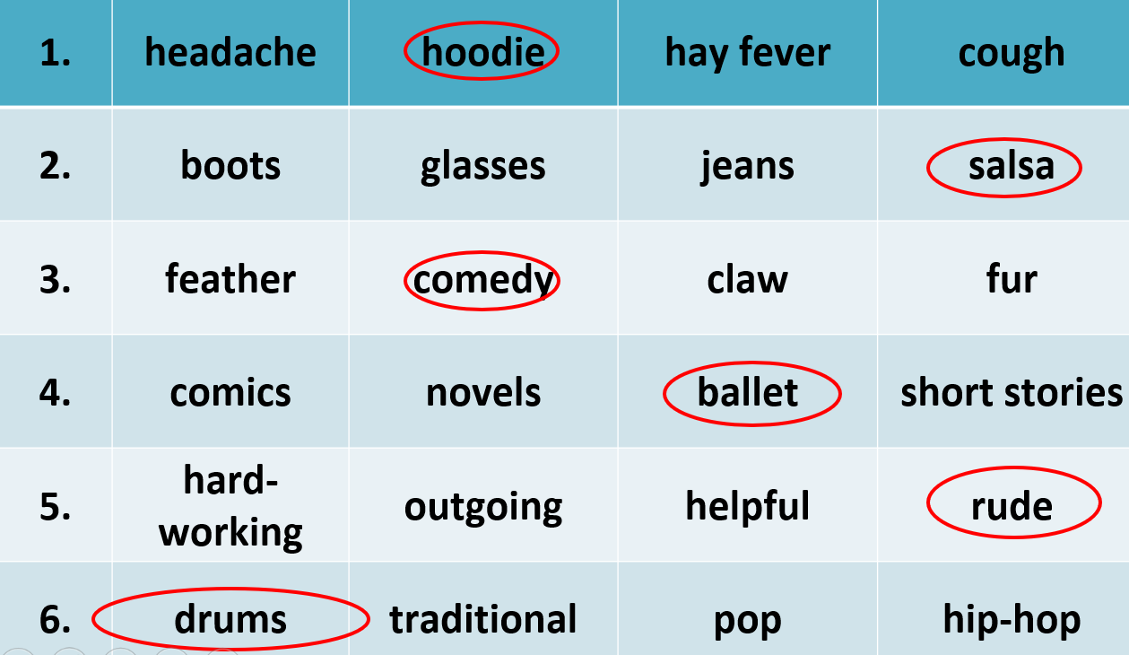
4. (7’) Fill in the blank with a suitable word. In pairs, say if the sentences are true for you.  - T calls a student to read the instruction then checks Ss’ understanding of it.  - T asks Ss to work in groups of four to read then complete the activity.  - Ss work in groups to complete the task and compare the answers.  - T checks as the whole class.  Exercise 2 - Time to talk:  - T asks Ss to work in groups to share their facts.  - Ss work in groups to say which statements are true for them. | Answer keys:  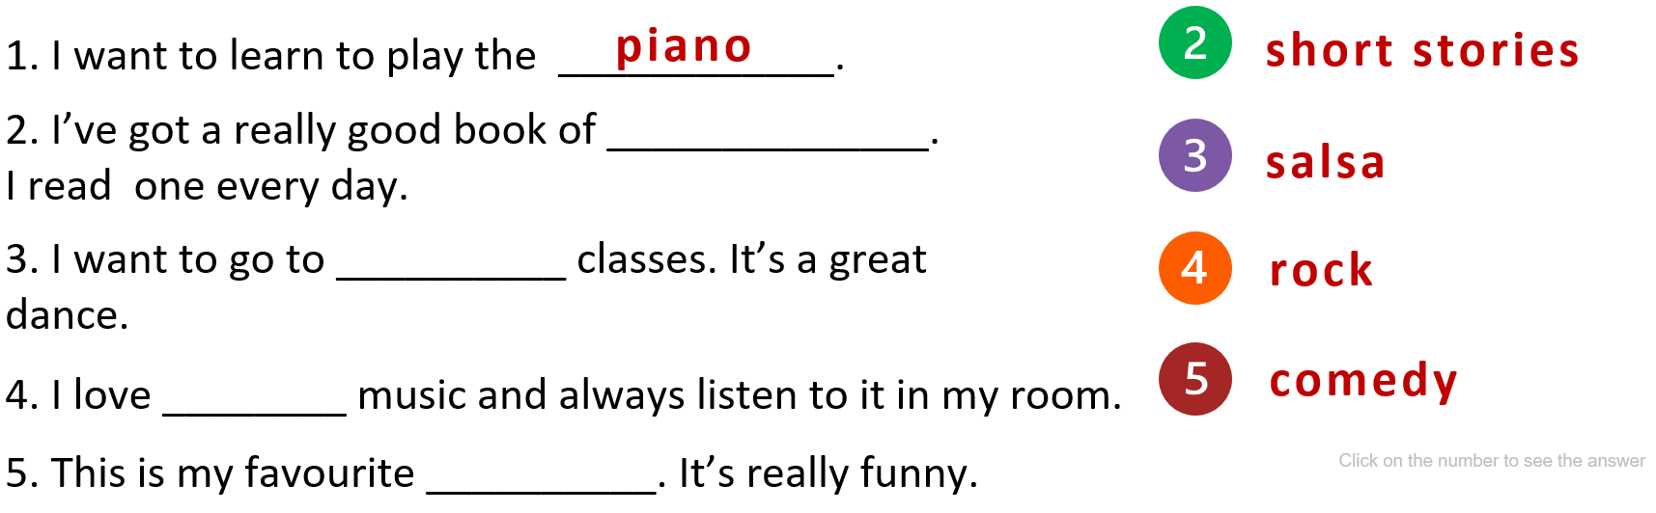  Example:  Number 1 is true for me. I’m cheerful.  Number 4 is not true for me.
3. REVIEW GRAMMAR (7’)
ACTIVITY 5:
*Aim: To help students revise grammar.
* Content: Pac-man game (past simple).
* Outcome: Give the correct answers.
* Organisation: Teacher’s instructions...

5. Pac-man game:  - T gives and checks instructions for the game.  - T corrects Ss if any. | Game rules:  - 2 teams take turns to answer questions.  - 1 correct answer = 10 points.  - The winning team = the team with a higher point.
4. REVIEW PRONUNCIATION (5’)
ACTIVITY 6:
*Aim: To help students review the sounds: /æ/ and /e/, /i:/ and /ɪ/.
* Content: Words with sounds /æ/ and /e/, /i:/ and /ɪ/.
* Outcome: Discuss and choose the correct word.
* Organisation: Teacher’s instructions…...
6. Circle the word which has the underlined part pronounced differently.  - T asks Ss to work in pairs, discuss and give answers.  - Ss work in pairs to discuss and answer.  - T corrects Ss’ pronunciation if any. | Answer keys:  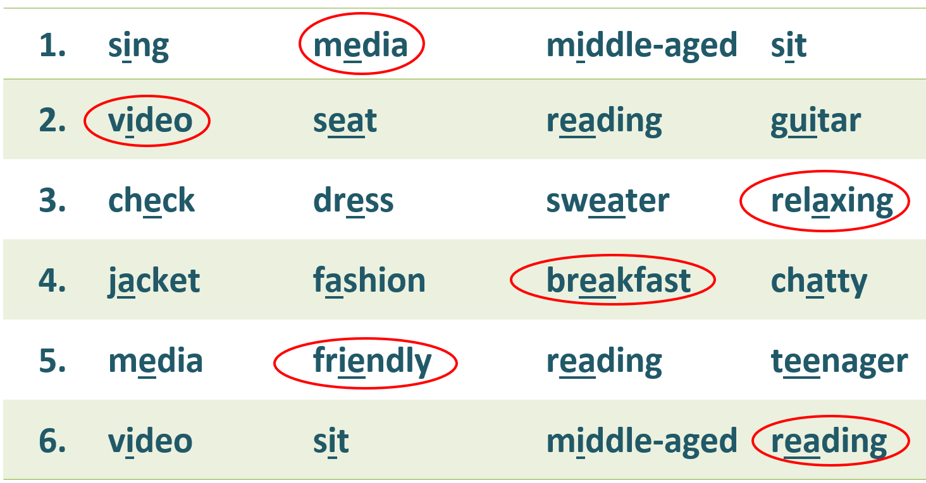
WRAP-UP & HOME WORK (2’)
- T asks Ss to talk about what they have learnt in the lesson.
- Review Unit 1 – 4 vocabulary and grammar.
- Review Unit 1 – 4 pronunciation.
HOME WORK
- Prepare for 1st term test.

Date of planning:  Date of teaching: | Period 50: THE FINALTEST FOR THE FIRST TERM

A. Objectives: By the end of the lesson, SS can review knowledge from unit 0 to unit 3. They will be able to realize their studying result and know how to learn to improve it.
1. Knowledge:
* Pronunciation: pronounce and stressed syllable
* Grammar - Vocabulary:
- Choose the best answer to complete the sentences.
* Reading:
- Read the passage and decide which statement is True (T), False (F) or Not Given (NG).
- Read the passage and choose the best answer.
* Writing:
- Put the words and phrases in the correct order to make complete sentences.
- Use the given words to make complete sentences. (2 points)
- Use the word in capitals to rewrite the sentences. Do not change the given word
2. Competence: SS will develop some competences such as working independently and being determined, using language in the right ways.
3. Behavior: Students are hard-working and serious.
B. Teaching aids:
1. Teacher: Textbooks, teaching plan, loud speakers, paper tests.
2. Students: Notebooks, pens…
C. Procedures:
The content of the test

ĐỀ PGD BA VÌ

Date of planning:  Date of teaching: | Period 51: CORRECTING THE FINALTEST FOR THE FIRST TERM
A. Objectives
1. Knowledge: By the end of the lesson, SS will be able to understand the test better. They will also develop the skill of doing a test and recognize their errors. They will know how to learn to get better results.
- Vocabulary: lexical items related to unit 0, 1,2,
- Grammar: The present simple and the present continuous.
2. Competence: They can self-evaluate their studying and have good plans to improve it.
3. Behavior: Students are hard-working and attentive. They will try their best to get better results.
B. Teaching aids:
1. Teacher: Textbooks, teaching plan, teacher’s book…
2. Students: Textbooks, notebooks…
C. Procedures:
1. Checking: During the lesson.
2. New lesson: Mid-term test correction (43’)
Teacher’s and Students’ activities | Contents
I. WARM UP (5’)  - Delivers the paper test.  II. PRESENTATION (25’) | - Receive the tests, check the answer.
CÂU | ĐÁP ÁN | ĐIỂM
- PRONUNCIATION  II. GRAMMAR-VOCABULARY  III. READING (2,5 p)  Read 1 :  Read 2 :  IV. WRITING  A. Writing 1 :  B. Writing 2 : 1,5 p  B. Writing 2 | 1- C 2- B 3- C 4- C 5 – B 6 - C  7. B 8.C 9. D 10. C  11. C 12. B 13. C 14. C  - T 16. NG 17. F 18. T  19. C 20. A 21. B 22. A  23. C 24. C  25. My favorite film is The Jungle Book.  26. In my free time, I sing and play the guitar.  27. They are going to / have a party this evening.  28. How often does Nam listen to the weather forecast the on radio?  29. I am into listening to pop music.  30. My father is interested in reading romantic novels.  31. She often goes to bed late but tonight she is going to bed early.  32. They are not taking part in the tournament this week.  33. I am not interested in listening to classical music 34.I feel relaxed to go for a walk in the park./ I feel relaxed when I go for a walk in the park . | 1.5 p : 0.25 p for each correct answer.  2.0 p : 0.25 p for each correct answer.  2.5 pts : 0,25p for each correct answer.  1p : 0.25p for each correct answer  2p : 0. 5p for each correct answer  1.0 p: 0.5 p for each correct answer.
III. REMARK – SOLUTION (8’)
- Strong points :
- Weak point :
IV. SUMMARY & HOMEWORK (2’)
- Do the test again.
Prepare next lesson : Clil 3

Date of planning:  Date of teaching: | Period 52: CLIL 3 - HISTORY
I. OBJECTIVES
By the end of the lesson, students are expected to achieve the following objectives:
- Read a text about the Temple of Literature – Văn Miếu.
- Identify the location of Văn Miếu, its construction, uses and other interesting information.
- Identify the historical events related to the building in specific years.
- Make notes about a historic building using a graphic organizer and the provided materials.
- Write a paragraph about a historic building using the notes, the history-related vocabulary items and Simple Past tense.
- Knowledge:
- Language lesson
- Vocabulary: Understand the meaning of the key words or word collocations related to Văn Miếu: temple, worship, Confucius, talented (people), (stone) stelae, outstanding, doctors, (show) respect (to).
- Grammar: Use the Simple Present and the Simple Past tense to provide general facts and describe past events of a historical site
- History lesson
- Have a better understanding of the history of Văn Miếu
- Be able to answer all the questions related to Văn Miếu
- Competencies:
- General competencies:
Form and/or improve such competencies as group work, independent working, pair work, linguistic competence, and cooperative learning.
- Specific competencies:
Improve competences related to language learning: reading, writing skills and the use of language (vocabulary, phonetics, grammar)
- For a language lesson: Students are expected to
- Use the Past Simple Tense to talk about the history of Văn Miếu and other historic sites in Việt Nam
- Understand the meaning of the keywords about Văn Miếu as well as the phrases and expressions used to describe a historic building
- For a skills lesson: Students are expected to
- Identify key information of the text about Văn Miếu through reading for general ideas and for specific details
- Develop a paragraph (60 – 80 words) about a historic site
- Qualities:
- Be hard-working and attentive in class
- Have better understanding of the Temple of Literatire – Văn Miếu
- Love history
II. PREPARATIONS
Teacher: Textbooks, worksheet, PowerPoint slides, video clip, TV, projector, loudspeaker
Students: Textbooks, notebooks
III. PROCEDURE
ACTIVITY 1: WARM-UP
- Aim: to get students be ready and excited about the lesson
- Content: guess the names of 5 historical sites
- Products: Ss give the correct names of the 5 historical sites
- Implementation:
TEACHER AND STUDENTS’ ACTIVITIES | CONTENTS
Step 1: Task delivering
- Have students look at the photos of 5 historical sites in Hanoi and guess their names: Thang Long Imperial Citadel, Ho Chi Minh Mausoleum, Hanoi Opera House, One Pillar Pagoda & Temple of Literature.

Step 2: Task performance
- Students say aloud the name of the historical places they can know.
Step 3: Report and discussion
- Teacher discusses with the students about the places and asks what the students know about each of them. Teacher draws students’ attention to the Temple of Literature.
Step 4: Judgment
Teacher comments on students’ answers. Teacher gets students to guess the theme of the lesson (History).
ACTIVITY 2: KNOWLEDGE FORMATION
Pre -reading
- Aim: to activate students’ prior knowledge about the topic.
- Content: Students work in pair to ask and answer some questions.
- Products: Students are able to apply their own words to answer the questions.
- Implementation:
TEACHER AND STUDENTS’ ACTIVITIES | CONTENTS
Step 1: Task delivering  - Teacher ask students to work in pairs to ask and answer the questions.  Step 2: Task performance  - Students work in pairs. One student asks and the other answers.  Step 3: Report and discussion  - Teacher asks some pairs to report their answers.  Step 4: Judgment  - Teacher comments on the answers. Teacher gets students to guess what they are going to learn about. This will lead to the lesson naturally. | Practice questions  - Have you ever been to the Temple of Literature? What for?  - What can you see at the Temple of Literature?  - Say at least 2 things you know about the building.
Pre-teaching of vocabulary
- Aim: To provide students with some lexical items before reading the text
- Content: Learn some vocabulary related to the topic
- Products: Read and understand the meaning of words
- Implementation:
TEACHER AND STUDENTS’ ACTIVITIES | CONTENTS
Step 1: Task delivering  - Teacher uses different techniques to teach vocabulary (pictures, situation, explanation, ...)  - Ask students to listen and repeat the words  Step 2: Task performance  - Students listen to the teacher and repeat the words in chorus and individually  - Copy all the words  Step 3: Report and discussion  - Call someone to read aloud all the new words  Step 4: Judgment  - Teacher checks and corrects students’ pronunciation | 1. temple / ˈtem.pəl/ (n)  a building used for religious worship  2. worship / ˈwɜː.ʃɪp / (v)  to have or show a strong feeling of respect and admiration for God or a god  3. Confucius /kənˈfjuː.ʃəs/ (n)  a Chinese philosopher, politician, and teacher, who lived from 551 - 479 BCE  => the temple to worship Confucius  4. talented / ˈtæl.ən.tɪd/ (adj)  having a natural ability to do something well  => talented people  5. stelae /ˈkəʊ.stəl/ (n)  a vertical piece of stone with writing cut into it, often used in the past as a gravestone  => stone stelae  6. outstanding /ˌaʊtˈstæn.dɪŋ/ (adj) very much better than usual; excellent  7. doctor /ˈdɒk.tər/ (n)  a person who holds a doctorate  => outstanding doctors  8. respect /rɪˈspekt/ (n)  admiration felt or shown for someone or something that you believe has good ideas or qualities  => show respect to
ACTIVITY 3: PRACTICE While – reading
Task 1
- Aim: To provide students with the main idea of the text and give them a reason/ motivation to read
- Content: Students circle the location of Văn Miếu on the map
- Products: Students locate the exact location of Văn Miếu on the map
- Implementation:
TEACHER AND STUDENTS’ ACTIVITIES | CONTENTS
Step 1: Task delivering  - Teacher asks students to look at Student’s Book page 105, read the text and look at the map in task 1, then work individually to circle the location of Văn Miếu  Step 2: Task performance  - Students work individually to circle the location of Văn Miếu on the map  Step 3: Report and discussion  - Teacher calls some students to answer  Step 4: Judgment  - Teacher checks and corrects students’ pronunciation  - Teacher checks the exercise with the students | Exercise 1  Answers: A
Task 2
- Aim: To get students to practice their comprehensive reading skills and help them understand more deeply the content of the text
- Content: Read the text and answer the questions
- Products: Students answer the questions correctly
- Implementation:
TEACHER AND STUDENTS’ ACTIVITIES | CONTENTS
Step 1: Task delivering  - Teacher asks students to look at task 2 page 105, read the text again and work in groups of four to answer the questions.  - Teacher asks them to locate the information.  Step 2: Task performance  - Students work in group to read the text again and discuss the questions in the task.  - Then underline the information they found in the text.  Step 3: Report and discussion  - Invite members of some groups to answer the questions.  Step 4: Judgement  - Teacher checks the answers with the whole class. | Exercise 2  1. In 1070, King Lý Thánh Tông bulit the Temple of Literature.  2. The Temple of Literature – Văn Miếu was finished.  3. In 1253, King Trần Thái Tông opened the school (Quốc Tử Giám) to everybody.  4. In 1484, King Lê Thánh Tông started to build stone stelae on tortoises to honor the most outstanding doctors.
ACTIVITY 4: APPLICATION Post – reading
      - Aim:
- To help personalize students’ own opinions about a religious activity Vietnamese people often do at Văn Miếu.
- To help students reflect on what they’ve learnt and apply the learnt knowledge to write a paragraph about a historic building.
      - Content:
- Give reasons for why or why not visit Văn Miếu prior to an important exam
- Search for information about a historic site, then write a paragraph (60 – 80 words) about it and present in front of class
3. Products: Students can express their own opinions about Văn Miếu; develop a complete paragraph about a historic site and make a presentation about it
4. Implementation:
TEACHER AND STUDENTS’ ACTIVITIES | CONTENTS
Task 3  Step 1: Task delivering  - Teacher asks students to work in pairs to give reasons for why they would or wouldn’t visit Văn Miếu if they have an important exam.  - Ask them to take note of their own answers on the notebooks.  Step 2: Task performance  - Students work in pairs to discuss the task and take note the answers on the notebooks.  Step 3: Report and discussion  - Teacher calls some pairs to give the answers.  Step 4: Judgement  - Teacher checks and gives feedback.  Task 4  Step 1: Task delivering  - Teacher provides students with simple reading materials about some historic buildings in Việt Nam.  - Teacher asks students to read through all the questions of the task and guides them on how to make notes of key information while reading the given materials by using a graphic organizer.  - Teacher gives an example of the graphic organizer using the reading text about Văn Miếu.  Step 2: Task performance  - Students create their own notes using the given reading materials or their own knowledge about a historic site.  - Teacher facilitates while students are making notes with the graphic organizer.  - Students exchange their notes with a partner and check their friends’ one.  Step 3: Report and discussion  - Teacher calls some students to present what they have found about a historic site with their notes.  Step 4: Judgement  - Teacher checks and give feedbacks for their writing.  Task 5  Step 1: Task delivering  - Teacher has students complete the task by using their notes in task 4 and the sample text about Văn Miếu.  Step 2: Task performance  - Students write a full paragraph (60 – 80 words) based on the graphic organizer.  - Teacher facilitates while students are writing.  - Students exchange their writing to check their friends’ one.  Step 3: Report and discussion  - Teacher calls some students to show their writing on the board.  Step 4: Judgement  - Teacher checks and give feedbacks for their writing.  ***T might ask Ss to prepare this content in advance so their writing can be better and more diverse. | Exercise 3  Students’ own answers.  Exercise 4  Graphic organizer illustration
  The Temple of Literature – Văn Miếu
  Where |  | …
  Who & When |  | …
  What happened | In 1070 | …
  What happened | In 1076 | …
  What happened | In 1253 | …
  What happened | In 1484 | …
  Today’s uses |  | …
  Other interesting information |  | …
HOME ASSIGNMENT
- Students take note of the homework: Write a paragraph about a different historic site. Encourage them to ask or search for more information to put in the writing.
IV. FEED-BACK:
With class
………………………………………………………………………………
With class
………………………………………………………………………………
Notes:
…………………………………………………………………………………

Date of planning:  Date of teaching: | Period 53: CLIL 4: SCIENCE - ANTIBIOTICS
STAGE I. DESIRED OBJECTIVES
A. OBJECTIVES
By the end of the lesson, students are expected to achieve the following objectives:
1. Cognition/ knowledge:
- Read a text about Antibiotics – the important medicines in our live.
- Identify the main points of each paragraph.
- Identify the specific ideas in the text.
- Based on the text, present opinions about the reasons people often take unnecessary antibiotics.
- Use the internet to enhance the knowledge.
- Understand the meaning of the key words or word collocations about health and medicines.
- Use the grammar structures presented in the lesson: present simple tense, past simple tense.
2. Competencies:
General competencies:
- Develop communication and cooperative learning through pair work, group work.
- Develop self-study, problem-solving, and creativity by reading read for general ideas and for specific information about book information and detailed writing.
Specific competencies:
Improve competences related to language learning: reading, writing skills and the use of language (vocabulary, phonetics, grammar).
3. Attributes/ personal qualities:
- Show facts about antibiotics and the point of view about them.
B. LANGUAGE FOCUS
Key terms/ Vocabulary: antibiotic, medicine, infection, bacteria.
C. INSTRUCTIONAL RESOURCES
Textbooks, worksheet, video clip, TV, projector, loudspeaker
STAGE II. ASSESSMENT EVIDENCE.
Performance Tasks | Performance Products | Assessment Tools
1. In groups of four, discuss all what you know about antibiotics. Then share with the class. | Students’ discussion  Ss’ oral answers in at least 6 words. | T’s observation.  Peer’s correction  T’s feedback
2. Read the text and match the information A-D with sections 1-4. | Ss’ practice  Ss’ written answers | T’s observation.  Peer’s correction  T’s feedback
3. Read the text and decide whether the statements are true (T) or false (F). | Ss’ practice  Ss’ written answers | T’s observation.  Peer’s correction  T’s feedback
4. Work in pairs. Why do you think people often take unnecessary antibiotics. | Students’ discussion  Ss’ oral answers in at least 6 words. | T’s observation.  Peer’s correction  T’s feedback
5. Use the Internet to search for information. | Ss’ practice  Ss’ written answers | T’s observation.  Peer’s correction  T’s feedback
6. Write a report (60-80 words) about the information you find in Exercise 5. Present your report to the class. Remember to add pictures. | Ss’ practice  Ss’ written answers | T’s observation.  Peer’s correction  T’s feedback
STAGE III: TEACHING PROCEDURE/ LEARNING EXPERIENCES:
ACTIVITY 1: WARM-UP: BRAINSTORMING (5’)
Step 1: - Teacher asks students to work in groups of 4 or 5.
- Teacher asks each group to think and list out all the things they know about antibiotics.
- Then students discuss to answer the question: Should we take medicines whenever we get sick?
Step 2: Students work in groups.
Step 3: Teacher goes around the class to monitor and support each group.
Step 4: Teacher gives comments and invites 1 member from each group to answer the question. Teacher gets students to guess what they are going to learn about.
ACTIVITY 2: KNOWLEDGE FORMATION
Pre-teaching of vocabulary (5’)
Step 1: Teacher uses different techniques to teach vocab (pictures, situation, explanation, slides)
antibiotic /ˌæntibaɪˈɒtɪk/ (n) a medicine or chemical that can destroy harmful bacteria in the body or limit their growth.
medicine /ˈmedɪsən/ (n) treatment for illness or injury.
infection /ɪnˈfekʃən/ (n) a condition in which viruses that cause disease have entered the body.
bacteria /bækˈtɪəriə/ (n) the simplest and smallest forms of life.
- Ask students to listen and repeat the words.
Step 2: - Students listen to the teacher and repeat the words in chorus and individually
- Copy all the words
Step 3: - Call someone to read aloud all the new words
Step 4: - Teacher checks and corrects students’ pronunciation.
ACTIVITY 3: PRACTICE: While – reading
Exercise 2: Read the text and match the information A-D with sections 1-4. (5’)
Step 1: Teacher asks students to look at Student’s Book page 106, read (skim) the entire text in in 2 minutes.
Step 2: Students work individually to read and match the information.
Step 3: Teacher calls some students to answer, then calls others to give comments.
Step 4: Teacher checks and corrects students’ pronunciation
- Teacher checks the exercise with the students.
Answers:
1 B 2 C 3 D 4 A
Exercise 3: Read the text again and decide whether the statements are true (T) or (F) (5’)
Step 1: Teacher asks students to look at Exercise 2 - SB page 106, read (scan) the text more thoroughly in 3 minutes.
- Teacher ask them to identify the specific information.
Step 2: Students work individually to read the text again and do the exercise.
- Students underline the information they found in the text.
Step 3: Teacher invites some students to present about their answers, others give comments.
Step 4: Teacher checks the answer with the whole class.
Answers:
1 True 2 True 3 False 4 False 5 True
Exercise 4: Work in pairs. Why do you think people often take unnecessary antibiotics? (5’)
Step 1: Teacher puts students in pairs, has them to discuss the question with reasons.
- T sets a time limit for students to work in pair.
Step 2: Students work in pairs to discuss about the question.
- Students need to give reasons for their opinions.
- Teacher goes around the class, provides support when needed and takes note.
Step 3: Students volunteer to share about their answers with the class.
Step 4: Teacher gives comments.
ACTIVITY 4: APPLICATION Post – reading
Exercise 5: Use the Internet to search for information (10’)
Step 1: Teacher divides the class into group of 4 or 5.
- Teacher asks students to choose 1 topic and use their devices to search for the information.
Step 2: Members in each group assign the duties and choose their topic.
- Teacher ensures that students use their devices for the right purpose.
Step 3: Teacher goes around the class to monitor and take notes about students’ group work.
Step 4: Teacher checks and give feedbacks if needed.
Exercise 6: Write a report (60-80 words) about the information you find in Exercise 5. Present your report to the class. Remember to add pictures. (5’)
Step 1: Teacher has students complete the task by using the information they found in Exercise 5.
Step 2: Students write a short report (60 – 80 words) based on the information.
- Teacher facilitates while students are writing.
- Students exchange their writing to check their friends’ one.
Step 3: Teacher calls some students to show their writing on the board.
Step 4: - Teacher checks and give feedbacks for their writing.
***T might ask Ss to prepare this content in advance so their writing can be better and more diverse.
*Wrap-up: (3’) Ask students to answer the following question:
Question 1: What are antibiotics?
Question 2: Is it necessary to take antibiotics? Why?
Question 3: Before taking antibiotics, what should we do?
Question 4: Can you give some examples of good health habits?
* Assignments: (2’) Remind students to
- Write a short report about the other topics.

Date of planning:  Date of teaching: | Period 54: CLIL 5 : GEOGRAPHY
EXPLORE VIỆT NAM
I. OBJECTIVES
By the end of the lesson, students are expected to achieve the following objectives:
- Read a text about Da Lat – A famous sightseeing in Vietnam
- Identify the location of Da Lat, its special food, weathers and local attractions.
- Design a presentation of a famous sightseeing.
1. Knowledge:
- Language lesson
- Vocabulary: Understand the meaning of the key words or word collocations related to Da Lat: plateau, mountainous, destination, lakes, hills, forests, waterfall, attract, tourists.
- Grammar: Use the Simple Present and the Simple Past tense to
- Geography lesson
- Have a better understanding of Da Lat.
- Be able to answer all the questions related to Da Lat.
2. Competencies:
a. General competencies:
Form and/or improve such competencies as group work, independent working, pair work, linguistic competence, and cooperative learning.
b. Specific competencies:
Improve competences related to language learning: reading, writing skills and the use of language (vocabulary, phonetics, grammar)
- For a language lesson: Students are expected to
- Use the Simple Tense to talk about a sightseeing in Vietnam.
- Understand the meaning of the keywords about Da Lat as well as the phrases and expressions used to describe a sightseeing.
- For a skills lesson: Students are expected to
- Identify key information of the text about Da Lat through reading for general ideas and for specific details
- Develop a paragraph (60 – 80 words) about a famous sightseeing.
4. Qualities:
- Be hard-working and attentive in class
- Have better understanding of Da Lat
II. PREPARATIONS
Teacher: Textbooks, worksheet, PowerPoint slides, video clip, TV, projector, loudspeaker
Students: Textbooks, notebooks
III. PROCEDURE
ACTIVITY 1: WARM-UP
Aim: to get students be ready and excited about the lesson
Content: guess the names of 5 famous places in Da Lat.
Products: Ss give the correct names of the 5 famous places.
Implementation:
TEACHER AND STUDENTS’ ACTIVITIES |  |  |  | CONTENTS
Step 1: Task delivering  - Give 5 names of the famous places in column A with and get Ss match with the appropriate nouns in column B.  Step 2: Task performance  - Get Ss work in 3 minutes in group to match words in column A with words in column B.  Step 3: Report and discussion  - Call some Ss to give their answers.  Step 4: Judgment  - Give feedback to Ss’s answers  - Get Ss guess what the famous place is and encourage them to say something more about Da Lat if they can. |  |  |  | Key
  Xuan Huong | valley
  Love | Lake
  Cam Ly | mountain
  Langbiang | Garden
  Vegetable | waterfall
  Xuan Huong | lake
  Love | valley
  Cam Ly | waterfall
  Langbiang | mountain
  Vegetable | garden
ACTIVITY 2: KNOWLEDGE FORMATION
Pre -reading
Aim: to activate students’ prior knowledge about the topic.
Content: Students work in pair to ask and answer some questions.
Products: Students are able to apply their own words to answer the questions.
Implementation:
TEACHER AND STUDENTS’ ACTIVITIES |  | CONTENTS
Step 1: Task delivering
- Get Ss to work in pairs to list out all things they know about Da Lat.
Step 2: Task performance
- Get each group send one Ss go to the board and write down their list.
Step 3: Report and discussion
- Check Ss’ lists and get Ss add more information if they can.
Step 4: Judgment
- Teacher comments on the answers. Teacher gets students to guess what they are going to learn about. This will lead to the lesson naturally.
Pre-teaching of vocabulary
Aim: To provide students with some lexical items before reading the text
Content: Learn some vocabulary related to the topic
Products: Read and understand the meaning of words
Implementation:
TEACHER AND STUDENTS’ ACTIVITIES |  | CONTENTS
Step 1: Task delivering  - Teacher uses different techniques to teach vocabulary (pictures, situation, explanation, ...)  - Ask students to listen and repeat the words  Step 2: Task performance  - Students listen to the teacher and repeat the words in chorus and individually  - Copy all the words  Step 3: Report and discussion  - Call someone to read aloud all the new words  Step 4: Judgment  - Teacher checks and corrects students’ pronunciation |  | 1. plateau / ˈplæt.əʊ / (n) a large flat area of land that is high above sea level  2. mountainous / ˈmaʊn.tɪ.nəs / (v) having a lot of mountains  3. destination / des.tɪˈneɪ.ʃən / (n) the place where someone is going or where something is being sent or taken  4. lake / leɪk / (n) a large area of water surrounded by land and not connected to the sea except by rivers or streams  5. hill / hɪl / (n) an area of land that is higher than the surrounding land  6. forest /ˈfɒr.ɪst / (n) a large area of land covered with trees and plants, usually larger than a wood, or the trees and plants themselves  7. waterfall / ˈwɔː.tə.fɔːl/ / (n) water, especially from a river or stream, dropping from a higher to a lower point, sometimes from a great height  8. attract / əˈtrækt / (n) (of people, things, places, etc.) to pull or draw someone or something towards them, by the qualities they have, especially good ones:  9. tourist /ˈtʊə.rɪst/ someone who visits a place for pleasure and interest, usually while on holiday.
ACTIVITY 3: PRACTICE While – reading
Task 1
Aim: To provide students with vocabularies relating to some sightseeing in Da Lat
Content: Students match the words with the photos
Products: Students make a presentation about Da Lat
Implementation:
TEACHER AND STUDENTS’ ACTIVITIES |  | CONTENTS
Step 1: T ask delivering  - Teacher asks students to look at Student’s Book page 107, read the text and look at the pictures and given words in task 1, then work individually to match the pictures with the pictures.  Step 2: Task performance  - Students work individually to match the pictures with the answers.  Step 3: Report and discussion  - Teacher calls some students to give the answers  Step 4: Judgment  - Teacher checks and corrects students’ pronunciation  - Teacher checks the exercise with the students |  | Exercise 1  Answers: 1D; 2C; 3A; 4B
Task 2
Aim: to recall Ss’s knowledge about famous places in Da Lat relating to vocabularies in task 1
Content: Read the text and answer the questions
Products: Students answer the questions correctly
Implementation:
TEACHER AND STUDENTS’ ACTIVITIES |  |  | CONTENTS
Step 1: Task delivering
- Teacher asks students to look at the pictures and share with their partner what the pictures are.
Step 2: Task performance
- Students work in pairs to talk about the places they have known.
Step 3: Report and discussion
- Invite some pair to talk about the places they’ve known.
Step 4: Judgement
- Teacher checks the answers with the whole class.
Task 3
- Aim: To get students to practice their comprehensive reading skills and help them understand more deeply the content of the text
- Content: Read the text and answer the questions
- Products: Students answer the questions correctly
- Implementation:
TEACHER AND STUDENTS’ ACTIVITIES | CONTENTS
Step 1: Task delivering  - Teacher asks students to read text and answer the questions.  Step 2: Task performance  - Teachers gets Ss to underline the key words of each question to understand the meaning of the questions.  - Teacher have Ss read the text and find the information to write the answers.  Step 3: Report and discussion  - Teachers asks some Ss to show their answers.  - Teacher call some other Ss give feedback to Ss’s answers  Step 4: Judgement  - Teacher checks the answers with the whole class. | Exercise 3.  - Where is Đà Lạt?  It’s in Lâm Đồng province.  2. What is the average height of this city?  It’s 1,500m above the sea level.  3. Why does Đà Lạt have a mild and temperate climate?  Because there are many high mountains surrounding Đà Lạt.  4. What types of weather can you find in a day in Đà Lạt?  I can find 4 different types of weather in a day in Đà Lạt: wet and humid in the morning, hot at noon, cool in the afternoon and cold at night.  5. What is Đà Lạt famous for?  It is famous for lakes, hills, waterfalls, a variety of flowers, vegetables, fruits and plants.  6. How often does Đà Lạt Flower Festival take place?  It takes place every two years.
ACTIVITY 4: APPLICATION Post – reading
1. Aim:
- To help personalize students’ own opinions about Đà Lạt
- To help students reflect on what they’ve learnt and apply the learnt knowledge to make a presentation
2. Content:
- Work in group of 3 or 4, then search information in the internet to answer the questions.
- Add more pictures and make a presentation about Đà Lạt.
3. Products: Students can express their own opinions about Đà Lạt using both their own experience and what they have learnt in the paragraph.
4. Implementation:
TEACHER AND STUDENTS’ ACTIVITIES |  | CONTENTS
Task 4  Step 1: Task delivering  - Teacher asks students to work in group of 3 or 4 to search more information about Đà Lạt basing on the notes in task 4.  - Ask them to take notes on the notebooks.  Step 2: Task performance  - Students work in pairs to discuss the task and take note the answers on the notebooks.  Step 3: Report and discussion  - Teacher calls some Ss to give the answers.  Step 4: Judgement  - Teacher listens and gives feedback.  Task 5  Step 1: Task delivering  - Teacher gets Ss to work in group, add more information and pictures about Đà Lạt.  - Teacher has Ss present in front of the class about Đà Lạt.  Step 2: Task performance  - Students create their own notes using the given reading materials or their own knowledge about Đà Lạt.  - Teacher facilitates while students are making their presentation.  - Students work in group to finalize their presentation.  Step 3: Report and discussion  - Teacher calls the representative of each group to present their products.  Step 4: Judgement  - Teacher gets Ss give some feedback to other’s presentation.  - Teachers gives feedback to Ss’ presentation. |  | Exercise 4  Students’ own answers.
HOME ASSIGNMENT
- Students take note of the homework: Write a letter to your friend to talk about Đà Lạt. Encourage them to ask or search for more information to put in the writing.
IV. FEED-BACK:
With class
………………………………………………………………………………
With class
………………………………………………………………………………
With class
………………………………………………………………………………
Notes:
…………………………………………………………………………………
…………………………………………………………………………………

