Date of teaching: 21/3/2023 | PERIOD 81: UNIT 7- SHOPPING AROUND  Lesson 6: Speaking
I. OBJECTIVES:
By the end of the lesson, Ss will be able to:
- use vocabulary and phrases to talk about favorite subjects and activities at school.
1. Knowledge:
* Vocabulary: use the phrases to shop for clothes and other things
* Grammar: make a conversation at clothes shop.
2. Competence:
- General competences: form and / or improve such competences as group work, independent working, pair work, linguistic competence, and cooperative learning.
- Specific competences:
- Improve communicative competence related to the use of language (vocabulary, phonetics, grammar):
- For a language lesson: Ss are expected to use vocabulary and phrases to shop for clothes and other things, do the tasks assigned in the textbook.
- For a skills lesson: Ss are expected to make a conversation at a clothes shop.

3. Quality/behavior:
- Being hard-working and attentive in class
- Have a positive attitude towards the lesson
II. TEACHING AIDS:
- Grade 7 textbook, Unit 7 (SB p. 76, WB p.65)
- Computer (accessible to the Internet is the best)
- Projector / TV/ PPT slides / Active teach
LANGUAGE ANALYSIS

Vocabulary: Vocabulary at clothes shop.
Expressions:
- Shop for clothes and other things: Use a Speaking Box

ASSUMPTIONS
Anticipated difficulties | Solutions
1. Ss may use the structures while speaking incorrectly. | Keep the useful expressions on the board for reference.  Encourage peer-check.
2. Ss may not have sufficient speaking and co-operating skills. | Give clear instructions, give examples before letting Ss work in pairs / groups.  Provide feedback and help if necessary.

III. PROCEDURE:
1. WARM UP + LEAD-IN (5’)
* Aim:
- To create a positive classroom atmosphere to start a new lesson.
- To review words of clothes and other things.
- To lead into the topic.
* Content: Game (clothes and accessories)
* Outcome: Ss review vocabulary about school activities.
* Organization of implementation: T-Ss, Ss-Ss, Ss-T.
Teacher’s & Student’s activities |  |  | Content
Activity 1: Game  - T divides Ss into 4 teams.  - T gives the topic is clothes and accessories.  - When Ss finish the game, T tells Ss that, they are using the vocabulary to do some speaking tasks today.  - T writes the title of new lesson: Unit 7/ Lesson 7 - Speaking |  |  | Game rules:  - Time limitation: 1 minute for preparation and 3 minutes for writing.  - Ss take turns to write all clothes and accessories.  - 1 correct answer = 1 point.
2. PRE-SPEAKING (6’)
ACTIVITY 2:
* Aims:
- To activate Ss’ prior knowledge of the topic.
- To lead into the topic.
* Content:
- Listen to the dialogue and answer the questions.
* Outcome: Ss understand how to use the model questions and answers to talk about clothes and other things.
* Organisation: T-Ss, Ss-T, Pair work.
Teacher’s & Student’s activities |  |  |  | Content
Activity 2: Exercise 1 – SB p.76  Is Nam going to buy the red trainers? Listen and check.  - T shows pictures in SB p.76 on the slide.  - Ss work in pairs to describe them.  - T asks Ss answers from a few volunteers.  - T encourages Ss to guess Nam is going to buy the trainers or not and give reasons for their answers.  - T plays the audio for Ss to listen, note down any new words and details.  - Ss check their guess.  - T asks further questions relating to the audio.  + How much are the trainers?  + What size is Nam?  + Are the trainers fit?  - Ss work in pairs to role play the dialogue.  - T invites 2 groups to model in front of the class.  - Ss underline evidence from the dialogue and useful vocabulary/ structures that they can use later. |  |  |  | Answer keys:
3. WHILE-SPEAKING (24’)
ACTIVITIES 3, 4, 5, 6:
* Aims:
- To introduce the Speaking Box.
- To reinforce the expressions of shopping for clothes.
- To practice using the new expressions in contexts.
* Content:
- Study the Speaking box and find similar questions in the dialogue.
- Complete the dialogue.
* Outcome: Ss understand the dialogue about shopping.
* Organisation: T-Ss, Ss-T, Individual work.
Teacher’s & Student’s activities | Content
Activity 3: Exercise 2 – SB p. 76  In pairs, underline eight phrases that are in the dialogue.  - T goes through the Speaking box and asks students to find three similar questions in the dialogue.  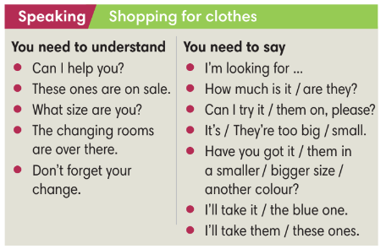  - When they have finished, T asks them to work in pairs to create a short conversation using these phrases.  - T invites different pairs to act out their dialogues in front of the class and the provide feedback. | Answer keys:  
Activity 4: Exercise 3 - SB p.76  Complete the dialogue with the phrases from the Speaking box. Listen and check.  - T asks Ss finish the dialogue and then check answers in pairs.  - T asks some pairs to read out loud in front of the class and other Ss give the comments.  - T plays the audio for students to check. | Answer keys:
Activity 5: Exercise 4 - SB p.76  Complete the sentences with one and ones.  - T asks Ss to look at the dialogue in Exercise 1 and 3 and explain the difference usage of one and ones.  - T asks Ss to finish Exercise 4.  Activity 6: Game  - T divides the class into 2 groups.  - Each team has 1 minute for preparation to write sentences describing the classroom.  - After 1 minutes, 1 representative from each team write all sentences on the board. The other team needs to write the follow-up sentence using one or ones.  Team A: This table is yellow.  Team B: But this one is black. | Answer keys:  - Each team has 1 minute for preparation to write sentences describing the classroom.  - After 1 minutes, 1 representative from each team write all sentences on the board. The other team needs to write the follow-up sentence using one or ones.  Team A: This table is yellow.  Team B: But this one is black.
4. POST-SPEAKING ( 8’)
ACTIVITY 7:
- *Aims: To help students applying the new language and skills related to the topic in communicating.
* Content: In pair, Ss make a conversation.
* Outcome: Ss can know how to buy and sell things.
* Organisation: T-Ss, Ss-Ss.
Teacher’s & Student’s activities |  | Content
Activity 7: Exercise 5 - SB p.76  In pairs, imagine you buy and sell things below, Student A is the customer, Student B is the shop assistant. Then change roles. Use the Speaking box to help you.  - T asks Ss to work in pairs for discussion.  - T invites 2 random students to make a conversation in front of the class. Other Ss listen and provide feedback.  - T tells students to look at the speaking box in their student book again and work in groups to prepare for the task.  - T set time for Ss to prepare and practice speaking.  - T walk around the class to listen and provide feedback.  - T asks 5 groups to practice the conversation in front of the class. |  | 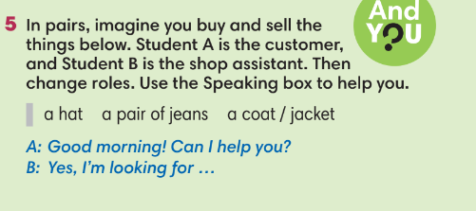
WRAP-UP & HOME WORK (3’)
- T asks Ss to talk about what they have learnt in the lesson.
- Shop for clothes and other things.
* HOME WORK
- Do exercises in the workbook page 65.
- Prepare for Lesson 7.7: Writing.

