Teaching date: 2/10/2023
UNIT 1: PEOPLE ARE PEOPLE
Lesson 1.7: Writing

I. OBJECTIVES
By the end of the lesson, Ss are expected to achieve the following objectives:
- Knowledge:
- Vocabulary: Adjectives to describe general appearance and personality; jobs, nationality, languages
- Grammar: and/but; present simple tense; have/has got; can/ can’t
- Competencies:
- General competencies:
Form and improve group work and independent working, pair work, and cooperative learning.
- Specific competencies:
Improve communicative competence related to writing skills and use of language (vocabulary, phonetics, grammar)
- For a language lesson: Ss are expected to know the meaning of the keywords used to describe a person (appearance, personality, clothes, etc.), the outline of a basic description, and understand the main grammatical points, then do the tasks assigned in the textbook.
- For a skills lesson: Ss are expected to use their writing skills to practice writing a description of their heroes.
- Qualities:
- Being hard-working and attentive in class
- Have a positive attitude towards the lesson
- Respect and treasure people around them
II. PREPARATIONS
Teacher: Textbooks, PowerPoint slides, Unit 1 Resource 9 Worksheet, TV, projector, loudspeaker
Students: Textbooks, notebooks
III. PROCEDURE
ACTIVITY 1: WARM-UP (5’)
- Aim: To recall words to describe people that they’ve learned in this unit.
- Content: Ss work individually under the instruction of T.
- Products: Ss are able to correctly answer the given questions by recalling words
- Implementation:
TEACHER AND STUDENTS’ ACTIVITIES | CONTENTS
Odd one out  Step 1: Task delivering  - T instructs S to do the task  Step 2: Task performance  - T shows an example with 4 words. Ss think and choose one that is different and explain why.  Step 3: Judgment  - T checks the exercise with the whole class.  Step 4: Report and discussion  - Repeat the process.  - T develops further discussion if needed. | Questions
  - friendly | blonde | long | dark
  - brave | funny | sweater | quiet
  - old | young | slim | clever
  - Spanish | French | Japan | Irish
  - footballer | cooker | actor | doctor
ACTIVITY 2: KNOWLEDGE FORMATION (10’)
- Aim: To introduce the objectives of the lesson with a can-do statement.
- Content: The objective of the lesson is listed as below
- I can write a short description of a person.
- Products: Ss acknowledge the lesson’s objectives
- Implementation: T introduces objectives to students
ACTIVITY 3: PRE-WRITING (15’)
- Aim: To analyze the writing samples.
- Content: Ss work individually and in pairs under the instruction of T to discuss and share their opinions and answers about the given passage
- Products: Ss can grasp the idea of what a description of a person look like
- Implementation:
TEACHER AND STUDENTS’ ACTIVITIES | CONTENTS
Lead-in  Step 1: Task delivering  - T shows a photo of Lionel Messi and encourages Ss to say what they’ve already known about him.  - Ss say what they’ve already known about him.  Step 2: Task performance  - T shows a photo of Jade Pryce and asks if Ss know her. She’s not famous so they don’t know her, of course.  - T tells Ss that 2 people wrote about Jade and Messi because they think Jade and Messi are heroes. (Explains the word “hero” if they don’t know.)  Step 3: Report and discussion  - Invite some Ss to discuss.  Step 4: Judgment  - Check with the whole class. | - Questions to elicit:  - What does he look like?  - What is his job?  - Where is he from? What is his nationality?  - What can/ can’t he do?  - Has he got any brothers or sisters?  - Is he married?  - Is he a great person?  - Is he famous?
Think Pair Share  Step 1: Task delivering  - T asks Ss to read the texts quickly and decide if Jade and Messi are heroes and why.  - T asks Ss to work in groups of 4 to share their ideas.  Step 2: Task performance  - Ss work in groups of 4 to share their ideas.  Step 3: Report and discussion  - T calls some volunteers to share with the whole class.  Step 4: Judgment  - Check with the whole class. | Exercise 1: Class vote. Read the text quickly. In your opinion, are Jade and Lionel heroes?  - The answer may vary.
Step 1: Task delivering  - T asks Ss to read the texts again and mark the sentences in exercise 2 true or false; then share with their partners.  Step 2: Task performance  - Ss do Exercise 2 and share with their partners.  Step 3: Judgment  - T calls some volunteers to check the answers.  Step 4: Judgment  - Check with the whole class. | Exercise 2: In pairs, read the texts again. Mark the sentences T (true) or F (false).  Answers:  1 T (She has health problems.)  2 F (She’s a good student.)  3 F (He’s from Argentina.)  4 T (He’s married and he’s got three children.)
Step 1: Task delivering  - T asks Ss to read the text quickly and tick the things the writer mentions in their descriptions.  Step 2: Task performance  - Ss read the text quickly and tick the things the writer mentions in their descriptions.  - T tells Ss to circle the words in each category that the writers used.  Step 3: Report and discussion  - Invite some Ss to present their works.  Step 4: Judgment  - Check with the whole class. | Exercise 3: In pairs, tick the things Karin and Paulo mention in their descriptions in Exercise 1.  Answers: 1, 2, 4, 5
ACTIVITY 4: WHILE WRITING (10’)
- Aim: To practice writing short sentences or a completed short description of a hero.
- Content: Ss work individually to accomplish the exercise given by T.
- Products: Ss are able to use the given guideline to develop their writing.
- Implementation:
Writing box  Step 1: Task delivering  - T and Ss discuss the phrases in the Writing box.  - T guides Ss to practice making sentences with Exercise 1 in RESOURCE 9.  Step 2: Task performance  - Ss practice making sentences with Exercise 1 in RESOURCE 9  Step 3: Judgment  - T and Ss check.  Step 4: Report and discussion  - T develops further discussion if needed. | Unit 1 RESOURCE 9 Worksheet – Exercise 1  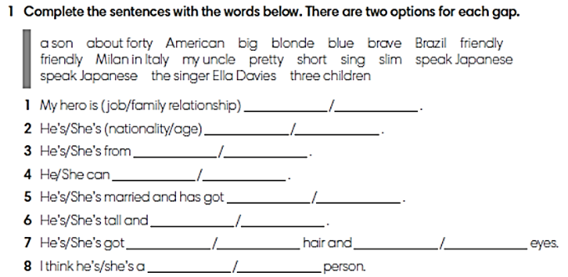  Answers:  1. my uncle/the singer Ella Davies  2. American/about forty  3. Brazil/Milan in Italy  4. sing/speak Japanese  5. a son/three children  6. pretty/slim  7. blonde/short, big/blue  8. brave/friendly
Guided writing  Step 1: Task delivering  - T tells Ss to think of a hero of their own and to complete the same sentences in a way that makes the sentences true about their hero. They can use the vocabulary from the previous activity, but they should also try to use different vocabulary where appropriate.  Step 2: Task performance  - Ss complete the same sentences in a way that makes the sentences true about their hero.  - T walks around to help. T asks them to complete their writing at home.  - For stronger students: They don’t have to follow the frame in exercise 2. They can write freely.  - T introduces the rubric to check:  - Is there a topic sentence?  - Is there a final sentence?  - Are there any vocabulary or grammar mistakes?  - Do you use linking words?  Step 3: Judgment  - Ss check their writings themselves when they finish with the rubric.  Step 4: Report and discussion  - T develops further discussion if needed. | Worksheet – Unit 1 Resource 9 – Exercise 2 (adapt Exercise 5 in SB)  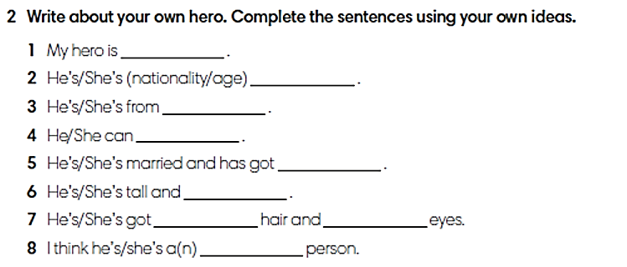
ACTIVITY 5: POST WRITING (5’)
- Aim: To revise their writings based on feedback from their partners.
- Content: Ss work in groups to cross-check their writing using the rubric
- Products: Ss have their writing checked and commented by their group mates and Teacher
- Implementation:
Step 1: Task delivering  - T give Ss instructions for the next task.  Step 2: Task performance  - Ss work in groups to swap their writings. They take turns to read their friends’ paragraphs and follow the rubric to check.  - Ss re-edit their paragraph if necessary.  Step 3: Judgment  - T walks around to take notes and give general comments.  Step 4: Report and discussion  - T develops further discussion if needed. | - Ss may say:  - I think it’s not a topic sentence.  - I think you have a mistake here. It should be …
HOME ASSIGNMENT  - T assigns the home assignments.  - Ss copy their home assignments.  - T explains it carefully. | - Do exercises 1,2,3,4,5 on Workbook page 13.  - Prepare Unit 1 Lesson 8 Pronunciation and Revision.

