Teaching date: 21/9/2023

Unit 1: LOCAL ENVIRONMENT
Period 8: Lesson 7 : looking back and project

I. Aims
- vocabulary relating to the handicrafts, places of interest
- Grammar: phrasal verbs, complex sentences
II. Objectives:
By the end of the lesson, Ss will be able to:
- revise the vocabulary, grammar they've learnt in Unit 1
III. Materials
Textbook, a cardboard for the word web activity
IV. WAYS OF WORKS:
T- Wc, Pairs work, Group works, Individual work
V. Procedure
A. Warm- UP:
Greets and checks attendance.
B./ Check- UP:
During the lesson
C./ New lesson:

Teacher’s activities | Students’ activities
Asks Ss to do the word web in pairs  Asks them to write on the cardboard  (pots, vases, paintings, drums, silk, lanterns, conical hats, lacquer ware, marble sculpture)  Do the task individually  Asks some Ss to read aloud their sentences  Comments and correct  Have Ss do the task individually  Asks them to compare with their partner  Comments and give correct answer  Have Ss complete the complex sentences with their own ideas  Ss do individually  Asks them to share their idea with each other  Asks Ss to do this task individually and then compare with partner  Have a S write the answer on the board  The others comment and correct  Asks Ss to work in groups  Example:  Is the place near the city centre?  Can we…  Do… | Vocabulary:  1. Write some traditional handicrafts in the word web  Handicrafts  2.Complete the second sentence  Keys:  1.cast 2. Embroidering 3. Wove  4. knitted 5. Carved 6. Mould  3. Complete the passage  do the task individually  compare with partner  Keys:  zoo 2. Looking forward to  3. looked 4. Team-building  5. lunch 6. Museum  7. craft 8. Interest  Grammar  4. Complete the complex sentences  do individually  share with the other  5. Rewrite the sentence  do this task individually and then compare with partner  comment and correct  Keys:  1.I don’t…when my parents set up this..  2. we have…can keep up with theirs  3. What time will you set off..?  4. We…..but she never turned up.  5. The artisans….can live on money from basket weaving.  Work in groups  One student thinks of a popular place of interest in their area.  Other s ask Yes/No questions to guess what place he/she is thinking about

Project: What makes you proud of your area?

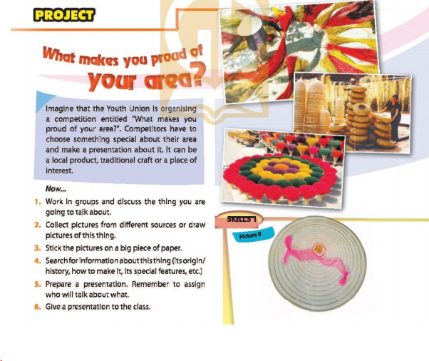
Good morning everyone, we are group 1. Today, we would like to present about Đông Hồ paintings.
Đông Hồ Painting is a kind of Vietnamese folk painting originating in Đông Hồ Village in Song Ho Commune, Thuận Thanh District, Bac Ninh Province. Đông Hồ paintings have about 300 years of history in the north of Vietnam.
……………………………………………………………………………………………………………………………………………………………………………………….
D. Consolidation
Guide students to do Finished
E. Homework
Review vocabulary and grammar of unit 1
Prepare: Unit 2: Getting started
-------------- --------------

