Date of planning:  Date of teaching: | ENGLISH 7  UNIT 1: CULTURE INTERESTS  Lesson 1: Vocabulary
I. OBJECTIVES:
By the end of the lesson, students will be able to:
- have an overview of the topic “Culture Interests”.
- use vocabulary and grammar points to talk about cultural activities, like and dislike.
1. Knowledge:
* Vocabulary: an understanding of the meaning of keywords or word collocations below:
Types of films | cartoons, comedies, documentaries, fantasy films, romantic films, science fiction (sci-fi) films, action films, horror films.  watching cartoons / comedies / documentaries / fantasy films, romantic films / science fiction (sci-fi) films / action films / horror films.
Things to read | comics, novels, short stories.  reading comics / novels / short stories.
Types of dance | ballet, salsa, zumba.  dancing ballet / salsa / zumba.
Musical instruments | drums, guitar, piano, violin.  playing drums / the guitar / the piano / the violin.
Types of music | classical music, hip-hop, pop, traditional rock.  listening to classical music / hip-hop / pop / traditional rock.

* Grammar: expressions to talk about likes and dislikes:

LIKES | DISLIKES
I like /  I’m interested in /  I love /  I really like /  I’m into | I hate /  I’m not into / I don’t like | + N / V-ing

2. Competence:
To know the meaning of the keywords used to talk about cultural activities, and understand the main grammatical points, then do the tasks assigned in the textbook.
3. Quality/Behavior: To teach Ss to be hard-working and attentive in class. Ss have a positive attitude to working in groups, individual work, pair work, cooperative learning and working.
II. TEACHING AIDS:
- Teacher: Grade 7 textbook, Unit 1 (SB p.14, WB p.6-7) , laptop/computer connected to the Internet, loudspeaker, projector/TV, PPT slides…
- Students: Text books, studying equipment…
- Method: Active teach, T-WC; group works; individual ……
III. PROCEDURE:
1. WARM UP( 3’)
* Aims:
- To activate Ss’ prior knowledge and get students involved in the lesson.
- To set the context for introducing new words.
* Content: Play Guessing game to get students involved in the lesson and to set the context for the lesson.
* Outcome: Students name some types of cultural activities they’ve already known.
* Organisation: Teacher’s instructions…

Teacher’s & Student’s activities | Content
Guessing game  - T explains the game rules then checks instructions.  - T sets the context for the lesson: Write the title on the board Unit 1: Cultural interests / Lesson 1.1: Culture.  - T asks Ss to name some types of cultural activities they’ve already known. | Game rules:  - Look at the pictures.  - Guess the activities.  - Choose 1, 2 or 3 then read the words.  - 1 correct answer = 1 point.
2. Presentation 1 (5’) VOCABULARY
(Types of cultural activities)
ACTIVITY 1:
* Aims:
- To reinforce the types of cultural activities that students have already known.
- To teach five types of cultural activities.
- To lead into the next activity.
* Content: Some brief notes; Some things about cultural activities.
* Outcome: Know new words about cultural activities.
* Organisation: Teacher’s instructions….

Teacher’s & Student’s activities |  | Content
1. What can you see in the photos. In pairs, match photos 1-5 with phrase a-e.  (Ex 1, p.10)  - T asks Ss to open their SB page 10, look at exercise 1.  - T calls a student to read the instruction then checks Ss’ understanding of it.  - T quickly checks Ss’ understanding of vocabulary in this by asking the question about each picture  Prompts:  (1) What’s he / she doing in picture ...?  (2) What are they doing in picture ...?  (3) In which picture, the girl / boy is ...?  (4) In which picture, the people are ...?  - T gives and check instructions for exercise 1 (SB page 10) then sets a time limit for Ss to complete it.  - Ss work in pairs to complete the matching.  - T checks as the whole class.  - T drills the vocabulary:  (1) dance  (2) reading  (3) musical instruments  (4) music  (5) cinema  Further discussion:  - T asks more questions to encourage Ss to think and speak.  (1) What types of dance / music / films / musical instruments do you know?  (2) Name some things you often read.  - T tells Ss that they are going to know more types of cultural activities in the next activity. |  | Answer keys:  a-4 / c-2 / d-5 / e-3
3. PRESENTATION 2 (9’)
(Cultural activities)
ACTIVITY 2:
* Aims:
- To pre-teach vocabulary of cultural activities.
- To introduce the vocabulary of cultural activities to Ss.
- To help Ss classify cultural activities and into types.
- To let Ss work cooperatively.
* Content: Some brief notes; Some things about cultural activities.
* Outcome: Know new words about cultural activities and classify them into types.
* Organisation: Teacher’s instructions …
Teacher’s & Student’s activities | Content
Extra activity 2 (4’): Balloon game  - T gives and checks instructions for the game.  - T waits 10 seconds for Ss to read each definition before clicks to show the balloons.  - T corrects Ss’ pronunciation if any.  2. (5’) Add the words below to the correct category. Listen and check.  (Ex 2, p.10)  - T asks Ss to look at excersise 2 (SB page 10).  - T calls a student to read the instruction then checks Ss’ understanding of it.  - T sets a time limit and asks Ss to work in groups of five to complete the exercise.  - T calls groups to give answers then checks as the whole class.  - T drills the vocabulary and corrects Ss’ pronunciation if any. | Game rules:  - Look at the pictures.  - Read the definitions.  - Choose the correct answer.  - 1 correct answer = 2 points.  Answer keys:  (2) horror films (3) short stories (4) zumba  (5) violin (6) rock
4. PRACTICE (14’)
ACTIVITY 3:
* Aims:
- To provide Ss with chances to practice pronouncing new words.
- To help Ss use the new vocabulary in collocations.
- To review and reinforce the expressions to talk about likes and dislikes.
* Content:
* Outcome:
* Organisation: Teacher’s instructions….
Teacher’s & Student’s activities | Content
3. (7’) Complete the sentences with the words below.  (Ex 3, p.11)  - T asks Ss to look at exercise 3 (SB page 11).  - T calls a student to read the instruction then checks Ss’ understanding of it.  - T asks Ss to read the given words aloud, checks their understanding of the words by asking them to do the corresponding actions.  - T sets a time limit and asks Ss to work in groups of four to complete the exercise.  - T calls groups to give answers then checks as the whole class.  - T corrects Ss’ pronunciation if any.  Further discussion:  - T asks Ss to underline the expressions to talk about likes and dislikes in exercise 3.  - T calls some volunteers to give answers then confirms with the whole class.  - T tells Ss that they are going to use those structures to talk about what they like and don’t like.  - T drills the structures. | Answer keys:  (2) listening (3) playing (4) taking  (5) acting (6) drawing (7) reading (8) watching
(7’) Extra activity 3: Pokemon game (Adapted from exercise 2 – Workbook p.6)  - T gives and checks instructions for the game.  - T monitors Ss while they are playing then confirms to answers.  - Ss work individually, rearrange words to make sentences, choose A, B or C.  - Ss raise their hand to give answers.  - T corrects Ss’ grammar and pronunciation if any. | Answer keys:  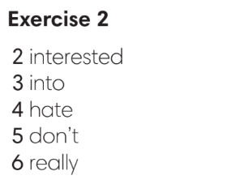
4. PRODUCTION (11’)
ACTIVITY 4:
* Aims: To help Ss practice applying the vocabulary items and grammar points related to the topic in speaking.
* Content: Ss work in groups to talk about their likes and dislikes.
* Outcome: Ss talk about their likes and dislikes using vocabulary and grammar points.
* Organisation: Teacher’s instructions…..
Teacher’s & Student’s activities | Content
4. In groups of four, talk about likes and dislikes. Use exercise 3 to help you.  (Ex 4, p.11)  - T asks Ss to look at excersise 4 (SB page 11).  - T calls a student to read the instruction then checks Ss’ understanding of it.  - T asks a pair to read the sample dialogue then asks some new pairs to make new dialogues to ask and answer about likes and dislikes.  - T divides Ss into groups of four, models the activity in front of the class then asks groups to make conversations about their likes and dislikes.  - T sets a time limit and monitors Ss while they are working in groups.  - T notes down common mistakes for delayed feedback.  - T calls some groups to come to the front of the class, make conversations to talk about their likes and dislikes.  - T asks the rest to give comments on their classmates’ performance.  - T gives feedback on Ss’ work. | 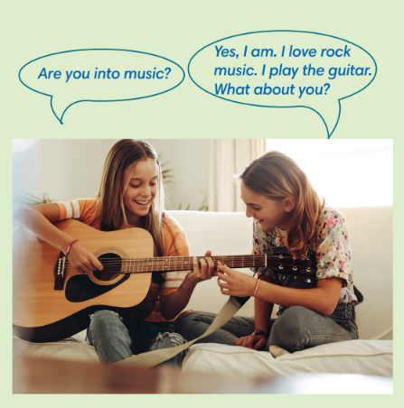

WRAP-UP & HOME WORK (3’)

- T asks Ss to talk about what they have learnt in the lesson.
- Vocabulary of types of cultural activities.
- Vocabulary of cultural activities.
- Grammar points: Expressions to talk about likes and dislikes.
* HOME WORK
- Do exercises in the workbook page 6-7.
- Prepare for Lesson 2: Grammar 1.

Date of planning:  Date of teaching: | UNIT 1: CULTURE INTERESTS  Lesson 2: Grammar
I. OBJECTIVES:
By the end of the lesson, students will be able to:
- use Present Simple to talk about habits, likes and dislikes.
1. Knowledge:
* Grammar:
- write affirmative and negative forms of the Present Simple tense correctly.
- use the Present Simple tense to talk about habits and routines.
2. Competence: Students know to use vocabulary about habits and routines, and understand the main grammatical points, then do the tasks assigned in the textbook; use the affirmative and negative forms in the present simple tense correctly to talk about habits and routines.
3. Quality/ behavior: To teach Ss to be hard-working and attentive in class. Ss have a positive attitude to working in groups, individual work, pair work, cooperative learning and working.
II. TEACHING AIDS:
- Teacher: Grade 7 textbook, Unit 1 (SB p. 12), laptop/computer connected to the Internet, loudspeaker, projector/TV, PPT slides…
- Students: Text books, studying equipment…
- Method: Active teach, T-WC; group works; individual ……
III. PROCEDURE:

1. WARM UP ( 4’)
* Aims:
- To activate students’ prior knowledge and get students involved in the lesson.
- To set the context for introducing new structures.
* Content: Play Guessing game to get students involved in the lesson and to set the context for the lesson.
* Outcome: Students know the context of the lesson.
* Organisation : T_ Ss , …
Teacher’s Student’s activities | Content
Extra activity 1: Guessing Game  - T divides Ss into 2 teams. Team boys and team girls.  - T explains the game rules then checks instructions.  - T corrects Ss if necessary.  - T set the scene for the new lesson: T tells Ss that these are activities we do regularly. Today we are going to learn the affirmative and negative forms in the Present Simple tense.  - T writes the title on the board Unit 1: Cultural interests / Lesson 1.2: Grammar | Game rules:  ✔ Look at the pictures.  ✔ Fill in the gap with the suitable words  ✔ 1 correct answer = 1 point.
2. LEAD-IN ( 3’)
* Aims: To lead into the new lesson.
* Content: Differentiate the people in the picture on the slide.
* Outcome: Make guesses about the picture then give answers.
* Organisation : T_ Ss , …
Teacher’s Student’s activities | Content
Extra Activity 2: See – think – wonder.  - T shows a picture on the slide then asks students four questions.  (1) What do you see in the picture?  (2) Do they look the same?  (3) Do you have brothers or sisters?  - T sets a time limit for Ss’ quick discussion.  - Ss work in pairs to make guesses about the picture then give answers.  - T calls some Ss to give answers then note them down on the board.  - T tells Ss that they’re going to read Rose’s blog in exercise 1 (SB p.12) to check all the answers. | 
3. PRESENTATION (9’)
(Questions and answers in the Present Simple tense)
ACTIVITY 1 + 2:
Aims:
- To present the grammar point in context.
- To lead into the next activity.
- To help Ss recognize the form of affirmative and negative in the Present Simple form.
- To provide Ss with chances to work cooperatively.
- To explain the grammar point for Ss.
* Content: Read Rose’s blog and find out new words. Learn the Present Simple.
* Outcome: Know more new words. Understanding the reading document; the topic of the lesson, grammar points…
* Organisation: T_ Ss , …
Teacher’s Student’s activities |  |  | Content
1. (5’) Read Rose’s blog. How are Rose and her sister, Violet different?  (Ex 1, p.12)  - T asks Ss to open their SB page 12, look at exercise 1.  - T calls a student to read the instruction then checks Ss’ understanding of it.  - T asks Ss to read the blog and fill in the gap with the missing information.  - Ss work individually.  - T calls some Ss to give answers then shows the answers on the slide.  - T asks Ss to look at the sentences and elicits the tense of those for Ss (affirmative and negative forms in the Present Simple tense). |  |  | Answer keys:  1. Violet studies classical music, but Rose studies art.  2. Violet reads novels and poems, but Rose doesn’t read much.  3. Violet watches TV, but it doesn’t interest Rose.  4. Violet writes poems, but Rose paints pictures.  5. Rose loves hip hop, but hip hop annoys Violet.
2. (4’) Find more examples of Present Simple in the text in Exercise 1.  (Ex 2, p.12)  - T asks Ss to look at exercise 2.  - T calls a student to read the instruction then checks Ss’ understanding of it.  - T asks Ss to work in groups of three to complete the activity.  - T calls groups to give answers then shows the answers on the slide to check as the whole class.  - T shows the affirmative and negative forms of the Present Simple tense then elicits information from Ss.  - T explains the grammar points and tells Ss that they’re going to use the Present Simple tense to talk about habits and routines.  - T circles and tells the class information about adverbs of frequency (use, position)  - T shows the grammar notes, then Ss can read aloud. |  |  | 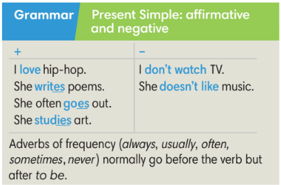
3. PRACTICE (19’)
ACTIVITY 3 + 4:
Aim:
- To help students practice completing the correct forms of the verbs with corresponding singular/plural subjects.
- To help students identify the correct form of the verbs in the present simple tense.
- To help students put adverbs of frequency in the correct positions
* Content: Complete the text/sentences with the correct form of the verbs.
Understand the text; grammar points; present simple tense..
* Outcome: Know how to form a sentence with the correct form of the verbs. Understand the conversation; the topic of the lesson, vocabulary, grammar points…
* Organisation : T_ Ss .…..
Teacher’s Student’s activities |  |  |  | Content
(6’) Extra activity 3: Minion game.  - T explains the game rules then checks instructions.  - Ss join in the game individually.  - T corrects Ss if any. |  |  |  | Game rules:  ✔ Read the sentence  ✔ Put the correct verbs in the brackets.  ✔ Raise your hand to give answers.  ✔ Get points.
3. (4’) Bookwork: Complete the text with the correct form of the verbs in the brackets.  (Ex 3 SB p.12)  - T asks Ss to look at exercise 3.  - T calls a student to read the instruction then checks Ss’ understanding of it.  - T asks Ss to work in individually.  - T calls students to give answers then shows them on the slide to check as the whole class.  - T corrects Ss if any. |  |  |  | Answer keys:  1. live  2. don’t go  3. watches  4. prefer  5. wins  6. doesn’t win  7. don’t play  8. play
4. (5’) Correct the information in the following sentences.  (Ex 4 SB p.12)  - T asks Ss to look at exercise 3.  - T asks Ss to correct the information in the following sentences.  - T corrects Ss if any. |  |  |  | Answer key:  2. One Direction don’t play classical music. They play pop music.  3. Director Tim Burton doesn’t make documents. He makes films.  4. J.K Rowling doesn’t act in films. She writes books.  5. Daniel Radcliffe and Emma Watson don’t paint pictures. They act in film.
(4’) Extra activity 4: Order the words to make sentences.  (Ex 5 WB p.8)  - T asks Ss to look at exercise 5.  - T asks Ss to order the words to make sentences.  - T corrects Ss if any. |  |  |  | Answer key:  2. I often play computer games with my friends.  3. I don’t understand Spanish.  4. I usually buy clothes online.  5. Our teacher doesn’t drive a car.  6. Tom is never late for class.
4. PRODUCTION ( 7’)
ACTIVITY 5:
*Aim: To help students applying the vocabulary items and grammar points related to the topic in communicating.
* Content: Ss describe themselves and their partners (what they like and dislike).
* Outcome: Ss know how to express themselves and describe others.
* Organisation: T_Ss…
Teacher’s Student’s activities |  | Content
5. In pairs or groups: Tell your class about you and your partner (what you like and dislike)  (Ex 5, p.12)  - T asks Ss to look at exercise 5 (SB page 12).  - T calls a student to read the instruction then checks Ss’ understanding of it.  - T models the activity in front of the class.  - T divides Ss into new pairs, asks them to make conversations to ask and answer about habits and routines.  - T walks around to listen and notes down common mistakes for delayed feedback.  - T calls some groups to come to the front of the class, and make conversations.  - T asks the rest to give comments on their classmates’ performance.  - T gives feedback on Ss’ work. |  | 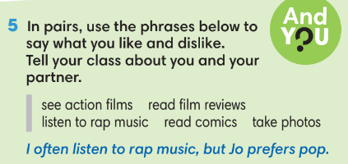
WRAP-UP & HOME WORK (2’)
- T asks Ss to talk about what they have learnt in the lesson.
✔ The present simple tense: affirmative and negative
✔ The adverbs of frequency
* HOME WORK
- Do exercises in the workbook page 8.
- Prepare for Lesson 1.3: Reading.

Date of planning:  Date of teaching:  WEEK: | UNIT 1: CULTURE INTERESTS  Lesson 3: Reading and Vocabulary
I. OBJECTIVES:
By the end of the lesson ss will be able to:
- find specific detail in an article and talk about age groups.
1. Knowledge:
* Vocabulary: an understanding of the vocabulary on age groups.

New words | Pronunciation | Definition | Vietnamese meaning
1. adults (n) | /ˈæd.ʌlt/ /əˈdʌlt | People that have grown to full size and strength. | Người lớn
2. kids (n) | /kɪd/ | Children | Trẻ con
3. middle-aged (adj) | /ˌmɪd.əlˈeɪdʒd/ | Being of the age intermediate between youth and old age, roughly between 45 and 65. | Trung tuổi
4. pensioners (n) | /ˈpen.ʃən.ər/ | People who receive a pension, especially the government pension given to old people. | Người được hưởng tiền trợ cấp/tiền dưỡng lão
5. teenagers (n) | /ˈtiːnˌeɪ.dʒər/ | Young people between 13 and 19 years old. | Thanh thiếu niên

* Grammar:
- Reading skills: the ability to find specific details in an article (scanning skill).
2. Competence: Understand know the meaning of the keywords used to talk about cultural activities, and understand the main grammatical points, then do the tasks assigned in the textbook; locate information and find specific details in an article (scanning skill); identify the main ideas of the paragraphs in the text or the text itself (skimming skill).
3. Quality/behavior: To teach Ss to be hard-working and attentive in class. Ss have a positive attitude to working in groups, individual work, pair work, cooperative learning and working.
II. TEACHING AIDS:
- Teacher: Grade 7 textbook, Unit 1 (SB p.13, WB p.9), laptop/computer connected to the Internet, loudspeaker, projector/TV, PPT slides …
- Students: Text books, studying equipment …
- Method: Active teach, T-WC; group works; individual …
III. PROCEDURE:
1. WARM-UP (5’)
* Aim:
- To help Ss review the use of adverbs of frequency in the Present Simple tense they have learnt in lesson 1.2.
- To lead into the next activity.
* Content: Game: Lucky Stars Game ( about watching habits)
* Outcome: Ss use adverbs of frequency in the Present Simple tense to talk about their watching habits.
* Organisation: T_ Ss …
Teacher’s &Student’s activities | Content
Extra activity 1: Lucky Stars Game  - T explains the game rules then checks instructions.  - T asks Ss the question “ Do you often watch TV?” after the last question of the game.  - Ss raise their hands if the answer is “Yes”.  - T will ask Ss to tell more about their watching habits in the next activity. | Game rules:  - Look at the timetable.  - Choose A, B or C to fill in the blank.  - Open the star to get point(s).
2. PRE-READING (3’)
ACTIVITY 1:
* Aim:
- To activate Ss’ background knowledge of the topic.
- To make students to move.
- To provide Ss with reasons for reading the text in the next stage.
- To lead in to the topic of the reading text.
* Content: To discuss Ss’s watching habits by reading, and answering T’s questions.
* Outcome: Know new words, and grammar points when talking about one’s habits.
* Organisation: T_ Ss …
Teacher’s & Student’s activities |  | Content
1. How many hours of TV do you usually watch after school?  (Ex 1, p.13)  - T shows the slide, reads aloud the question “How many hours of TV do you usually watch after school?”  - T asks a student to read the four options then model the corresponding poses on the slide.  - I never watch TV.  - Under one hour.  - One or two hours.  - More than two hours.  - T asks all Ss to stand up, give answers by doing the corresponding poses when the teacher mentions to.  - T sets the context for the lesson: Write the title on the board Unit 1: Cultural interests / Lesson 1.3: Reading and Vocabulary.  - T asks Ss to base on the answer to the above question and look at the title of the reading text, elicits from Ss what are they going to read about.  - T notes down Ss’ ideas on the board to check later. |  | 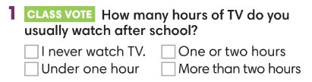
2. WHILE-READING (12’)
ACTIVITY 2 + 3:
*Aim: teach vocabulary in context:
- To encourage Ss to guess the meaning of new words in context.
- To teach topic-related vocabulary in context.
- To help Ss pull out tips for guessing the meaning of new words in the reading text.
* Content: To use the present simple to do the exercises.
* Outcome: To know more new words about habits. Understand more about using the words in contexts.
* Organisation: T_ Ss …
2. (5’) Read the first paragraph of the text. What do you think these phrases mean?  (Ex 2, p.13)  - T asks Ss to look at excersise 2 (SB page 13).  - T calls a student to read the instruction then checks Ss’ understanding of it.  - T sets a time limit and asks Ss to work in pairs to complete the activity.  - T elicits the ideas from Ss, asks them in which line of the paragraph they see the answers.  - T confirms the answers then drills the pronunciation of the phrases and corrects Ss’ pronunciation if any.  Further discussion:  - T and students discuss tips for guessing the meaning of new words in the reading text. |  | Answer keys:  a. a couch potato (n): someone who spends a lot of time sitting or lying on the sofa (or a couch) watching TV.  b. to have square eyes (v): to watch a lot of TV.
3. Find the following words in the text. What do they mean?  (Ex 3, p.13)  - T asks Ss to look at excersise 3 (SB page 13).  - T calls a student to read the instruction then checks Ss’ understanding of it.  - T guides Ss to find the words in the text.  - T sets a time limit and asks Ss to work in groups of three to complete the exercise.  - T calls groups to give answers then checks as the whole class.  - T confirms the answers then drills the vocabulary and corrects Ss’ pronunciation if any.  Further discussion:  - T and students may discuss the ages each word corresponds to. For example, a teenager is any age ending in-teen, but when does middle age start and finish, and do you become an adult at eighteen, twenty-one or some other age? |  | Answer keys:  1. adults (n): People that have grown to full size and strength.  2. kids (n): Children  3. middle-aged (adj): Being of the age intermediate between youth and old age, roughly between 45 and 65.  4. teenagers (n): Young people between 13 and 19 years old.  5. pensioners (n): People who receive a pension, especially the government pension given to old people.
3. PRACTICE (15’)
ACTIVITY 4 + 5:
* Aim:
- To help Ss practice reading for the main idea of each paragraph and matching the correct headings with the paragraph.
- To help Ss practice reading for specific information.
* Content: To match correctly the headings and the paragraphs by understanding the subject and the content of the given texts.
* Outcome: Understanding and explaining the meaning of the given texts. Using scanning skills for reading.
* Organisation: T_ Ss …
4. (7’) Read the rest of the text. Match headings a-e with paragraphs 1-4. There is one extra heading.  (Ex 4, p.13)  - T asks Ss to look at exercise 3 (SB page 13).  - T calls a student to read the instruction then checks Ss’ understanding of it.  - T asks Ss to read the given headings aloud, checks Ss’ understanding of them (by eliciting the ideas of what the headings could refer to. For example, a global change  could refer to a new TV habit taken up by people all over  the world, such as watching TV over the internet.  - T sets a time limit and asks Ss to work individually to complete the exercise.  - T calls Ss to give answers then checks with the whole class.  - T corrects Ss’ pronunciation if any.  Further discussion:  - T asks Ss to explain their answers by referring to the clues in the text.  Further discussion:  - T and students discuss tips for identifying the main idea of each paragraph in the long text. (This should be done after Ss complete paragraph 1). |  | 4. Answer keys:  1d / 2b / 3a / 4e
5. (5’) Cross The River Game.  (Adapt from Ex 5, p.13)  - T explains the game rules then checks instructions.  - T corrects Ss’ pronunciation if any.  Further discussion:  - T asks Ss to explain their answers. |  | Game rules:  - Choose numbers for questions.  - Choose A, B or C to answer.  - 1 fish = 1 correct answer  Answer keys:  1. 🗸  2. 🗸  3. x (They watch six hours a day.)  4. x (They spend the time on the internet.)  5. ? (It says they use the internet in their bedrooms but doesn’t mention TVs.)
(3’) Extra activity 3 – Gist Task: Look at the title of the reading text “Where are all the couch potatoes?”. Answer the question.  - T call a student to read the instruction on the slide then check the student’s understanding of it.  - T asks Ss to discuss in groups of five in 1 minute then volunteer to give answers.  - T accepts Ss’ answers and asks them to explain by giving clues from the reading text.  Further discussion:  - T tells Ss that they can use the tips as in doing exercise 5 to find the general idea of the text. |  | Answer:  - They are just back in their bedrooms surfing the internet.
4. PRODUCTION (7’)
ACTIVITY 6:
* Aim: To encourage Ss to talk about the watching habits of their family members using the topic-related vocabulary.
* Content: To discuss the SS’s family member’s watching habits.
* Outcome: Making sentences to talk about their family members’ watching habits. Commenting about the sentences of others.
* Organization: T, Ss...
6. The survey shows British people watch a lot of TV. What about you and your family?  (Ex 6, p.13)  - T asks Ss to look at exercise 6 (SB page 13).  - T calls a student to read the instruction then checks Ss’ understanding of it.  - T asks a student to read the example then models the activity in front of the class.  - T elicits more information on kinds of programs and favorite programs that different family members watch.  - T asks Ss to work in pairs and talk about their family members’ watching habits.  - Ss may use the result in class vote activity (activity 1) and adverbs of frequency they have learnt.  - T sets a time limit and monitors Ss while they are working in pairs.  - T notes down common mistakes for delayed feedback.  - T calls some pairs to come to the front of the class, make sentences to talk about their family members’ watching habits.  - T asks the rest to give comments on their classmates’ performance.  - T gives feedback on Ss’ work. |  |  | 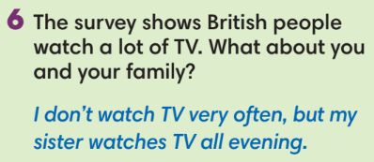
WRAP-UP & HOME WORK (3’)
- T asks Ss to talk about what they have learnt in the lesson.
- Vocabulary of age groups.
- Reading text about watching habits of different age groups.
* HOME WORK
- Do exercises in the workbook page 9.
- Prepare for Lesson 1.4: Grammar 2.

====================

Date of planning:  Date of teaching: | UNIT 1: CULTURE INTERESTS  Lesson 4: Grammar 2
I. OBJECTIVES:
By the end of the lesson students will be able to:
- ask and answer questions about habits and routines.
1. Knowledge:
* Vocabulary: about habits and routines.
* Grammar:
- write the questions and answers of the Present Simple tense correctly.
- use the Present Simple tense to ask and answer about habits and routines.
2. Competence: Understand and use vocabulary about habits and routines, and understand the main grammatical points, then do the tasks assigned in the textbook. Use the questions and answers in the present simple tense correctly to talk about habits and routines.
3. Quality/ behavior: To teach Ss to be hard-working and attentive in class. Ss have a positive attitude to working in groups, individual work, pair work, cooperative learning and working.
II. TEACHING AIDS:
- Teacher: Grade 7 textbook, Unit 1 (SB p. 14), laptop/computer connected to the Internet, loudspeaker, projector/TV, PPT slides…
- Students: Text books, studying equipment…
- Method: Active teach, T-WC; group works; individual ……
III. PROCEDURE:

1. WARM UP (5’)
* Aim:
- To create a positive classroom atmosphere to start a new lesson.
- To help Ss review the Present Simple tense they have learnt in Lesson 1.2.
* Content: Game: Tom & Jerry (with the simple present)
* Outcome: Ss use the correct form of the verb in the Present Simple tense.
* Organisation: T_ Ss ..….

Teacher’s & Student’s activities |  | Content
Extra activity 1: Tom & Jerry Game  - T asks Ss to prepare 3 letter cards A, B and C (T may ask Ss to prepare them before the lesson.)  - T explains the game rules then checks instructions.  - Ss join in the game individually.  - T corrects Ss if necessary.  - T set the scene for the new lesson: T tells Ss that they are going to learn the questions and answers in the Present Simple tense.  - T writes the title on the board Unit 1: Cultural interests / Lesson 1.4: Grammar 2. |  | Game rules:  - Read the sentence  - Put the verb into the correct verb form in the Present Simple tense.  - Show the letter card A, B or C to give answers.  - 1 correct answer = 1 point.  - 1 wrong answer => Tom catches Jerry.
2. LEAD-IN (15’)
*Aim:
- To lead into the new lesson.
- To provide Ss with reasons for listening to the dialogue in exercise 1 (SB p.14).
* Content: Ss answer the questions about the habits.
* Outcome: Get the right answers on time.
* Organisation: T_ Ss …

Teacher’s & Student’s activities | Content
Extra activity 2: See – think – wonder.  - T shows a picture on the slide then asks students four questions.  (1) What can you see in the picture?  (2) What are they doing?  (3) Can the boy play the guitar?  (4) Do you like playing the piano or the guitar in your free time?  - T sets a time limit for Ss’ quick discussion.  - Ss work in pairs to make guesses about the picture then give answers.  - T calls some Ss to give answers then note them down on the board.  - T tells Ss that they’re going to read the conversation in exercise 1 (SB p.14) to check all the answers. | 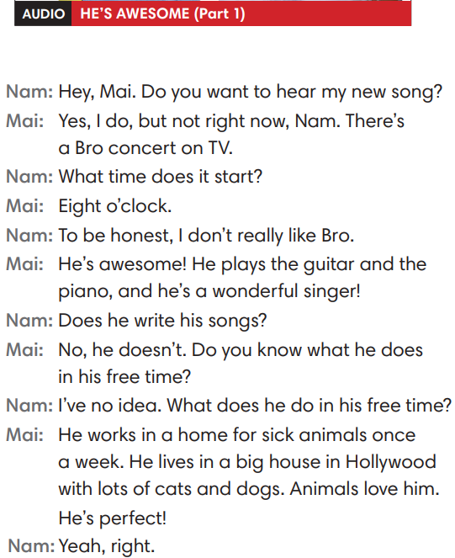
3. PRESENTATION (14’)
ACTIVITY 1 + 2:
*Aim:
- To present the grammar point in context.
- To lead into the next activity.
- To provide Ss with chances to spot the questions and answers in the Present Simple tense.
- To help Ss recognize the form of questions and answers in the Present Simple form.
- To provide Ss with chances to work cooperatively.
- To explain the grammar point for Ss.
- To introduce the everyday phrases and expressions pulled out from the conversation shortly.
* Content: To practice using the present simple in context, practice using adverbs of frequency in context by choosing the correct answer.
* Outcome: Practicing the use of the present simple by writing the correct form of the verbs, using adverbs of frequency in context.
* Organisation: T_Ss …

Teacher’s & Student’s activities | Content
1. Listen to part 1. Answer the questions below.  (Ex 1, p.14)  - T asks Ss to open their SB page 14, look at exercise 1.  - T calls a student to read the instruction then checks Ss’ understanding of it.  - T calls four students to read for questions.  - T tells Ss that they are going to listen to a conversation between Mai and Nam.  - Ss work individually, listen and note down the answers to the given questions.  - T calls some Ss to give answers then shows the answers on the slide.  - T asks Ss to look at the highlighted verbs in the above answers and elicits the tense of those from Ss (in the Present Simple tense). | Answer keys:  (1) It starts at eight o’clock.  (2) Mai thinks that Bro is awesome.  (3) He plays the guitar and the piano.  (4) He works in a home for sick animals once a week.
2. Find more Present Simple questions and answers in the dialogue.  (Ex 2, p.14)  - T asks Ss to look at exercise 2.  - T calls a student to read the instruction then checks Ss’ understanding of it.  - T asks Ss to work in groups of three to read the complete the activity.  - T calls groups to give answers then shows the answers on the slide to check as the whole class.  - T shows the interrogative form of the Present Simple tense (short questions / WH- questions) with missing words then elicits information from Ss.  - T explains the grammar points and tells Ss that they’re going to use the questions and answers in the Present Simple tense to talk about habits and routines. | 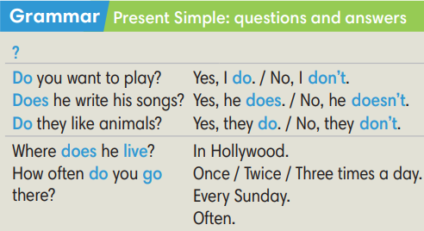
Extra activity 3: Read the phrases aloud. What do they mean? Use the dialogue to help you.  (Out of class box)  - T asks Ss to look at the Out of class box, find and underline the phrases in the dialogue.  - T calls students to read the phrases and asks for meaning based on the conversation.  - T corrects Ss’ pronunciation if any.  - T confirms the answers. | 
4. PRACTICE (13’)
ACTIVITY 3:
* Aims:
- To help Ss identify singular/plural subjects and use auxiliary verbs (do/does) correctly.
- To help students practice making questions and answers in the Present Simple tense for habits and routines.
* Content: Making questions; Listen to the audio track partners to answer the questions.
* Outcome: Making questions correctly. Then listen to choose the correct answers.
* Organisation: T_ Ss , Individual, Pair work, …
Teacher’s & Student’s activities | Content
Extra activity 4: Lucky stars game.  (Adapted from ex3 WB p.10)  - T explains the game rules then checks instructions.  - Ss join in the game individually.  - T corrects Ss if any. | Game rules:  - Read the sentence  - Fill in the blank with “do / does / don’t / doesn’t.”  - Raise your hand to give answers.  - 1 correct answer => choose a lucky star for points.
3. Make questions in the Present Simple. Listen to part 2 to answer the questions.  (Ex 3 SB p.14)  - T asks Ss to look at exercise 3.  - T calls a student to read the instruction then checks Ss’ understanding of it.  Step 1:  - T asks Ss to work in individually to read the written questions.  - T calls students to give answers then shows them on the slide to check with the whole class.  - T corrects Ss if any.  Step 2:  - T asks Ss to listen to part 2 of the dialogue to answer questions.  - T asks Ss to work in pairs, compare their answers with their partners.  - T calls students to give answers then shows the answers on the slide to check with the whole class.  - T corrects students if any. | 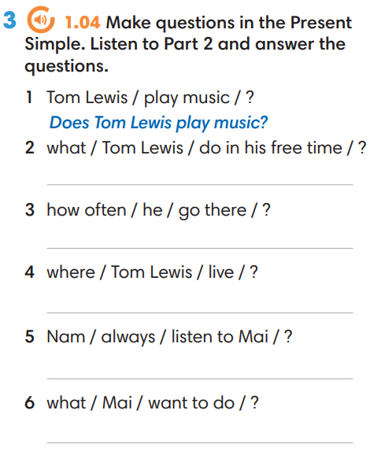
4. Production (7’)
ACTIVITY 4:
* Aims: To let Ss make conversations to ask and answer about habits and routines.
* Content: Making questions; Interview partners using the cues words.
* Outcome: Making questions correctly. Then Interview partners.
* Organisation: T_ Ss , Individual, Pair work, …

Teacher’s & Student’s activities | Content
4. In pairs, ask and answer questions about the activities below.  (Ex 4, p.14)  - T asks Ss to look at excersise 4 (SB page 14).  - T calls a student to read the instruction then checks Ss’ understanding of it.  - T models the activity in front of the class.  - T divides Ss into new pairs, asks them to make conversations to ask and answer about habits and routines.  - T gives a signal for Ss to change partners after every 3 minutes.  - T walk around to listen and notes down common mistakes for delayed feedback.  - T calls some groups to come to the front of the class, make conversations.  - T asks the rest to give comments on their classmates’ performance.  - T gives feedback on Ss’ work. | 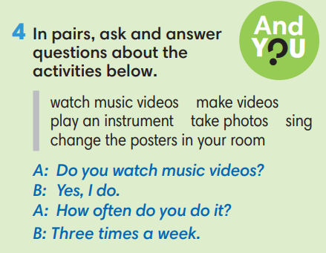
WRAP-UP & HOME WORK (3’)
- T asks Ss to talk about what they have learnt in the lesson.
✔ The present simple tense: questions and answers.
* HOME WORK
- Do exercises in the workbook page 10.
- Prepare for Lesson 1.5: Listening and vocabulary.

Date of planning: Date of teaching: | UNIT 1: CULTURE INTERESTS  Lesson 5: Listening and Vocabulary
I. OBJECTIVES:
By the end of the lesson student will be able to:
- identify specific details in a conversation and talk about media habits.
1. Knowledge:
* Vocabulary: use vocabulary of types of media to talk about media habits.
* Grammar: make sentences in the Present Simple with different personal pronouns correctly.
2. Competence: Understand and use the vocabulary of types of media and TV programs, do the tasks assigned in the textbook. Listen and identify specific details in a conversation and talk about media habits.
3. Quality/ behavior: To teach Ss to be hard-working and attentive in class. Ss have a positive attitude to working in groups, individual work, pair work, cooperative learning and working.
II. TEACHING AIDS:
- Teacher: Grade 7 textbook, Unit 1 (SB p. 15, WB p.11), laptop/computer connected to the Internet, loudspeaker, projector/TV, PPT slides …
- Students: Text books, studying equipment …
- Method: Active teach, T-WC; group works; individual …
III. PROCEDURE:
1. WARM UP + LEAD-IN (7’)
ACTIVITY 1:
* Aim:
- To create a positive classroom atmosphere to start a new lesson.
- To lead into the topic.
- To get students to think about the topic.
- To provide Ss with reasons for more discussions
* Content: Ss do the survey about the type of media that they’re using.
* Outcome: Name some types of media. Know more information about the media habits.
* Organisation: T_ Ss …
Teacher’s &Student’s activities | Content
1. (4’) Class Vote (SB p.15 - Ex 1)  - Set the scene: T tells Ss to look at the girl in Student book page 15. T asks some questions to elicit that the girl is going to do an interview about types of media.  - Teacher introduces the Vote and the survey questions in the student book.  - T explains How-to-vote steps then checks instructions.  - Ss join in the survey in pairs or in small groups.  - T sets the scene for the new lesson: T tells Ss that they are going to learn more words of media by doing a listening task.  - T writes the title on the board Unit 1: Cultural interests / Lesson 1.5: Listening and Vocabulary | How to vote:  - Read the questions  - Ask your classmates questions from 1-6  - Put a dot next to the type of media that you hear  - Answer your classmate questions if you are asked
Extra activity 1: (3’) Count and Announce  - T writes 4 types of media on the board: Newspaper, The Radio, The TV, and The Internet  - T asks students to count the number of the dots next to the name of media in their book.  - Ss work in pairs to count and tell teacher the answer.  - T asks some students to help with working out the most popular type of media in the class.  - T tells Ss that they’re going to learn more words of media in the next steps of the lesson. | 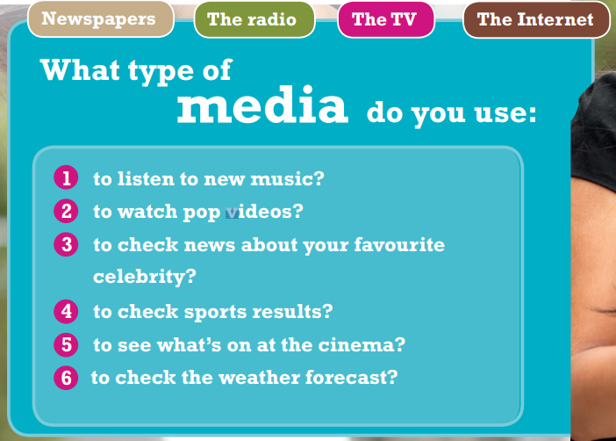
2. PRE-LISTENING (20’)
ACTIVITY 2 + 3:
*Aim:
- To activate Ss’ prior knowledge of the topic.
- To pre-teach words of news and entertainment
- To check Ss’ answers in “Think and Share” activity.
- To reinforce words of programs
* Content: Some brief notes; vocabulary about news and entertainment. Use them to complete the exercise.
* Outcome: Know some more new words about news and entertainment. Chose the correct words to answer the questions.
* Organisation: T_ Ss …
Teacher’s &Student’s activities | Content
Extra activity 2: (10’) Multiple Choice Game  (pre-teach vocabulary)  - Teacher introduces that Ss will learn more words of media by joining a game.  - T explains the game rules then checks instructions.  - Ss join the game in team. Ss take turns to answer each question.  - Teacher leads the game and asks students to read aloud each word or phrase.  - When the game ends, teacher shows all the new words again for students to read. | How to play:  - Look at the pictures and read the definitions  - Read the words of programs  - Choose 1, 2, or 3 to match the word with the picture  - 1 correct answer = 1 point
2. (4’) Think and Share.  (SB p.15 – Ex 2)  - T asks Ss to look at exercise 2.  - T calls a student to read the instruction then checks Ss’ understanding of it.  - T asks Ss to work in groups of three to read then complete the activity.  - T calls groups to give answers to check as the whole class. | 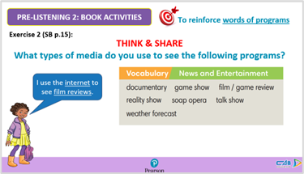
3. (3’) Use the Vocabulary box to complete the sentences. Change the words if necessary.  (SB p.15 - Ex 3)  - T asks Ss to look at exercise 3.  - T calls a student to read the instruction then checks Ss’ understanding of it.  - T asks Ss to work in pairs to read then complete the activity.  - T checks as the whole class. | Answer keys:  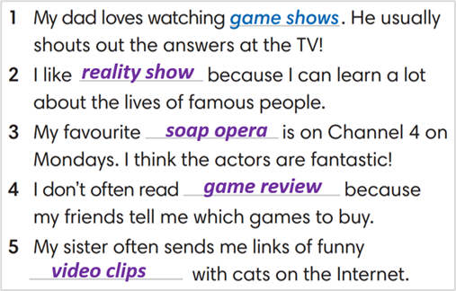
Extra activity 3: (3’) Match comments 1-6 with the types of media.  (WB p.11 - Ex 2)  - T asks Ss to look at exercise 2 in workbook page 11.  - T calls a student to read the instruction then checks Ss’ understanding of it.  - T asks Ss to work in pairs to read then complete the activity.  - T checks as the whole class. | Answer keys:  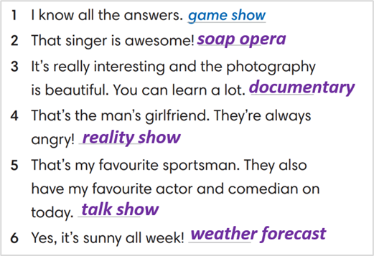
3. WHILE-LISTENING (8’)
ACTIVITY 4:
* Aim:
- To help Ss identify specific details in a conversation
- To provide Ss with chances to think and talk about personal media habits
* Content: Listen and understand to the audio track and complete the exercise.
* Outcome: Understanding the types of radio programs by matching the correct answers.
* Organisation : T_ Ss …
Teacher’s &Student’s activities | Content
4. Listen and match speakers 1-4 with the type of program they like a-e.  (SB p.15 - Exercise 4)  - T asks Ss to look at exercise 4 in student book page 15.  - T calls a student to read the instruction then checks Ss’ understanding of it.  - T asks students to look at the different kinds of programs and think of reasons why people might like these kinds of show.  - T asks Ss to work in pairs to listen then complete the activity and peer check for the first listening.  - T plays the audio again and checks as the whole class.  - Teacher asks students to give the evidence that they hear from the audio track to prove their answer. | Answer keys: 1-c, 2-e, 3-b, 4-a
4. POST-LISTENING (6’)
ACTIVITY 5:
*Aim: To help students applying the vocabulary items related to the topic in communicating.
* Content: Complete the sentences about the specific habits of each student. Share with partners their habits.
* Outcome: Think and share about individual habits.
* Organisation : T_ Ss ..
Teacher’s &Student’s activities | Content
5. Complete the following sentences to make them true for you. Then share with your partner  (SB p.15 - Exercise 5a & 5b)  - T asks Ss to look at exercise 5a in student book page 15.  - T calls a student to read the instruction then checks Ss’ understanding of it.  - T asks Ss to work in pairs to read then complete the activity.  - T sets a time limit for student.  - Students work in pair to think and share.  - Teacher invites different students to talk about their partner. | 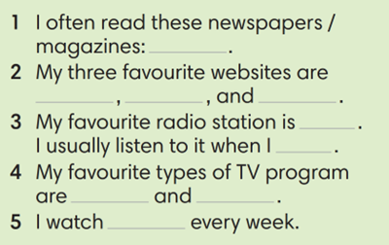
WRAP-UP & HOME WORK ( 2’)

- T asks Ss to talk about what they have learnt in the lesson.
- Vocabulary of types of media
* HOME WORK
- Do exercises in the workbook page 11.
- Prepare for Lesson 1.6: Speaking.

=====================

Date of planning:  Date of teaching: | UNIT 1: CULTURE INTERESTS  Lesson 6: Speaking
I. OBJECTIVES:
By the end of the lesson student will be able to:
- improve speaking skills by practicing say cinema expression to buy tickets.
1. Knowledge:
* Vocabulary: use vocabulary of types of films, time expression.
* Grammar: make dialogue in the Present Simple with cinema expressions.
2. Competence: Ss understand and use the vocabulary of types film and other related topics to the lesson content, do the tasks assigned in the textbook. Listen for comprehension and say cinema expression to buy tickets.
3. Quality/behavior: To teach Ss to be hard-working and attentive in class. Ss have a positive attitude to working in groups, individual work, pair work, cooperative learning and working.
II. TEACHING AIDS:
- Teacher: Grade 7 textbook, Unit 1 (SB p. 16, WB p.12), laptop/computer connected to the Internet, loudspeaker, projector/TV, PPT slides…
- Students: Text books, studying equipment…
- Method: Active teach, T-WC; group works; individual ……
III. PROCEDURE:
1. WARM UP + LEAD-IN (5’)
* Aim:
- To create a positive classroom atmosphere to start a new lesson.
- To review types of films
- To lead into the topic
* Content: Do mind-map for “Types of films”. Present their idea in front of the class.
* Outcome: Students share their knowledge about films, types of films…
* Organization of implementation: T- Ss …
Teacher’s & Student’s activities |  | Content
Extra activity 1: Mind-map  - T writes the words “TYPES OF FILMS” on board and asks students to work in pairs/small group.  - Students discuss and list out all words they remember from previous lesson.  - Students use a mind-map to present their ideas.  - Teacher encourages students to stand up and share their answers in front of the class.  - Teachers explains that students will use their knowledge about types of film to complete some tasks of the new lesson.  Unit 1 – Lesson 6: Speaking (At the cinema) |  | 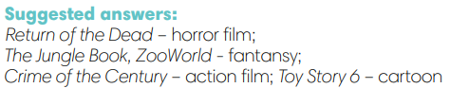
2. PRE-LISTENING (15’)
ACTIVITY 1 + 2:
* Aim:
- To activate Ss’ prior knowledge of the topic.
- To reinforce types of film
- To start a class discussion
- To listen and identify specific information to answer the questions
* Content: Some vocabularies related to films, and types of films. Listen to the conversation to answer the questions about Nam and Mai’s plan.
* Outcome: Knowledge about types of films. Understand the conversation.
* Organisation: Teacher’s instructions …

Teacher’s & Student’s activities |  |  | Content
1. (5’) Class vote  (SB p.16 – Ex 1)  - Set the scene: T tells Ss to look at the cinema program in Student book page 16. T asks some questions to elicit that the program tell students about the titles or the movies and when they start.  - Teacher introduces the Class Vote task in student book.  - T explains How-to-vote steps then checks instructions.  - Ss join in the survey in pairs or in small groups.  - T sets the transition for the next step of the lesson: “Now, let’s do a listening task to know Nam and Mai’s plan.” |  |  | How to vote:  - Read the program  - Say what types of films are on  - Answer the question for yourself “Which ones would you like to see”  - Use the given expression: “I think the … is a/an … film. I’d like to see it.”
2. (10’) Listen and answer the questions.  (SB p.16 – Ex 2)  - T asks students to look at the cinema program again and elicits some information about the program, tickets, seats and rows. (pre-teach the words if needed)  - T asks Ss to look at exercise 2.  - T calls a student to read the instruction then checks Ss’ understanding of it.  - T asks Ss to work in groups of three to listen for the first time  - Students works in pair to listen, answer, and compare their answers.  - T allows students to listen again, read the dialogue to double-check their answers.  - T calls groups to give answers to check with the whole class.  - T tells students to practice reading the dialogue again in a limited time. |  |  | Answer keys:  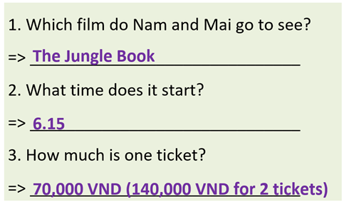
3. WHILE-SPEAKING (10’)
ACTIVITY 3:
* Aim:
- To reinforce the cinema expressions
- To practice the “buy ticket” dialogue
* Content: Complete the dialogue about buying tickets.
* Outcome: Understanding more about cinema expressions. Knowing the dialogue to buy movie tickets.
* Organisation: T_ Ss …
Teacher’s & Student’s activities |  |  |  | Content
3. Complete the dialogue below with one word in each gap. Listen again and check.  (SB p.16 - Exercise 3)  - T asks Ss to look at exercise 3.  - T goes through the Speaking box with students.  - T calls a student to read the instruction then checks Ss’ understanding of it  - Students find examples of the phrases in the dialogue.  - T asks Ss to work in pairs to read then complete the activity.  - T checks as the whole class.  - T sets a limit for students to work in pairs to practice the dialogue as a role play.  - T invites some pairs of students to act out the roleplay in front of the class.  - Ss work in pairs, practice the dialogue, then act out. |  |  |  | Answer keys:  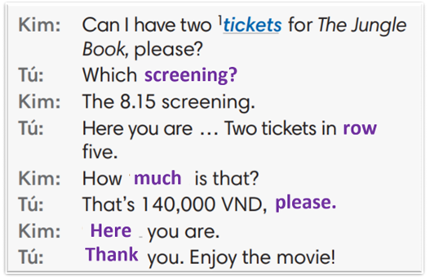
4. POST-SPEAKING ( 8’)
ACTIVITY 4:
*Aims: To help students applying the new language and skills related to the topic in communicating.
* Content: Ask and answer the questions to buy tickets for a film.
* Outcome: To practice speaking by asking and discussing the choices of films, and “buy ticket” related…
* Organisation: T_ Ss …

Teacher’s & Student’s activities | Content
4. In pairs, ask and answer to buy tickets for a film.  (Adaptation for Exercise 4 - SB p.16)  - T tells student to look at the speaking box in their student book again and prepare for the task.  - T gives students time to think about what they are going to say in their roleplays.  - T encourages stronger students to introduce a problem into their role play, e.g. the film is sold out, the only seats leaf are in the front row, there are two tickets left but they aren’t seated together.  - Students work in the same pairs from the last activity and practice their role plays, focus on using the correct intonation.  - Teacher invites pairs to act out their roleplays in front of the class. | 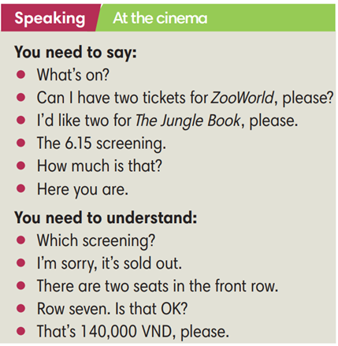
WRAP-UP & HOME WORK (2’)
- T asks Ss to talk about what they have learnt in the lesson.
Cinema expression
* HOME WORK
- Do exercises in the workbook page 12.
- Prepare for Lesson 1.7: Writing.

=====================

Date of planning:  Date of teaching: | UNIT 1: CULTURE INTERESTS  Lesson 7: Writing
I. OBJECTIVES:
By the end of the lesson, Ss are able to:
- write a personal introduction to a webpage.
1. Knowledge:
* Vocabulary: use vocabulary of common topics (age / school / places / subjects / foods, etc.) to write about personal information.
* Grammar: make sentences in the Present Simple tense correctly.
2. Competence: Ss understand and use the vocabulary of common topics (age / school / places / subjects / foods, etc.), do the tasks assigned in the textbook. Write a personal introduction for a webpage.
3. Quality/behavior: To teach Ss to be hard-working and attentive in class. Ss have a positive attitude to working in groups, individual work, pair work, cooperative learning and working.
II. TEACHING AIDS:
- Teacher: Grade 7 textbook, Unit 1 (SB p. 17, WB p.13), laptop/computer connected to the Internet, loudspeaker, projector/TV, PPT slides …
- Students: Text books, studying equipment …
- Method: Active teach, T-WC; group works; individual …
III. PROCEDURE:
1. WARM UP (4’)
* Aim:
- To create a positive classroom atmosphere to start a new lesson.
- To lead into the sample writing.
* Content: Game: Telepathy Game (about friends)
* Outcome: Ss guess and choose the correct picture.
* Organization of implementation:
Teacher’s & Student’s activities | Content
Extra activity 1: Telepathy Game  - Set the scene: T tells Ss that she / he’s going to give some sentences about her / his friends. Ss are going to play this game to find which friend she / he is talking about.  - T explains the game rules then checks instructions.  - Ss join in the game individually.  - T set the scene for the new lesson: T tells Ss that they are going to read and write about personal information in this lesson.  - T writes the title on the board Unit 1: Cultural interests / Lesson 1.7: Writing. | Game rules:  - Read the sentence  - Make guesses and choose A or B as the correct picture.  - 1 correct answer = 1 point.
2. LEAD-IN (3’)
* Aim:
- To get students to think about the topic.
- To provide Ss with reasons for reading the sample writing in exercise 1 (SB p.17).
* Content: Discuss groups and give the answer about the boy in the picture.
* Outcome: Guess the correct answers to the questions.
* Organisation: T_ Ss ..….
Teacher’s & Student’s activities | Content
Extra activity 2: See – think – wonder.  - T shows a picture of a boy on the slide then asks students four questions.  (1) How old is he?  (2) Which grade is he in?  (3) Where is he from?  (4) What’s his favorite subject?  - T sets a time limit for Ss’ quick discussion.  - Ss work in pairs to make guesses about the picture then give answers.  - T calls some Ss to give answers then note them down on the board for checking later.  - T tells Ss that they’re going to read the conversation in exercise 1 (SB p.17) to check all the answers. | 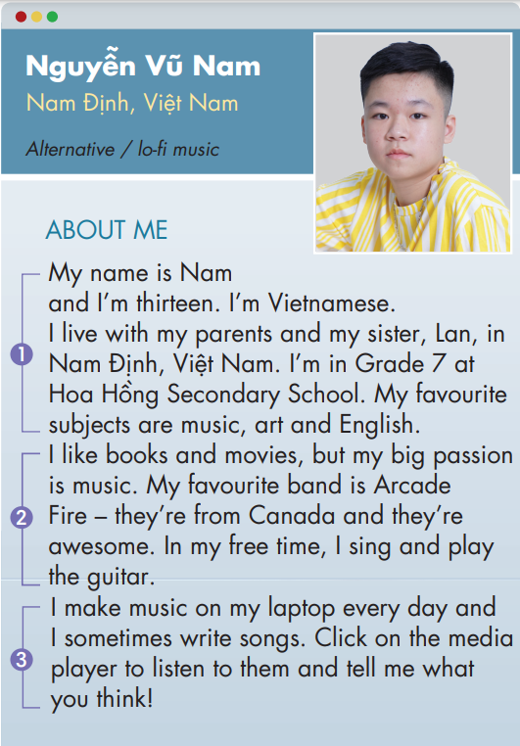
3. PRE-WRITING (13’)
ACTIVITY 1 + 2 + 3:
Aim:
- To activate Ss’ prior knowledge of the topic.
- To lead into the next activity.
- To check Ss’ answers in the “See – think – wonder” activity.
- To help Ss understand the sample writing.
- To help Ss focus on personal information while reading the sample.
- To provide Ss with useful expressions for writing a personal introduction.
* Content: Read Nam’s webpage to get used to writing skills
* Outcome: Do the exercise to improve writing skills.
* Organisation: T_ Ss ..….
Teacher’s & Student’s activities | Content
1. (3’) Class vote. Have you got a personal webpage?  (Ex 1, p.17)  - T calls a student to read the instruction then checks Ss’ understanding of it.  - T asks Ss if they’ve got a personal webpage.  - T shows slides to provide Ss with some clues.  - T names some types of social media and asks Ss to raise their hands if they’ve got accounts on one or some of them.  - T encourages Ss to name more webpages that they’ve joined.  - T tells Ss that they are going to look at Nam’s personal webpage in the next activity. |   Some types of social media:  
2. (4’) Read Nam’s webpage.  Step 1: Check your answers.  (Extra activity 3)  - T asks Ss to look at Nam’s webpage, read and compare with their answers in “See – think – wonder” activity.  - T checks with the whole class on the board.  Step 2: Which of the sentences are true. Write T.  (Ex 2, p.17)  - T asks Ss to look at exercise 2.  - T calls a student to read the instruction then checks Ss’ understanding of it.  - T asks Ss to work in groups of three to read then complete the activity.  - T calls groups to give answers then shows the answers on the slide to check as the whole class. | 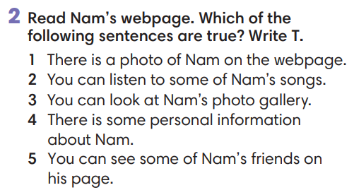
3. (3’) In pairs, read Nam’s personal information. Tick the things he writes about.  (Ex 3, p.17)  - T asks Ss to look at exercise 3.  - T calls a student to read the instruction then checks Ss’ understanding of it.  - T asks Ss to work in pairs to read then complete the activity.  - T checks as the whole class. | 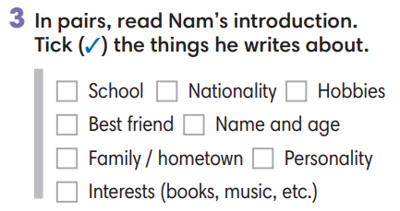
Extra activity 4: Look at the writing box. Which structures did Nam use? Underline.  - T asks Ss to look at the writing box and the sample writing again.  - T asks Ss to work individually, underlined the useful structures Nam used in his writing.  - T sets a time limit for the activity.  - T shows the slide and check as the whole class.
  Writing a personal introduction
  1. Personal details | My name is ….  I’m … years old.  I come from … [place] / I’m … [nationality]  I live with my family. / My hometown is …  I’m in Grade … at … school.
  2. Interests / Hobbies | I like / I’m into / I’m a big fan of ...  I’m interested in ... / My big passion is ...  My favorite is ...  In my free time, I ... / After school, I ...  I often ...
  3. Routines | I often / sometimes / usually ...  I ... once a week / every day.
4. WHILE-WRITING (17’)
ACTIVITY 4:
Aim:
- To help Ss identify correct personal information.
- To provide Ss with chances to think and write about their personal information.
- To help student practice writing a personal introduction for a webpage.
* Content: Use the writing box and Nam’s page to practice writing skills.
* Outcome: Write a personal introduction.
* Organisation: T_ Ss.. ….

Teacher’s & Student’s activities | Content
Extra activity 5: (4’) Mole hunt game.  (Adapted from ex3 WB p.13)  - T explains the game rules then checks instructions.  - Ss think and write individually then check sentences in pairs.  - T corrects Ss if any. | Game rules:  - Read the sentence  - Fill in the blank with A, B or C.  - Write the sentence in your notebook.  - 1 correct answer = 2 points.  - Check answers in pairs.
Extra activity 6: (5’) Write about you. Complete the sentences about you.  - T calls a student to read the instruction on the slide then checks Ss’ understanding of it.  - T asks Ss to work individually to complete the exercise.  - T sets a time limit for the task.  - T asks students to sit in pairs, compare their answers with partners.  - T calls some Ss to read their sentences.  - T corrects Ss if any. | 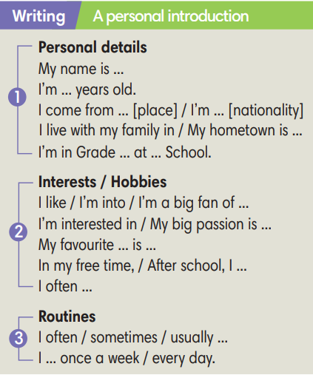
4. (8’) Write a personal introduction (60-80 words) for a webpage. Use the writing box and Nam’s page to help you.  (Ex 4 SB p.17)  - T asks Ss to look at exercise 4.  - T calls a student to read the instruction then checks Ss’ understanding of it.  - T asks Ss to work individually to write basing on the writing box and Nam’s page.  - T sets a time limits and walk around as a monitor while Ss are writing. | 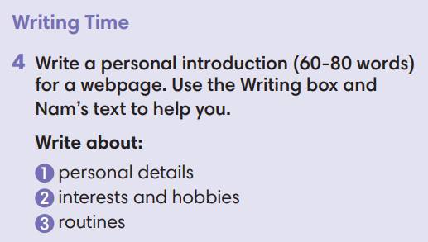
5. POST-WRITING (6’)
*Aim:
- To let Ss do peer-check.
- To give general comments on Ss’ writing pieces.
* Content: Ss swapping their writing in pairs.
* Outcome: Cross-check writing pieces and follow the writing rubric.
* Organisation: T_ Ss .…….

Teacher’s & Student’s activities | Content
Extra activity 7: In pairs, swap your writing then check.  (Ex 4, p.14)  - T explains the writing rubric before checking.  - T asks Ss to swap their writing pieces, use the given writing rubric then do cross-check.  - T gives feedback on common mistakes of Ss’ work.  - T may collect Ss’ writing for detailed comments. | Writing rubric:  (1) Does the writing include personal details, interests and hobbies, routines?  (2) Does the writing meet word limit (60-80 words)?  (3) Does the writing make any vocabulary and grammar mistakes?
WRAP-UP & HOME WORK (2’)
- T asks Ss to talk about what they have learnt in the lesson.
- A personal introduction for a webpage.
* HOME WORK:
- Do exercises in the workbook page 13.
- Prepare for Lesson 1.8: Self-check.

======================

Date of planning:  Date of teaching: | UNIT 1: CULTURE INTERESTS  Lesson 8: Vocabulary In Action and Pronunciation
I. OBJECTIVES:
By the end of the lesson student will be able to:
1. Knowledge:
* Vocabulary: review vocabulary
- The lexical items related to hobbies: types of film, types of radio/TV programs, type of music, things you can read.
- Verbs of liking and disliking
* Pronunciation: Correctly pronounce words that contain the sounds /ɪ/ and /i:/
2. Competence: Students develop communication skills, presentation skills, and creativity; being collaborative and supportive in pair work, teamwork, and actively join in class activities.
3. Quality/behavior: To teach Ss the love of talking about their hobbies, and develop self-study skills. Ss have a good attitude to working in groups, individual work, pairwork, cooperative learning, and working
II. TEACHING AIDS:
- Teacher: Grade 7 textbook, Unit 1 (SB p.18, WB p.14), laptop/computer connected to the Internet, loudspeaker, projector/TV, PPT slides… .
- Students: Text books, studying equipment…
- Method: Active teach, T-WC; group works; individual ……
III. PROCEDURE:
1. WARM UP + LEAD-IN (4’)
*Aims:
- To create an active atmosphere in the class before the lesson.
- To lead into the new lesson.
* Content: Game: NAME 3 THINGS CHALLENGE (culture interests)
* Outcome: Students say words relating to the given topic quickly.
* Organisation : Teacher’s instructions…
Teacher’s & Student’s activities | Content
Extra activity 1: NAME 3 THINGS CHALLENGE  * Teacher asks students to spend 1 minutes to quickly review all vocabulary they have learnt in Unit 1 before they play a warm-up game.  - T tells students that they are going to play a game called NAME 3 THINGS CHALLENGE  - T explains the game rules then checks instructions.  - Teacher uses the slides to show the challenge  - Ss join in the game pairs or in small groups.  - Teacher listens to the Ss answers and calls several Ss to check for the whole class.  - T tells Ss that they can remember better with Glossary Table and asks Ss to open their Student Book page 18 – Exercise 1. | Game rules:  - Choose a number to get the challenge  - Read the topic word  - Say 3 words relating to that topic quickly.
2. REVIEW VOCABULARY (9’)
ACTIVITY 1 + 2 + 3:
*Aim:
- To introduce the glossary and its uses.
- To give further practice with verbs of liking / disliking.
* Content: Revise what they have learnt during the unit. Glossary and its uses.
* Outcome: Remember the new words and use liking / disliking.
* Organisation: Teacher’s instructions…
Teacher’s & Student’s activities | Content
1. Use the Glossary to find.  (Exercise 1 – Student Book page 18)  - Teacher introduces the Glossary Table.  - T asks Ss to look at exercise 1 in student book page 18  - T has students use the glossary to find the words which belong to the correct category  - T asks students to work in pairs and quickly do the task.  - T allows students to peer check first.  - T checks and confirms the answers. | Answer key:  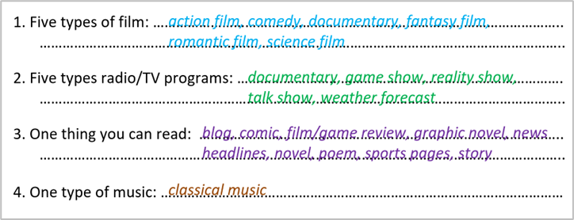
2. In pairs, say which three things you prefer in each category in activity 1.  (Exercise 2 – Student Book page 18)  - T reminds students about the form of verbs of liking / disliking.  - T asks students to do this activity individually. Have students read all the sentences carefully to make sure they understand the sentences.  - T lets them share their answers in pairs. Invite some students to give the answers.  - T writes the correct answers on the board. | e.g.  I prefer horror films, comedies and ….
3. Complete the Word Friends. In pairs, say if the sentences are true for you.  (Exercise 3 – Student Book page 18)  - T asks students to complete the sentences with suitable words.  - T asks students to work individually and check in pairs.  - T invites students to share their answers.  - T confirms the correct answers. | Answer key:  1. into  2. take  3. about  4. happy  5. check  6. in
3. PRONUNCIATION (14’)
3.1. Presentation ( 4’)
* Aims:
- To present new sounds
- To help students identify how to pronounce the sounds /ɪ/ and /i:/
* Content: Game: HEAR AND CLAP to practice pronunciation.
* Outcome: Pronoun some sounds after each play.
* Organisation: Teacher’s instructions …
Teacher’s & Student’s activities | Content
Extra activity 2: HEAR AND CLAP GAME  - T tells students that they are going to play a game called HEAR AND CLAP  - T explains the game rules then checks instructions.  - Teacher uses the slides to lead the game  - Ss join in the game pairs or in small groups.  - T listens to the Ss answers and calls several Ss to check for the whole class.  - T asks students to say the word again to practice some sounds after each play. | Game rules:  - Hear the sound  - Read the words  - Clap your hands 1 or 2 times to choose the word you hear.
3.2. Practice (10’)
ACTIVITY 4:
* Aims:
- To help students practice pronouncing these sounds in words.
- To help students pronounce the sounds /ɪ/ and /i:/ correctly in sentences.
- To help students identify the sounds /ɪ/ and /i:/ correctly in words
* Content: Listen to the sample pronunciation to choose the correct answer.
* Outcome: Read and write the words correctly.
* Organisation: Teacher’s instructions…

Teacher’s & Student’s activities | Content
4a. Listen to the underlined vowel(s) in each word and describe which sound you hear. Write the word in the correct column.  (Exercise 4a– Student Book page 18)  - T calls some students to read out the words first.  - T plays the recording for them to listen and underline vowel(s) in each word.  - T asks Ss to write the word in the correct column.  /ɪ/ and /i:/  - T invites some students to share their answers.  - T confirms the correct ones.
  /i:/ | /ɪ/
  media  reading  seat  teenagers | interest  middle-aged  sing  video
4b. Listen, check and repeat.  (Exercise 4b– Student Book page 18)  - T plays the recording for them to listen and repeat the words they hear.  - T asks Ss to pay close attention to the two sounds.  - T plays the recording again if needed.  - T explains to students the difference between the two sounds if needed.  - T invites some students to say some words they know that include the two sounds.  - T confirms the correct answers. | (Teacher can play the pronunciation guide video of this unit for students to watch and learn).
4. FURTHER PRACTICE (5’)
* Aim: To reinforce the student's recognition of the targeted sounds.
* Content: Game: ODD ONE OUT - practice the pronunciations by choosing the word that has a different sound.
* Outcome: Differentiate the sounds to practice the pronunciations. Saying the sounds correctly.
* Organisation: Teacher’s instructions….

Teacher’s & Student’s activities | Content
Extra activity 3: ODD ONE OUT  - T explains the game rules then checks instructions.  - Teacher uses the slides to lead the activity  - Ss join the activity in pairs or in small groups.  - T listens to the Ss answers and calls several Ss to check for the whole class.  - T asks students to say the word again to practice some sounds after each question. | Game rules:  - Read and choose A, B or C to odd out one word  - Explain by correctly saying the sounds
WRAP-UP & HOME WORK ( 3’)
- Teacher asks students to talk about what they have learnt in the lesson.
* HOME WORK
- Find 3 more words relating to hobbies that have the sounds /ɪ/ and /i:/

==================

Date of planning:  Date of teaching: | UNIT 1: CULTURE INTERESTS  Lesson 9: Revision
I. OBJECTIVES:
By the end of the lesson, Ss are able to:
1. Knowledge:
* Vocabulary: revise words related to cultures, cultural activities, likes and dislikes, age groups, news and entertainment
* Grammar: review present simple tense to talk about habits and routines, likes and dislikes, media habits.
2. Competence: Ss understand and use the vocabulary of the unit, do the tasks assigned in the textbook. Write a personal introduction for a webpage.
3. Quality/ behavior : To teach Ss to be hard-working and attentive in class. Ss have a positive attitude to working in groups, individual work, pair work, cooperative learning and working.
II. TEACHING AIDS:
- Teacher: Grade 7 textbook, Unit 1 (SB p. 17, WB p.13), laptop/computer connected to the Internet, loudspeaker, projector/TV, PPT slides …
- Students : Text books, studying equipment …
- Method: Active teach, T-WC; group works; individual …
III. PROCEDURE:

- WARM-UP (4’)
*Aims:
- To create a positive classroom atmosphere to start a new lesson.
- To lead into the review lesson.
* Content: Game: SUPER EYES
* Outcome: Ss understand that they are going to review Unit 1.
* Organisation: Teacher’s instructions …
Teacher’s & Student’s activities | Content
Extra activity 1: SUPER EYES  - Set the scene: T asks students to do quick exercises for eyes such as look up and down, look left and right, row the eyes  - T tells students that they are going to play a game called SUPER EYES  - T explains the game rules then checks instructions.  - Teacher uses the slides to show the collages  - Ss join in the game in pairs or in small groups.  - Teacher shows the collage again with displayed answers to check for the whole class.  - T tells Ss that they are going to review Unit 1 | Game rules:  - Look carefully at a collage of different small pictures  - The collage will disappear in a few seconds  - Recall as many words about the collage as you can remember.
- REVIEW VOCABULARY (15’)

ACTIVITY 1 + 2 + 3:
* Aims:
- To help students reviews topic words and word friends from the unit
- To review vocabulary in context
* Content: Do the exercise to revise the vocabulary of Unit 1.
* Outcome: Understand the vocabulary to do the exercise correctly.
* Organisation : Teacher’s instructions….
Teacher’s & Student’s activities | Content
Extra activity 2: (5’) SUPER MIND  - T tells students to open the Glossary box in student book page 18  - T introduces the SUPER MIND game and rules  - T shows the slides of the game  - Ss take turns to choose the numbers for their teams.  - Ss discuss and list out all words related to the topic they get.  - T calls some Ss to give answers and confirms the winner. | How to play:  - Play in team  - Choose a number to open a block  - Read the topic word  - Write as many words related to the topic as you can  - The faster finisher gets points
1. (3’) Write the correct word for each definition  (Exercise 1 – Student Book page 19)  - T asks Ss to look at exercise 1 in student book page 19  - T calls a student to read the instruction then checks Ss’ understanding of it.  - T asks Ss to work in pairs to read then complete the activity.  - T checks as the whole class. | Answer keys:  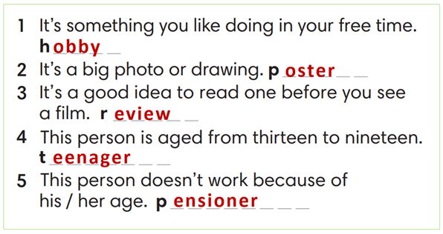
2. (4’) Complete the word friends in the text. Then ask and answer the questions in pairs.  (Exercise 2 – Student Book page 19)  - T asks Ss to look at exercise 2 in student book page 19  - T calls a student to read the instruction then checks Ss’ understanding of it.  - T asks Ss to work in pairs to read then complete the activity.  - Ss work in pairs to complete the task and compare the answers.  - T checks as the whole class. | Answer keys:  1-news / 2- forecast / 3-soap / 4-talk / 5-game / 6-reality / 7-magazines
3. (3’) Complete the poem with the words below.  (Exercise 3 – Student Book page 19)  - T asks Ss to look at exercise 3 in the student book on page 19  - T calls a student to read the instruction and then checks Ss’ understanding of it.  - T asks Ss to work in pairs to read and then complete the activity.  - Ss work in pairs to complete the task and compare the answers.  - T checks as the whole class. | Answer keys:  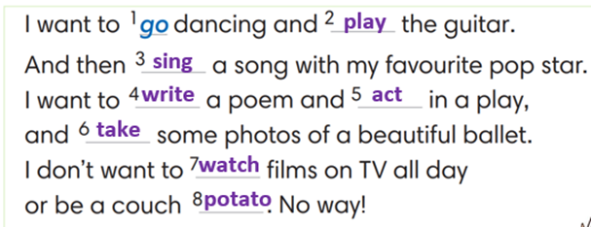
3. REVIEW GRAMMAR ( 15’)
ACTIVITY 4 + 5 + 6:
*Aim:
- To help students practice the present simple.
- To help students practice the present simple in a communicative activity
- To help students practice writing a personal introduction for a webpage.
* Content: Use the present simple tense to complete the exercises.
* Outcome: Use the present simple tense for communication and writing.
* Organisation: Teacher’s instructions….
Teacher’s & Student’s activities | Content
4. Complete the sentences with Present Simple form of verbs in brackets  (Exercise 4 – Student Book page 19)  - T asks Ss to look at exercise 4 in student book page 19  - T calls a student to read the instruction then checks Ss’ understanding of it.  - T asks Ss to work in pairs to read then complete the activity.  - Ss work in pairs to complete the task and compare the answers.  - T checks as the whole class. | Answer keys:  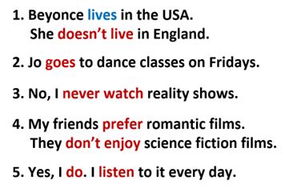
5. In pairs, use the words in A and B to write five sentences about a classmate. Then ask your classmate questions with How often to check.  (Exercise 5 – Student Book page 19)  Step 1: Time to write  - T tells students to read words in part A and B.  - T reminds them that they belong to 2 groups: Adverbs of frequency and verbs.  - T elicits the form of the sentence and gives an example.  - Ss work in pairs to write.  Step 2: Time to talk  - T calls a pair of strong students to demonstrate the dialogue in front of the class.  - Ss work in pairs to practice asking and answering.  - T encourages some pairs to roleplay the dialogue in front of the class. | Step 1:  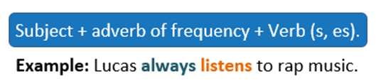  Step 2:  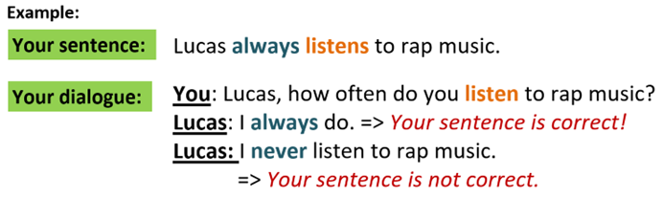
6. Your class has a new webpage. Write a text (60-80 words) to introduce a member from your class and post it on the webpage.  (Exercise 6 – Student Book page 19)  - T asks Ss to look at exercise 6.  - T calls a student to read the instruction then checks Ss’ understanding of it.  - T asks Ss to work individually to write based on the writing box in the student book page 17  - T sets a time limit and walks around as a monitor while Ss are writing.  - T asks Ss to swap their writing pieces for peer check.  - Ss work in pairs to write and give feedback for their partner’s writing product.  - T may collect Ss’ writing for detailed comments. | 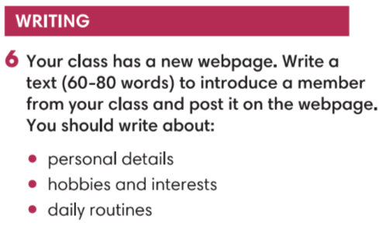
WRAP-UP & HOME WORK ( 2’)
- T asks Ss to talk about what they have learned in the lesson.
- Review Unit 1 vocabulary and grammar.
- Write a personal introduction for a webpage.
* HOMEWORK
- Do exercises in the workbook page 13.
- Prepare for Unit 2/Lesson 2.1: Vocabulary

