Date of planning:  Date of teaching: | ENGLISH 7  UNIT 9: FUTURE TRANSPORT  Lesson 1: Vocabulary
I. OBJECTIVES:
By the end of the lesson, Ss will be able to:
- know the meaning of the keywords used to talk about present and future means of transport.
- use the targeted language to practice talking about present and future means of transport.
1. Knowledge:
* Vocabulary: an understanding of the meaning of keywords below:
Means of transport | bullet train, e-bus, electric car, flying car, hot air balloon, self-driving car, sky train
On the road | accident, drive, passengers, road, traffic jam, vehicles
New words |  | Pronunciation | Vietnamese meaning
bullet train | (n) | /ˈbʊlɪt treɪn/ | tàu cao tốc
e-bus | (n) | /iː bʌs/ | xe buýt điện
electric car | (n) | /ɪˈlektrɪk kɑː(r)/ | ô tô điện
flying car | (n) | /ˈflaɪɪŋ kɑː(r)/ | ô tô bay
hot air balloon | (n) | /ˌhɒt ˈeə bəluːn/ | khinh khí cầu
jetpack | (n) | /ˈdʒetpæk/ | phương tiện bay cất cánh thẳng đứng
self-driving car | (n) | /ˌself ˈdraɪvɪŋ kɑː(r)/ | xe tự lái
sky train | (n) | /skaɪ treɪn/ | tàu điện trên cao
accident | (n) | /ˈæksɪdənt/ | tai nạn
drive | (v) | /draɪv/ | lái
passenger | (n) | /ˈpæs.ən.dʒər/ | hành khách
road | (n) | /rəʊd/ | đường
traffic jam | (n) | /ˈtræfɪk dʒæm/ | tắc đường
vehicle | (n) | /ˈviːəkl/ or /ˈviːhɪkl/ | phương tiện giao thông

* Grammar: expressions to talk about present and future means of transport. This is a … It can carry … It will use …
2. Competence:
- To know the meaning of the keywords used to talk about present and future means of transport, then do the tasks assigned in the textbook.
- To use the targeted language to practise present and future means of transport.
3. Quality/Behavior: To teach Ss to be hard-working and attentive in class. Ss have a positive attitude to working in groups, individual work, pair work, cooperative learning and working.
II. TEACHING AIDS:
- Teacher: Grade 7 textbook, Unit 9 (SB p.90-91, WB p.77-78), laptop/computer connected to the Internet, loudspeaker, projector/TV, PPT slides…
- Students: Text books, studying equipment…
- Method: Active teach, T-WC; group works; individual ……
III. PROCEDURE:
1. WARM UP (6’)
* Aims:
- To activate Ss’ prior knowledge and get Ss involved in the lesson.
- To set the context for introducing new words.
* Content: Name 4 Game.
* Outcome: Ss review learnt vocabulary and prepare for the new lesson.
* Organisation: T-Ss, Ss-T, Ss-Ss, Pair work.
Teacher’s & Student’s activities | Content
Extra activity 1: Name 4 Game  - T explains the game rules then check instructions.  - T can either use PPT slides or write on the board to lead the game.  - For each category, T asks some Ss to name the things and asks some follow-up questions.  - The last category that T mentions is Means of Transport to lead in the lesson.  - After finishing the game, T writes the title on the board:  Unit 9: Means of Transport / Lesson 9.1: Vocabulary | Game rules:  - Ss work in pairs to write down 4 things of a category given by T.  - The fastest pair is given 1 bonus point.  - Pairs crosscheck each other and give 1 point for each correct word.
2. PRESENTATION (8’)
ACTIVITY 1:
* Aims:
- To reinforce the words of means of transport that Ss have already known.
- To teach more new words.
* Content: Ss match the pictures with the names of means of transport.
* Outcome: Ss know new words about means of transport.
* Organisation: T-Ss, Individually/ Pair work.
Teacher’s & Student’s activities |  | Content
1. Match the pictures 1-8 with the names.  (Ex 1 – SB p.90)  - T asks Ss to open their SB page 90, look at Exercise 1.  - T calls a S to read the instruction then checks Ss’ understanding.  - T elicits the meaning of words in the Vocabulary Box and quickly checks Ss’ understanding of vocabulary by randomly showing pictures of means of transport and asking them to name its means of transport.  - Then, T asks students to look at exercise 1 and complete.  - Ss can work individually or in pairs to finish the task.  - After Ss have finished, T asks Ss to classify the means of transport into some of the following categories:  Travels on land / Travels in air  Present type of transport / future type of transport  Slow / fast |  | Answer keys:  1 flying car  2 e-bus  3 hot air balloon  4 electric car  5 bullet train  6 sky train  7 jetpack  8 self-driving car
3. PRACTICE (23’)
ACTIVITIES 2, 3, 4, 5:
* Aims:
- To predict what future means of transport look like.
- To help Ss understand words in context and find other words of the same meaning.
- To provide more words related to the topic.
- To help Ss reinforce the studied vocabulary in collocations
* Content:
- Choose the correct option.
- Listen about future means of transportation and complete the gaps.
- Listen again and complete the phrases with the words given.
- Work in pairs to talk about means of transport.
* Outcome: Understand new words in context.
* Organisation: T-Ss, Ss-T, Individual work, Group work, Pair work.
Teacher’s & Student’s activities | Content
2. (7’) Choose the option (A or B) that can best replace the underlined word(s).  (Ex 2 – SB p.91)  - T shows some pictures of means of transport in the past and at the present, asks Ss to put them into two categories: In the past and at the present and invites some volunteers to tell why they know that.  - Then, T asks Ss to work in groups to predict what they think a future mode of transport will be like.  - T invites some Ss to share their thought with the class.  - T asks Ss to look at the predictions on page 91, elicits the meaning of any unknown words and may provide further explanations of the words in Vietnamese.  - Ss can work individually or in pairs to complete the exercise.  - T asks Ss to read the predictions with the replaced word again, check pronunciation if needed. | Answer keys:
3. (6’) Listen about future means of transportation and complete the gaps.  (Ex 3 – SB p.91)  - T calls a S to read the instruction then checks Ss’ understanding of it.  - T asks Ss to look at Vocabulary B (SB page 91) and check their understanding of the words.  - T asks Ss to predict what can be filled in the gap.  - T plays the audio for the whole class to listen and do the exercise individually  - T sets a time limit and asks Ss to work in groups to compare their answer and complete the exercise together.  - T calls groups to give answers then checks as the whole class.  - T corrects Ss’ pronunciation if any. | Answer keys:  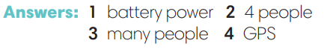
4. (4’) Listen again and complete the phrases with the words given.  (Ex 4 – SB p.91)  - T asks Ss to look at Exercise 4 (SB page 91).  - T calls a S to read the instruction then checks Ss’ understanding of it.  - T asks Ss to quickly complete the phrases individually.  - T calls pairs to give answers then checks as the whole class.  - T corrects Ss’ pronunciation if any. | Answer keys:  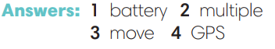
5. (6’) In pairs, choose one means of transport from Exercise 1. Tell your partner about it.  (Ex 5 – SB p.91)  - T asks Ss to work in pairs and asks each of them to choose one means of transport in Exercise 1 and tell their partner about it using the expression: This is a … It can carry … It will use …  Then, T calls some Ss to talk about their partner’s means of transport. | 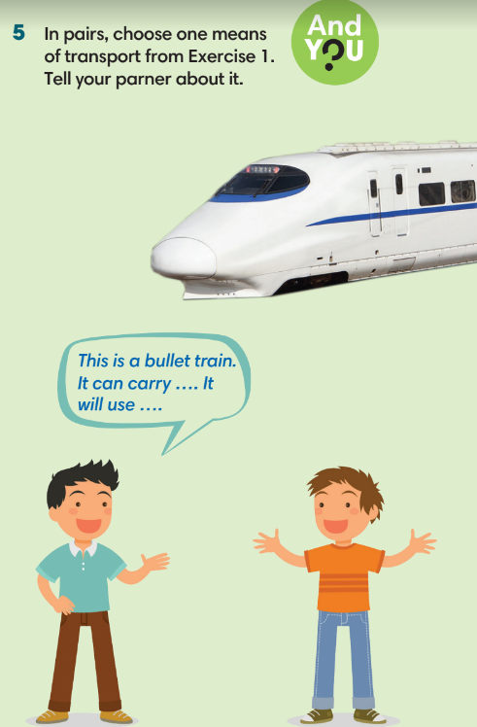
4. PRODUCTION (5’)
HOT SEAT GAME
* Aims: To help Ss practice applying the vocabulary and grammar points related to the topic in speaking.
* Content: Hot seat game
* Outcome: Ss practise using the vocabulary and grammar points related to the topic in speaking.
* Organisation: T-Ss, Ss-Ss
Teacher’s & Student’s activities | Content
Extra activity 2: Hot seat game.  - T explains the game rules then check instructions. | Game rules:  - T divides the class into 2 teams, one S from each team for each turn.  - Two Ss sit/stand in front of the class, back to the board.  - T shows pictures of means of transport on the slide.  - Teammates give description of the given means of transport for their team’s player to guess what it is.  - 1 correct answer = 1 point.
WRAP-UP & HOME WORK (3’)

T asks Ss to talk about what they have learnt in the lesson.
- Vocabulary of means of transports and on the road.
- Grammar points: Future tense to talk about future means of transport

* HOME WORK
- Do exercises in the workbook page 77-78.
- Prepare for Lesson 9.2: Grammar 1.

Date of planning:  Date of teaching: | UNIT 9: FUTURE TRANSPORT  Lesson 2: Grammar 1
I. OBJECTIVES:
By the end of the lesson, Ss will be able to:
1. Knowledge:
* Grammar:
- Identify and understand how to use the future simple tense will / will not.
- Use will / will not to talk about future means of transportation.
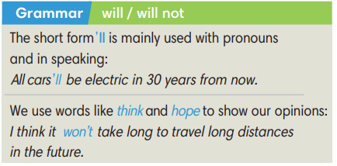
2. Competence: Ss know how to use vocabulary about means of transportation, and understand the main grammatical points, then do the tasks assigned in the textbook; use the future tense will / will not to talk about future means of transportation.
3. Quality / behavior: To teach Ss to be hard-working and attentive in class. Ss have a positive attitude to working in groups, individual work, pair work, cooperative learning and working.
II. TEACHING AIDS:
- Teacher: Grade 7 textbook, Unit 9 (SB p.92), laptop/computer connected to the Internet, loudspeaker, projector/TV, PPT slides…
- Students: Text books, studying equipment…
- Method: Active teach, T-WC; group works; individual ……
III. PROCEDURE:

1. WARM UP (5’)
SENTENCE SCRAMBLE GAME
* Aims:
- To activate students’ prior knowledge and get students involved in the lesson.
- To set the context for introducing new structures.
* Content: Play game to get Ss involved in the lesson and to set the context for the lesson.
* Outcome: Ss know the context of the lesson.
* Organisation: T-Ss, Group work
Teacher’s and Student’s activities | Content
Extra activity 1: Sentence scramble game  - T explains the game rules then check instructions.  - T gives few unscrambled sentences about future means of transportation using will / will not.  - T sets the scene for the new lesson: T elicits the meaning of will / will not and tells Ss that they are going to learn how to use will / will not to talk about future means of transportation.  - T writes the title on the board: Unit 9: Future transport - Lesson 9.2: Grammar. | Game rules:  ✔ Ss work in groups of 3-4 to put the given words into the correct order to make meaningful sentences.  ✔ Three quickest groups are given 1 bonus point.  ✔ Each correct sentence = 1 point.
2. PRESENTATION (14’)
ACTIVITIES 1 + 2:
* Aims:
- To present the grammar point in context.
- To lead into the next activity.
- To introduce the Grammar box.
- To explain the grammar point to Ss.
* Content:
- Ss match the bold words with the definitions.
- Ss find more examples of will / will not in the text.
* Outcome: Ss learn how to use will / will not in context.
* Organisation: T-Ss, Ss-T, Pair work, Individually.
Teacher’s & Student’s activities |  |  | Content
1. (7’) Read the text. Find the bold words in the text that match the definitions below.  (Ex 1 – SB p.92)  - T asks Ss to look at the 2 pictures and elicits what they think about flying cars.  - Ss work in pairs to discuss their thought.  - T invites some volunteers to share their partner’s thought with the class.  - T asks Ss to complete the exercise individually.  - T checks Ss’ answers, explains the meaning and checks Ss’ understanding. |  |  | Answer keys:  1 take-off  2 aircrafts  3 engines  4 rush hour
2. (7’) Study the Grammar box. Find more examples of will / will not in the text in Exercise 1.  (Ex 2 – SB p.92)  - T goes through the Grammar box with Ss.  - T stresses that the short form ’ll is mainly used with pronouns and in speaking, and Ss should use think / hope to show their opinions.  - Ss underline all sentences that contain will / will not in the text in Exercise 1.  - T invites some volunteers to say sentences containing will / will not in the text and check pronunciation if needed.  - T divides Ss in pairs to make a sentence with will / won’t.  - T goes around to help, asks some volunteers to say their sentences and check Ss’ understanding. |  |  | 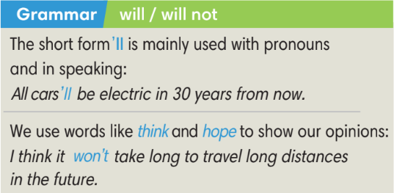  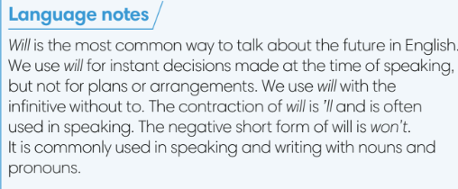
3. PRACTICE (13’)
ACTIVITY 3 + Workbook activity 3:
* Aims:
- To provide Ss with grammar exercises to practise.
* Content:
- Ss read the advertisement and complete the sentences.
- Ss use will to complete the paragraph.
* Organisation : T-Ss, Ss-T, Pair work
Teacher’s & Student’s activities |  |  |  | Content
3. (7’) Read the advertisement for the JetPack Model X87. Complete the following sentences with will and will not.  (Ex 3 – SB p.92)  - T calls a S to read the instruction then checks Ss’ understanding.  - T asks Ss to work in pairs to finish Exercise 3 and then share answers with other pairs.  - T checks Ss’ answers and corrects if needed.  - T asks Ss to work in groups of 4 to write 2-3 additional sentences about the JetPack Model X87 using the advertisement. |  |  |  | Answer keys:  1 will  2 will  3 will not  4 will  5 will not
(6’) Extra activity 2: Exercise 3 - WB p.79. Use will and one of the verbs below to complete the following paragraph.  - T calls a S to read the instruction then checks Ss’ understanding.  - T asks for any new words in the text, check for Ss’ understanding and explains if needed.  - Ss work individually to complete the exercise, then crosscheck the answer with a partner.  - T calls some Ss to give answers with the text, corrects the answers and gives feedback. |  |  |  | Answer keys:  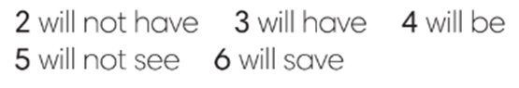
4. PRODUCTION (10’)
ACTIVITY 4:
*Aims:
- To help Ss understand more about the flying cars in the text in Exercise 1.
- To help Ss applying the vocabulary items and grammar points related to the topic in speaking.
* Content: Ss ask and answer questions about flying cars, and practise using will / will not.
* Outcome: Ss can use will / will not in speaking.
* Organisation: T-Ss, Ss-Ss, Ss-T
Teacher’s & Student’s activities |  | Content
4. (5’) In pairs, ask and answer questions about the flying cars in Exercise 1. Use the following words.  (Ex 4 – SB p.92)  - T calls a S to read the instruction then checks Ss’ understanding.  - T checks Ss’ understanding of given words, explains if needed.  - T asks Ss to work in pairs to ask and answer questions using the given words.  - T calls 2 good Ss to model the question and answer.  - T walks around to help and give feedback.  - T calls some pairs to practise asking and answering in front of the class. |  | 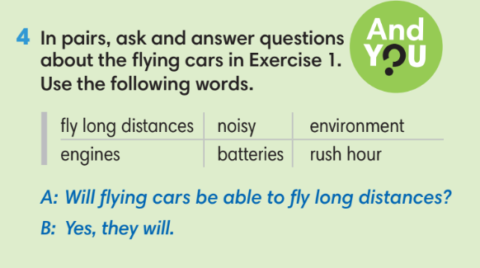
Extra activity 3 (5’): Pictionary game  - T prepares pictures of common objects such as: eraser, pen, battery, egg, orange, bottle, etc.  - T explains the game rules then check instructions.  - T can either model the activity or invite one good S to start the game. |  | Game rules:  - One S chooses a picture and makes sentences about that object using will / will not for the class to guess what the object is.  - Other Ss can make questions using will to clarify.
WRAP-UP & HOME WORK (3’)
T asks Ss to talk about what they have learnt in the lesson.
- Will and will not
* HOME WORK
- Do exercises in the workbook page 79.
- Prepare for Lesson 9.3: Reading and Vocabulary.

Date of planning:  Date of teaching:  WEEK: | UNIT 9: FUTURE TRANSPORT  Lesson 3: Reading and Vocabulary
I. OBJECTIVES:
By the end of the lesson, Ss will be able to:
1. Knowledge:
* Vocabulary: an understanding of the vocabulary about future means of transport.

New words |  |  | Pronunciation |  | Vietnamese meaning
vertically | (adv) | /ˈvɜːtɪkli/ |  | thẳng đứng
emission | (n) | /ɪˈmɪʃn/ |  | khí xả
compact | (adj) | /kəmˈpækt/ |  | nhỏ gọn
recharge | (v) | /ˌriːˈtʃɑːdʒ/ |  | nạp điện lại
solar panel | (n) | /ˌsəʊlə ˈpænl/ |  | pin mặt trời

* Grammar:
- Reading skills: Find main ideas and specific details in a text about a means of transport.

2. Competence: Understand the meaning of the keywords used to talk about future means of transport, then do the tasks assigned in the textbook; match titles to correct paragraphs (scanning skill); identify information in the text and answer right, wrong, doesn’t say questions ( (skimming skill).
3. Quality/behavior: To teach Ss to be hard-working and attentive in class. Ss have a positive attitude to working in groups, individual work, pair work, cooperative learning and working.
II. TEACHING AIDS:
- Teacher: Grade 7 textbook, Unit 9 (SB p.93, WB p.80), laptop/computer connected to the Internet, loudspeaker, projector/TV, PPT slides …
- Students: Text books, studying equipment …
- Method: Active teach, T-WC; group works; individual …
III. PROCEDURE:
1. WARM-UP (5’)
* Aim:
- To help Ss review grammar they have learnt.
- To lead into the next activity.
* Content: Prediction about future transportation
* Outcome: Ss review grammar points and prepare for the new lesson.
* Organisation: T-Ss, Ss-T, Ss-Ss, Group work.
Teacher’s & Student’s activities | Content
Extra activity 1: Prediction about future transportation.  - T explains the rules then checks instructions.  - T uses slide to lead the game.  - Groups raise their hands to share their prediction.  - T records on the board some of Ss’ predictions using will / will not.  - T tells Ss that they are going to read about future means of transport.  - T writes the title for the new lesson:  Unit 9/Lesson 3: Reading and vocabulary. | Rules:  - T divides Ss into 2-3 groups.  - Groups choose a number which reveals an aspect of transport such as: speed, cost, energy use, convenience, etc.  - Groups make prediction sentences using will / will not.  - Each prediction sentence = 2 points.
2. PRE-READING (7’)
ACTIVITY 1:
* Aim:
- To activate Ss’ background knowledge of the topic.
* Content: Ss guess the name of the means of transport.
* Outcome: Ss have background knowledge of the topic.
* Organisation: T-Ss, Ss-T, Pair work.
Teacher’s & Student’s activities |  | Content
1. In pairs, look at the photos. What do you think they are?  (Ex 1 – SB p.93)  - T shows the three pictures on slide and elicits the type of transport in each photo.  - T asks Ss to work in pairs to compare these three types of transport in terms of their safety, speed and convenience.  - T calls some Ss to share their thought and check. |  | 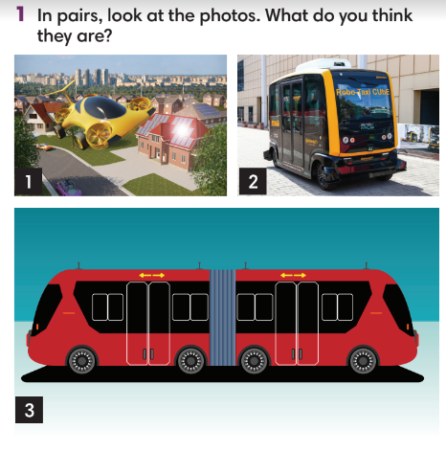
3. WHILE-READING (18’)
ACTIVITY 2 + 3:
*Aim:
- To read the text and do some reading tasks.
- To help Ss practise finding main ideas of the text.
- To help Ss practise reading for specific details in the text.
* Content:
- Ss read the texts and match the titles with the passages.
- Ss read the text again and mark the sentences right, wrong or doesn’t say.
* Outcome: Ss can find main ideas of the text and read for specific details.
* Organisation: T-Ss, Ss-T, Individually, Pair work.
2. (9’) Read the text and match them with the titles below. Write the titles in the blanks.  (Ex 2 – SB p.93)  - T asks Ss to look at Exercise 2 – SB p. 93.  - T explains that Ss need to do skimming for main ideas.  - T sets a time limit for Ss to skim the text just to find the main ideas, 30 seconds for each paragraph and finish the exercise.  - T asks Ss to check answers with a partner before checking with the whole class and explain reasons for their answers. |  | Answer keys:  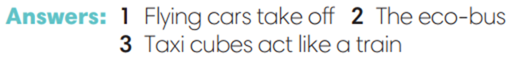
3. (9’) Read the text again. Mark the sentences right, wrong or doesn’t say.  (Ex 3 – p.93)  - T asks Ss to read the text again and complete Exercise 3 individually before comparing their answer in pairs.  - T reminds Ss to underline the key words in Exercise 3 before reading.  - T set time limitation such as 3 minutes.  - T checks the answers with the whole class and asks them to explain their choices.  - After Ss have finished the exercise, T asks some Ss to read the text out loud to check pronunciation.  - T lists all new words and provide the meaning.  - T asks Ss which of the three types of future modes of transport they like the most and explain their answer. |  | Answer keys:
4. POST-READING (15’)
ACTIVITIES 4 & 5:
* Aim:
- To study the vocabulary.
- To review new words from the text.
- To reinforce word friends and practise asking and answering about future means of transport.
* Content:
- Complete the sentences with the verbs and prepositions.
- Game: Sentence race.
- Ask questions about one means of transport.
* Outcome: Ss can use the vocabulary from the text in context.
* Organisation: T-Ss, Ss-Ss, Pair work, Group work, Individually.
4. (5’) Complete the sentences with the verbs in Group A and the prepositions in Group B. Use the text in Exercise 2 to help you.  (Ex 4 – SB p.93)  - T calls a S to read the instruction then check for Ss’ understanding.  - T asks Ss to complete Exercise 4 individually before comparing their answers in pairs.  - T checks the answers with the whole class. |  | Answer keys:  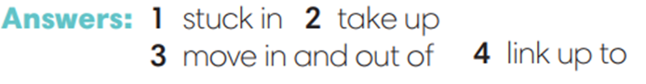
(5’) Sentence Race Game.
- T divides Ss into groups of 3-4 to create their own sentences using the learnt phrasal verbs.
- T sets time limitation such as 3 minutes.
- Groups crosscheck each other’s sentences.
- Each correct sentence = 1 point.
- T invites some volunteers to read their sentences then other Ss shadow their classmate’s sentence.
5. (5’) In pairs, complete the table. Then ask your partner questions about one means of transport.  (Ex 5 – SB p.93)  - T asks Ss to look at the three categories in the left column and elicits from the class questions that they can use for each of these.  - T asks Ss to work in pairs to complete the table, then ask and answer questions about one means of transport in the table.  - T invites some good Ss to model the activity.  - T asks some pairs to practise asking and answering questions in front of the class.  - T asks the whole class to listen and give feedback. |  | 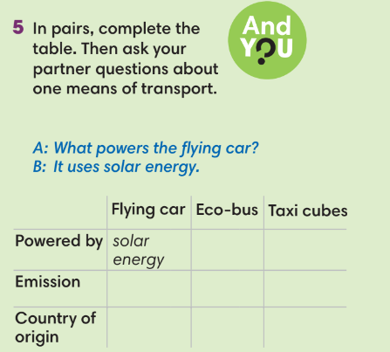
WRAP-UP & HOME WORK (3’)
- T asks Ss to talk about what they have learnt in the lesson.
- Find main ideas and specific details about a future means of transport.
- Ask and answer about future means of transport.

* HOME WORK
- Do exercises in the workbook page 80.
- Prepare for Lesson 9.4: Grammar 2.

====================

Date of planning:  Date of teaching: | UNIT 9: FUTURE TRANSPORT  Lesson 4: Grammar 2
I. OBJECTIVES:
By the end of the lesson, Ss will be able to:
1. Knowledge:
* Vocabulary:
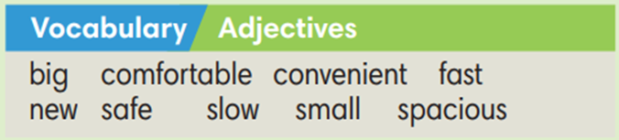
* Grammar:
- Use as … as and different from to compare means of transport.
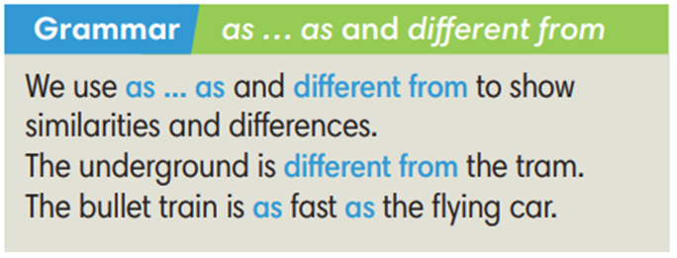
2. Competence: Understand the main grammatical points, then do the tasks assigned in the textbook. Use as … as and different from to compare different means of transport in Vietnam and other countries.
3. Quality/ behavior: To teach Ss to be hard-working and attentive in class. Ss have a positive attitude to working in groups, individual work, pair work, cooperative learning and working.
II. TEACHING AIDS:
- Teacher: Grade 7 textbook, Unit 9 (SB p.94), laptop/computer connected to the Internet, loudspeaker, projector/TV, PPT slides…
- Students: Text books, studying equipment…
- Method: Active teach, T-WC; group works; individual ……
III. PROCEDURE:

1. WARM UP (5’)
* Aim:
- To create a positive classroom atmosphere to start a new lesson.
- To lead into the new lesson.
* Content: Comparison game.
* Outcome: Ss prepare for the new lesson.
* Organisation: T-Ss, Ss-Ss, Group work.
Teacher’s & Student’s activities |  | Content
Extra activity 1: Comparison game.  - T prepares a collection of things for Ss to compare.  - T explains the game rules then checks instructions.  - T elicits the words ‘similarity’ and ‘difference’, writes these two words at the top of the board and draws a vertical line between them.  - T elicits the similarities and differences between ‘a pen’ and ‘a pencil’ as an example.  - T tells Ss that, today they will learn about as … as and different from to compare different means of transport. |  | Game rules:  - Ss work in groups of three.  - Each group works with one pair of things.  - Ss write down as many similarities and differences as possible.  - T sets time limitation of 2 or 3 minutes  - Groups crosscheck each other, Ss can edit and add more information.  - Each reasonable similarity/ difference = 1 point.
2. LEAD-IN (6’)
ACTIVITY 1
*Aim:
- To set the context for the new grammar point.
* Content: Ss choose their favourite flying cars.
* Outcome: Ss know the context for new grammar points.
* Organisation: T-Ss, Ss-T.
Teacher’s & Student’s activities | Content
1. Look at the photos. Which flying car do you like more, the red or the yellow one?  (Ex 1 – SB p.94)  - T asks Ss to look at the photos and circle the red and the yellow flying cars in the picture.  - T asks Ss to choose which flying car do they like more, the red or the yellow one.  - T calls some Ss to share which one they choose and explain their choice. | 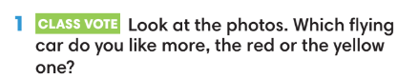
3. PRESENTATION (10’)
ACTIVITY 2:
*Aim:
- To present the grammar point in context.
- To introduce the Grammar Notes and explain the grammar point.
* Content:
- Ss read and listen, then underline examples of as … as and different from in the dialogue.
* Outcome: Ss understand the grammar point in context.
* Organisation: T-Ss, Ss-T.
Teacher’s & Student’s activities | Content
2. Read and listen. Underline examples of the as … as and different from in the dialogue.
(Ex 2 – SB p.64)
- T tells S to read the Grammar box and elicits the usage of as… as and different from.
- T asks Ss to listen and read the dialogue and underline all examples of the as … as and different from.
- T asks some Ss to read out loud sentences with as … as and different from, checks their pronunciation if necessary.
- T asks Ss to write down the sentences from the dialogue that use the patterns. Then, have them create their own sentences by keeping the patterns and changing just one or two words.
- Ss exchange sentences with a partner, then change the partner’s sentences even further by changing two or three more words.
- Ss return sentences to their partner and read their new sentences.
- T invites some Ss to share their new sentences with the whole class.
4. PRACTICE (11’)
ACTIVITY 3:
* Aims:
- To help Ss practice making sentences with as … as and different from.
* Content:
- Ss write senteces to compare the vehicles.
- Play Game: Hot potato (practice using as … as and different from).
* Outcome: Ss can compare things using as … as and different from.
* Organisation: T-Ss, Ss-T, Ss-Ss, Individually, Pair work
Teacher’s & Student’s activities | Content
3. (5’) Write sentences using (not) as … as … comparing the two vehicles below.  (Ex 3 – SB p.94)  - T calls a S to read the instruction then checks Ss’ understanding.  - T asks Ss to do Exercise 3 individually before comparing their answers in pairs.  - T invites Ss to give their answers and checks answers with the whole class. | Answer keys:  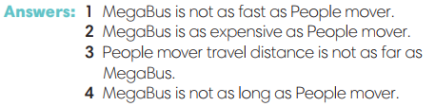
(6’) Extra activity 2: Game – Hot potato.  - T explains the game rules then checks instructions.  - T checks the sentences with the whole class. | Game rules:  ✔ T plays music and Ss pass a ball to each other in the whole class.  ✔ When the music stops, the S has the ball needs to make a sentence with either as … as or different from to compare people and things in the class.  ✔ 1 correct sentence = 1 point.
5. PRODUCTION (10’)
ACTIVITY 4:
* Aims: To help Ss applying the vocabulary items and grammar points related to the topic in communicating.
* Content: Ss ask and answer about different means of transport in Việt Nam, using as … as and different from and some of the given adjectives.
* Outcome: Ss can use as … as and different from in conversation.
* Organisation: T-Ss, Ss-Ss, Pair work.
Teacher’s & Student’s activities | Content
4. In pairs, ask and answer about different means of transport in Vietnam. Use as … as and different from and some of the adjectives below.  (Ex 4 – SB p.94)  - T asks Ss to look at exercise 4 (SB page 94).  - T calls a S to read the instructions.  - T goes over the vocabulary to make sure Ss understand it.  - T asks Ss to make example sentences for each of the adjectives in the Vocabulary box and asks them to find its antonym.  - T elicits different means of transport in Việt Nam and writes on the board.  - T puts Ss into pairs to ask and answer about different means of transport in Việt Nam.  - T reminds Ss to use as … as and different from and the given adjectives.  - T asks a good pair to model the activity in front of the class.  - T walks around to note down any mistakes for later feedback.  - T invites some pairs to practise asking and answering in front of the class and asks the other Ss to give comments on their classmates’ performance. | 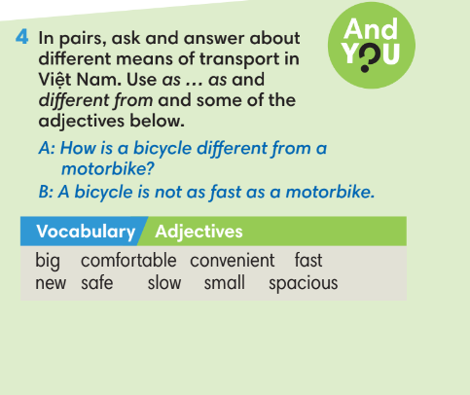
WRAP-UP & HOME WORK (3’)
- T asks Ss to talk about what they have learnt in the lesson.
✔ Use as … as and different from to compare different means of transport.
* HOME WORK
- Do exercises in the workbook page 81.
- Prepare for Lesson 9.5: Listening and vocabulary.
Date of planning: Date of teaching: | UNIT 9: FUTURE TRANSPORT  Lesson 5: Listening and Vocabulary
I. OBJECTIVES:
By the end of the lesson, Ss will be able to gain:
1. Knowledge:
* Vocabulary: an understanding of the vocabulary about traffic problems.

New words | Vietnamese meaning
condos | tòa căn hộ
apartment | căn hộ
intersection | chỗ giao nhau
narrow/ wide road | đường hẹp/ rộng
public transportation | phương tiện công cộng

* Grammar:
2. Competence: Know the meaning of the keywords used to talk about traffic problems and discuss some solutions. Do the tasks assigned in the textbook. Listen and identify general and specific details in a recording about traffic problems.
3. Quality/ behavior: To teach Ss to be hard-working and attentive in class. Ss have a positive attitude to working in groups, individual work, pair work, cooperative learning and working.
II. TEACHING AIDS:
- Teacher: Grade 7 textbook, Unit 9 (SB p.95, WB p.82), laptop/computer connected to the Internet, loudspeaker, projector/TV, PPT slides …
- Students: Text books, studying equipment …
- Method: Active teach, T-WC; group works; individual …
III. PROCEDURE:
1. WARM UP + LEAD-IN (10’)
* Aims:
- To review grammar points from the previous lesson and get students involved in the lesson.
* Content: Game: Comparison sentence race.
* Outcome: Ss can recall how to use as … as and different from to compare things.
* Organisation: T-Ss, Group work.
Teacher’s & Student’s activities | Content
Extra activity 1: Game – Comparison sentence race.
- T shows on the slide 2 pictures of the busy traffic in Hà Nội and the little or no traffic in a province.
- T asks Ss to compare these two places using as … as and different from.
- T divides the class into 3 teams.
- T sets time limitations of 2-3 minutes.
- Three teams race to write comparing sentences on the board.
- Each correct sentence = 2 points.
- T checks all comparing sentences on the board with the whole class and gives feedback.
- T sets the scene for the new lesson: T tells Ss that they are going to learn how to listen for main ideas and specific details about traffic problems, and later on talk about traffic problems.
- T writes the title on the board Unit 9: Future transport
Lesson 9.5: Listening and Vocabulary
2. PRE-LISTENING (5’)
ACTIVITY 1:
*Aims:
- To lead into the topic.
* Content: Look at the pictures and discuss the traffic problem.
* Outcome: Ss understand the background of the recording.
* Organisation: T-Ss, Ss-T, Pair work
Teacher’s & Student’s activities | Content
1. Look at the picture. Where do you think this is? What is causing it?  (Ex 1 – SB p.95)  - T asks Ss to look at the pictures and tell where it is and how they know that.  - T gives Ss a quick scenario about when T got stuck in traffic.  - T asks Ss to work in pairs and discuss the possible causes of these traffic problems.  - T invites some volunteers to share their group’s discussion and notes down some causes on the board. | 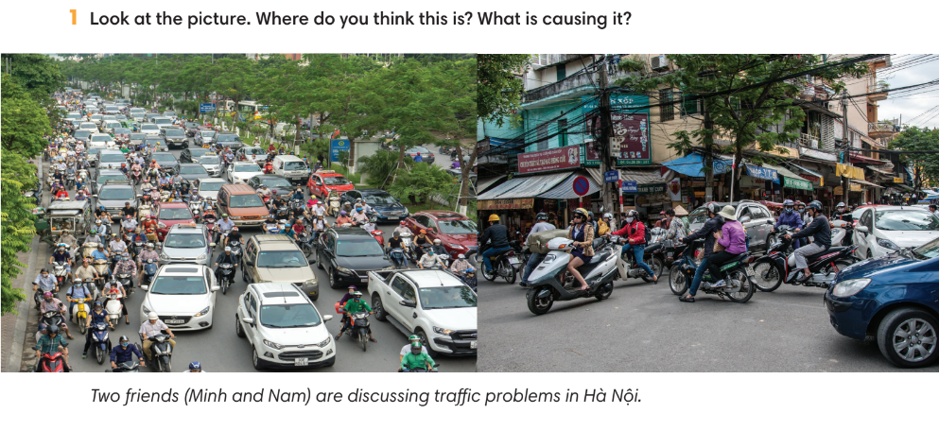
3. WHILE-LISTENING (15’)
ACTIVITIES 2, 3 & 4:
* Aims:
- To help Ss identify main ideas of the recording.
- To help Ss identify specific details in the recording.
- To introduce new words in context.
* Content: Listen and understand the audio track and complete the exercises.
* Outcome: Ss can identify the main ideas and specific details in the recording.
* Organisation: T-Ss, Ss-T.
Teacher’s & Student’s activities | Content
2. (5’) Lisen and tick the topics that are mentioned in the recording.  (Ex 2 – SB p.95)  - T asks Ss to look at Exercise 2 on SB p.95, to read the instruction and all items in Exercise 2.  - T goes through each item in Exercise 2 to make sure Ss know their meanings.  - T lets Ss listen once to the recording and complete Exercise 2.  - T elicits Ss’ answers on the board.  - T plays the audio again and checks the answers with the whole class.  - T encourages Ss to give the evidence that they hear from the audio track to prove their answers. | Answer keys:  Tick: 1, 2, 3, 4, 5, 7
3. (5’) Listen to the recording again. Mark the sentences (right), (wrong), ? (doesn’t say).  (Ex 3 – SB p.95)  - T asks Ss to read instructions and all sentences then underline any key words in the statements, and make guesses from their memory of the first listening by marking the sentences right, wrong or doesn’t say.  - T plays the recording again to let Ss do Exercise 3.  - T elicits Ss’ answers on the board. | Answer keys:
4. (5’) Listen again. Tick () the phrases you hear in the recording.  (Ex 4 – SB p.95)  - T asks Ss to do Exercise 4 using their memory of the recording.  - T plays the recording again to let Ss check their answer.  - T elicits Ss’ answers on the board then check the correct answers to all Exercise 2, 3 and 4 with the whole class.  - T asks Ss to give evidence for the answers from the recording.  - T explains the meaning of Word friends if needed and asks Ss to make sentences with word friends list. | Answer keys:  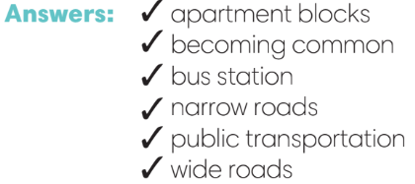
4. POST-LISTENING (12’)
ACTIVITY 5:
*Aims:
- To reinforce word friends.
- To practise using new words in context.
* Content:
- Quiz, Quiz, Trade game.
- Ss tick the solutions they agree with.
* Outcome: Ss can use the word friends to discuss the given solutions to traffic problems.
* Organisation: T-Ss, Pair work.
Teacher’s & Student’s activities | Content
(6’) Quiz, Quiz, Trade game.  - T selects a set of task cards for the activity. Task cards with word friend list, multiple choice or concrete short answer questions about different means of transports and traffic problems.  - T explains the game rules then checks the instruction.  - T models the activity with one volunteer and makes sure Ss know the rules. | Game rules:  - Each S is given a task card.  - Ss work in pairs: Partner 1 asks Partner 2 his/her question, Partner 2 answers, then Partner 1 acknowledges a correct answer or give the answer if needed.  - The process reverses with Partner 2 asking the questions.  - After both questions have been asked, while music plays, the partners switch cards, find new partners and the process begins again when the music stops.
5. (6’) In pairs, read the following solutions and tick the ones you agree with. Then compare your answers.  (Ex 5 – SB p.95)  - T asks Ss to read the instructions and all solutions.  - Ss work in pairs to discuss the given solutions.  - T reminds Ss to you the structure I think we should … to express their opinion.  - T walks around to provide feedback.  - T asks some good pairs to model the discussion. | 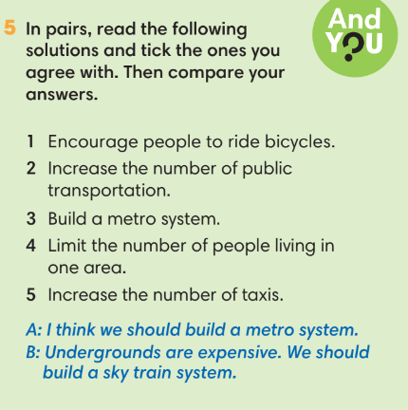
WRAP-UP & HOME WORK (3’)
- T asks Ss to talk about what they have learnt in the lesson.
- Listen for main ideas and specific details about traffic problems.
- Discuss some solutions for traffic problems.

* HOME WORK
- Do exercises in the workbook page 82.
- Prepare for Lesson 9.6: Speaking.

=====================

Date of planning:  Date of teaching: | UNIT 9: SCHOOLS  Lesson 6: Speaking
I. OBJECTIVES:
By the end of the lesson, Ss will be able to gain:
1. Knowledge:
* Vocabulary: Use the vocabulary and phrases to talk about a means of transport and its advantages.
* Grammar: Use connecting words to list and connect ideas.
2. Competence: Ss can use vocabulary and phrases to talk about a means of transport and its advantages, and do the tasks assigned in the textbook.
3. Quality/behavior: To teach Ss to be hard-working and attentive in class. Ss have a positive attitude to working in groups, individual work, pair work, cooperative learning and working.
II. TEACHING AIDS:
- Teacher: Grade 7 textbook, Unit 9 (SB p.96, WB p.83), laptop/computer connected to the Internet, loudspeaker, projector/TV, PPT slides…
- Students: Text books, studying equipment…
- Method: Active teach, T-WC; group works; individual ……
III. PROCEDURE:
1. WARM UP + LEAD-IN (5’)
* Aim:
- To create a positive classroom atmosphere to start a new lesson.
- To lead into the topic.
* Content: Transport definition game.
* Outcome: Ss review vocabulary about means of transportation and prepare for the new lesson.
* Organization of implementation: T-Ss, Group work.
Teacher’s & Student’s activities |  | Content
Extra activity 1: Transport definition game.  - T prepares a set of words about different means of transport.  - T divides Ss into 3-4 teams.  - T explains the game rules and check the instruction.  - T can introduce some phrases can be used for describing:  I has … wheels.  It’s powered by …  It has enough room for ….. people.  It’s cheap/expensive/light/quick, etc.  It’s on the road/sea/tracks.  - When Ss finish the game, T tells Ss that they are going to talk about a means of transport and its advantages.  - T writes the title of new lesson: Unit 9  Lesson 9.6 – Speaking. |  | Game rules:  - Time limitation: 20 seconds for each round.  - T randomly chooses a S to pick up a word for describing.  - Each round, one S from each team stands in the front and tries to describe a means of transport for other team members guess the word.  - The quickest team says correct word = 1 points.
2. PRE-SPEAKING (14’)
ACTIVITIES 1, 2, 3:
* Aims:
- To activate Ss’ prior knowledge of the topic.
- To lead into the topic.
- To introduce the Speaking box.
* Content:
- Discuss which means of transport is the most popular.
- Identify the details in the talk.
- Find examples of connecting words in the talk.
* Outcome:
- Ss understand the topic of the lesson.
- Ss know how to use connecting words in context.
* Organisation: T-Ss, Ss-T, Individually.
Teacher’s & Student’s activities |  |  | Content
1. (5’) Class vote: What is the most popular means of transport?  (Ex 1 – SB p.96)  - Before taking a class vote, T elicits on the board some popular means of transport in Việt Nam.  - T asks some Ss to share their choice and explain why the means of transport they choose is the most popular. |  |  | 
2. (6’) Read or listen. What type of transport does Nam think we should you? Why?  (Ex 2 – SB p.96)  - T asks Ss to close their book and listen to the recording, and write down the type of transport Nam thinks we should use and the reasons for that.  - T can play the recording twice if needed.  - Then, T asks Ss to open the book and read the text to check their answers.  - T asks Ss to work in pairs to brainstorm any other advantages of taking a bus.  - T invites some volunteers to express their ideas and write on the board. |  |  | Answer keys:  Nam thinks we should use bus because travelling by bus is cheaper than travelling by car. It also helps the environment and reduce traffic jams.
3. (3’) Study the Speaking box. Find examples of connecting words in the prepared talk.  (Ex 3 – SB p.96)  - T goes through the Speaking box and asks students to read the talk again to find all the examples of connecting words in the talk. Then check the answer with the whole class. |  |  | 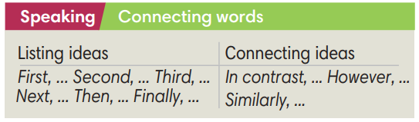
3. WHILE-SPEAKING (13’)
ACTIVITIES 4 & 5:
* Aims:
- To reinforce the use of Speaking box.
- To practise using the new expression in context.
* Content:
- Complete the sentences with words from the Speaking box.
- Underline the opening and ending expressions in a prepared talk in Exercise 2 and 4.
- Word to sentence game.
* Outcome: Ss understand how to use connecting words in context.
* Organisation: T-Ss, Ss-T, Pair work, Group work, Individually.
Teacher’s & Student’s activities |  |  |  | Content
4. (5’) Complete the sentences with words from the Speaking box.  (Ex 4 – SB p.96)  - T asks Ss to work individually before checking their answer with a partner.  - T asks Ss for their answers and explanation.  - T asks some Ss to read the text in Exercise 4 out loud and checks for their pronunciation if needed. |  |  |  | Answer keys:  1 First  2 Second  3 Finally
5. (3’) Underline the opening and ending expressions in a prepared talk in Exercise 2 and 4.
(Ex 5 – SB p.96)
- T asks Ss to underline the opening and ending expression in Exercise 2 and 4.
(5’) Word to sentence game.  - T explains the game rules and checks the instruction. |  |  |  | Game rules:  - Ss are divided into 4 teams.  - Each team member is assigned a number.  - T calls out a number and a word from the Speaking box.  - The 4 Ss with that number run to the board and try to make a sentence using the word.  - The first S to write a grammatically correct sentence containing the word scores 2 points for their team.  - Each correct sentence of other team = 1 point.
4. POST-SPEAKING (10’)
ACTIVITY 6:
*Aims: To help Ss applying the new language and skills related to the topic in communicating.
* Content: In pairs, Ss plan a talk about a means of transport and its advantages, using connecting words.
* Outcome: Ss can talk about a means of transport and its advantages.
* Organisation: T-Ss, Ss-Ss, Pairwork.
Teacher’s & Student’s activities | Content
6. In pairs, plan a talk about a means of transport and its advantages. Then tell the class. Use these ideas or your own. Use some connecting words too.  (Ex 6 - SB p.96)  - T asks Ss to work in pairs to make notes about advantages of a means of transport of their choice.  - T reminds S to use connecting words.  - T suggests Ss to use opening and ending expression that they underlined in Exercise 5 when they talk about their means of transport.  - T walk around the class to listen and provide feedback.  - T asks some Ss to talk about their ideas.  - T invites some good pairs to deliver their talk in front of the class.  - T asks other Ss for their questions and peer-feedback. | 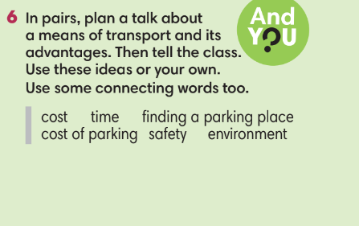
WRAP-UP & HOME WORK (3’)
- T asks Ss to talk about what they have learnt in the lesson.
- Use connecting words to talk about a means of transport and its advantages.
* HOME WORK
- Do exercises in the workbook page 83.
- Prepare for Lesson 9.7: English in use.

=====================

Date of planning:  Date of teaching: | UNIT 9: FUTURE TRANSPORT  Lesson 7: Writing
I. OBJECTIVES:
By the end of the lesson, Ss are able to gain:
1. Knowledge:
* To practice writing a paragraph about advantages and disadvantages.
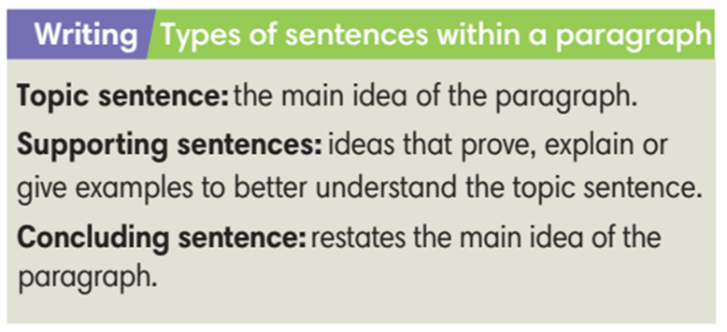
2. Competence: Ss can write a paragraph about the advantages and disadvantages of a means of transport.
3. Quality/behavior: To teach Ss to be hard-working and attentive in class. Ss have a positive attitude to working in groups, individual work, pair work, cooperative learning and working.
II. TEACHING AIDS:
- Teacher: Grade 7 textbook, Unit 9 (SB p.97, WB p.84), laptop/computer connected to the Internet, loudspeaker, projector/TV, PPT slides …
- Students: Text books, studying equipment …
- Method: Active teach, T-WC; group works; individual …
III. PROCEDURE:
1. WARM UP & LEAD-IN (10’)
ACTIVITY 1
* Aims:
- To set the context for the lesson;
- To brainstorm about advantages and disadvantages;
- To lead into the lesson.
* Content: Advantages and disadvantages of some prepared things/topics.
* Organization: Teacher’s instructions
Teacher’s & Student’s activities | Content
(5’) Extra activity 1: Quick Fire Game.  - T explains the game rules and instructions.  - Ss are divided into 3 teams to discuss the advantages and disadvantages of given things/topics.  - T calls Ss to talk about their group’s ideas.  - T corrects Ss’ pronunciation if any. | Game rules:  ✔ T shows a thing/topic on the slide.  ✔ Ss have 1 minute discussion for each topic and write down all advantages and disadvantages that they have discussed.  ✔ Teams crosscheck each other.  ✔ 1 reasonable advantage/disadvantage = 1 point.
1. (5’) Read the text about travelling by car. In pairs, answer the questions.  (Exercise 1 – SB p.97)  - T asks Ss to look at the photo and elicit some advantages and disadvantages of travelling by car.  - T asks Ss to read the text and do exercise 2 individually before checking their answers with the whole class. | 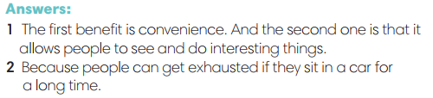
2. PRACTICE 1 (5’)
ACTIVITY 2:
* Aims: To helps Ss distinguish main ideas (MI) and supporting details (SD)
* Content: Text about the advantages and disadvantages of travelling by cars.
* Outcome: Can identify MI and SD sentences.
* Organisation: Teacher’s instructions….
Teacher’s & Student’s activities |  | Content
2. Look at the ideas below from the text.  Label them as MI (main ideas) or SD  (supporting details).  (Exercise 2 – SB p.97)  - T calls Ss to read the instructions and all the statements.  - T elicits the difference with MI sentence and SD sentence.  - T asks Ss to do the exercise 2 individually before comparing their answers with a partner.  - T checks the correct answers with the whole class and clarifies any misunderstanding among Ss. |  | 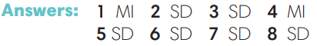
3. PRESENTATION (12’)
ACTIVITY 3:
* Aims:
- To present three types of sentences in a paragraph.
- To identify these three types of sentences in paragraphs.
* Content: Paragraphs about the advantages and disadvantages of different means of transport.
* Outcome: Understand the function and differences of three types of sentences in a paragraph.
* Organisation: Teacher’s instructions….
Teacher’s & Student’s activities | Content
3. (6’) Studying the Writing box. In pairs, find the topic sentence, supporting sentences and concluding sentence in the text in Exercise 1.  (Exercise 3 – SB p.97)  - T calls a S to read the instruction then checks Ss’ understanding of it.  - T asks Ss to read the Writing box and elicits from them different types of sentences within a paragraph.  - T asks Ss to do find these sentences in the text in Exercise 1.  - T checks the correct sentences with the whole class.  4. (6’) Read the following paragraph and label the sentence types: topic sentence (TS), supporting sentence (SS) and concluding sentence (CS).  (Exercise 4 – SB p.97)  - T calls a S to read the instruction then checks Ss’ understanding of it.  - T asks Ss to work in pairs to do the Exercise 4.  - T checks the answers with the whole class. | 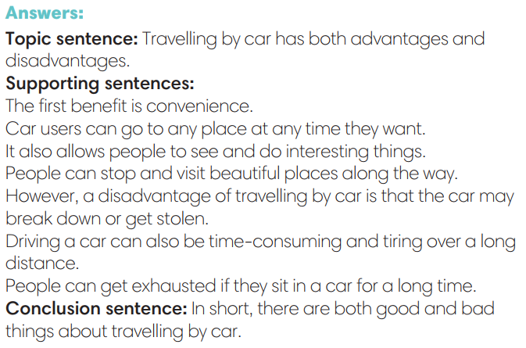  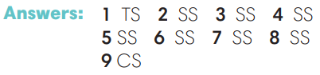
4. PRACTICE 2 (5’)
* Aims: To help Ss practiSe grammar points.
* Content: Sentences in paragraphs about advantages and disadvantages
* Outcome: Identify correct sentences in paragraphs
* Organisation: Teacher’s instructions…..
Teacher’s & Student’s activities | Content
Extra activity 2: Is that sentence correct game.  - T prepares a bunch of sentences, each sentence on a slide.  - T explains the game rules then checks instructions.  - T divides the class into 3 teams.  - T provides the correct answers with the whole class. | Game rules:  ✔ Ss work together in their teams to decide if the sentence is correct or not.  ✔ If not, they have to write down the correct form.  ✔ Each team is given 10 points to start the game.  ✔ For each sentence, teams bet their answers with maximum 5 points.  ✔ 1 correct answer = 3 points.
5. FURTHER PRACTICE (10’) Writing
ACTIVITY 5:
* Aims: To encourage Ss to apply vocabulary and grammar points they have learnt to write a paragraph about the advantages and disadvantages of a means of transport.
* Content: Paragraphs about the advantages and disadvantages of a means of transport.
* Outcome: Write a paragraph about the advantages and disadvantages of a means of transport.
* Organisation: Teacher’s instructions…..
Teacher’s & Student’s activities | Content
5. Write a paragraph (60-80 words) about the advantages and disadvantages of a means of transport.  (Exercise 5 – SB p.97)  - T calls a S to read the instruction then checks Ss’ understanding of it.  - T asks Ss to think about one means of transport then make notes of its advantages and disadvantages before writing the paragraph.  - Ss exchange their writing with a partner for peer-feedback.  - T walks around to see Ss’ writing and notes down common mistakes for later feedback.  - T gives feedback on Ss’ work. | 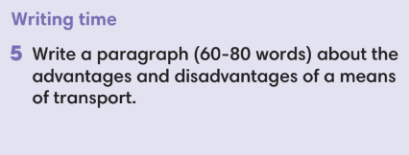
WRAP-UP & HOME WORK (3’)

- T asks Ss to talk about what they have learnt in the lesson.
✔ Paragraphs about the advantages and disadvantages of a means of transport.
✔ Three types of sentences in a paragraph.
* HOME WORK
- Do exercises in the workbook page 84.
- Prepare for Lesson 9.8: Glossary and Vocabulary in action.

======================

Date of planning:  Date of teaching: | UNIT 9: FUTURE TRANSPORT  Lesson 8: Glossary and Vocabulary In Action
I. OBJECTIVES:
By the end of the lesson, Ss will be able to gain:
1. Knowledge:
- To practise speaking in context.
* Vocabulary: Review vocabulary
- Different means of transport.
- Transportation adjectives.
2. Competence: To know how to use vocabulary to talk about different means of transport then do the tasks assigned in the textbook.
3. Quality/behavior: To teach Ss the love of talking about food and drink, and develop self-study skills. Ss have a good attitude to working in groups, individual work, pairwork, cooperative learning, and working.
II. TEACHING AIDS:
- Teacher: Grade 7 textbook, Unit 9 (SB p.98, WB p.85), laptop/computer connected to the Internet, loudspeaker, projector/TV, PPT slides…
- Students: Text books, studying equipment…
- Method: Active teach, T-WC; group works; individual…
III. PROCEDURE:
1. WARM UP (6’)
*Aims:
- To create an active atmosphere in the class before the lesson.
- To recall vocabulary learnt from the unit.
* Content: Vocabulary about different means of transport.
* Outcome: Recall the vocabulary learnt
* Organisation: T’s instructions
Teacher’s & Student’s activities | Content
Extra activity 1: Board race game  - T explains the game rules then checks the instruction.  - T divides the class into 3 teams and asks them to line up facing the board.  - T gives the S at the front board markers/chalks.  - T reminds Ss to write words related to the unit’s topic: Transport | Game rules:  ✔ Ss line up facing the board in 3 teams.  ✔ When T says a vocabulary topic ad says GO, the teams have to race to write that list of words on the board.  ✔ Each S writes one word at a time, passes the marker/chalk to the next S and goes to the back of the line.  ✔ S sets time limitation for each topic of 30 – 60 seconds.  ✔ 1 correct word = 1 point.
2. INTRODUCTION (10’)
ACTIVITIES 1 + 2:
*Aims:
- To introduce the glossary and its uses.
* Content: Glossary table.
* Outcome: Review vocabulary with glossary table.
* Organisation: T’s instructions.
Teacher’s & Student’s activities | Content
1. (5’) Use the glossary to find.  (Ex 1 – SB p.98)  - T introduces the glossary table.  - T asks Ss to look at the Exercise 1.  - T has Ss use the glossary to find the words which belong to the correct category.  - T asks Ss to do the exercise individually before checking their answers with a partner.  - T checks the answers with the whole class. | Answer keys:  1 e-bus, bullet train, electronic car, self-driving car.  2 flying car, aircraft, hot air balloon.  3 comfortable, convenient, spacious.
2. (5’) Find words in the glossary to complete the Word Friends below.  (Ex 2 – SB p.98)  - T asks Ss to do Exercise 2 before checking their answers with a partner.  - T checks the answers with the whole class.  - T asks Ss to make sentences with this word friends list.  - T calls some Ss to read their sentences and asks other Ss to give feedback. | Answer keys:  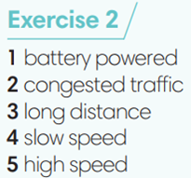
3. PRACTICE 1 ( 10’) VOCABUALRY
ACTIVITY 3
* Aims: To review the vocabulary of the unit in term of definition.
* Content: Word definition.
* Outcome: Understanding the definition of words.
* Organisation: T’s instruction.
Teacher’s & Student’s activities | Content
(5’) Extra activity 2: Hot seat game  - T explains the game rules then checks instructions.  - Ss are divided into 3 teams.  - T takes an empty chair for each team and put it in front of the class, facing the team members. These chairs are the hot seats.  - T prepares a list of the vocabulary learnt in the unit.  - T either shows a word/picture on the slide or writes a word on the board. | Game rules:  ✔ One S from each team comes to sit on the hot seat facing their teammates.  ✔ Ss in 3 teams describe the provided word using synonyms, antonyms, definitions, etc. to their teammate on the hot seat.  ✔ The Ss on the hot seat listen to their teammates and try to guess the word.  ✔The first hot seat S to say the word wins 1 point for their team  ✔ Then, change the hot seat Ss.
3. (5’) Write the correct word / phrase for each definition.  (Ex 3 – SB p.98)  - T calls a S to read the instruction and checks for Ss’ understanding.  - T asks Ss to work individually before checking their answers with a partner.  - T checks the answers with the whole class. | Answer keys:  /ð/: another, father, that, their, together.  /θ/: anything, healthy, thing, think, thought, tooth, through.
4. PRACTICE 2 (10’) PRONUNCIATION
ACTIVITY 4:
* Aim: To review the vocabulary of the unit in term of identifying the stress in two and three-syllable words.
* Content: Review vocabulary learnt in the unit.
* Outcome: Pronounce words correctly with correct word stress.
* Organisation: T’s instruction.
4. (5’) Listen and pay attention to the stress in two and three-syllable words. Listen again and repeat.  (Ex 4 – SB p.98)  - T calls a S to read the instruction then checks Ss’ understanding.  - T asks Ss to say the words and mark the stress of the words individually before listening to the recording to check their answers.  - T elicits that the stress is normally on the first syllable of two and three-syllable nouns and adjectives while the stress is normally on the second syllabus of two-syllable verbs. | 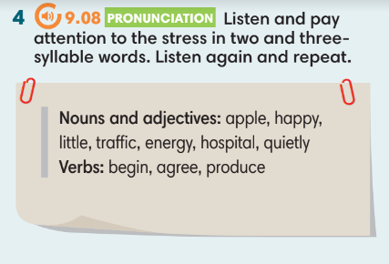
5. (5’) In pairs, say the words. Listen, check and repeat.  (Ex 5 – SB p.98)  - T asks Ss to work in pairs to practice saying the sentences.  - T reminds Ss to pay attention to the bold word stress and read the sentences with intonations.  - T walks around the class, listen to Ss’ speaking and notes any mistakes if yes for later feedback. | 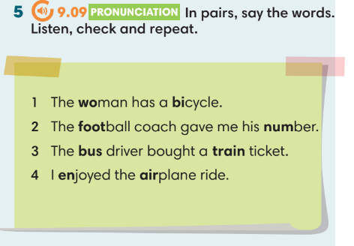
5. PRODUCTION (6’)
FURTHER ACTIVITY:
* Aims:
- To review the vocabulary learnt in term of pronunciation.
* Content: Vocabulary learnt in the unit.
* Outcome: Identify the numbers of syllables and word stress
* Organisation: T’s instructions
Extra activity 3: Word stress game.  - T prepares 12 papers of colored A4 paper with the target vocabulary and post them to the board. Each sheet has a number in the top and consists of a few words.  - T explains the game rules then check the instruction.  - T divides the class into groups of 3-4.  - T checks the answers with the whole class. | Game rules:  ✔ Each team in turn chooses one sheet of paper (e.g. Green paper number 5).  ✔ Then, the team have 30-60 seconds to decide:  - How many syllables it has.  - Where the word tress is.  - Give another word of the same number of syllable and word stress.  ✔Each correct answer for a word = 1 point.  ✔ While the teams are discussing their answers, the other teams can be doing the same as they might get a chance to steal the other teams’ points.
WRAP-UP & HOME WORK (3’)

- T asks Ss to talk about what they have learnt in the lesson.
✔ Use the glossary to review the learnt vocabulary.
✔ Word stress of two and three-syllable words.

* HOME WORK
- Do exercises in the workbook page 85.
- Prepare for Lesson 9.9: Revision.

==================

Date of planning:  Date of teaching: | UNIT 9: SCHOOLS  Lesson 9: Revision
I. OBJECTIVES:
By the end of the lesson, students will be able to:
- Use the vocabulary and grammar of the unit to talk about different means of transport.
- Practise writing a paragraph about the advantages and disadvantage of a means of transport.
1. Knowledge:
* Vocabulary:
- Vocabulary learnt in the unit: means of transport, transportation adjectives.
* Grammar:
- will / will not
- as … as, different from
2. Competence: Understand and use vocabulary to talk about different means of transport.
3. Quality/ behavior: To teach Ss to be hard-working and attentive in class. Ss have a positive attitude to working in groups, individual work, pair work, cooperative learning, and working.
II. TEACHING AIDS:
- Teacher: Grade 7 textbook, Unit 9 (SB p.99), laptop/computer connected to the Internet, loudspeaker, projector/TV, PPT slides …
- Students: Text books, studying equipment….
- Method: Active teach, T-WC; group works; individual ……
III. PROCEDURE:

1. WARM UP & INTRODUCTION (8’)
*Aims:
* Aim: To help Ss review the vocabulary learnt in the unit.
* Content: Vocabulary of the unit.
* Outcome: Review the vocabulary.
* Organisation: T’s instruction.
Teacher’s & Student’s activities | Content
(4’) Extra activity 1: Quiz, quiz, trade game.  - T prepares a set of word cards.  - T explains the game rules then checks the instruction.  - T models the activity with a volunteer S.  - T can play music while Ss are playing, and pause the music to stop the activity.  - T walks around to help Ss and notes any difficulties/challenges for later feedback. | Game rules:  ✔ Each S is given a word card.  ✔ Ss work with partners to explain the word for their partners to guess the word.  ✔ Once both Ss in a pair finish describing their word, they exchange their word card and find another partner to continue.
(4’) Extra activity 2: Creative sentence making.
- T writes three random words of different forms on the board and asks Ss to identify their word forms.
- T asks Ss to make a sentence containing these 3 words individually before sharing with a partner.
- T walks around the class and notes any difficulties/ mistakes for later feedback.
- T asks some Ss to read out their sentences and asks their classmates to give peer feedback.
2. PRACTICE (13’) – VOCABULARY
ACTIVITIES 1, 2, 3:
*Aim:
- To review vocabulary in context.
* Content: Vocabulary learnt in the unit.
* Outcome: To clearly understand the learnt vocabulary and use them correctly in the context.
* Organisation: T’s instruction.
Teacher’s & Student’s activities | Content
1. (5’) Choose the odd one out. Explain why.  (Ex 1 – SB p.99)  - T asks Ss to open their SB page 99, look at exercise 1.  - T calls a S to read the instruction then checks Ss’ understanding.  - T asks Ss to work in pairs to do exercise 1.  - T calls some Ss to give answers and checks the answers with the whole class. | Answer keys:  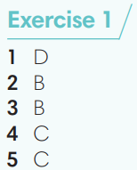
2. (4’) Use the word below to complete the phrases.  (Ex 2 – SB p.99)  - T calls a S to read the instruction then checks Ss’ understanding.  - T asks Ss to do the exercise individually before checking their answers with a partner.  - T checks the answers with the whole class.  - T asks Ss to write a sentence for each phrase to describe it.  - When S have finished, ask a S to read out one of their sentences so the other Ss can guess which phrase the description is for. | Answer keys:  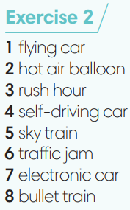
3. (4’) Complete the sentences with one word.  (Ex 3 – SB p.99)  - T asks Ss to do the exercise individually before checking their answers with a partner.  - T calls some Ss to read their answers and corrects if needed. | Answer keys:  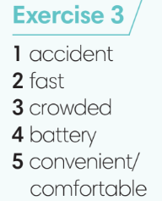
3. PRACTICE (13’) GRAMMAR
ACTIVITIES 4 & 5:
* Aim: To review the grammar points learnt in the unit.
* Content: Texts about different means of transport.
* Outcome: To review will / will not, as … as, different from and use them correctly in sentences.
* Organisation: T’s instruction.
Teacher’s & Student’s activities | Content
(3’) Extra activity 3: Sentence Jumble game.  - T prepares a set of paper strips of jumbled sentences using the grammar points learnt in the unit.  - T puts all the paper strips into a box/bag.  - T divides the class into 3-4 teams.  - T sets time limitation of 2-3 minutes. | Game rules:  ✔ Teams take a strip from the given box/bag and work together to unjumble the sentence then write the answer on a sheet of paper.  ✔ When one sentence is unjumbled, teams take another strip and continue.  ✔ Each correct sentence = 2 points.
4. (4’) Read the text and make predictions about the way people might travel in 2050. Complete the sentences with will, will not or won’t.  (Ex 4 – SB p.99)  - T calls a S to read the instruction and check Ss’ understanding.  - T asks Ss to do exercise 4 individually before checking their answers with a partner.  - T calls some Ss to give their answers and corrects if needed. | Answer keys:  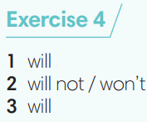
5. (4’) Complete the sentences using as … as or different from.  (Ex 5 – SB p.99)  - T calls a S to read the instruction then checks Ss’ understanding.  - T asks Ss to do exercise 5 individually before checking their answers with a partner.  - T calls some Ss to give their answers and corrects if needed.  - T gives feedback on Ss’ work. | 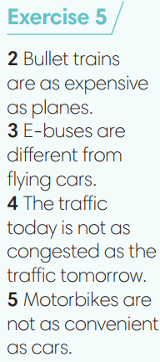
4. PRODUCTION (8’)
ACTIVITY 6:
* Aim: To practice writing a paragraph about the advantages and disadvantages of a means of transport.
* Content: Writing a paragraph.
* Outcome: To review three types of sentences in a paragraph.
* Organisation: T’s instruction.
Teacher’s & Student’s activities | Content
6. Write a paragraph (60-80words) about the advantages of travelling by motorcycle. You should include a topic sentence, supporting sentences and a concluding sentence.  (Ex 6 – SB p.99)  - T calls a S to read the instruction then checks Ss’ understanding.  - T brainstorms some advantages of travelling by motorcycle with the whole class.  - T asks Ss to write their paragraph individually.  - T walks around the class to correct any mistakes if needed.  - Ss check in pairs to find any mistakes.  - T invites some Ss to share their writing and other Ss comment. | 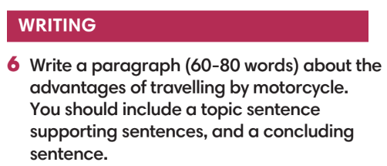
WRAP-UP & HOME WORK (3’)
T asks Ss to talk about what they have learned in the lesson.
- Review vocabulary and grammar of Unit 9.
* HOMEWORK
- Do exercises in the workbook page 85.

