Date of teaching: | REVIEW (UNIT 8-9)
I. OBJECTIVES:
1. Knowledge: By the end of this review, students will be able to revise the language they have learnt and the skills they have practiced in Units 8 - 9.
a) Vocabulary: revise the vocabulary which students have learnt in Unit 8 and Unit 9: words related to festivals and future transport.
b) Grammar: review the grammar points which students have learnt in Unit 8 and Unit 9: Adjectives ending in –ing and –ed; Future simple.
c) Writing: Writing sentences and paragraph.
d) Speaking: Talking about how to make a traditional dish for Vietnamese festival.
2. Competence: Ss use the vocabulary of the unit, and do the tasks assigned in the textbook. Participate in a guided conversation to give and respond to the news using the given information.
3. Quality/ behavior: Having a positive attitude towards the lesson and a good relationship with friends. The love of learning English. Hard-working; attentive; cooperative; sociable; good communication in class.
II. TEACHING AIDS:
- Teacher: Textbook, laptop, loudspeaker, projector…
- Students: Grade 7 textbook, Unit 8&9 (SB p. 99), studying equipment….
- Method: T-WC; group works; individual ……
III. PROCEDURE:
1. REVIEW VOCABULARY UNIT 8 (14’)
ACTIVITY 1 + 2:
* Aim:
- To help students reviews topic words and word friends from the unit.
- To review vocabulary in context.
* Content: Glossary of unit 8, Racing Animal Game: vocabulary of unit 8.
* Outcome: Students’ correct pronunciation and answers.
* Organization of implementation:
Teacher’s & Student’s activities |  | Content
1. (7’) Activity 1:  - T tells students to open the Glossary box in student book page 88.  - T asks Ss work in pairs: 1 student points to the word, 1 student pronounces it. Then they swap their roles.  - T corrects Ss’ pronunciation if any. |  | 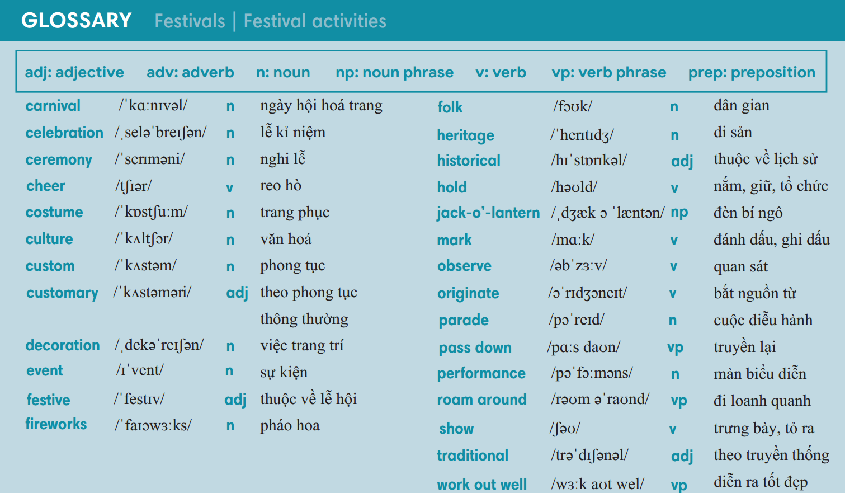
2. (7’) Racing Animal Game:  - T gives and checks instructions for the game.  - T corrects Ss’ pronunciation if any. |  | How to play:  - 2 teams: Rabbit and Turkey.  - Each team takes turn to move rabbit and turkey from number 1 to number 5.  - Choose question 1-8 to answer.  - 1 correct answer = move forward 1 step. 1 incorrect answer = move back 1 step.  - Choose CHANCE to get your lucky or unlucky gift.  - The team that touch CANDIES first is the winner.
2. REVIEW GRAMMAR UNIT 8 (7’)
ACTIVITY 3:
*Aim: To help students revise Adjectives ending in –ing and –ed; however, nevertheless; Question words.
* Content: Matching Game.
* Outcome: Complete the sentences by matching in the blanks correctly.
* Organisation: Teacher’s instructions…..
3. Matching Game  - T gives and checks instructions for the game.  - T corrects Ss if any. | How to play:  - 12 sentences.  - Match a suitable word with a sentence.  - 1 correct answer = 1 point.
3. REVIEW VOCABULARY UNIT 9 (14’)
ACTIVITY 4 + 5:
Aim:
- To help students review topic words and word friends from the unit.
- To review vocabulary in context.
* Content: Glossary of unit 9, Lucky Person Game: vocabulary have learnt in the unit 9.
* Outcome: Call out the vocabulary. Revision. Do exercises correctly.
* Organisation: Teacher’s instructions…...

4. (7’) Activity 4:  - T tells students to open the Glossary box in student book page 98.  - T asks Ss work in pairs: 1 student points to the word, 1 student pronounces it. Then they swap their roles.  - T corrects Ss’ pronunciation if any. | 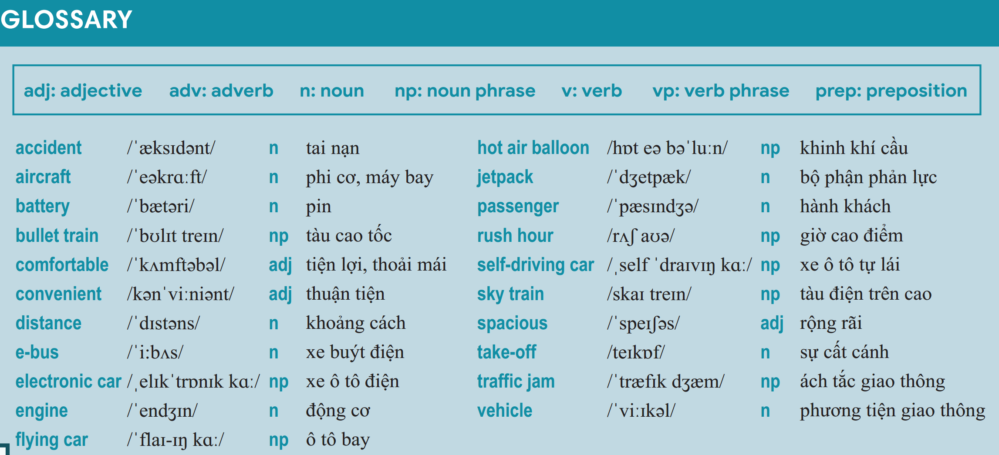
5. (7’) Lucky Person Game:  - T gives and checks instructions for the game.  - T corrects Ss’ pronunciation if any. | How to play:  - 4 teams, each team takes turn to guess which word is inside the mystery box by choosing A, B, C or D.  - Each team has 5 points at first.  - Guess correctly = 1 point/ incorrectly = -1 point.  - The team with the most correct guesses wins the game.
4. REVIEW GRAMMAR UNIT 9 (7’)
ACTIVITY 6:
* Aim: To help students revise Future tense; as … as, different from.
* Content: Review grammar elements taught in unit 9 by playing Rearrange Game.
* Outcome: Do exercises correctly.
* Organisation: Teacher’s instructions…..

Teacher’s & Student’s activities | Content
6. Rearrange Game.  - T gives and checks instructions for the game.  - T corrects Ss if any. | How to play:  - 8 sentences.  - Rearrange the words to make a meaningful sentence.  - 1 correct answer = 1 point.
WRAP-UP & HOME WORK (3’)
- T asks Ss to talk about what they have learnt in the lesson.
- Review Unit 8 vocabulary and grammar.
- Review Unit 9 vocabulary and grammar.
* HOME WORK
- Prepare for PREPARATION FOR 2nd TERM TEST.
- Do exercises in WB.

