Teaching date : …………………………
Week 17 - Period 51
REVIEW 1 (UNIT 3+4)
I. Objectives: By the end of the lesson, students will be able to revise and practise all the vocabulary and grammar in Unit 3 + 4.
Knowledge:
- Vocabulary and grammar of Unit 3 + 4
Competences:
- Groupwork and independent working, pair work, linguistic competence, cooperative learning and communicative competence
- Teaching aids:
Materials: textbooks, PowerPoint slides
Equipment: TV, projector, loudspeaker
- Procedure:
Checking: integrated into the warm-up activity
New lesson:
Teacher’s and students’ activities | Contents
1. Warm-up
Aims: to attract Ss’ attention to the lesson and review the previous lessons.
- T asks Ss to work in 4 big groups and gives each group an A4 paper.  - Ss in each group take turns to write the words they know.  - After 3 minutes, the group with the most words wins the game.  - T asks Ss to read aloud all the words. | Review of Classroom objects, subjects and prepositions of place vocabulary
  Classroom objects | Subjects | Daily routines
2. Set objectives
Aims: to introduce the objectives of the lesson with a can-do statement.
- I can name classroom objects and school subjects. I can talk about habits and what is happening now.
3. Activity 1
Aims: to identify the words that have the opposite meaning and practice Present simple forms.
- T asks Ss to read the sentences in the exercise.  - Ss replace the words in bold with the words in the list.  - T calls some Ss to give their answers and checks for them.  - Ss work in pairs to make these sentences true for them. | Exercise 2 (p.38) Replace the word in bold with the words below to make sentences with the opposite meaning. In pairs, say which sentences are true for you.  Answers:  2. never 3. bored  4. early 5. worried  6. unhappy 7. work  - A: I don’t enjoy sleeping in a sleeping bag. What about you?  - B: Me too. I don’t enjoy sleeping in a sleeping bag.
4. Activity 2
Aims: to recall Word Friends and practice Present simple forms.
- T elicits the word forms for each blank.  - Ss work individually to fill one word in the blank. Then they can compare the answers with friends.  - T checks with the whole class.  - Challenge: Ss work in groups of 4 to change sentences 1, 3, 6 into negative and interrogative forms. | Exercise 1 (p.39): Complete the sentences with ONE word.  - Answers for Exercise 1:  - Text 2. have/ eat  3. fall 4. watch/ listen  5. can’t 6. have  7. don’t  - Answers for Challenge activity:  - Sentence 1:  (-) I don’t text my friends all the time.  (?) Do you text your friends all the time?  - Sentence 3  (-) My parents don’t often fall asleep in front of the TV.  (?) Do your parents often fall asleep in front of the TV?  - Sentence 6  (-) I don’t always have a party on my birthday.  (?) Do you always have a party on your birthday?
5. Activity 3
Aims: to recall Word Friends and practice Present simple forms.
- Before doing the exercise, T asks Ss to review the Present Continuous.  - T asks Ss to read all the diary entries and work in groups of 4.  - Ss discuss the tenses they have to use in each gap and put the verbs in the correct forms.  - After 3 minutes, T calls some groups to give their answers  - T checks and gives marks. | Teacher’s resources Unit4_11:  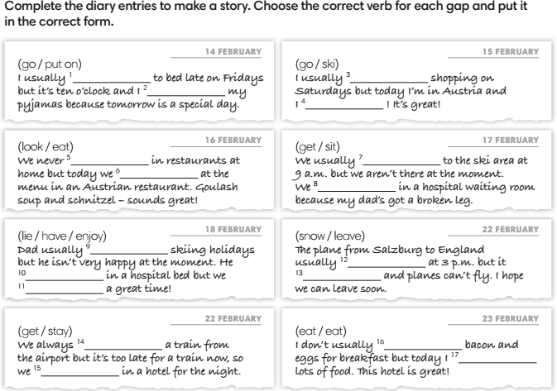
6. Activity 4
Aims: to recall the usage of prepositions.
Quiz corner  - T shows the sentences one by one on the screen.  - Ss work in pairs to write the answers on mini-boards or paper.  - T shows the answers on the screen.  - Ss get the point for correct answers. | Exercise 6 (WB p.41): Complete the sentences with prepositions. (Adaptation)  - in/ on  - behind  - next to/ next to  - in front of  - between
3. Guides for homework:
- Do exercises in Self-check Unit 3 and 4 in Workbook.
- Prepare for Unit 5 lesson 1.
----------- ---------
Teaching date : …………………………
Week 17 - Period 52
REVIEW 1 (UNIT 5)
- Objectives: Students will be able to revise and practise all the vocabulary and grammar in Units 5 + 6.
- Knowledge:
- Vocabulary and grammar of Unit 5 + 6
- Competences:
- Groupwork and independent working, pair work, linguistic competence, cooperative learning and communicative competence
- Teaching aids:
- Materials: textbooks, worksheet, PowerPoint slides
- Equipment: TV, projector, loudspeaker
- Procedure:
- Checking: integrated into the warm-up activity
- New lesson:
Teacher’s and students’ activities | Contents
1. Warm-up
Aims: to attract Ss’ attention to the lesson and review the previous lesson.
Hangman  - T shows the words with blank one by one.  - Ss guess the letters to find the words. | Complete the types of music (Exercise 2 – SB p.58)  - It’s a kind of music. (hip-hop)  - It’s a musical instrument. (accordion)  - It’s a type of sport. (ice hockey)  - It’s a sportsperson. ( cyclist)
2. Vocabulary
Aims: to review vocabulary in Units 5 and 6.
- T asks Ss to work in 4 groups and give each group a small board.  - T asks Ss to remember the words about sports, types of music and musical instruments.  - T gives the topics one by one and asks Ss to write the words.  - The fastest group with correct answers will get 1 point for their group.  - T continues with other topics. | Possible topics and examples:  1. Three sports with races: motor racing, mountain biking, running, …  2. Four ball sports: basketball, football, hockey, table tennis, tennis, volleyball, …  3. Five sportpeople: champion, footballer, reporter, sports fan, sports star, …  4. Six sport places: football field/ pitch, gymnasium, running track, sports center, stadium, tennis court, …  5. Six types of musical instruments: piano, guitar, saxophone, trumpet, accordion, drum, harmonica,…  6. Four types of music: rap, classical, rock, ballad, jazz,…
- T asks Ss to read the sentences in the exercise.  - T asks Ss to work in pairs to do the exercise.  - There may be more than one correct answer for each sentence. | Exercise 2 (WB p.50) Complete the words in the review.  Answers:  - fantastic  - brilliant  - gorgeous/ great  - terrible  - bad/ boring  - cool  - alright
3. Grammar
Aims: to revise and practise all the grammar points in Unit 5 + 6
- Before doing the exercise, T asks Ss to review the superlative forms of the adjectives.  - T asks Ss to read all the adjectives in the brackets and decide which adjectives are short/long adjectives.  - SS discuss and do the exercise on their own.  - After that, T asks some Ss to give their answer and check for them.  - T asks Ss to work in pairs to ask and answer the questions in the exercise.  - Then T calls some pairs to talk in front of the class. | Exercise 5 (SB p.59): Complete the question with the superlative forms of the adjectives in the brackets. In pairs, ask and answer the questions.  Answers:  2. the funniest  3. the most talented  4. the nicest  5. the fittest  6. the most interesting  7. the best  8. the most successful.
- T tells Ss that they are going to play a board game with a coin and a counter (a small piece of paper would be fine).  - The rules are that students flip the coin and if it lands ‘heads’ up, they move two places on the board; if it lands ‘tails’ up, they move one place.  - Explain that if a player lands on a numbered square, they have to choose the correct option and then ask the completed question to the other two students in the group, who both have to answer. If a player lands on an unnumbered square, they have to use their imagination to complete the sentence.  - The student to the player’s left has to start from that same square, not from the start, and the process is repeated.  - Rather than being a competitive game to see which student can finish first, the idea of the game is that students take turns to move the whole group through the board.  - Put students into groups of three, and hand out a worksheet, a coin and a counter to each group.  - When the groups have reached ‘FINISH’, invite them to ask and answer some of the questions in front of the class. | Teacher’s Resource Book Unit 6_11: RESOURCE 76  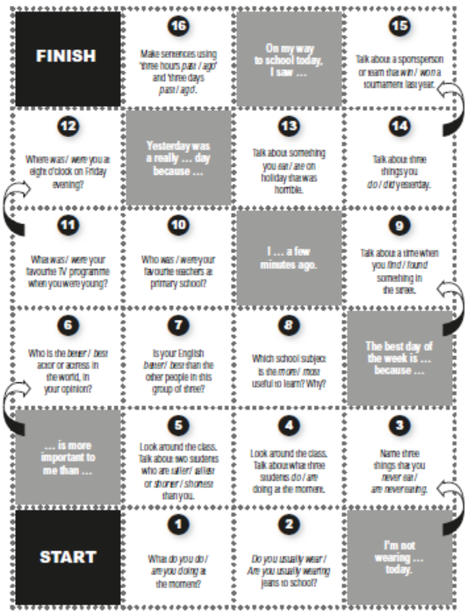
3. Guides for homework:
- Do Exercises of Unit 6 in Workbook pages 50 and 59.
- Prepare for the next Unit
----------- ---------
Teaching date : …………………………
Week 18 - Period 53
THE FIRST END-TERM TEST
A. Objectives
1. Knowledge: By the end of the lesson, ss will be able to finish the test on time.
2. Competence: SS can use language correctly.
3. Behavior: SS are serious to do the test.
B. Teaching aids: CD and stereo, paper tests.
C. Procedures
ĐỀ THI DO PHÒNG GIÁO DỤC RA.

--------------------------------------------------------------------------

Teaching date : …………………………
Week 18 - Period 54
TEST CORRECTION
A. Objectives
1. Knowledge: By the end of the lesson, ss will be able to realize what they have done, what they haven’t done.
2. Competence: They can self-evaluate their studying and have good plans to improve.
3. Behavior: Students are hard-working and attentive. They will try their best to get better results.
B. Teaching aids
1. Teacher: Textbooks, teaching plan, paper tests, loud speaker.
2. Students: Textbooks, notebooks, paper tests.
C. Procedures
1. Checking: During the lesson.
2. The Mid-term 45-minute Test correction: (43’)
Teacher’s and students’ activities | Contents
I. Correct the second end-term test  Listen (0,25 pt for each correct answer )  Listen and Complete their conversation with the words below.  - Asks ss to fill in each question and explain.  - Gets feedback.  PRONUNCIATION  Choose the word whose underlined part is pronounced differently. 0,2 5pt for each correct  - Asks ss to answer again each question and explain. - Gets feedback.  Choose the word that does not belong to the group of the other three. 0,2 5pt for each correct  - Asks ss to answer again each question and explain. - Gets feedback.  VOCABULARY AND GRAMMAR  Fill with the present simple or present continuous form of the verb in brackets. (0,25 pt for each correct answer )  - Asks ss to answer again each question and explain.- Gets feedback.  Choose the best option to complete each sentence. (0,25 pt for each correct answer )  - Asks ss to answer again each question and explain.- Gets feedback.  Supply the correct form of the word. (0,25 pt for each correct answer )  READING : Read the passage and decide if each statement is true (T) or false (F). Write T or F.(0,25 pt for each correct answer )  - Asks ss to answer and explain.- Gets feedback.  Read the passage and fill in the gaps with A, B, C, or D.(0,25 pt for each correct answer )  - Asks ss to answer again each question and explain.- Gets feedback.  WRITING : Rewrite the sentences based on the given words.(0,25 pt for each correct answer )  - Asks ss to answer again each question and explain.- Gets feedback.  Order the following words to make sentences.(0,25 pt for each correct answer )  - Asks ss to answer again each question and explain. - Gets feedback.  II. Let Ss know their common mistakes: (10’)  Listening: Most Ss do well.  Grammar – Vocabulary – Language function:  - Many Ss do incorrectly question 3,4,6,8,10.  Reading:- Part I: Most Ss do well.  - Part II: Many students couldn’t answer question 1, 3 correctly.  Writing:  - Part I: Many Ss couldn’t do questions 2, 3 well.  - Part II: Many SS make spelling mistakes in their writing. Their words are not clear enough for reading. The grammar and structure are quite good.  * Solution : - Gives compliment to good students and gives the criticism to lazy students.  - Encourages students to study harder.  - Reminds students to avoid making the common mistakes. | - LISTENING  - Buy 2. good  3. like 4 . much  - cheap 6. get  7. about 8. expensive  9. A 10. C 11. C  12. D 13. B  III.  - speak 15. walks 16. aren’t  17. B 18. A 19. C 20. C 21. B 22. C 23. D 24. A  - friendly 26. Japanese  IV. READING  F 28. T 29. F 30. T 31. T  32. A 33. B 34. B 35. D 36. C  - Mary has long hair and round face.  - There are two bookshelves in Tom’s bedroom.  - How much salt is there in the soup?  - There aren’t a lot of restaurants in my town.  - Listen, take notes and remember.  - Recall and remember.
- Result:
Class | 0 - 2 | % | 2,5 – 4,5 | % | 5 - 6,5 | % | 7 - 8,5 | % | 9 - 10 | %
8B
Grade 8
3. Guides for homework (2’)
- Asks Ss to review all the knowledge they have studied so far at home.
--------------------------------------------------------------------------

Teaching date : …………………………
Week 17 - Period …
REVIEW 1 (UNIT 1+2)
- Objectives: By the end of the lesson, students will be able to revise and practice all the vocabulary and grammar in Unit 1 + 2.
- Knowledge:
- Vocabulary and grammar of Unit 1 + 2
- Competences:
- Groupwork and independent working, pair work, linguistic competence, cooperative learning, and communicative competence
- Teaching aids:
- Materials: textbooks, PowerPoint slides, Teacher’s resource book Unit 1_2 worksheets
- Equipment: TV, projector, loudspeaker
- Procedure:
- Checking: integrated into the warm-up activity
- New lesson:
Teacher’s and students’ activities | Contents
1. Warm-up
Aims: To revise the language that Ss have learned in Unit 1 and 2.
Memory game  - T draws or sticks an unfinished chart that summarizes the language that Ss have learned in Unit 1 and 2 on the board.  - T divides the class into 2 teams and asks Ss to run in a relay to complete the chart:  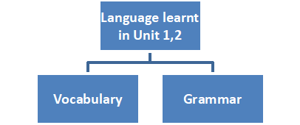  Use ___ to talk about abilities  Use ____ to talk about possession  ____/_____ nouns  There ___/ ____  Family  _________  Personailty  _________  Clothes  Food and _____ | Suggested answer:  - Vocabulary: Family, Nationality, Personality, Appearance, Clothes, Food, and drink.  - Grammar: Use "can" to talk about abilities, Use have got to talk about possession, There is / There are, Countable/Uncountable noun
2. Set objectives
Aims: To introduce the objectives of the lesson with a can-do statement.
- I can talk about people, food and drink.
- I can use "can" to talk about abilities, "have to" to talk about possession.
- I can identify countable and uncountable nouns
- I can make sentences with “there is/ are + noun”.
3. Activity 1
Aims: To help Ss to review the Vocabulary about people, food, and drink.
- Solve the crossword puzzle.  - T shows the crossword puzzle.  - T divides the class into 2 teams and asks Ss to run in relay to complete the crossword puzzle.  - The team with the most correct answers will be the winner.  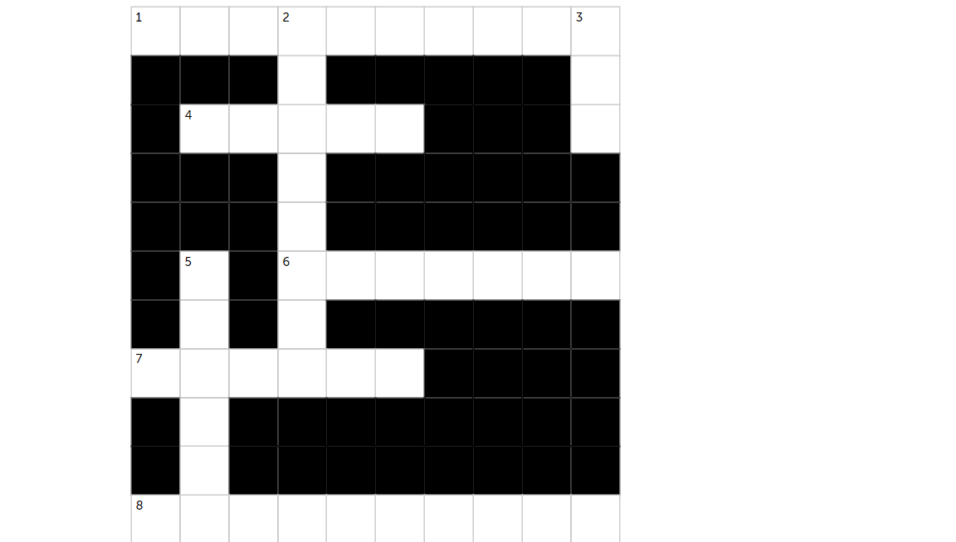  - Across  - A place where you can buy and eat a meal.  - You look very ____ in that suit.  - Is the official language of England.  - A child of your aunt or uncle.  - a person who does not eat meat or fish  - Down  - a kind of shoe that you wear for sports or as informal clothing.  - Would you like some___?  - She has got long ____ hair. | Answers:  - restaurant  - trainers  - tea  - smart  - blonde  - English  - cousin  - vegetarian
4. Activity 2
Aims: To help Ss review grammar elements taught in Unit 1 and 2.
- T asks Ss to review meaning, usage, and form of can.  - T gives Ss hand out and asks Ss to match the words with pictures.  - T elicits the answers and asks Ss to look at the picture and make sentences with I can…  Who is the fastest?  - T divides the class into groups.  - Round 1: T says a sentence: I can or I have got….. loudly. Ss have to choose the picture and run to the board and give the teacher. The first group to give the correct picture will get 1 point.  - Round 2: T shows pictures one by one. Ss in groups have to race to be the first group to write a sentence. When a group has written their sentence, they should put their hands up. If they have the correct answer, they get 1 point.  - The winning group is the one that has won the most points. | Teacher’s resources Unit 1_2  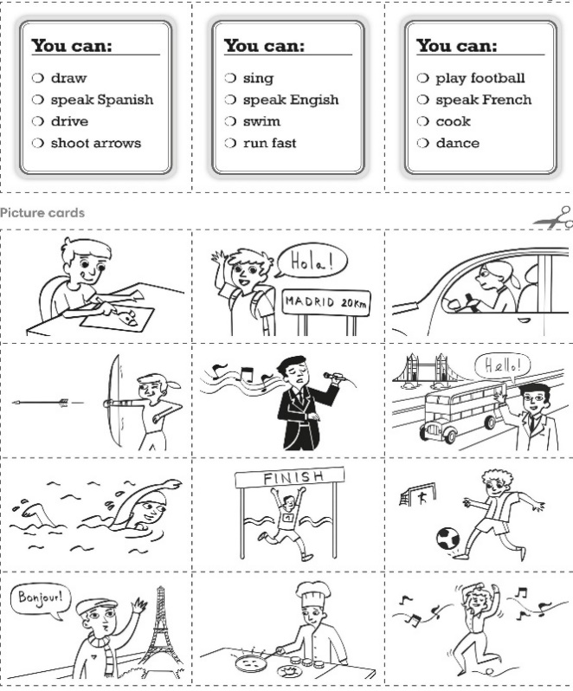
5. Activity 3
Aims: To review and practice have got.
- T asks Ss to look at the sentences.  - T asks Ss to work in pairs to complete the sentences.  - T elicits the answers and asks Ss the reasons. | Exercise 5 (WB p.23): Complete the sentences with one or two words in each gap.  Answers:  - much  - any  - many  - any  - a  - are  - many / any  - not  - any  - piece
6. Activity 4
Aims: to review speaking expression in Units 1 and 2.
- T asks Ss to match questions with answers to make a dialogue with the partner.  - Excuse me, can I help you?  - What does she look like?  - Is her name Lan?  - She is waiting for you at table 5. Do you come with her?  - What would you like?  - Is everything ok?  - How much is this?  - Thank you. I need to find my friend.  - She has got long black hair. She is tall and wearing a green dress.  - Yes, it is  - Yes. Thank you.  - Fish fingers and chips, please.  - It's delicious.  - $150, please.  - T asks Ss to practice this dialogue in pairs. Ss can add more questions and answers.  - T calls some pairs to go to the board and roleplay. | - Answers  1 – A  2 – B  3 – C  4 – D  5 – E  6 – F  7 – G
3. Guides for homework:
- Do exercises in Self-check Units 1 and 2 in Workbook.
- Prepare for Unit 3 lesson 1.
----------- ---------

