Teaching date : ………………
Period: 10,11,12

COMPARATIVE OF ADJECTIVES
I./Aims:
Review the Compareative form of adjectives.
II./ Objectives:
By the end of the lesson, Ss will be able to know again how to use the Compareative form of adjectives and do exercises.
III./ WAYS OF WORK:
T – WC, Pair work, Individual work, group work
IV./ MATERIALS:
Lesson plan, sách BT Tiếng Anh 8
V./ PROCEDURE:
A. WARM- UP:
Greets and checks attendance.
B. CHECK – UP:
C. NEW LESON:

Teacher’s activities | Students’ activities
I. Vocabulary  A. Nomadic life  B. Buffalo-drawn cart  C. Huge pasture  D. Livestock  E. Paddy field  F. Ger  II. GRAMMAR  Asks SS to remind the forms  Comparative forms of adj and adv:  + ADJECTIVES  + ADVERBS  S1 + V + as + adj/adv + as + S2 + auxiliary V  S1 + V + as + adj/ adv + as + O/ N/ pronoun  Asks SS to do some exercises  Ex 1.  Ask SS to do Exercises on voc and gram in the workbook in groups  Asks some good SS to write the answers on the board  Ex2. Give the correct form of the words in the brackets in each of the following sentences.  1. better  2. more heavily  3. heavier than  4. longer than  5. more happily  6. healthily  7. more quickly  8. taller than  9. more noisily  10. Friendly  11. easier than  12. more powerful than  13. Harder  14. cheaper than  15. more brightly  16. more beautiful than  17. more comfortable than  18. more easily  19. more effective than  Ex3: Some of the comparisons in these sentences are incorrect. Underline and correct the mistakes.  - Incorrect -> lower than  - Incorrect -> as difficult as  - Correct  - Incorrect-> better than  - Correct  - Incorrect-> nearer to the main road than  - Correct  - Correct  Ex4:  1.A 2.D 3.D 4.D 5B  Ex5:  1. Her new house isn’t so/as big as her old one.  2. Peter is the tallest in my class.  3. The white dress isn’t so/ as expensive as the black one.  4. According to me, Maths isn’t so/as easy as English.  5. Mary is the most intelligent in my group.  6. The Nile is the longest river in the world.  7. No mountain in the world is higher than Mount Everest.  8. She is the prettiest girl I have ever met.  9. The more he works, the more tired he feels.  10. That computer doesn’t work so/as well as that one. | I. Vocabulary  Ex 1: Match the word to the right picture  Livestock  Paddy field  Nomadic life  Huge pasture  Ger  Buffalo-drawn cart  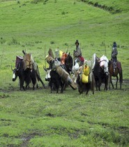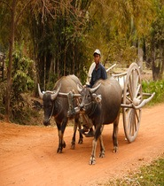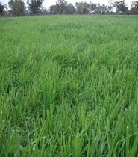  A B C  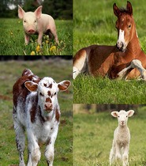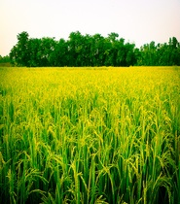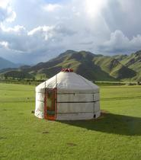  D E F  II. GRAMMAR  Write the forms in the notebooks  Ex 1. Write the comparative form of the adverbs  Fast………………………..  Early………………………..  Badly………………………..  Happily………………….  Expensive…………………………  Polluted……………………………  Hard…………………….  Successfully………………………  Ex2. Give the correct form of the words in the brackets in each of the following sentences.  Ex3: Some of the comparisons in these sentences are incorrect. Underline and correct the mistakes.  - The cost of living in the countryside is more low than in the city.  - In general, putting up a tent is not as difficult than building a house.  - Harvest is the busiest time of year in the countryside.  - Dogs are much more better than human beings at detecting smells.  - Life in a big city is more exciting than life in a small town.  - This cottage is near to the main road than that red one.  - The paddy fields in the mountains are usually not as large as those in the lowlands.  - The path through Dead Valley is the most dangerous in my country.  Ex4: Find the word which has a different sound in the part underlined. Read the words aloud.  1. A. country B. cloud C. loudly D. mouse  2. A. camel B. cattle C. paddy D. buffalo  3. A. populated B. loaded C. harvested D. lived  4. A. fields B. flowers C. lemons D. parks  5. A. normal B. visitor C. transport D. chore  Ex5: Rewrite sentences:  1. Her old house is bigger than her new one.  -> Her new house…………………………………  2. No one in my class is taller than Peter.  -> Peter ……………………………….………….  3. The black dress is more expensive than the white one.-> The white dress ……….…………  4. According to me, English is easier than Maths.  -> According to me, Maths …………………  5. No one in my group is more intelligent than Mary.  -> Mary ……………………..……………….  6. No river in the world is longer than the Nile.  -> The Nile …………………………………..  7. Mount Everest is the highest mountain in the world.-> No mountain …………….…………...  8. This is the first time I have ever met such a pretty girl.-> She is ……………..……………..  9. He works much. He feels tired.-> The more……  10. This computer works better than that one.  -> That computer …………………………..  Ex 6: Give the correct form of the adverbs  1. Farmers collect fruit ………..….than others. (fast)  2. That young nomad herds his livestock ……..than his father. (well)  3. City children seem to react …………….than those in the countryside. (quickly)  4. After the summer holiday in a remote area, Jim studies …………… (hard)  5. My cousin painted his own room ……………than I did. (skillfully)
  Đối với tính từ ngắn:
  S + to be + adj + er + than + S2
  Đối với tính từ dài:
  S + to be + more + adj + than + S2
  1. | A tractor can plough ________ than a buffalo or a horse. (good)
  2. | It usually rains ________in Central Viet Nam than in other regions. (heavy)
  3. | Blue whales are ________ elephant. (heavy)
  4. | The Mekong River is ___the Red River. (long)
  5. | Our family ha lived ________ in the country than in the town since last year. (happy)
  6. | I like to eat ________, so I eat a lot of fruits and vegetables every day. (health)
  7. | Time goes by _____when we are busy. (quick)
  8. | My sister is ________ me. (tall)
  9. | They boys were playing the game ________ than the girls. (noisy)
  10. | We want ___relations with all countries. (friend)
  11. | Do you think English is ________ French in grammar? (easy)
  12. | A tractor is ________ a buffalo. (powerful)
  13. | I will have to try a bit ______than this. (hard)
  14. | Tea is ________ coffee. (cheap)
  15. | The hall was lighted ________ than the corridors. (bright)
  16. | The countryside is ________ the town. (beautiful)
  17. | My new bed is ______ my old bed. (comfortable)
  18. | This task can be completed _____than that one. (easy)
  19. | The new harvest machine is _____ then the old one. (effective)
D. Consolidation:
- Retell the main points of this lesson.
E. Homework:
- Revision the Comparative forms of adj and adv
----------- ----------

