UNIT 3: EVERY DAY
Period 28: Lesson 3.1: Vocabulary
I. OBJECTIVES
By the end of the lesson, students are expected to achieve the following objectives:
- Knowledge:
- Vocabulary: Verbs to describe routines and adverbs of frequency
- Grammar: Present simple tense
- Competencies:
- General competencies:
Form and improve such competencies as group work, independent working, pair work, and cooperative learning.

- Specific competencies:
Improve communicative competencies related to the use of language (vocabulary, phonetics, grammar)
For a language lesson: Students are expected to know the meaning of the keywords used to describe routines, and understand the main grammatical points, then do the tasks assigned in the textbook.
For a skills lesson: Students are expected to use the verbs and phrases about daily life activities to practice talking about daily routines.
- Qualities:
- Being hard-working and attentive in class
- Have a positive attitude towards the lesson
- Being polite when asking about each other’s personal routines
II. PREPARATIONS
Teacher: Textbooks, worksheet, PowerPoint slides, TV, projector, loudspeaker
Students: Textbooks, notebooks
III. PROCEDURE

ACTIVITY 1: WARM-UP
- Aim: To attract Ss’ attention to the lesson and review the previous lesson.
- Content: Ss work in groups under the instruction from T to play the warm up game where they will mime eating a specific food for their team members to guess.
- Products: Ss are able to recall all vocabulary from the previous unit.
Implementation:

TEACHER AND STUDENTS’ ACTIVITIES | CONTENTS
Step 1: Task delivering  - T puts Ss into 2 groups. Choose 1 S from each group to come to the front of the class and show them a food item.  Step 2: Task performance  - Explain to the two Ss that they should mime eating this food item for their groups to guess.  Step 3: Judgment | Review of Vocabulary from the previous unit.  Suggested words: egg, yoghurt, banana, carrot, chips, a hamburger, noodles, …

- When Ss can guess the food item correctly, they raise their hands and receive a point.
Step 4: Report and discussion
- Repeat the process with different food items and Ss.
ACTIVITY 2: KNOWLEDGE FORMATION
- Aim: To introduce the objectives of the lesson with a can-do statement.
- Content: The objective of the lesson is listed below
- I can talk about daily routines.
- Products: Ss acknowledge the lesson’s objectives.
- Implementation: T introduces objectives to Ss.
ACTIVITY 3: PRESENTATION
- Aim: To teach verbs about daily routines and adverbs of frequency.
- Content: Ss work individually with the guidance from T to do the exercises in the textbook.
- Products: Ss are able to use the vocabulary and grammar structure to answer questions from T and accomplish the assigned exercises.
- Implementation:
TEACHER AND STUDENTS’ ACTIVITIES | CONTENTS
Set the scene:  Step 1: Task delivering  - T instruct S to do the task  Step 2: Task performance  - T asks Ss these questions below respectively:  - “What’s your favourite time of day?”  - “What do you often eat at breakfast?”  - Ss answers questions given by T respectively  Step 3: Judgment  - T checks the exercise with the whole class.  Step 4: Report and discussion  - T leads to the new lesson by saying: “Today we are going to talk about routines”.  Step 1: Task delivering  - T asks Ss to read the text in 2 mins.  - T shows 3 words “often, sometimes, never” on the screen and asks Ss to listen and repeat the words chorally and individually.  Step 2: Task performance  - Ss listen and repeat the words chorally and individually.  Step 3: Judgment  - T says that they are three adverbs of frequency, and checks the pronunciation and meanings of the words.  Step 4: Report and discussion  Ask Ss to write down 3 words into their notebook and give examples for them. | Exercise 1: What’s your favourite time of day?  Suggested answer:  - Morning is my favourite time of day.  - I often eat noodles.  Exercise 2: Read and tell how you say the underlined words in the text below in your language.  Adverbs of frequency:  - often  - sometimes  - never

Step 1: Task delivering  - T asks Ss to read aloud the Vocabulary box, and explains some new words if necessary.  - T tells Ss that these verbs are used to describe routines.  - T asks Ss to match the verbs with the photos A-J on page 30. Note: Ss use almost all words in the Vocabulary box. Some are not in the box.  Step 2: Task performance  - Ss have 3 mins to do the exercise and answer it with the whole class.  Step 3: Judgment  - T checks the meanings of the words that are not used in exercise 3, such as have a shower, relax, work, go home with definitions and pictures.  Step 4: Report and discussion  - T develops further discussion if needed. | Exercise 3: Study the vocabulary box. Match the verbs with photos A-J on page 30.  Answers:  A. wake up  B. get up  C. have breakfast  D. go to school  E. arrive at school  F. study  G. have lunch  H. exercise  I. have dinner  J. read books
ACTIVITY 4: PRACTICE
- Aim: To make sentences with adverbs of frequency and verbs that describe daily routines.
- Content: Ss work individually and then in pairs in exercise 4, and work individually again to complete the quiz in exercise 5.
- Products: Ss are able to use the given verbs to complete the phrases and sentences in the two assigned exercises correctly.
- Implementation:
Step 1: Task delivering  - T instructs Ss to do exercises in the textbook.  Step 2: Task performance  - Ss underline routines in the text in Exercise 2 and put them in order. T gives each pair a worksheet to take notes.  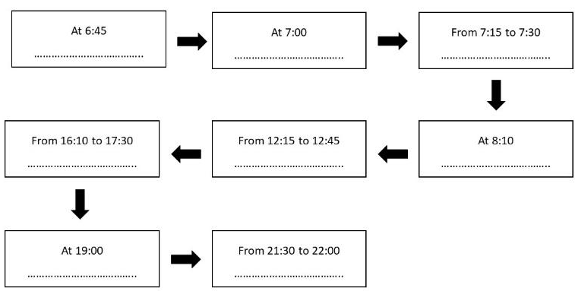  - T asks Ss to read the verbs in the list. underline the following nouns or verbs in 5 sentences. Then find them in the text in Exercise 2.  Step 3: Report and discussion  - T ask Ss to work individually to complete the phrases and then share the answers in pairs.  - Ss listen and check their answers with the whole class.  Step 4: Judgment  - T checks Ss answers and explains new words if necessary. | Answers for the worksheet:  …  …  Exercise 4: Complete the phrases with the verbs below. Use the text in Exercise 2 to help you.  Keys:  - spend  - have  - participate in  - catch  - study
Step 1: Task delivering  - T instruct S to do the task  Step 2: Task performance  - Ask Ss to work individually to complete the sentences in the quiz.  Step 3: Report and discussion  - T calls some Ss to give their answers by reading the whole sentences.  Step 4: Judgment  - After that, T asks Ss to tick sentences that are true for them and go to page 111 and check the results  - T asks Ss to give their facts. | Exercise 5: Complete the sentences with the quiz in one word. Tick the sentences that are true for you. Go to page 111 and check.  Answers:  1-3-4-8
ACTIVITY 5: FURTHER PRACTICE
- Aim: To do a class survey about the topic.
- Content: Ss work as a whole class to carry out the survey using the given questions with the instruction from T.
- Products: Ss are able to ask and answer questions using correct grammar structure and then report the result to the class.
- Implementation:
Step 1: Task delivering  - T explains the activities to the Ss.  Step 2: Task performance  - In the shortest time, Ss need to interview 3 students in the class, write their names and their answers in the columns.  - Ss can walk around the class to interview.  - T makes a model for Ss.  Step 3: Report and discussion  - After 3 mins, T asks Ss to go back to their seats and report the results of their survey to the whole class.  Step 4: Judg ment  - T gives feedback to Ss. | Exercise 6: Interview three students in your class using the questions below. Write their names and answers in the columns. Then report to the class.
   | Student 1 | Student 2 | Student 3
  What time do you often wake up on weekends?
  How often do you exercise?
HOME ASSIGNMENT  - T assigns the home assignments.  - Ss copy their home assignments.  - T explains it carefully. | - Do exercises on Workbook pages 24-25.  - Prepare Unit 3 Lesson 3.2 – Grammar.

