UNIT 1: CULTURAL INTERESTS
PERIOD 11. LESSON 1.5: LISTENING & VOCABULARY

I. OBJECTIVES
By the end of the lesson, Ss are able to:
1. Knowledge
- Vocabulary: use vocabulary of types of media to talk about media habits.
- Grammar: make sentences in the Present Simple with different personal pronouns correctly.
2. Core competences
- General competences: form and / or improve such competences as group work, independent working, pair work, linguistic competence, and cooperative learning.
- Specific competences:
- Improve communicative competence related to the use of language (vocabulary, phonetics, grammar):
- For a language lesson: Ss are expected to use vocabulary of types of media and TV programs, do the tasks assigned in the textbook.
- For a skills lesson: Ss are expected to listen and identify specific details in a conversation and talk about media habits.
3. Personal qualities
- Being hard-working and attentive in class
- Have a positive attitude towards the lesson
II. MATERIALS
- Grade 7 textbook, Unit 1 (SB p. 15, WB p.11)
- Computer (accessible to the Internet is the best)
- Projector / TV/ PPT slides / Active teach
III. LANGUAGE ANALYSIS
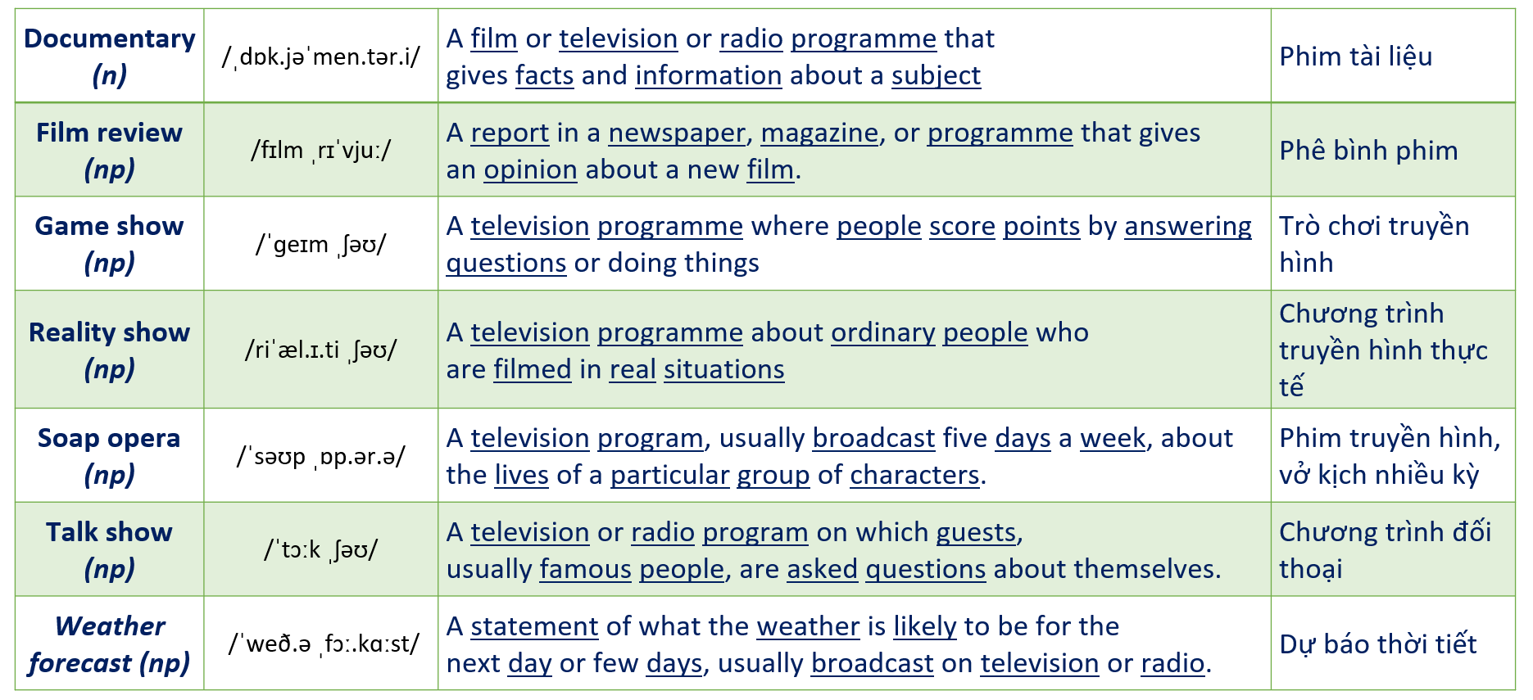
IV. ASSUMPTIONS
Anticipated difficulties | Solutions
1. Ss may write the structures incorrectly. | Keep the useful expressions on the board for reference.  Encourage peer-check.
2. Ss may not have sufficient speaking and co-operating skills. | Give clear instructions, give examples before letting Ss work in pairs / groups.  Provide feedback and help if necessary.

V. BOARD PLAN
UNIT 1: CULTURAL INTERESTS
PERIOD 11. LESSON 1.5: LISTENING & VOCABULARY
I. Vocabulary
types of media | game show | film/game review
documentary | reality show | soap opera
talk show | weather forecast | programs
II. Class Work: Listening task and exercises in Student Book page 15
II. Homework
- Do exercises on workbook page 11.
- Prepare Unit 1 – Lesson 1.6: Speaking.

VI. PROCEDURE
Stage | Stage aim | Procedure | Interaction
WARM-UP  &  LEAD-IN | - To create a positive classroom atmosphere to start a new lesson.  - To lead in to the topic | Activity 1: Class Vote (SB p.15 - Ex 1)  - Set the scene: T tells Ss to look at the girl in Student book page 15. T asks some questions to elicit that the girl is going to do an interview about types of media.  - Teacher introduces the Vote and the survey questions in student book.  - T explains How-to-vote steps then checks instructions.  How to vote:  - Read the questions  - Ask your classmates questions from 1-6  - Put a dot next to the type of media that you hear  - Answer your classmate questions if you are asked  - Ss join in the survey in pairs or in small groups.  - T sets the scene for the new lesson: T tells Ss that they are going to learn more words of media by doing a listening task.  - T writes the title on the board Unit 1: Cultural interests / Lesson 1.5: Listening and Vocabulary | T-Ss  Ss-T
WARM-UP  &  LEAD-IN | - To get students to think about the topic.  - To provide Ss with reasons for more discussions | Activity 2: Count and Announce  - T writes 4 types of media on the board: Newspaper, The Radio, The TV, and The Internet  - T asks students to count the number of the dots next to the name of media in their book.  - Ss work in pairs to count and tell teacher the answer.  - T asks some student to help with work out the most popular type of media in the class.  - T tells Ss that they’re going to learn more words of media in the next steps of the lesson. | T-Ss  T-Ss  Ss-T
PRE-LISTENING | - To activate Ss’ prior knowledge of the topic.  - To pre-teach words of news and entertainment | Activity 3: Multiple Choice Game  (pre-teach vocabulary)  - Teacher introduces that Ss will learn more words of media by joining a game.  - T explains the game rules then checks instructions.  How to play:  - Look at the pictures and read the definitions  - Read the words of programs  - Choose 1, 2 or 3 to match the word with the picture  - 1 correct answer = 1 point  - Ss join the game in team. Ss take turns to answer each question.  - Teacher leads the game and asks students to read aloud each word or phrase.  - When the game ends, teacher shows all the new words again for students to read. | T-Ss  T-Ss  Ss-T  T-Ss
PRE-LISTENING | - To check Ss’ answers in “Think and Share” activity.  - To reinforce words of programs | Activity 4: Think and Share. (SB p.15 – Ex 2)  - T asks Ss to look at exercise 2.  - T calls a student to read the instruction then checks Ss’ understanding of it.  - T asks Ss to work in groups of three to read then complete the activity.  - T calls groups to give answers to check as the whole class.  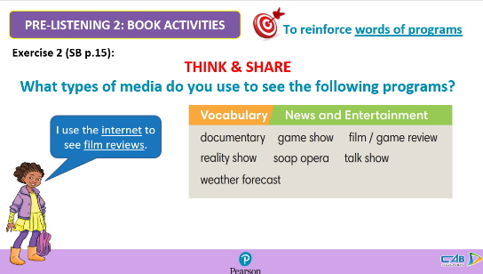 | T-Ss  Group work  Ss-T  T-Ss  Ss-T
 | - To reinforce words of programs | Activity 5: Exercise 3 (SB p.15)  Use the Vocabulary box to complete the sentences.  Change the words if necessary.  - T asks Ss to look at exercise 3.  - T calls a student to read the instruction then checks Ss’ understanding of it.  - T asks Ss to work in pairs to read then complete the activity.  - T checks as the whole class.  Answer keys:  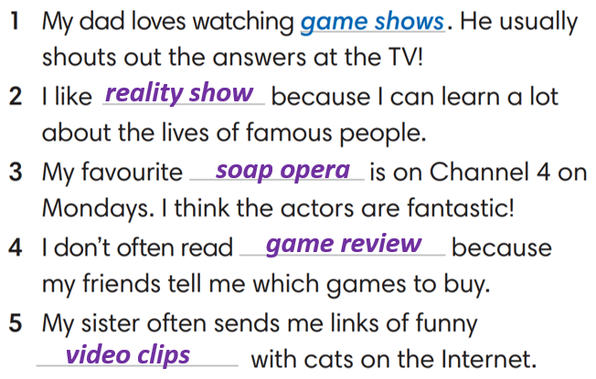 | T-Ss  Pair work  T-Ss  Ss-T
 | - To reinforce words of programs | Activity 6: Exercise 2 (WB p.11)  Match comments 1-6 with the types of media.  - T asks Ss to look at exercise 2 in workbook page 11.  - T calls a student to read the instruction then checks Ss’ understanding of it.  - T asks Ss to work in pairs to read then complete the activity.  - T checks as the whole class.  Answer keys:  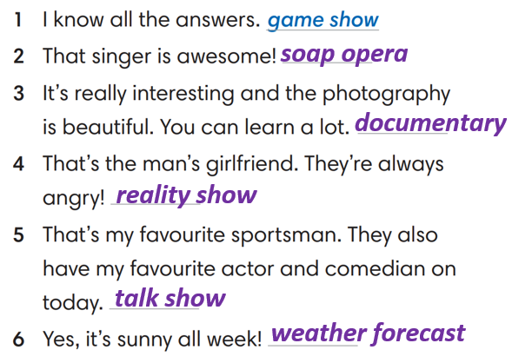 | T-Ss  Pair work  T-Ss  Ss-T
WHILE-LISTENING | - To help Ss identify specific details in a conversation  - To provide Ss with chances to think and talk about personal media habits | Activity 7: Exercise 4 (SB p.15)  Listen and match speakers 1-4 with the type of program they like a-e.  - T asks Ss to look at exercise 4 in student book page 15.  - T calls a student to read the instruction then checks Ss’ understanding of it.  - T asks students to look at the different kinds of programs and think of reasons why people might like these kinds of show.  - T asks Ss to work in pairs to listen then complete the activity and peer check for the first listening.  - T plays the audio again and checks as the whole class.  - Teacher asks students to give the evidence that they hear from the audio track to prove their answer.  Answer keys: 1-c, 2-e, 3-b, 4-a | T-Ss  Ss-Ss  T-Ss  T-Ss
POST-LISTENING | To help students applying the vocabulary items related to the topic in communicating. | Activity 8: Exercise 5a & 5b (SB p.15):  Complete the following sentences to make them true for you. Then share with your partner  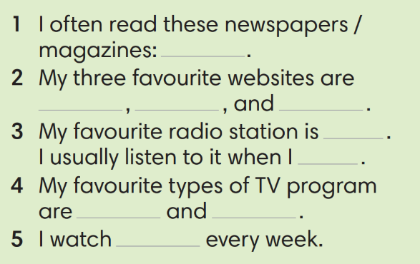  - T asks Ss to look at exercise 5a in student book page 15.  - T calls a student to read the instruction then checks Ss’ understanding of it.  - T asks Ss to work in pairs to read then complete the activity.  - T sets a time limit for student.  - Students work in pair to think and share.  - Teacher invites different students to talk about their partner. | T-Ss  Ss-Ss  T-Ss
WRAP-UP | To consolidate what Ss have learnt in the lesson. | - T asks Ss to talk about what they have learnt in the lesson.  - Vocabulary of types of media | T-Ss  Ss-T
HOMEWORK | To review the lesson and prepare for the next lesson. | - Do exercises in the workbook page 11.  - Prepare for Lesson 1.6: Speaking. | T-Ss

……………………………………………………………………………………………
Date of preparing: ………………………………………
Date of teaching: ………………………………………

