UNIT 1: CULTURAL INTERESTS
PERIOD 14. LESSON 1.8: VOCABULARY IN ACTION & PRONUNCIATION

I. OBJECTIVES
By the end of the lesson, Ss are able to:
1. Knowledge
- Vocabulary: review vocabulary
+ The lexical items related to hobbies: types of film, types of radio/TV programs, type of music, things you can read.
+ Verbs of liking and disliking
- Pronunciation: Correctly pronounce words that contain the sounds /ɪ/ and /i:/
2. Core competences
- Develop communication skills and creativity
- Be collaborative and supportive in pair work and teamwork
- Develop presentation skill
- Actively join in class activities
3. Personal qualities
- Love talking about their hobbies
- Develop self-study skills
II. MATERIALS
- Grade 7 textbook, Unit 1 (SB p.18, WB p.14).
- Computer (accessible to the Internet is the best)
- Projector / TV/ PPT slides / Active teach

Assumptions
Anticipated difficulties | Solutions
1. Students may lack experience of group/ teamwork. | Encourage students to work in groups so that they can help each other.
2. Students may not have sufficient listening, speaking and co-operating skills. | - Play the recording, the replay depends on the students’ need and level.  - Encourage students to work in pairs, in groups so that they can help each other.  Provide feedback and help if necessary.

Board Plan
UNIT 1: CULTURAL INTERESTS
PERIOD 14. LESSON 1.8: VOCABULARY IN ACTION & PRONUNCIATION

I. Vocabulary
Review types of film, types of radio/TV programs, type of music, things you can read
II. Pronunciation
Identify the sounds /ɪ/ and /i:/ in words and sentences.
III. Homework
- Do exercises on workbook page 14.
- Prepare Unit 1 – Lesson 1.9: Revision

III. PROCEDURES
Stage | Stage aim | Procedure | Interaction
WARM-UP  LEAD - IN | - To create an active atmosphere in the class before the lesson.  - To lead into the new lesson. | Activity 1: NAME 3 THINGS CHALLENGE  * Teacher asks students to spend 1 minutes to quickly review all vocabulary they have learnt in Unit 1 before they play a warm-up game.  - T tells students that they are going to play a game called NAME 3 THINGS CHALLENGE  - T explains the game rules then checks instructions.  Game rules:  - Choose a number to get the challenge  - Read the topic word  - Say 3 words relating to that topic quickly.  - Teacher uses the slides to show the challenge  - Ss join in the game pairs or in small groups.  - Teacher listens to the Ss answers and calls several Ss to check for the whole class.  - T tells Ss that they can remember better with Glossary Table and asks Ss to open their Student Book page 18 – Exercise 1. | T-Ss  T-Ss  Ss-T
REVIEW  VOCABULARY  WITH GLOSSARY TALBE | To introduce the glossary and its uses.  - To give further practice with verbs of liking / disliking. | Activity 2: Exercise 1 – Student Book page 18  Use the Glossary to find:  - Teacher introduces the Glossary Table.  - T asks Ss to look at exercise 1 in student book page 18  - T has students use the glossary to find the words which belong to the correct category  - T asks students to work in pairs and quickly do the task.  - T allows students to peer check first.  - T checks and confirms the answers.  Answer key:  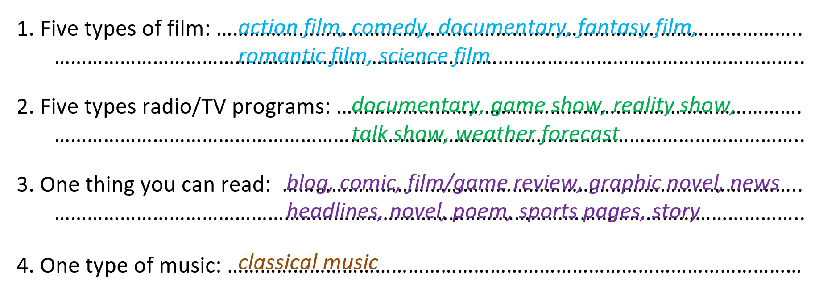  Activity 3: Exercise 1 – Student Book page 18  In pairs, say which three things you prefer in each category in activity 1.  - T reminds students about the form of verbs of liking / disliking.  - T asks students to do this activity individually. Have students read all the sentences carefully to make sure they understand the sentences.  - T lets them share their answers in pairs. Invite some students to give the answers.  - T writes the correct answers on the board.  e.g.  I prefer horror films, comedies and ….  Activity 4: Exercise 3 – Student Book page 18  Complete the Word Friends. In pairs, say if the sentences are true for you.  - T asks students to complete the sentences with suitable words.  - T asks students to work individually and check in pairs.  - T invites students to share their answers.  - T confirms the correct answers.  Answer key:  1. into  2. take  3. about  4. happy  5. check  6. in | T-Ss  Pair work  T-Ss  T-Ss
PRONUNCIATION  Presentation and Practice | - To present new sounds  - To help students identify how to pronounce the sounds /ɪ/ and /i:/ | Activity 5: HEAR AND CLAP GAME  - T tells students that they are going to play a game called HEAR AND CLAP  - T explains the game rules then checks instructions.  Game rules:  - Hear the sound  - Read the words  - Clap your hands 1 or 2 times to choose the word you hear.  - Teacher uses the slides to lead the game  - Ss join in the game pairs or in small groups.  - T listens to the Ss answers and calls several Ss to check for the whole class.  - T asks students to say the word again to practice some sounds after each play.
PRONUNCIATION  Presentation and Practice | - To help students practice pronouncing these sounds in words.  To help students pronounce the sounds /ɪ/ and /i:/ correctly in sentences.  To help students identify the sounds /ɪ/ and /i:/ correctly in words | Activity 6: Exercise 4a– Student Book page 18  Listen to the underlined vowel(s) in each word and describe which sound you hear. Write the word in the correct column.  - T calls some students to read out the words first.  - T plays the recording for them to listen and underline vowel(s) in each word.  - T asks Ss to write the word in the correct column.  /ɪ/ and /i:/  - T invites some students to share their answers.  - T confirms the correct ones.  Activity 7: Exercise 4b– Student Book page 18  Listen, check and repeat.  - T plays the recording for them to listen and repeat the words they hear.  - T asks Ss to pay close attention to the two sounds.  - T plays the recording again if needed.  - T explains to students the difference between the two sounds if needed.  - T invites some students to say some words they know that include the two sounds.  - T confirms the correct answers.  (Teacher can play the pronunciation guide video of this unit for students to watch and learn). | T-Ss  Individual work  Ss-T  T-Ss  T-Ss  Group work  T-Ss
  /i:/ | /ɪ/
  media  reading  seat  teenagers | interest  middle-aged  sing  video
FURTHER PRACTICE | To reinforce the student recognition of the targeted sounds. | Activity 8 – ODD ONE OUT  - T explains the game rules then checks instructions.  Game rules:  - Read and choose A, B or C to odd out one word  - Explain by correctly saying the sounds  - Teacher uses the slides to lead the activity  - Ss join the activity in pairs or in small groups.  - T listens to the Ss answers and calls several Ss to check for the whole class.  - T asks students to say the word again to practice some sounds after each question. | T-Ss  Group work  T-Ss  Ss-T
WRAP-UP | To consolidate what students have learnt in the lesson. | Teacher asks students to talk about what they have learnt in the lesson. | T-Ss
HOMEWORK | To reactivate the knowledge that students have gained | Find 3 more words relating to hobbies that have the sounds /ɪ/ and /i:/  - Do exercises on workbook page 14.  - Prepare Unit 1 – Lesson 1.9: Revision | T-Ss

……………………………………………………………………………………………
Date of preparing: ………………………………………
Date of teaching: ………………………………………

