Date of planning: …………….  Date of teaching: …………….. | UNIT 2: FAMILY AND FRIENDS  PERIOD 22 . LESSON 2.6. SPEAKING

I. OBJECTIVES:
By the end of the lesson student will be able to:
- improve speaking skills by giving and responding to news.
1. Knowledge:
* Vocabulary: use the expressions of giving and responding to news.
* Grammar: make dialogue in the Present Simple, Present Continuous with expressions of giving and responding to news.
2. Competence: Ss understand and use the expressions of giving and responding to news as well as the other related topics to the lesson content, do the tasks assigned in the textbook. Listen and read a dialogue for comprehension and practice in giving and responding news.
3. Quality/ behavior: To teach Ss to be hard-working and attentive in class. Ss have a positive attitude to working in groups, individual work, pair work, cooperative learning and working.
II. TEACHING AIDS:
- Teacher: Grade 7 textbook, Unit 2 (SB p. 26, WB p.21), laptop/computer connected to the Internet, loudspeaker, projector/TV, PPT slides…
- Students: Text books, studying equipment…
- Method: Active teach, T-WC; group works; individual ……
III. PROCEDURE:
1. WARM UP + LEAD-IN (5’)
* Aim:
- To create a positive classroom atmosphere to start a new lesson.
- To review adjectives of personalities.
- To lead into the topic.
* Content: Play Minion Games to recall the vocabulary in previous lessons.
* Outcome: Students choose the correct answers by using the vocabulary in previous lessons.
* Organization of implementation: T- Ss
Teacher’s & Student’s activities |  | Content
Extra activity 1: Minion Games  - T greets students and asks Ss what topic they learnt from last lesson.  - Students discuss and list out all words they remember from previous lesson.  - T introduces the Minion Games and How to play steps  - T uses the slides to lead the game.  - When Ss finish the game, T shows a picture of Mai and reminds students of Mai’s friends’ opinions about her.  - T introduces that Mai and one friend will be the main characters in today lesson.  - T writes the title of new lesson: Unit 2 / Lesson 6 - Speaking |  | How to play:  - Read the sentence carefully.  - Choose A or B to fill in the blank.  - 1 correct answer = 1 point.
2. PRE-SPEAKING (15’)
ACTIVITY 1 + 2:
* Aim:
- To activate Ss’ prior knowledge of the topic.
- To present the prompts of news
- To introduce 3 questions
- To introduce the Speaking Box
- To identify the different news and response
* Content: Listen to the conversation to answer the questions about Kim and Mai’s news.
* Outcome: Know about giving and receiving news. Understand the conversation.
* Organisation: Teacher’s instructions…

Teacher’s & Student’s activities |  |  | Content
1. (5’) Listen. What is the news from Mai and Kim?  (Exercise 1 – SB p.261)  - Set the scene: T tells Ss to look at the picture in their student book page 26. Today, Mai meets Kim, and they are giving each other some news.  - T encourages students to predict what news Mai and Kim may give.  - T asks Ss to read exercise 1 directions and check understanding.  - T plays the audio for students to listen  - Ss listen and note down in their notebooks what they can here.  - T calls some students to share their answers and checks as the whole class.  - T shows the three questions in OUT OF CLASS part  - T introduces that the three questions are asked to update news from our friends.  - T sets the transition for the next step of the lesson: “Now, let’s learn more of expressions to give and respond to the news.” |  |  | Key answers:  Mai: My mum’s sister is staying with us, and we all love her.  Kim:  - My dance class is going well.  - We’ve got a new teacher. She’s great, friendly, and cheerful!
2. (10’) In pairs, complete the Speaking Box with the phrases below.  (Exercise 2 – SB p. 26)  - T asks Ss to look at exercise 2.  - T calls a student to read the instruction then checks Ss’ understanding of it.  - T asks students to read the three expressions of responding, elicits the meaning if needed.  - You’re kidding!  - Cool!  - Poor you!  - T raises the questions: When do we say the phrases?  - T allows students to discuss in pairs or small groups before sharing the answers to teacher.  - T confirms the correct answers.  - T tells students to look at the Speaking Box and complete the missing phrases.  - T calls groups to give answers to check as the whole class.  - T tell students to practice reading aloud the Speaking Box  - T explains that the news we give can be surprising, positive, or negative. So that we respond differently to each type of news.  - T tells students to read the Speaking Box again and say which expression is used for surprising/ positive/ negative news. |  |  | Answer keys:  - You’re kidding! In response to surprising news  - Cool! to say something is positive  - Poor you! if something bad has happened to the others  Answer keys:  1 – Cool!  2 – Poor you!  3 – You’re kidding!
3. WHILE-SPEAKING (13’)
ACTIVITY 3:
* Aim:
- To reinforce expressions of giving and responding to news
- To practice using the new expression in context
- To reinforce expressions of giving and responding to news
* Content: Choose the correct answer to talk about news.
* Outcome: Understand the use of expressions to communicate.
* Organisation: T, Ss ..….
Teacher’s & Student’s activities |  |  |  | Content
3. (10’) Choose the correct option.  (Exercise 3 - SB p.26)  - T goes through the Speaking Box with students again.  - T asks Ss to look at exercise 3.  - T calls a student to read the instruction then checks Ss’ understanding of it  - T asks Ss to work in pairs to read then complete the activity.  - T checks as the whole class.  Pair work task 1  - T sets a limit for students to work in pairs to practice the 4 situations in Exercise 3 as a role play.  - T invites some pairs of students to act out the roleplay in front of the class.  Pair work task 2: Use the Speaking Box and replace the current response by another suitable expression  - Ss work in pair, practice the dialogue, then act out. |  |  |  | Answer keys:  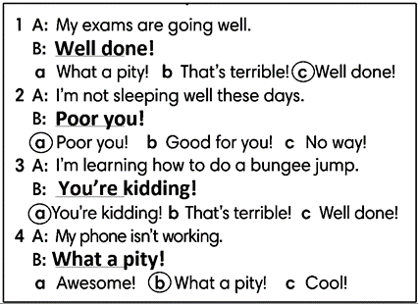
Extra activity 2 (3’): Extended Practice to reinforce the new expressions
- T shows 4 pieces of news with multiple choice responses.
- T asks Ss to read and classify the news as surprising (S), positive (P) or negative (N).
- T tells Ss to choose the correct response for each news.
- Ss read, say, and choose the answers as the whole class.
- T checks and confirms the correct answers.
4. POST-SPEAKING ( 8’)
ACTIVITY 4:
*Aims: To help students applying the new language and skills related to the topic in communicating.
* Content: Give and receive the news from each other’s.
* Outcome: To practice speaking by sharing both bad and good news; use expressions in communicating.
* Organisation : T, Ss .…

Teacher’s & Student’s activities | Content
4. Work in pairs. Student A gives some good and bad news. Student B responds to the news. Use the Speaking box.  (Exercise 4 - SB p.26)  - T tells student to look at the speaking box in their student book again and prepare for the task.  - T gives students time to think about what they are going to say in their roleplays.  - If students have difficulty thinking of true pieces of news, T encourages them to use their imagination.  - T encourages stronger students to give some very first examples.  - Students work in the same pairs from the last activity and practice their role plays, focus on using the correct intonation.  - T tells students to do the activity with their books closed, so that their reactions can be natural, and they don’t just read from the Speaking box.  - Teacher invites pairs to act out their roleplays in front of the class. | 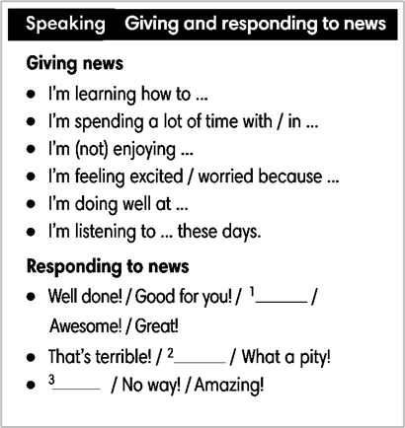
WRAP-UP & HOME WORK (2’)
- T asks Ss to talk about what they have learnt in the lesson.
- Expressions of giving and responding to news
* HOME WORK
- Do exercises in the workbook page 21.
- Prepare for Lesson 2.7: English In Use

