Date of planning: ………………….  Date of teaching: ………………….. | UNIT 4: HEALTH AND FITNESS  PERIOD 42. LESSON 4.4. GRAMMAR 2
I. OBJECTIVES:
By the end of the lesson students will be able to:
- use Past Simple of irregular verbs to talk about the past.
1. Knowledge:
* Grammar:
- Identify the past form of irregular verbs
- Understand and use the forms of past simple tense
- Use past simple of irregular verbs to talk about the past
2. Competence: Understand and use vocabulary about everyday activities and understand the forms of past simple tense, then do the tasks assigned in the textbook; use the correct tense of verbs to form questions and answers to talk about what happened in the past.
3. Quality/ behavior: To teach Ss to be hard-working and attentive in class. Ss have a positive attitude to working in groups, individual work, pair work, cooperative learning and working.
II. TEACHING AIDS:
- Teacher: Grade 7 textbook, Unit 4 (SB p. 44), laptop/computer connected to the Internet, loudspeaker, projector/TV, PPT slides…
- Students: Textbooks, studying equipment…
- Method: Active teach, T-WC; group works; individual ……
III. PROCEDURE:

1. WARM UP (5’)
* Aim:
- To create a positive classroom atmosphere to start a new lesson.
- To review the past simple of regular verbs.
* Content: Game: Football Game (past simple verbs)
* Outcome: Ss use the correct form of the verb in the Past Simple tense.
* Organisation: T, Ss ..….

Teacher’s & Student’s activities |  | Content
Extra activity 1: Football Game  - T asks Ss to prepare 3 letter cards A, B (T may ask Ss to prepare them before the lesson.)  - T explains the game rules then checks instructions.  - Ss join in the game individually.  - T corrects Ss if necessary.  - T tells students to recall all verbs they see from the warm-up game  - T tells Ss that, today they will learn more of past simple verbs. |  | Game rules:  - Read the questions carefully  - Show the letter card A, B to give answers.  - 1 correct answer = 1 point.
2. LEAD-IN (3’)
*Aim: To lead into the new lesson.
* Content: Describe the picture on the slide.
* Outcome: Guess correctly what the boy is doing do in the picture.
* Organisation: T_ Ss ..….
Teacher’s & Student’s activities | Content
Extra activity 2: See – think – wonder.  - T shows a picture on the slide then asks students four questions.  (1) What can you see in the picture?  (2) Where was the boy?  - T sets a time limit for Ss’ quick discussion.  - Ss work in pairs to make guesses about the picture then give answers.  - T calls some Ss to give answers then checks with the whole class. | Answer keys:  - A boy and a dentist  - The boy was at the dentist’s.
3. PRESENTATION 1 (7’)
ACTIVITY 1 + 2:
*Aim:
- To present the grammar point in context.
- To lead into the next activity.
* Content: To practice changing irregular verbs into past simple form.
* Outcome: Remember the past simple form of some irregular verbs.
* Organisation: T, Ss ..….
Teacher’s & Student’s activities | Content
1. (3’) Read the text and answer the questions.  (Ex 1, p.44)  - T asks Ss to open their SB page 44, look at exercise 1.  - T calls a student to read the instruction then checks Ss’ understanding of it.  - T asks Ss to find the line in the reading that prove their guessing from See – think – wonder activity.  - T uses the slide to confirm the answer. | 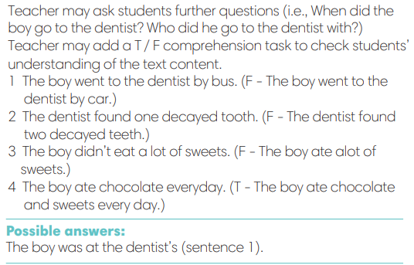
2. (4’) Find the past form of verbs below in the text. Add to the list 5 irregular verbs that you know. Then change them into Past Simple form.  (Ex 2, p.44)  - T calls a student to read the instruction then checks Ss’ understanding of it.  - T tells Ss to work in groups of three to read the text and find the answers.  - Ss work in groups, read, and note down the answers to the given verbs.  - T calls some Ss to give answers then shows the answers on the slide.  - T tells Ss that went, drove, got, found are the past form of irregular verbs.  - T asks Ss to work in groups again and do the second task: Add more of irregular verbs they know.  - T allows Ss to add and share massively in a time limit.  - T asks Ss to look at the Grammar Box in SB p.44. | Answer keys:  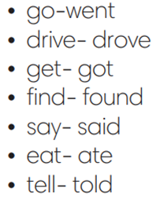
4. PRESENTATION 2 (4’)
ACTIVITY 1 + 2:
*Aim: To introduce the Grammar Notes and explain the grammar point
* Content: Practicing the use of the past simple by writing the correct form of the verbs.
* Outcome: Make sentences in past simple.
* Organisation: T, Ss ..….
Teacher’s & Student’s activities | Content
Extra activity 3:  - T asks Ss to look at the Grammar Box in SB and elicits the forms.  - T uses slide to display the Grammar Note again.  - T encourage Ss to make sentences using the grammar note. | 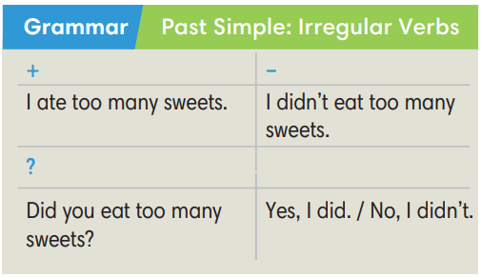
5. PRACTICE 1 (7’)
ACTIVITY 3:
* Aims:
- To help students identify the form of Past Simple tense
- To help Ss practice then new grammar points in context
- To practice solving some types of Grammar exercises

* Content: Choose the correct form of the verb in the past simple tense.
* Outcome: Choose the form correctly in grammar and use the past simple to explain their options.
* Organisation: T, Ss, ….
Teacher’s & Student’s activities | Content
Extra activity 4 (2’): GAME – CHOOSE THE BEST ANSWER  - T explains the game rules then checks instructions.  - Ss join in the game individually.  - T corrects Ss if necessary.  - T tells students to recall all verbs they see from the game. | Game rules:  - Read the questions carefully  - Show the possible answer from some options  - 1 correct answer = 1 point.
3. (3’) Complete then sentences with Past Simple form of the verbs in brackets  (E Exercise 3 – SB p. 44)  - T elicits the direction with students.  - T encourages students to discuss the answers in pairs,  to decide on the correct form and the reasons for this.  - Ss work in pair to complete the exercise.  - T calls some students to share their answers.  - T uses slides to confirm the answer.  - T corrects Ss’ pronunciation if any. | Answer keys:  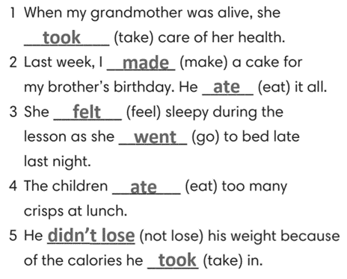
Extra activity 5 (2’):  (Adapted from Exercise 2 – WB p. 37)  - Repeat the steps in Exercise 3 – SB p,44. | Answer keys:  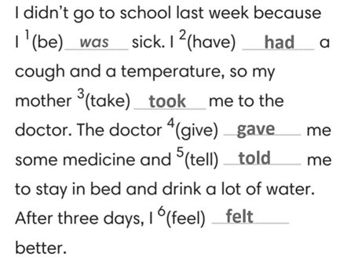
5. PRACTICE 2 (10’)
ACTIVITY 4:
* Aims: To help students practice making sentences in the Past Simple.
* Content: Choose the correct form of the irregular verbs in the past simple tense.
* Outcome: Make sentences correctly in grammar and use the past simple.
* Organisation: T, Ss, ….
Teacher’s & Student’s activities | Content
4. (5’) Write questions in Simple Past for these sentences.  (Exercise 4 – SB p.44)  - T asks Ss to look at exercise 4.  - T calls a student to read the instruction then checks Ss’ understanding of it.  - T asks Ss to work in individually to write.  - Students write full questions in their notebooks.  - T calls students to give answers then shows them on the slide to check as the whole class.  - T corrects Ss if any. | Answer keys:  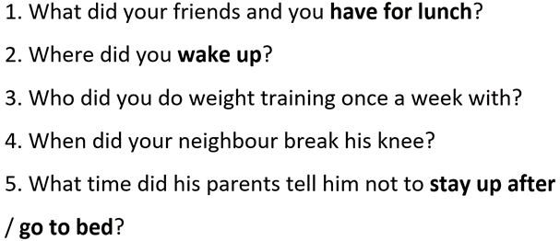
Extra activity 6 (5’): Reorder the words to make complete sentences  (Adapted from Exercise 3 – AB p.37)  - T asks Ss to look at exercise 3 in AB p.37.  - T calls a student to read the instruction then checks Ss’ understanding of it.  - T asks Ss to work in individually to write.  - Students write full questions in their notebooks.  - T calls students to give answers then shows them on the slide to check as the whole class.  - T corrects Ss if any. | Answer keys:  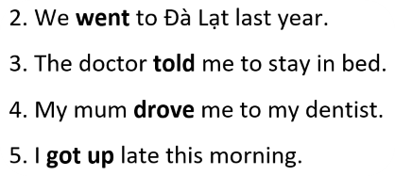
7. PRODUCTION (7’)
ACTIVITY 5:
* Aims: To help students applying the vocabulary items and grammar points related to the topic in communicating.
* Content: Interview partners using the cues words.
* Outcome: Use vocabulary items and grammar points related to the topic to interview partners.
* Organisation: T. Ss , Individual, Pair work, ….

Teacher’s & Student’s activities | Content
5. In pairs, ask and answer about what you often did during Covid-19 lockdown to keep fit and stay healthy.  (Exercise 5 – SB p.44)  - T asks Ss to look at exercise 5 (SB page 44).  - T calls a student to read the instructions then checks Ss’ understanding of it.  - T explains to the students that they are going to do the task in pairs  - T elicits some stay-home-safe-activities  - T models the activity in front of the class.  - T asks students to stand up and walk around the class and choose a new classmate to pair with.  - Ss think, pair, and share.  - T walk around to listen and notes down common mistakes for delayed feedback.  - T invites some students to report their answers to the class.  - T asks the other students to give comments on their classmates’ performance.  - T gives feedback on Ss’ work. | 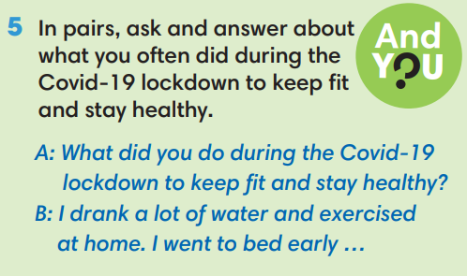
WRAP-UP & HOME WORK (2’)
- T asks Ss to talk about what they have learnt in the lesson.
- The past continuous: irregular verbs.
* HOME WORK
- Do exercises in the workbook page 37.
- Prepare for Lesson 4.5: Listening and vocabulary.

……………………………………………………………………………

