Date of planning:  Date of teaching: | UNIT 4: HEALTH AND FITNESS  PERIOD 46.LESSON 4.8. PRONUNCIATION & REVIEW VOCABULARY
I. OBJECTIVES:
By the end of the lesson student will be able to:
1. Knowledge:
* Vocabulary: review vocabulary
- The lexical items related to: parts of the body, accidents and injuries, keeping fit, snacks, sleep, symptoms and illnesses.
- Present simple and present continuous.
* Pronunciation: Listen and identify the silent letters in words then correctly pronounce the words that contain the silent letters.
2. Competence: Students develop communication skills, and creativity; be collaborative and supportive in pair work, and teamwork; actively join in class activities.
3. Quality/ behavior: To teach Ss the love of talking about relating topics to unit 4 and using word friends or phrasal verbs in pair work or group work, and develop self-study skills. Ss have a good attitude to working in groups, individual work, pairwork, cooperative learning, and working
II. TEACHING AIDS:
- Teacher: Grade 7 textbook, Unit 4 (SB p.47), laptop/computer connected to the Internet, loudspeaker, projector/TV, PPT slides… .
- Students: Text books, studying equipment…
- Method: Active teach, T-WC; group works; individual ……
III. PROCEDURE:
1. WARM UP + LEAD-IN (5’)
*Aims:
- To create an active atmosphere in the class before the lesson.
- To lead into the new lesson.
* Content: Game: NAME 3 THINGS CHALLENGE (health and fitness)
* Outcome: Students say words relating to the given topic quickly.
* Organisation: Teacher’s instructions…
Teacher’s & Student’s activities | Content
Extra activity 1: NAME 3 THINGS CHALLENGE  * Teacher asks students to spend 1 minutes to quickly review all vocabulary they have learnt in Unit 4 before they play a warm-up game.  - T tells students that they are going to play a game called NAME 3 THINGS CHALLENGE  - T explains the game rules then checks instructions.  - Teacher uses the slides to show the challenge  - Ss join in the game pairs or in small groups.  - Teacher listens to the Ss answers and calls several Ss to check for the whole class.  - T tells Ss that they can remember better with Glossary Table and asks Ss to open their Student Book page 48 – Exercise 1. | Game rules:  - Choose a number to get the challenge  - Read the topic word  - Say 3 words relating to that topic quickly.
2. REVIEW VOCABULARY (22’)
(GLOSSARY TALBE)
ACTIVITY 1 + 2 + 3:
*Aim:
- To introduce the glossary and its uses.
- To give further practice in making sentences using the Glossary.
* Content: Revise what they have learnt during the unit. Glossary and its uses.
* Outcome: Remember the new words and animals’ name.
* Organisation : Teacher’s instructions…
Teacher’s & Student’s activities | Content
1. (5’) Use the Glossary to find:  - Three items of food or drink that are bad for you.  - Three health problems ending with –ache  - Two things you can take when you are ill.  (Exercise 1 – Student Book page 48)  - Teacher introduces the Glossary Table.  - T asks Ss to look at exercise 1 in student book page 48  - T has students use the glossary to find the words which belong to the correct category  - T asks students to work in pairs and quickly do the task.  - T allows students to peer check first.  - T checks and confirms the answers. | Answer key:  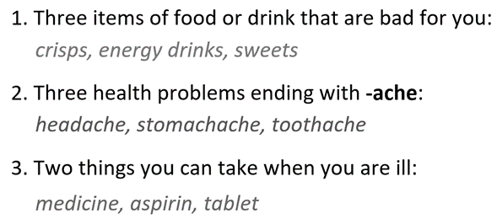
2. (12’) Complete the phrasal verbs.  (Exercise 2 – Student Book page 48)  - T asks students to complete the sentences with suitable words.  - T asks students to work individually and check in pairs.  - T invites students to share their answers.  - T confirms the correct answers.  Extra-Practice  TIME TO TALK: Use the Phrasal Verbs and make sentence for you.  - T encourage students to make sentences using the phrasal verbs in exercise 2.  - Ss work in pairs to share true information about themselves. | Answer key:  1. after / 2. up / 3. up / 4. up
3. (5’) Complete the sentences with the words below. In pairs, say which sentences are true for you.  (Exercise 3 – Student Book page 48)  - T asks Ss to open their SB page 48, look at exercise 3.  - T calls a student to read the instruction then checks Ss’ understanding of it.  - T gives students a time limit to work individually.  - T allows Ss to share their answers massively before checking the final ones as the whole class.  - T provides the meanings of the phrasal verbs if needed  TIME TO TALK  - T pairs students up and asks them to share the sentences which are true about them with their partners. | Answer key:  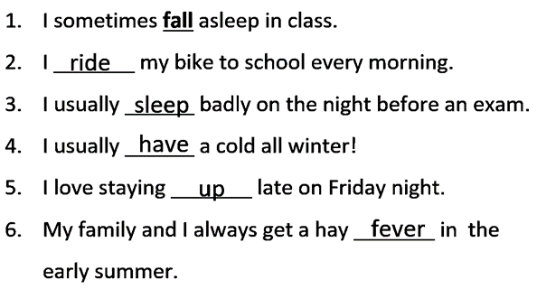
3. PRONUNCIATION (10’)
Presentation and Practice
ACTIVITY 4:
* Aims:
- To present the list of words which contain the silent letters
- To help students identify the silent letters in words
- To help students listen and identify the words which contain silent letters
* Content: Do exercises to practice pronunciation.
* Outcome: Identify and say silent letters in words correctly.
* Organisation: Teacher’s instructions…

Teacher’s & Student’s activities | Content
Extra activity 2: (5’) HEAR AND CLAP GAME  - T tells students that they are going to play a game called HEAR AND CLAP  - T explains the game rules then checks instructions.  - Teacher uses the slides to lead the game  - Ss join in the game pairs or in small groups.  - T listens to the Ss answers and calls several Ss to check for the whole class.  - T asks students to say the word again to practice some sounds after each play. | Game rules:  - Hear the sound  - Read the words  - Clap your hands 1 or 2 times to choose the word you hear.
4. (5’) Listen to the words below and decide if you hear the underlined letter(s). Then listen again and repeat.  (Exercise 4a– Student Book page 48)  - T calls a student to read the instruction of Exercise 4 then checks Ss’ understanding of it.  - T calls some students to read out the words first.  - T plays the audio tracks for them to listen take notes.  - T invites some students to share their answers.  - T confirms the answer using the slide.  Listen again and repeat  - T shows the slide with full words, IPA and individual audio track for Ss to practice listening and pronouncing words. | Answer keys:  All the underlined letters are silent.  => You can’t hear them.
WRAP-UP & HOME WORK (3’)
- Teacher asks students to talk about what they have learnt in the lesson.
- Use a Glossary to review
- Identify silent letters in words
* HOME WORK
- Find more words which contain the silent letters
- Prepare for Unit 4 – Lesson 9: Revision

……………………………………………………………………………………

