Date of planning: ………………………  Date of teaching: ……………………… | UNIT 4: HEALTH AND FITNESS  PERIOD 47.LESSON 4.9. REVISION
I. OBJECTIVES:
By the end of the lesson, Ss are able to:
1. Knowledge:
* Vocabulary: revise words related to parts of the body, accidents and injuries, keeping fit, snacks, sleep, symptoms and illnesses.
* Grammar: review present simple of irregular verbs, quantifiers, phrasal verbs to talk about health, fitness, illnesses and give advice.
2. Competence: Ss understand and use use vocabulary of the unit, do the tasks assigned in the textbook; participate in a guided conversation to talk about illnesses and give advice.
3. Quality/ behavior : To teach Ss to be hard-working and attentive in class. Ss have a positive attitude to working in groups, individual work, pair work, cooperative learning and working.
II. TEACHING AIDS:
- Teacher: Grade 7 textbook, Unit 4 (SB p. 49, WB p.41), laptop/computer connected to the Internet, loudspeaker, projector/TV, PPT slides…
- Students : Text books, studying equipment….
- Method: Active teach, T-WC; group works; individual ……
III. PROCEDURE:

- WARM-UP (4’)

*Aims:
- To create a positive classroom atmosphere to start a new lesson.
- To lead into the review lesson.
* Content: Game: SUPER EYES
* Outcome: Ss understand that they are going to review Unit 4.
* Organisation: Teacher’s instructions…
Teacher’s & Student’s activities | Content
Extra activity 1: SUPER EYES  - Set the scene: T asks students to do quick exercises for eyes such as look up and down, look left and right, row the eyes  - T tells students that they are going to play a game called SUPER EYES  - T explains the game rules then checks instructions.  - Teacher uses the slides to show the collages  - Ss join in the game pairs or in small groups.  - Teacher shows the collage again with displayed answers to check for the whole class.  - T tells Ss that they are going to review Unit 4 | Game rules:  - Look carefully at a collage of different small pictures  - The collage will disappear in a few seconds  - Recall as many words about the collage as you can remember.
- REVIEW VOCABULARY (16’)
ACTIVITY 1 + 2:
* Aims:
- To help students reviews topic words and word friends from the unit.
- To review vocabulary in context.
* Content: Do the exercise to revise the vocabulary of Unit 4.
* Outcome: Understand the vocabulary to do the exercise correctly.
* Organisation : Teacher’s instructions….
Teacher’s & Student’s activities | Content
Extra activity 2: (5’) SUPER MIND  - T tells students to open the Glossary box in student book page 48  - T introduce the SUPER MIND game and rules  - T shows the slides of the game  - Ss take turns to choose the numbers for their teams.  - Ss discuss and list out all words related to the topic they get.  - T calls some Ss to give answers and confirms the winner. | How to play:  - Play in team  - Choose a number to open a block  - Read the topic word  - Write as many words related to the topic as you can  - The faster finisher gets points
1. (5’) Write the correct word for each definition.  (Exercise 1 – Student Book page 49)  - T asks Ss to look at exercise 1 in student book page 49  - T calls a student to read the instruction then checks Ss’ understanding of it.  - T asks Ss to work in pairs to read then complete the activity.  - T encourages students to give the reason for their answer.  - T checks as the whole class. | Answer keys:  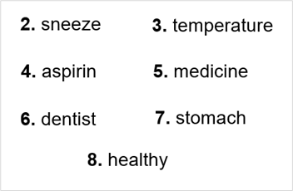
2. (6’) In pairs, read the text and choose the correct option. Do you have any one in your family like Grandpa George?  (Exercise 2 – Student Book page 49)  - T asks Ss to look at exercise 2 in student book page 29  - T calls a student to read the instruction then checks Ss’ understanding of it.  - T asks Ss to work in pairs to read then complete the activity.  - Ss work in pair to complete the task and compare the answers.  - T checks as the whole class.  Exercise 2 - Time to talk:  - T asks Ss to work in pairs to share their facts.  - Ss work in pairs to talk about anyone in the family who is like Grandpa George.  Example:  - My cousin is like Grandpa George. He always talks with food in his mouth. | Answer keys:  1-woke up/ 2-did/ 3-mouth/ 4-elbows/ 5-shoulders/ 6-hair
3. REVIEW GRAMMAR (15’)
ACTIVITY 3 + 4 + 5:
*Aim:
- To reinforce the grammar of unit 4
- To review words of quantifiers
- To help students review past simple tense with irregular verbs
- To provide more practice of Past Simple
* Content: Use the past simple tense to complete the exercises.
* Outcome: Use the past simple tense for communication and writing.
* Organisation : Teacher’s instructions….
Teacher’s & Student’s activities | Content
Extra activity 3: (2’) Read the grammar boxes and review the grammar points.  - T asks Ss to look at the grammar box and read the example.  - T shows slides for detail review grammar  - Ss read the review content together before they do some grammar tasks. | 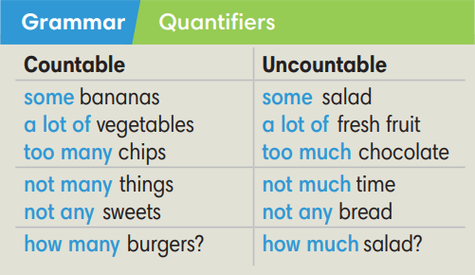  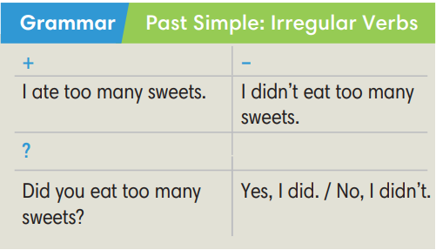
3. (3’ Choose the correct options.  (Exercise 3 – Student Book page 49)  - T asks Ss to look at exercise 3 in student book page 49  - T calls a student to read the instruction then checks Ss’ understanding of it.  - T asks Ss to work in pairs to read then complete the activity.  - Ss work in pairs to complete the task and compare the answers.  - T checks as the whole class. | Answer keys:  2-any / 3-any / 4-some / 5-many / 6-not many / 7-a lot of
4. (5’) Complete the text with the Past Simple form of the verbs in brackets  (Exercise 4 – Student Book page 49)  - T asks Ss to look at exercise 4 in student book page 49  - T calls a student to read the instruction then checks Ss’ understanding of it.  - T asks Ss to work in pairs to read then complete the activity.  - Ss work in pairs to complete the task and compare the answers.  - T checks as the whole class. | Answer keys:  1-heard 2- ran 3- saw 4- told  5- broke 6- did…say 7- didn’t pay 8- fell
Extra activity 4 (5’): Mystery Box Game  - T introduce the Mystery Box Game and rules  - T shows the slides of the game  - Ss take turns to play the game.  - Ss discuss and say out loud their answers.  - T calls some Ss to give answers and confirms.  - Ss decide to KEEP or to GIVE their mystery box. | How to play:  - Play in team  - Answer a question or do a task.  - Choose: KEEP THE BOX or GIVE THE BOX
4. SPEAKING (8’)
ACTIVITY 5:
*Aim: To help student practice speaking skill in a task: talk about illnesses and give advice.
* Content: Talk about feeling ill and complete the exercises.
* Outcome: Practice speaking by talking about illness and give advice/make appointment.
* Organisation: Teacher’s instructions….
Teacher’s & Student’s activities | Content
5. Work in pairs, talk about feeling ill. Student A, look below. Student B, look at page 102.  (Exercise 5 – Student Book page 49)  - T asks Ss to look at exercise 5.  - T calls a student to read the instruction then checks Ss’ understanding of it.  - T asks Ss to work in pairs to prepare for their dialogues  - T sets a time limit and walk around as a monitor while Ss are discussing.  - Ss work in pairs to practice the speaking task  - T moves around and takes notes for any issues that need improving from students work.  - T encourages some strong students to role-play their dialogues in front of the class.  - T gives some general feedback for Ss’ performances. | 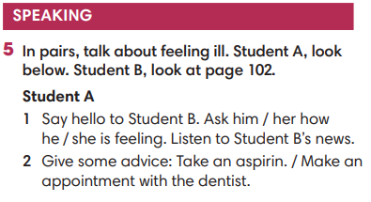
WRAP-UP & HOME WORK (2’)
- T asks Ss to talk about what they have learnt in the lesson.
- Review Unit 4 vocabulary and grammar.
- Talk about illnesses and give some advice
* HOMEWORK
- Do exercises in the workbook page 41
- Prepare for REVIEW 2

………………………………………………………………………………………………

