Date of planning:...............................  Date of teaching: ………………….. | PERIOD 48 : REVIEW 2 (UNIT 1-2)
I. OBJECTIVES:
1. Knowledge: By the end of this review, students will be able to revise the language they have learnt and the skills they have practiced in Units 1 - 2.
a) Vocabulary: Ss revise words related to cultural activities, clothing items, and personality adjectives.
b) Grammar: review present simple and present continuous tense to describe people.
c) Writing: Writing a personal introduction to a webpage.
d) Speaking: talking about cultural activities and types of habits; talking about clothes and appearances; talking about family activities; describing a friend’s personality.
2. Competence: SS can revise the language they have learnt and the skills they have practiced in Units 1 – 2. Use the vocabulary of the units, and do the tasks assigned in the textbook. Participate in a guided conversation to give and respond to the news using the given information.
3. Quality/ behavior: Having a positive attitude towards the lesson and a good relationship with friends. The love of learning English. Hard-working; attentive; cooperative; sociable; good communication in class.
II. TEACHING AIDS:
- Teacher: Textbook, laptop, loudspeaker, projector…
- Students: Grade 7 textbook, Unit 1&2 (SB p. 18, 28), studying equipment….
- Method: T-WC; group works; individual ……
III. PROCEDURE:
1. REVIEW VOCABULARY UNIT 1 (14’)
ACTIVITY 1 + 2:
* Aim:
- To help students reviews topic words and word friends from the unit.
- To review vocabulary in context.
* Content: Glossary of unit 1, Mario Playing Tennis Game: vocabulary of unit 1.
* Outcome: Students’ correct pronunciation and answers.
* Organization of implementation:
Teacher’s & Student’s activities |  | Content
1. (7’) Activity 1:  - T tells students to open the Glossary box in student book page 18.  - T asks Ss to work in pairs: 1 student points to the word, 1 student pronounces it. Then they swap their roles.  - T corrects Ss’ pronunciation if any.  *) Circle the odd one out.  - T gives and checks the instruction.  - T set a time limit and asks Ss to work in pairs to read and then complete the activity.  - T encourages students to give the reason for their answers.  - T checks as the whole class  * Circle the word which has the underlined part pronounced differently.  - T asks Ss to work in pairs, discuss and give answers.  - Ss work in pairs to discuss and answer.  - T corrects Ss’ pronunciation if any. |  | 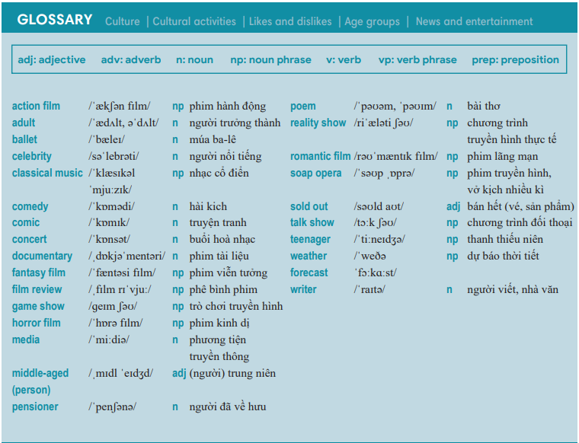  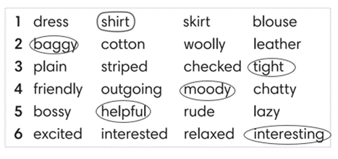  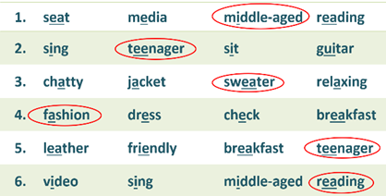
2. (7’) Mario Playing Tennis Game:  - T gives and checks instructions for the game.  - T corrects Ss’ pronunciation if any. |  | How to play:  - Read the sentences.  - Choose A, B or C for answers.  - 1 correct answer = 2 points.
2. REVIEW GRAMMAR UNIT 1 (7’)
ACTIVITY 3:
*Aim: To help students revise the form and use of the present simple.
* Content: Football Game: sentences use present simple.
* Outcome: Complete the sentences correctly.
* Organisation: Teacher’s instructions…..
3. Football Game  - T gives and checks instructions for the game.  - T corrects Ss if any. | How to play:  - Read the sentences.  - Choose A, B, C or D to fill in the blanks.  - 1 correct answer = 2 points.
3. REVIEW VOCABULARY UNIT 2 (14’)
ACTIVITY 4 + 5:
Aim:
- To help students reviews topic words and word friends from the units.
- To review vocabulary in context.
* Content: Glossary of unit 2, Classifying Game: vocabulary have learnt in the unit 2.
* Outcome: Call out the vocabulary. Revision. Do exercises correctly.
* Organisation : Teacher’s instructions…...

4. (7’) Activity 4:  - T tells students to open the Glossary box in student book page 28.  - T asks Ss work in pairs: 1 student points to the word, 1 student pronounces it. Then they swap their roles.  - T corrects Ss’ pronunciation if any. | 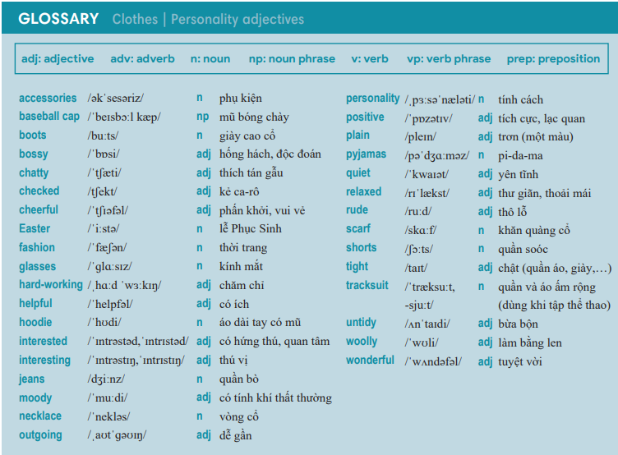
5. (7’) Classifying Game:  - T gives and checks instructions for the game.  - T corrects Ss’ pronunciation if any. | How to play:  - Look at the words.  - Think about which topic the word belongs to.  - Classify them into 2 groups.  - 1 correct answer = 2 points.
4. REVIEW GRAMMAR UNIT 2 (7’)
ACTIVITY 6:
* Aim: To help students revise the form and use of the present simple and present continuous.
* Content: Review grammar elements taught in unit 2; Compare the present simple and the present continuous.
* Outcome: Remember how to form and use them. Do exercises correctly.
* Organisation : Teacher’s instructions…..

Teacher’s & Student’s activities | Content
6. Obstacle Race Game.  - T gives and checks instructions for the game.  - T corrects Ss if any. | How to play:  - Read the sentences.  - Put the verbs in brackets into the correct form.  - 1 correct answer => open the present for points.
WRAP-UP & HOME WORK (3’)
- T asks Ss to talk about what they have learnt in the lesson.
- Review Unit 1 vocabulary and grammar.
- Review Unit 2 vocabulary and grammar.
* HOME WORK
- Prepare for PREPARATION FOR MID-TERM TEST 1.

…………………………………………………………………………………

