Date of planning: …………………..  Date of teaching: ………………….. | UNIT 6: SCHOOLS  PERIOD 71. LESSON 6.8  VOCABULARY IN ACTION AND PRONUNCIATION

I. OBJECTIVES:
By the end of the lesson, Ss will be able to:
- review vocabulary about school subjects and activities.
- correctly pronounce /ð/ and /θ/.
1. Knowledge:
* Vocabulary: Review vocabulary
- The lexical items related to school subjects and school activities.
* Pronunciation: /ð/: their, father,… /θ/: thing, tooth,…
2. Competence: Ss develop communication skills, presentation skills, and creativity; being collaborative and supportive in pair work, teamwork, and actively join in class activities.
3. Quality/behavior: To teach Ss the love of talking about food and drink, and develop self-study skills. Ss have a good attitude to working in groups, individual work, pairwork, cooperative learning, and working.
II. TEACHING AIDS:
- Teacher: Grade 7 textbook, Unit 6 (SB p.68, WB p.59), laptop/computer connected to the Internet, loudspeaker, projector/TV, PPT slides… .
- Students: Text books, studying equipment…
- Method: Active teach, T-WC; group works; individual ……
III. PROCEDURE:
1. WARM UP + LEAD-IN (5’)
*Aims:
- To create an active atmosphere in the class before the lesson.
- To lead into the new lesson.
* Content: Game: Hot seat (school subjects and activities).
* Outcome: Ss can recall the vocabulary of Unit 6.
* Organisation: T-Ss, Ss-Ss.
Teacher’s & Student’s activities | Content
Extra activity 1: Game: Hot seat.  * T asks Ss to spend 1 minute to quickly review all vocabulary they have learnt in Unit 6 before they play a warm-up game.  - T divides the class into 2 groups.  - T explains the game rules then checks instructions.  - T tells Ss that they can remember better with Glossary Table and asks Ss to open their Student Book page 68 – Exercise 1. | Game rules:  - 2 Ss from 2 groups go to the board, their backs facing the board.  - T writes 1 word on the board.  - Two teams explain the word for their teammates.  - The faster team gets 1 point.
2. REVIEW VOCABULARY (22’)
ACTIVITIES 1 + 2 + 3:
*Aims:
- To introduce the glossary and its uses.
- To give further practice with vocabulary of Unit 6.
* Content: Revise what they have learnt during the unit, using the Glossary.
* Outcome: Recall the vocabulary of Unit 6 and use them in sentences.
* Organisation: T-Ss, Ss-T, Pair work.
Teacher’s & Student’s activities | Content
1. (5’) Use the glossary to find.  (Ex 1 – SB p.68)  - T introduces the Glossary Table.  - T asks Ss to look at Exercise 1 in student book page 68.  - T has Ss use the glossary to find the words which belong to the correct category.  - T asks Ss to work in pairs and quickly do the task.  - T allows Ss to peer check first.  - T checks and confirms the answers. | Answer keys:  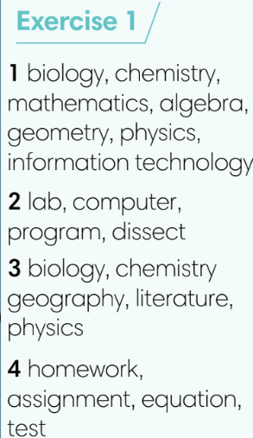
2. (5’) Use the glossary to complete the sentences. In pairs, say if the statements are true for you.  (Ex 2 – SB p.68)  - T asks Ss to complete the sentences with suitable words.  - T asks Ss to check answers in pairs.  - T invites Ss to share their answers.  - T confirms the correct answers.  (6’) Extra-Practice  TIME TO TALK: Use the Glossary to make sentences about school subjects and activities.  - Ss work in groups of 4 to make as many sentences as possible.  - T asks some groups to share in front of the class to get feedbacks. | Answer keys:  1 competing in a game.  2 musical instruments.  3 microscope.  4 literature.  5 healthy.
3. (6’) In pairs, discuss the differences between the words below.  (Ex 3 – SB p.68)  - T asks Ss to open their SB page 68, look at exercise 3.  - T calls a S to read the instruction then checks Ss’ understanding of it.  - T gives Ss a time limit for discussion.  - For each item, T invites 3 groups to share their ideas and then do a class vote for the best pairs. | Words for discussion:  1. biology/ biology lab.  2. chemistry/ physics.  3. English/ foreign languages.  4. literature/ history.  5. a test tube/ a microscope.
3. PRONUNCIATION (16’)
3.1. Presentation (5’)
ACTIVITY 4
* Aims:
- To learn how to pronounce the /ð/ and /θ/ sounds.
* Content: Listen to the words and sort them according to their sounds.
* Outcome: Learn how to pronounce the /ð/ and /θ/ sounds.
* Organisation: T-Ss, Ss-T.
Teacher’s & Student’s activities | Content
4. (4’) Listen to how we pronounce the /ð/ and /θ/ sounds. Listen and write the words in the blank.  (Ex 4 – SB p.68)  - T calls a S to read the instruction of Exercise 4 then checks Ss’ understanding of it.  - T asks Ss to guess the answer basing on their own pronunciation.  - T plays the audio for Ss to check their guess and finish Exercise 4.  - T asks Ss to repeat and corrects Ss’ pronunciation. | Answer keys:  /ð/: another, father, that, their, together.  /θ/: anything, healthy, thing, think, thought, tooth, through.
3.2. Practice (11’)
ACTIVITY 5:
* Aims:
- To help students practice full sentences with the /ð/ and /θ/ sounds.
* Content:
- In pairs, say sentences with the /ð/ and /θ/ sounds.
- Play a game to practise listening to the /ð/ and /θ/ sounds.
* Outcome: Can identify the /ð/ and /θ/ sounds and pronounce them correctly.
* Organisation: T-Ss, Ss-T, Ss-Ss.
Teacher’s & Student’s activities | Content
5. (5’) In pairs, say the sentences. Listen, check and repeat.  (Ex 5 – SB p.68)  - T plays the audio for Ss to repeat.  - Ss work in pairs to practice these sentences.  - T asks 5 pairs to read out loud in front of the class.  - T corrects Ss pronunciation if needed. | 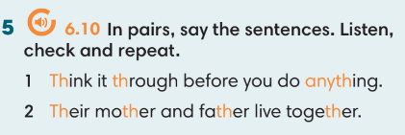
(6’) Extra activity 2: Game  - T divides the class into 2 teams and then invites 10 Ss from each team to make one line. | Game rules:  - Listen to the word (T prepares an audio).  - If Ss hear /ð/ sound, Ss jump on the left side. If Ss hear /ð/ sound, Ss jump on the right side.  - Ss with wrong answer is out. The team with more Ss left in the line get more points.
WRAP-UP & HOME WORK (2’)
Teacher asks students to talk about what they have learnt in the lesson.
- use a Glossary to review.
- /ð/ and /θ/ sounds
* HOME WORK
- Find more words with /ð/ and /θ/ sounds.
- Prepare for Unit 6 – Lesson 9: Revision.

………………………………………………………………………………….

