Date of planning: ..............................  Date of teaching: .............................. | UNIT 7: SHOPPING AROUND  PERIOD 73. LESSON 7.1 VOCABULARY
I. OBJECTIVES:
By the end of the lesson, Ss are able to gain:
- know the meaning of the new words and talk about favorite subjects
- use the targeted language to practice talking about favorite school activities.
1. Knowledge:
* Vocabulary: an understanding of the meaning of keywords below:
Types of shops | bakery, bookshop, butcher’s, clothes shop, florist’s, greengrocer’s, newsagent’s, pharmacy, shoe shop

New words |  | Pronunciation | Definition | Vietnamese meaning
bakery | (n) | /ˈbeɪ.kər.i/ | a place where bread and cakes are made and sometimes sold | tiệm bánh mỳ
bookshop | (n) | /ˈbʊk.ʃɒp/ | a shop or website where  books are sold | hiệu sách
butcher’s | (n) | /ˈbʊtʃ.əz/ | a shop where meat is prepared and sold | cửa hàng thịt
clothes shop | (n) | /kləʊðz ʃɒp/ | a shop or website where  clothes are sold | cửa hàng quần áo
florist’s | (n) | /ˈflɒr.ɪst/ | a shop that sells cut flowers and plants for inside the house | cửa hàng hoa
greengrocer’s | (n) | /ˈɡriːŋ.ɡrəʊ.sər/ | a shop in which fresh vegetables and fruit are sold | cửa hàng rau quả
newsagent’s | (n) | /ˈnjuːzˌeɪ.dʒənt/ | a shop that sells newspapers and magazines,as well as some foods and things that people often buy  such as cigarettes | sạp báo
pharmacy | (n) | /ˈfɑː.mə.si/ | a shop in which medicines are prepared and sold | hiệu thuốc
shoe shop | (n) | /ʃuː ʃɒp / | a shop or website where  shoes are sold | cửa hàng giày

* Grammar:. Items at the shops and quantifiers.
2. Competence:
- General competences: form and / or improve such competencies as group work, independent working, pair work, linguistic competence, and cooperative learning.
- Specific competences:
- Improve communicative competence related to the use of language (vocabulary, phonetics, grammar):
- For a language lesson: Ss are expected to know the meaning of the new words and talk about their favorite food (ingredients, taste).
- For a skills lesson: Ss are expected to use the targeted language to practice talking about their favorite food.

3. Quality/Behavior:
- Being hard-working and attentive in class.
-Being confident when presenting in front of the class.
-Have a positive attitude towards the lesson.
II. TEACHING AIDS:
- Grade 7 textbook, Unit 7 (SB p.70-71, WB p.60-61)
- Computer (connected to the Internet is the best)
- Projector / TV/ PPT slides / Active teach

III. PROCEDURE:
1. WARM UP( 5’)
* Aims:
- To activate Ss’ prior knowledge and get students involved in the lesson.
- To set the context for introducing new words.
* Content: Game – 3 seconds.
* Outcome: Ss review vocabulary from previous unit.
* Organisation: T-Ss, Ss-T.
Teacher’s & Student’s activities | Content
Activity 1: 3 seconds  - T divides the class into 4 teams, explains the game rules then checks instructions.  - T bases on Ss answer and ask where they can buy these items: supermarket, market, shops, etc.  - T tells Ss that they are learning more types of shops.  - T sets the context for the lesson: Write the title on the board Unit 7: Shopping around / Lesson 7.1: Vocabulary | Game rules:  - 2 minutes for preparation (list all food and drinks that they know)  - Each team takes turn to say one kind of food and drink  The team can’t say the word in 3 seconds or repeat the word is out of the game
2. PRESENTATION 1 (10’)
ACTIVITY 2+3:
* Aims:
- To teach more new words
- To lead in to the next activity.
* Content: Ss learn about types of shops.
* Outcome: Ss know new words about types of shops.
* Organisation: T-Ss, Ss-T, Pair work,Ss-Ss.

Teacher’s & Student’s activities |  | Content
VOCABULARY  Activity 2: Exercise 1 (SBp70)  In pairs, ask and answer the questions.  - T asks Ss to open their SB page 70, look at exercise 1.  - T calls a student to read the instruction then checks Ss’ understanding of it.  - Ss work in pairs or small groups to ask and answer questions.  - T asks some Ss to share the answers in front of the class.  Activity 3: Game: Word chain.  - T divides the class into group of ten.  - Game rule:  - 1st student says “I went shopping and I bought an apple”  - 2nd student says “I went shopping and I bought an apple and a banana”  Continue until 1 student says incorrectly. |  | 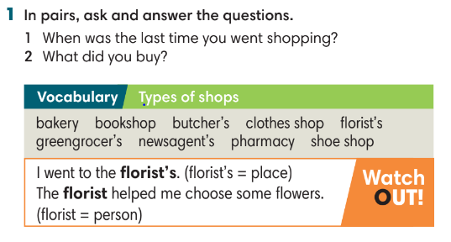
3. PRESENTATION 2 (7’)
ACTIVITIES 4 & 5:
* Aims:
- To study the Vocabulary box
* Content: label the shops, study word friends.
* Outcome: understand types of shops.
* Organisation: T-Ss, Ss-T, Pair work
Teacher’s & Student’s activities | Content
Activity 4: Exercise 2 (SBp71)  In pairs, use the words in the Vocabulary box to label the shops A-I in the picture. Use the clues below.  - T asks students to look at the pictures on page 71.  - T asks Ss to work in pairs and match shop with pictures and provide reasons for their answers. | Answer keys:    - T checks and provides meaning of all words.  - T asks Ss to read all the words and correct pronunciation.
Activity 5: Exercise 3 – SB p.71  Match the shops on the left with the items on the right.  - Ss work individually to finish Exercise 3.  - T check students answer. | Answer keys:    - T encourage Ss to list more items they can buy at these shops.
4. PRACTICE (7’)
ACTIVITY 6:
* Aims:
- To provide more words related to the topic
- To help Ss use the new vocabulary in collocations.
* Content: listen to a shopping list.
* Outcome: Ss know the types of shops and shopping list.
* Organisation: T-Ss, Ss-T, Individual work.
Teacher’s & Student’s activities | Content
Activity 5: Exercise 4 – SB p.71  Listen and complete Jas’s shopping list. What did he forget to buy?  - T reminds Ss about the difference of countable and uncountable nouns, quantifiers: a glass/ carton of milk, a loaf of bread.  - T asks some Ss to provide more examples of food and quantifiers.  - Before listening, T asks Ss to guess the answer.  - T plays the recording for Ss to check the answers. | Answer keys:  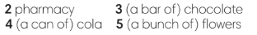  - T plays the recording again. Ss listen to find out what Jas forgot to buy and how they solved it.
5. PRODUCTION (10’)
ACTIVITY 6 + 7:
* Aims: To help Ss practice applying the vocabulary items and grammar points related to the topic in speaking.
* Content: Ss work in pairs to talk about their favourite shops.
* Outcome: Ss talk about their favourite shops using vocabulary and grammar points.
* Organisation: T-Ss, Ss-T
Teacher’s & Student’s activities | Content
Activity 6: Exercise 5 – SB p.71  Work in pairs. Ask and answer about your favorite shop. Use the following questions:  - T asks Ss to look at Exercise 5 (SB page 71).  - T calls a student to read the instruction then checks Ss’ understanding of it.  - Ss work in pairs to ask and answer all questions.  - T walks around the class and provides feedback.  - T invites some volunteers to provide answers in front of the class.  Activity 7: Interview  - T set a time limit of 2 minutes. Ss interview each other and note down all information that they have.  - After 2 minutes, T checks to find which Ss interview most partner and correct information. | 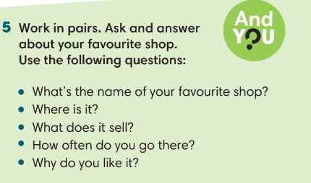

WRAP-UP & HOME WORK (3’)

- T asks Ss to talk about what they have learnt in the lesson.
- Vocabulary of shop.
- Grammar points: Items at the shops and quantifiers.
* HOME WORK
--Do exercises in the workbook page 60.
- Prepare for Lesson 2: Grammar 1.

…………………………………………………………………………………………………………..

