Date of planning: ..............................  Date of teaching: .............................. | UNIT 7: SHOPPING AROUND  PERIOD 74. LESSON 7.2 GRAMMAR 1

I. OBJECTIVES:
By the end of the lesson, Ss will be able to:
1. Knowledge:
* Grammar:
-Identify and understand how to use although, despite and in spite of.
-Use although, despite and in spite of to talk about shopping habits.

2. Competence:
- General competences: form and / or improve such competencies as group work, independent working, pair work, linguistic competence, and cooperative learning.
- Specific competences:
- Improve communicative competence related to the use of language (vocabulary, phonetics, grammar):
- For a language lesson: Ss are expected to use vocabulary about types of shops and understand the main grammatical points, then do the tasks assigned in the textbook.
For a skills lesson: Ss are expected to use although, despite and in spite of to talk about shopping habits.
3. Quality / behavior:
- Being hard-working and attentive in class.
- Have a positive attitude towards the lesson.

II. TEACHING AIDS:
- Grade 7 textbook, Unit 7 (SB p. 72)
- Computer (connected to the Internet is the best)
- Projector / TV/ PPT slides / Active teach
Language analysis
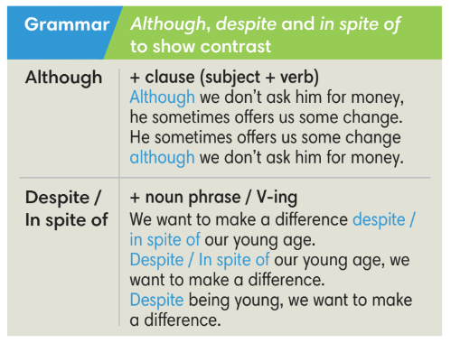
Assumptions
Anticipated difficulties | Solutions
1. Ss may not use although, despite and in spite of incorrectly. | Remind them regularly during the time of the lesson  Place a note on the board for Ss to see.  Give clear examples
2. Ss may not have sufficient speaking and co-operating skills. | Give clear instructions, give examples before letting Ss work in groups.  Provide feedback and help if necessary.

III. PROCEDURE:

1. WARM UP (5’)
* Aims:
- To activate students’ prior knowledge and get students involved in the lesson.
- To set the context for introducing new structures.
* Content: Play game to get Ss involved in the lesson and to set the context for the lesson.
* Outcome: Ss know the context of the lesson.
* Organisation: T-Ss, Ss-T
Teacher’s and Student’s activities | Content
Activity 1: Game  - T divides Ss into 2 teams:  - Ss receive types of shops from T.  - T sets the scene for the new lesson: T tells Ss that they are going to learn how to use although, despite and in spite of to talk about shopping habits.  - T writes the title on the board: Unit 7: Shopping around  Lesson 7.2: Grammar | Game rules:  - 2 minutes to list all items that Ss can buy from the shop.  - 1 correct answer = 1 point.
2. LEAD-IN (6’)
* Aims: To lead into the text.
* Content: Ss look and describe pictures.
* Outcome: Ss answer given questions.
* Organisation : T-Ss, Ss-T.
Teacher’s and Student’s activities | Content
Activity 2: Exercise 1 – SB p.72  Work in pairs. Look at the pictures. Which one is your favorite place to buy flowers?  - T asks Ss look at 2 pictures and find the difference of these places.  - Ss work in pairs to discuss which is their favorite place to buy flowers.  - T conducts a quick class vote and asks Ss to provide the reasons for their choices. | 
3. PRESENTATION (13’)
ACTIVITIES 3 + 4:
* Aims:
- To present the grammar point in context.
- To lead into the next activity.
- To introduce the Grammar Box
- To provide Ss with chances to work cooperatively.
- To explain the grammar point for Ss
* Content:
- Ss read a text using although and despite.
- Ss study the Grammar Box to complete the exercise.
* Outcome: Ss learn about school rules and can use although and despite in contexts.
* Organisation: T-Ss, Ss-T, Group work.
Teacher’s Student’s activities |  |  | Content
Activity 3: Exercise 2 – SB p.72  Read the text below. Underline although and despite. Answer the questions below.  - T asks Ss to read the text, list all new words and answer the questions. |  |  | Answer keys:  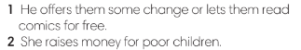  - Ss underline although, despite in the text, try to guess the difference and meaning.  - T checks Ss answer, explains all new words and summarize the difference between although, despite.
Activity 4: Exercise 3 – SB p72.  Study the Grammar box. Complete the sentences below, using although and despite/ in spite of.  STEP 1: Introduce the Grammar Box  - T goes through the Grammar Box with Ss  - T reminds students that although is followed by a clause whereas despite and in spite of are followed by a noun phrase, pronoun or V-ing.  - T provides at least 1 example for each word and then ask some Ss to make sentences.  STEP 2: Exercise 3  - T asks Ss to look at exercise 3.  - T calls a student to read the instruction then checks Ss’ understanding of it.  - T asks Ss to finish Exercise 3 individually and then check in pairs.  - T checks Ss answers. |  |  | Answer keys:  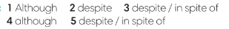
5. PRACTICE (11’)
ACTIVITIES 5 and 6:
* Aim:
- To help Ss understand the difference between although and despite/ in spite of.
- To provide Ss grammar exercises to practice
* Content:
- Ss write sentences with although and despite/ in spite of.
* Outcome: Ss know how to use although and despite/ in spite of in sentences.
* Organisation : T-Ss, Ss-T, Pair work, Ss-Ss
Teacher’s and Student’s activities |  |  |  | Content
Activity 5: Exercise 4 – SB p.72  In pairs, use your own ideas to complete the following sentences.  - T asks Ss to look at exercise 4.  - T calls a student to read the instruction then checks Ss’ understanding of it.  - Ss work in pairs to finish Exercise 4 and then share answers with other pairs.  - T check Ss answers and correct if needed. |  |  |  | 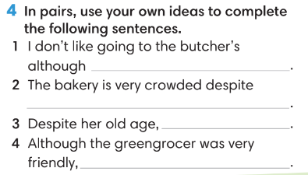
Activity 6: Game
- T divides the class into 4 groups and set time limit of 2 minutes for preparation.
- Each team makes clauses for other team to finish the sentence using although, despite and in spite of.
- After getting the clause, each team has 10 seconds to finish the sentence.
- 1 correct answer = 1 point.
6. PRODUCTION ( 7’)
ACTIVITY 7:
*Aim: To help students applying the vocabulary items and grammar points related to the topic in communicating.
* Content: Ss discuss shopping habits.
* Outcome: Ss talk about shopping habits using although, despite and in spite of.
* Organisation: T-Ss, Ss-Ss, Ss-T, Pair work
Teacher’s Student’s activities |  | Content
Activity 7: Exercise 5 – SB p.72  In groups of four, talk about the shopping habits of your family. Use although and despite.  - T asks Ss to look at exercise 5 (SB page 72).  - T calls a student to read the instruction and example then checks Ss’ understanding of it.  - T models the activity in front of the class.  - T asks Ss to work in groups of 4 to finish Exercise 5.  - T walk around to listen and notes down common mistakes for delayed feedback.  - T calls some groups to come to the front of the class, make conversations.  - T asks the rest to give comments on their classmates’ performance.  - T gives feedback on Ss’ work. |  | 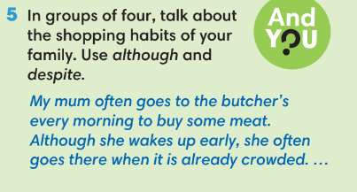
WRAP-UP & HOME WORK (3’)
- T asks Ss to talk about what they have learnt in the lesson.
- Although, despite, in spite of
* HOME WORK
- Do exercises in the workbook page 61.
- Prepare for Lesson 7.3: Reading.

…………………………………………………………………………………….

