Date of planning: ..............................  Date of teaching: .............................. | UNIT 7: SHOPPING AROUND  PERIOD 75. LESSON 7.3  READING AND VOVABULARY
I. OBJECTIVES:
By the end of the lesson, Ss will be able to:
- locate information and find specific details in a text (scanning skill).
- identify the main ideas of the paragraphs in the text or the text itself (skimming).
1. Knowledge:
* Vocabulary: - an understanding of the vocabulary about markets in Vietnam.

New words | Vietnamese meaning
crowds of tourists | đám đông du khách
overlook | nhìn từ trên cao xuống
catalogue | catalog_danh mục
reasonable price | giá cả hợp lý

* Grammar:
- Reading skills: - Identify specific details about shopping in Hội An, Việt Nam.
2. Competence:
- General competences: form and / or improve such competencies as group work, independent working, pair work, linguistic competence, and cooperative learning.
- Specific competences:
- Improve communicative competence related to the use of language (vocabulary, phonetics, grammar):
- For a language lesson: Ss are expected to know the meaning of the keywords used to talk about school system in Vietnam.
- For a skills lesson:
- Ss are expected to locate information and find specific details in a text (scanning skill).
- Ss are expected to identify the main ideas of the paragraphs
3. Quality/behavior:
- Being hard-working and attentive in class
- Have a positive attitude towards the lesson
- Know more and respect the family time together.

II. TEACHING AIDS:
- Grade 7 textbook, Unit 7 (SB p.73, WB p.62).
- Computer (connected to the Internet is the best)
- Projector / TV/ PPT slides / Active teach
Assumptions
Anticipated difficulties | Solutions
1. Ss may pronounce the new words incorrectly. | Reinforce the pronunciation of the new words while presenting and practicing.
2. Ss may not have sufficient speaking and co-operating skills. | Give clear instructions, give examples before letting Ss work in pairs / groups.  Provide feedback and help if necessary.
3. Ss may not know how to scan for information. | Guide Ss to underline keywords in the question before finding them in the text.

III. PROCEDURE:
1. WARM-UP (5’)
* Aim:
- To help Ss review grammar they have learnt.
- To lead into the next activity.
* Content: Game: Lucky number (about although, despite, in spite of)
* Outcome: Ss recall the modal verbs from previous lesson.
* Organisation: T-Ss, Ss-T.
Teacher’s & Student’s activities | Content
Activity 1: Lucky number  - T explains the game rules then checks instructions.  - T uses slide to lead the game.  - Ss raise their hands if they have the answer.  - T tells students that they are going to read about shopping in Hoi An, Vietnam.  - T writes the title for the new lesson:  Unit 7/Lesson 3: Reading and vocabulary. | Game rules:  - T shows key words on the slide.  - Ss make sentences using although, despite, in spite of.  - Choose randomly one number (1-9) to see your score
2. PRE-READING (5’)
ACTIVITY 2:
* Aim:
- To activate Ss’ background knowledge of the topic.
* Content: Ss describe photos.
* Outcome: Ss provide simple facts about Hội An, Việt Nam.
* Organisation: T-Ss, Ss-T, Pair work.
Teacher’s & Student’s activities |  | Content
Activity 2: Exercise 1 – SB p.73  In pairs, look at the photos. What do you know about this place?  - T shows the pictures on slide and ask Ss to describe what they can see and guess the name of this place.  - Ss work in groups to discuss the questions.  - T collects Ss answer and check. |  | 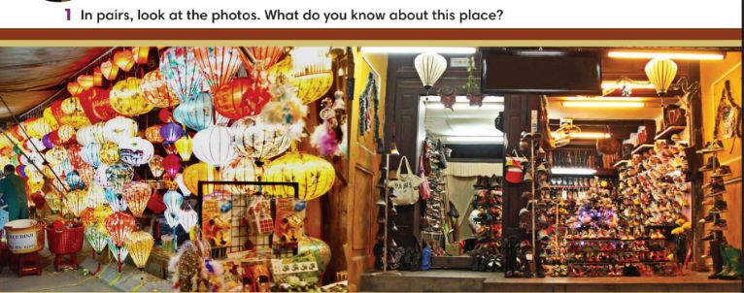
3. WHILE-READING (15’)
ACTIVITY 3 + 4:
*Aim:
- To read two texts and do reading tasks.
- To help students practice finding main ideas of the text.
- To help students practice reading for specific information in a text.
* Content: Ss read the texts and answer the questions.
* Outcome: Ss can identify specific information in the texts and learn more about Hội An, Việt Nam.
* Organisation: T-Ss, Ss-T.
Activity 3: Exercise 2 – SB p.73  Read the text. Where most likely can you find the information in the text?  - T asks some Ss to read the text out loud to check pronunciation.  - T lists all new words and provide the meaning.  - T asks Ss to look at Exercise 2 (SB page 73).  - T explain to Ss that they need to do skimming and find main ideas.  - T set time limit for Ss to find main ideas and finish exercise 2.  - T asks Ss to check answers with partner before checking with the whole class and explain reasons for their answers. |  | Answer keys:  
Activity 4: Exercise 3 – SB p.73  Read the text and write N for the night market and S for the shoe shop or B for both places.  Step 1: Scanning  - T asks Ss to read the text again, underline key information and try to remember.  - T set time limitation such as 3 minutes.  - T asks Ss to close the book and answer some questions about the text basing on memory.  1. How big is Hội An market?  2. Which river is mentioned in the text?  3. What can you see at night?  4. What can you buy at Hội An shoe shop?  5. When can you get 100% money back?  Step 2: Exercise 3  - T asks Ss to look at exercise 3 (SB page 73).  - T tells student to read the text again individually to  complete Exercise 3.  - T asks students to underline the evidence for their answers. |  | 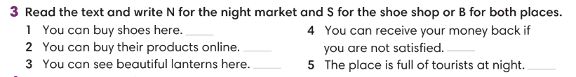  Answer keys:
4. POST-READING (17’)
ACTIVITIES 5 + 6 +7:
* Aim:
- To study the Vocabulary.
- To review new words from the text.
* Content:
- Complete the sentences using given words.
- Play Game: Hot seat.
- Describe one shop/ market.
* Outcome: Ss can understand the new words and talk about shop/ market.
* Organisation: T-Ss, Ss-T, Ss-Ss, Group work, Pair work.
Activity 5: Exercise 4 – SB p.73  Choose the words from the text to complete the sentences. Make changes to the words if necessary?  - T asks Ss to work in pairs, find these phrases in the text and explain the meaning.  - T asks Ss to work individually to finish Exercise 4 and then check Ss answers. |  | Answer keys:  
Activity 6: Hot seat game  - T tells Ss that they are play a game to remember new words from the text.  - T tells the game rules. |  | Game rules:  - T divides the class into 2 teams, each turn needs 2 representatives.  - T gives one new word (from the text).  - 2 representatives need to guess the word.  - 1 correct answer = 1 point.
Activity 7: Exercise 5 – SB p.73  Work in groups. Describe one shop or one market in your hometown. The present to the class.  - T asks Ss to look at exercise 5 (SB page 73).  - T calls a student to read the instruction then checks Ss’ understanding of it.  - T provides one example for Ss to understand.  - Ss work in groups of 4.  - T invites some volunteers to present in front of the class and notes down useful or interesting sentences.  - T asks the rest to give comments on their classmates’ performance and then provides teacher’s feedback. |  | 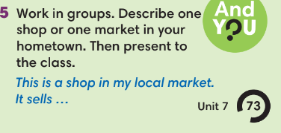
WRAP-UP & HOME WORK (3’)
- T asks Ss to talk about what they have learnt in the lesson.
- Identify specific details about shopping in Hội An, Việt Nam
- Group discussion
* HOME WORK
- Do exercises in the workbook page 62.
- Prepare for Lesson 7.4: Grammar 2.

………………………………………………………………………….

