Date of planning: ..............................  Date of teaching: .............................. | PERIOD 78. REVIEW 3  VOCABULARY AND GRAMMAR UNIT 5,6,7

I. OBJECTIVES:
1. Knowledge: By the end of this review, students will be able to revise the language they have learnt and the skills they have practiced in Units 5 – 6 – 7.
a) Vocabulary: revise the vocabulary which students have learnt in Units 5, 6, 7: words related to food, schools and shopping.
b) Grammar: review the grammar points which students have learnt in Units 5, 6, 7: Quantifiers; Articles; Modal verb; used to; Conjunctions and time expression; although, despite, in spite of and Future forms.
c) Writing: Writing an email, a sentence and a note or message.
d) Speaking: Order food in restaurant; talk about favourite subjects and activities at school; shop for clothes and other things.
2. Competence: Ss use the vocabulary of the unit, and do the tasks assigned in the textbook. Participate in a guided conversation to give and respond to the news using the given information.
3. Quality/ behavior: Having a positive attitude towards the lesson and a good relationship with friends. The love of learning English. Hard-working; attentive; cooperative; sociable; good communication in class.
II. TEACHING AIDS:
- Teacher: Textbook, laptop, loudspeaker, projector…
- Students: Grade 7 textbook, Unit 5, 6, 7 (SB p.79), studying equipment….
- Method: T-WC; group works; individual ……
III. PROCEDURE:
1. REVIEW VOCABULARY UNIT 5 (8’)
ACTIVITY 1:
* Aim:
- To help students reviews topic words and word friends from the unit.
- To review vocabulary in context.
* Content: Glossary of unit 5, Survival Game: vocabulary of unit 5.
* Outcome: Students’ correct pronunciation and answers.
* Organization of implementation:
Teacher’s & Student’s activities |  | Content
1. (3’) Activity 1a:  - T tells students to open the Glossary box in student book page 58.  - T asks Ss work in pairs: 1 student points to the word, 1 student pronounces it. Then they swap their roles.  - T corrects Ss’ pronunciation if any. |  | 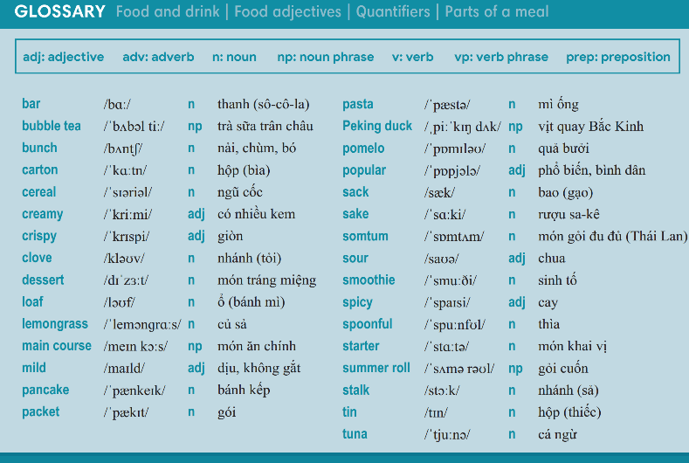
2. (5’) Survival Game:  - T gives and checks instructions for the game.  - T corrects Ss’ pronunciation if any. |  | How to play:  - Four teams (50 hearts for each teams).  - Choose number randomly.  - Answer question.  - If answer correctly = open number.  - More hearts = winner.
2. REVIEW GRAMMAR UNIT 5 (6’)
ACTIVITY 2:
*Aim: To help students revise Quantifiers and Articles.
* Content: Football Game: practice using Quantifiers and Articles.
* Outcome: Complete the sentences by filling in the blanks correctly.
* Organisation: Teacher’s instructions…..
Football Game  - T gives and checks instructions for the game.  - T corrects Ss if any. | How to play:  - 10 questions.  - 2 teams: BLUE – RED.  - Choose number to answer the question.  - Click and move the ball.  - Who kick the ball into the goal first is the winner.
3. REVIEW VOCABULARY UNIT 6 (8’)
ACTIVITY 3:
Aim:
- To help students review topic words and word friends from the unit.
- To review vocabulary in context.
* Content: Glossary of unit 6, Classifying Game: vocabulary have learnt in the unit 6.
* Outcome: Call out the vocabulary. Revision. Do exercises correctly.
* Organisation: Teacher’s instructions…...

1. (3’) Activity 3a:  - T tells students to open the Glossary box in student book page 68.  - T asks Ss work in pairs: 1 student points to the word, 1 student pronounces it. Then they swap their roles.  - T corrects Ss’ pronunciation if any. | 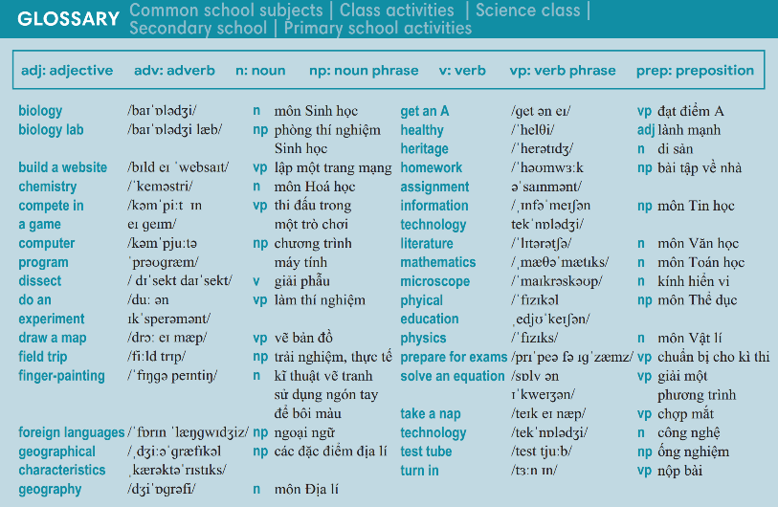
2. (5’) Classifying Game:  - T gives and checks instructions for the game.  - T corrects Ss’ pronunciation if any. | How to play:  - Look at the words.  - Think about which topic the word belongs to.  - Classify them into 2 groups.  - 1 correct answer = 2 points.
4. REVIEW GRAMMAR UNIT 6 (6’)
ACTIVITY 4:
* Aim: To help students revise Modal verbs, used to, Conjunctions and time expression.
* Content: Review grammar elements taught in unit 6 by playing Wheel of fortune.
* Outcome: Do exercises correctly.
* Organisation: Teacher’s instructions…..

Teacher’s & Student’s activities | Content
Wheel of fortune Game:  - T gives and checks instructions for the game.  - T corrects Ss if any. | How to play:  - 4 teams.  - Each team will take turns from team 1 to team 4 to get point.  - The team that has the highest point is the winner.
5. REVIEW VOCABULARY UNIT 7 (8’)
ACTIVITY 5:
Aim:
- To help students review topic words and word friends from the unit.
- To review vocabulary in context.
* Content: Glossary of unit 7, Top 5 Quiz: vocabulary have learnt in the unit 7.
* Outcome: Call out the vocabulary. Revision. Do exercises correctly.
* Organisation: Teacher’s instructions…...

1. (3’) Activity 5a:  - T tells students to open the Glossary box in student book page 78.  - T asks Ss work in pairs: 1 student points to the word, 1 student pronounces it. Then they swap their roles.  - T corrects Ss’ pronunciation if any. | 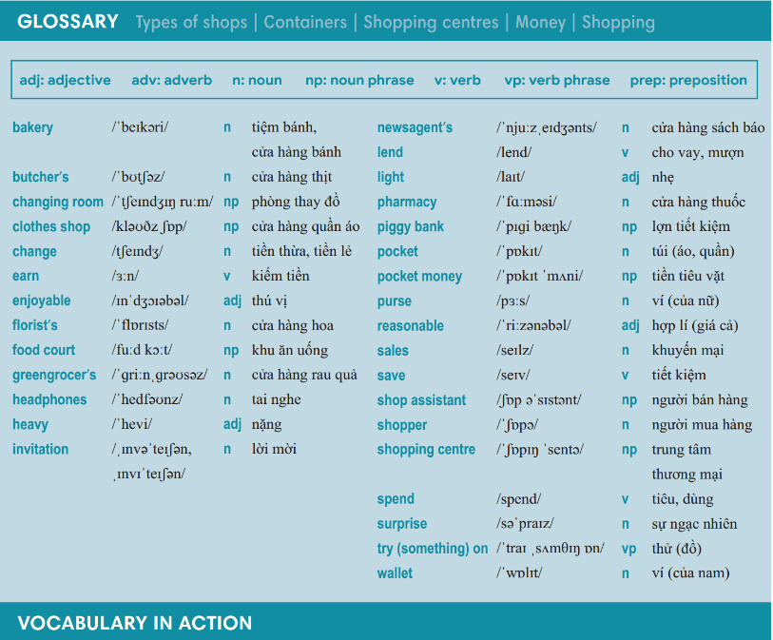
2. (5’) Top 5 Quiz Game:  - T gives and checks instructions for the game.  - T corrects Ss’ pronunciation if any. | How to play:  - Read the question and write down ONE answer in 10 seconds.  - If you answer is in the top 5, you will get point.  - Student with the highest point is the winner.
6. REVIEW GRAMMAR UNIT 7 (6’)
ACTIVITY 6:
* Aim: To help students revise although, despite, in spite of, Future time.
* Content: Review grammar elements taught in unit 7 by playing Wheel of fortune.
* Outcome: Do exercises correctly.
* Organisation: Teacher’s instructions…..

Teacher’s & Student’s activities | Content
Hidden Picture Game:  - T gives and checks instructions for the game.  - T corrects Ss if any. | How to play:  - There are 9 numbers.  - Choose number.  - Turn over the card and answer the question.  - A hidden picture is shown under the card per round.  - 1 correct answer = 1 point.
WRAP-UP & HOME WORK (3’)
- T asks Ss to talk about what they have learnt in the lesson.
- Review Unit 5 vocabulary and grammar.
- Review Unit 6 vocabulary and grammar.
- Review Unit 7 vocabulary and grammar.
* HOME WORK
- Exercises in WB.

