UNIT 6: A QUESTION OF SPORT
Period 57: Lesson 6.3: Reading and Vocabulary
I. OBJECTIVES
By the end of the lesson, students are expected to achieve the following objectives:
- Knowledge:
- Vocabulary (Places to play sport): basketball court, tennis court, football field/pitch, swimming pool, running track.
- Competencies:
- General competencies:
Strengthen group work and independent working, pair work, linguistic competence, cooperative learning and communicative competence.
- Specific competencies:
Improve communicative competencies related to reading skills and use of language (vocabulary, phonetics, grammar)
- For a language lesson: Students are expected to know the meaning of the keywords and phrases used to talk about their favorite sports, and understand the main grammatical points, then do the tasks assigned in the textbook.
- For a skills lesson: Students are expected to find specific details in a text and talk about places to play sports.
- Qualities:
- Being hard-working and attentive in class
- Being collaborative while doing in-class exercises
- Being respectful and active listening when having a conversation about each other's favorite sport.

II. PREPARATIONS
Teacher: Textbooks, paper, TV, projector, loudspeaker
Students: Textbooks, notebooks
III. PROCEDURE
ACTIVITY 1: WARM-UP
- Aim: To attract Ss’ attention to the lesson and review the previous lesson.
- Content: Ss work as a whole class to play the game under instruction of T.
- Products: Ss are able to make as many sentences using was/were to show the differences between 2 pictures.
- Implementation:
TEACHER AND STUDENTS’ ACTIVITIES | CONTENTS
Find the differences  Step 1: Task delivering  - T shows 2 pictures on the Resource 67 worksheet on the screen.  Step 2: Task performance  - Ss work in pairs to make as many sentences using was/were to show the differences between 2 pictures as they can in 3 minutes.  Step 3: Report and discussion  - T calls some pairs to share their ideas.  Step 4: Judgment  - Check with the whole class. | RESOURCE 67 Unit 6 Lesson 2  - 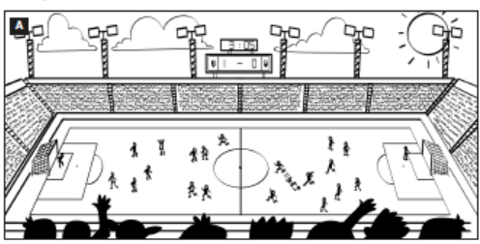  - 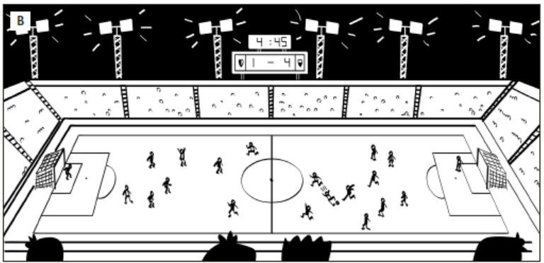  Answers (in any order):  - In picture A it was five past three, but in picture B it is a quarter to five.  - In picture A there were lots of/a lot of people/fans, but in picture B there aren’t (many).  - In picture A the lights were off, but in picture B they are on.  - In picture A there were eleven players on both teams, but in picture B one team has only nine players.  - In picture A the score was 1–0 but in picture B it is 1–4.
ACTIVITY 2: KNOWLEDGE FORMATION
- Aim: To introduce the objectives of the lesson with a can-do statement.
- Content: The objective of the lesson is listed as below
- I can find specific details in a text and talk about places to play sports.
- Products: Ss acknowledge the lesson’s objectives.
- Implementation: T introduces objectives to Ss.
ACTIVITY 3: PRE-READING
- Aim: To get students’ interest in the topic “sports star”.
- Content: Ss work in groups with the guidance from T to discuss and vote for the most popular sports stars in Vietnam.
- Products: Ss are able to ask and explain to each other about their memories of their first day at school, as well as recall related vocabulary.
- Implementation:
TEACHER AND STUDENTS’ ACTIVITIES | CONTENTS
Set the scene  Step 1: Task delivering  - T raises the question: What kinds of sports are you interested in?  Step 2: Task performance  - Ss discuss with friends to vote for the most popular sports stars in Vietnam.  Step 3: Report and discussion  - Invite some Ss to present their works.  Step 4: Judgment  - Check with the whole class. | Exercise 1: Who is the most popular sports star in your country?  The answers may vary.
ACTIVITY 4: WHILE-READING
- Aim: To help students practice reading skills with some reading comprehension tasks.
- Content: Ss work individually and in pairs under the instruction from T to do the given reading-related exercises respectively.
- Products: Ss are able to accomplish the given exercises as much as they can.
- Implementation:
Step 1: Task delivering  - T elicits the sports shown in the photos before Ss do the exercise.  - T asks Ss to read the texts and complete the exercise individually.  Step 2: Task performance  - Ss to read the texts and complete the exercise individually.  Step 3: Judgment  - Ss swap to compare the answers.  - T checks their answers.  Step 4: Report and discussion  - T develops further discussion if needed. | Exercise 2: Read the texts and complete the table. If you can’t find the information in the texts, try to guess the answers from the photos.  Answers:  *Age of sportspeople is due to the year the lesson is taught.
   | Country | Sports | Age
  Lan’s mother | Vietnam | swimming | Vary
  Garnine Muguruza | Spain | tennis | Vary
  Dina Asher Smith | Britain | running | Vary
  Kristaps Porzingis | Latvia | basketball | Vary
Step 1: Task delivering  - T instruct S to do the task  Step 2: Task performance  - T asks Ss to read the texts again and tell Ss that they should look for information in the texts which shows whether the sentences are true or false.  - T explains that if they can’t find the information in the texts, the correct answers are probably “doesn’t say”.  Step 3: Judgment  - After that, T elicits the answers and the references from the texts.  Step 4: Report and discussion  - T develops further discussion if needed | Exercise 3: Read the texts again. Match the sentences ✓ (right), X (wrong) or ? (doesn’t say)  Answers:  1. X  2. ✓  3. ?  4. ✓  5. X  6. ?  7. ✓  8. ?
Step 1: Task delivering  - T asks Ss to read all the words in the Vocabulary Box.  - T asks Ss to match the words with the photos.  Step 2: Task performance  - Ss do the exercise as guided by T.  Step 3: Judgment  - T checks by a game: Ss match the definitions to the words.  Step 4: Report and discussion  - T develops further discussion if needed. | Exercise 4: Study the Vocabulary Box. Which places can you see in the photos?  Answers:  A. swimming pool  B. tennis court  C. running track  D. basketball court.
Quiz  Step 1: Task delivering  - T adapts this exercise into a quiz.  - T shows sentences one by one, giving some minutes to write the answers in pairs.  Step 2: Task performance  - Ss write the answers in pairs.  Step 3: Judgment  - T shows the answers to check.  Step 4: Report and discussion  - T develops further discussion if needed. | Exercise 5: In pairs, complete the text with one word in each gap.  Answers:  2. track  3. courts  4. court  5. pool
ACTIVITY 5: POST READING
- Aim: To practice speaking in pairs to talk about favourite sports and sportspeople.
- Content: Ss work in groups of 3 to practice to ask and answer the given questions in Exercise 6.
- Products: Ss are able to get the idea of how to develop a short speech about sports in general.
- Implementation:
Interview  Step 1: Task delivering  - T instruct S to do the task  Step 2: Task performance  - Ss find 3 partners to ask and answer the questions in exercise 6, then fill in the table.  - T elicits some expressions to answer the questions.  - Ss complete the task within about 5 minutes.  Step 3: Report and discussion  - T calls some to report to the class.  Step 4: Judgment  - Check with the whole class. | Exercise 6: In pairs, ask and answer the questions below.  Suggestion:  - My favourite sport is … and my favourite star is …  - Sports stars earn a lot of money. They are very popular.  - Sports stars work very hard. They can get injured.
  Questions | F1 | F2 | F3
  1.
  2.
HOME ASSIGNMENT  - T assigns the home assignments.  - Ss copy their home assignments.  - T explains it carefully. | - Do exercises on Workbook page 54.  - Prepare: Lesson 6.4 – Grammar 2.

