Teaching date: 07/9/2022
Period 2 UNIT 1: FREE TIME
Lesson 1.1 - Vocabulary and Reading (Page 4)

I. OBJECTIVES
By the end of the lesson, Ss will be able to:
1.1. Language knowledge and skills
- talk about their hobbies, using words: build models, bake cakes, make vlogs, read comics, play online games, collect soccer stickers.
- practice reading and understanding general and specific information about a teen’s hobby.
- use the Present Simple for talking about habits.
1.2. Competences
- improve communication, collaboration, analytical and critical thinking skills.
1.3. Attributes
- take up a useful hobby and spend a suitable amount of time on this hobby.
- build good habits for themselves and ditch bad ones.
II. TEACHING AIDS AND LEARNING MATERIALS
1. Teacher’s aids: Student book and Teacher’s book, class CDs, Digital Book (DCR phần mềm tương tác SB, DHA (từ vựng/ cấu trúc) phần mềm trò chơi tương tác), projector/interactive whiteboard / TV (if any), PowerPoint slides.
2. Students’ aids: Student’s book, Workbook, Notebook.
III. ASSESSMENT EVIDENCE
Performance Tasks | Performance Products | Assessment Tools
- Activate the free time activities that Ss may know.  - Match the words with the pictures in a.  - Listen and repeat.  - Compare Ss’ hobbies to Kate, or a classmate.  - Talk about Ss’ hobbies and what cool things they can make | - Ss’ answers in notebooks.  - Ss’ answers.  - Ss’ practice.  - Ss’ performance.  - Ss’ answers/ presentation. | - T’s feedback.  - T’s observation/ DCR.  - T’s observation.  - T’s feedback/Peers’ feedback.  - T’s feedback/Peers’ feedback.
IV. PROCEDURES
A. Warm up: (5’)
a. Objective: Introduce the new lesson and set the scene for Ss to acquire new language; get students' attention at the beginning of the class by enjoyable and short activities as well as to engage them in the follow-up steps.
b. Content: Introduce words about hobbies.
c. Expected outcomes: Ss have general ideas about the topic “free time activities”.
d. Organization of the activity:
TEACHER’S ACTIVITIES | STUDENTS’ ACTIVITIES
- Give greetings.  - Check attendance.  Option 1: Number the pictures.  - Use the “New words” part a.– page 4 for the warm-up activity.  - Show pictures and words (using DCR), have Ss number the pictures (in pairs).  - Call Ss to give answers.  - Give feedback and show correct answers (using DCR).  - Lead to the new lesson.  - Play the audio (CD1 – Track 02), have Ss listen and repeat.  - Correct Ss’ pronunciation if necessary.  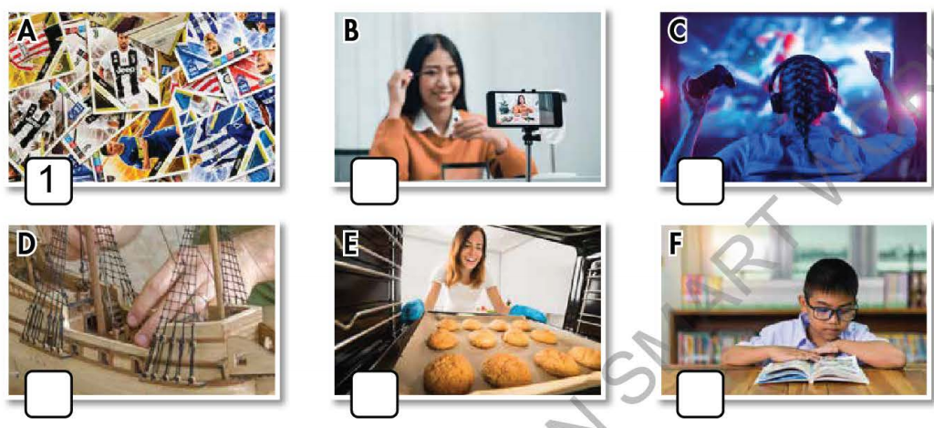  Option 2: Chatting.  - Ask Ss some questions about their free time activities:  Eg: - What do you often do in your free time?  - How much time do you spend doing it?  - Do you find it useful?  - Lead to the new lesson: Free time. | - Greet T.  - Work in pairs to number the pictures.  - Give answers.  - Listen.  Answer keys: A1 B4 C6 D2 E3 F5  - Answer the questions.  - Listen.
B. New lesson (35’)
Activity 1: Pre-Reading (Vocabulary) (12’)
a. Objective: Ss know words about free time activities.
b. Content:
- Vocabulary study (build models, bake cakes, make vlogs, read comics, play online games, collect soccer stickers).
- Speaking: Note more than 3 hobbies you know and discuss if you like them.
c. Expected outcomes: Ss know how to pronounce the new words correctly and use them in appropriate situations.
d. Organization of the activity:
TEACHER’S ACTIVITIES | STUDENTS’ ACTIVITIES
Task a. Number the pictures. Listen and repeat.  Option 1 (If the teacher hasn’t used this part for the Warm-up activity)  - Demonstrate the activity, using the example (using DCR).  - Have Ss number the pictures.  - Divide class into pairs and have them check their answers with their partners.  - Call Ss to give answers (read or write).  - Check answers as a whole class.  - Play audio (CD1 – Track 02) (using DCR). Have Ss listen and repeat.  - Correct Ss’ pronunciation.  Option 2: Matching. (If the teacher has used part a. for the Warm-up activity)  - Have Ss review the words they have known in the warm-up activity by matching words with pictures (T uses different pictures from those in the textbook).  - Call Ss to give answers (read or write).  - Check answers as a whole class.  - Call some Ss to read the words again.  - Correct Ss’ pronunciation if necessary.  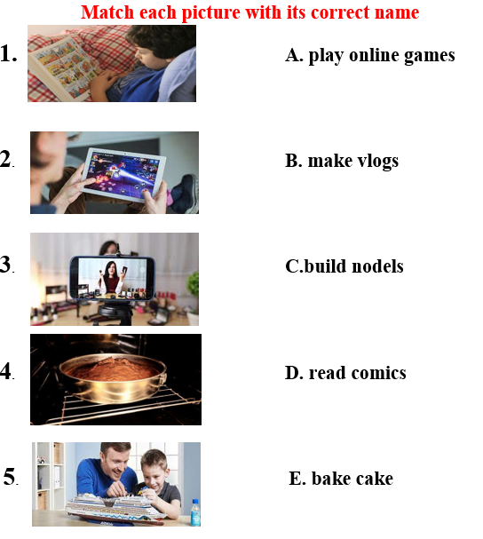  - For more practice and options, have Ss play a vocabulary game using DHA.  Task b. Note three more hobbies you know. Discuss if you like them.  Option 1:  - Have Ss talk in pairs about their hobbies using the new words and three other hobbies they know.  - Remind Ss to use the structure:  Do you like +V.ing …?  - Have Ss share their ideas in front of the class.  - Give feedback and evaluation.  Option 2: (for class with better students)  - Give Ss an extra activity: Have Ss work in groups to have a free talk about their hobbies. Encourage students to use their own ideas. Remind students to state whether they like these hobbies and whether these hobbies are useful or not.  - Call some groups to present their conversation with the class.  - Give feedback and evaluation. | - Look and listen.  - Work individually.  - Work in pairs.  - Give answers.  - Listen and repeat.  Answer keys:  A1 B4 C6 D2 E3 F5  - Work in pairs.  - Give answers.  - Read.  Answer keys  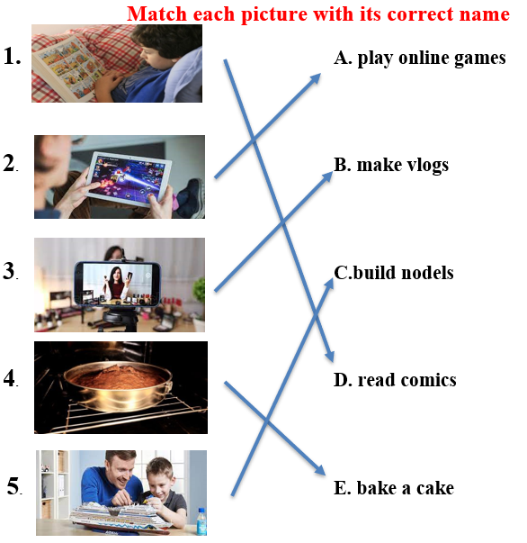  - Watch and play.  - Work in pairs.  - Present.  Suggested three more hobbies: playing sports, arranging flowers, making origami, …  - Work in groups.  - Present.  Suggested conversation  A: My hobby is playing online games. Do you like it?  B: Yes, I like it too  C: I think playing online games is relaxing, but it’s rather time-consuming.  A: Oh really? So what do you often do in your free time?  C: I collect old correction pen. I find this hobby not really challenging but relaxing
Activity 2: While - Reading
a. Objective: Students can develop their reading skills.
b. Content: Reading a teen blogger and choosing the best title, then circling the correct answer.
c. Expected outcomes: Students can read and understand general and specific information about a teen’s hobby.
d. Organization of the activity:
TEACHER’S ACTIVITIES | STUDENTS’ ACTIVITIES
Task a. Read Kate’s blog post and choose the best title.  Option 1:  - Ask Ss to read two options and find out key words.  - Show the task using DCR. Have Ss read the blog individually.  - Have Ss work in pairs to read the blog again.  - Have Ss circle the correct answers.  - Have some Ss share their answers with the class (read), explain for their answers.  - Give feedback.  - Give feedback and correct Ss’ answers if necessary.  Option 2:  - Have students look at the picture in part Reading a (using DCR) and ask them some questions about Kate:  What is her name?  What is her hobby?  What is the title of the blog?  - Retell students what a blog is  - Lead to the reading text.  - Have Ss read the questions and guess the answers.  - Have Ss read the blog and circle the correct answers – underline the supporting ideas.  - Have Ss check answers with their partners.  - Call Ss to give answers, explain.  - Give feedback and evaluation.  Task b. Now, read and circle the correct answers.  - Use DCR to show the task. Have Ss read the questions, underline key words and guess the answers.  - Have Ss read the blog again and circle the correct answers – underline or highlight the supporting ideas.  - Have Ss check answers with their partners.  - Call Ss to give answers, explain.  - Give feedback and evaluation. | -Work individually.  - Work in pairs.  - Circle the correct answers.  - Read answers, explain.  - Check answers.  Answer keys  1.My Model Collection  - Look and give answers.  - Listen.  - Read and do the task.  - Work in pairs.  - Give answers, explain.  Answer key: No  1. My Model Collection  - Read and underline.  - Do the task.  - Check answers.  - Give answers, explain.  Answer keys  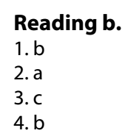
Activity 3: Post - Reading (6’)
a. Objective: Students can use the vocabulary and the sample text to develop their speaking skills.
b. Content: Speaking: What cool things can you make?
c. Expected outcomes: Students can have a free-talk about a cool thing they can make (What is it? How do you make it? What is it used for? Who helped you to make it…)
d. Organization of the activity:
TEACHER’S ACTIVITIES | STUDENTS’ ACTIVITIES
Task c. What cool things can you make?  - Have Students work in groups to talk about what cool things they can make.  -If there is enough time, ask Students to choose a cool thing to draw it (each group draws a picture).  -Have students hang the pictures on the board, ask the whole class to vote for the best picture.  -Make comments and announce the best picture. | - Work in groups to discuss and then draw.  - Take part in the class activities.
C. Consolidation and homework assignments (4’)
* Words about free time activities: build models, bake cakes, make vlogs, read comics, play online games, collect soccer stickers.
* Homework:
- Learn the new words by heart.
- Practice talking about your hobby.
- Do the exercises in Workbook: Lesson 1 - New words (page 2).
- Prepare: Lesson 1.2 – Grammar (page 5 – SB).
- Do the vocabulary exercise in Tiếng Anh 7 i-Learn Smart World Notebook (page 4).
****************************************************************
Teaching date: 09/9/2022
Period 3 UNIT 1: FREE TIME
Lesson 1.2 - Grammar (Page 5)
I. OBJECTIVES
By the end of the lesson, Ss will be able to:
1.1. Language knowledge and skills
- listen to 2 people asking and answering about a free time activity.
- talk about habits or things that happen regularly.
- use the Present Simple correctly.
- write simple sentences about habits.
1.2. Competences
- improve speaking, listening and writing skills.
- improve the use of English.
1.3. Attributes
- take up a useful hobby and spend a suitable amount of time on this hobby.
- build good habits for themselves and kick bad ones.
II. TEACHING AIDS AND LEARNING MATERIALS
1. Teacher’s aids: Student book and Teacher’s book, class CDs, Digital Book (DCR phần mềm tương tác SB, DHA (từ vựng/ cấu trúc) phần mềm trò chơi tương tác), projector/interactive whiteboard / TV (if any), PowerPoint slides, handouts.
2. Students’ aids: Student’s book, Workbook, Notebook.
III. ASSESSMENT EVIDENCE
Performance Tasks | Performance Products | Assessment Tools
- Listen and repeat.  - Fill in the blanks with the correct form of the verbs.  - Write sentences about habits using the pictures and prompts.  - Ask your partner about what they do and don’t do in their free time. | - Ss’ performance.  - Ss’ answers.  - Ss’ answers.  - Ss’ answers/ presentation. | - T’s feedback.  - T’s feedback/Peers’ feedback.  - T’s feedback/Peers’ feedback.  - T’s observation, T’s feedback/Peers’ feedback.
IV. PROCEDURES
A. Warm up: (5’)
a. Objective: Introduce the new lesson and set the scene for Ss to acquire new language; get students' attention at the beginning of the class by enjoyable and short activities as well as to engage them in the follow-up steps.
b. Content: Jumbled word or rearranging words to make a meaningful sentence.
c. Expected outcomes: Ss review words about hobbies or Ss have general ideas about the grammar point they are going to study in the new lesson.
d. Organization of the activity:
TEACHER’S ACTIVITIES | STUDENTS’ ACTIVITIES
- Give greetings.  - Check attendance.  Option 1: Game “JUMBLED WORD”  - Have Ss rearrange letters to make a meaningful word.  - Call Ss to give answers.  - Check Ss’ answers, give feedback and lead to the new lesson.  1. bbohy 2. deloms 3. Moiccs  4. lonnie 5. bouYutre  - Have Ss make sentences, using the words they have just made.  - For more vocabulary games, use DHA.  - Lead to the new lesson.  Option 2: REARRANGING  - Have Ss rearrange the words to make a meaningful English sentence.  1. do / do / free time / What / you / your / in?  2. play / you / Do / soccer?  3. reading / like / comics / I  4. online / He / on / plays / games / Sundays  5. We / on / like / movies / the / watching / weekends.  - Have Ss read their answers.  - Tell Ss about the grammar point they are going to study in the new lesson.  - Lead to the new lesson. | - Greet T.  - Take part in the game.  - Give answers (write on the board).  Answers keys  1. hobby 2. models 3. comics  4. online 5. Youtuber  - Read sentences.  - Work in pairs.  Answers keys  1. What do you do in your free time?  2. Do you play soccer?  3. I like reading comics.  4. He plays online games on Sundays.  5. We like watching movies on the weekends.  - Give answers.  - Listen.
B. New lesson (35’)
Activity 1: Presentation (10’)
a. Objective: Help Ss review Present Simple (form, usage).
b. Content:
- Listen and repeat.
- Review the form and usage of the Present Simple.
c. Expected outcomes: Ss remember the Present Simple and use it in some exercises that follow.
d. Organization of the activity:
TEACHER’S ACTIVITIES | STUDENTS’ ACTIVITIES
Task a. Listen and repeat.  - Have Ss look at the picture (using DCR).  - Play audio (CD1 – Track 03) and have Ss listen and read the speech bubbles.  - Play the audio again and have Ss listen and repeat.  Grammar box:  Option 1:  - Have Ss look at the grammar explanation (using DCR).  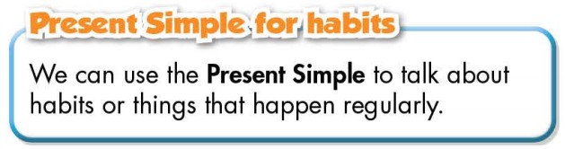  - Have Ss look at the box and read examples of different forms.  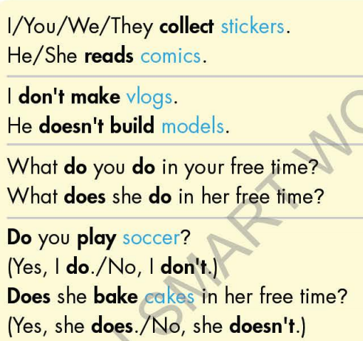  - Explain more about the form and the usage of the Present Simple, have Ss pay attention to the negative and the question form.  Form:  Be: (+) S + am / is / are + …  (-) S + am / is / are + not + …  (?) Am / Is / Are + S + …  Normal verb: (+) S + V _{s/es}  (-) S + don’t / doesn’t + V _{bare infinitive}  (?)Do / Does + S + V _{bare infinitive}  Usage: to talk about habits or things that happen regularly.  - Have some Ss read aloud the sentences in the Grammar Box aloud.  - Ask Ss to give more examples using the Present Simple.  Option 2:  - Have Ss close books.  - Give some model sentences, ask Ss to indicate which tense is being used, then have Ss retell form of the Present Simple.  *Suggested model sentences:  1. I always watch TV after I finish my exercises.  2. We go to the library every Saturday.  3. My father often has a cup of coffee every morning.  - Call Ss to give answers, comment on Ss’ answers  - Ask Ss: What are these sentences about?  - Then have Ss open the books and read the grammar box.  - Have Ss give more examples of the Present Simple,  encourage them to make sentences with their own ideas.  - Give feedback and evaluation. | - Look.  - Listen, then read.  - Listen and repeat.  - Look and read.  - Read.  - Listen and take notes.  - Read.  - Give examples.  - Close all books.  - Look and answer.  Expected answer: The sentences are about habits or activities that happen regularly.  - Read.  - Give examples.  - Listen.
Activity 2: Practice (19’)
a. Objective: Students can use the “Present Simple for habits” to do the given exercises.
b. Content:
- Filling in the blanks.
- Writing sentences about habits, using the pictures and prompts.
c. Expected outcomes: Students can get used to the use of Present Simple and use it correctly.
d. Organization of the activity:
TEACHER’S ACTIVITIES | STUDENTS’ ACTIVITIES
Task b. Fill in the blanks with the correct form of the verbs.  - Demonstrate the activity, using the example (using DCR).  - Have Ss fill in the blanks with the correct form of the verbs.  - Have Ss work in pairs to check each other’s work.  - Have some Ss share their answers with the whole class.  - Give feedback, correct Ss’ answers if necessary.  Task c. Write sentences about habits, using the pictures and prompts.  Option 1:  - Demonstrate the activity, using the example (using DCR).  - Have Ss write sentences about habits, using the pictures and prompts, remind Ss to pay attention to the form (negative, affirmative, or interrogative)  - Have Ss check answers with their partners.  - Call Ss to write answers.  - Check Ss’ answers, give feedback.  Option 2:  - Help Ss remember the activities in the pictures given in the exercise first (using DCR).  - Have Ss work in pairs to give names of activities in the pictures.  Eg: Picture 1: collect soccer stickers  - Have Ss write sentences about habits, using the pictures and prompts, remind Ss to use the verb phrases they have reviewed and pay attention to the form (negative, affirmative, or interrogative).  - Have Ss check answers with their partners.  - Call Ss to give answers by reading them aloud.  - Give feedback and show correct answers (using DCR). | - Look and listen.  - Work individually.  - Work in pairs.  - Read answers.  Answer keys  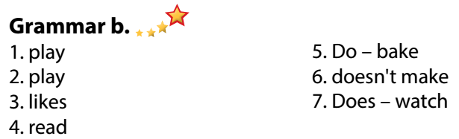  - Look and listen.  - Work individually.  - Work in pairs.  - Write answers.  Answer keys (use DCR)  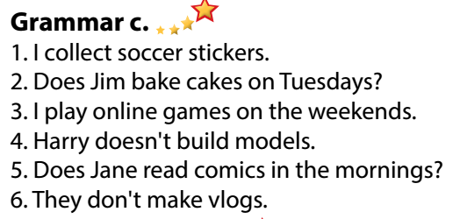  - Listen and memorize.  - Work in pairs.  Expected answers:  Picture 2: bake cakes / bake a cake  Picture 3: play online games  Picture 4: build models  Picture 5: read comics  Picture 6: make vlogs  - Work individually.  - Work in pairs.  - Give answers.  Answer keys
Activity 3: Production (6’)
a. Objective: Students master the grammar point they study in the lesson.
b. Content: Speaking: Asking and answering about what they do and don’t do in their free time.
c. Expected outcomes: Ss produce the new language successfully, and they can apply the Present Simple in everyday speaking and writing.
d. Organization of the activity:
TEACHER’S ACTIVITIES | STUDENTS’ ACTIVITIES
Task d. Ask your partner about what they do and don’t do in their free time.  - Divide class into pairs.  - Have Ss ask their partner about what they do and don’t do in their free time.  - Have some pairs demonstrate the activity in front of the class.  - Give feedback and evaluation.  - For more practice, have Ss play grammar games with DHA. | - Have conversation in pairs.  - Present.  - Listen.
C. Consolidation and homework assignments (5’)
*Consolidation:
- Form and usage of the Present Simple:
Form: Be: (+) S + am / is / are + …
(-) S + am / is / are + not + …
(?) Am / Is / Are + S + …
Normal verb: (+) S + V _{s/es}
(-) S + don’t / doesn’t + V _{bare infinitive}
(?)Do / Does + S + V _{bare infinitive}
Usage: to talk about habits or things that happen regularly.
*Homework:
- Make 3 sentences, use the Present Simple to talk about your habits.
- Do the exercises in WB: Lesson 1 - Grammar (page 5).
- Prepare: Lesson 1 – Pronunciation and Speaking (page 6 – SB).
- Complete the grammar notes in Tiếng Anh 7 I-Learn Smart World Notebook (page 5).
- Play consolation games in Tiếng Anh 7 i-Learn Smart World DHA App on
*******************************************************************
Teaching date: 13/9/2022
Period 4 UNIT 1: FREE TIME
Lesson 1.3 – Pronunciation and Speaking (Page 6)
I. OBJECTIVES
By the end of the lesson, Ss will be able to:
1.1. Language knowledge and skills
- pronounce the sound /eɪ/ correctly.
- ask and answer about free time activities, using time expressions of the Simple Present.
- conduct a survey about hobbies.
1.2. Competences
- improve listening and speaking skills.
1.3. Attributes
- take up a useful hobby and spend a suitable amount of time on this hobby.
- build good habits for themselves and ditch bad ones.
II. TEACHING AIDS AND LEARNING MATERIALS
1. Teacher’s aids: Student book and Teacher’s book, class CDs, Digital Book (DCR phần mềm tương tác SB, DHA (từ vựng/ cấu trúc) phần mềm trò chơi tương tác), projector/interactive whiteboard / TV (if any), PowerPoint slides, handouts.
2. Students’ aids: Student’s book, Workbook, Notebook.
III. ASSESSMENT EVIDENCE
Performance Tasks | Performance Products | Assessment Tools
- Listen to the words with the sound /eɪ/.  - Listen and cross out the word that doesn’t contain the sound /eɪ/.  - Read the words with the sound /eɪ/.  - Ask and answer about free time activities, using time expressions of the Simple Present.  - Complete the survey for themselves, then ask 3 more friends to have more information about hobbies, then fill in the table. | - Ss’ performance.  - Ss’ answers.  - Ss’ performance.  - Ss’ performance.  - Ss’ performance /  Presentation. | - T’s observation.  - T’s feedback/Peers’ feedback.  - T’s feedback/Peers’ feedback.  - T’s feedback/Peers’ feedback.  - T’s observation, T’s feedback/Peers’ feedback.
IV. PROCEDURES
A. Warm up: (5’)
a) Objective: Introduce the new lesson and set the scene for Ss to acquire new language; get students' attention at the beginning of the class by enjoyable and short activities as well as to engage them in the follow-up steps.
b) Content: Review vocabulary about hobbies.
c) Expected outcomes: Ss remember old words and use them in other speaking activities.
d) Organization of the activity:
TEACHER’S ACTIVITIES | STUDENTS’ ACTIVITIES
- Give greetings.  - Check attendance.  Option 1: MATCHING  - Have Ss work in pairs, do the matching exercises.  - Call Ss to read answers.  - Give feedback and lead to the new lesson.  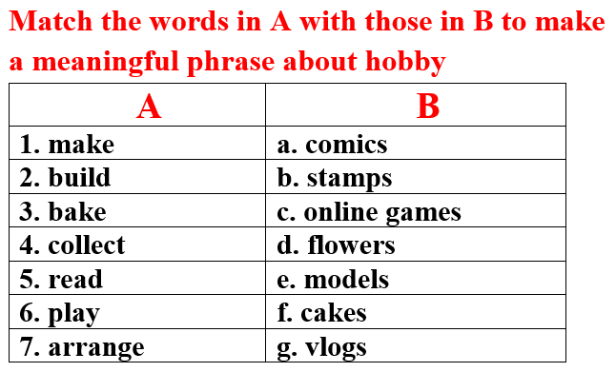  - Lead to the new lesson.  Option 2:  - Give a sample sentence:  David makes eight cakes for his classmates on Sunday.  - Have Ss practice reading this sentence fluently.  - Ask Ss to find as many as possible words that contain the same sound in this sentence.  - Introduce the sound /eɪ/ and lead to the new lesson. | - Greet T.  - Work in pairs, then give answers.  Answer keys  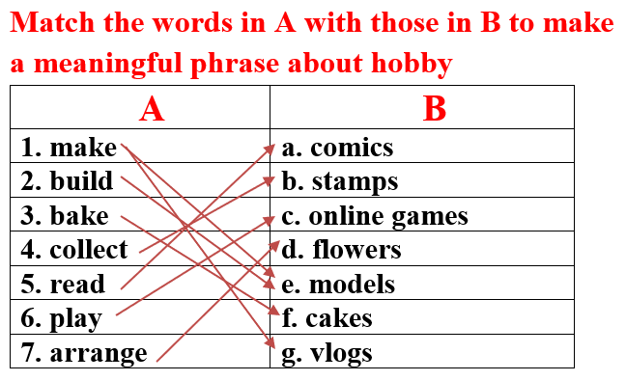  -Read.  - Practice reading out loud.  - Give answers.  Answer keys: David, makes, eight, cakes, classmates, Sunday
B. New lesson (35’)
Activity 1: Pre-Speaking: Pronunciation (10’)
a) Objective: Introduce the sound /eɪ/ and how to pronounce it.
b) Content:
- recognize the sound /eɪ/.
- listen and check, find mistakes.
- practice.
c) Expected outcomes: Ss distinguish and pronounce the sound /eɪ/ correctly in their speaking.
d) Organization of the activity:
TEACHER’S ACTIVITIES | STUDENTS’ ACTIVITIES
Task a + b. Listen to the sentences and focus on the /eɪ/ sound.  - Play the recording (CD1, track 04) using DCR.  - Ask Ss to listen and pay attention to the /eɪ/ sound.  - Have Ss make comments on the sound of the underlined words.  - Play the recording again, have Ss listen and repeat with a focus on the pronunciation feature.  Task c + d. Listen and cross out the word that doesn’t have /eɪ/ sound, then read the words with the sound noted: /eɪ/  - Play the recording (CD 1 – Track 05) using DCR, have Ss listen and cross out the option that doesn’t use the noted sound.  - Call Ss to give answers.  - Play the recording again and check answers as a whole class.  - Then have Ss practice reading the words with a partner, using the noted sound.  - Call some Ss to read in front of the class.  - Ask Ss to find more words containing the /eɪ/ sound. | - Listen.  - Comment.  - Listen again and repeat.  - Listen and cross out.  - Give answers.  - Listen again and check.  - Work in pairs.  - Present.  - Give answers.
Activity 2: While-speaking (20’)
a) Objective: Students can talk about their hobbies and their friends’ hobbies.
b) Content:
- asking and answer about free time activities, using time expressions of the Simple Present.
- conducting a survey about hobbies, filling in the table.
c) Expected outcomes: Ss produce the new language successfully.
d) Organization of the activity:
TEACHER’S ACTIVITIES | STUDENTS’ ACTIVITIES
PRACTICE  Task a. Ask and answer.  - Use DCR to show the task.  - Demonstrate the activity by asking and answering with a student.  - Have pairs ask and answer, using the pictures.  - Remind Ss to use the time expressions of the Present Simple.  - Have some pairs demonstrate the activity in front of the class.  b. Practice with your own ideas.  - Have pairs practice the conversation with their own ideas, then swap roles.  - Call some pairs to demonstrate the activity in front of the class.  - Give feedback and evaluation.  SPEAKING: Top Teen Hobbies.  Task a. You’re asking your classmates about their hobbies. In groups of 4, complete the survey for yourself, then ask 3 more friends. Fill in the table.  - Use DCR to show the task. Demonstrate the activity by practicing role-play with a student.  - Have Ss work in groups, ask and answer, then complete the table with information about their hobbies  - Observe, give help if necessary. | - Observe, listen.  - Work in pairs.  - Present.  - Work in pairs.  - Present.  Suggested conversation  - What do you do in your free time?  - I arrange flowers  - How often do you arrange flowers?  - I arrange flowers on the weekends or on some special occasions such as my family members’ birthday, Tet holiday or Christmas.  - Observe and listen.  - Work in groups.
Activity 3: Production (5’)
a) Objective: Students report to the class about the survey results of their group.
b) Content: Answering: What is the most popular hobby in your group?
c) Expected outcomes: Ss produce the new language successfully in everyday speaking and writing.
d) Organization of the activity:
TEACHER’S ACTIVITIES | STUDENTS’ ACTIVITIES
SPEAKING: Top Teen Hobbies.  Task b. Answer the question: What is the most popular hobby in your group?  - Have some Ss share their findings with the class.  - Give feedback and evaluation.  -Ask Ss some more questions:  1.What is the most popular hobby in your class?  2.Can you list top 3 most popular hobbies in your group / class?  3. In your group, is there any easy or difficult hobby? | - Present.  - Listen.  - Give answers.

C. Consolidation and homework assignments (5’)
* Consolidation:
- Words with the sound /eɪ/: make, play, place, bake, game, say, day, …
- Time expressions in the Simple Present: once a week, every day, a few times a month, on the weekends, …
* Homework:
- Make 2 sentences containing some words with the sound /eɪ/, then practice reading them.
- Complete the survey for those who haven’t finished it in class.
- Prepare: Lesson 2 – New words and Listening (page 7 – SB).
- Review the vocabulary and grammar notes in Tiếng Anh 7 i-Learn Smart World Notebook
(pages 4 & 5).
- Play consolation games in Tiếng Anh 7 i-Learn Smart World DHA App on www.eduhome.com.vn
*********************************************************************
Teaching date: 14/9/2022
Period 5 UNIT 1: FREE TIME
Lesson 2.1 – New words and Listening (Page 7)
I. OBJECTIVES
By the end of the lesson, Ss will be able to:
1.1. Language knowledge and skills
- talk about their free time activities, using words about places of entertainment: sports center, bowling alley, theater, ice rink, water park, market, fair.
- practice listening to 2 students having a phone call to make plans to meet each other (for general and specific details).
- know how to start a friendly conversation and practice using it.
1.2. Competences
- improve communication, collaboration, and critical thinking skills.
1.3. Attributes
- entertain themselves after study hard.
- know how to make plans for an informal meeting.
II. TEACHING AIDS AND LEARNING MATERIALS
1. Teacher’s aids: Student book and Teacher’s book, class CDs, Digital Book (DCR phần mềm tương tác SB, DHA (từ vựng/ cấu trúc) phần mềm trò chơi tương tác), projector/interactive whiteboard / TV (if any), PowerPoint slides.
2. Students’ aids: Student’s book, Workbook, Notebook.
III. ASSESSMENT EVIDENCE
Performance Tasks | Performance Products | Assessment Tools
- Activate some places of entertainment that Ss may know.  - Match the words with the pictures in a.  - Listen and repeat.  - Talk about activities students can do in these places of entertainment.  - Listen to 2 students having a phone call to make plans to meet each other, then circle the right answer.  - Speak: Where do you like to meet friends? What do you do there? | - Ss’ answers.  - Ss’ answers.  - Ss’ performance.  - Ss’ answers/ presentation.  - Ss’ answers.  - Ss’ answers/ presentation | - T’s feedback.  - T’s observation/ DCR.  - T’s observation.  - T’s feedback/Peers’ feedback.  - T’s feedback/Peers’ feedback.  - T’s feedback/Peers’ feedback.
IV. PROCEDURES
A. Warm up: (5’)
a) Objective: Introduce the new lesson and set the scene for Ss to acquire new language; get students' attention at the beginning of the class by enjoyable and short activities as well as to engage them in the follow-up steps.
b) Content: Introduce words about places of entertainment.
c) Expected outcomes: Ss get to know some new words they are going to study in the lesson.
d) Organization of the activity:
TEACHER’S ACTIVITIES | STUDENTS’ ACTIVITIES
- Give greetings.  - Check attendance.  Option 1: Match the words with the pictures  - Use the “New words” part a.– page 7 for the warm-up activity (using DCR).  - Show pictures and words, have Ss match the words with the pictures (in pairs).  - Call Ss to give answers.  - Give feedback and show correct answers.  - Lead to the new lesson.  - Play the audio (CD1 – Track 06), have Ss listen and repeat.  - Correct Ss’ pronunciation if necessary.  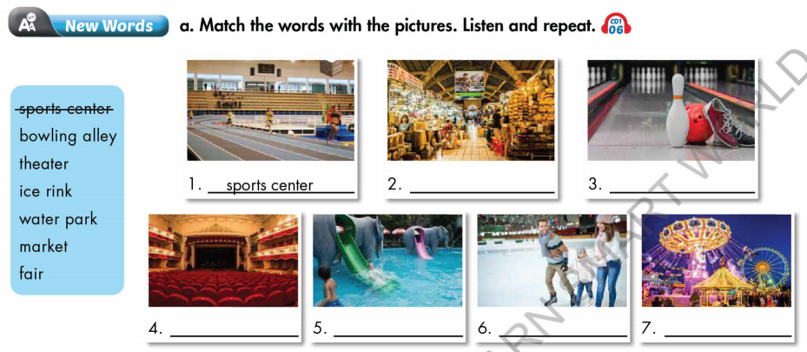  Option 2: Fill in the blanks  - Have Ss work in pairs to fill in the blanks.  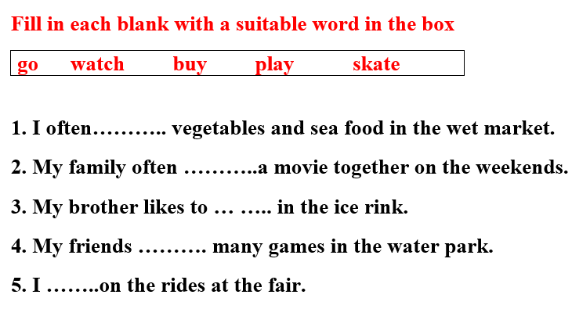  - Call Ss to give answers.  - Lead to the new lesson. | - Greet T.  - Work in pairs.  - Give answers.  - Listen.  - Listen and repeat.  Answer keys  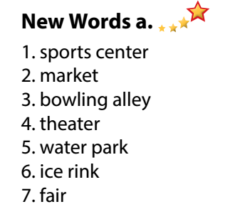  - Work in pairs.  - Give answers.  - Listen.  Answer keys  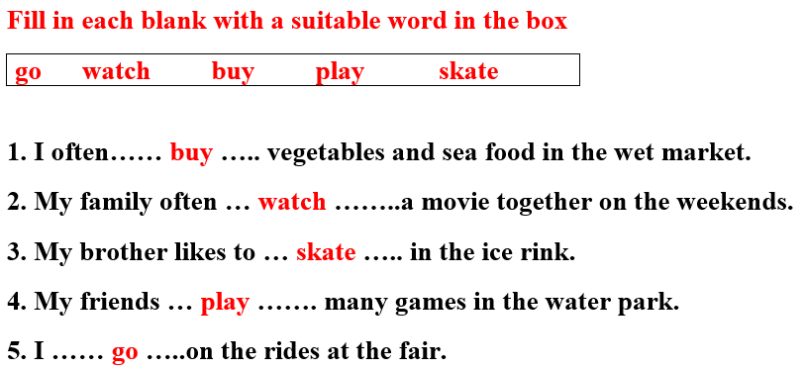
B. New lesson (35’)
Activity 1: Pre-Listening (Vocabulary) (12’)
a) Objective: Ss get to know words about places of entertainment.
b) Content:
- Vocabulary study (sports center, bowling alley, theater, ice rink, water park, market, fair).
- Speaking: Say what activities you can do at each place using the verbs in the box (page 7).
c) Expected outcomes: Ss know how to pronounce the new words correctly and use them in appropriate situations.
d) Organization of the activity:
TEACHER’S ACTIVITIES | STUDENTS’ ACTIVITIES
Task a. Match the words with the pictures. Listen and repeat.  Option 1 (If the teacher hasn’t used this part for the Warm-up activity.)  - Demonstrate the activity (using DCR), using the example  - Have Ss number the pictures.  - Divide class into pairs and have them check their answers with their partners.  - Call Ss to give answers (read or write).  - Check answers as a whole class.  - Play audio (CD1 – Track 06). Have Ss listen and repeat.  - Correct Ss’ pronunciation.  Option 2: Matching (If the teacher has used part a. for the Warm-up activity.)  - Have Ss review the words they have known in the warm-up activity by filling in the blanks (T uses different pictures from those in the textbook).  - Call Ss to give answers (read or write).  - Check answers as a whole class.  - Call some Ss to read the words again.  - Correct Ss’ pronunciation if necessary.  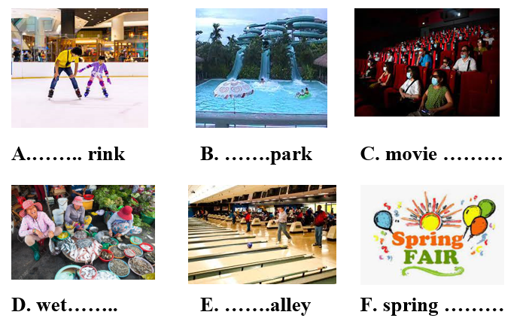  Task b. Say what activities you can do at each place using the verbs in the box.  - Use DCR to show the task.  - Have Ss work in pairs to talk about activities they can do at each place using the verbs in the box.  - Have some pairs share their ideas with the class.  - Give feedback and evaluation. | - Look and listen.  - Work individually.  - Work in pairs.  - Give answers.  - Listen and repeat.  Answer keys  - Work in pairs.  - Give answers.  - Read.  Answer keys  A. ice  B. water  C. theater  D. market  E. bowling  F. fair  - Work in pairs.  - Present.  Suggested ideas  - I watch movies in a movie theater.  - I play sports in the sports center.  - I play bowling in the bowling alley  - I skate in the ice rink.  …
Activity 2: While - Listening (17’)
a) Objective: Students can develop their listening skill.
b) Content: Listening to 2 students having a phone call to make plans to meet each other (for general and specific details).
c) Expected outcomes: Students can listen and understand general and specific information about making plans for an informal meeting with friends.
d) Organization of the activity:
TEACHER’S ACTIVITIES | STUDENTS’ ACTIVITIES
Task a. Listen to Becky calling Toby to make plans to meet. Which place will they visit together?  - Use DCR to show the task.  - Have Ss read the question.  - Play audio (Track 1.07).  - Have Ss listen and answer the question.  - Check answer as a whole class.  Task b. Now, listen and circle  - Use DCR to show the task.  - Have Ss read the questions, underline key words and guess the answers.  - Play the audio again (Track 1.07).  - Have Ss listen and circle the correct answer.  - Have Ss check answers with their partners.  - Call Ss to give answers.  - Give feedback and show correct answers. | - Work individually.  - Circle the correct answers.  Answer keys  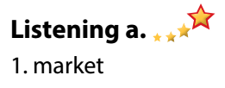  - Read and underline.  - Do the task.  - Check answers.  Answer keys  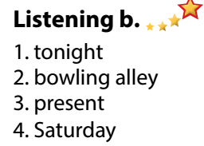
Activity 3: Post - Listening (6’)
a) Objective: Students can use the vocabulary and the content in listening part to develop their speaking skill.
b) Content: Speaking: Where do you like to meet you friends? What do you do there?
c) Expected outcomes: Students can have a free-talk about things to do when hanging out with friends.
d) Organization of the activity:
TEACHER’S ACTIVITIES | STUDENTS’ ACTIVITIES
Conversation skill  - Use DCR to show the task.  - Have Ss look at the Conversation box and read.  - Play audio (Track 08), have Ss listen and repeat.  - Ask Ss to find more ways to start a friendly conversation.  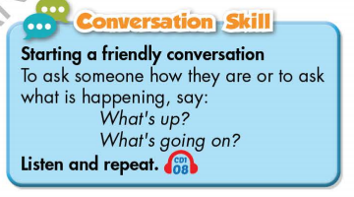  Task c. Where do you like to meet you friends? What do you do there?  - Have Ss work in pairs to discuss.  - Observe and give help if necessary.  - Call some pairs to share their ideas with the class.  - Give feedback and evaluation.  - For more practice, have Ss play vocabulary games with DHA. | - Look and read.  - Listen and repeat.  - Give answers.  - Work in pairs.  - Present.
C. Consolidation and homework assignments (4’)
* Consolidation:
- Words about places of entertainment: sports center, bowling alley, theater, ice rink, water park, market, fair.
- Language to start a friendly conversation: What’s up? / What’s going on? / Hi there! / Hey! …
*Homework
- Learn the new words by heart.
- Practice making a plan.
- Do the exercises in WB: New words and Listening (pages 4,5).
- Do the vocabulary exercise in Tiếng Anh 7 i-Learn Smart World Notebook (page 6).
- Play consolation games in Tiếng Anh 7 i-Learn Smart World DHA App on
- Prepare: Lesson 1 – Grammar (page 8 – SB).
*********************************************************************
Teaching date: 16/9/2022
Period 6 UNIT 1: FREE TIME
Lesson 2.2 - Grammar (Page 8)
I. OBJECTIVES
By the end of the lesson, Ss will be able to:
1.1. Language knowledge and skills
- listen to 2 people asking and answering about a plan.
- talk about future plans.
- use the Present Continuous and prepositions of place correctly.
- write questions about next week’s plan, then answer them.
1.2. Competences
- improve speaking, listening and writing skills
- improve the use of English.
1.3. Attributes
- make plans for themselves.
- be well-organized and disciplined.
II. TEACHING AIDS AND LEARNING MATERIALS
1. Teacher’s aids: Student book and Teacher’s book, class CDs, Digital Book (DCR phần mềm tương tác SB, DHA (từ vựng/ cấu trúc) phần mềm trò chơi tương tác), projector/interactive whiteboard / TV (if any), PowerPoint slides, handouts.
2. Students’ aids: Student’s book, Workbook, Notebook.
III. ASSESSMENT EVIDENCE
Performance Tasks | Performance Products | Assessment Tools
- Listen and repeat.  - Circle the correct word.  - Write questions using the prompts in the next week’s plan, then answer them.  - Work with your partner to make a plan to go out with your friend. | - Ss’ performance.  - Ss’ answers.  - Ss’ answers.  - Ss’ answers/ presentation. | - T’s feedback.  - T’s feedback/Peers’ feedback.  - T’s feedback/Peers’ feedback.  - T’s feedback/Peers’ feedback.
IV. PROCEDURES
A. Warm up: (5’)
a) Objective: Introduce the new lesson and set the scene for Ss to acquire new language; get students' attention at the beginning of the class by enjoyable and short activities as well as to engage them in the follow-up steps.
b) Content: Jumbled word or rearranging words to make a meaningful sentence.
c) Expected outcomes: Ss review words about hobbies or Ss have general ideas about the grammar point they are going to study in the new lesson.
d) Organization of the activity:
TEACHER’S ACTIVITIES | STUDENTS’ ACTIVITIES
- Give greetings.  - Check attendance.  Option 1: Review: Prepositions of place.  - Have Ss review some prepositions of place by doing the matching activity:  - Call Ss to give answers.  - Check Ss’ answers, give feedback and lead to the new lesson.  Near / under / next to / on / in front of / behind  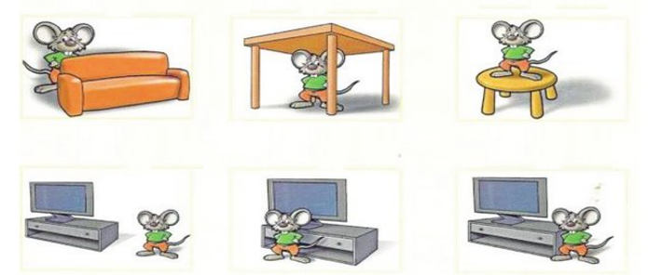  - Have Ss make sentences, using the prepositions of places.  - Lead to the new lesson.  Option 2: Fill in the blank  - Have Ss close all books and notebooks.  - Show some sentences with pictures, have Ss use the pictures to think of a word/phrase to fill in each blanks.  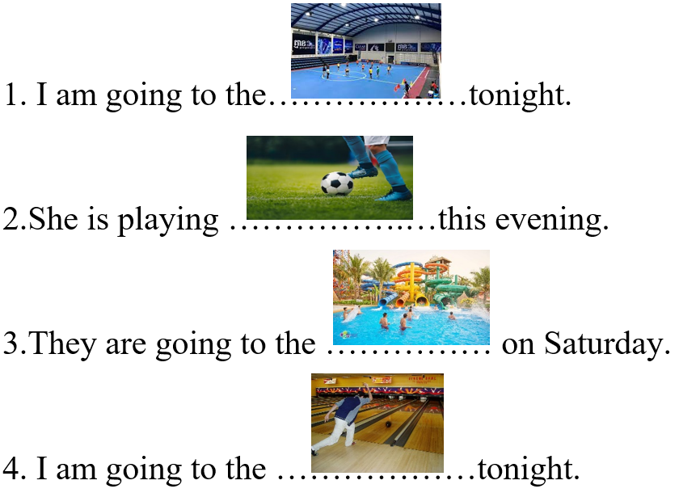  - Have Ss read their answers.  - Tell Ss about the grammar point they are going to study in the new lesson.  - Lead to the new lesson. | - Greet T.  - Work in pairs.  - Give answers.  Answers keys  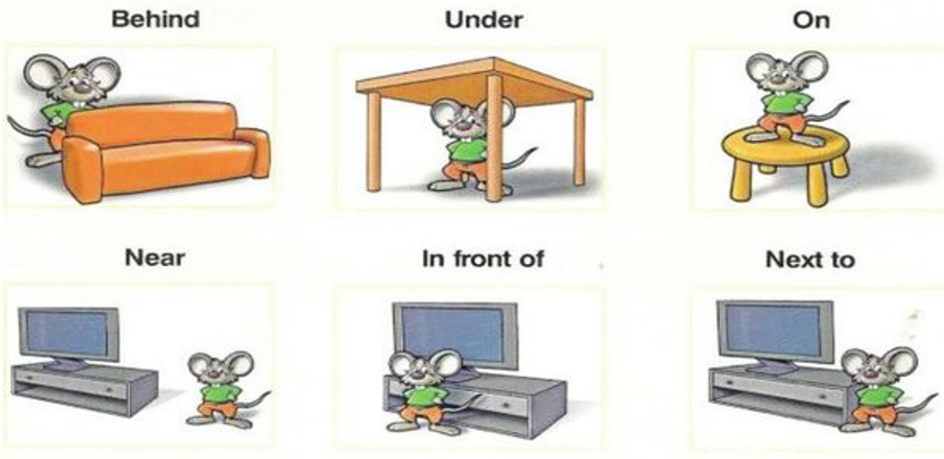  - Read sentences.  - Close books and notebooks, then work in pairs.  - Give answers.  Answers keys  1. sport center 2. soccer  3. water park 4. bowling alley  - Listen
B. New lesson (35’)
Activity 1: Presentation (10’)
a) Objective: Help Ss review Present Continuous tense (form, usage).
b) Content:
- Listen and repeat
- Review the form and usage of the Present Continuous.
- Review: Prepositions of place.
c) Expected outcomes: Ss remember the Present Continuous, prepositions of place and use them in some exercises that follow.
d) Organization of the activity:
TEACHER’S ACTIVITIES | STUDENTS’ ACTIVITIES
Task a. Listen and repeat  - Have Ss look at the picture (using DCR).  - Play audio (CD1 – Track 09) and have Ss listen and read the speech bubbles.  - Play the audio again and have Ss listen and repeat.  Grammar box  Option 1:  - Have Ss look at the grammar explanation (using DCR).  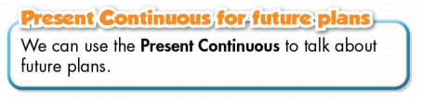  - Have Ss look at the box and read examples of different forms.  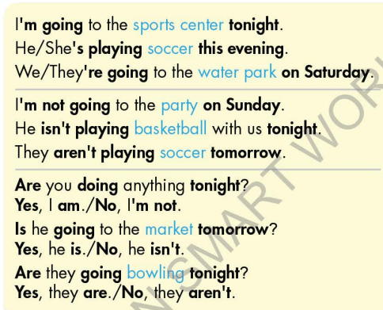  - Explain more about the form and the usage of the Present Simple, have Ss pay attention to the negative and the question form.  Form:  (+) S + am / is / are + V-ing …  (-) S + am / is / are + not + …  (?) Am / Is / Are + S + V-ing …  Usage: to talk about future plans.  - Have some Ss read aloud the sentences in the Grammar Box aloud.  - Ask Ss to give more examples using the Present Continuous.  - Have Ss look at the Prepositions of Place box, remind them that Prepositions of Place are used to talk about where something or someone is located.  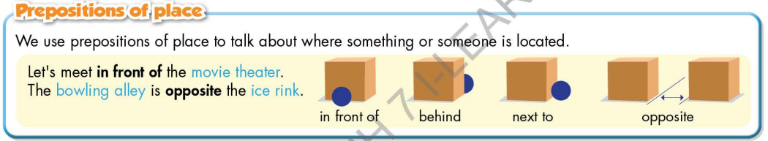  Option 2:  - Have Ss close books.  - Give some model sentences (T can use the sentences form the warm-up activity), ask Ss to indicate which tense is being used, then have Ss retell form of the Present Continuous.  *Suggested model sentences:  1. I am going to the sports center tonight.  2.She is playing soccer this evening.  3.They are going to the water park on Saturday.  4. I am going to the bowling alley tonight.  - Call Ss to give answers, comment on Ss’ answers.  - Ask Ss: What are these sentences about?  - Then have Ss open the books and read the grammar box.  - Have Ss give more examples of the Present Continuous, encourage them to make sentences with their own ideas.  - Give feedback and evaluation.  * Prepositions of Place: If T has used it in the warm-up activity, there’s no need to carry out this grammar part again. | - Look.  - Listen, then read.  - Listen and repeat.  - Look and read.  - Read.  - Listen and take notes.  - Read.  - Give examples.  - Close all books.  - Look and answer.  Expected answer: The sentences are about future plans.  - Read.  - Give examples.  - Listen.
Activity 2: Practice (19’)
a) Objective: Students can use the “Present Continuous for future plans” and “Prepositions of Place” to do the given exercises.
b) Content:
- Circling the correct words.
- Writing questions using the prompts in the next week’s plan, then answer them.
c) Expected outcomes: Students can get used to the use of the “Present Continuous for future plans”. and Prepositions of Place and use it correctly.
d) Organization of the activity:
TEACHER’S ACTIVITIES | STUDENTS’ ACTIVITIES
Task b. Circle the correct words.  - Use DCR to show the task.  - Demonstrate the activity, using the example.  - Have Ss read the sentences and circle the correct words.  - Have Ss work in pairs to check each other’s work.  - Have some Ss share their answers with the whole class.  - Give feedback, correct Ss’ answers if necessary  Task c. Look at the next week’s plan. Write questions using the prompts, then answer the questions.  - Use DCR to show the task.  - Demonstrate the activity, using the example.  - Have Ss write questions using the prompts, then answer the questions.  - Have Ss check answers with their partners.  - Call Ss to write answers.  - Check Ss’ answers, give feedback. | - Look and listen.  - Work individually.  - Work in pairs.  - Read answers.  Answer keys  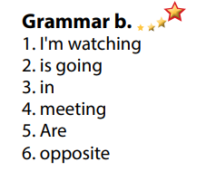  - Look and listen.  - Work individually.  - Work in pairs.  - Write answers.  Answer keys  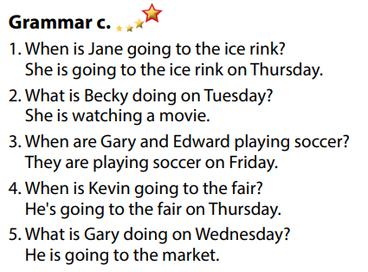
Activity 3: Production (6’)
a) Objective: Students master the grammar point they study in the lesson.
b) Content: Speaking: Making a plan to go out with your friend.
c) Expected outcomes: Ss produce the new language successfully, and they can apply the Present Continuous in speaking and writing.
d) Organization of the activity:
TEACHER’S ACTIVITIES | STUDENTS’ ACTIVITIES
Task d. In pairs: Make a plan to go out with your friend.  *Remind Ss some useful structures to make plan:  - How about / What about + V-ing  - Let’s + V _{B.I}  - Why don’t we / Shall we + V _{B.I}  - Divide class into pairs.  - Have Ss discuss their plan to go out.  - Have some pairs demonstrate the activity in front of the class.  - Give feedback and evaluation.  - For more practice, have Ss play grammar games with DHA. | -Listen and take notes.  - Have conversation in pairs.  - Present.  - Listen.
C. Consolidation and homework assignments (5’)
*Consolidation
- Present Continuous
Form:
(+) S + am / is / are + V-ing …
(-) S + am / is / are + not + …
(?) Am / Is / Are + S + V-ing …
Usage: to talk about future plans.
- Prepositions of place: in front of, behind, next to, opposite, on, under, .
*Homework:
- Make 2 sentences, use the Present Continuous to talk about your future plans.
- Make 2 sentences with prepositions of place.
- Do the exercises in WB: Grammar & Writing (page 5).
- Complete the grammar notes in Tiếng Anh 7 i-Learn Smart World Notebook (page 7).
- Play consolation games in Tiếng Anh 7 i-Learn Smart World DHA App on
- Prepare: Lesson 2 – Pronunciation and Speaking (page 9 – SB).
********************************************************************
Teaching date: 20/9/2022
Period 7 UNIT 1: FREE TIME
Lesson 2.3 – Pronunciation and Speaking (Page 9)

I. OBJECTIVES
By the end of the lesson, Ss will be able to:
1.1. Language knowledge and skills
- use intonation for Yes / No questions.
- ask and answer about future plan, using the Present Continuous and prepositions of places.
- discuss a plan to join in a free time activity.
- start a friendly conversation.
1.2. Competences
- improve listening and speaking skills.
1.3. Attributes
- make plans for themselves.
- be well-organized and disciplined.
II. TEACHING AIDS AND LEARNING MATERIALS
1. Teacher’s aids: Student book and Teacher’s book, class CDs, digital book (DCR phần mềm tương tác SB, DHA (từ vựng/ cấu trúc) phần mềm trò chơi tương tác), projector/interactive whiteboard / TV (if any), PowerPoint slides, handouts.
2. Students’ aids: Student’s book, workbook, notebook, handouts.
III. ASSESSMENT EVIDENCE
Performance Tasks | Performance Products | Assessment Tools
- Listen to the questions and notice how the intonation rises.  - Listen and cross out the sentence doesn’t follow the note: intonation for Yes / No questions rises.  - Read the questions with the rising intonation to a partner.  - Ask and answer about making plan, using the Present continuous and prepositions of place.  - Invite your friend to join you in a free time activity, discuss the plan and complete the table. | - Ss’ performance and answers.  - Ss’ answers.  - Ss’ performance.  - Ss’ performance.  - Ss’ performance /  Presentation. | - T’s observation.  - T’s feedback/Peers’ feedback.  - T’s feedback/Peers’ feedback.  - T’s feedback/Peers’ feedback.  - T’s observation, T’s feedback/Peers’ feedback.
IV. PROCEDURES
A. Warm up: (5’)
a) Objective: Introduce the new lesson and set the scene for Ss to acquire new language; get students' attention at the beginning of the class by enjoyable and short activities as well as to engage them in the follow-up steps.
b) Content: Review vocabulary about hobbies.
c) Expected outcomes: Ss remember old words and use them in other speaking activities.
d) Organization of the activity:
TEACHER’S ACTIVITIES | STUDENTS’ ACTIVITIES
- Give greetings.  - Check attendance.  Option 1:  - Give Ss a set of questions.  - Have Ss work in pairs to divide the questions given into 2 groups: Yes/No questions and Wh-questions.  - Call Ss to read answers.  - Give feedback and lead to the new lesson: intonation for Yes/No questions.  *Suggested questions  1.Can you talk now?  2. Are you going to the fair tonight?  3.Where should we meet?  4. Is she coming with us?  5. What are you doing tonight?  6. Do you like bowling?  Option 2: Rising or Falling?  - Let Ss play a game: T reads some questions with rising tone and falling tone.  - For each question with rising tone, Ss stand up. For each question with falling tone, Ss sit down.  - Ask 2 Ss to stand in front of the class to observe.  - Any Ss who do not follow the game rules will be sent out of the game.  - T may have the losers sing a song or do any fun activities in front of the class.  - Introduce the new lesson: intonation for Yes/No questions. | - Greet T.  - Work in pairs, divide the questions into 2 groups.  - Give answers.  Answer keys  * Yes/No questions  1.Can you talk now?  2. Are you going to the fair tonight?  4. Is she coming with us?  6. Do you like bowling?  * Wh-questions  3.Where should we meet?  5. What are you doing tonight?  - Listen.  - Take part in the class activity.
B. New lesson (35’)
Activity 1: Pre-Speaking: Pronunciation (10’)
a) Objective: Introduce intonation for Yes/No questions.
b) Content:
- recognize the intonation for Yes/No questions.
- listen and check, find mistakes.
- practice.
c) Expected outcomes: Ss distinguish and use intonation for Yes/No questions correctly in their speaking.
d) Organization of the activity:
TEACHER’S ACTIVITIES | STUDENTS’ ACTIVITIES
Task a + b. Listen to the question and notice how the intonation rises.  - Use DCR to show the task.  - Play the recording (CD1, track 10).  - Ask Ss to listen and notice how the intonation rises.  - Play the recording again, have Ss listen and repeat with a focus on the pronunciation feature.  Task c + d. Listen and cross out the sentence that doesn’t follow the sound feature, then read the questions with the rising intonation to a partner.  - Use DCR to show the task.  - Play the recording (CD 1 – Track 11), have Ss listen and cross out the option that doesn’t follow the sound feature in “a”.  - Call Ss to give answers.  - Play the recording again and check answers as a whole class.  - Then have Ss practice saying the examples with a partner, using the pronunciation feature.  - Call some Ss to read questions in front of the class.  - Ask Ss to make some more Yes/ No questions and practice reading them with rising tone. | - Listen.  - Listen again and repeat.  - Listen and cross out.  - Give answers.  - Listen again and check.  - Work in pairs.  - Present.  - Give answers.
Activity 2: While-speaking (19’)
a) Objective: Students can make plans.
b) Content:
- asking and answering about making plan for tonight, using the Present Continuous and Prepositions of place.
- inviting a friend to join a free time activity, discussing time and place to meet, then completing in the table.
c) Expected outcomes: Ss produce the new language successfully.
d) Organization of the activity:
TEACHER’S ACTIVITIES | STUDENTS’ ACTIVITIES
PRACTICE  Task a. Practice the conversation. Swap the roles and repeat.  - Use DCR to show the task.  - Demonstrate the activity by practicing the role-play with a student.  - Have pairs practice the conversation.  - Remind Ss to use the prepositions of place and the Present Continuous.  - Have Ss swap roles and repeat, using the ideas on the right.  - Have some pairs demonstrate the activity in front of the class.  - Give feedback and evaluation.  Task b. Practice with your own ideas.  - Have pairs practice the conversation with their own ideas, then swap roles.  - Remind Ss to use some words to start a friendly conversation.  - Call some pairs to demonstrate the activity in front of the class.  - Give feedback and evaluation.  SPEAKING: Let’s Go Out!  Task a. You’re inviting your friend to join you in a free time activity. Student B goes to page 118, file 1. Student A writes activities and places in the table, then invite student B. If he/she can come, discuss where and when to meet and complete the table.  - Use DCR to show the task.  - Demonstrate the activity by practicing role-play with a student.  - Have student A look at the schedule on the bottom of the page and student B turn to page 118, file 1.  - Ask Ss to fill in the table with their own ideas.  - Have Ss take turns to invite each other to complete the table.  - Observe, give help if necessary. | - Observe, listen.  - Work in pairs to practice the conversation.  - Swap roles and continue the task.  - Present.  - Work in pairs to practice the conversation, then swap roles.  - Present.  - Observe and listen.  - Work in pairs to make plan.
Activity 3: Production (6’)
a) Objective: Students can make plans.
b) Content: Asking your partner what they arranged to do with their friend, when and where they will meet them.
c) Expected outcomes: Ss produce the new language successfully in everyday speaking and writing.
d) Organization of the activity:
TEACHER’S ACTIVITIES | STUDENTS’ ACTIVITIES
SPEAKING: Let’s Go Out!  Task b. Make a new pair. Ask your partner what they arranged to do with their friend, when and where they will meet them.  - Pair each student with a new partner.  - Have Ss ask their partners about what they arranged to do with their friends, where they arranged to meet, and at what time.  - Have some Ss share their answers with the class  - Give feedback and evaluation. | - Make a new pair.  - Work with new partner.  - Give answers.

C. Consolidation and homework assignments (5’)
* Consolidation:
- Intonation for Yes / No questions: rising.
*Homework:
- Make 2 Yes / No questions, then practice reading them.
- Complete the table for those who haven’t finished it in class.
- Prepare: Lesson 3 – Listening and Reading (page 10– SB).
- Review the vocabulary and grammar notes in Tiếng Anh 7 i-Learn Smart World Notebook
(pages 6 & 7).
- Play consolation games in Tiếng Anh 7 i-Learn Smart World DHA App on
********************************************************************
Teaching date: 21/9/2022
UNIT 1: FREE TIME
Lesson 3.1 - Listening and Reading (Page 10)
I. OBJECTIVES
By the end of the lesson, Ss will be able to:
1.1. Language knowledge and skills
- talk about extreme sports.
- practice listening and understanding general and specific information about extreme sports.
- read an invitation email for gist and detail.
1.2. Competences
- improve communication, collaboration, analytical and critical thinking skills.
1.3. Attributes
- take up a sport and practice it regularly.
- be careful when trying extreme sports.
II. TEACHING AIDS AND LEARNING MATERIALS
1. Teacher’s aids: Student book and Teacher’s book, class CDs, Digital Book (DCR phần mềm tương tác SB, DHA (từ vựng/ cấu trúc) phần mềm trò chơi tương tác), projector/interactive whiteboard / TV (if any), PowerPoint slides.
2. Students’ aids: Student’s book, workbook, notebook.
III. ASSESSMENT EVIDENCE
Performance Tasks | Performance Products | Assessment Tools
- Activate the extreme sports that Ss may know.  - Match the extreme sports to the pictures. Name 3 other extreme sports.  - Listen to a talk about extreme sports. How does the speaker feel about them?  - Listen again and circle.  - Read Mark’s email. What is the email about?  -Read again and answer the questions.  -Speaking: Which extreme sports would you like to try? Why? | - Ss’ answers.  - Ss’ answers.  - Ss’ answers.  - Ss’ answers.  - Ss’ answers.  - Ss’ answers / presentation.  - Ss’ answers / presentation. | - T’s feedback.  - T’s feedback.  - T’s feedback/Peers’ feedback.  - T’s feedback/Peers’ feedback.  - T’s observation/ DCR and T’s feedback.  - T’s observation/ DCR and T’s feedback.
IV. PROCEDURES
A. Warm up: (5’)
a) Objective: Introduce the new lesson and set the scene for Ss to acquire new language; get students' attention at the beginning of the class by giving enjoyable and short activities as well as to engage them in the follow-up steps.
b) Content: Name of some extreme sports.
c) Expected outcomes: Ss have general ideas about extreme sports, which they are going to listen and read in the new lesson.
d) Organization of the activity:
TEACHER’S ACTIVITIES | STUDENTS’ ACTIVITIES
Option 1: Let’s talk!  - Use the “Let’s talk!” part in the textbook– page 10 for warm-up activity.  - Show pictures and words (using DCR), have Ss match the name of extreme sports to the pictures (in pairs).  - Call Ss to give answers.  - Give feedback and show correct answers.  - Have Ss discuss the questions.  - Elicit answers from some students.  - Lead to the new lesson.  Option 2:  - Have Ss watch a clip about extreme sports: Best of Extreme Sports Compilation 2019.  - Link: https://www.youtube.com/watch?v=wsg8k-2HYXA  - Ask Ss whether they know any names of the sports in the clip.    - Lead to the new lesson: Extreme sports. | - Work in pairs to match the name of extreme sports to the pictures.  - Give answers.  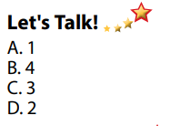  Answer keys  - Discuss the questions, then give answers.  Suggested some other extreme sports: waterskiing, scuba diving, bungee jumping, parasailing, ice climbing, slacklining,…  - Listen  - Watch and try to give names of some extreme sports in the clip.  - Listen.

B. New lesson (35’)
Activity 1: Pre-Listening (Vocabulary) (5’)
a) Objective: Ss know names of some extreme sports.
b) Content:
- Vocabulary study (skateboarding, surfing, rock climbing, zorbing, …)
- Speaking: Would you like to try any of the extreme sports in the pictures? Name 3 others extreme sports.
c) Expected outcomes: Ss know how to pronounce the new words correctly, understand the meaning and have good preparation for the listening part.
d) Organization of the activity:
TEACHER’S ACTIVITIES | STUDENTS’ ACTIVITIES
Let’s Talk!: Match the name of extreme sports to the pictures. Would you like to try any of them? Can you name three other extreme sports?  Option 1 (If the teacher hasn’t used this part for the Warm-up activity.)  - Use DCR to show the task.  - Have Ss match the name of extreme sports to the pictures (in pairs).  - Call Ss to give answers.  - Give feedback and show correct answers.  - Have Ss discuss the questions.  - Elicit answers from some students.  Option 2: Matching (If the teacher has used the Let’s Talk! part for the Warm-up activity)  - T reads names of some extreme sports that Ss have learnt as a model.  - Have Ss practice reading the names of some extreme sports again.  - Call some Ss to read again.  - Correct Ss’ pronunciation if necessary. | - Work in pairs to do the matching activity.  - Give answers.  Answer keys  - Discuss in pairs, then give answers.  - Listen.  - Listen.  - Practice reading the names of some extreme sports again.  - Read.
Activity 2: While - Listening (10’)
a) Objective: Students can develop their listening skill.
b) Content: Listening to a talk about extreme sports.
c) Expected outcomes: Students can practice listening and understanding general + specific information about extreme sports.
d) Organization of the activity:
TEACHER’S ACTIVITIES | STUDENTS’ ACTIVITIES
Task a. Listen to a talk about extreme sports. How does the speaker feel about them?  - Use DCR to show the task.  - Have Ss read the questions and guess the answers.  - Play audio (CD1 - Track 12).  - Have Ss listen and choose the correct answers.  - Call Ss to give answer, explain.  - Check answers as a whole class using DCR.  Task b. Now, listen and circle.  - Use DCR to show the task.  - Have Ss read the sentences first.  - Play the audio again (CD1 - Track 12).  - Have Ss listen and circle the correct answers.  - Have Ss check answers with their partners.  - Call Ss to give answers, explain.  - Check answers as a whole class using DCR. | - Read.  - Listen and choose the correct answers.  Answer keys  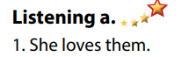  - Read.  - Listen and circle the correct answers.  - Exchange answers.  - Give answers.  Answer keys  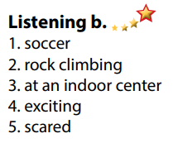
Activity 3: Reading (20’)
a) Objective: Students can develop their reading skill.
b) Content: Reading an invitation email, choosing the main idea of the email, then answering comprehension questions.
c) Expected outcomes: Students can read an invitation email for gist and detail, and they can talk about the extreme sport they would like to try.
d) Organization of the activity:
TEACHER’S ACTIVITIES | STUDENTS’ ACTIVITIES
Task a. Read Mark’s email quickly. What is the email about?  - Use DCR to show the task.  - Have Ss read the question and guess the answer.  - Ask Ss to read the email quickly and circle the correct answer.  - Call 1 S to give answer.  - Check answers as a whole class using DCR.  Task b. Now, read and answer the questions.  - Use DCR to show the task.  - Have Ss read the questions and underline the key words.  - Have Ss read the email again and answer the questions.  - Have Ss check their answers with a partner.  - Call Ss to give answers (read or write on the board).  - Check answers as a whole class using DCR.  Task c. Speaking: In pairs: Which extreme sport would you like to try? Why?  - Have Ss discuss the questions in pairs.  - Call Ss some s to share their answers with the whole class.  - Give feedback and evaluation. | - Read and guess.  - Scan the email for general idea.  - Give answer.  Answer keys  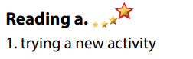  - Read and underline the key words.  - Read the email again for detail.  - Exchange answers.  - Give answers.  Answer keys  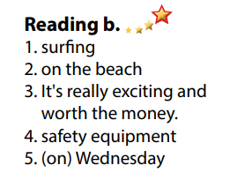  - Discuss in pairs.  - Present.
C. Consolidation and homework assignments (5’)
*Consolidation:
- Vocabularies: Name of some extreme sports: skateboarding, surfing, rock climbing, zorbing, waterskiing, scuba diving, bungee jumping, parasailing, ice climbing, slacklining …
*Homework
- Learn by heart the new vocabularies.
- Practice talking about the extreme sport you like.
- Do the exercises in WB: Lesson 3 – Listening and Reading (page 6).
- Do the vocabulary exercise in Tiếng Anh 7 i-Learn Smart World Notebook (page 8).
- Play consolation games in Tiếng Anh 7 i-Learn Smart World DHA App on www.eduhome.com.vn
- Prepare: Lesson 3 – Writing (page 11 – SB).
****************************************************************
Teaching date: 23/9/2022
Period 9 UNIT 1: FREE TIME
Lesson 3.2 – Speaking and Writing (Page 11)
I. OBJECTIVES
By the end of the lesson, Ss will be able to:
1.1. Language knowledge and skills
- use some adjectives to talk about extreme sports (exciting, dangerous, fascinating, challenging, adventurous).
- invite a friend to join an activity.
- write an invitation email to ask a friend to join an activity.
1.2. Competences
- improve communication, collaboration, writing and critical thinking skills.
1.3. Attributes
- take up a sport and practice it regularly.
- be careful when trying extreme sports.
II. TEACHING AIDS AND LEARNING MATERIALS
1. Teacher’s aids: Student book and Teacher’s book, class CDs, Digital Book (DCR phần mềm tương tác SB, DHA (từ vựng/ cấu trúc) phần mềm trò chơi tương tác), projector/interactive whiteboard / TV (if any), PowerPoint slides.
2. Students’ aids: Student’s book, workbook, notebook.
III. ASSESSMENT EVIDENCE
Performance Tasks | Performance Products | Assessment Tools
- Speaking: Discuss what you think the activities in the pictures are like.  - Choose one of the extreme sports or choose your own activity. Then, take turns asking and answering the questions below.  - Writing: Read about writing invitation emails and number the parts.  - Reorder the parts of the email. Use the skill box.  - Write an invitation email to ask a friend to join you for an activity. | - Ss’ answers.  - Ss’ performance.  - Ss’ answers.  - Ss’ answers.  - Ss’ answers/ presentation. | - T’s feedback.  - T’s observation/ DCR.  - T’s observation.  - T’s feedback/Peers’ feedback.  - T’s feedback/Peers’ feedback.  - T’s observation and feedback.
IV. PROCEDURES
A. Warm up: (5’)
a) Objective: Introduce the new lesson and set the scene for Ss to acquire new language; get students' attention at the beginning of the class by enjoyable and short activities as well as to engage them in the follow-up steps.
b) Content: Review names of some extreme sports.
c) Expected outcomes: Ss remember names of some extreme sports that they are going to talk about in the lesson.
d) Organization of the activity:
TEACHER’S ACTIVITIES | STUDENTS’ ACTIVITIES
Option 1: Jigsaw puzzle  - Divide class into groups.  - Give each group a set of many pieces of paper, have them use these pieces to make a right picture about an extreme sport, then give the name of the extreme sport.  - The group which has a correct picture and give the right name of that extreme sport in the shortest time will be the winner.  - Give a small present to the winner and the runner-up.  - Ask Ss extra question: What do you think about this extreme sport?  - Have Ss give answers.  - Give feedback and evaluation.  - Lead to the new lesson.  (T can use same activity for the picture: windsurfing.)    Option 2:  - Give Ss icons of some extreme sports.  - Have Ss give the right name of each icon.  - Call Ss to give answers.  - Give feedback.  àLead to the new lesson.   | - Take part the games in groups.  - Give answers.  - Listen.  Answer keys    Name of the extreme sport: mountain biking  - Work in pairs.  - Look and give answers  - Listen.  Answer keys  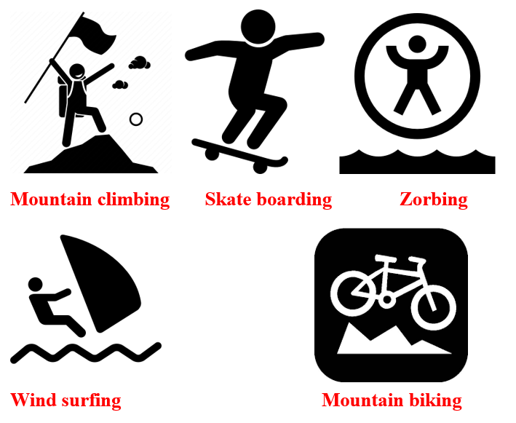
B. New lesson (35’)
Activity 1: Pre-Writing (Speaking) (10’)
a) Objective: Ss prepare for what they are going to write about.
b) Content:
- Speaking: Discuss what you think the activities in the pictures are like.
- Asking and answering the questions about planning for joining an extreme sport activity.
c) Expected outcomes: Ss can use some adjectives to talk about extreme sports and they can apply the language from speaking to their writing.
d) Organization of the activity:

TEACHER’S ACTIVITIES | STUDENTS’ ACTIVITIES
Task a. Look at the pictures in the lesson. Discuss what you think the activities are like.  - Have Ss observe the pictures (using DCR), then work in pairs to discuss what they think the activities are like.  - Remind Ss to use more adjectives to describe (exciting, dangerous, fascinating, challenging, adventurous)  - Have some Ss share their ideas with the class.  - Give feedback and evaluation.  Task b. Choose one of the extreme sports or choose your own activity. Then, take turns asking and answering the questions below and note your ideas.  - Have Ss choose an extreme sport (from the pictures in the books or their own).  - Have Ss take turns asking and answering the questions, then note their ideas in the table.  - Have some pairs share their ideas with the class  - Give feedback and evaluation. | - Look and discuss.  - Give answers.  - Work in pairs: Choose an extreme sport, asking and answering the questions, then note discussed ideas in the table.  - Present.
Activity 2: While - Writing (20’)
a) Objective: Students can develop their writing skill.
b) Content:
- Numbering the parts of an invitation email.
- Reordering the parts of an invitation email.
- Writing an invitation email to ask a friend to join you for an activity.
c) Expected outcomes: Students can write an invitation email, using the Present Continuous, prepositions of place and structures of suggestion.
d) Organization of the activity:
TEACHER’S ACTIVITIES | STUDENTS’ ACTIVITIES
Task a. Read about writing invitation emails. Then, read Mark’s email again and number the parts.  - Briefly explain the Writing skill box (using DCR).  - Have Ss read the Writing skill box and Mark’s email again (page 10), then number the pars of his email.  - Have Ss check their answers with a partner.  - Call Ss to give answers.  - Check answer as a whole class.  Task b. Reorder the parts of the email. Use the skill box to help you.  - Use DCR to show the task.  - Have Ss read the email and reorder the parts.  - Have Ss check their answers with a partner.  - Call Ss to give answers.  - Check answer as a whole class.  *Let’s Write: Now, write an invitation email to ask a friend to join you for an activity. Use the feedback form to help you.  - Draw Ss’ attention to the feedback form (using DCR).  - Have Ss use their notes in speaking part and the form of the invitation email to write an invitation email to ask a friend to join them for an activity.  - Have some Ss write their emails in front of the class. | - Listen.  -Work in pairs.  - Exchange their answers with a partner.  - Give answers.  Answer keys  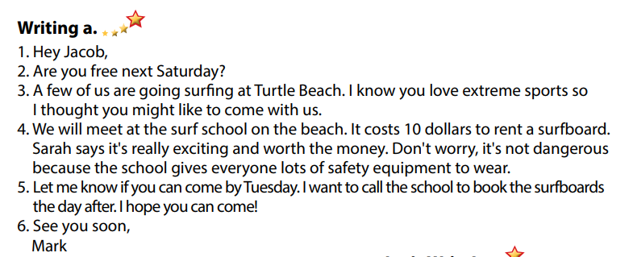  - Read and reorder the parts.  - Exchange answers.  - Give answers.  Answer keys  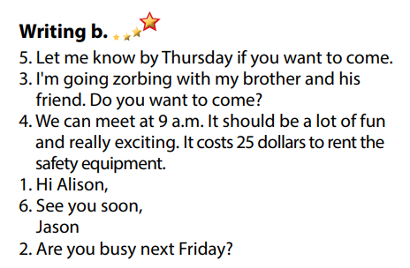  - Look and listen.  - Do the writing part.  -Write.  Sample answer  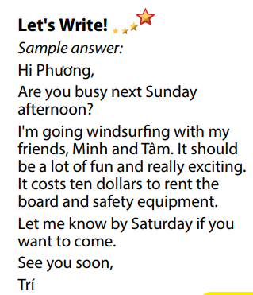
Activity 3: Post - Writing (5’)
a) Objective: Help Ss realize their mistakes in writing and correct them.
b) Content: Correcting Ss’ writings.
c) Expected outcomes: Students know whether their emails follow the model and uses the correct structures, whether their writings are interesting and understandable or not.
d) Organization of the activity:
TEACHER’S ACTIVITIES | STUDENTS’ ACTIVITIES
Conversation skill  - Give feedback, correct Ss’ mistakes.  - Use the feedback form to give evaluation. Focus on:  + the format, the structures.  + the understandability.  + the coherence and cohesion. | - Look, listen and correct mistakes.
C. Consolidation and homework assignments (5’)
* Consolidation:
- Adjectives to describe extreme sports: exciting, dangerous, fascinating, challenging, adventurous, …
- Format of an invitation email:
1. Start with a greeting
2. Check their availability
3. Write the invitation
4. Give more details
5. Ask for a reply
6. Sign off
*Homework
- Remember how to write an invitation letter.
- Finish the writing part.
- Do the exercises in WB: Writing (page 7).
- Complete the grammar notes in Tiếng Anh 7 i-Learn Smart World Notebook (page 9).
- Play consolation games in Tiếng Anh 7 i-Learn Smart World DHA App on www.eduhome.com.vn
- Prepare: Unit 1 – Review (page 84).
Teaching date: 27/9/2022
Period 10 UNIT 1: FREE TIME
Lesson 4 – Review (Page 84)
I. OBJECTIVES
By the end of the lesson, Ss will be able to:
1.1. Language knowledge and skills
- review words about free time activities (play badminton, bake cakes, make vlogs, play online games, play volleyball, take photos, build models).
- review words about places of entertainment (sports center, ice rink, market, fair, water park).
- review grammar: prepositions of place, the Present Continuous.
- pronoun some sounds correctly: /ɒ/, /ɪ/, /aɪ/, / eɪ/.
1.2. Competences
- improve speaking, listening, reading and writing skills.
- improve the use of English.
1.3. Attributes
- have positive attitude in English language learning so that they actively participate in all classroom activities.
- review the old lesson and have good preparation for any assessment.
II. TEACHING AIDS AND LEARNING MATERIALS
1. Teacher’s aids: Student book and Teacher’s book, class CDs, Digital Book (DCR phần mềm tương tác SB, DHA (từ vựng/ cấu trúc) phần mềm trò chơi tương tác), projector/interactive whiteboard / TV (if any), PowerPoint slides, handouts.
2. Students’ aids: Student’s book, workbook, notebook.
III. ASSESSMENT EVIDENCE
Performance Tasks | Performance Products | Assessment Tools
- Listening: Listen to John talking to his mom about his friend’s free time activities. Which activity does each person do? For each question, write letter A-H next to each person.  - Reading: Read about 3 people and choose the correct answer.  - Vocabulary: Fill in the blanks with the words from the box.  - Grammar: Unscramble the sentences + Circle the correct words.  - Pronunciation: sound and stress. | - Ss’ answers.  - Ss’ answers.  - Ss’ answers.  - Ss’ answers.  - Ss’ answers/ presentation. | - T’s feedback/Peers’ feedback.  - T’s feedback/Peers’ feedback.  - T’s feedback/Peers’ feedback.  - T’s feedback/Peers’ feedback.  - T’s observation, T’s feedback/Peers’ feedback.
IV. PROCEDURES
A. Warm up: (5’)
a) Objective: Introduce the new lesson and set the scene for Ss to acquire new language; get students' attention at the beginning of the class by enjoyable and short activities as well as to engage them in the steps that followed.
b) Content: Reviewing vocabulary.
c) Expected outcomes: Ss are ready for the new lesson.
d) Organization of the activity:
TEACHER’S ACTIVITIES | STUDENTS’ ACTIVITIES
Option 1: Word Dictation  - Choose 7 words from Vocabulary tasks (pages 4 to 11), find mp3 sound.  - Play the mp3 sound of each word (or T reads the words out loud), have Ss listen and write the word down on the board.  - Check and correct Ss’ answers.  - Give feedback.  - Lead to the new lesson.  Option 2: Game: LEAVE ME OUT  - Give Ss some words with wrong spelling (There is 1 extra letter in each word).  - Have Ss find the extra letter to leave it out to make a right English word.  - Have Ss read their answers.  - Give feedback.  - Lead to the new lesson.  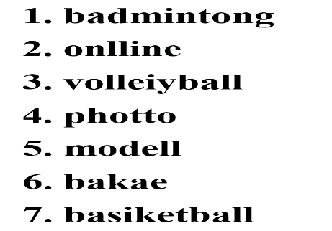 | - Listen and write the words you can hear.  Answer Keys  1. badminton  2. online  3. volleyball  4. photo  5. model  6. bake  7. basketball  - Take part in the class activity.  - Give answers.  Answers keys  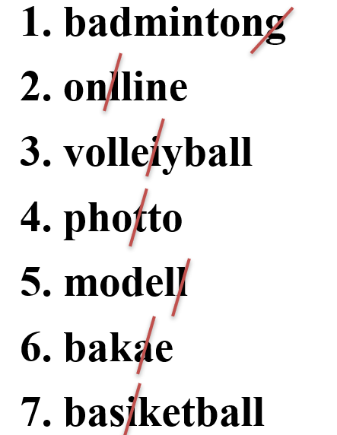
B. New lesson (35’)
Activity 1: Listening (7’)
a) Objective: Help Ss improve their listening skill.
b) Content:
- Listening and writing letter A-H next to each person.
c) Expected outcomes: Ss listen in details and get familiar with the listening test format.
d) Organization of the activity:
TEACHER’S ACTIVITIES | STUDENTS’ ACTIVITIES
You will hear John talking to his mom about his friends’ free time activities. Which activity does each person do? For each question, write a letter (A-H) next to each person.  - Use DCR to show the task.  - Have Ss read through the listening part.  - Demonstrate the activity by using the example.  - Play the audio (CD 2 – Track 34).  - Have Ss check answers with pairs and then give answers.  - Check answers as a whole class. | - Read in silence.  - Listen and then give answers.  Answer keys  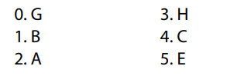
Activity 2: Reading (7’)
a) Objective: Students can improve their reading skill.
b) Content:
- Reading a text and choose the correct answer.
c) Expected outcomes: Ss read for comprehension and get familiar with the reading test format.
d) Organization of the activity:
TEACHER’S ACTIVITIES | STUDENTS’ ACTIVITIES
Read about three people. Choose the correct answer (A, B or C).  - Use DCR to show the task.  - Demonstrate the activity by using the example.  - Have Ss read the text about three people and choose the correct answer.  - Call Ss to give answers, explain.  - Give feedback and evaluation. | - Observe and listen.  - Work individually.  - Give answers, explain.  Answer keys 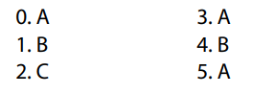
Activity 3: Vocabulary (7’)
a) Objective: Ss can review vocabulary about places of entertainment.
b) Content: Filling in the blanks with the correct words from the box.
c) Expected outcomes: Ss produce the new language successfully, and they can use these words in speaking and writing.
d) Organization of the activity:
TEACHER’S ACTIVITIES | STUDENTS’ ACTIVITIES
Fill in the blanks with the words from the box  - Use DCR to show the task.  - Have Ss read the sentences.  - Ask Ss to work in pairs to fill in the blanks with the words from the box.  - Have Ss give answers, tell the meaning of the words again.  - Check answers as a whole class. | - Read the sentences.  - Work in pairs.  - Give answers.  Answer keys  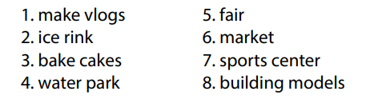
Activity 4: Grammar (10’)
a) Objective: Ss can review the use of English: The Present Continuous and prepositions of place.
b) Content:
- Unscrambling the sentences.
- Circling the correct words (using the map).
c) Expected outcomes: Ss produce the new language successfully, and they can use the grammar points in speaking and writing.
d) Organization of the activity:
TEACHER’S ACTIVITIES | STUDENTS’ ACTIVITIES
Task a. Unscramble the sentences.  - Use DCR to show the task.  - Have Ss read the sentences and unscramble the words to make a meaningful sentence.  - Ask Ss to work in pairs to check each other’s work.  - Have Ss write answers on the board.  - Check Ss’ answers, give feedback.  Task b. Look at the map and circle the correct words.  - Use DCR to show the task.  - Ask Ss to work individually to circle the correct answer.  - Have Ss work in pairs to check each other’s work.  - Call Ss to give answers, explain for their choice.  - Check answers as a whole class. | - Do the task.  - Exchange answers.  - Write answers on the board.  Answer keys  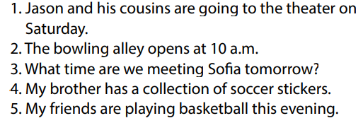  - Work individually.  - Work in pairs.  - Give answers.  Answer keys  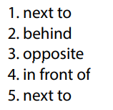
Activity 5: Pronunciation (4’)
a) Objective: Ss can review the word stress and vowels.
b) Content:
- Circling the word that has the underlined part pronounces differently from the others.
- Circling the word that has different stress from the rest.
c) Expected outcomes: Ss produce the new language successfully.
d) Organization of the activity:
TEACHER’S ACTIVITIES | STUDENTS’ ACTIVITIES
Task a. Circle the word that has the underlined part pronounced differently from the others.  - Use DCR to show the task.  - Have Ss distinguish the sound /i/ and / ai/, /ɒ/ and /eɪ/.  - Ask Ss to work individually to circle the answer.  - Have Ss work in pairs to check each other’s work.  - Call Ss to give answers, pronounce the words again.  - Give feedback, correct Ss’ pronunciation if necessary.  Task b. Circle the word that differs from the other three in the position of primary stress in each of the following questions.  - Use DCR to show the task.  - Remind Ss some basic rules of putting stress on words with 2 or 3 syllables.  - Ask Ss to work individually.  - Have Ss work in pairs to check each other’s work.  - Call Ss to give answers, pronounce the words again.  - Give feedback, correct Ss’ pronunciation if necessary. | - Listen.  - Work individually.  - Work in pairs.  - Give answers.  Answer keys  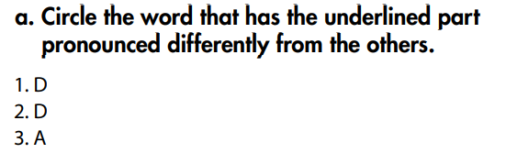  - Listen.  - Work individually.  - Work in pairs.  - Give answers.  Answer keys  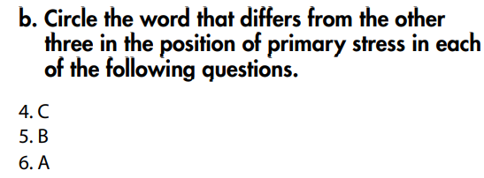
C. Consolidation and homework assignments (5’)
*Consolidation:
*Grammar of Unit 1: The Present Continuous and prepositions of place.
*Vocabulary of Unit 1: Vocabulary about free time activities and places of entertainment.
*Homework:
- Review vocabulary, grammar of unit 1.
- Do the exercises in WB: Review of Unit 1 (page 62).
- Prepare: Unit 2 – New words and Reading (page 12 – SB).
****************************************************************
Teaching date: 28/9/2022

Period 11 UNIT 2: HEALTH
Lesson 1.1 - Vocabulary and Reading (Page 12)
I. OBJECTIVES
By the end of the lesson, Ss will be able to:
1.1. Language knowledge and skills
- talk about a healthy and unhealthy lifestyle, using phrases: get some sleep, eat fruits and vegetables, eat fast food, drink soda, healthy, unhealthy.
- practice reading and understanding general and specific information about Toby and Lisa’s healthy living class survey.
- use indefinite quantifiers.
1.2. Competences
- improve communication, collaboration, analytical and critical thinking skills.
1.3. Attributes
- lead a healthy lifestyle and ditch bad ones.
II. TEACHING AIDS AND LEARNING MATERIALS
1. Teacher’s aids: Student book and Teacher’s book, class CDs, Digital Book (DCR phần mềm tương tác SB, DHA (từ vựng/ cấu trúc) phần mềm trò chơi tương tác), projector/interactive whiteboard / TV (if any), PowerPoint slides.
2. Students’ aids: Student’s book, workbook, notebook.
III. ASSESSMENT EVIDENCE
Performance Tasks | Performance Products | Assessment Tools
- Introduce some verb phrases and adjectives about life style.  - Match the words with the pictures in a.  - Listen and repeat.  - Discuss which things are healthy and unhealthy.  - Read Toby and Lisa’s class report and circle the correct answer.  - Read the questions and circle the correct answers. | - Ss’ answers in notebooks.  - Ss’ answers.  - Ss’ answers/ presentation.  - Ss’ answers.  - Ss’ answers. | - T’s feedback.  - T’s observation/ DCR.  - T’s observation.  - T’s feedback/Peers’ feedback.  - T’s feedback/Peers’ feedback.
IV. PROCEDURES
A. Warm up: (5’)
a) Objective: Introduce the new lesson and set the scene for Ss to acquire new language; get students' attention at the beginning of the class by enjoyable and short activities as well as to engage them in the follow-up steps.
b) Content: Introducing some verb phrases and adjectives about life style.
c) Expected outcomes: Ss have general ideas about the topic of the new lesson: “health”.
d) Organization of the activity:
TEACHER’S ACTIVITIES | STUDENTS’ ACTIVITIES
Option 1: Matching  - Use the “New words” part a.– page 12 for the warm-up activity.  - Show pictures and words (using DCR), have Ss match the words and phrases with the pictures (in pairs).  - Call Ss to give answers.  - Give feedback and show correct answers (using DCR).  - Lead to the new lesson.  - Play the audio (CD1 – Track 13), have Ss listen and repeat.  - Correct Ss’ pronunciation if necessary.  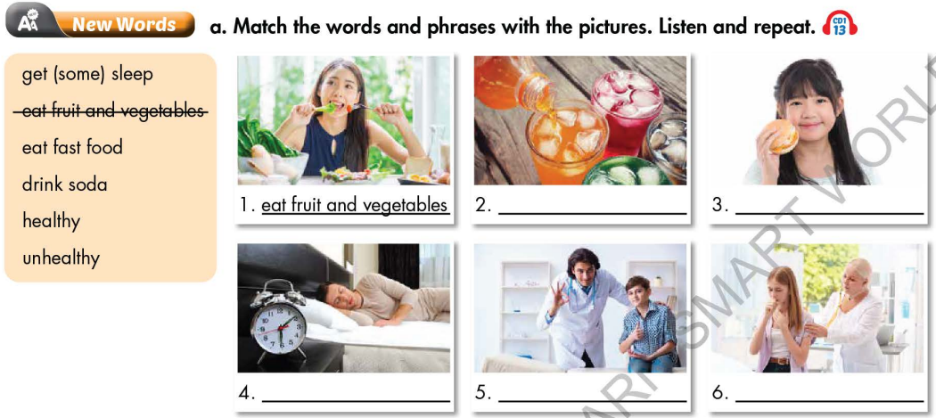  Option 2: Game: CROSSWORD  - Explain the rules of the game.  - Design the game “Crossword Puzzle” with words and pictures about food and drink.  - Let Ss play the game, encourage Ss to guess the key word.  - If any S can give the correct key word, T hasn’t confirmed yet, the game will be continued until the keyword is opened (to check whether his/her answer is correct or not and to let other Ss take part in the game eagerly).  - Give a small gift to the Ss who is the fastest to give the correct key word.  - Ask Ss an extra question: Which food / drink is good / not good for your health?  - Give feedback and lead to the new lesson. | - Work in pairs to match the words and phrases with the pictures.  - Give answers.  - Listen.  Answer keys  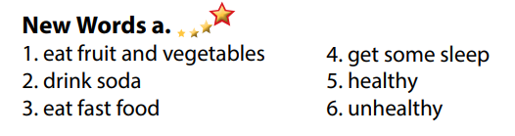  - Listen.  - Take part in the game by answering the questions in horizontal line (not in order) and try to guess keyword in the vertical column.  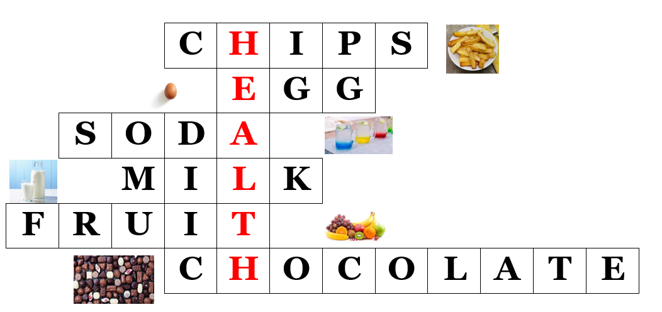  Keyword: HEALTH
B. New lesson (35’)
Activity 1: Pre-Reading (Vocabulary) (12’)
a) Objective: Ss know some verb phrases about life style.
b) Content:
- Vocabulary study (get some sleep, eat fruits and vegetables, eat fast food, drink soda, healthy, unhealthy).
- Speaking: Discuss which things are healthy and unhealthy.
c) Expected outcomes: Ss know how to pronounce the new words correctly and use them in appropriate situations.
d) Organization of the activity:

TEACHER’S ACTIVITIES | STUDENTS’ ACTIVITIES
Task a. Match the words and phrases with the pictures. Listen and repeat.  Option 1 (If the teacher hasn’t used this part for the Warm-up activity)  - Demonstrate the activity, using the example (using DCR).  - Have Ss match the words and phrases with the pictures.  - Divide class into pairs and have them check their answers with their partners.  - Call Ss to give answers (read or write).  - Check answers as a whole class (using DCR).  - Play audio (CD1 – Track 13). Have Ss listen and repeat.  - Correct Ss’ pronunciation.  Option 2: Matching (If the teacher has used part a. for the Warm-up activity)  - Have Ss review the words they have known in the warm-up activity by looking at the pictures and filling in the blanks, (T uses different pictures from those in the textbook).  - Call Ss to give answers (read or write).  - Check answers as a whole class.  - Call some Ss to read the words again.  - Correct Ss’ pronunciation if necessary.  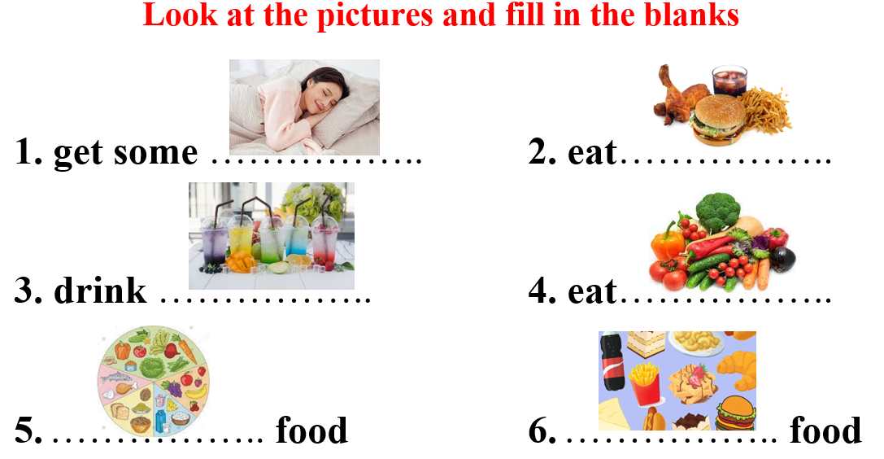  Task b. Discuss which things are healthy and unhealthy.  - Have Ss discuss in pairs which things are healthy and unhealthy.  - Have Ss share their ideas in front of the class.  - Give feedback and evaluation.  - Have Ss give more activities related to lifestyle which are divided into 2 groups: healthy and unhealthy.  - Give feedback and evaluation. | - Look and listen.  - Work individually.  - Work in pairs.  - Give answers.  - Listen and repeat.  Answer keys  - Work in pairs.  - Give answers.  - Read.  Answer keys  1. get some sleep  2. eat fast food  3. drink soda  4. eat vegetables  5. healthy food  6. unhealthy food  - Work in pairs.  - Present.  Suggested answers  Healthy: get some sleep, east fruit and vegetables  Unhealthy: eat fast food, drink soda
Activity 2: While - Reading (17’)
a) Objective: Students can develop their reading skill.
b) Content: Reading Toby and Lisa’s class report and choosing the correct answer, then reading Toby and Lisa’s Healthy Living Class Survey and circling the correct answer.
c) Expected outcomes: Students can read and understand general and specific information about a healthy living class survey.
d) Organization of the activity:
TEACHER’S ACTIVITIES | STUDENTS’ ACTIVITIES
Task a. Read Toby and Lisa’s class report and circle the correct answer  - Use DCR to show the task. Ask Ss to read two options and find out key words.  - Have Ss read the class report individually.  - Have Ss circle the correct answers.  - Have some Ss share their answers with the class (read), explain for their answers.  - Give feedback.  - Give feedback and correct Ss’ answers if necessary.  Task b. Now, read and circle the correct answers.  - Use DCR to show the task. Have Ss read the questions, underline key words and guess the answers.  - Have Ss read the text again and circle the correct answers – underline or highlight the supporting ideas.  - Have Ss check answers with their partners.  - Call Ss to give answers, explain.  - Give feedback and evaluation. | - Work individually.  - Circle the correct answers.  - Read answers, explain.  - Check answers.  Answer keys  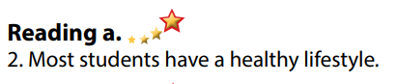  - Read and underline.  - Do the task.  - Check answers.  Answer keys  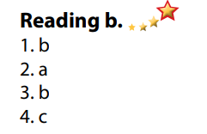
Activity 3: Post - Reading (6’)
a) Objective: Students can use the vocabulary and ideas from the reading text to develop their speaking skill.
b) Content: Speaking: Do you have a healthy lifestyle? Why / Why not?
c) Expected outcomes: Students can talk about their own lifestyle and try to lead a healthy lifestyle.
d) Organization of the activity:
TEACHER’S ACTIVITIES | STUDENTS’ ACTIVITIES
Task c. In pairs: Do you have a healthy lifestyle? Why / Why not?  - Have Students work in pairs to talk about their lifestyle and decide whether it is healthy or not.  - Call some Ss to share their ideas with the whole class.  - Give feedback and evaluation.  - For more practice, have Ss play a game with DHA. | - Discuss in pairs.  - Listen.
C. Consolidation and homework assignments (5’)
*Consolidation:
- Verb phrases about lifestyle: get some sleep, eat fruits and vegetables, eat fast food, drink soda.
- Adjectives: healthy and unhealthy.
* Homework:
- Learn the new words by heart.
- Practice talking about lifestyle.
- Do the exercises in WB: Unit 2 - Lesson 1 - New words + Reading (pages 8,9).
- Do the vocabulary exercise in Tiếng Anh 7 i-Learn Smart World Notebook (page 10).
- Play consolation games in Tiếng Anh 7 i-Learn Smart World DHA App on www.eduhome.com.vn
- Prepare: Lesson 1.2 – Grammar (page 13 – SB)
Teaching date: 30/9/2022
Period 12 UNIT 2: HEALTH
Lesson 1.2 - Grammar (Page 13)
I. OBJECTIVES
By the end of the lesson, Ss will be able to:
1.1. Language knowledge and skills
- listen to 2 people asking and answering about eating pizza.
- use indefinite quantifiers to talk about how much people so something.
- review countable and uncountable nouns.
1.2. Competences
- improve speaking, listening skills.
- improve the use of English.
1.3. Attributes
- lead a healthy lifestyle and give up bad ones.
II. TEACHING AIDS AND LEARNING MATERIALS
1. Teacher’s aids: Student book and Teacher’s book, class CDs, Digital Book (DCR phần mềm tương tác SB, DHA (từ vựng/ cấu trúc) phần mềm trò chơi tương tác), projector/interactive whiteboard / TV (if any), PowerPoint slides, handouts.
2. Students’ aids: Student’s book, Workbook, Notebook.
III. ASSESSMENT EVIDENCE
Performance Tasks | Performance Products | Assessment Tools
- Listen and repeat.  - Circle the correct words.  - Look at the table and answer the questions.  - Ask your partner about the activities in task c. | - Ss’ performance.  - Ss’ answers.  - Ss’ answers.  - Ss’ answers/ presentation. | - T’s feedback.  - T’s feedback/Peers’ feedback.  - T’s feedback/Peers’ feedback.  - T’s observation, T’s feedback/Peers’ feedback.
IV. PROCEDURES
A. Warm up: (5’)
a. Objective: Introduce the new lesson and set the scene for Ss to acquire new language; get students' attention at the beginning of the class by enjoyable and short activities as well as to engage them in the follow-up steps.
b. Content: Reviewing countable and uncountable nouns / singular and plural nouns.
c. Expected outcomes: Ss review old grammar points which are very useful for them in the new lesson.
d. Organization of the activity:
TEACHER’S ACTIVITIES | STUDENTS’ ACTIVITIES
Option 1: Countable and Uncountable nouns  - Give a list of some nouns, have Ss divide them into 2 groups: Countable and Uncountable nouns.  - Call Ss to give answers.  - Check Ss’ answers, give feedback.  *Noun list: pizza, exercises, water, junk food, cake, soda, salad, student, candy, juice  - Lead to the new lesson  Option 2: Singular nouns and Plural nouns  - Give a list of some nouns, have Ss divide them into 2 groups: Singular nouns and Plural nouns.  - Call Ss to give answers.  - Check Ss’ answers, give feedback.  *Noun list: bananas, chocolate, carrots, milk, juice, apples, sandwiches, cheese, candies, cereal  - Lead to the new lesson. | - Work in groups.  - Read answers.  Answers keys  - Countable nouns: exercises, student, candy, cake  - Uncountable nouns: soda, water, salad, pizza, junk food, juice  - Work in groups.  - Read answers.  Answers keys  - Singular nouns: milk, chocolate, juice, cheese, cereal  - Plural nouns: bananas, carrots, apples, sandwiches, candies
B. New lesson (35’)
Activity 1: Presentation (10’)
a. Objective: Introduce indefinite quantifiers.
b. Content:
- Listen and repeat.
- Go through the grammar point.
c. Expected outcomes: Ss know about indefinite quantifiers and use it in some exercises that follow.
d. Organization of the activity:
TEACHER’S ACTIVITIES | STUDENTS’ ACTIVITIES
Task a. Listen and repeat  - Have Ss look at the picture (using DCR).  - Play audio (CD1 – Track 14) and have Ss listen and read the speech bubbles.  - Play the audio again and have Ss listen and repeat.  Grammar box  Option 1:  - Have Ss look at the grammar explanation (using DCR).  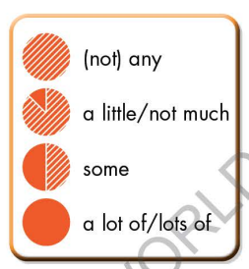  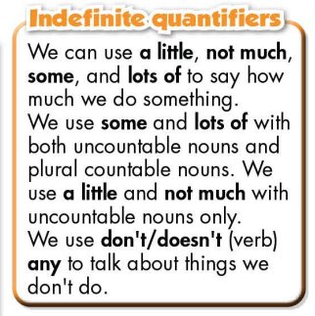  - Have Ss look at the box and read examples of different forms.  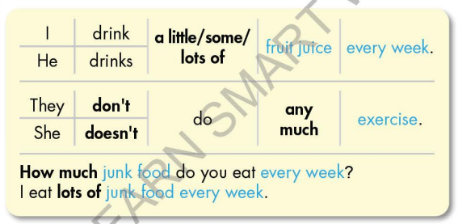  - Ask Ss to give more examples using indefinite quantifiers.  Option 2:  - Have Ss close books.  - Show some model sentences (using DCR), ask Ss to look at the nouns in blue and decide which are countable and which are uncountable.  - Then have Ss pay attention to the bold words, make comment on the way they use the bold words with countable or uncountable nouns.  - Introduce: indefinite quantifiers.  - Show grammar box, have Ss look and read.  - Ask Ss to make more examples using indefinite quantifiers.  - Give feedback and evaluation. | - Look.  - Listen, then read.  - Listen and repeat.  - Look and read.  - Read.  - Read examples of different forms.  - Give more examples.  - Close all books.  - Look and give answers.  - Give answers.  - Look and read.  - Give more examples.
Activity 2: Practice (19’)
a. Objective: Students can use the indefinite quantifiers to do the given exercises.
b. Content:
- Circle the correct words.
- Look at the table and answer the questions.
c. Expected outcomes: Students can get used to the use of the indefinite quantifiers and use them correctly.
d. Organization of the activity:
TEACHER’S ACTIVITIES | STUDENTS’ ACTIVITIES
Task b. Circle the correct words  - Demonstrate the activity, using the example (using DCR).  - Have Ss read the sentences and circle the correct words.  - Have Ss work in pairs to check each other’s work.  - Have some Ss share their answers with the whole class.  - Give feedback, correct Ss’ answers if necessary.  Task c. Look at the table and answer the questions  - Demonstrate the activity, using the example (using DCR).  - Have Ss look at the table and answer the questions.  - Have Ss check answers with their partners.  - Call Ss to write answers.  - Check Ss’ answers, give feedback and evaluation. | - Look and listen.  - Work individually.  - Work in pairs.  - Read answers.  Answer keys  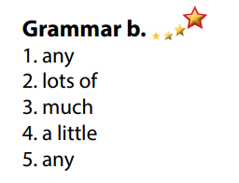  - Look and listen.  - Work individually.  - Work in pairs.  - Write answers.  Answer keys  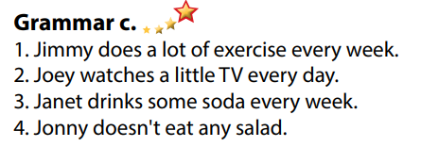

Activity 3: Production (6’)
a. Objective: Students master the grammar point they study in the lesson.
b. Content: Speaking: Ask your partner about the activities in Task c.
c. Expected outcomes: Ss produce the new language successfully, and they can use indefinite quantifiers in everyday speaking and writing.
d. Organization of the activity:
TEACHER’S ACTIVITIES | STUDENTS’ ACTIVITIES
Task d. In pairs: Ask your partner about the activities in Task c  - Divide class into pairs.  - Have Ss take turns asking their partner about the activities in Task c.  - Have some pairs demonstrate the activity in front of the class.  - Give feedback and evaluation.  - For more practice, have Ss play a game with DHA. | - Have conversation in pairs.  - Present.  - Listen.
C. Consolidation and homework assignments (5’)
* Consolidation:
- Indefinite quantifiers: a little, not much, some, lots of / a lot of, not any.
*Homework:
- Make 3 sentences, use Indefinite quantifiers.
- Do the exercises in WB: Grammar (page 9).
- Complete the grammar notes in Tiếng Anh 7 i-Learn Smart World Notebook (page 11).
- Play consolation games in Tiếng Anh 7 i-Learn Smart World DHA App on www.eduhome.com.vn
- Prepare: Lesson 1 – Pronunciation and Speaking (page 14 – SB).
***********************************************************************************
Teaching date: 04/10/2022
Period 13 UNIT 2: HEALTH
Lesson 1.3 – Pronunciation and Speaking (Page 14)
I. OBJECTIVES
By the end of the lesson, Ss will be able to:
1.1. Language knowledge and skills
- use intonation for Wh-questions correctly.
- ask and answer about how much people do something for a healthy lifestyle, using indefinite quantifiers.
- conduct a survey about healthy lifestyles.
1.2. Competences
- improve listening and speaking skills.
1.3. Attributes
- lead a healthy lifestyle and give up bad ones.
II. TEACHING AIDS AND LEARNING MATERIALS
1. Teacher’s aids: Student book and Teacher’s book, class CDs, Digital Book (DCR phần mềm tương tác SB, DHA (từ vựng/ cấu trúc) phần mềm trò chơi tương tác), projector/interactive whiteboard / TV (if any), PowerPoint slides, handouts.
2. Students’ aids: Student’s book, workbook, notebook.
III. ASSESSMENT EVIDENCE
Performance Tasks | Performance Products | Assessment Tools
- Listen to the questions and notice how the intonation falls.  - Listen and cross out the sentence doesn’t follow the note: intonation for Wh- questions falls.  - Read the questions with the rising intonation to a partner.  - Ask and answer about how much people do something for a healthy lifestyle, using indefinite quantifiers.  - Complete the survey about healthy lifestyles for themselves, then ask 2 more friends about theirs, then write score. | - Ss’ performance and answers.  - Ss’ answers.  - Ss’ performance.  - Ss’ performance.  - Ss’ performance /  Presentation. | - T’s observation.  - T’s feedback/Peers’ feedback.  - T’s feedback/Peers’ feedback.  - T’s feedback/Peers’ feedback.  - T’s observation, T’s feedback/Peers’ feedback
IV. PROCEDURES
A. Warm up: (5’)
a. Objective: Introduce the new lesson and set the scene for Ss to acquire new language; get students' attention at the beginning of the class by enjoyable and short activities as well as to engage them in the follow-up steps.
b. Content: Review Wh- questions.
c. Expected outcomes: Ss remember old knowledge and use them in other speaking activities.
d. Organization of the activity:
TEACHER’S ACTIVITIES | STUDENTS’ ACTIVITIES
Option 1: Rearranging  - Have Ss work in pairs, rearrange the words given to make meaningful questions.  1. much / you / every week / do / How / fast food / eat?  2. exercise / do / do / everyday / you / much / How?  3. water / How / do / drink / much / every day / you?  4. How / you / get / much / do / sleep / every night?  - Call Ss to read answers.  - Give feedback.  - Introduce intonation of Wh-questions.  - Lead to the new lesson.  Option 2: Question words  - Divide class into 2 groups. Group 1: say a question word. Group 2: make a sentence with that question word  - Example: Group 1: When Group 2: When do you go to school?  - T can change the role: Group 2 gives a question word and group 1 makes a sentence  - Introduce intonation of Wh-questions  - Lead to the new lesson. | - Work in pairs, then give answers.  Answer keys  1. How much fast food do you eat every week?  2. How much exercise do you do every day?  3. How much water do you drink every day?  4. How much sleep do you get every night?  - Take part in the class’s activity.  - Listen.
B. New lesson (35’)
Activity 1: Pre-Speaking: Pronunciation (10’)
a. Objective: Introduce intonation for Wh-questions.
b. Content:
- recognize the intonation for Wh-questions.
- listen and check, find mistakes.
- practice.
c. Expected outcomes: Ss distinguish and use intonation for Wh-questions correctly in their speaking.
d. Organization of the activity:
TEACHER’S ACTIVITIES | STUDENTS’ ACTIVITIES
Task a + b. Listen to the sentence and notice how the intonation falls.  - Play the recording (CD1, track 15) (using DCR).  - Ask Ss to listen and notice how the intonation falls.  - Play the recording again, have Ss listen and repeat with a focus on the pronunciation feature.  Task c + d. Listen and cross out the question that doesn’t follow the sound feature, then read the questions with the falling intonation to a partner.  - Play the recording (CD 1 – Track 16) (using DCR), have Ss listen and cross out the option that doesn’t follow the sound feature in “a”.  - Call Ss to give answers.  - Play the recording again and check answers as a whole class.  - Then have Ss practice saying the examples with a partner, using the pronunciation feature.  - Call some Ss to read questions in front of the class.  - Ask Ss to make some more wh-questions and practice reading them with falling tone. | - Listen.  - Listen again and repeat.  - Listen and cross out  - Give answers  - Listen again and check  Answer keys  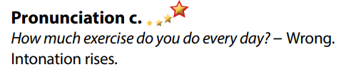  - Work in pairs.  - Present.  - Give answers.
Activity 2: While-speaking (20’)
a. Objective: Students can talk about how much they do something for a healthy lifestyle, using indefinite quantifiers.
b. Content:
- ask and answer about how much they do something for a healthy lifestyle, using indefinite quantifiers.
- do a survey about healthy lifestyle, fill in the survey for yourself, then ask 2 friends about their lifestyles, write scores.
c. Expected outcomes: Ss produce the new language successfully.
d. Organization of the activity:
TEACHER’S ACTIVITIES | STUDENTS’ ACTIVITIES
PRACTICE  Ask and answer  - Use DCR to show the task.  - Demonstrate the activity by asking and answering with a student.  - Have pairs ask and answer, using the pictures.  - Have Ss pay attention to the time expressions and the indefinite quantifiers in the box.  - Have some pairs demonstrate the activity in front of the class.  SPEAKING: Who Has the Healthiest Lifestyle?  Task a. You’re doing a survey about healthy lifestyles. In threes: Fill in the survey for yourself, then ask two friends about theirs. For each (+) answer, add points, for each (-) answer, subtract points.  - Use DCR to show the task.  - Demonstrate the activity by practicing the activity with a student.  - Divide the class into groups of 3.  - Have Ss complete the survey for themselves.  - Have Ss ask and answer to complete the survey with their partners.  - Observe, give help if necessary. | - Observe, listen.  - Work in pairs.  - Present.  - Observe and listen.  - Work in groups of 3.  - Complete the survey.
Activity 3: Production (5’)
a. Objective: Students report to the class about the survey results.
b. Content: Answer: Who has the healthiest lifestyle?
c. Expected outcomes: Ss produce the new language successfully in everyday speaking and writing.
d. Organization of the activity:
TEACHER’S ACTIVITIES | STUDENTS’ ACTIVITIES
SPEAKING: Who has the healthiest lifestyle?  Task b. Answer the question: Who has the healthiest lifestyle?  - Have Ss discuss who has the healthiest lifestyle in their group.  - Have some Ss share their findings with the class (scores included).  - Give feedback and evaluation. | - Discuss.  - Present.  - Listen.
C. Consolidation and homework assignments (5’)
* Consolidation:
- Intonation falls for Wh-questions.
*Homework:
- Make 2 Wh-questions, then practice reading them.
- Complete the survey for those who haven’t finished it in class.
- Prepare: Unit 2 - Lesson 2 – New words and Listening (page 15 – SB).
- Review the vocabulary and grammar notes in Tiếng Anh 7 i-Learn Smart World Notebook
(pages 10 & 11).
- Play consolation games in Tiếng Anh 7 i-Learn Smart World DHA App on www.eduhome.com.vn
***************************************************************
Teaching date: 05/10/2022
Period 14 UNIT 2: HEALTH
Lesson 2.1 – New words and Listening (Page 15)
I. OBJECTIVES
By the end of the lesson, Ss will be able to:
1.1. Language knowledge and skills
- give advice and persuade someone to have a healthy lifestyle.
- practice listening to a conversation between a student and his doctor (for general and specific details).
- offer help politely and practice offering help.
1.2. Competences
- improve communication, collaboration, and critical thinking skills.
1.3. Attributes
- give advice and persuade someone to have a healthy lifestyle.
- lead a healthy lifestyle for themselves.
II. TEACHING AIDS AND LEARNING MATERIALS
1. Teacher’s aids: Student book and Teacher’s book, class CDs, Digital Book (DCR phần mềm tương tác SB, DHA (từ vựng/ cấu trúc) phần mềm trò chơi tương tác), projector/interactive whiteboard / TV (if any), PowerPoint slides.
2. Students’ aids: Student’s book, workbook, notebook.
III. ASSESSMENT EVIDENCE
Performance Tasks | Performance Products | Assessment Tools
- Activate some health problems that Ss may know.  - Number the pictures.  - Listen and repeat.  - Discuss more health problems and advice and note them down.  - Listen to Jacob visiting his doctor. Circle the reason for Jacob’s visit.  - Listen and fill in the blanks.  - Speak: What do you do when you’re sick? Why? | - Ss’ answers.  - Ss’ answers.  - Ss’ performance.  - Ss’ answers/ presentation.  - Ss’ answers.  - Ss’ answers.  - Ss’ answers/ presentation. | - T’s feedback.  - T’s observation/ DCR.  - T’s feedback/Peers’ feedback.  - T’s feedback/Peers’ feedback.  - T’s feedback/Peers’ feedback.  - T’s feedback/Peers’ feedback.  - T’s observation and feedback / DCR
IV. PROCEDURES
A. Warm up: (5’)
a. Objective: Introduce the new lesson and set the scene for Ss to acquire new language; get students' attention at the beginning of the class by enjoyable and short activities as well as to engage them in the follow-up steps.
b. Content: Introduce words about health problems and advice.
c. Expected outcomes: Ss get to know some new words they are going to study in the lesson.
d. Organization of the activity:
TEACHER’S ACTIVITIES | STUDENTS’ ACTIVITIES
Option 1: Number the pictures. Listen and repeat.  - Use the “New words” part a.– page 15 for the warm-up activity.  - Show pictures and words (using DCR), have Ss look at the pictures and read phrases from 1-8, then number the pictures (in pairs).  - Call Ss to give answers.  - Give feedback and show correct answers.  - Lead to the new lesson.  - Play the audio (CD1 – Track 17), have Ss listen and repeat.  - Correct Ss’ pronunciation if necessary.  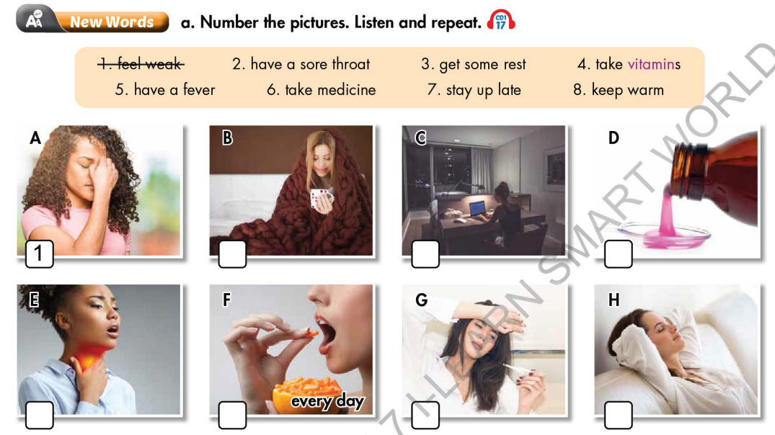  Option 2: Health problems and advice  - Give Ss some phrases about health problems and equivalent advice, but not in order.  - Have Ss work in pairs to match health problems with suitable advice.  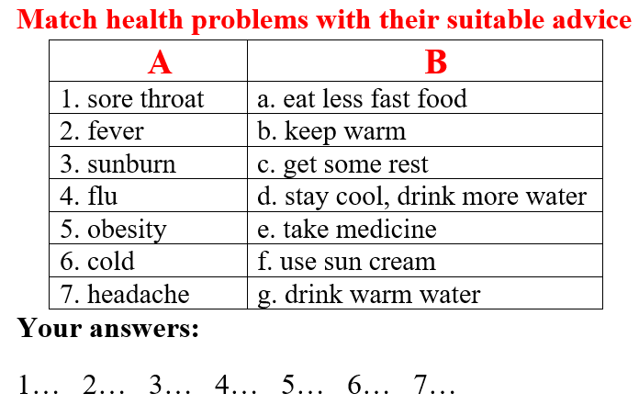  - Call Ss to give answers.  - Give feedback and evaluation.  - Lead to the new lesson | - Work in pairs.  - Give answers.  - Listen.  - Listen and repeat.  Answer keys  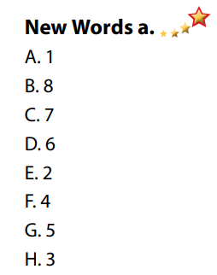  - Work in pairs.  - Give answers.  - Listen.  Answer keys  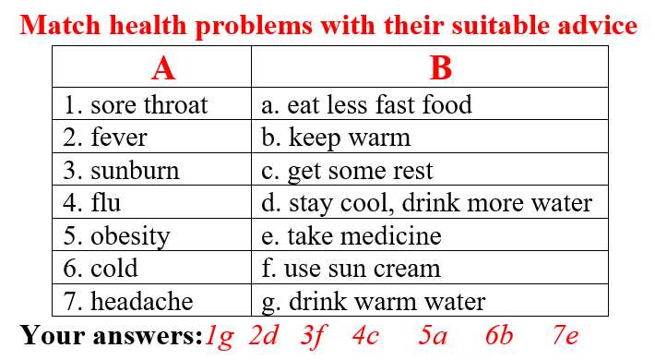
B. New lesson (35’)
Activity 1: Pre-Listening (Vocabulary) (12’)
a. Objective: Ss get to know words and phrase about health problems and how to give advice.
b. Content:
- Vocabulary study (feel weak, have a sore throat, get some rest, take vitamins, have a fever, take medicine, stay up late, keep warm).
- Speaking: Discuss more health problems and advice and note them down (page 15).
c. Expected outcomes: Ss know how to pronounce the new words / phrases correctly and use them when talking about health problems and giving advice.
d. Organization of the activity:
TEACHER’S ACTIVITIES | STUDENTS’ ACTIVITIES
Task a. Number the pictures. Listen and repeat.  Option 1 (If the teacher hasn’t used this part for the Warm-up activity.)  - Demonstrate the activity, using the example (using DCR).  - Have Ss number the pictures.  - Divide class into pairs and have them check their answers with their partners.  - Call Ss to give answers (read or write).  - Check answers as a whole class.  - Play audio (CD1 – Track 17). Have Ss listen and repeat.  - Correct Ss’ pronunciation.  Option 2: Filling in the blanks (If the teacher has used part a. for the Warm-up activity.)  - Have Ss review the words they have known in the warm-up activity by filling in the blanks (T uses different pictures from those in the textbook).  - Call Ss to give answers (read or write).  - Check answers as a whole class.  - Call some Ss to read the words again.  - Correct Ss’ pronunciation if necessary.  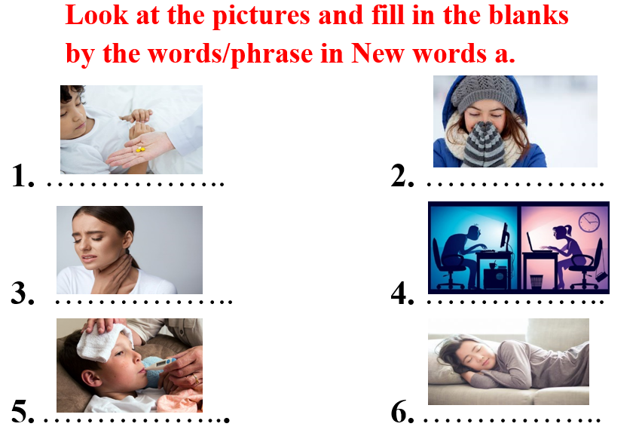  Task b. In pairs: Discuss more health problems and advice and note them down.  - Have Ss work in pairs to discuss more health problems and advice and note them down.  - T can ask Ss to use the health problems and advice they have known in the Warm-up activity as a reference.  - Have some pairs share their ideas with the class.  - Give feedback and evaluation. | - Look and listen.  - Work individually.  - Work in pairs.  - Give answers.  - Listen and repeat.  Answer keys  - Work in pairs.  - Give answers.  - Read.  Answer keys  1. take medicine  2. keep warm  3. have a sore throat  4. stay up late  5. have a fever  6. get some rest  - Work in pairs.  - Present.  Suggested ideas
Activity 2: While - Listening (17’)
a. Objective: Students can develop their listening skill.
b. Content: Listen to a conversation between Jacob and his doctor, circle the reason for Jacob’s visit and then listen again to fill in the blanks.
c. Expected outcomes: Students can listen and understand general and specific information about a health problem and how to overcome it.
d. Organization of the activity:
TEACHER’S ACTIVITIES | STUDENTS’ ACTIVITIES
Task a. Listen to Jacob’s visiting the doctor. Circle the reason for Jacob’s visit.  - Have Ss read the sentence, guess the answer (using DCR).  - Play audio (CD1 - Track 18).  - Have Ss listen and circle the correct answer.  - Check answer as a whole class.  Task b. Now, listen and fill in the blanks  - Have Ss read the through the uncompleted sentences in task b, guess what types of words / parts of speech that will be possible for each blank (using DCR).  - Play the audio again (CD1 - Track 18).  - Have Ss listen and fill in the blanks.  - Have Ss check answers with their partners.  - Call Ss to give answers.  - Give feedback and show correct answers. | -Work individually.  - Listen.  - Circle the correct answers.  Answer keys  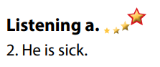  - Read and guess.  - Do the task.  - Check answers.  Answer keys  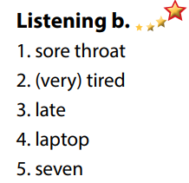
Activity 3: Post - Listening (6’)
a. Objective: Students can use the vocabulary and the content in listening part to develop their speaking skill.
b. Content: Speaking: What do you do when you are sick?
c. Expected outcomes: Students can have a free-talk about how to overcome sickness.
d. Organization of the activity:
TEACHER’S ACTIVITIES | STUDENTS’ ACTIVITIES
Conversation skill  - Have Ss look at the Conversation box and read (using DCR).  - Play audio (CD 1 - Track 19), have Ss listen and repeat.  - Ask Ss to find more ways to offer help.  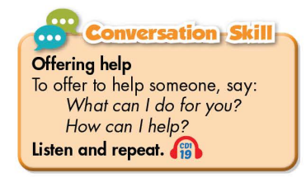  - Task c. What do you do when you are sick? Why?  - Have Ss work in pairs to discuss.  - Observe and give help if necessary.  - Call some pairs to share their ideas with the class.  - Give feedback and evaluation.  - For more practice, have Ss play a game with DHA. | - Look and read.  - Listen and repeat.  - Give answers.  - Work in pairs.  - Present.
C. Consolidation and homework assignments (4’)
*Consolidation:
- Words about health problems and giving advice: feel weak, have a sore throat, get some rest, take vitamins, have a fever, take medicine, stay up late, keep warm.
- Language to offer help: What can I do for you?/How can I help?/May I help you?
*Homework
- Learn the new words by heart.
- Practice asking and answering about giving advice for a health problem.
- Do the exercises in WB: New words + Listening (pages 10, 11).
- Do the vocabulary exercise in Tiếng Anh 7 I-Learn Smart World Notebook (page 12).
- Play consolation games in Tiếng Anh 7 I-Learn Smart World DHA App on www.eduhome.com.vn
- Prepare: Lesson 2 – Grammar (page 16 – SB).
*************************************************************
Teaching date: 07/10/2022
Period 15 UNIT 2: HEALTH
Lesson 2.2 - Grammar (Page 16)
I. OBJECTIVES
By the end of the lesson, Ss will be able to:
1.1. Language knowledge and skills
- listen to 2 people asking and answering about a health problem and advice.
- use “should” and “shouldn’t” to ask for and give advice.
1.2. Competences
- improve speaking, listening and writing skills.
- improve the use of English.
1.3. Attributes
- know how to ask for advice and give advice.
- lead a healthy life.
II. TEACHING AIDS AND LEARNING MATERIALS
1. Teacher’s aids: Student book and Teacher’s book, class CDs, Digital Book (DCR phần mềm tương tác SB, DHA (từ vựng/ cấu trúc) phần mềm trò chơi tương tác), projector/interactive whiteboard / TV (if any), PowerPoint slides, handouts.
2. Students’ aids: Student’s book, workbook, notebook.
III. ASSESSMENT EVIDENCE
Performance Tasks | Performance Products | Assessment Tools
- Listen and repeat.  - Study the grammar box.  - Use the prompts to give advice for each problem.  - Fill in the blanks using “should” or “shouldn’t”.  - Ask for and give advice using the prompts (in pairs). | - Ss’ performance.  - Ss’ task.  - Ss’ answers /performance.  - Ss’ answers.  - Ss’ answers/ presentation. | - T’s feedback.  - T’s feedback/Peers’ feedback.  - T’s feedback/Peers’ feedback.  - T’s observation, T’s feedback/Peers’ feedback.
IV. PROCEDURES
A. Warm up: (5’)
a. Objective: Introduce the new lesson and set the scene for Ss to acquire new language; get students' attention at the beginning of the class by enjoyable and short activities as well as to engage them in the follow-up steps.
b Content: Review vocabulary about health problems / Introduce “should”.
c Expected outcomes: Ss review words about health problems and Ss have general ideas about the grammar point they are going to study in the new lesson.
d Organization of the activity:
TEACHER’S ACTIVITIES | STUDENTS’ ACTIVITIES
Option 1: Health problems  - Have Ss look at the pictures and give names of health problems.  - Call Ss to give answers.  - Check Ss’ answers, give feedback and lead to the new lesson.  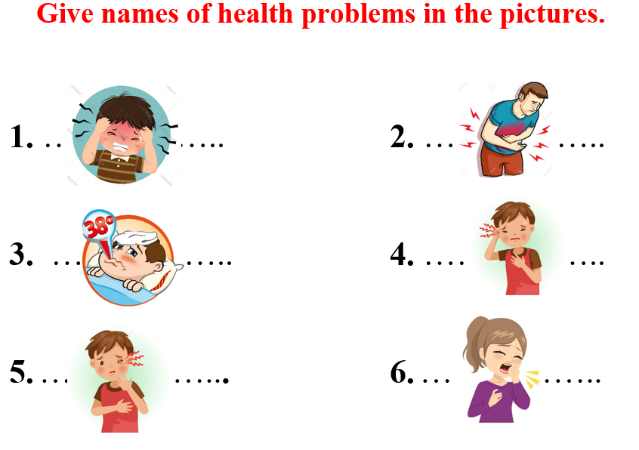  - Have Ss make sentences, using the vocabularies above.  - Lead to the new lesson.  Option 2: Game: Letter Lingo  - Have Ss close all books and notebooks.  - Show some pictures, have Ss choose number at random and then give names of the pictures.  - Have Ss use the red letter of their answers (the red letter is shown on the screen) to form a new word.  - The first student to give the correct key word in the shortest time will be the winner.  - Give praise or a small present to the winner.  *Illustration:  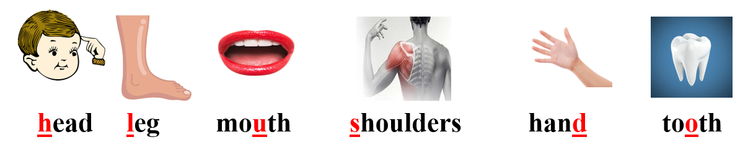  - Tell Ss about the grammar point they are going to study in the new lesson: “should” and “shouldn’t”.  - Lead to the new lesson. | - Work in pairs.  - Give answers.  Answers keys  1. headache  2. stomachache  3. fever  4. sore eye  5. earache  6. cough  - Read sentences.  - Close books and notebooks.  - Choose number and answer.  Answers keys  Keyword: SHOULD  - Listen.
B. New lesson (35’)
Activity 1: Presentation (10’)
a. Objective: Introduce “should” and “shouldn’t”.
b. Content:
- Listen and repeat.
- Introduce “should” and “shouldn’t” (affirmative, negative and interrogative form).
c. Expected outcomes: Ss know how to use “should” and “shouldn’t” to do some following exercises.
d. Organization of the activity:
TEACHER’S ACTIVITIES | STUDENTS’ ACTIVITIES
Task a. Listen and repeat  - Have Ss look at the picture (using DCR).  - Play audio (CD1 – Track 20) and have Ss listen and read the speech bubbles.  - Play the audio again and have Ss listen and repeat.  Grammar box  Option 1:  - Have Ss look at the grammar explanation (using DCR).  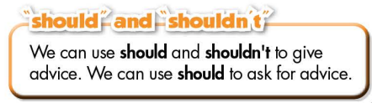  - Have Ss look at the box and read examples of different forms.  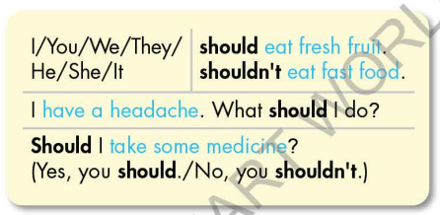  - Explain more about the form and the usage of “should” and “shouldn’t”, have Ss pay attention to the negative and the question form.  Form:  (+) S + should + V_{B.I} …  (-)S + shouldn’t + V_{B.I} …  (?)Should + S+ V_{B.I} …  Usage: to ask for and to give advice.  *Note: V_{B.I} = verb in bare infinitive form  - Have some Ss read aloud the sentences in the Grammar Box.  - Ask Ss to give more examples using “should” and “shouldn’t”.  Option 2:  - Have Ss close books.  - Show sample sentences in the grammar box (using DCR).  - Have Ss read the sentences aloud  - Have Ss make comment on the way they use “should” and “shouldn’t” by asking Ss some questions:  *Suggested questions:  1.What type of verb is used after “should” and “shouldn’t”?  2.In each sentence, what so they use “should” and “shouldn’t” for?  3. How do we answer question with “should”?  - Call Ss to give answers, comment on Ss’ answers  - Then have Ss open the books and read the grammar box  - Have Ss give more examples of “should” and “shouldn’t”, encourage them to make sentences with their own ideas.  - Give feedback and evaluation | - Look.  - Listen, then read.  - Listen and repeat.  - Look and read.  - Look and read.  - Listen and take notes.  - Read.  - Give examples.  - Close all books.  - Look and answer.  .  - Read.  - Answer the questions.  - Open the books and read the grammar box.  - Give examples.
Activity 2: Practice (19’)
a. Objective: Students can use “should” and “shouldn’t” to ask for and give advice.
b. Content:
- Use the prompts to give advice for each problem.
- Fill in the blanks using “should” and “shouldn’t”.
c. Expected outcomes: Students can apply “should” and “shouldn’t” to ask for and give advice in their speaking.
d. Organization of the activity:
TEACHER’S ACTIVITIES | STUDENTS’ ACTIVITIES
Task b. Use the prompts to give advice for each problem.  - Demonstrate the activity, using the example (using DCR).  - Have Ss use the prompts to give advice for each problem (in individual).  - Have Ss work in pairs to check each other’s work.  - Have some Ss share their answers with the whole class.  - Give feedback, correct Ss’ answers if necessary.  Task c. Fill in the blanks using “should” and “shouldn’t”  - Demonstrate the activity, using the example (using DCR).  - Have Ss fill in the blanks using “should” and “shouldn’t”.  - Have Ss check answers with their partners.  - Call Ss to read answers.  - Check Ss’ answers, give feedback. | - Look and listen.  - Work individually.  - Work in pairs.  - Write answers on the board.  Answer keys  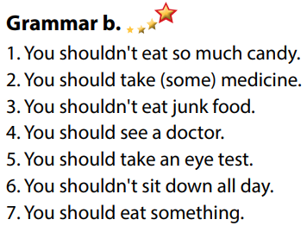  - Look and listen.  - Work individually.  - Work in pairs.  - Read answers.  Answer keys  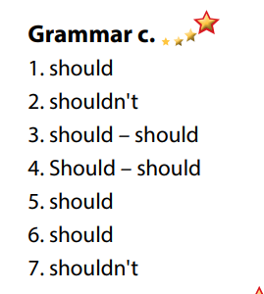
Activity 3: Production (6’)
a. Objective: Students master the grammar point they study in the lesson.
b. Content: Speaking: Ask for and give your partner advice using the prompts.
c. Expected outcomes: Ss produce the new language successfully, and they can apply “should” and “shouldn’t” in speaking and writing.
d. Organization of the activity:
TEACHER’S ACTIVITIES | STUDENTS’ ACTIVITIES
Task d. In pairs: Ask for and give your partner advice using the prompts.  - Use DCR to show the task.  - Divide class into pairs.  - Have Ss ask for and give their partner advice using the prompts.  - Encourage Ss to use more words about health problems and give advice with their own ideas.  - Have some pairs demonstrate the activity in front of the class.  - Give feedback and evaluation. | -Listen and take notes.  - Have conversation in pairs.  - Present.  - Listen.
C. Consolidation and homework assignments (5’)
*Consolidation
- “should” and “shouldn’t”
Form:
(+) S + should + V_{B.I} …
(-)S + shouldn’t + V_{B.I} …
(?)Should + S+ V_{B.I} …
Usage: to ask for / give advice
*Homework:
- Make 2 sentences, use “should” and “shouldn’t to ask for / give advice.
- Do the exercises in WB: Grammar (page 11).
- Complete the grammar notes in Tiếng Anh 7 I-Learn Smart World Notebook (page 13).
- Play consolation games in Tiếng Anh 7 I-Learn Smart World DHA App on www.eduhome.com.vn
- Prepare: Lesson 2 – Pronunciation and Speaking (page 17 – SB).
***************************************************************
Teaching date: 11/ 10/2022
Period 16 UNIT 2: HEALTH
Lesson 2.3 – Pronunciation and Speaking (Page 17)
I. OBJECTIVES
By the end of the lesson, Ss will be able to:
1.1. Language knowledge and skills
- recognize and practice the sound changes in phrase “Do you…?”.
- practice a conversation about health problem and then ask for / give advice.
- ask about someone else’s health.
- offer help politely.
1.2. Competences
- improve listening and speaking skills.
1.3. Attributes
- know how to ask for advice and give advice.
- lead a healthy life.
- know how to take care of themselves.
II. TEACHING AIDS AND LEARNING MATERIALS
1. Teacher’s aids: Student book and Teacher’s book, class CDs, Digital Book (DCR phần mềm tương tác SB, DHA (từ vựng/ cấu trúc) phần mềm trò chơi tương tác), projector/interactive whiteboard / TV (if any), PowerPoint slides, handouts.
2. Students’ aids: Student’s book, workbook, notebook, handouts.
III. ASSESSMENT EVIDENCE
Performance Tasks | Performance Products | Assessment Tools
- Listen and notice the sound changes of the underlined words.  - Listen and cross out the sentence doesn’t follow the note in Task a.  - Read the sentences with the sound changes noted in Task a to a partner.  - Practice the conversation between a doctor and a patient. Swap the roles and repeat.  - Role-play: A doctor is giving advice to a sick patient, using questionnaire.  - Swap the roles, answer the questions in the questionnaire and write down the advice. | - Ss’ performance and answers.  - Ss’ answers.  - Ss’ performance.  - Ss’ performance.  - Ss’ performance /  Presentation.  - Ss’ performance /  Presentation. | - T’s observation.  - T’s feedback/Peers’ feedback.  - T’s feedback/Peers’ feedback.  - T’s feedback/Peers’ feedback.  - T’s observation, T’s feedback/Peers’ feedback.  - T’s observation, T’s feedback/Peers’ feedback.
IV. PROCEDURES
A. Warm up: (5’)
a) Objective: Introduce the new lesson and set the scene for Ss to acquire new language; get students' attention at the beginning of the class by enjoyable and short activities as well as to engage them in the follow-up steps.
b) Content: Introduce the phrase: “Do you…?”
c) Expected outcomes: Ss have good preparation for the new lesson.
d) Organization of the activity:
TEACHER’S ACTIVITIES | STUDENTS’ ACTIVITIES
Option 1:  - Play a video clip with a lot of questions beginning with “Do you…?”  - Have watch, listen and pay attention to the way he sings: “Do you…?”  - Call Ss to make comment on the way the singer sings: “Do you…?”  - Give feedback and lead to the new lesson: sound change in the phrase: “Do you…?”  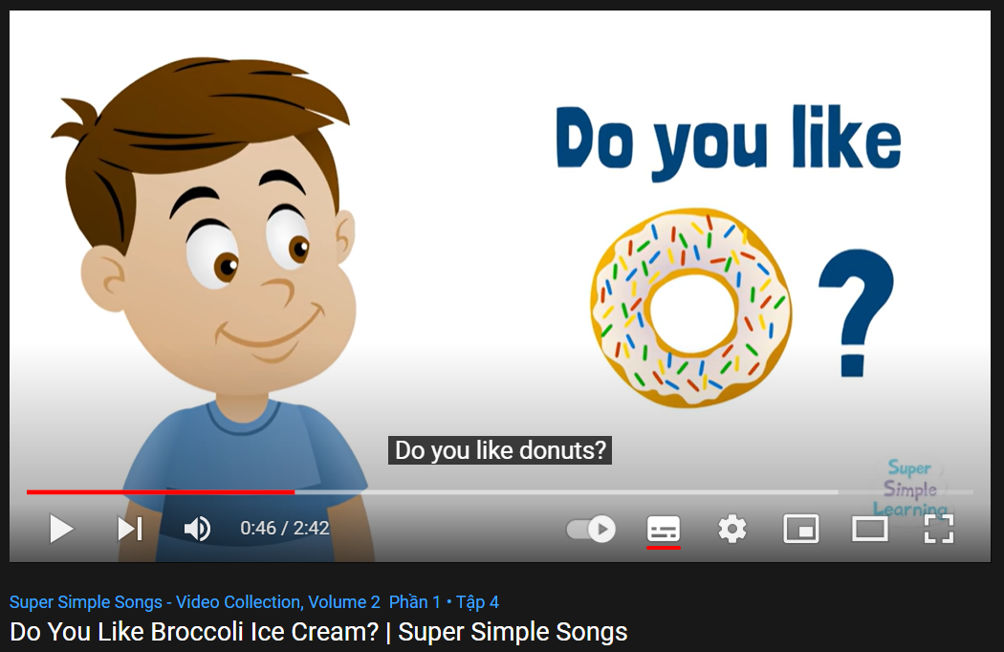  *Link: https://www.youtube.com/watch?v=frN3nvhIHUk  Option 2:  - Divide class into 4 groups.  - Have Ss in each group write as many as possible questions beginning with “Do you…?.  - Set a limit time (about 2-3 minutes).  - Have 4 group representatives write answers on the board, or hang their extra-boards on the main board to check.  - Check Ss’ answers, give feedback and evaluation.  - Announce the winner.  - Give a small present or extra marks to the winner.  - Introduce the new lesson: sound change in the phrase: “Do you…?” | - Listen and watch, pay attention to the way the singer sings: “Do you…?”.  - Give answers.  - Listen.  - Take part in the class activity in groups.  - Listen.
B. New lesson (35’)
Activity 1: Pre-Speaking: Pronunciation (8’)
a. Objective: Introduce sound change in the phrase: “Do you…?”
b. Content:
- recognize the sound change in the phrase: “Do you…?”
- listen and check, find mistakes.
- practice.
c. Expected outcomes: Ss distinguish sound change in the phrase: “Do you…?”and use it naturally in their speaking.
d. Organization of the activity:
TEACHER’S ACTIVITIES | STUDENTS’ ACTIVITIES
Task a + b. Notice the sound changes of the underlined words.  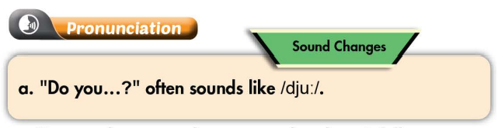  - Play the recording (CD1, track 21) using DCR.  - Ask Ss to listen and notice how sound changes of the underlined words.  - Play the recording again, have Ss listen and repeat with a focus on the pronunciation feature.  Task c + d. Listen and cross out the sentence that doesn’t follow the sound feature, then read the sentences with the sound changes of the phrase “Do you..?” to a partner.  - Play the recording (CD 1 – Track 22) using DCR, have Ss listen and cross out the option that doesn’t follow the sound feature in “a”.  - Call Ss to give answers.  - Play the recording again and check answers as a whole class.  - Then have Ss practice saying the examples with a partner, using the pronunciation feature.  - Call some Ss to read the sentences in front of the class.  - Ask Ss to make some more questions with the phrase “Do you..?” and practice reading them with the right sound feature of the lesson. | - Listen.  - Listen again and repeat.  - Listen and cross out.  - Give answers.  Answer keys  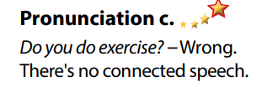  - Listen again and check.  - Work in pairs.  - Present.  - Give answers.
Activity 2: While-speaking (21’)
a. Objective: Students can ask for advice and give advice.
b. Content:
- Practice the conversation between a doctor and a patient. Swap the roles and repeat.
- Role-play: A doctor is giving advice to a sick patient, using questionnaire.
- Swap the roles, answer the questions in the questionnaire and write down the advice.
c. Expected outcomes: Ss produce the new language successfully and have a good role play.
d. Organization of the activity:
TEACHER’S ACTIVITIES | STUDENTS’ ACTIVITIES
PRACTICE  Practice the conversation. Swap the roles and repeat.  - Use DCR to show the task.  - Demonstrate the activity by practicing the role-play with a student.  - Have pairs practice the conversation.  - Remind Ss the way to offer help politely at the beginning of the conversation and give + ask for advice with “should” and “shouldn’t”.  - Have Ss swap roles and repeat, using the ideas on the right.  - Have some pairs demonstrate the activity in front of the class.  - Give feedback and evaluation.  SPEAKING: How Are You Feeling Today?  Task a. Student B, go to page 118 - file 2. Student A, you’re a doctor giving advice to a sick patient. Ask your patient questions, complete the questionnaire, and give advice if you need to for each question.  - Use DCR to show the task.  - Demonstrate the activity by practicing role-play with a student.  - Have Ss work in pairs.  - Have student B go to page 118 - file 2.  - Have students ask and answer to complete the questionnaire.  - Have some students share the ideas with the class.  - Observe, give help if necessary.  Task b. Swap roles. Student A, now you’re the patient. Answer the doctor’s questions and write down their advice.  - Have students swap roles and repeat.  - Observe, give help if necessary.  - T may call 1-2 pairs to present their role-play in front of the class.  - Give feedback and evaluation. | - Observe, listen.  - Work in pairs to practice the conversation.  - Swap roles and continue the task.  - Present.  - Observe and listen.  - Work in pairs to ask and answer to complete the questionnaire.  - Swap roles and repeat.  - Present.

Activity 3: Production (6’)
a. Objective: Help Ss remember questions about health beginning with “Do you…?
b. Content: Retell some questions about health beginning with “Do you…?” that the doctor uses to ask his / her patient.
c. Expected outcomes: Ss produce the new language successfully in everyday speaking and writing.
d. Organization of the activity:
TEACHER’S ACTIVITIES | STUDENTS’ ACTIVITIES
Extra Task. Retell some questions about health beginning with “Do you…? that the doctor uses to ask his / her patient.  - Have Ss close all books and notebooks.  - Ask Ss to retell some questions about health beginning with “Do you…?” that the doctor uses to ask his / her patient.  - Pay attention to the way to pronounce the sound change in the phrase “Do you…?”.  - Give feedback and evaluation. | - Close all books and notebooks.  - Remember and retell.  - Give answers.  - Listen.

C. Consolidation and homework assignments (5’)
* Consolidation:

* Homework:
- Make 2 questions with the phrase “Do you…?”and practice reading them.
- Complete the questionnaire for those who haven’t finished it in class.
- Prepare: Lesson 3 – Listening and Reading (page 18– SB).
- Review the vocabulary and grammar notes in Tiếng Anh 7 i-Learn Smart World Notebook
(pages 12 & 13).
- Play consolation games in Tiếng Anh 7 i-Learn Smart World DHA App on www.eduhome.com.vn
****************************************************************
Teaching date: 12/10/2022
Period 17 UNIT 2: HEALTH
Lesson 3.1 - Listening and Reading (Page 18)
I. OBJECTIVES
By the end of the lesson, Ss will be able to:
1.1. Language knowledge and skills
- talk about healthy and unhealthy food.
- practice listening and understanding general and specific information about food in cafeteria.
- read a request letter for gist and detail.
1.2. Competences
- improve communication, collaboration, analytical and critical thinking skills.
1.3. Attributes
- choose healthy food for themselves.
- lead a healthy life.
II. TEACHING AIDS AND LEARNING MATERIALS
1. Teacher’s aids: Student book and Teacher’s book, class CDs, Digital Book (DCR phần mềm tương tác SB, DHA (từ vựng/ cấu trúc) phần mềm trò chơi tương tác), projector/interactive whiteboard / TV (if any), PowerPoint slides.
2. Students’ aids: Student’s book, workbook, notebook.
III. ASSESSMENT EVIDENCE
Performance Tasks | Performance Products | Assessment Tools
- Speaking: What food and drinks can you buy at your school? Which are healthy and unhealthy?  - Listen to an interview with James Olive. Where is the interview taken place?  - Listen again and circle the correct answer.  - Read Tony’s letter and circle who you think Mrs. Clancy is.  - Read again and circle the correct answer.  - Speaking: What can you buy in your school cafeteria? | - Ss’ answers.  - Ss’ answers.  - Ss’ answers.  - Ss’ answers.  - Ss’ answers.  - Ss’ answers / presentation. | - T’s feedback.  - T’s feedback.  - T’s feedback/Peers’ feedback.  - T’s feedback/Peers’ feedback.  - T’s feedback/Peers’ feedback.  - T’s observation/ DCR and T’s feedback.
IV. PROCEDURES
A. Warm up: (5’)
a. Objective: Introduce the new lesson and set the scene for Ss to acquire new language; get students' attention at the beginning of the class by giving enjoyable and short activities as well as to engage them in the follow-up steps.
b. Content: Words about food and drinks.
c. Expected outcomes: Ss have general ideas about food and drinks at the school cafeteria, which they are going to listen and read in the new lesson.
d. Organization of the activity:
TEACHER’S ACTIVITIES | STUDENTS’ ACTIVITIES
Option 1: Let’s Talk!  - Use the “Let’s talk!” part in the textbook– page 18 for warm-up activity.  - Ask Ss to work in pairs to discuss what food and drinks they can buy at school. Which are healthy and which are unhealthy.  - Call Ss to share their answers with the whole class.  - Give feedback and evaluation.  - Lead to the new lesson.  Option 2:  - Use some real pictures taken from school canteen to show to Ss.  - Have Ss look at the pictures of their own canteen / cafeteria to talk about what food and drinks they can buy there.  - Ask Ss to state which are healthy and which are unhealthy.  - Call some Ss to share their ideas with the whole class.  - Give feedback and evaluation.  - Lead to the new lesson. | - Work in pairs to discuss.  - Present.  Suggeted answers  - Healthy food / drinks: bread, mineral water, …  - Unhealthy food / drinks: burger, chocolate, chips, crisps, snack, soda…  - Look and discuss.  - Give answers.  - Present.  - Listen.
B. New lesson (35’)
Activity 1: Listening (17’)
a. Objective: Students can develop their listening skill.
b. Content: Listening to an interview with James Olive about food and drinks.
c. Expected outcomes: Students can practice listening and understanding general + specific information about food and drinks.
d. Organization of the activity:
TEACHER’S ACTIVITIES | STUDENTS’ ACTIVITIES
Task a. Listen to an interview with James Olive. Where is the interview taking place?  - Use DCR to show the task.  - Have Ss read the questions and guess the answers.  - Play audio (CD1 - Track 23).  - Have Ss listen and choose the correct answers.  - Call Ss to give answer, explain.  - Check answers as a whole class using DCR.  Task b. Now, listen and circle.  - Use DCR to show the task.  - Have Ss read through the content of Task b first.  - Play the audio again (CD1 - Track 23).  - Have Ss listen and circle the correct answers.  - Have Ss check answers with their partners.  - Call Ss to give answers, explain.  - Check answers as a whole class using DCR. | - Read.  - Listen and choose the correct answers.  Answer keys  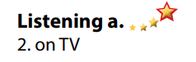  - Read.  - Listen and circle the correct answers.  - Exchange answers.  - Give answers.  Answer keys  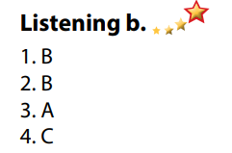
Activity 3: Reading (18’)
a. Objective: Students can develop their reading skill.
b. Content: Read a request letter and circle the correct answers.
c. Expected outcomes: Students can read a request letter for gist and detail, and they can talk about the food and drinks at their school canteen / cafeteria.
d. Organization of the activity:
TEACHER’S ACTIVITIES | STUDENTS’ ACTIVITIES
Task a. Read Tony’s letter and circle who you think Mrs. Clancy is.  - Use DCR to show the task.  - Have Ss read the question and guess the answer.  - Ask Ss to read the letter quickly and circle the correct answer.  - Call 1 S to give answer.  - Check answers as a whole class using DCR.  Task b. Now, read and circle the correct answer.  - Have DCR to show the task.  - Have Ss read the questions and underline the key words.  - Have Ss read the letter again and answer the questions.  - Have Ss check their answers with a partner.  - Call Ss to give answers.  - Check answers as a whole class using DCR.  Task c. Speaking: In pairs: What can you buy in your school cafeteria?  - Have Ss discuss the questions in pairs.  - Call Ss some s to share their answers with the whole class.  - Give feedback and evaluation. | - Read and guess.  - Scan the letter for general idea.  - Give answer.  Answer keys  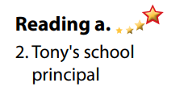  - Read and underline the key words.  - Read the letter again for detail.  - Exchange answers.  - Give answers.  Answer keys  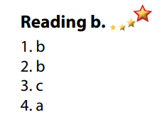  - Discuss in pairs.  - Present.
C. Consolidation and homework assignments (5’)
*Consolidation:
- Vocabulary: Healthy food: fruit, mineral water, egg, bread, mineral …
*Homework
- Practice talking about the food and drinks in your school canteen or cafeteria.
- Do the exercises in WB: Listening and Reading (page 12).
- Do the vocabulary exercise in Tiếng Anh 7 i-Learn Smart World Notebook (page 14).
- Play consolation games in Tiếng Anh 7 i-Learn Smart World DHA App on www.eduhome.com.vn
- Prepare: Lesson 3 – Writing and Speaking (page 19 – SB).
***************************************************************

Teaching date: 14/10/2022
Period 18 UNIT 2: HEALTH
Lesson 3.2 Writing (Page 19)
I. OBJECTIVES
By the end of the lesson, Ss will be able to:
1.1. Language knowledge and skills
- study format of a request letter.
- discuss healthy food (food which help Ss to study better).
- write a request letter to ask for better food in the school cafeteria.
1.2. Competences
- improve communication, collaboration, writing and critical thinking skills.
1.3. Attributes
- choose healthy food for themselves.
- lead a healthy life.
- make a polite request for better things in everyday life.
II. TEACHING AIDS AND LEARNING MATERIALS
1. Teacher’s aids: Student book and Teacher’s book, class CDs, Digital Book (DCR phần mềm tương tác SB, DHA (từ vựng/ cấu trúc) phần mềm trò chơi tương tác), projector/interactive whiteboard / TV (if any), PowerPoint slides.
2. Students’ aids: Student’s book, workbook, notebook.
III. ASSESSMENT EVIDENCE
Performance Tasks | Performance Products | Assessment Tools
- Speaking: Look at the pictures. Discuss which foods you think would help you study better. Why or why not? Can you buy any of these at your school?  - Complete the table about your school.  - Writing: Read about writing request letters. Then, read Tony’s letter again and fill in the labels.  - Number the sentences (1-7). Use the skill box.  - Write a letter to your school’s principal asking for better food in your cafeteria. | - Ss’ answers.  - Ss’ answers.  - Ss’ answers.  - Ss’ answers.  - Ss’ answers/ presentation. | - T’s feedback.  - T’s observation/ DCR.  - T’s feedback/Peers’ feedback.  - T’s feedback/Peers’ feedback.  - T’s observation and feedback.
IV. PROCEDURES
A. Warm up: (5’)
a. Objective: Introduce the new lesson and set the scene for Ss to acquire new language; get students' attention at the beginning of the class by enjoyable and short activities as well as to engage them in the follow-up steps.
b. Content: Food names / Introduce: Request.
c. Expected outcomes: Ss remember names of some food that they are going to talk about in the lesson.
d. Organization of the activity:
TEACHER’S ACTIVITIES | STUDENTS’ACTIVITIES
Option 1:  - Divide class into groups.  - Give Ss a list of food.  - Have Ss work in groups to divide foods into 4 groups: vegetables, fruit, dairy and protein.  - Ask Ss in 4 groups to give answers.  - Ask Ss extra question: Which food is good for your brain?  - Have Ss give answers.  - Give feedback and evaluation.  - Lead to the new lesson.  *Suggested food list: lettuce, banana, cheese, apple, broccoli, yoghurt, egg, butter, ham, carrots, watermelon, milk, potatoes, beef, cream, pork, guava…  Option 2: Game: Wheel of Fortune  - Have Ss play the game: Wheel of fortune.  - Design the game, have some voluntarily Ss spin the wheel and say a letter in English alphabet. If this letter is included in the key word, he / she will receive the thing in the wheel where the arrow stops. If he / she gets the wrong answer, T calls another one.  - Call Ss to spin and guess letters until the keyword is opened.  - The first S to give the right keyword will be the winner.  - Give feedback.  - Lead to the new lesson: Introduce “REQUEST” à request letter.  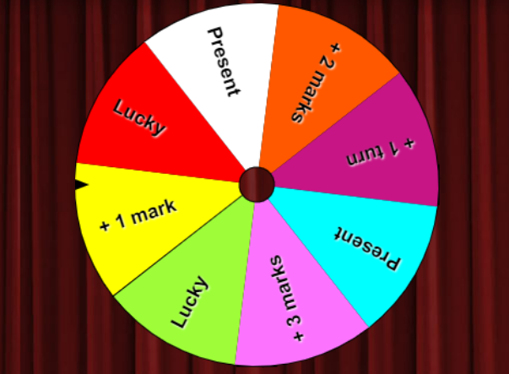 | - Take part the games in groups.  - Give answers.  - Listen.  Answer keys  - Vegetables: lettuce, broccoli, carrots, potatoes  - Fruit: banana, apple, watermelon, guava  - Dairy: cheese, yoghurt, butter, milk, cream  - Protein: egg, ham, beef, pork, …  - Take part in the game.  Keyword: REQUEST  - Listen.
B. New lesson (35’)
Activity 1: Pre-Writing (Speaking) (10’)
a. Objective: Ss prepare for what they are going to write about.
b. Content:
- Speaking: Look at the pictures. Discuss which foods you think would help you study better. Why or why not? Can you buy any of these at your school?
- Complete the table about your school.
c. Expected outcomes: Ss know more vocabularies about food and apply the language from speaking to their writing.
d. Organization of the activity:
TEACHER’S ACTIVITIES | STUDENTS’ ACTIVITIES
Task a. Look at the pictures. Discuss which foods you think would help you study better. Why or why not? Can you buy any of these at your school?  - Use DCR to show the task.  - Have Ss observe the pictures, then work in pairs to which foods you think would help you study better, explain for their answers.  - Have some Ss share their ideas with the class.  - Give feedback and evaluation.  Task b. Complete the table about your school  - Use DCR to show the task.  - Have Ss complete the table about their school.  - Go round and give help if necessary.  - Have some pairs share their ideas with the class.  - Give feedback and evaluation. | - Look and discuss.  - Give answers.  - Complete the table.  - Present.
Activity 2: While - Writing (20’)
a. Objective: Students can develop their writing skill.
b. Content: - Read about writing request letter. Read Tony’s letter (page 18) again and fill in the labels.
- Number the sentences of a request letter.
- Write a request letter to your school’s principal asking for better food in your cafeteria.
c. Expected outcomes: Students can write a request letter, using vocabulary about food and polite language.
d. Organization of the activity:
TEACHER’S ACTIVITIES | STUDENTS’ ACTIVITIES
Task a. Read about writing request letter. Read Tony’s letter (page 18) again and fill in the labels.  - Briefly explain the Writing skill box (using DCR).  - Have Ss read the Writing skill box and Tony’s letter again (page 18), then fill in the labels.  - Have Ss check their answers with a partner.  - Call Ss to give answers.  - Check answer as a whole class.  Task b. Number the sentences (1-7) of a request letter.  - Use DCR to show the task.  - Have Ss read the sentences, then number 1-7.  - Have Ss check their answers with a partner.  - Call Ss to give answers.  - Check answer as a whole class.  *Let’s Write: Now, write a request letter to your school’s principal asking for better food in your cafeteria. Use the feedback form to help you.  - Draw Ss’ attention to the feedback form (using DCR).  - Have Ss use their notes in speaking part and the form of the request letter to write a request letter to ask for better food in the school cafeteria.  - Have some Ss write their letter on the board. | - Listen.  -Work in pairs.  - Exchange their answers with a partner.  - Give answers.  Answer keys  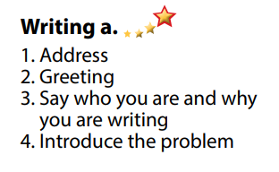  - Read and number the sentences.  - Exchange answers.  - Give answers.  Answer keys  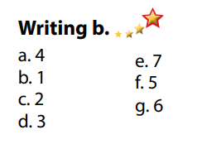  - Look and listen.  - Do the writing part.  - Write.  Suggested writing  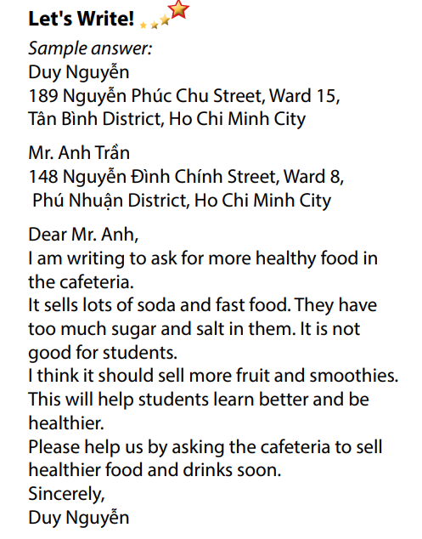
Activity 3: Post - Writing (5’)
a. Objective: Help Ss realize their mistakes in writing and correct them.
b. Content: Correcting Ss’ writings.
c. Expected outcomes: Students know whether their letters follow the model and use the correct structures and language, whether their writings are interesting and understandable or not.
d. Organization of the activity:
TEACHER’S ACTIVITIES | STUDENTS’ ACTIVITIES
- Give feedback, correct Ss’ mistakes.  - Use the feedback form to give evaluation. Focus on:  + the format, the structures.  + the understandability.  + the coherence and cohesion. | - Look, listen and correct mistakes.
C. Consolidation and homework assignments (5’)
* Consolidation:
- Format of a request letter:
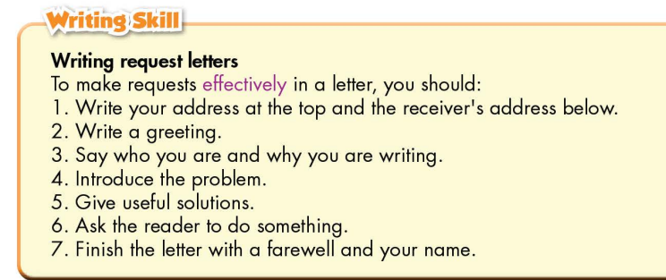

* Homework
- Remember how to write a request letter.
- Finish the writing part.
- Do the exercises in WB: Writing (page 13).
- Complete the grammar notes in Tiếng Anh 7 i-Learn Smart World Notebook (page 15).
- Play consolation games in Tiếng Anh 7 i-Learn Smart World DHA App on www.eduhome.com.vn
- Prepare: Unit 2 – Review.
***************************************************************
Teaching date: 18/10/2022
Period 19 UNIT 2: HEALTH
Lesson 4 – Review (Page 86)
I. OBJECTIVES
By the end of the lesson, Ss will be able to:
1.1. Language knowledge and skills
- review phrases about leading a healthy lifestyle (eat fruits and vegetables, get some sleep, take medicine, take vitamins, keep warm, …).
- review words about health problems (have a sore throat, headache, toothache, …).
- review grammar: Indefinite quantifiers, should, shouldn’t.
- pronoun some sounds correctly: /e/, /a/, /aɪ/, /æ/, / eɪ/.
1.2. Competences
- improve speaking, listening, reading and writing skills.
- improve the use of English.
1.3. Attributes
- have positive attitude in English language learning so that they actively participate in all classroom activities.
- review the old lesson and have good preparation for the midterm test.
II. TEACHING AIDS AND LEARNING MATERIALS
1. Teacher’s aids: Student book and Teacher’s book, class CDs, Digital Book (DCR phần mềm tương tác SB, DHA (từ vựng/ cấu trúc) phần mềm trò chơi tương tác), projector/interactive whiteboard / TV (if any), PowerPoint slides, handouts.
2. Students’ aids: Student’s book, workbook, notebook.
III. ASSESSMENT EVIDENCE
Performance Tasks | Performance Products | Assessment Tools
- Listening: Listen to a doctor talking to a group of students about staying healthy. Listen and fill in the blanks.  - Reading: Read the article about how to stay healthy. Choose the correct answer (A, B or C).  - Vocabulary: Fill in the blanks with the words from the box.  - Grammar: Unscramble the sentences + Circle the correct words.  - Pronunciation: sound and stress. | - Ss’ answers.  - Ss’ answers.  - Ss’ answers.  - Ss’ answers.  - Ss’ answers/ presentation. | - T’s feedback/Peers’ feedback.  - T’s feedback/Peers’ feedback.  - T’s feedback/Peers’ feedback.  - T’s feedback/Peers’ feedback.  - T’s observation, T’s feedback/Peers’ feedback.
IV. PROCEDURES
A. Warm up: (5’)
a. Objective: Introduce the new lesson and set the scene for Ss to acquire new language; get students' attention at the beginning of the class by enjoyable and short activities as well as to engage them in the follow-up steps.
b. Content: Review vocabulary.
c. Expected outcomes: Ss are ready for the new lesson.
d. Organization of the activity:
TEACHER’S ACTIVITIES | STUDENTS’ ACTIVITIES
Option 1: Word Dictation  - Choose 7 words from Vocabulary tasks (pages 12&15), find mp3 sound.  - Play the mp3 sound of each word (or T reads the words out loud), have Ss listen and write the word down on the board.  - Check and correct Ss’ answers.  - Have Ss make sentences with the words they hear.  - Give feedback and evaluation.  - Lead to the new lesson.  Option 2: Chatting: How to stay healthy?  - Ask Ss a question: How do you do to stay healthy?  - Have Ss give some solutions / activities to keep them fit and healthy  - Have Ss read their answers.  - Give feedback and evaluation.  - Lead to the new lesson. | - Listen and write the words you can hear.  - Make sentences.  Answer Keys  1. healthy 2. unhealthy  3. vitamin 4. sleep  5. fever 6. rest  7. fast food  - Give answers.  - Listen.
B. New lesson (35’)
Activity 1: Listening (7’)
a. Objective: Help Ss improve their listening skill.
b. Content:
- Listen to a doctor talking to a group of students about staying healthy. Listen and fill in the blanks.
c. Expected outcomes: Ss listen in details and get familiar with the listening test format.
d. Organization of the activity:
TEACHER’S ACTIVITIES | STUDENTS’ ACTIVITIES
You will hear a doctor talking to a group of students about staying healthy. Listen and fill in the blanks.  - Use DCR to show the task.  - Have Ss read through the listening part.  - Demonstrate the activity by using the example.  - Play the audio (CD 2 – Track 35).  - Have Ss check answers with pairs and then give answers.  - Check answers as a whole class. | - Read in silence.  - Listen and then give answers.  Answer keys  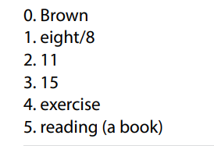
Activity 2: Reading (7’)
a. Objective: Students can improve their reading skill.
b. Content:
- Read the article about how to stay healthy and choose the correct answer.
c. Expected outcomes: Ss read for comprehension and get familiar with the reading test format.
d. Organization of the activity:
TEACHER’S ACTIVITIES | STUDENTS’ ACTIVITIES
Read the article about how to stay healthy and choose the correct answer (A, B or C)  - Use DCR to show the task.  - Demonstrate the activity by using the example.  - Have Ss read the article and choose the correct answer, underline the supporting ideas for their answers.  - Call Ss to give answers, explain.  - Give feedback and evaluation. | - Observe and listen.  - Work individually.  - Give answers, explain.  Answer keys  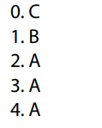
Activity 3: Vocabulary (7’)
a. Objective: Ss can review vocabulary about health.
b. Content: Fill in the blanks with the correct words from the box.
c. Expected outcomes: Ss produce the new language successfully, and they can use these words in speaking and writing.
d. Organization of the activity:
TEACHER’S ACTIVITIES | STUDENTS’ ACTIVITIES
Fill in the blanks with the words from the box.  - Use DCR to show the task.  - Have Ss read the sentences.  - Ask Ss to work in pairs to fill in the blanks with the words from the box.  - Have Ss give answers, tell the meaning of the words /phrase again.  - Check answers as a whole class. | - Read the sentences.  - Work in pairs.  - Give answers.  Answer keys  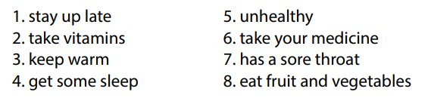
Activity 4: Grammar (10’)
a. Objective: Ss can review the use of English: Indefinite quantifiers, should and shouldn’t.
b. Content:
- Circle the correct words.
- Unscramble the sentences.
c. Expected outcomes: Ss produce the new language successfully, and they can use the grammar points in speaking and writing.
d. Organization of the activity:
TEACHER’S ACTIVITIES | STUDENTS’ ACTIVITIES
Task a. Circle the correct words  - Use DCR to show the task.  - Have Ss retell the way to use indefinite quantifiers: some, any, much, a lot of, lots of, a little.  - Ask Ss to work individually to circle the correct answer.  - Have Ss work in pairs to check each other’s work.  - Call Ss to give answers, explain for their choice.  - Check answers as a whole class.  Task b. Unscramble the sentences.  - Use DCR to show the task.  - Have Ss read the sentences and unscramble the words to make a meaningful sentence.  - Ask Ss to work in pairs to check each other’s work.  - Have Ss write answers on the board.  - Check Ss’ answers, give feedback. | - Review old knowledge.  - Work individually.  - Work in pairs.  - Give answers.  Answer keys  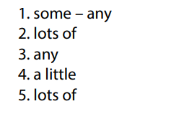  - Do the task.  - Exchange answers.  - Write answers on the board.  Answer keys  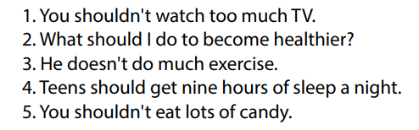
Activity 5: Pronunciation (4’)
a. Objective: Ss can review the word stress and vowels.
b. Content:
- Circle the word that has the underlined part pronounces differently from the others.
- Circle the word that has different stress from the rest.
c. Expected outcomes: Ss produce the new language successfully.
d. Organization of the activity:
TEACHER’S ACTIVITIES | STUDENTS’ ACTIVITIES
Task a. Circle the word that has the underlined part pronounced differently from the others.  - Have Ss distinguish the sound /e/, /a/, /aɪ/, /æ/ and /eɪ/.  - Use DCR to show the task.  - Ask Ss to work individually to circle the answer.  - Have Ss work in pairs to check each other’s work.  - Call Ss to give answers, pronounce the words again.  - Give feedback, correct Ss’ pronunciation if necessary.  Task b. Circle the word that differs from the other three in the position of primary stress in each of the following questions.  - Use DCR to show the task.  - Remind Ss some basic rules of putting stress on words with 2 or 3 syllables.  - Ask Ss to work individually.  - Have Ss work in pairs to check each other’s work.  - Call Ss to give answers, pronounce the words again.  - Give feedback, correct Ss’ pronunciation if necessary. | - Listen.  - Work individually.  - Work in pairs.  - Give answers.  Answer keys  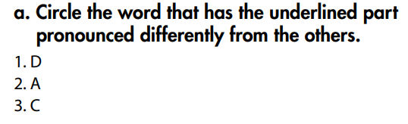  - Listen.  - Work individually.  - Work in pairs.  - Give answers.  Answer keys  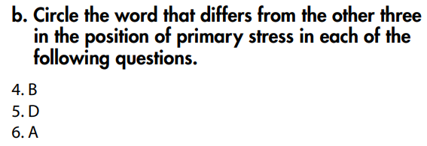
C. Consolidation and homework assignments (5’)
* Consolidation:
* Grammar of Unit 2: The indefinite quantifiers and should/shouldn’t.
* Vocabulary of Unit 2: Vocabulary about health problems and phrases about keep fit and stay healthy.
*Homework: - Review vocabulary, grammar of unit 2.
- Do the exercises in WB: Review of Unit 2 (page 63).
- Prepare: Unit 3 – New words and Reading (page 20 – SB).
****************************************************************
Teaching date: 19/10/2022
Period 20 UNIT 3: MUSIC AND ARTS
Lesson 1.1 - Vocabulary and Reading (Page 20)
I. OBJECTIVES
By the end of the lesson, Ss will be able to:
1.1. Language knowledge and skills
- talk about types of music (jazz, hip hop, pop, classical music, rock, country music).
- use some adjectives to describe types of music (boring, noisy, interesting, exciting, fun, terrible, beautiful).
- read and understand general and specific information about two students’ favorite types of music.
- use Present simple for facts.
1.2. Competences
- improve communication, collaboration, analytical and critical thinking skills.
1.3. Attributes
- love music.
- relax with music after hard studying days.
II. TEACHING AIDS AND LEARNING MATERIALS
1. Teacher’s aids: Student book and Teacher’s book, class CDs, Digital Book (DCR phần mềm tương tác SB, DHA (từ vựng/ cấu trúc) phần mềm trò chơi tương tác), projector/interactive whiteboard / TV (if any), PowerPoint slides.
2. Students’ aids: Student’s book, workbook, notebook.
III. ASSESSMENT EVIDENCE
Performance Tasks | Performance Products | Assessment Tools
- Introduce some words about types of music.  - Introduce adjectives to describe types of music.  - Match the words with the pictures in a.  - Listen and repeat.  - Discuss which types of music you like and dislike. Describe them using the adjectives in the book.  - Read the blog post of Binh and Linh. Do they like rock music?  - Read the unfinished sentences and circle the correct answers. | - Ss’ answers in notebooks.  - Ss’ answers.  - Ss’ answers.  - Ss’ answers.  - Ss’ answers/ presentation.  - Ss’ answers.  - Ss’ answers. | - T’s feedback.  - T’s observation/ DCR.  - T’s feedback/Peers’ feedback.  - T’s observation / feedback.  - T’s feedback/Peers’ feedback.  - T’s feedback/Peers’ feedback.
IV. PROCEDURES
A. Warm up: (5’)
a. Objective: Introduce the new lesson and set the scene for Ss to acquire new language; get students' attention at the beginning of the class by enjoyable and short activities as well as to engage them in the follow-up steps.
b. Content: Introduce some words about types of music (jazz, hip hop, pop, classical music, rock, country music).
c. Expected outcomes: Ss have general ideas about the topic of the new lesson: “music and arts”.
d. Organization of the activity:
TEACHER’S ACTIVITIES | STUDENTS’ ACTIVITIES
Option 1: Matching  - Use the “New words” part a.– page 20 for the warm-up activity.  - Show pictures and words using DCR, have Ss match the words and phrases with the pictures (in pairs).  - Call Ss to give answers.  - Give feedback and show correct answers.  - Lead to the new lesson.  - Play the audio (CD1 – Track 24), have Ss listen and repeat.  - Correct Ss’ pronunciation if necessary.  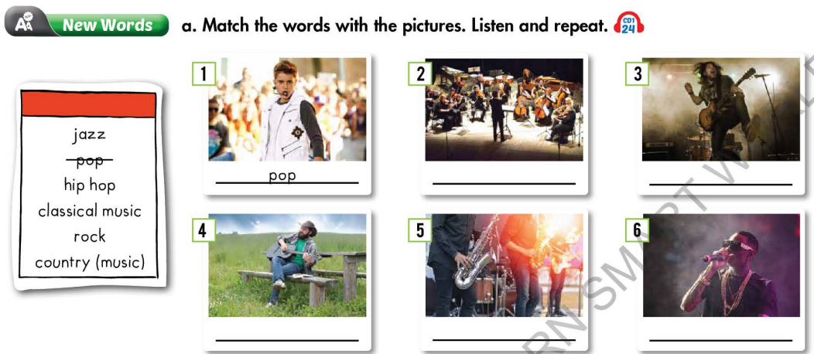  Option 2:  - Play a video clip about kinds of music.  - Have Ss listen and watch, then try to remember the kinds of music listed in the clip.  - Call Ss to give answers.  - Give feedback and lead to the new lesson: Music and arts.  *Link: https://www.youtube.com/watch?v=wiF8YlKNx4g  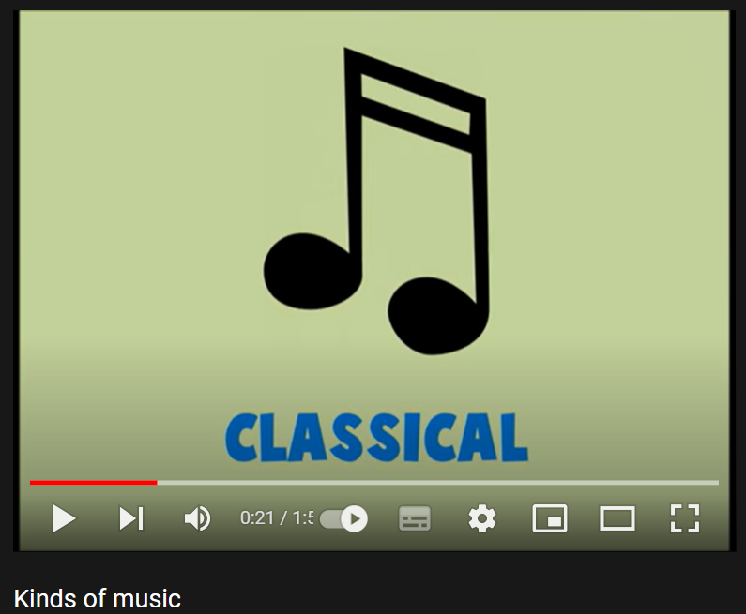 | - Work in pairs to match the words and phrases with the pictures.  - Give answers.  - Listen.  Answer keys  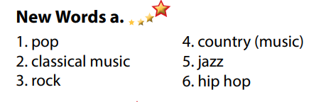  - Listen, watch and try to remember the kinds of music listed in the clip.  - Give answers.  Suggested answers  Kinds of music listed in the clip: blues, classical, country, rock, folk, hip hop, jazz, pop, reggae, rock.
B. New lesson (35’)
Activity 1: Pre-Reading (Vocabulary) (12’)
a. Objective: Ss know some words about types of music and adjectives to describe them
b. Content:
- Vocabulary study: words about types of music (jazz, hip hop, pop, classical music, rock, country music) and some adjectives to describe types of music (boring, noisy, interesting, exciting, fun, terrible, beautiful).
- Speaking: Say which types of music do you like and dislike. Use the adjectives in the box to describe them.
c. Expected outcomes: Ss know how to pronounce the new words correctly and use them in appropriate situations.
d. Organization of the activity:
TEACHER’S ACTIVITIES | STUDENTS’ ACTIVITIES
Task a. Match the words and phrases with the pictures. Listen and repeat.  Option 1 (If the teacher hasn’t used this part for the Warm-up activity)  - Demonstrate the activity on DCR, using the example.  - Have Ss match the words and phrases with the pictures.  - Divide class into pairs and have them check their answers with their partners.  - Call Ss to give answers (read or write).  - Check answers as a whole class.  - Play audio (CD1 – Track 24). Have Ss listen and repeat.  - Correct Ss’ pronunciation.  Option 2: Matching (If the teacher has used part a. for the Warm-up activity)  - Have Ss review the words they have known in the warm-up activity by looking at the pictures of some famous music bands / singers (Artists) in the word and matching them with words about types of music Ss have learnt.  - Call Ss to give answers (read or write).  - Check answers as a whole class.  - Call some Ss to read the words again.  - Correct Ss’ pronunciation if necessary.  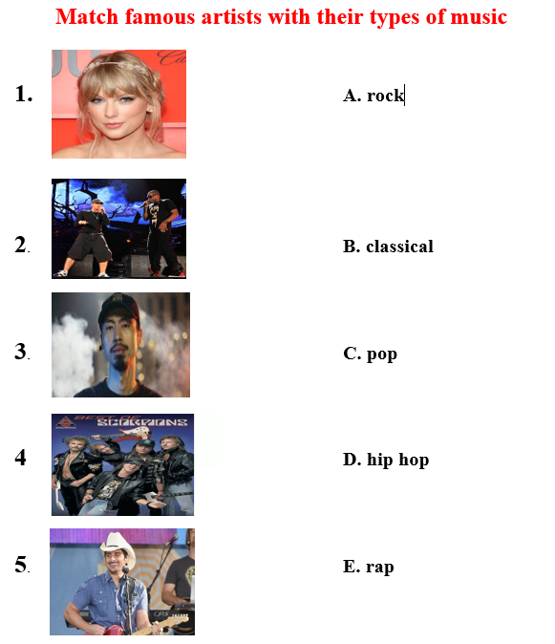  Task b. Discuss which types of music do you like and dislike. Describe them using the adjectives in the box.  - Have Ss discuss in pairs which types of music they like and dislike, encourage Ss to use some more adjectives besides the ones given in the textbook.  - Have Ss share their ideas in front of the class.  - Give feedback and evaluation. | - Look and listen.  - Work individually.  - Work in pairs.  - Give answers.  - Listen and repeat.  Answer keys  - Work in groups of 3 or 4.  - Give answers.  - Read.  Answer keys  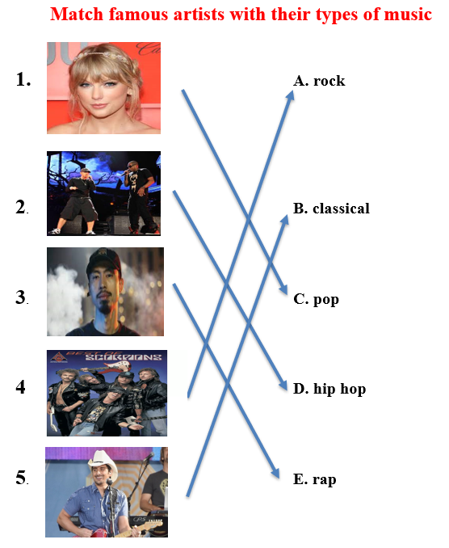  - Work in pairs.  - Present.
Activity 2: While - Reading (17’)
a. Objective: Students can develop their reading skill.
b. Content: Read the blog post. Do Bình and Linh both like rock music?
c. Expected outcomes: Students can read and understand general and specific information about a blog post about music types.
d. Organization of the activity:
TEACHER’S ACTIVITIES | STUDENTS’ ACTIVITIES
Task a. Read the blog post. Do Bình and Linh both like rock music?  - Ask Ss to read the blog post, and then answer the question.  - Remind Ss to underline or highlight the keywords or supporting ideas for their answers.  - Have Ss exchange their answers with a partner.  - Have some Ss share their answers with the class (read), explain for their answers.  - Give feedback.  - Give feedback and correct Ss’ answers if necessary.  Task b. Now, read and circle the correct answers.  - Have Ss read the questions, underline key words and guess the answers.  - Have Ss read the blog post again and circle the correct answers – underline or highlight the supporting ideas.  - Have Ss check answers with their partners.  - Call Ss to give answers, explain.  - Give feedback and evaluation. | -Work individually.  - Exchange answers.  - Read answers, explain.  - Check answers.  Answer keys    - Read and underline.  - Do the task.  - Check answers.  - Give answers.  Answer keys  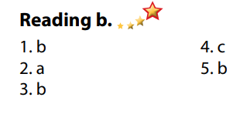
Activity 3: Post - Reading (6’)
a. Objective: Students can use the vocabulary and ideas from the reading text to develop their speaking skill.
b. Content: Speaking: When do you like to listen to music?
c. Expected outcomes: Students can talk about their favorite kinds of music and the time they listen to them.
d. Organization of the activity:
TEACHER’S ACTIVITIES | STUDENTS’ ACTIVITIES
Task c. In pairs: When do you like to listen to music?  - Have Students work in pairs to favorite kinds of music and the time they listen to them  - Call some Ss to share their ideas with the whole class  - Give feedback and evaluation | - Discuss in pairs.  - Present.  - Listen.

C. Consolidation and homework assignments (5’)
*Consolidation:
- Words about types of music (jazz, hip hop, pop, classical music, rock, country music).
- Adjectives to describe types of music (boring, noisy, interesting, exciting, fun, terrible, beautiful).
* Homework:
- Learn the new words by heart.
- Practice talking about types of music.
- Do the exercises in WB: New words + Reading (pages 14, 15).
- Do the vocabulary exercise in Tiếng Anh 7 i-Learn Smart World Notebook (page 16).
- Play consolation games in Tiếng Anh 7 i-Learn Smart World DHA App on www.eduhome.com.vn- - - Prepare: Unit 3 - Lesson 1.2 – Grammar (page 21 – SB).
******************************************************************
Teaching date: 21/10/2022
Period 21 UNIT 3: MUSIC AND ARTS
Lesson 1.2 - Grammar (Page 21)
I. OBJECTIVES
By the end of the lesson, Ss will be able to:
1.1. Language knowledge and skills
- listen to 2 people asking and answering about types of music.
- use present simple for facts.
- use correct spelling of “s” and “es” endings.
- talk about their favorite types of music.
1.2. Competences
- improve speaking, listening skills.
- improve the use of English.
1.3. Attributes
- love music.
- relax with music.
II. TEACHING AIDS AND LEARNING MATERIALS
1. Teacher’s aids: Student book and Teacher’s book, class CDs, Digital Book (DCR phần mềm tương tác SB, DHA (từ vựng/ cấu trúc) phần mềm trò chơi tương tác), projector/interactive whiteboard / TV (if any), PowerPoint slides, handouts.
2. Students’ aids: Student’s book, workbook, notebook, handouts.
III. ASSESSMENT EVIDENCE
Performance Tasks | Performance Products | Assessment Tools
- Listen and repeat.  - Circle the correct words.  - Write sentences using the pictures.  - Ask your partner about favorite kinds of music. | - Ss’ performance.  - Ss’ answers.  - Ss’ answers.  - Ss’ answers/ presentation. | - T’s feedback.  - T’s feedback/Peers’ feedback.  - T’s feedback/Peers’ feedback.  - T’s observation, T’s feedback/Peers’ feedback.
IV. PROCEDURES
A. Warm up: (5’)
a. Objective: Introduce the new lesson and set the scene for Ss to acquire new language; get students' attention at the beginning of the class by enjoyable and short activities as well as to engage them in the follow-up steps.
b. Content: Review types of music / Review present simple tense.
c. Expected outcomes: Ss review old vocabularies / grammar points which are very useful for them in the new lesson.
d. Organization of the activity:
TEACHER’S ACTIVITIES | STUDENTS’ ACTIVITIES
Option 1: Game “JUMBLED WORD”  - Have Ss rearrange letters to make a meaningful word.  - Call Ss to give answers.  - Check Ss’ answers, give feedback and lead to the new lesson.  1. lislascac 2. okrc 3. opp  4. ipophh 5. zajz 6.trouncy  - Have Ss make sentences, using the words they have just made.  - Lead to the new lesson.  Option 2: Error Identification  - Give Ss a small exercise: Choose a word / phrase in each sentence that does not follow the English standard. (or Choose a word / phrase in each sentence that needs correcting) and correct it.  - Have Ss work in pairs.  - Call Ss to give answers, explain for their choice and correct the false sentences.  - Check Ss’ answers, give feedback.  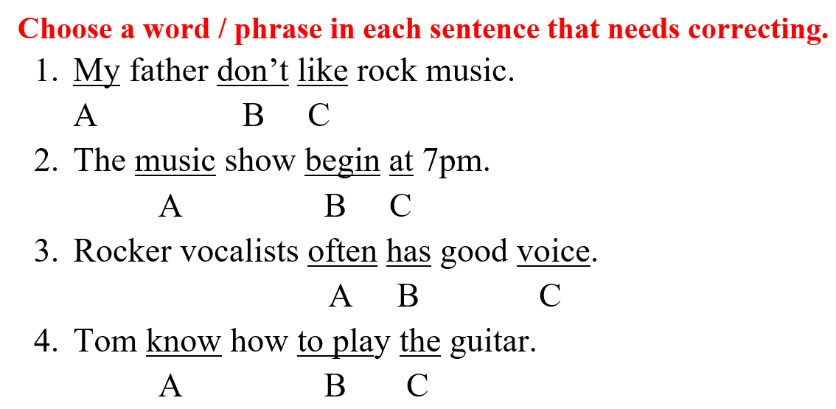  - Ask Ss an extra question: What are these sentences about? (habit or fact?)  - Lead to the new lesson: Present Simple for facts. | - Take part in the game.  - Give answers (write on the board).  Answers keys  1. classical 2. rock 3. pop  4. hip hop 5. Jazz 6. country  - Read sentences.  - Work in pairs.  - Read answers, explain, correct the mistakes.  Answers keys  1. B: don’t or doesn’t  2. B: begin or begins  3. B: has or have  4. A: know or knows  Answers keys  These sentences are about fact.
B. New lesson (35’)
Activity 1: Presentation (10’)
a. Objective: Introduce Present Simple for facts.
b. Content:
- Listen and repeat.
- Go through the grammar point.
c. Expected outcomes: Ss know about indefinite quantifiers and use it in some exercises that follow.
d. Organization of the activity:
TEACHER’S ACTIVITIES | STUDENTS’ ACTIVITIES
Task a. Listen and repeat  - Have Ss look at the picture (using DCR).  - Play audio (CD1 – Track 25) and have Ss listen and read the speech bubbles.  - Play the audio again and have Ss listen and repeat.  Grammar box  Option 1:  - Have Ss look at the grammar explanation and read.  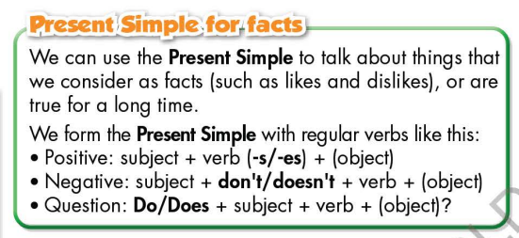  - Have Ss look at the box and read examples of different forms.  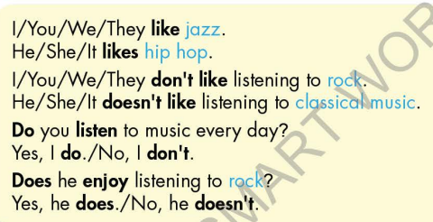  - Remind Ss the spelling of “s” / “es” endings.  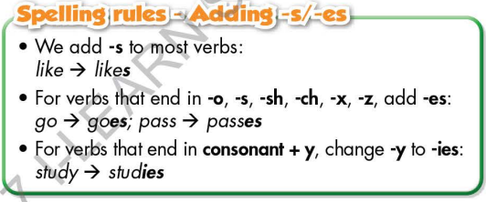  - Ask Ss to make more sentences using Present Simple for facts.  Option 2:  - Have Ss close books.  - Show some model sentences, ask Ss to read the sentences, paying attention to the bold verbs in these sentences.  - Have Ss think and answer the questions:  1.What tense is being used in these sentences?  2.What are these sentences about?  - Then, lead to the grammar box, briefly explain the way to use the Present Simple for facts.  - Have Ss read the grammar box again.  - Ask Ss to make more examples using the Present Simple for facts.  - Give feedback and evaluation.  - Remind Ss the spelling of “s” / “es” endings. | - Look.  - Listen, then read.  - Listen and repeat.  - Look and read.  - Read examples of different forms.  - Listen.  - Give more examples.  - Close all books.  - Look and read.  - Give answers.  Suggested answers  1.The present simple tense.  2.These sentences are about things that we consider as facts (likes / dislikes).  - Look and read.  - Give more examples.  - Listen.
Activity 2: Practice (19’)
a. Objective: Students can use the Present Simple for facts to do the given exercises.
b. Content:
- Circle the correct words.
- Write sentences using the pictures.
c. Expected outcomes: Students can get used to the form and usage of the Present Simple for facts and use them correctly.
d. Organization of the activity:

TEACHER’S ACTIVITIES | STUDENTS’ ACTIVITIES
Task b. Circle the correct words  - Demonstrate the activity on DCR, using the example.  - Have Ss read the sentences and circle the correct words.  - Have Ss work in pairs to check each other’s work.  - Have some Ss share their answers with the whole class.  - Give feedback, correct Ss’ answers if necessary.  Task c. Write sentences, using the pictures.  - Demonstrate the activity on DCR, using the example.  - Have Ss look at the pictures and write sentences.  - Have Ss check answers with their partners.  - Call Ss to write answers on the board.  - Check Ss’ answers, give feedback and evaluation. | - Look and listen.  - Work individually.  - Work in pairs.  - Read answers.  Answer keys  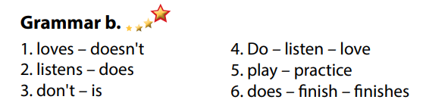  - Look and listen.  - Work individually.  - Work in pairs.  - Write answers.  Answer keys  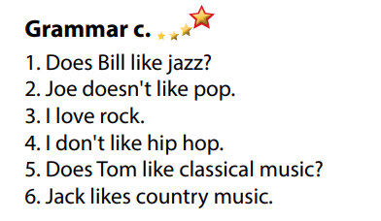
Activity 3: Production (6’)
a. Objective: Students master the grammar point they study in the lesson.
b. Content: Speaking: Ask and answer about favorite kind of music.
c. Expected outcomes: Ss produce the new language successfully, and they can use the Present Simple for facts in everyday speaking and writing.
d. Organization of the activity:
TEACHER’S ACTIVITIES | STUDENTS’ ACTIVITIES
Task d. In pairs: Ask and answer with your partner about his / her favorite music type.  - Divide class into pairs.  - Have Ss take turns asking their partner about his / her favorite music type.  - Have some pairs demonstrate the activity in front of the class.  - Give feedback and evaluation. | - Have conversation in pairs.  - Present.  - Listen.
C. Consolidation and homework assignments (5’)
* Consolidation:
*Homework:
- Make 3 sentences using the Present Simple for facts.
- Do the exercises in WB: Lesson 1 – Grammar & writing (page 15).
- Complete the grammar notes in Tiếng Anh 7 i-Learn Smart World Notebook (page 17).
- Play consolation games in Tiếng Anh 7 i-Learn Smart World DHA App on www.eduhome.com.vn
- Prepare: Lesson 1.3 – Pronunciation and Speaking (page 22 – SB)
******************************************************************
Teaching date: 25/10/2022
Period 22 UNIT 3: MUSIC AND ARTS
Lesson 1.3 – Pronunciation and Speaking (Page 22)
I. OBJECTIVES
By the end of the lesson, Ss will be able to:
1.1. Language knowledge and skills
- pronoun the sounds /s/ and /z/ of “s” at the end of the verbs.
- ask and answer about whether a person likes a type of music or not.
- conduct a music survey.
1.2. Competences
- improve listening and speaking skills.
1.3. Attributes
- love music.
- relax with music.
II. TEACHING AIDS AND LEARNING MATERIALS
1. Teacher’s aids: Student book and Teacher’s book, class CDs, Digital Book (DCR phần mềm tương tác SB, DHA (từ vựng/ cấu trúc) phần mềm trò chơi tương tác), projector/interactive whiteboard / TV (if any), PowerPoint slides, handouts.
2. Students’ aids: Student’s book, workbook, notebook.
III. ASSESSMENT EVIDENCE
Performance Tasks | Performance Products | Assessment Tools
- Listen to the words and focus on the underlined letters.  - Listen and cross out the word with the different sound.  - Read the words with the correct sound to a partner.  - Point, ask and answer.  - Practice with their own ideas.  - Carry out a survey in groups of 4: Fill in the table with your own information. Put a ✓ if you like the music or a cross (x) if you don’t, and add an adjective to give your opinion. Then, ask 3 friends and complete the table. | - Ss’ performance and answers.  - Ss’ answers.  - Ss’ performance.  - Ss’ performance.  - Ss’ performance.  - Ss’ performance /  Presentation. | - T’s observation.  - T’s feedback/Peers’ feedback.  - T’s feedback/Peers’ feedback.  - T’s feedback/Peers’ feedback.  - T’s feedback/Peers’ feedback.  - T’s observation, T’s feedback/Peers’ feedback.
IV. PROCEDURES
A. Warm up: (5’)
a. Objective: Introduce the new lesson and set the scene for Ss to acquire new language; get students' attention at the beginning of the class by enjoyable and short activities as well as to engage them in the follow-up steps.
b. Content: Review adjectives to describe films / review “s” or “es” after verbs spelling.
c. Expected outcomes: Ss remember old knowledge and use them in other speaking activities.
d. Organization of the activity:
TEACHER’S ACTIVITIES | STUDENTS’ ACTIVITIES
Option 1:  - Give Ss a list of adjectives, have Ss work in pairs to divide them into 2 groups: positive and negative.  - Suggested adjective list: boring, interesting, fun, terrible, exciting, beautiful, frightening, amazing, incredible, bad, cool, romantic, tragic, violent, great.  - Call Ss to read answers.  - Give feedback.  - Lead to the new lesson.  Option 2: “s” / “es” ending spelling  - Give Ss a list of verbs, have Ss work in pairs to put “s” or “es” after these verbs, using correct spelling.  - Suggested verb list: learn, study, play, touch, miss, watch, listen, wash, go, get, do, like, sing, walk, eat, reply, teach.  - Call Ss to read answers.  - Give feedback.  - Lead to the new lesson. | - Work in pairs, then give answers.  Answer keys  - Positive adjectives to describe films: interesting, fun, exciting, beautiful, amazing, incredible, cool, romantic, great  - Negative adjectives to describe films: boring, terrible, frightening, bad, tragic, violent  - Listen.  - Work in pairs, then give answers.  Answer keys  learns, studies, plays, touches, misses, watches, listens, washes, goes, gets, does, likes, sings, walks, eats, replies, teaches.  - Give answers.  - Listen.
B. New lesson (35’)
Activity 1: Pre-Speaking: Pronunciation (10’)
a) Objective: Introduce the sound /s/, /z/ of “s” at the end of verbs.
b) Content:
- recognize the sound /s/, /z/ of “s” at the end of verbs.
- listen and check, find mistakes.
- practice.
c) Expected outcomes: Ss distinguish and use the sound /s/, /z/ of “s” at the end of verbs correctly in their speaking.
d) Organization of the activity:
TEACHER’S ACTIVITIES | STUDENTS’ ACTIVITIES
Task a + b. Listen to the words and focus on the underlined letters.  - Play the recording (CD1, track 26) using DCR.  - Ask Ss to listen and focus on the underlined letters  - Play the recording again, have Ss listen and repeat with a focus on the pronunciation feature.  - Explain more about the tips how to pronounce the sound /s/, /z/ of “s” at the end of verbs.  *The pronunciation of the final “s” in plural words and verbs in the third person singular depends on the final consonant sound before that “s”. The ending is pronounced /s/ after a voiceless sound, it is pronounced /z/ after a voiced sound.  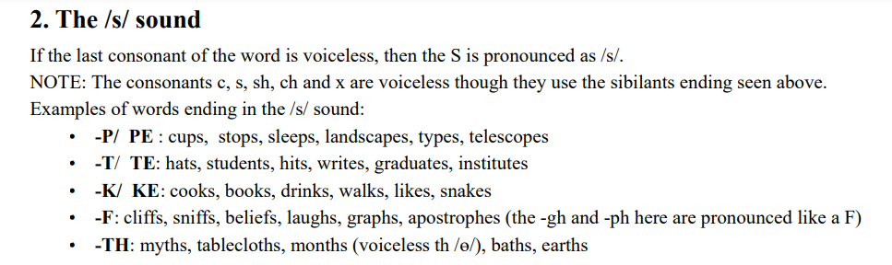  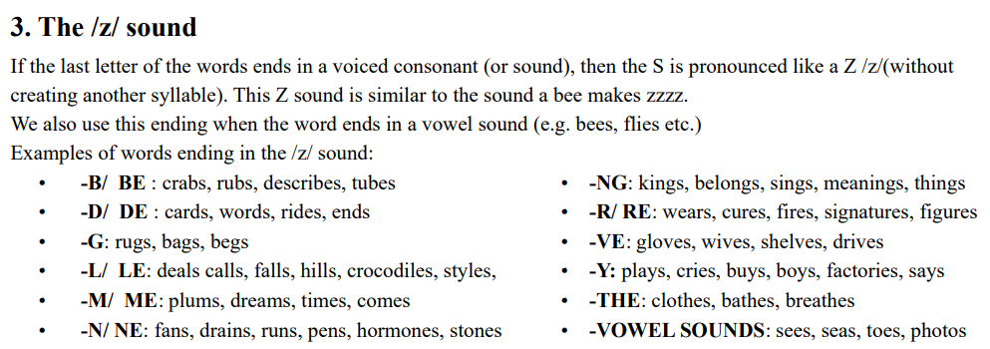  Task c + d. Listen and cross out the word with the different sound, then read the words with the correct sound to a partner.  - Play the recording (CD 1 – Track 27) using DCR, have Ss listen and cross out the option that doesn’t follow the sound feature in “a”.  - Call Ss to give answers.  - Play the recording again and check answers as a whole class.  - Then have Ss practice saying the examples with a partner, using the correct pronunciation feature.  - Call some Ss to read the words in front of the class.  - Ask Ss to find some more English words with an “s” ending which contains /s/ and /z/ sound.  - Give feedback and evaluation. | - Listen.  - Listen again and repeat.  - Listen again and take notes.  - Listen and cross out.  - Give answers.  - Listen again and check.  Answer keys  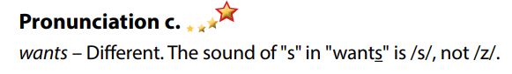  - Work in pairs.  - Read.  - Give answers.
Activity 2: While-speaking (20’)
a. Objective: Students can talk about whether a person likes a type of music or not, using adjectives to describe it.
b. Content:
- point to the pictures, ask and answer.
- do a music survey about favorite type of music, fill in the table with your own information , then ask 3 friends to complete the table.
c. Expected outcomes: Ss produce the new language successfully.
d. Organization of the activity:
TEACHER’S ACTIVITIES | STUDENTS’ ACTIVITIES
PRACTICE  *Point, ask and answer  - Use DCR to introduce the task.  - Demonstrate the activity by asking and answering with a student.  - Have pairs take turns pointing, asking, and answering using the pictures and words in the box.  - Remind Ss to pay attention to the adjectives to describe film types in the box.  - Have some pairs demonstrate the activity in front of the class.  SPEAKING: Music Survey  Task a. In fours: Fill in the table with your own information. Put a tick (✔) if you like the music or a cross (✘) if you don't, and add an adjective to give your opinion. Then, ask three friends and complete the table  - Demonstrate the activity by practicing the activity with a student.  - Divide the class into groups of 4.  - Have students fill in the table for themselves.  - Have students ask three friends and complete the table.  - Observe, give help if necessary. | - Observe, listen.  - Work in pairs.  - Present.  - Observe and listen.  - Work in groups of 4.  - Complete the survey.
Activity 3: Production (5’)
a. Objective: Students report to the class about the survey results.
b. Content: Answer: What is the most popular kind of music in your group?
c. Expected outcomes: Ss produce the new language successfully in everyday speaking and writing.
d. Organization of the activity:
TEACHER’S ACTIVITIES | STUDENTS’ ACTIVITIES
SPEAKING: Music Survey  Task b. Answer the question: What is the most popular kind of music in your group?  - Have students decide which is the most popular kind of music in their group.  - Have some Ss share their findings with the class.  - Give feedback and evaluation. | - Discuss.  - Present.  - Listen.
C. Consolidation and homework assignments (5’)
*Consolidation:

* Homework:
- Practice pronouncing words with “s” endings.
- Complete the survey for those who haven’t finished it in class.
- Prepare: Unit 3 - Lesson 2 – New words and Listening (page 23 – SB).
- Review the vocabulary and grammar notes in Tiếng Anh 7 i-Learn Smart World Notebook
(pages 16 & 17).
- Play consolation games in Tiếng Anh 7 i-Learn Smart World DHA App on www.eduhome.com.vn
********************************************************************
Teaching date: 26/10/2022

Period 23 UNIT 3: MUSIC AND ARTS
Lesson 2.1 – New words and Listening (Page 23)
I. OBJECTIVES
By the end of the lesson, Ss will be able to:
1.1. Language knowledge and skills
- know more words about other different types of music (which are unfamiliar with teenagers): blues, reggae, electronic, RnB, folk (music), heavy metal.
- make plans to go to a music event.
- practice listening to a conversation between three friends about a music event (for general and specific details).
- invite someone to speak.
1.2. Competences
- improve communication, collaboration, and critical thinking skills.
1.3. Attributes
- love other music types in the world.
- be well-organized for planning to do some activities with friends.
II. TEACHING AIDS AND LEARNING MATERIALS
1. Teacher’s aids: Student book and Teacher’s book, class CDs, Digital Book (DCR phần mềm tương tác SB, DHA (từ vựng/ cấu trúc) phần mềm trò chơi tương tác), projector/interactive whiteboard / TV (if any), PowerPoint slides.
2. Students’ aids: Student’s book, workbook, notebook.
III. ASSESSMENT EVIDENCE
Performance Tasks | Performance Products | Assessment Tools
- Activate some new words about music types.  - Match the words with the description.  - Listen and repeat.  - Ask and answer about each type of music. Do you like any of them?  - Listen to three friends talking about a music event. Where are they?  - Listen and answer the questions.  - Speak: What kind of music concert would you like to go to? Which band or singer would you like to see? | - Ss’ answers.  - Ss’ answers.  - Ss’ performance.  - Ss’ answers/ presentation.  - Ss’ answers.  - Ss’ answers.  - Ss’ answers/ presentation. | - T’s feedback.  - T’s observation/ DCR.  - T’s feedback/Peers’ feedback.  - T’s feedback/Peers’ feedback.  - T’s feedback/Peers’ feedback.  - T’s feedback/Peers’ feedback.  - T’s observation and feedback / DCR.
IV. PROCEDURES
A. Warm up: (5’)
a. Objective: Introduce the new lesson and set the scene for Ss to acquire new language; get students' attention at the beginning of the class by enjoyable and short activities as well as to engage them in the follow-up steps.
b. Content: Introduce words about some more music types: electronic, heavy metal, reggae, blues, folk music, RnB.
c. Expected outcomes: Ss get to know some new words they are going to study in the lesson.
d. Organization of the activity:
TEACHER’S ACTIVITIES | STUDENTS’ ACTIVITIES
Option 1: Match the words with the descriptions. Listen and repeat.  - Use the “New words” part a.– page 23 for the warm-up activity.  - Show pictures with description (using DCR), have Ss look at the pictures and read the description, then match them with the words in the box (in pairs).  - Call Ss to give answers.  - Give feedback and show correct answers.  - Lead to the new lesson.  - Play the audio (CD1 – Track 28), have Ss listen and repeat.  - Correct Ss’ pronunciation if necessary.  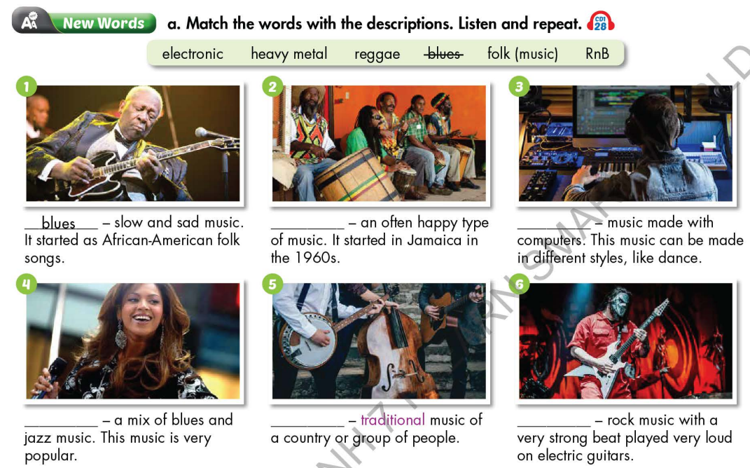  Option 2: Listen and identify music types  - Find some pieces of music of different music types on the internet (mp3 files – each file lasts about 15-20 seconds). There are 6 sound files of 6 types: electronic, heavy metal, reggae, blues, folk music, RnB.  - Play the mp3 sound files, have Ss listen and give names of music types.  - Call Ss to give answers.  - Give feedback and evaluation.  - Lead to the new lesson. | - Work in pairs.  - Give answers.  - Listen.  - Listen and repeat.  Answer keys  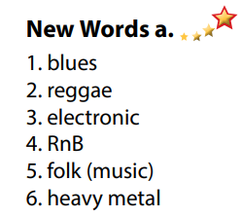  - Listen and guess the names of music types.
B. New lesson (35’)
Activity 1: Pre-Listening (Vocabulary) (12’)
a. Objective: Ss get to know words about music types and state whether they like them or not.
b. Content:
- Vocabulary study (electronic, heavy metal, reggae, blues, folk music, RnB).
- Speaking: Ask and answer about each type of music. Do you like any of them?
c. Expected outcomes: Ss know how to pronounce the new words correctly and use them when talking about music types.
d. Organization of the activity:
TEACHER’S ACTIVITIES | STUDENTS’ ACTIVITIES
Task a. Match the words with the descriptions. Listen and repeat.  Option 1 (If the teacher hasn’t used this part for the Warm-up activity)  - Demonstrate the activity on DCR, using the example.  - Have Ss match the words with the descriptions.  - Divide class into pairs and have them check their answers with their partners.  - Call Ss to give answers (read or write).  - Check answers as a whole class.  - Play audio (CD1 – Track 28). Have Ss listen and repeat.  - Correct Ss’ pronunciation.  Option 2: Matching (If the teacher has used part a. for the Warm-up activity)  - Have Ss review the words they have known in the warm-up activity by matching music types with its short description.  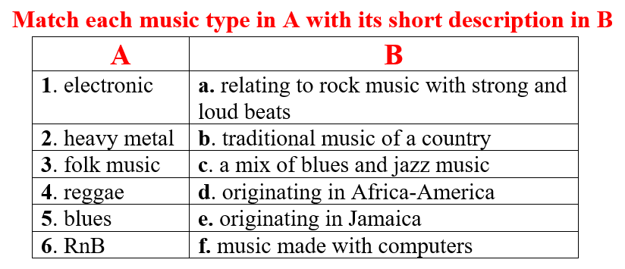  - Call Ss to read answers.  - Check answers as a whole class.  - Call some Ss to read the words again.  - Correct Ss’ pronunciation if necessary.  Task b. In pairs: Ask and answer about each type of music. Do you like any of them?  - Have Ss work in pairs to ask and answer about each type of music.  - Have pairs discuss whether they like any of the types of music in Task a.  - Have some pairs share their ideas with the class.  - Give feedback and evaluation. | - Look and listen.  - Work individually.  - Work in pairs.  - Give answers.  - Listen and repeat.  Answer keys  - Work in pairs.  - Give answers.  - Read.  Answer keys  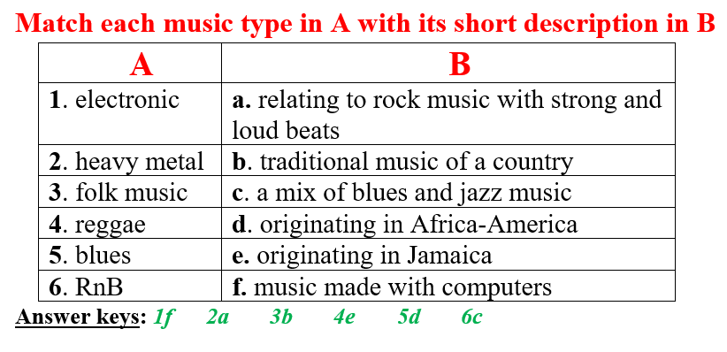  - Work in pairs.  - Present.
Activity 2: While - Listening (17’)
a. Objective: Students can develop their listening skill.
b. Content: Listen to three friends talking about a music event. Where are they?
c. Expected outcomes: Students can listen and understand general and specific information about a music event.
d. Organization of the activity:
TEACHER’S ACTIVITIES | STUDENTS’ ACTIVITIES
Task a. Listen to three friends talking about a music event. Where are they?  - Have Ss read the phrases, guess the answer.  - Play audio (CD1 - Track 29) using DCR.  - Have Ss listen and circle the correct answer.  - Check answer as a whole class.  Task b. Now, listen and answer the questions  - Have Ss read the through the questions in task b, underline the key words.  - Play the audio again (CD1 - Track 29) using DCR.  - Have Ss listen and answer the questions.  - Remind Ss to give short answers, not a full sentence to answer for each question.  - Have Ss check answers with their partners.  - Call Ss to give answers.  - Give feedback and show correct answers. | -Work individually.  - Listen.  - Circle the correct answers.  Answer keys  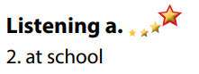  - Read and underline the key words.  - Do the task.  - Check answers.  Answer keys  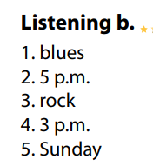
Activity 3: Post - Listening (6’)

a. Objective: Students can use the vocabulary and the content in listening part to develop their speaking skill.
b. Content: Speaking: What kind of music concert would you like to go to? Which band or singer would you like to see?
c. Expected outcomes: Students can have a free-talk about how to overcome sickness.
d. Organization of the activity:
TEACHER’S ACTIVITIES | STUDENTS’ ACTIVITIES
Conversation skill  - Have Ss look at the Conversation skill box and read.  - Play audio (CD 1 - Track 30) using DCR, have Ss listen and repeat.  - Ask Ss to find more ways to invite someone to speak.  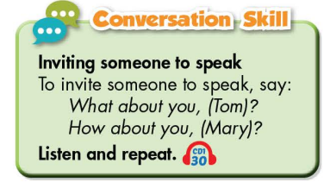  Task c. In pairs: What kind of music concert would you like to go to? Which band or singer would you like to see?  - Have Ss work in pairs to discuss.  - Observe and give help if necessary.  - Call some pairs to share their ideas with the class  - Give feedback and evaluation. | - Look and read.  - Listen and repeat.  - Give answers.  - Work in pairs.  - Present.
C. Consolidation and homework assignments (4’)
*Consolidation:
- Words about music types: electronic, heavy metal, reggae, blues, folk music, RnB.
- Language to invite someone to speak: What about you? / How about you? …
*Homework
- Learn the new words by heart.
- Practice making plans to go to a music event.
- Do the exercises in WB: New words and Listening (page 16).
- Do the vocabulary exercise in Tiếng Anh 7 i-Learn Smart World Notebook (page 18).
- Play consolation games in Tiếng Anh 7 i-Learn Smart World DHA App on www.eduhome.com.vn
- Prepare: Lesson 2.2 – Grammar (page 24 – SB).
********************************************************************

Teaching date: 28/10/2022
Period 24 Revision: Unit 1

I. OBJECTIVES
By the end of the lesson, Ss will be able to:
1.1. Language knowledge and skills
- review vocabulary related to hobbies
- grammar (present simple), prepositions of place
1.2. Competences
- improve speaking, listening and writing skills.
- improve the use of English.
1.3. Attributes
- enjoy your hobbies.
II. TEACHING AIDS AND LEARNING MATERIALS
1. Teacher’s aids: Student book and Teacher’s book, class CDs, Digital Book (DCR phần mềm tương tác SB, DHA (từ vựng/ cấu trúc) phần mềm trò chơi tương tác), projector/interactive whiteboard / TV (if any), PowerPoint slides, handouts.
2. Students’ aids: Student’s book, workbook, notebook.
III. PROCEDURES
A. Warm up: (5’)
a. Objective: Introduce the revision lesson; get students' attention at the beginning of the class by enjoyable and short activities as well as to engage them in the follow-up steps.
b. Content: Introduce words about hobbies
c. Expected outcomes: Ss get to know some new words they are going to study in the lesson.
d. Organization of the activity:
A. Vocabulary
1. Hobbies
Từ | Từ loại | Phát âm | Nghĩa
collect soccer stickers | (v.phrase) | /kəˈlekt ˈsɒkə(r) ˈstɪkərz/ | Thu thập nhãn dán bóng đá
(build) models | (v.phrase) | /bɪld ˈmɒdlz/ | Dựng mô hình
bake (cakes) | (v.phrase) | /beɪk keɪks/ | Nướng bánh
(make) vlogs | (v.phrase) | /meɪk vlɒɡz/ | Làm vlogs
(read) comics | (v.phrase) | /riːd ˈkɒmɪks/ | Đọc truyện tranh
(play) online games | (v.phrase) | /pleɪ ˌɒnˈlaɪn ɡeɪmz/ | Chơi trò chơi trực tuyến
2. Places
Từ | Từ loại | Phát âm | Nghĩa
sports center | (n) | /ˈspɔːrts sentər/ | Trung tâm thể thao
bowling alley | (n) | /ˈbəʊlɪŋ æli/ | Sàn chơi bowling
theater | (n) | /ˈθiːətər/ | Rạp hát, nhà hát
ice rink | (n) | /ˈaɪs rɪŋk/ | Sân trượt băng
water park | (n) | /ˈwɔːtər pɑːrk/ | Công viên nước
market | (n) | /ˈmɑːrkɪt/ | Chợ
fair | (n) | /fer/ | Hội chợ
3. Extreme sports
Từ | Từ loại | Phát âm | Nghĩa
extreme sport | (n.phrase) | /ɪkˈstriːm spɔːrt/ | Môn thể thao mạo hiểm
skateboarding | (n) | /ˈskeɪtbɔːrdɪŋ/ | Môn trượt ván
surfing | (n) | /ˈsɜːrfɪŋ/ | Môn lướt sóng
rock climbing | (n) | /ˈrɒk klaɪmɪŋ/ | Môn leo núi đá
zorbing | (n) | /ˈzɔːrbɪŋ/ | Môn lăn xuống dốc bên trong một quả cầu trong suốt
safety equipment | (n.phrase) | /ˈseɪfti ɪˈkwɪpmənt/ | Thiết bị an toàn
availability | (n) | /əˌveɪləˈbɪləti/ | Tính sẵn dùng, sự sẵn sàng
B. Grammar
1. Present simple for habits (Thì Hiện tại đơn nói về thói quen)
a. Cách dùng
- Sử dụng thì Hiện tại đơn dùng để diễn tả một thói quen hoặc một hành động có tính lặp đi lặp lại, xảy ra thường xuyên ở hiện tại.
b. Công thức
 | Công thức
(+) | I/ You/ We/ They + V-inf.  He/ She/ It + V(s/es).
(-) | I/ You/ We/ They + don’t + V-inf.  He/ She/ It + doesn’t + V-inf.
(?) | Do + I/ you/ we/ they + V-inf?  Does + he/ she/ it + V-inf?  - Yes, S do/ does.  - No, S don’t/ doesn’t.
(?) | Wh-word + do/ does + S + V-inf?
c. Dấu hiệu nhận biết
- Cụm từ với “every”: every day, every year, every month, every afternoon, every morning, every evening ...
- Cụm từ chỉ tần suất: once a week, twice a week, three times a week, four times a week, five times a week, once a month, once a year, …
- Trạng từ chỉ tần suất: always, usually, often, sometimes, never, rarely...
2. Present Continuous for future plans (Thì Hiện tại tiếp diễn nói về tương lai)
a. Cách sử dụng
- Sử dụng thì Hiện tại tiếp diễn để diễn tả một kế hoạch sắp xảy ra trong tương lai gần (thường có thời gian đi cùng).
b. Công thức
(+) | I + am + V-ing.  You/ We/ They/ Danh từ số nhiều + are + V-ing.  He/ She/ It/ Danh từ số ít/ Danh từ không đếm được + is + V-ing.
(-) | I + am not + V-ing.  You/ We/ They/ Danh từ số nhiều + aren’t + V-ing.  He/ She/ It/ Danh từ số ít/ Danh từ không đếm được + isn’t + V-ing.
(?) | Am/ Is/ Are + S + V-ing?  - Yes, S + am/ is/ are.  - No, S + am not/ isn’t/ aren’t.
(?) | Wh + am/ is/ are (not) + S + V-ing?
c. Thêm “-ing” vào động từ
- Thông thường, thêm “-ing” vào sau các động từ.
- Khi động từ kết thúc bằng “e” bỏ “e” trước khi thêm “-ing”. (have, make)
- Khi động từ kết thúc bằng “ee” thêm “-ing” mà không bỏ “-e”. (see, agree)
- Khi động từ kết thúc bằng “ie” đổi “ie” thành “y” rồi thêm “-ing”. (lie, die)
- Khi động từ có 1 âm tiết kết thúc bằng 1 phụ âm (trừ h, w, x, y) đi trước là 1 nguyên âm gấp đôi phụ âm cuối rồi thêm “-ing”. (run, stop)
- Khi động từ có 2 âm tiết trở lên, nếu trọng âm nhấn vào âm cuối thì gấp đôi phụ âm, nếu trọng âm không nhấn vào âm cuối thì không gấp đôi phụ âm. (permit, enter)
3. Preposition of places
- Giới từ chỉ vị trí được sử dụng để nói về vị trí của một vật hay một người nào đó.
- 1 số giới từ chỉ vị trí:
next to: bên cạnh
opposite: đối diện
in front of: phía trước
behind: phía sau
TEST FOR UNIT 1
I. Choose the words whose underlined part is pronounced differently from that of the others in each group.
1. A. bake B. cake C. safety D. habits
2. A. ice B. comic C. online D. climbing
3. A. anything B. brother C. together D. they
4. A. sport B. surfing C. sure D. spend
5. A. theater B. beach C. teacher D. speaker
6. A. about B. bought C. found D. mountain
7. A. gifts B. models C. friends D. cars
8. A. games B. hobbies C. classmates D. gives
9. A. invited B. sounded C. excited D. scared
10. A. provided B. helped C. collected D. noted
II. Choose the word whose main stressed syllable is placed differently from that of the other in each group.
11. A. online B. comic C. soccer D. sticker
12. A. bowling B. market C. water D. collect
13. A. arrange B. theater C. surfing D. center
14. A. zorbing B. safety C. building D. tonight
15. A. coffee B. alley C. idea D. detail
III. Choose the best answer to complete each sentence.
16. Jenny likes cooking, so she often__________ in her free time.
A. plays online games B. bakes cakes C. makes vlogs D. collect stickers
17. Let’s go to the__________. I would like to watch a film.
A. amusement park B. megacity C. theater D. fair
18. What are you doing__________?
A. tonight B. yesterday C. every day D. twice a week
19. We are__________ in front of the park tonight.
A. meets B. meet C. is meet D. meeting
20. We enjoy__________ in the ice rink.
A. running B. skating C. buying D. going
21. __________Anna often__________ to the water park in summer?
A. Does-go B. Do-go C. Do-goes D. Does-goes
22. My little sister is sometimes interested in__________ crafts at the fair.
A. going B. buying C. making D. taking
23. __________ are dangerous sports.
A. Yoga B. Playing badminton C. Swimming D. Extreme sports
24. My team__________ football this evening.
A. are playing B. play C. is play D. plays
25. My school__________ safety equipment to the students when we have a trip.
A. takes B. does C. provides D. makes
IV. Rewrite the following sentences without changing the meaning.
26. She loves making vlogs about her family. (interested)
→ She is__________________________________________________________________
27. Let’s go to the fair tonight!
→ Why___________________________________________________________________
28. The movie theater is behind my house.
→ My house_______________________________________________________________
29. I want to make a big cake for my mother’s birthday.
→ I would like_____________________________________________________________
30. Don’t forget to bring your surfboard to the beach tomorrow!
→ Remember______________________________________________________________
V. Put the words in the correct order to make correct sentences.
31. My friends/ I/ play/ and/ online games/ weekends./ the/ on/ often
_________________________________________________________________________
32. I/ collecting/ love/ stickers./ soccer
_________________________________________________________________________
33. My sister/ usually/ makes/ cakes/ Sunday./ on
_________________________________________________________________________
34. Jenny/ reading/ enjoys/ comics/ in/ morning./ the
_________________________________________________________________________
35. My brother/ building/ his/ an/ hour/ a day/ models./often/ spends
_________________________________________________________________________
********************************************************************
Teaching date: 01/11/2022
Period 25 Revision: Unit 2

I. OBJECTIVES
By the end of the lesson, Ss will be able to:
1.1. Language knowledge and skills
- review vocabulary related to health
- grammar: Indefinite quantifiers, should/ shouldn’t.
1.2. Competences
- improve speaking, listening and writing skills.
- improve the use of English.
1.3. Attributes
- Protect your health.
II. TEACHING AIDS AND LEARNING MATERIALS
1. Teacher’s aids: Student book and Teacher’s book, class CDs, Digital Book (DCR phần mềm tương tác SB, DHA (từ vựng/ cấu trúc) phần mềm trò chơi tương tác), projector/interactive whiteboard / TV (if any), PowerPoint slides, handouts.
2. Students’ aids: Student’s book, workbook, notebook.
III. PROCEDURES
A. Warm up: (5’)
a. Objective: Introduce the revision lesson; get students' attention at the beginning of the class by enjoyable and short activities as well as to engage them in the follow-up steps.
b. Content: Introduce words about health
c. Expected outcomes: Ss get to know some new words they are going to study in the lesson.
d. Organization of the activity:
A. Vocabulary
1. A healthy lifestyle
Từ | Từ loại | Phát âm | Nghĩa
get some sleep | (v.phrase) | /ɡet sʌm sliːp/ | Đi ngủ một chút
eat fruit and vegetables | (v.phrase) | /iːt fruːt ənd ˈvedʒtəbl/ | Ăn hoa quả và rau
eat fast food | (v.phrase) | /iːt ˌfæst ˈfuːd/ | Ăn đồ ăn nhanh
drink soda | (v.phrase) | /drɪŋk ˈsəʊdə/ | Uống nước khoáng có ga
healthy | (adj) | /ˈhelθi/ | Có lợi cho sức khỏe
unhealthy | (adj) | /ʌnˈhelθi/ | Có hại cho sức khỏe
2. Advice to have a healthy lifestyle
Từ | Từ loại | Phát âm | Nghĩa
feel weak | (v.phrase) | /fiːl wiːk/ | Yếu, yếu ớt
have a sore throat | (v.phrase) | /hæv ə sɔːr θrəʊt/ | Viêm họng, đau họng
get some rest | (v.phrase) | /ɡet sʌm rest/ | Sự nghỉ ngơi
take vitamins | (v.phrase) | /teɪk ˈvaɪtəmɪnz/ | Vi chất dinh dưỡng, vitamin
have a fever | (v.phrase) | /hæv ə ˈfiːvər/ | Cơn sốt
take medicine | (v.phrase) | /teɪk ˈmedɪsn/ | Thuốc
stay up late | (v.phrase) | /steɪ ʌp/ | Thức khuya
keep warm | (v.phrase) | /kiːp wɔːrm leɪt/ | Ấm áp
3. Healthy food
Từ | Từ loại | Phát âm | Nghĩa
cafeteria | (n) | /ˌkæfəˈtɪriə/ | Quán ăn tự phục vụ
brain | (n) | /breɪn/ | Bộ não
smoothie | (n) | /ˈsmuːði/ | Sinh tố
fall asleep | (v.phrase) | /fɔːl əˈsliːp/ | Buồn ngủ
effectively | (adv) | /ɪˈfektɪvli/ | Có hiệu quả
B. Grammar
1. Indefinite quantifiers
a. a little: có một chút, đủ để làm gì
- “a little” đứng trước danh từ không đếm được
- “a little” được dùng trong câu khẳng định.
b. not much: không nhiều
- “not much” đứng trước danh từ không đếm được
- “not much” được dùng trong câu phủ định
c. some: một vài, một ít
- “some” đứng trước danh từ đếm được số nhiều và danh từ không đếm được
- “some” được dùng trong câu khẳng định
- “some” được dùng trong câu nghi vấn với nghĩa mời ai đó cái gì
d. any: nào
- “any” đứng trước danh từ đếm được số nhiều và danh từ không đếm được
- “any” được dùng trong câu phủ định và câu nghi vấn
- “don’t/ doesn’t + verb + any”: nói về những hoạt động ta không làm
e. a lot of/ lots of: nhiều
- “a lot of” và “lots of” đứng trước danh từ không đếm được và danh từ đếm được số nhiều
- “a lot of” và “lots of” được dùng trong câu khẳng định và câu nghi vấn
2. Modal verb: Should/ Shouldn’t
a. Câu khẳng định + Câu phủ định
 | SHOULD | SHOULDN’T
Cách sử dụng | Diễn tả lời khuyên, hay ý nghĩ điều gì là đúng, nên làm | Dể diễn tả lời khuyên, hay ý nghĩ điều gì là không đúng, không nên làm
Cấu trúc | S + should/ shouldn't + V-inf + (các thành phần khác). | S + should/ shouldn't + V-inf + (các thành phần khác).
b. Câu nghi vấn
- Câu hỏi dạng nghi vấn với “should” được dùng để hỏi ý kiến hay yêu cầu một lời khuyên.
- Cấu trúc: Should + S + V-inf + (các thành phần khác)?
Yes, S + should. / No, S + shouldn't.
TEST FOR UNIT 2
I. Choose the words whose underlined part is pronounced differently from that of the others in each group.
1. A. fast B. stay C. take D. lazy
2. A. ice cream B. medicine C. vitamin D. life
3. A. hand B. hurt C. hour D. health
4. A. sleep B. soda C. sick D. sugar
5. A. headache B. meat C. eat D. weak
6. A. enough B. should C. trouble D. amount
7. A. news B. things C. students D. brains
8. A. vegetables B. smoothies C. lifestyles D. lunches
9. A. rested B. asked C. helped D. placed
10. A. sounded B. presented C. visited D. checked
II. Choose the word whose main stressed syllable is placed differently from that of the other in each group.
11. A. healthy B. lifestyle C. soda D. advice
12. A. candy B. doctor C. address D. dentist
13. A. midnight B. problem C. structure D. repeat
14. A. solution B. chocolate C. principal D. exercise
15. A. understand B. interview C. introduce D. underline
III. Choose the best answer to complete each sentence.
16. How much exercise__________ your brother do every week?
A. do B. does C. did D. is
17. Let’s go to the__________. I would like to eat seafood.
A. restaurant B. cafeteria C. sports centre D. school
18. I have a lot of energy and I can do a lot of work. I feel__________.
A. weak B. unhealthy C. strong D. tired
19. She feels hot and sick. I think she has__________.
A. a fever B. a headache C. earache D. sore eye
20. We don’t enjoy__________ fast food. It isn’t good for our health.
A. eat B. ate C. eaten D. eating
21. How much soda__________ you drink every week?
A. do B. did C. does D. are
22. My mother doesn’t eat__________ junk food.
A. some B. any C. a little D. many
23. Fast food is a (an)__________ food for children who are putting on weight.
A. healthy B. unhealthy C. good D. better
24. My sister should__________ medicine because she has a fever now.
A. taking B. having C. have D. take
25. If you__________ vitamins every day, your skin will be very fair.
A. take B. took C. taking D. taken
IV. Rewrite the following sentences without changing the meaning.
26. My mother loves doing morning exercise. (fond)
→ My mother is_______________________________________________________
27. Let’s go to the cafeteria this afternoon!
→ How_______________________________________________________________
28. Eating fruit and vegetables is healthy.
→ It is_______________________________________________________________
29. I would to drink some orange juice now.
→ I want_____________________________________________________________
30. Don’t forget to sleep at least eight hours a day. It’s enough for you!
→ Remember_________________________________________________________
VIII. Put the words in the correct order to make correct sentences.
31. I/ do/ every day./ think/ we/ morning exercise/ should _____________________________________________________________________
32. You/ junk food./ so/ much/ eat/ shouldn’t
____________________________________________________________________
33. How much/ do/ eat/ every week?/ fast food/ you
____________________________________________________________________
34. The dentist/ me/ to/ told/ brush / teeth/ my/ three times/ a day.
____________________________________________________________________
35. I/ am/ to/ keep my/ health/ doing/ by/ trying/ exercise every day.
____________________________________________________________________
*********************************************************************
Teaching date: 02/11/2022
Period 26 The middle semester test
I. OBJECTIVES
By the end of the lesson, Ss will be able to:
1.1. Language knowledge and skills
- Use knowledge and skills that they learned in unit 1 and 2 to do the test
- practice listening
1.2. Competences
- improve vocabulary, grammar, other skills.
1.3. Attributes
- Love learning English

Teacing date: 04/11/2022
Period 27 UNIT 3: MUSIC AND ARTS
Lesson 2.2 - Grammar (Page 24)
I. OBJECTIVES
By the end of the lesson, Ss will be able to:
1.1. Language knowledge and skills
- listen to 2 people asking and answering about musical instrument.
- use prepositions of time and possessive adjectives correctly.
1.2. Competences
- improve speaking, listening and writing skills.
- improve the use of English.
1.3. Attributes
- love music.
- choose a musical instrument to try practicing playing it.
II. TEACHING AIDS AND LEARNING MATERIALS
1. Teacher’s aids: Student book and Teacher’s book, class CDs, Digital Book (DCR phần mềm tương tác SB, DHA (từ vựng/ cấu trúc) phần mềm trò chơi tương tác), projector/interactive whiteboard / TV (if any), PowerPoint slides, handouts.
2. Students’ aids: Student’s book, workbook, notebook.
III. ASSESSMENT EVIDENCE
Performance Tasks | Performance Products | Assessment Tools
- Listen and repeat.  - Study the grammar box.  - Fill in the blanks with in, on, or at, and the correct possessive adjectives.  - Look at the table and write the answers.  - Ask and answer using the information in the table (in pairs). | - Ss’ performance.  - Ss’ task.  - Ss’ answers /performance.  - Ss’ answers.  - Ss’ answers/ presentation. | - T’s feedback.  - T’s observation.  - T’s feedback/Peers’ feedback.  - T’s feedback/Peers’ feedback.  - T’s observation, T’s feedback/Peers’ feedback.
IV. PROCEDURES
A. Warm up: (5’)
a. Objective: Introduce the new lesson and set the scene for Ss to acquire new language; get students' attention at the beginning of the class by enjoyable and short activities as well as to engage them in the follow-up steps.
b. Content: Introduce vocabulary about musical instruments / review phrases about time expressions.
c. Expected outcomes: Ss review words about musical instruments and Ss have general ideas about the grammar point they are going to study in the new lesson.
d. Organization of the activity:
TEACHER’S ACTIVITIES | STUDENTS’ ACTIVITIES
Option 1: Musical instrument  - Have Ss look at the pictures and give names of musical instruments.  - Call Ss to give answers.  - Check Ss’ answers, give feedback and lead to the new lesson.  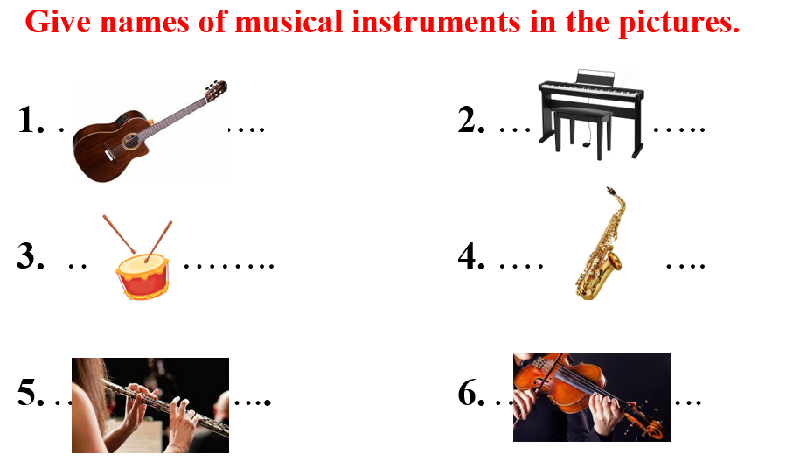  - Have Ss make sentences, using the vocabularies above.  - Lead to the new lesson.  Option 2: Time Expressions  - Have Ss close all books and notebooks.  - Divide class into 4 groups.  - Have Ss in each group write down time expressions in English as many as possible (in about 2 minutes).  - Call Ss to write answers on the board.  - Check Ss’ answers, give feedback and evaluation.  - The group with the most correct answers will be the winner.  - Give a small present to the winner.  - Lead to the new lesson. | - Work in pairs.  - Give answers.  Answers keys  1. guitar  2. piano  3. drum  4. saxophone  5. flute  6. violin  - Make sentences and read them.  - Close books and notebooks.  - Work in groups of 4.  Suggested answers  Time Expressions: yesterday, in the morning, in the afternoon, in the evening, on Sundays, on / at the weekends, at night, in the winter, in March, in 2022, …
B. New lesson (35’)
Activity 1: Presentation (10’)
a. Objective: Introduce Prepositions of time and Possessive adjectives.
b. Content:
- Listen and repeat.
- Introduce the grammar point: Prepositions of time and Possessive adjectives.
c. Expected outcomes: Ss know how to use Prepositions of time and Possessive adjectives to do some following exercises.
d. Organization of the activity:

TEACHER’S ACTIVITIES | STUDENTS’ ACTIVITIES
Task a. Listen and repeat  - Have Ss look at the picture (using DCR).  - Play audio (CD1 – Track 31) and have Ss listen and read the speech bubbles.  - Play the audio again and have Ss listen and repeat.  Grammar box  Option 1:  - Have Ss look at the grammar explanation and read: Prepositions of time.  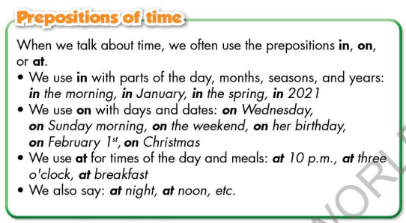  - Have Ss look at the grammar explanation and read: Possessive adjectives.  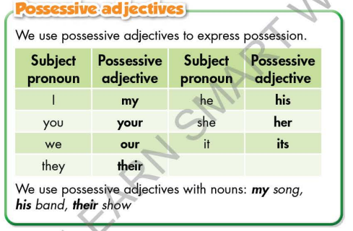  - Briefly explain the grammar point.  - Ask Ss to give more examples using Prepositions of time and Possessive adjectives.  Option 2:  - Have Ss close books.  - Show sample phrases, have Ss read them and make comment on the way teacher uses preposition before time expressions.  *Suggested sample phrases: in the morning, in the afternoon, in the evening, on Sundays, on / at the weekends, at night, in the winter, in March, in 2022, …  - Have Ss give answers.  - Give feedback and evaluation.  - Lead to the grammar box and explain more: Prepositions of time.  - Next, show sample sentences, have Ss read them and make comment on the way teacher uses possessive adjectives (In each sentence: Identify which is possessive adjective, identify possessive adjective’s position).  *Suggested sample sentences:  1. My father worked in that company in 2015.  2.I study with her son.  3. His piano is quite new.  4. Their music performance is very great.  - Have Ss give answers.  - Give feedback and evaluation.  àLead to the grammar box and explain more: Possessive adjectives.  - Have Ss give more examples of Prepositions of time and Possessive adjectives, encourage them to make sentences with their own ideas.  - Give feedback and evaluation. | - Look.  - Listen, then read.  - Listen and repeat.  - Look and read.  - Look and read.  - Listen and take notes.  - Give examples.  - Close all books.  - Look and answer.  - Give answers.  - Open the books and read the grammar box.  - Read and comment.  Suggested answers  1. Possessive adjectives: my, her, his, their  2. Position: before noun  - Open the books and read the grammar box.  - Give examples.
Activity 2: Practice (19’)
a. Objective: Students can use Prepositions of time and Possessive adjectives correctly.
b. Content:
- Fill in the blanks with in, on, or at, and the correct possessive adjectives.
- Look at the table and write the answers.
c. Expected outcomes: Students can use Prepositions of time and Possessive adjectives in their speaking.
d. Organization of the activity:
TEACHER’S ACTIVITIES | STUDENTS’ ACTIVITIES
Task b. Fill in the blanks with in, on, or at, and the correct possessive adjectives  - Demonstrate the activity on DCR, using the example.  - Have Ss fill in the blanks with in, on, or at, and the correct possessive adjectives.  - Have Ss work in pairs to check each other’s work.  - Have some Ss share their answers with the whole class.  - Give feedback, correct Ss’ answers if necessary.  Task c. Look at the table and write the answers.  - Demonstrate the activity on DCR, using the example.  - Have Ss look at the table and write the answers.  - Have Ss check answers with their partners.  - Call Ss to read or write answers.  - Check Ss’ answers, give feedback. | - Look and listen.  - Work individually.  - Work in pairs.  - Write answers on the board.  Answer keys  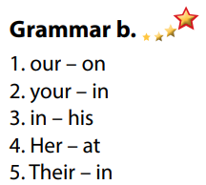  - Look and listen.  - Work individually.  - Work in pairs.  - Read or write answers.  Answer keys  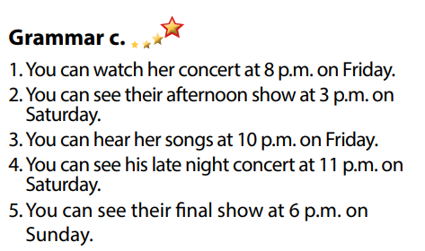
Activity 3: Production
a. Objective: Students master the grammar point they study in the lesson.
b. Content: Speaking: Ask and answer using the information in the table.
c. Expected outcomes: Ss produce the new language successfully, and they can apply the grammar point they have learnt in speaking and writing.
d. Organization of the activity:
TEACHER’S ACTIVITIES | STUDENTS’ ACTIVITIES
Task d. In pairs: Ask and answer using the information in the table  - Divide class into pairs.  - Have Ss ask and answer using the information in the table.  - Then, encourage Ss to add their own ideas to practice.  - Have some pairs demonstrate the activity in front of the class.  - Give feedback and evaluation. | - Work in pairs.  - Have conversation in pairs.  - Present.  - Listen.
C. Consolidation and homework assignments (5’)
*Consolidation
- Prepositions of time
- Possessive Adjectives
.
*Homework:
- Make 2 sentences, use prepositions of time and possessive adjectives.
- Do the exercises in WB: Grammar (page 17).
- Complete the grammar notes in Tiếng Anh 7 i-Learn Smart World Notebook (page 19).
- Play consolation games in Tiếng Anh 7 i-Learn Smart World DHA App on www.eduhome.com.vn
- Prepare: Lesson 2.3 – Pronunciation and Speaking (page 25 – SB).
*********************************************************************

Teaching date: 07/11/2022
Period 28 UNIT 3: MUSIC AND ARTS
Lesson 2.3 – Pronunciation and Speaking (Page 25)
I. OBJECTIVES
By the end of the lesson, Ss will be able to:
1.1. Language knowledge and skills
- recognize and practice intonation at the end of statements.
- practice a conversation about a plan to go to a music show.
- talk about music show.
- invite a friend to speak.
1.2. Competences
- improve listening and speaking skills.
1.3. Attributes
- love music.
- relax with music.
II. TEACHING AIDS AND LEARNING MATERIALS
1. Teacher’s aids: Student book and Teacher’s book, class CDs, digital book (DCR phần mềm tương tác SB, DHA (từ vựng/ cấu trúc) phần mềm trò chơi tương tác), projector/interactive whiteboard / TV (if any), PowerPoint slides, handouts.
2. Students’ aids: Student’s book, workbook, notebook, handouts.
III. ASSESSMENT EVIDENCE
Performance Tasks | Performance Products | Assessment Tools
- Listen to the sentences and notice: intonation falls at the end of statements. | - Ss’ performance and answers. | - T’s observation.
- Listen and cross out the sentence doesn’t follow the note in Task a. | - Ss’ answers. | - T’s feedback/Peers’ feedback.
- Read the sentences with the sound feature noted in Task a to a partner. | - Ss’ performance. | - T’s feedback/Peers’ feedback.
- Practice the conversation between two students. Swap the roles and repeat. | - Ss’ performance. | T’s observation, T’s feedback.
- Ask and answer about the different music shows, then choose four artists to see. Complete the notes. | - Ss’ performance /  Presentation. | - T’s observation, T’s feedback.
- Answer: Which bands or singers will you see at Festibeat? | - Ss’ performance /  Presentation. | - T’s observation, T’s feedback.
IV. PROCEDURES
A. Warm up:
a. Objective: Introduce the new lesson and set the scene for Ss to acquire new language; get students' attention at the beginning of the class by enjoyable and short activities as well as to engage them in the follow-up steps.
b. Content: Music.
c. Expected outcomes: Ss have good preparation for the new lesson.
d. Organization of the activity:
TEACHER’S ACTIVITIES | STUDENTS’ ACTIVITIES
Option 1:  - Play a short video clip about a music show of a famous singer / band in Vietnam or in the world (or a song).  - Have Ss listen and watch.  - Lead to the new lesson.  *Suggested clip: Link: https://www.youtube.com/watch?v=x  4D1jt0aThg  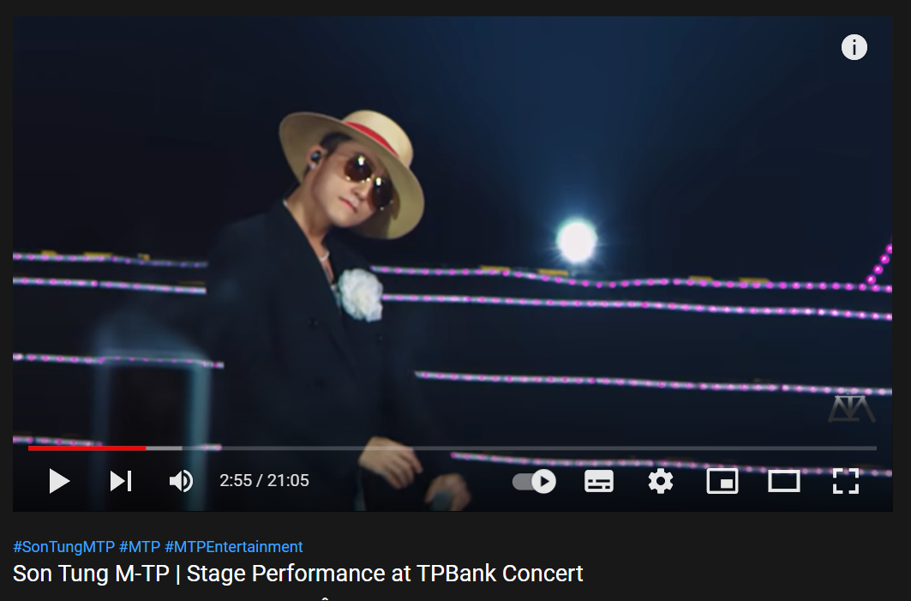  Option 2:  - Prepare and play mp3 files of sounds of some musical instrument.  - Have Ss listen and guess the name of musical instrument.  - Give feedback, show correct answers.  - Introduce the new lesson. | - Listen and watch.  - Give answers.  - Listen.  - Listen and give names of musical instruments.  - Listen.
B. New lesson
Activity 1: Pre-Speaking: Pronunciation
a. Objective: Introduce: Intonation falls at the end of the statements.
b. Content:
- recognize: Intonation falls at the end of the statements.
- listen and check, find mistakes.
- practice.
c. Expected outcomes: Ss practice: “Intonation falls at the end of the statements” and use it naturally in their speaking.
d Organization of the activity:
TEACHER’S ACTIVITIES | STUDENTS’ ACTIVITIES
Task a + b. Listen to the sentences and focus on how the intonation falls.  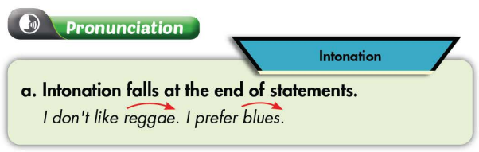  - Play the recording (CD1, track 32) using DCR.  - Ask Ss to listen and focus on how the intonation falls.  - Play the recording again, have Ss listen and repeat with a focus on the pronunciation feature.  Task c + d. Listen and cross out the sentence that doesn’t follow the sound feature noted in Task a.  - Play the recording (CD 1 – Track 33) using DCR, have Ss listen and cross out the option that doesn’t follow the sound feature in “a”.  - Call Ss to give answers.  - Play the recording again and check answers as a whole class.  - Then have Ss practice saying the examples with a partner, using the pronunciation feature.  - Call some Ss to read the sentences in front of the class.  - Ask Ss to make some more statements and practice reading them with the right sound feature of the lesson. | - Listen.  - Listen again and repeat.  - Listen and cross out.  - Give answers.  Answer keys  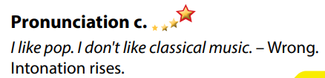  - Listen again and check.  - Work in pairs.  - Present.  - Make sentences and practice reading them.
Activity 2: While-speaking
a. Objective: Students can talk about music shows.
b. Content:
- Practice the conversation between two students. Swap the roles and repeat.
- Ask and answer about the different music shows, then choose four artists to see. Complete the notes.
- Answer: Which bands or singers will you see at Festibeat?
c. Expected outcomes: Ss produce the new language successfully and have a good role play.
d. Organization of the activity:
TEACHER’S ACTIVITIES | STUDENTS’ ACTIVITIES
PRACTICE  Practice the conversation. Swap the roles and repeat  - Demonstrate the activity by practicing the role-play with a student.  - Have pairs practice the conversation.  - Remind Ss the way to invite partners to speak.  - Have Ss swap roles and repeat, using the ideas on the right.  - Have some pairs demonstrate the activity in front of the class.  - Give feedback and evaluation.  SPEAKING: It’s Show Time!  Task a. There's a music festival in your town this weekend. In threes: Ask and answer about the different music shows, then choose four artists to see. Complete the notes.  - Demonstrate the activity having 2 Ss practice reading the conversation.  - Have Ss work in groups of 3.  - Have students ask and answer about the different music shows, then choose four artists to see. Complete the notes.  - Observe, give help if necessary.  - Have some students share the ideas with the class.  - Give feedback and evaluation.  Task b. Swap roles. Student A, now you’re the patient. Answer the doctor’s questions and write down their advice.  - Have students discuss which bands or singers they will see.  - Observe, give help if necessary.  - Have some students share their ideas with the class.  - Give feedback and evaluation. | - Observe, listen.  - Work in pairs to practice the conversation.  - Swap roles and continue the task.  - Present.  - Observe and listen.  - Work in groups of 3 to ask and answer about the different music shows and complete the notes.  - Present.  - Discuss.  - Present.
Activity 3: Production
a. Objective: Help Ss relax after class.
b. Content: List some famous music shows on TV in Vietnam, and choose a show that you would like to see. Explain for your choice.
c. Expected outcomes: Ss produce the new language successfully in everyday speaking and writing.
d. Organization of the activity:
TEACHER’S ACTIVITIES | STUDENTS’ ACTIVITIES
Extra Task. List some famous music shows on TV in Vietnam, and then choose a show that you would like to see. Explain for your choice.  - Have Ss close all books and notebooks.  - Divide class into 4 groups to list some famous music shows in Vietnam.  - Have Ss choose a show that they would like to see and explain for their choice.  - Call some Ss to share their answers with the whole class.  - Give feedback and evaluation. | - Close all books and notebooks.  - Take part in the class’s activity.  - Give answers.  - Listen.  Suggested answers  - Famous music shows on TV in Vietnam: Rock Viet, Rap Viet, The voice, Song ca cùng thần tượng, Hát với ngôi sao, Giọng ải giọng ai, …
C. Consolidation and homework assignments (5’)
* Consolidation:
* Homework:
- Make 2 statements and practice reading them, paying attention to: Intonation falls at the end of the statements.
- Prepare: Lesson 3.1 – Listening and Reading (page 26).
- Review the vocabulary and grammar notes in Tiếng Anh 7 i-Learn Smart World Notebook
(pages 18 & 19).
- Play consolation games in Tiếng Anh 7 i-Learn Smart World DHA App on www.eduhome.com.vn
*******************************************************************
Teaching date: 09/11/2022
Period 29 UNIT 3: MUSIC AND ARTS
Lesson 3.1 - Listening and Reading (Page 26)
I. OBJECTIVES
By the end of the lesson, Ss will be able to:
1.1. Language knowledge and skills
- talk about a movie you like.
- talk about different types of movie.
- practice listening and understanding general and specific information about things relating to a film.
- read a film description.
1.2. Competences
- improve communication, collaboration, analytical and critical thinking skills.
1.3. Attributes
- love movies and appreciate the film industry.
- choose suitable movies to watch and relax.
II. TEACHING AIDS AND LEARNING MATERIALS
1. Teacher’s aids: Student book and Teacher’s book, class CDs, Digital Book (DCR phần mềm tương tác SB, DHA (từ vựng/ cấu trúc) phần mềm trò chơi tương tác), projector/interactive whiteboard / TV (if any), PowerPoint slides.
2. Students’ aids: Student’s book, workbook, notebook.
III. ASSESSMENT EVIDENCE
Performance Tasks | Performance Products | Assessment Tools
- Speaking: Name three movies you like and say why you like them. What are the different types of movie you can watch? | - Ss’ answers. | - T’s feedback.
- Fill in the blanks using the words in the box. Listen to an English teacher and check your answers. | - Ss’ answers. | - T’s feedback/Peers’ feedback.
- Listen again and circle the correct answer. | - Ss’ answers. | - T’s feedback/Peers’ feedback.
- Read the description and choose the best title. | - Ss’ answers. | - T’s feedback/Peers’ feedback.
- Read and fill in the blanks. | - Ss’ answers. | - T’s feedback/Peers’ feedback.
- Would you like to watch this movie? Why (not)? | - Ss’ answers / presentation. | - T’s observation/ DCR and T’s feedback.
IV. PROCEDURES
A. Warm up:
a. Objective: Introduce the new lesson and set the scene for Ss to acquire new language; get students' attention at the beginning of the class by giving enjoyable and short activities as well as to engage them in the follow-up steps.
b. Content: Movies.
c. Expected outcomes: Ss have general ideas about the topic “movies”, which they are going to listen and read in the new lesson.
d. Organization of the activity:
TEACHER’S ACTIVITIES | STUDENTS’ ACTIVITIES
Option 1: Let’s Talk!  - Use the “Let’s talk!” part in the textbook– page 26 for warm-up activity.  - Ask Ss to work in pairs to name three movies they like and say why they like them.  - Call Ss to share their answers with the whole class  - Give feedback and evaluation.  - Ask Ss: What are different types of movies can you watch?  - Call Ss to give answers, comment.  - Lead to the new lesson.  Option 2: Matching  - Have Ss match each picture / poster with its name of the film.  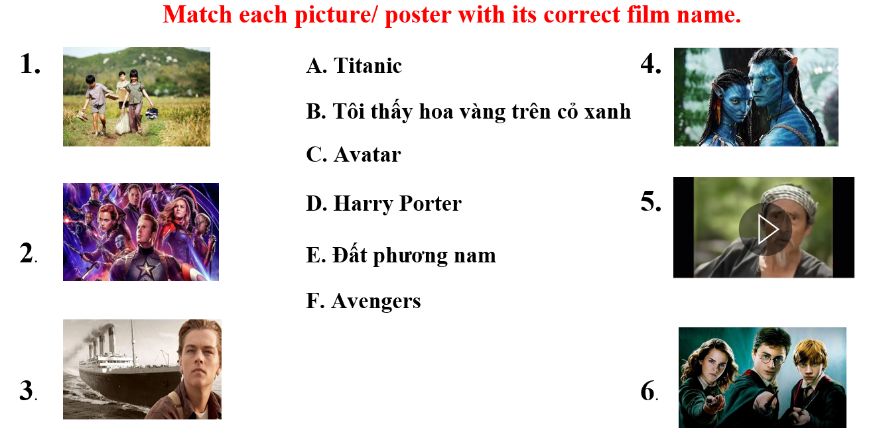  - Call Ss to give answers.  - Check and give correct answers.  - Extra question: What do you know about these films? (Ss can choose a film they know to talk about it.)  - Give feedback and evaluation.  - Lead to the new lesson. | - Work in pairs to discuss.  - Present.  - Discuss.  - Answer.  - Look and match.  - Give answers.  - Give answers.  - Listen.  Answer keys  1.B 2.F 3.A 4.C 5.E 6.D
B. New lesson
Activity 1: Listening
a. Objective: Students can develop their listening skill.
b. Content: Listen to an English teacher talking about film description.
c. Expected outcomes: Students can practice listening and understanding general + specific information about film description.
d. Organization of the activity:
TEACHER’S ACTIVITIES | STUDENTS’ ACTIVITIES
Task a. Fill in the blanks using the words in the box. Listen to an English teacher and check your answers  - Briefly explain the meaning of the words in the box.  - Have Ss read the uncompleted sentences and guess the answers.  - Play audio (CD1 - Track 34) using DCR.  - Have Ss listen and fill in the blanks with the words in the box.  - Call Ss to give answer, explain.  - Play the audio again and check the answer as a whole class using DCR.  Task b. Now, listen and circle the correct answers  - Have Ss read through the content of Task b first.  - Play the audio again (CD1 - Track 34) using DCR.  - Have Ss listen and circle the correct answers.  - Have Ss check answers with their partners.  - Call Ss to give answers, explain.  - Check answers as a whole class using DCR. | - Listen and take notes.  - Read.  - Listen and fill in the blanks with the words in the box.  Answer keys  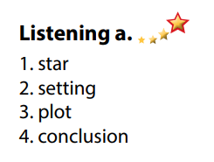  - Read.  - Listen and circle the correct answers.  - Exchange answers.  - Give answers.  Answer keys  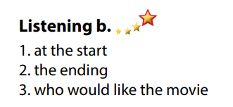
Activity 3: Reading
a. Objective: Students can develop their reading skill.
b. Content:
- Read the description and choose the best title.
- Read and fill in the blanks.
c. Expected outcomes: Students can read a film description for gist and details, and they can talk about their favorite film.
d. Organization of the activity:
TEACHER’S ACTIVITIES | STUDENTS’ ACTIVITIES
Task a. Read the description and choose the best title.  - Have Ss read Task a and guess the answer.  - Ask Ss to read the description quickly and circle the correct answer.  - Call 1 S to give answer.  - Check answers as a whole class using DCR.  Task b. Now, read and fill in the blanks  - Have Ss read the content in Task b and underline the key words.  - Have Ss read the text again and fill in the blanks.  - Have Ss check their answers with a partner.  - Call Ss to give answers.  - Check answers as a whole class using DCR.  Task c. Speaking: In pairs: Would you like to watch this movie? Why / Why not?  - Have Ss discuss the questions in pairs.  - Call some Ss to share their answers with the whole class.  - Give feedback and evaluation.  - For class with high level students: Give Ss an extra task: Describe your favorite film.  - Call Ss some Ss to share their answers with the whole class.  - Give feedback and evaluation. | - Read and guess.  - Scan the text for general idea.  - Give answer.  Answer keys  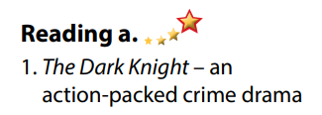  - Read and underline the key words.  - Read the text again for details.  - Exchange answers.  - Give answers.  Answer keys  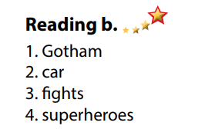  - Discuss in pairs.  - Present.  - Discuss in pairs.  - Present.
C. Consolidation and homework assignments
*Consolidation:
- Vocabulary: Film description: plot, conclusion, star, setting, characters, acting, dramatic.
*Homework
- Practice describing your favorite film.
- Do the exercises in WB: Lesson 3 – Listening and Reading (page 18).
- Do the vocabulary exercise in Tiếng Anh 7 i-Learn Smart World Notebook (page 20).
- Play consolation games in Tiếng Anh 7 i-Learn Smart World DHA App on www.eduhome.com.vn
- Prepare: Lesson 3 – Writing and Speaking (page 27 – SB).
*********************************************************************
Teaching date: 10/11/2022
Period 30 Correcting the test
I. OBJECTIVES:
By the end of the lesson, Ss will be able to:
1.1 Language knowledge and skills
- Help ss find out their mistakes and correct them . Students can improve their knowledge of English
- Grammar: phrasal verbs, comparison, reported speech
- Vocabulary: related to unit 1- 2
1.2. Qualities:
Skills: Practicing skills
Attitude: - Ss are interested in practicing skills
- Ss are interested in doing exercises
1.3. Competences
- Self- study: work individually.
II. PREPARATION:
1.Teacher: Test papers
2.Students:
III. TEACHING METHODS: Technical present….
IV. PROCEDURE
A. Remark on the tests:
-The number of the tests:
+ Exellent tests:
+ Good test
+ Average:
+ Under average:
- The number of the tests:
+ Exellent tests:
+ Good test
+ Average:
+ Under average:
- In general, all Ss have achieved the basic knowledge.
- There are many exellent and good tests.
- Some Ss' skill of doing general test is not good.
- The teacher shows some best and worst tests to correct before class:
***************************************************************************

Teaching date: 14/11/2022
Period 31 UNIT 3: MUSIC AND ARTS
Lesson 3.2 Writing (Page 27)
I. OBJECTIVES
By the end of the lesson, Ss will be able to:
1.1. Language knowledge and skills
- study format of writing a movie description.
- talk about their favorite movies.
- write a short description of a movie they like.
1.2. Competences
- improve communication, collaboration, writing and critical thinking skills.
1.3. Attributes
- love movies.
II. TEACHING AIDS AND LEARNING MATERIALS
1. Teacher’s aids: Student book and Teacher’s book, class CDs, Digital Book (DCR phần mềm tương tác SB, DHA (từ vựng/ cấu trúc) phần mềm trò chơi tương tác), projector/interactive whiteboard / TV (if any), PowerPoint slides.
2. Students’ aids: Student’s book, workbook, notebook.
III. ASSESSMENT EVIDENCE
Performance Tasks | Performance Products | Assessment Tools
- Speaking: You're talking about your favorite movies. In pairs: Ask your partner the following questions. | - Ss’ answers / presentation. | - T’s feedback.
- Make notes about your favorite movie using the questions. | - Ss’ answers. | - T’s feedback/Peers’ feedback.
- Writing: Read about writing a movie description. Then, read the description of The Dark Knight again and underline the plot summary. | - Ss’ answers. | - T’s feedback/Peers’ feedback.
- Reorder the movie description. Use the skill box to help you. | - Ss’ answers. | - T’s feedback/Peers’ feedback.
- Write a short description of a movie you like. | - Ss’ answers. | - T’s observation and feedback.
IV. PROCEDURES
A. Warm up:
a. Objective: Introduce the new lesson and set the scene for Ss to acquire new language; get students' attention at the beginning of the class by enjoyable and short activities as well as to engage them in the follow-up steps.
b. Content: Types of films.
c. Expected outcomes: Ss know some film types that they are going to talk and write about in new the lesson.
d. Organization of the activity:
TEACHER’S ACTIVITIES | STUDENTS’ ACTIVITIES
Option 1: Types of films  - Give a list of film types and their equivalent movie names.  - Have Ss look and guess the meaning of these film types.  - Have Ss give answers.  - Give feedback and show correct answers.  - Lead to the new lesson.  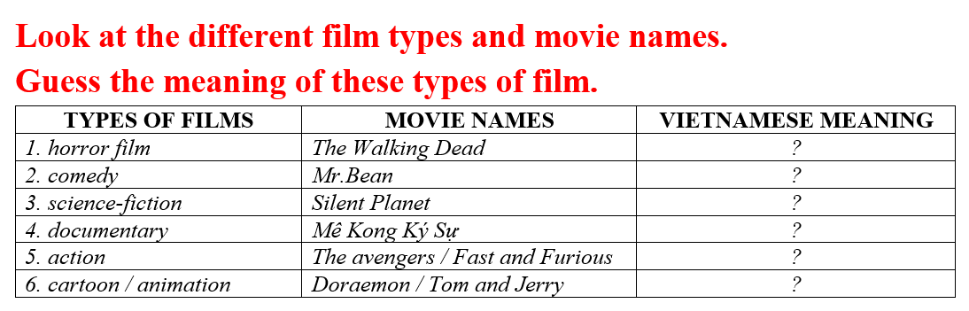  Option 2: Chatting  - Ask Ss some questions:  1. What is your favorite movie?  2. What kind of movie is it?  3. Who does it start?  4. What is it about?  5. What do many people / critics say about it?  - Have some Ss share their answers with the whole class.  - Give feedback and evaluation.  - Lead to the new lesson. | - Work in pairs: Look and guess.  - Give answers.  - Listen.  Answer keys  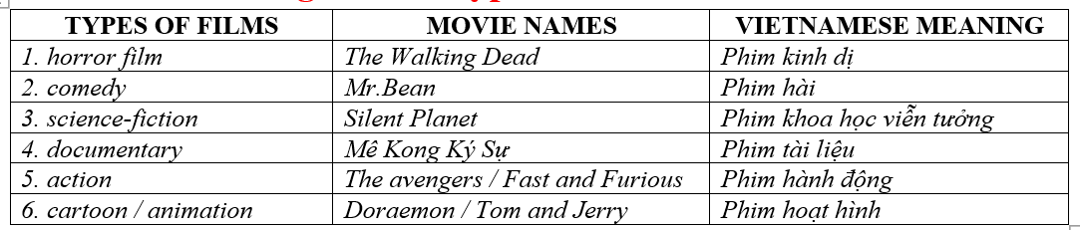  - Answer teacher’s questions.  - Listen.
B. New lesson
Activity 1: Pre-Writing (Speaking)
a. Objective: Ss prepare for what they are going to write about.
b. Content:
- Speaking: You're talking about your favorite movies. In pairs: Ask your partner the following questions.
- Make notes about your favorite movie using the questions.
c. Expected outcomes: Ss know more vocabularies about kinds of films and apply the language from speaking to their writing.
d. Organization of the activity:
TEACHER’S ACTIVITIES | STUDENTS’ ACTIVITIES
Task a. You're talking about your favorite movies. In pairs: Ask your partner the following questions.  - Divide the class into pairs.  - Have students ask and answer using the questions.  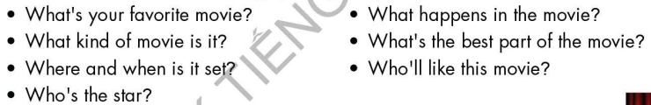  - Have some students share their ideas with the class.  - Give feedback and evaluation.  Task b. Make notes about your favorite movie using the questions  - Have students make notes about their favorite movie using the questions.  - Go round and give help if necessary.  - Have some pairs read their answers.  - Give feedback and evaluation. | - Work in pairs.  - Give answers.  - Make notes.  - Present.
Activity 2: While - Writing
a. Objective: Students can develop their writing skill.
b. Content: - Read about writing a movie description. Then, read the description of The Dark Knight again and underline the plot summary.
- Reorder the movie description. Use the skill box to help you.
- Write a short description of a movie you like.
c. Expected outcomes: Students can write a film description, using right format and rich vocabularies.
d. Organization of the activity:
TEACHER’S ACTIVITIES | STUDENTS’ ACTIVITIES
Task a. Read about writing a movie description. Then, read the description of The Dark Knight again (page 26) and underline the plot summary  -Briefly explain the Writing skill box.  - Have Ss read the description of The Dark Knight again (page 26), then underline the plot summary.  - Have Ss check their answers with a partner.  - Call Ss to give answers.  - Check answer as a whole class using DCR.  Task b. Reorder the movie description. Use the skill box to help you.  - Have Ss read the sentences, then reorder the movie description.  - Have Ss check their answers with a partner.  - Call Ss to give answers.  - Check answer as a whole class using DCR.  *Let’s Write: Now, write a short description of a movie you like. Use the feedback form to help you  - Draw Ss’ attention to the feedback form.  - Have Ss use their notes in speaking part and the instruction in the Writing box to write a short description of a movie they like.  - Go round, observe and give help if necessary.  - Have some Ss write their letter on the board. | - Listen.  - Work in pairs.  - Exchange their answers with a partner.  - Give answers.  Answer keys  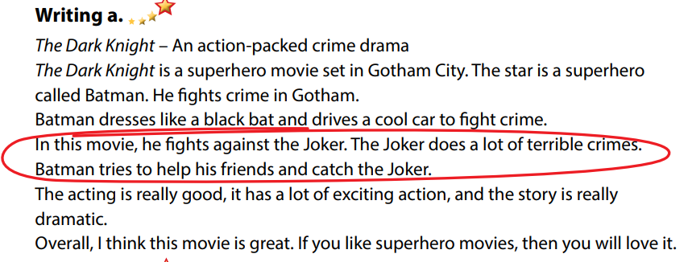  - Read and reorder the movie description.  - Exchange answers.  - Give answers.  Answer keys  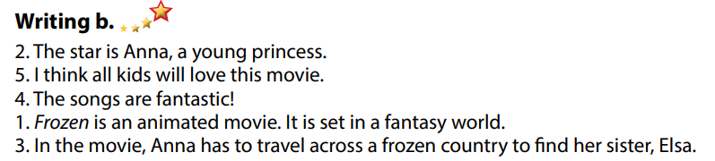  - Look and listen.  - Do the writing part.  - Write.  Suggested writing  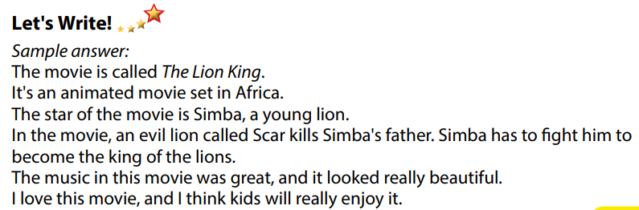
Activity 3: Post - Writing
a. Objective: Help Ss realize their mistakes in writing and correct them.
b. Content: Correcting Ss’ writings.
c. Expected outcomes: Students know whether their writings follow the model and use the correct structures and language, whether their writings are interesting and understandable or not.
d. Organization of the activity:
TEACHER’S ACTIVITIES | STUDENTS’ ACTIVITIES
- Give feedback, correct Ss’ mistakes.  - Use the feedback form to give evaluation. Focus on:  + the format, the structures.  + the understandability.  + the coherence and cohesion. | - Look, listen and correct mistakes.

C. Consolidation and homework assignments (5’)
* Consolidation:
- Writing Skill:
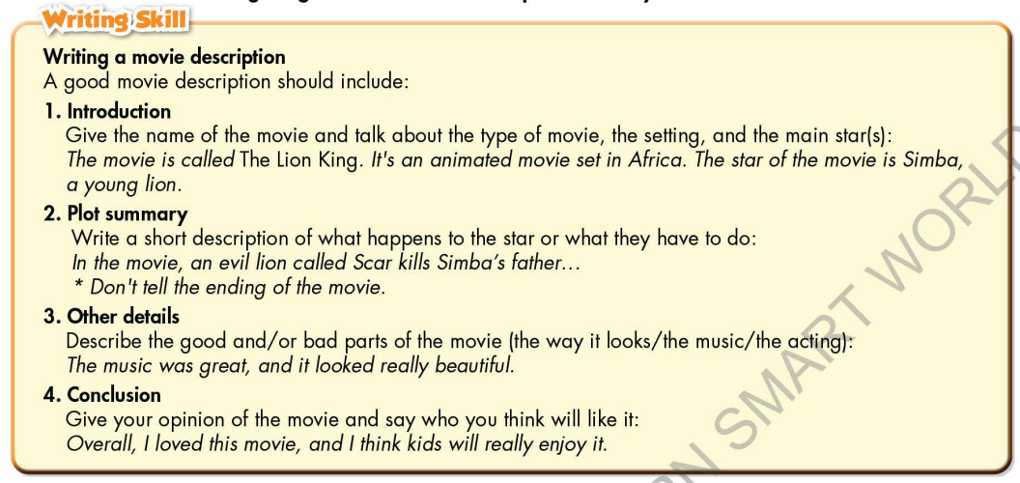
*Homework
- Remember how to write a movie description.
- Finish the writing part.
- Do the exercises in WB: Lesson 3 – Writing (page 19).
- Complete the grammar notes in Tiếng Anh 7 i-Learn Smart World Notebook (page 21).
- Play consolation games in Tiếng Anh 7 i-Learn Smart World DHA App on www.eduhome.com.vn
- Prepare: Unit 3 – Review (pages 88, 89 – SB).
***********************************************************************
Teaching date: 16/11/2022
Period 32 UNIT 3: MUSIC AND ARTS
Lesson 4 – Review (Pages 88, 89)
I. OBJECTIVES
By the end of the lesson, Ss will be able to:
1.1. Language knowledge and skills
- review words about music types (classical music, rock, country music, pop, hip hop, folk music, reggae, etc.) and talk about them.
- review grammar: Present simple for facts; prepositions of time; possessive adjectives.
- review how to make plans to go to a music event.
- pronoun some sounds correctly: /s/, /a/, /ɔ/, /æ/, / z/.
1.2. Competences
- improve speaking, listening, reading and writing skills.
- improve the use of English.
1.3. Attributes
- have positive attitude in English language learning so that they actively participate in all classroom activities.
- review the old lesson and have good preparation for any assessment.
II. TEACHING AIDS AND LEARNING MATERIALS
1. Teacher’s aids: Student book and Teacher’s book, class CDs, Digital Book (DCR phần mềm tương tác SB, DHA (từ vựng/ cấu trúc) phần mềm trò chơi tương tác), projector/interactive whiteboard / TV (if any), PowerPoint slides, handouts.
2. Students’ aids: Student’s book, workbook, notebook.
III. ASSESSMENT EVIDENCE
Performance Tasks | Performance Products | Assessment Tools
- Listening: You will hear five short conversations. You will hear each conversation twice. There is one question for each conversation. For each question, choose the correct answer (A, B, or C). | - Ss’ answers. | - T’s feedback/Peers’ feedback.
- Reading: Read the paragraph. Choose the best word (A, B, or C) for each space. | - Ss’ answers. | - T’s feedback/Peers’ feedback.
- Vocabulary: Number the pictures. | - Ss’ answers. | - T’s feedback/Peers’ feedback.
- Grammar: Underline the mistakes and write the correct answers on the lines. + Write sentences using the prompts. | - Ss’ answers. | - T’s feedback/Peers’ feedback.
- Pronunciation: sound and stress. | - Ss’ answers/ presentation. | - T’s observation, T’s feedback/Peers’ feedback
IV. PROCEDURES
A. Warm up:
a. Objective: Introduce the new lesson and set the scene for Ss to acquire new language; get students' attention at the beginning of the class by enjoyable and short activities as well as to engage them in the follow-up steps.
b. Content: Songs.
c. Expected outcomes: Ss are ready for the new lesson.
d. Organization of the activity:
TEACHER’S ACTIVITIES | STUDENTS’ ACTIVITIES
Option 1: Sing a song (Karaoke)  - Choose a simple English song and find its beat  - Play the clip of the song with lyrics.  - Have the whole class sing the song together.  → Lead to the new lesson.  *Suggested song: The farmer in the dell.  - Link: https://www.youtube.com/watch?v=tYoYuqBFsRU  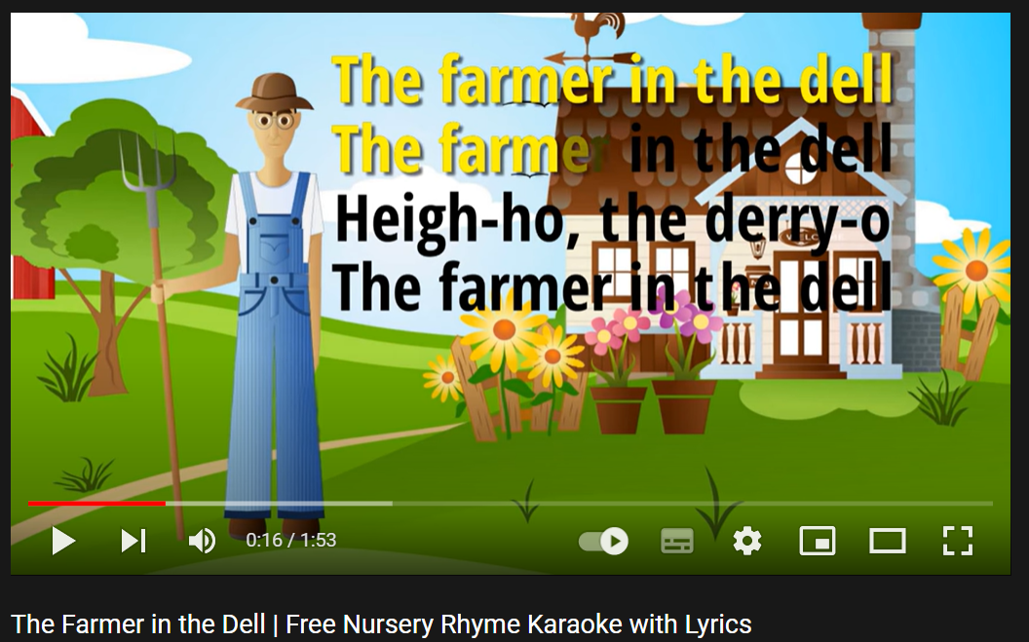  Option 2: What song is it?  - Prepare the sound files / video clips of some songs. T chooses songs that are popular with teenagers.  - Play the files / clips, have Ss listen and give names of the songs.  - If Ss give an incorrect answer, T continues to play the song. If Ss can give a correct answer, T stops and move to another song.  - Give feedback.  →Lead to the new lesson.  Suggested song list:  1 Baby once more time (Britney Spears)  2 My hear will go on (Celine Dion)  3 Dance Monkey (Tones and I)  4 Lily ( Allen Walker)  5 Despacito ( Luis Fonsi)  6 Lemon Tree (Fools Garden)  7 Senorita (Shaw Mendes)  8 Maps (Maron 5)  9 Happy new year (Abba)  10 Happy birthday to you ( many versions) | - Look and sing together.  - Give answers.  - Listen.  - Listen and give names of the songs.
B. New lesson
Activity 1: Listening
a. Objective: Help Ss improve their listening skill.
b. Content:
- Listen to five short conversations. There is one question for each conversation. For each question, choose the correct answer (A, B, or C).
c. Expected outcomes: Ss listen in details and get familiar with the listening test format.
d. Organization of the activity:

TEACHER’S ACTIVITIES | STUDENTS’ ACTIVITIES
You will hear five short conversations. You will hear each conversation twice. There is one question for each conversation. For each question, choose the correct answer (A, B, or C).  - Have Ss read through the listening part.  - Demonstrate the activity by using the example.  - Play the audio (CD 2 – Track 36).  - Have Ss check answers with pairs and then give answers.  - Check answers as a whole class using DCR. | - Read in silence.  - Listen and then give answers.  Answer keys  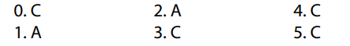
Activity 2: Reading
a. Objective: Students can improve their reading skill.
b. Content:
- Read the paragraph. Choose the best word (A, B, or C) for each space.
c. Expected outcomes: Ss read for comprehension and get familiar with the reading test format.
d. Organization of the activity:
TEACHER’S ACTIVITIES | STUDENTS’ ACTIVITIES
Read the paragraph. Choose the best word (A, B, or C) for each space  - Demonstrate the activity by using the example.  - Have Ss read the article and choose the correct answer, underline the supporting ideas for their answers.  - Call Ss to give answers, explain.  - Give feedback and evaluation. | - Observe and listen.  - Work individually.  - Give answers, explain.  Answer keys  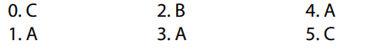
Activity 3: Vocabulary
a. Objective: Ss can review vocabulary about music types.
b. Content: Number the pictures.
c. Expected outcomes: Ss produce the new language successfully, and they can use these words in speaking and writing.
d. Organization of the activity:
TEACHER’S ACTIVITIES | STUDENTS’ ACTIVITIES
Number the pictures  - Have Ss read the phrases and observe the pictures.  - Ask Ss to work in pairs to number the pictures.  - Have Ss give answers, tell the meaning of the words /phrase again.  - Check answers as a whole class using DCR. | - Read the phrases and observe the pictures.  - Work in pairs.  - Give answers.  Answer keys  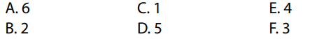
Activity 4: Grammar
a. Objective: Ss can review the use of English: Present simple for facts; prepositions of time; possessive adjectives.
b. Content:
- Underline the mistakes and write the correct answers on the lines.
- Write sentences using the prompts.
c. Expected outcomes: Ss produce the new language successfully, and they can use the grammar points in speaking and writing.
d. Organization of the activity:
TEACHER’S ACTIVITIES | STUDENTS’ ACTIVITIES
Task a. Underline the mistakes and write the correct answers on the lines.  - Have Ss retell the way to use present simple tense for facts.  - Ask Ss to work individually to underline the mistakes and write the correct answers on the lines.  - Have Ss work in pairs to check each other’s work.  - Call Ss to give answers, explain for their choice.  - Check answers as a whole class using DCR.  Task b. Write sentences using the prompts  - Have Ss write sentences using the prompts.  - Ask Ss to work in pairs to check each other’s work.  - Have Ss write answers on the board.  - Check Ss’ answers, give feedback. | - Review old knowledge.  - Work individually.  - Work in pairs.  - Give answers.  Answer keys  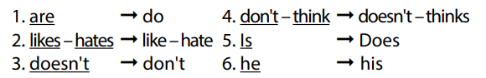  - Do the task.  - Exchange answers.  - Write answers on the board.  Answer keys  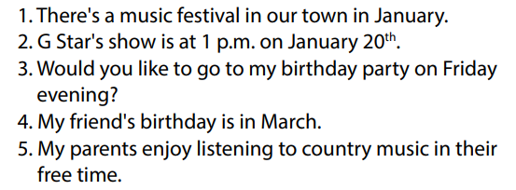
Activity 5: Pronunciation
a. Objective: Ss can review the word stress and vowels.
b. Content:
- Circle the word that has the underlined part pronounces differently from the others.
- Circle the word that has different stress from the rest.
c. Expected outcomes: Ss produce the new language successfully.
d. Organization of the activity:
TEACHER’S ACTIVITIES | STUDENTS’ ACTIVITIES
Task a. Circle the word that has the underlined part pronounced differently from the others.  - Have Ss distinguish the sound /s/, /a/, /ɔ/, /æ/, / z/.  - Ask Ss to work individually to circle the answer.  - Have Ss work in pairs to check each other’s work.  - Call Ss to give answers, pronounce the words again.  - Give feedback, correct Ss’ pronunciation if necessary.  Task b. Circle the word that differs from the other three in the position of primary stress in each of the following questions.  - Remind Ss some basic rules of putting stress on words with 2 or 3 syllables.  - Ask Ss to work individually.  - Have Ss work in pairs to check each other’s work.  - Call Ss to give answers, pronounce the words again.  - Give feedback, correct Ss’ pronunciation if necessary. | - Listen.  - Work individually.  - Work in pairs.  - Give answers.  Answer keys  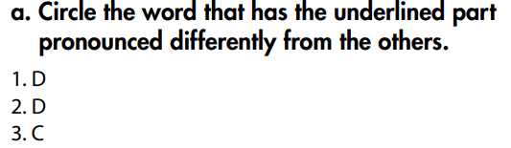  - Listen.  - Work individually.  - Work in pairs.  - Give answers.  Answer keys  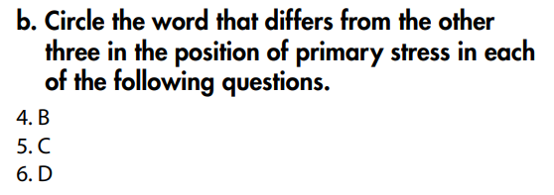
C. Consolidation and homework assignments
* Consolidation:
* Grammar of Unit 3: Present simple for facts; prepositions of time; possessive adjectives.
* Vocabulary of Unit 3: Words about music types (classical music, rock, country music, pop, hip hop, folk music, reggae, etc.).

* Homework:
- Review vocabulary, grammar of unit 3.
- Do the exercises in WB: Review of Unit 3 (page 64).
- Prepare: Unit 4 – New words and Reading (page 28 – SB).
*********************************************************************

Teaching date: 17/11/2022
Period 33 UNIT 4: COMMUNITY SERVICES
Lesson 1.1 - Vocabulary and Reading (Page 28)
I. OBJECTIVES
By the end of the lesson, Ss will be able to:
1.1. Language knowledge and skills
- know some words about charity activities and volunteer work (car wash, bake sale, craft fair, talent show, fun run, volunteer, charity event, right).
- talk about planning a charity event.
- read an article about children’s right to understand general and specific information.
- use “should”, “Let’s” and “How about” to make suggestions.
1.2. Competences
- improve communication, collaboration, analytical and critical thinking skills.
1.3. Attributes
- be active to take part in social activities.
- help other people.
II. TEACHING AIDS AND LEARNING MATERIALS
1. Teacher’s aids: Student book and Teacher’s book, class CDs, Digital Book (DCR phần mềm tương tác SB, DHA (từ vựng/ cấu trúc) phần mềm trò chơi tương tác), projector/interactive whiteboard / TV (if any), PowerPoint slides.
2. Students’ aids: Student’s book, workbook, notebook.
III. ASSESSMENT EVIDENCE
Performance Tasks | Performance Products | Assessment Tools
- Number the pictures. | - Ss’ answers. | - T’s feedback/Peers’ feedback.
- Listen and repeat. | - Ss’ answers/ presentation. | - T’s observation / feedback.
- Circle the correct definitions for the underlined words. Listen and repeat. | - Ss’ answers. | - T’s feedback/Peers’ feedback.
- Discuss and add more events to the box. | - Ss’ answers/ presentation. | - T’s observation / feedback.
- Read the article and choose the best headline. | - Ss’ answers. | - T’s feedback/Peers’ feedback.
- Read again and write Yes, No or Doesn’t Say. | - Ss’ answers. | - T’s feedback/Peers’ feedback.
IV. PROCEDURES
A. Warm up:
a. Objective: Introduce the new lesson and set the scene for Ss to acquire new language; get students' attention at the beginning of the class by enjoyable and short activities as well as to engage them in the follow-up steps.
b. Content: Introduce some words about charity activities and volunteer work (car wash, bake sale, craft fair, talent show, fun run, volunteer, charity event, right).
c. Expected outcomes: Ss have general ideas about the topic of the new lesson: “Community services”.
d. Organization of the activity:
TEACHER’S ACTIVITIES | STUDENTS’ ACTIVITIES
Option 1:  - Use the “New words” part a.– page 28 for the warm-up activity.  - Show pictures and words using DCR, have Ss number the pictures (in pairs).  - Call Ss to give answers.  - Give feedback and show correct answers.  - Lead to the new lesson.  - Play the audio (CD1 – Track 35), have Ss listen and repeat.  - Correct Ss’ pronunciation if necessary.  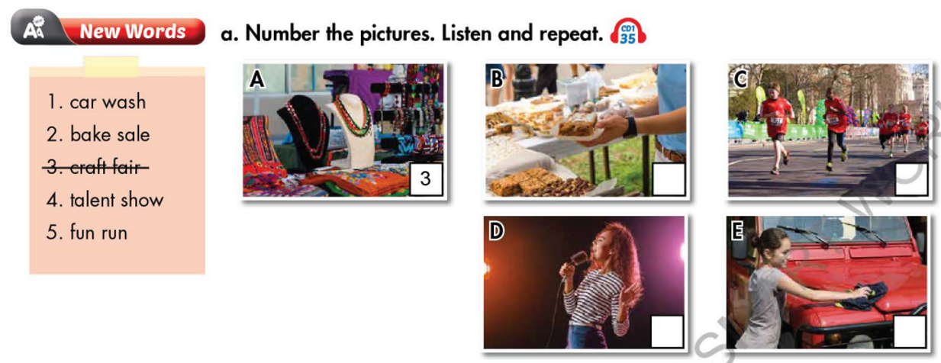  Option 2:  - Divide class into 4 groups.  - Give questions: What can you do to help other people?  - Have Ss in each group list some activities they can do to help other people in 2 minutes.  - Have 4 representatives of 4 groups write answers on the board.  - Check Ss’ answers.  - Give feedback and announce the winner (The group with most correct answers and interesting ideas will be the winner).  - Lead to the new lesson: Community Services. | - Work in pairs to number the pictures.  - Give answers.  - Listen.  Answer keys  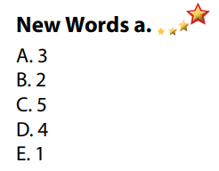  - Take part in the class’s activity in groups.  - Give answers.  Possible answers  Activities to help other people  - raise money for the poor  - provide classes / education for street children  - help old people / small children cross the street  - provide meals for homeless people  - clear up the streets / neighborhood / beach  - donate old clothes / books / school things to poor children,
B. New lesson
Activity 1: Pre-Reading (Vocabulary)
a. Objective: Ss know some words about charity activities and volunteer work.
b. Content:
- Vocabulary study: Number the picture: words about charity activities and volunteer work (car wash, bake sale, craft fair, talent show, fun run, volunteer, charity event, right).
- Circle the correct definitions for the underlined words. Listen and repeat.
- Speaking: Discuss and add more events to the box.
c. Expected outcomes: Ss know how to pronounce the new words correctly and use them in appropriate situations.
d. Organization of the activity:
TEACHER’S ACTIVITIES | STUDENTS’ ACTIVITIES
Task a. Match the words and phrases with the pictures. Listen and repeat.  Option 1 (If the teacher hasn’t used this part for the Warm-up activity)  - Demonstrate the activity on DCR, using the example.  - Have Ss look at the pictures and phrases, then number the pictures.  - Divide class into pairs and have them check their answers with their partners.  - Call Ss to give answers (read or write).  - Check answers as a whole class.  - Play audio (CD1 – Track 35). Have Ss listen and repeat.  - Correct Ss’ pronunciation.  Option 2: Matching (If the teacher has used part a. for the Warm-up activity)  - Have Ss review the words they have known in the warm-up activity by looking at the pictures and saying names of the phrases they have learnt. (T uses different pictures from those in the textbook.)  - Call Ss to give answers (read or write).  - Check answers as a whole class.  - Call some Ss to read the words again.  - Correct Ss’ pronunciation if necessary.  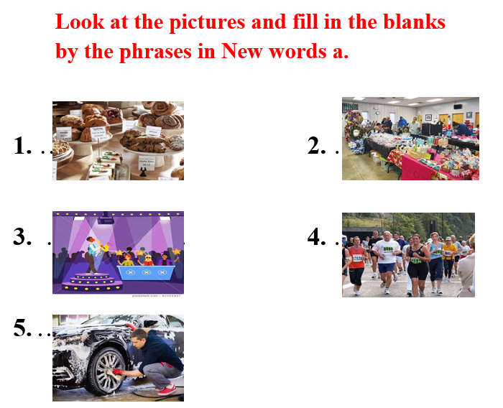  Task b. Circle the correct definitions for the underlined words. Listen and repeat.  - Have students read the sentences and circle the correct definitions.  - Divide the class into pairs and have them check their answers with their partners.  - Check answers as a whole class.  - Play audio (CD 1 – Track 36). Have students listen and repeat.  Task c. Discuss and add more events to the box  - Have Ss discuss in pairs and add more events to the box.  - Have Ss share their ideas in front of the class.  - Give feedback and evaluation. | - Look and listen.  - Work individually.  - Work in pairs.  - Give answers.  - Listen and repeat.  Answer keys  - Work in pairs.  - Give answers.  - Read.  Answer keys  1. bake sale  2. craft fair  3. talent show  4. fun run  5. car wash  - Read and do the task.  - Work in pairs.  - Listen and repeat.  Answer keys  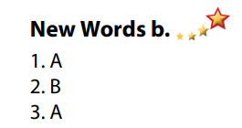  - Discuss in pairs.  - Present.
Activity 2: While - Reading
a. Objective: Students can develop their reading skill.
b. Content: Read the article, then choose the best headline and write Yes, No or Doesn’t Say.
c. Expected outcomes: Students can read an article about children’s right and understand general and specific information.
d. Organization of the activity:
TEACHER’S ACTIVITIES | STUDENTS’ ACTIVITIES
Task a. Read the article and choose the best headline.  - Have Ss read 2 headlines and guess the answer.  - Ask Ss to scan the article, then choose the best headline.  - Remind Ss to underline or highlight the keywords or supporting ideas for their answers.  - Have some Ss share their answers with the class (read), explain for their answers.  - Give feedback.  - Give feedback and correct Ss’ answers if necessary.  Task b. Now, read and write Yes, No or Doesn’t Say.  - Have Ss read the sentences, underline key words.  - Have Ss read the article again and write Yes, No or Doesn’t Say, underline or highlight the supporting ideas.  - Have Ss check answers with their partners.  - Call Ss to give answers, explain.  - Give feedback and evaluation. | - Work individually.  - Read answers, explain.  - Check answers.  Answer keys  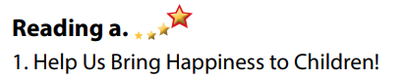  - Read and underline.  - Write answers.  - Check answers.  - Give answers.  Answer keys  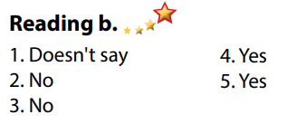
Activity 3: Post - Reading
a. Objective: Students can use the vocabulary and ideas from the reading text to develop their speaking skill.
b. Content: Speaking: Which of the two events would you like to take part in?
c. Expected outcomes: Students can talk about their favorite charity event.
d. Organization of the activity:
TEACHER’S ACTIVITIES | STUDENTS’ ACTIVITIES
Task c. In pairs: Which of the two events would you like to take part in?  - Have Students work in pairs to talk about their favorite charity event.  - Go round and give help if necessary.  - Call some Ss to share their ideas with the whole class.  - Give feedback and evaluation. | - Discuss in pairs.  - Present.  - Listen.
C. Consolidation and homework assignments
* Consolidation:
- Words about charity activities and volunteer work (car wash, bake sale, craft fair, talent show, fun run, volunteer, charity event, right).
*Homework:
- Learn the new words by heart.
- Practice talking about charity activities.
- Do the exercises in WB: New words + Reading (page 20).
- Do the vocabulary exercise in Tiếng Anh 7 i-Learn Smart World Notebook (page 22).
- Play consolation games in Tiếng Anh 7 i-Learn Smart World DHA App on www.eduhome.com.vn
- Prepare: Unit 4 - Lesson 1.2 – Grammar (page 29 – SB).
*********************************************************************
Teaching date: 21/11/2022
Period 34 UNIT 4: COMMUNITY SERVICES
Lesson 1.2 - Grammar (Page 29)
I. OBJECTIVES
By the end of the lesson, Ss will be able to:
1.1. Language knowledge and skills
- listen to 2 people asking and answering about community fundraiser ideas.
- use “should”, “Let’s” and “How about” to make suggestions.
- talk about charity event.
1.2. Competences
- improve speaking, listening skills.
- improve the use of English.
1.3. Attributes
- be active to take part in social activities.
- help other people.
II. TEACHING AIDS AND LEARNING MATERIALS
1. Teacher’s aids: Student book and Teacher’s book, class CDs, Digital Book (DCR phần mềm tương tác SB, DHA (từ vựng/ cấu trúc) phần mềm trò chơi tương tác), projector/interactive whiteboard / TV (if any), PowerPoint slides, handouts.
2. Students’ aids: Student’s book, workbook, notebook, handouts.
III. ASSESSMENT EVIDENCE
Performance Tasks | Performance Products | Assessment Tools
- Listen and repeat. | - Ss’ performance. | - T’s feedback.
- Fill in the blanks with “should”, “Let’s” or “How about”. | - Ss’ answers. | - T’s feedback/Peers’ feedback.
- Circle the correct words. | - Ss’ answers. | - T’s feedback/Peers’ feedback.
- Ask and answer about charity event. | - Ss’ answers/ presentation. | - T’s observation, T’s feedback/Peers’ feedback.
IV. PROCEDURES
A. Warm up:
a. Objective: Introduce the new lesson and set the scene for Ss to acquire new language; get students' attention at the beginning of the class by enjoyable and short activities as well as to engage them in the follow-up steps.
b. Content: Review words about fundraising activities.
c. Expected outcomes: Ss review old vocabularies which are very useful for them in the new lesson.
d. Organization of the activity:
TEACHER’S ACTIVITIES | STUDENTS’ ACTIVITIES
Option 1: Matching  - Have Ss work in pairs to match the words in A with those in B to make a right phrase about fundraising and charity activities.  - Call Ss to give answers.  - Check Ss’ answers, give feedback.  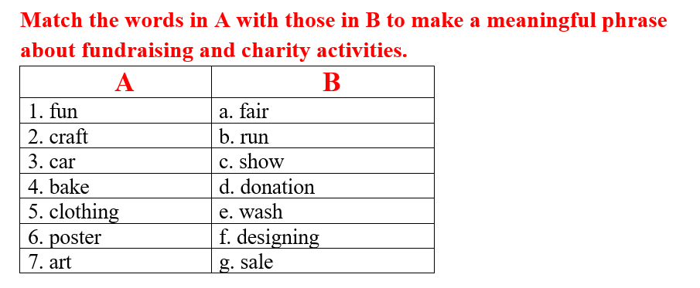  - Have Ss make sentences, using the phrases they have just made.  - Lead to the new lesson.  Option 2: Game: WORD SQUARE  - Give the game: Word Square.  - Have Ss look at the word square and find phrases about fundraising and charity activities.  - Call Ss to give answers.  - Check Ss’ answers, give feedback.  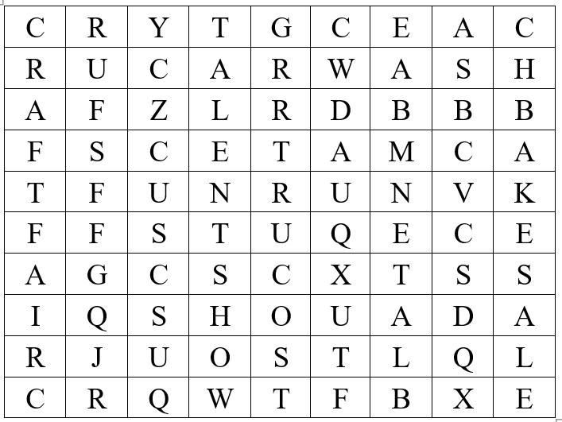  - Have Ss make sentences, using the phrases they have just found.  - Lead to the new lesson. | - Do the matching activity.  - Give answers.  Answers keys  1b  2a  33  4g  5d  6f  7c  - Read sentences.  - Take part in the game.  - Give answers.  Answers keys  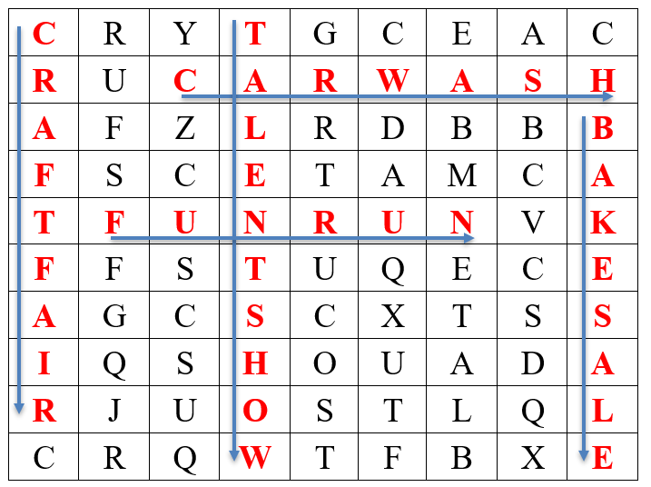  - Read sentences.  - Listen and write the new lesson.
B. New lesson
Activity 1: Presentation
a. Objective: Introduce: “should”, “Let’s” and “How about” to make suggestions.
b. Content:
- Listen and repeat.
- Introduce the grammar points.
c. Expected outcomes: Ss know the new grammar points: “should”, “Let’s” and “How about” to make suggestions and use them in some exercises that follow.
d. Organization of the activity:
TEACHER’S ACTIVITIES | STUDENTS’ ACTIVITIES
Task a. Listen and repeat  - Have Ss look at the picture using DCR.  - Play audio (CD1 – Track 37) and have Ss listen and read the speech bubbles.  - Play the audio again and have Ss listen and repeat.  Grammar box  Option 1:  - Have Ss look at the grammar explanation and read what to make suggestions for.  - Have Ss look at the box and read examples of different forms.  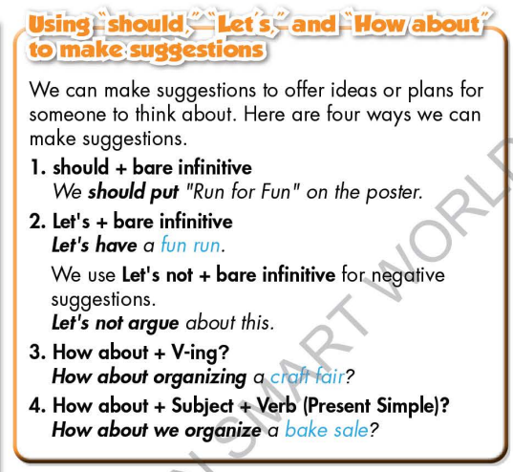  - Explain more about the way to use “should”, “Let’s” and “How about” to make suggestions.  - Ask Ss to make more sentences using “should”, “Let’s” and “How about” to make suggestions.  - Give feedback and evaluation.  Option 2:  - Have Ss look at the sentences in the speech bubbles in Task a and read them again.  - Have Ss make comments on the types of verbs used after “should”, “How about” and “Let’s”.  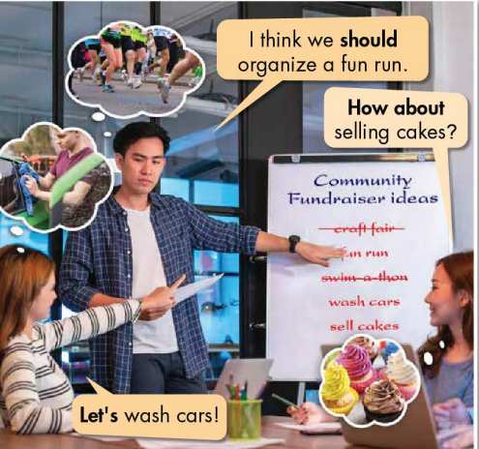  - Have Ss think and answer the question: What are the phrases “should”, “How about” and “Let’s” used for?  - Then, lead to the grammar box, briefly explain the way to use “should”, “How about” and “Let’s”.  - Have Ss read the grammar box again.  - Ask Ss to make more examples using “should”, “Let’s” and “How about” to make suggestions.  - Give feedback and evaluation. | - Look.  - Listen, then read.  - Listen and repeat.  - Look and read.  - Read examples of different forms.  - Listen.  - Give more examples.  - Look and read.  - Comment.  - Give answers.  Suggested answers  The phrases “should”, “How about” and “Let’s” are used for making suggestions.  - Listen.  - Read.  - Give more examples.  - Listen.
Activity 2: Practice
a. Objective: Students can use “should”, “How about” and “Let’s” to do the given exercises.
b. Content:
- Fill in the blanks with “should”, “Let’s” or “How about”.
- Circle the correct words.
c. Expected outcomes: Students can get used to the form and usage of “should”, “Let’s” and “How about” and use them correctly.
d. Organization of the activity:
TEACHER’S ACTIVITIES | STUDENTS’ ACTIVITIES
Task b. Fill in the blanks with “should”, “Let’s” or “How about”.  - Demonstrate the activity on DCR, using the example.  - Have Ss read through the uncompleted sentences and fill in the blanks with “should”, “Let’s” or “How about”.  - Have Ss work in pairs to check each other’s work.  - Have some Ss share their answers with the whole class.  - Give feedback, correct Ss’ answers if necessary.  Task c. Circle the correct words.  - Demonstrate the activity, using the example.  - Have Ss read the sentences and circle the correct words  - Have Ss work in pairs to check each other’s work  - Have some Ss share their answers with the whole class  - Give feedback, correct Ss’ answers if necessary | - Look and listen.  - Work individually.  - Work in pairs.  - Read answers.  Answer keys  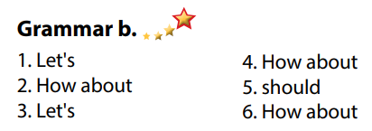  - Look and listen  - Work individually  - Work in pairs  - Read answers, explain  Answer keys  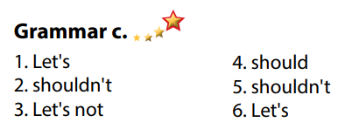
Activity 3: Production
a. Objective: Students master the grammar point they study in the lesson.
b. Content: Speaking: Ask and answer about what kind of charity event they should organize
c. Expected outcomes: Ss produce the new language successfully, and they can use “should”, “Let’s” and “How about” to make suggestions in everyday speaking and writing.
d. Organization of the activity:
TEACHER’S ACTIVITIES | STUDENTS’ ACTIVITIES
Task d. In pairs: Ask and answer about what kind of charity event we should organize.  - Divide class into pairs.  - Have Ss take turns asking their partner about what kind of charity event they should organize.  - Have some pairs demonstrate the activity in front of the class.  - Give feedback and evaluation. | - Have conversation in pairs.  - Present.  - Listen.

C. Consolidation and homework assignments (5’)
* Consolidation:
* Homework:
- Make 3 sentences, use “should”, “Let’s” and “How about” to make suggestions.
- Do the exercises in WB: Lesson 1 - Grammar (page 21).
- Complete the grammar notes in Tiếng Anh 7 i-Learn Smart World Notebook (page 23).
- Play consolation games in Tiếng Anh 7 i-Learn Smart World DHA App on www.eduhome.com.vn
- Prepare: Lesson 1.3 – Pronunciation and Speaking (page 30 – SB).
*********************************************************************
Teaching date: 23/11/2022
Period 35 UNIT 4: COMMUNITY SERVICES
Lesson 1.3 – Pronunciation and Speaking (Page 30)
I. OBJECTIVES
By the end of the lesson, Ss will be able to:
1.1. Language knowledge and skills
- put stress on the first word in compound nouns.
- ask and answer about charity event (types, activities, names, etc.).
- plan a charity event for community.
1.2. Competences
- improve listening and speaking skills.
1.3. Attributes
- be active to take part in social activities.
- help other people.
II. TEACHING AIDS AND LEARNING MATERIALS
1. Teacher’s aids: Student book and Teacher’s book, class CDs, Digital Book (DCR phần mềm tương tác SB, DHA (từ vựng/ cấu trúc) phần mềm trò chơi tương tác), projector/interactive whiteboard / TV (if any), PowerPoint slides, handouts.
2. Students’ aids: Student’s book, workbook, notebook.
III. ASSESSMENT EVIDENCE
Performance Tasks | Performance Products | Assessment Tools
- Listen to the words and focus on the underlined words. | - Ss’ performance and answers. | - T’s observation.
- Listen and cross out the word that doesn’t follow the note in “a”. | - Ss’ performance and answers. | - T’s feedback/Peers’ feedback.
- Read the words with the correct stress to a partner. | - Ss’ performance. | - T’s feedback/Peers’ feedback.
- Ask and answer using the questions and the prompts. | - Ss’ performance. | - T’s feedback/Peers’ feedback.
- Practice with your own ideas. | - Ss’ performance. | - T’s feedback/Peers’ feedback.
- Plan a charity event for your community. Discuss and decide who to help, plan the event and complete the poster. | - Ss’ performance /  Presentation. | - T’s observation, T’s feedback/Peers’ feedback.
IV. PROCEDURES
A. Warm up:
a. Objective: Introduce the new lesson and set the scene for Ss to acquire new language; get students' attention at the beginning of the class by enjoyable and short activities as well as to engage them in the follow-up steps.
b. Content: Review words/ phrases about charity and fund raising events.
c. Expected outcomes: Ss remember old knowledge and use them in other speaking activities.
d. Organization of the activity:
TEACHER’S ACTIVITIES | STUDENTS’ ACTIVITIES
Option 1: Word Dictation  - Prepare sound files of some phrases about charity and fund raising event.  - Play the files, have Ss listen and write down the phrases they can hear on the board.  - Check Ss’ answers.  - Have Ss tell the meaning and read the phrases again  - Correct Ss’s pronunciation if necessary.  - Suggested phrases: craft fair, fun run, art show, talent show, bake sale, car wash, book sale, ...  - Lead to the new lesson.  Option 2: Charity events and slogans  - Have Ss look at the pictures of some charity events, discuss and say the right slogan for each picture.  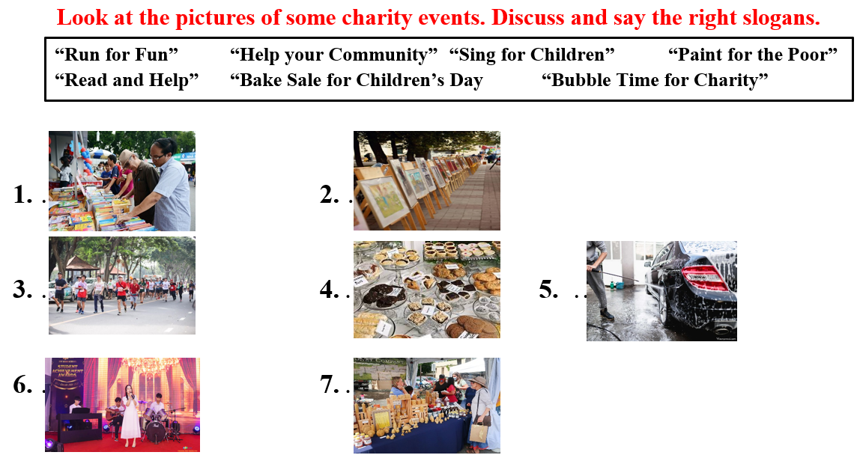  - Call Ss to read answers.  - Give feedback.  - Lead to the new lesson. | - Listen and write down.  - Listen and check.  - Tell the meaning and read the phrases again.  - Work in pairs, then give answers.  Answer keys  1. “Read and Help”  2. “Paint for the Poor”  3. “Run for Fun”  4. “Bake Sale for Children’s Day  5. “Bubble Time for Charity”  6. “Sing for Children”  7. “Help your Community”  - Give answers.  - Listen.
B. New lesson
Activity 1: Pre-Speaking: Pronunciation
a. Objective: Introduce: Stress the first word in compound nouns.
b. Content:
- recognize compound nouns and know how to put stress on compound nouns.
- listen and check, find mistakes.
- practice.
c. Expected outcomes: Ss distinguish and put stress on the first word in compound nouns in their speaking.
d. Organization of the activity:
TEACHER’S ACTIVITIES | STUDENTS’ ACTIVITIES
Task a + b. Listen to the words and focus on the underlined words.  - Briefly explain compound nouns and give some examples using DCR.  - Play the recording (CD1, track 38).  - Ask Ss to listen and focus on the underlined words.  - Play the recording again, have Ss listen and repeat with a focus on the pronunciation feature.  Task c + d. Listen and cross out the word that doesn’t follow the note in “a”, then read the words with the correct stress to a partner.  - Play the recording (CD 1 – Track 39), have Ss listen and cross out the option that doesn’t follow the sound feature in “a”.  - Call Ss to give answers.  - Play the recording again and check answers as a whole class using DCR.  - Then have Ss practice saying the examples with a partner, using the correct stress feature.  - Call some Ss to read the words in front of the class.  - Ask Ss to find some more compound nouns and practice putting stress on them.  - Give feedback and evaluation. | - Listen, take notes.  - Listen again and repeat.  - Listen again and cross out the option that doesn’t follow the sound feature in “a”.  - Give answers.  - Listen again and check.  Answer keys  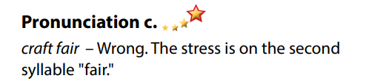  - Work in pairs.  - Read.  - Give answers.
Activity 2: While-speaking
a. Objective: Students can talk about charity event.
b. Content:
- Ask and answer using the questions and the prompts.
- Plan a charity event for your community. Discuss and decide who to help, plan the event and complete the poster.
c. Expected outcomes: Ss produce the new language successfully.
d. Organization of the activity:
TEACHER’S ACTIVITIES | STUDENTS’ ACTIVITIES
*PRACTICE  Task a: Ask and answer using the questions and the prompts.  - Demonstrate the activity by asking and answering with a student.  - Have pairs ask and answer using the questions and the prompts.  - Remind Ss to put stress on the first word in compound nouns.  - Have some pairs demonstrate the activity in front of the class.  - Give feedback and evaluation.  Task b: Practice with your own ideas.  - Have students practice the conversation with their own ideas. Swap roles.  - Have some pairs demonstrate the activity in front of the class.  - Give feedback and evaluation.  *SPEAKING: Charity for the Community  Task a. You're planning a charity event for your community. In threes: Discuss and decide who you want to help, then plan your event and complete the poster.  - Divide the class into groups of 3.  - Have students discuss who they want to help and plan their events together.  - Have students complete the posters.  - Observe, give help if necessary. | - Observe, listen.  - Work in pairs.  - Present.  - Practice the conversation with their own ideas. Swap roles.  - Present.  - Work in groups of 3.  - Complete the posters.
Activity 3: Production
a. Objective: Students report the results to the class.
b. Content: Share their answers with the class.
c. Expected outcomes: Ss produce the new language successfully in everyday speaking and writing.
d. Organization of the activity:
TEACHER’S ACTIVITIES | STUDENTS’ ACTIVITIES
SPEAKING: Charity for the Community  Task b. Share with the class.  - Have some Ss share their plan of the charity event with the class.  - Give feedback and evaluation. | - Present.  - Listen.
C. Consolidation and homework assignments (5’)
* Consolidation:
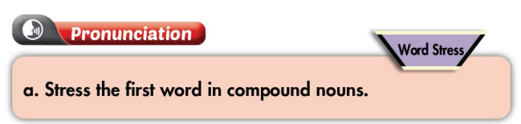
*Homework:
- Practice putting stress on compound nouns.
- Complete the poster for those who haven’t finished it in class.
- Prepare: Unit 4 - Lesson 2 – New words and Listening (page 31 – SB).
- Review the vocabulary and grammar notes in Tiếng Anh 7 i-Learn Smart World Notebook
(pages 22 & 23).
- Play consolation games in Tiếng Anh 7 i-Learn Smart World DHA App on www.eduhome.com.vn
*****************************************************************
Teaching date: 24/11/2022
Period 36 UNIT 4: COMMUNITY SERVICES
Lesson 2.1 – New words and Listening (Page 31)
I. OBJECTIVES
By the end of the lesson, Ss will be able to:
1.1. Language knowledge and skills
- know more words about activities to help community.
- talk about things to do to help community.
- practice listening to an interview about how students help community (for general and specific details).
- introduce a topic.
1.2. Competences
- improve communication, collaboration, and critical thinking skills.
1.3. Attributes
- be active to take part in social activities.
- help other people.
II. TEACHING AIDS AND LEARNING MATERIALS
1. Teacher’s aids: Student book and Teacher’s book, class CDs, Digital Book (DCR phần mềm tương tác SB, DHA (từ vựng/ cấu trúc) phần mềm trò chơi tương tác), projector/interactive whiteboard / TV (if any), PowerPoint slides.
2. Students’ aids: Student’s book, workbook, notebook.
III. ASSESSMENT EVIDENCE
Performance Tasks | Performance Products | Assessment Tools
- Fill in the table. | - Ss’ answers. | - T’s feedback/Peers’ feedback.
- Listen and repeat. | - Ss’ presentation. | - T’s feedback/Peers’ feedback.
- Add more words to the table. Share your ideas with the class. | - Ss’ answers. | - T’s feedback/Peers’ feedback.
- Listen to two people talking. What is the purpose of the interview? | - Ss’ answers. | - T’s feedback/Peers’ feedback.
- Listen and circle the correct answers. | - Ss’ answers. | - T’s feedback/Peers’ feedback.
- Speak: What kinds of things could you do to help your local community? | - Ss’ answers/ presentation. | - T’s observation and feedback / DCR.
IV. PROCEDURES
A. Warm up:
a. Objective: Introduce the new lesson and set the scene for Ss to acquire new language; get students' attention at the beginning of the class by enjoyable and short activities as well as to engage them in the follow-up steps.
b. Content: Introduce words about activities to help community.
c. Expected outcomes: Ss get to know some new words they are going to study in the lesson.
d. Organization of the activity:
TEACHER’S ACTIVITIES | STUDENTS’ ACTIVITIES
Option 1: Fill in the table. Listen and repeat.  - Use the “New words” part a.– page 31 for the warm-up activity.  - Show words and tables using DCR, have Ss fill in the table (in pairs).  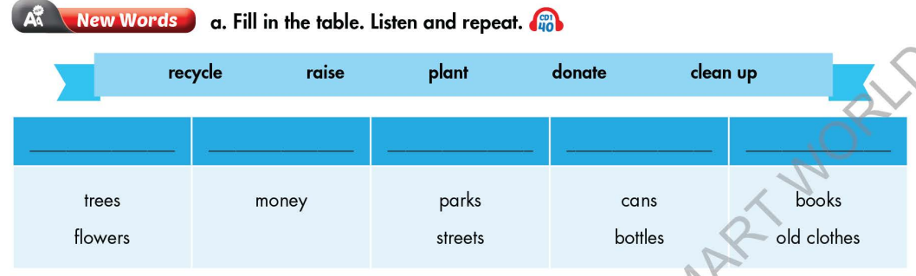  - Call Ss to give answers.  - Give feedback and show correct answers.  - Lead to the new lesson.  - Play the audio (CD1 – Track 40), have Ss listen and repeat.  - Correct Ss’ pronunciation if necessary.  Option 2: Matching  - Have Ss work in pairs and do the matching exercise.  - Call Ss to give answers.  - Read the words, have Ss listen and repeat.  - Give feedback and evaluation.  - Lead to the new lesson.  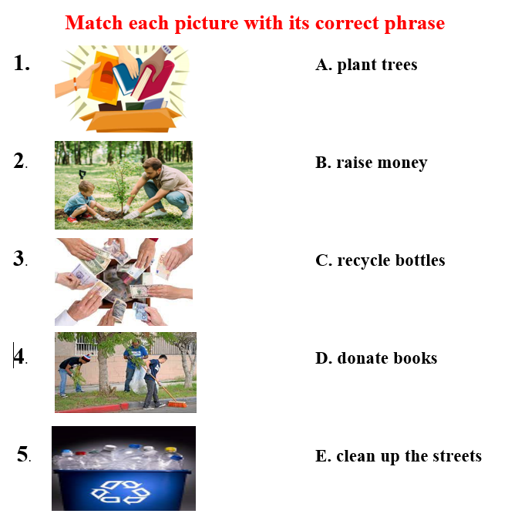 | - Work in pairs.  - Give answers.  - Listen.  - Listen and repeat.  Answer keys  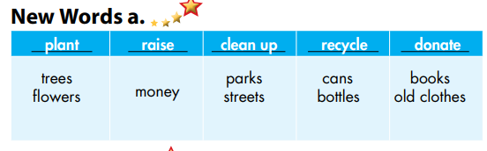  - Work in pairs and match.  - Give answers.  - Listen and repeat.  Answer keys  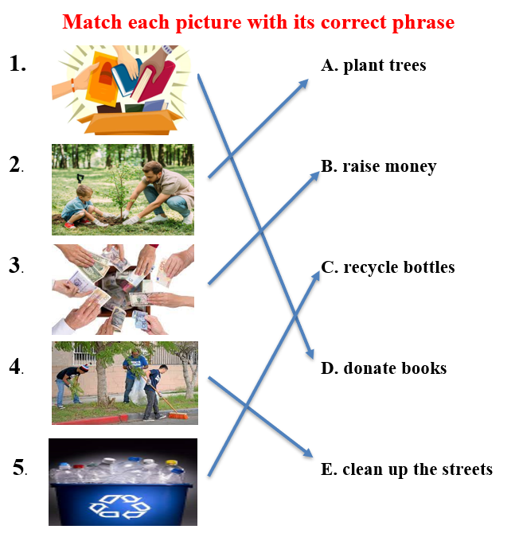
B. New lesson
Activity 1: Pre-Listening (Vocabulary)
a. Objective: Ss get to know words about activities to help community.
b. Content:
- Vocabulary study (recycle, raise, plant, donate, clean up).
- Speaking: Ask and answer about activities to help community.
c. Expected outcomes: Ss know how to pronounce the new words correctly and use them when talking about activities to help community.
d. Organization of the activity:
TEACHER’S ACTIVITIES | STUDENTS’ ACTIVITIES
Task a. Fill in the table. Listen and repeat.  Option 1 (If the teacher hasn’t used this part for the Warm-up activity)  - Demonstrate the activity on DCR, using the example.  - Have Ss fill in the table.  - Divide class into pairs and have them check their answers with their partners.  - Call Ss to give answers (read or write).  - Check answers as a whole class.  - Play audio (CD1 – Track 40). Have Ss listen and repeat.  - Correct Ss’ pronunciation.  Option 2: Odd one out (If the teacher has used part a. for the Warm-up activity)  - Give 5 sets of words.  - Have Ss work in pairs to odd one out (Find a word which doesn’t belong to the group).  - Have Ss give answers and explain for their answers.  - Check answers as a whole class.  - Call some Ss to read the words again.  - Correct Ss’ pronunciation if necessary.  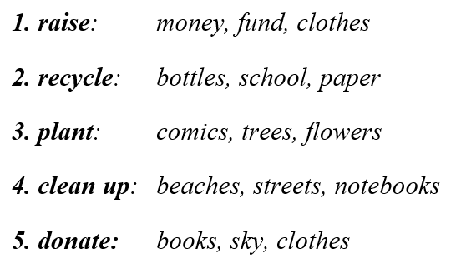  Task b. In pairs: Add more words to the table. Share your idea with the class.  - Have Ss work in pairs to add more words to the table.  - Go round and give help if necessary.  - Have some pairs share their ideas with the class.  - Give feedback and evaluation. | - Look and listen.  - Work individually.  - Work in pairs.  - Give answers.  - Listen and repeat.  Answer keys  - Work in pairs.  - Give answers, explain.  - Read.  Answer keys  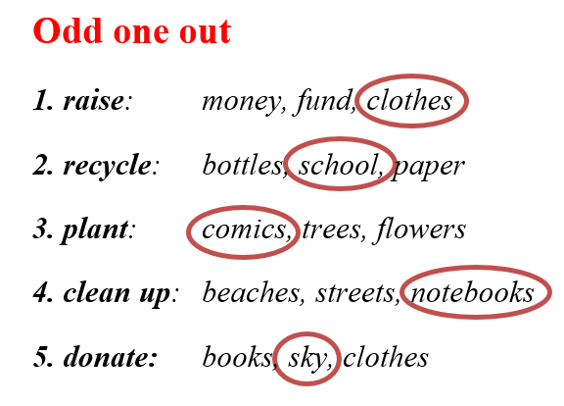  - Work in pairs.  - Present.  Suggested answers  1. raise: fund, awareness, …  2. recycle: paper, plastic products, food waste, …  3. plant: vegetables, herbs, …  4. clean up: beaches, rooms, schools, …  5. donate: blood, money, clothes, …
Activity 2: While - Listening
a Objective: Students can develop their listening skill.
b Content: Listen to two people talking. What is the purpose of the interview? + Circle the answers.
c Expected outcomes: Students can listen and understand general and specific information about activities to help community.
d. Organization of the activity:
TEACHER’S ACTIVITIES | STUDENTS’ ACTIVITIES
Task a. Listen to two people talking. What is the purpose of the interview?  - Have Ss read the phrases, guess the answer.  - Play audio (CD1 - Track 41).  - Have Ss listen and circle the correct answer.  - Check answer as a whole class.  Task b. Now, listen and circle.  - Have Ss read the through the content of task b, underline the key words.  - Play the audio again (CD1 - Track 41)  - Have Ss listen and circle the correct answers.  - Have Ss check answers with their partners.  - Call Ss to give answers.  - Give feedback and show correct answers using DCR. | -Work individually.  - Listen.  - Circle the correct answers.  Answer keys  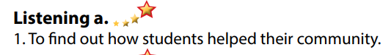  - Read and underline the key words.  - Do the task.  - Check answers.  Answer keys  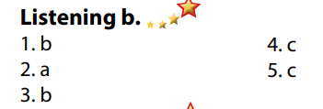
Activity 3: Post - Listening
a. Objective: Students can use the vocabulary and the content in listening part to develop their speaking skill.
b. Content: Speaking: What kinds of things could you do to help your local community?
c. Expected outcomes: Students can have a free-talk about things to do to help their local community
d. Organization of the activity:
TEACHER’S ACTIVITIES | STUDENTS’ ACTIVITIES
Conversation skill  - Have Ss look at the Conversation skill box and read.  - Play audio (CD 1 - Track 42), have Ss listen and repeat.  - Ask Ss to find more ways to introduce a topic.  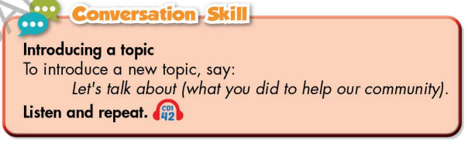  Task c. In pairs: What kinds of things could you do to help your local community?  - Have Ss work in pairs to discuss.  - Observe and give help if necessary.  - Call some pairs to share their ideas with the class.  - Give feedback and evaluation. | - Look and read.  - Listen and repeat.  - Give answers.  - Work in pairs.  - Present.
C. Consolidation and homework assignments (5’)
*Consolidation:
- Words about activities to help community:
1. raise: fund, awareness, money…
2. recycle: paper, plastic products, food waste, bottle, cans…
3. plant: vegetables, herbs, trees, flowers…
4. clean up: beaches, rooms, schools, streets, …
5. donate: blood, money, clothes, books, …
- Language to introduce a topic: Let’s talk about … / Let’s begin with …
*Homework
- Learn the new words by heart.
- Practice talking about how to help the community.
- Do the exercises in WB: New words and Listening (page 22 – WB).
- Do the vocabulary exercise in Tiếng Anh 7 i-Learn Smart World Notebook (page 24).
- Play consolation games in Tiếng Anh 7 i-Learn Smart World DHA App on www.eduhome.com.vn
- Prepare: Lesson 2.2 – Grammar (page 32 – SB).
*********************************************************************
Teaching date: 28/11/2022
Period 37 UNIT 4: COMMUNITY SERVICES
Lesson 2.2 - Grammar (Page 32)
I. OBJECTIVES
By the end of the lesson, Ss will be able to:
1.1. Language knowledge and skills
- listen to 2 people asking and answering about activity to help community.
- use Past Simple with regular verbs correctly.
1.2. Competences
- improve speaking, listening and writing skills.
- improve the use of English.
1.3. Attributes
- be active to take part in social activities.
- help other people.
II. TEACHING AIDS AND LEARNING MATERIALS
1. Teacher’s aids: Student book and Teacher’s book, class CDs, Digital Book (DCR phần mềm tương tác SB, DHA (từ vựng/ cấu trúc) phần mềm trò chơi tương tác), projector/interactive whiteboard / TV (if any), PowerPoint slides, handouts.
2. Students’ aids: Student’s book, workbook, notebook.
III. ASSESSMENT EVIDENCE
Performance Tasks | Performance Products | Assessment Tools
- Listen and repeat. | - Ss’ performance. | - T’s feedback.
- Study the grammar box. | - Ss’ task. | - T’s observation.
- Fill in the blanks with the Past Simple form of verbs in brackets. | - Ss’ answers. | - T’s feedback/Peers’ feedback.
- Look at the table and write the answers. | - Ss’ answers. | - T’s feedback/Peers’ feedback.
- Ask and answer using the information in Task c (in pairs). | - Ss’ performance/ presentation. | - T’s observation, T’s feedback / Peers’ feedback.
IV. PROCEDURES
A. Warm up:
a. Objective: Introduce the new lesson and set the scene for Ss to acquire new language; get students' attention at the beginning of the class by enjoyable and short activities as well as to engage them in the follow-up steps.
b. Content: Review phrases about helping community / introduce Past Simple with regular verbs.
c. Expected outcomes: Ss review old knowledge and have general ideas about the grammar point they are going to study in the new lesson.
d. Organization of the activity:
TEACHER’S ACTIVITIES | STUDENTS’ ACTIVITIES
Option 1:  - Give some sets of pictures.  - Have Ss find a word that can goes with the things in each set of pictures.  - Call Ss to give answers.  - Check Ss’ answers, give feedback.  - Have Ss make sentences, using the vocabularies above.  - Lead to the new lesson.  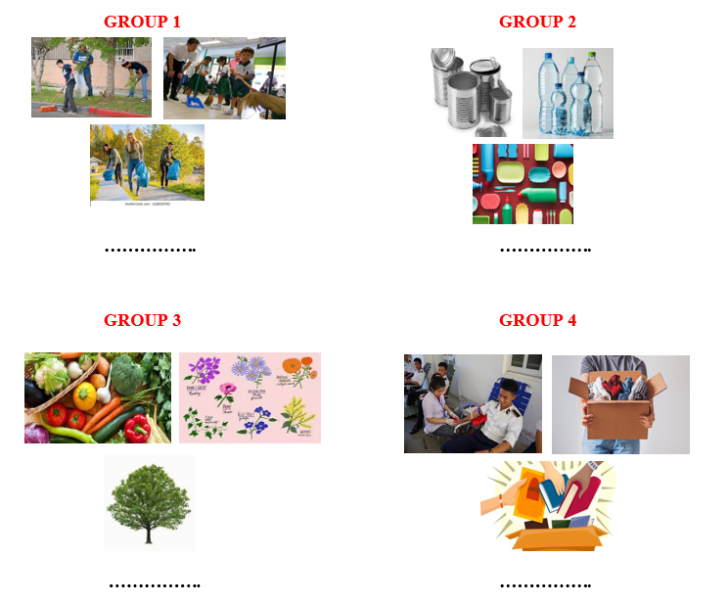  Option 2:  - Give Ss a list of many verbs.  - Divide class into 4 groups.  - Have Ss in each group give the past form of verbs and divide them into 2 groups: regular past form and irregular past form.  - Call Ss to give answers.  - Check Ss’ answers, give feedback and evaluation.  - Lead to the new lesson: Past Simple with regular verbs.  *Suggested verb list: go, recycle, become, raise, have, donate, plant, give, eat, clean, do. | - Work in pairs.  - Give answers.  - Make sentences and read them.  Answers keys  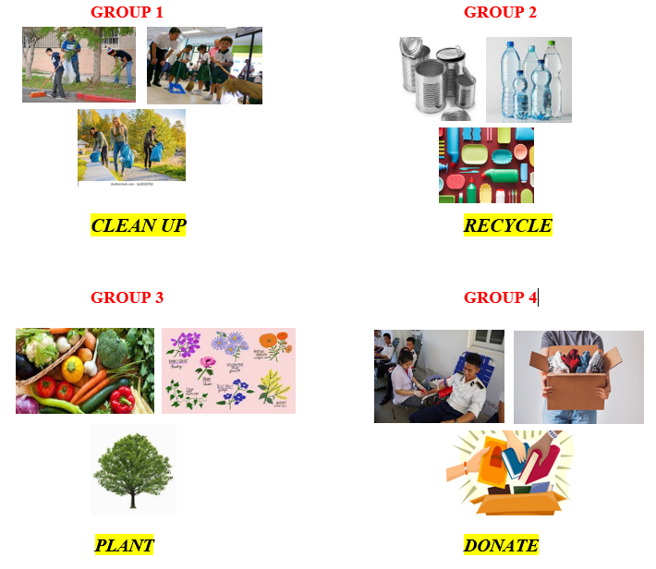  - Do the task.  - Give answers.  Expected answers  - regular past form: recycle, raise, donate, plant, clean.  - irregular past form: go, become, have, give, eat, do.
B. New lesson
Activity 1: Presentation
a. Objective: Introduce Past Simple with regular verbs.
b. Content:
- Listen and repeat.
- Introduce the grammar point: Past Simple with regular verbs.
c. Expected outcomes: Ss know how to use Past Simple with regular verbs to do some following exercises.
d. Organization of the activity:
TEACHER’S ACTIVITIES | STUDENTS’ ACTIVITIES
Task a. Listen and repeat.  - Have Ss look at the picture using DCR.  - Play audio (CD1 – Track 43) and have Ss listen and read the speech bubbles.  - Play the audio again and have Ss listen and repeat.  Grammar box  Option 1:  - Have Ss look at the grammar explanation and read: Past Simple with regular verbs.  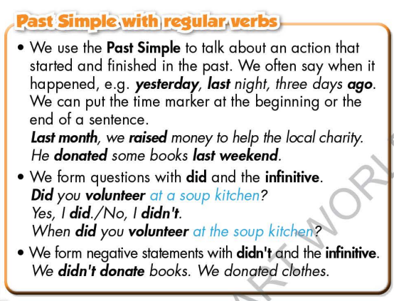  - Have Ss look at the “Past Simple-spelling rules for -ed” and read.  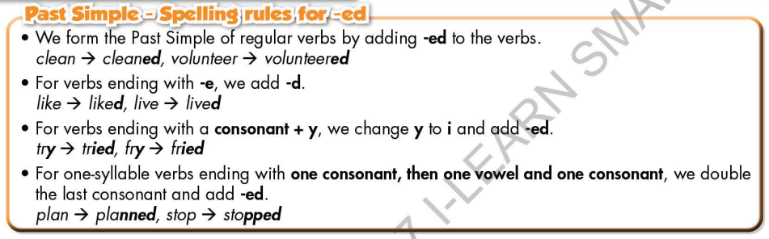  - Briefly explain the grammar point.  - Ask Ss to give more past Simple with regular verbs and make sentences with them.  Option 2:  - Have Ss close books.  - Show sample sentences, have Ss read them and make comment on the bold verbs and the underlined time expressions in these sentences.  *Suggested sentences:  1.Last month, we raised money to help the poor family.  2.He donated some books 2 weeks ago.  3. I volunteered to work for a local charity organization last year.  4. Yesterday my father planted some tress in the garden.  - Have Ss give answers.  - Give feedback and evaluation.  àLead to the grammar box and explain more: Past Simple with regular verbs.  - Next, have Ss look at the spelling rules of verbs ending with “ed” and read aloud.  - Get Ss to give more past Simple with regular verbs and make sentences with them.  - Give feedback and evaluation. | - Look.  - Listen, then read.  - Listen and repeat.  - Look and read.  - Look and read.  - Listen and take notes.  - Give more verbs and make sentences.  - Close all books.  - Look and answer.  Suggested answers  - The bold verbs are in simple past.  - The underlined time expressions can be put at the beginning or at the end of the sentence.  - Open the books and read the grammar box.  - Look and read.  - Give more verbs with regular past simple form and make sentences with them.
Activity 2: Practice
a. Objective: Students can use Past Simple with regular verbs correctly.
b. Content:
- Fill in the blanks with the Past Simple form of the verbs in brackets.
- Look at the table and write the answers.
c. Expected outcomes: Students can use Past Simple with regular verbs in their speaking.
d. Organization of the activity:
TEACHER’S ACTIVITIES | STUDENTS’ ACTIVITIES
Task b. Fill in the blanks with the Past Simple form of the verbs in brackets.  - Demonstrate the activity on DCR, using the example.  - Have Ss fill in the blanks with the Past Simple form of the verbs in brackets.  - Have Ss work in pairs to check each other’s work.  - Have some Ss share their answers with the whole class.  - Give feedback, correct Ss’ answers if necessary.  Task c. Look at the table and write the answers.  - Demonstrate the activity on DCR, using the example.  - Have Ss look at the table and write the answers.  - Have Ss check answers with their partners.  - Call Ss to read or write answers.  - Check Ss’ answers, give feedback. | - Look and listen.  - Work individually.  - Work in pairs.  - Write answers on the board.  Answer keys  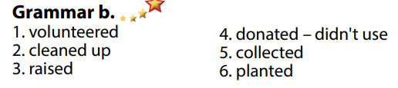  - Look and listen.  - Work individually.  - Work in pairs.  - Read or write answers.  Answer keys  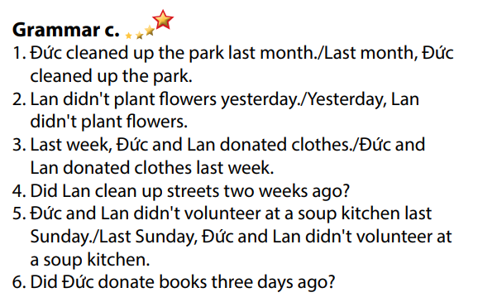
Activity 3: Production
a. Objective: Students master the grammar point they study in the lesson.
b. Content: Speaking: Ask and answer using the information in Task c.
c. Expected outcomes: Ss produce the new language successfully, and they can apply the grammar point they have learnt in speaking and writing.
d. Organization of the activity:
TEACHER’S ACTIVITIES | STUDENTS’ ACTIVITIES
Task d. In pairs: Ask and answer using the information in Task c.  - Divide class into pairs.  - Have Ss ask and answer using the information in Task c.  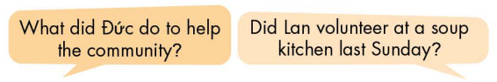  - Then, encourage Ss to add their own ideas to practice.  - Have some pairs demonstrate the activity in front of the class.  - Give feedback and evaluation. | - Work in pairs.  - Have conversation in pairs.  - Present.  - Listen.
C. Consolidation and homework assignments
*Consolidation
- Past Simple with regular verbs
- Spelling rules for “ed” endings
*Homework:
- Make 2 sentences using Past Simple with regular verbs.
- Do the exercises in WB: Grammar (page 23).
- Complete the grammar notes in Tiếng Anh 7 i-Learn Smart World Notebook (page 25).
- Play consolation games in Tiếng Anh 7 i-Learn Smart World DHA App on www.eduhome.com.vn
- Prepare: Lesson 2.3 – Pronunciation and Speaking (page 33 – SB).
*********************************************************************
Teaching date: 30/11/2022
Period 38 UNIT 4: COMMUNITY SERVICES
Lesson 2.3 – Pronunciation and Speaking (Page 33)
I. OBJECTIVES
By the end of the lesson, Ss will be able to:
1.1. Language knowledge and skills
- distinguish and pronounce verbs in past form endings with “ed”.
- ask and answer about activities to help community in the past.
- talk about activities to help community in details.
1.2. Competences
- improve listening and speaking skills.
1.3. Attributes
- be active to take part in social activities.
- help other people.
II. TEACHING AIDS AND LEARNING MATERIALS
1. Teacher’s aids: Student book and Teacher’s book, class CDs, Digital Book (DCR phần mềm tương tác SB, DHA (từ vựng/ cấu trúc) phần mềm trò chơi tương tác), projector/interactive whiteboard / TV (if any), PowerPoint slides, handouts.
2. Students’ aids: Student’s book, workbook, notebook.
III. ASSESSMENT EVIDENCE
Performance Tasks | Performance Products | Assessment Tools
- Listen to the words and focus on the underlined letters. | - Ss’ performance and answers. | - T’s observation.
- Listen and cross out the word that has the underlined part pronounced differently from the others. | - Ss’ answers. | - T’s feedback/Peers’ feedback.
- Read the words with the correct sound to a partner. | - Ss’ performance. | - T’s feedback/Peers’ feedback.
- Ask and answer. | - Ss’ performance. | - T’s feedback/Peers’ feedback.
- Practice with their own ideas. | - Ss’ performance. | - T’s feedback/Peers’ feedback.
- Fill in the table with details about what you did to help the community. Then, ask your partner about what they did and complete the table on the right. Swap the roles and repeat. | - Ss’ performance /  Presentation. | - T’s observation, T’s feedback/Peers’ feedback.
IV. PROCEDURES
A. Warm up: (5’)
a. Objective: Introduce the new lesson and set the scene for Ss to acquire new language; get students' attention at the beginning of the class by enjoyable and short activities as well as to engage them in the follow-up steps.
b. Content: Review: Past Simple of regular verbs.
c. Expected outcomes: Ss remember old knowledge and use them in other speaking activities.
d. Organization of the activity:
TEACHER’S ACTIVITIES | STUDENTS’ ACTIVITIES
Option 1: JUMBLED WORDS  - Give Ss a list of verbs in the Simple Past with “ed” ending (the letters are not in correct order).  - Have Ss rearrange the letters to make a meaningful verb.  1. receclyd  2. toandde  3. siarde  4. lecadne  5. ledptan  - Call Ss to write answers on the board.  - Give feedback.  - Lead to the new lesson: How to pronoun verbs in the Simple Past with “ed” ending.  Option 2: Verbs with “ed” ending  - Divide class into groups of 4.  - Set a limit time (about 2 minutes). Have Ss write as many as possible the verbs in past form ending with “ed”.  - Call Ss to write answers.  - Mark Ss’ answers.  - The group which has the most correct answers will be the winner.  - Lead to the new lesson. | - Work in pairs, then give answers.  Answer keys  1. recycled  2. donated  3. raised  4. cleaned  5. planted  - Listen.  - Work in pairs and write.  - Listen.
B. New lesson
Activity 1: Pre-Speaking: Pronunciation (10’)
a. Objective: Introduce different pronunciation /d/, /id/, /t/ of verbs ending “-ed”.
b. Content:
- recognize different pronunciation /d/, /id/, /t/ of verbs ending “-ed”.
- listen and check, find the word that has the underlined part pronounced differently from the others.
- practice.
c. Expected outcomes: Ss distinguish and use different pronunciation /d/, /id/, /t/ of verbs ending “-ed” correctly in their speaking.
d. Organization of the activity:
TEACHER’S ACTIVITIES | STUDENTS’ ACTIVITIES
Task a + b. Listen to the words and focus on the underlined letters.  - Play the recording (CD1, track 44) using DCR.  - Ask Ss to listen and focus on the underlined letters.  - Play the recording again, have Ss listen and repeat with a focus on the pronunciation feature.  - Explain more about the way how to have different pronunciation /d/, /id/, /t/ of verbs ending “-ed”.  1. The /id/ sound  If the last letter of the word is spelled with D or T, the ED is pronounced as a separate syllable with an /id/ sound (it rhymes with kid and lid).  - wanted (sounds like "want-id")  - waited  - needed  - folded  2. The /t/ sound  If the last consonant of the word is voiceless, then the ED is pronounced as a T. Be careful not to create an extra syllable or "id" sound.  - talked (sounds like "talk-t")  - kissed (the S sound comes from the front of mouth so it would sound like "kiss-t")  - parked  - helped  NOTE: As an example, with the word "helped", if you say "help-id" as a two-syllable word, then it is very likely that people will NOT understand the word or what you are saying. (It is pronounced like "help-t").  3. The /d/ sound  If the last letter of the words ends in a voiced consonant (or sound), then the ED is pronounced like a D (without creating another syllable).  - played (sounds like "play-d")  - closed (the S sounds like a vibrating Z so the word would sound like "cloz-d")  - opened  - lived  Task c + d. Listen and cross out the word that has the underlined part pronounced differently from the others.  - Play the recording (CD 1 – Track 45), have Ss listen and cross out the option that is pronounced differently from the others.  - Call Ss to give answers.  - Play the recording again and check answers as a whole class using DCR.  - Then have Ss practice saying the words with a partner, using the correct pronunciation feature.  - Call some Ss to read the words in front of the class.  - Ask Ss to find some more English words with an “ed” ending which contains /t/, /d/ and /id/ sound.  - Give feedback and evaluation. | - Listen.  - Listen again and repeat.  - Listen and take notes.  - Listen and cross out.  - Give answers.  - Listen again and check.  Answer keys  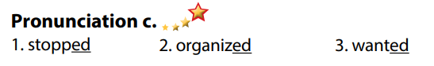  - Work in pairs.  - Read.  - Give answers.
Activity 2: While-speaking
a. Objective: Students can talk about activities to help community.
b. Content:
- Ask and answer.
- Your school went out to help the community. Fill in the table with details about what you did. Then, ask your partner about what they did and complete the table on the right. Swap roles and repeat.
c. Expected outcomes: Ss produce the new language successfully.
d. Organization of the activity:
TEACHER’S ACTIVITIES | STUDENTS’ ACTIVITIES
PRACTICE  * Ask and answer  - Demonstrate the activity by asking and answering with a student.  - Have pairs ask and answer using the pictures and words in the box.  - Remind Ss to pay attention to the time expressions of the Simple Past.  - Have some pairs demonstrate the activity in front of the class.  SPEAKING: Help The Community  Task a. Your school went out to help the community. Fill in the table with details about what you did. Then, ask your partner about what they did and complete the table on the right. Swap roles and repeat  - Demonstrate the activity by practicing the activity with a student.  - Divide the class into pairs.  - Have students complete the table with information about what they did to help the community and ask their partner to complete the table on the right.  - Have Ss swap roles and repeat.  - Observe, give help if necessary. | - Observe, listen.  - Work in pairs.  - Present.  - Observe and listen.  - Work in pairs.  - Do the task.  - Swap roles and repeat.
Activity 3: Production
a. Objective: Students report to the class what they did to help the community.
b. Content: Share with the class what they did to help the community.
c. Expected outcomes: Ss produce the new language successfully in everyday speaking and writing.
d. Organization of the activity:
TEACHER’S ACTIVITIES | STUDENTS’ ACTIVITIES
SPEAKING: Help The Community  Task b. Share with the class.  - Have students take a look at the table again, make any correction or adjustment if necessary.  - Have some Ss share their findings with the class.  - Give feedback and evaluation. | - Check the table.  - Present.  - Listen.
C. Consolidation and homework assignments (5’)
*Consolidation: How to pronounce verbs in past form endings with “ed”.
1. /t/: Verbs with ending sounds: /s/, /f/, /p/, /ʃ/, /tʃ/, /k/.
E.g:
- Hoped /hoʊpt/
- Coughed /kɔːft/
- Fixed /fɪkst/
2. /id/: Verbs with ending sounds: /t/ hay /d/.
E.g:
- Wanted /ˈwɑːntɪd/
- Added /ædɪd/
3. /d/ The other verbs
E.g:
- Cried /kraɪd/
- Smiled /smaɪld/
- Played /pleɪd/
*Homework:
- Practice pronouncing verbs with “ed” endings.
- Complete the table for those who haven’t finished it in class.
- Prepare: Unit 4 - Lesson 3 – Reading and Listening (page 34 – SB).
- Review the vocabulary and grammar notes in Tiếng Anh 7 i-Learn Smart World Notebook (pages 24 & 25).
- Play consolation games in Tiếng Anh 7 i-Learn Smart World DHA App on www.eduhome.com.vn
***************************************************************
Teaching date: 01/12/2022
Period 39 UNIT 4: COMMUNITY SERVICES
Lesson 3.1 - Listening and Reading (Page 34)
I. OBJECTIVES
By the end of the lesson, Ss will be able to:
1.1. Language knowledge and skills
- talk about how to protect the environment.
- review past simple.
- practice listening and understanding general and specific information about voluntary clean-up project.
- read and understand an email about cleaning up the beach.
1.2. Competences
- improve communication, collaboration, analytical and critical thinking skills.
1.3. Attributes
- be active to take part in social activities.
- help other people.
- raise awareness of protecting the environment.
II. TEACHING AIDS AND LEARNING MATERIALS
1. Teacher’s aids: Student book and Teacher’s book, class CDs, Digital Book (DCR phần mềm tương tác SB, DHA (từ vựng/ cấu trúc) phần mềm trò chơi tương tác), projector/interactive whiteboard / TV (if any), PowerPoint slides.
2. Students’ aids: Student’s book, workbook, notebook.
III. ASSESSMENT EVIDENCE
Performance Tasks | Performance Products | Assessment Tools
- Let’s Talk: Look at the picture. Do you know any beaches that look like this? How does it make you feel? What can we do to stop this from happening? | - Ss’ answers / presentation. | - T’s feedback/Peers’ feedback.
- Listen to Annie talking to Robert. What do you think Annie's job is? | - Ss’ answers. | - T’s feedback / Peers’ feedback.
- Listen again and circle the correct answer. | - Ss’ answers. | - T’s feedback / Peers’ feedback.
- Read Jane's email to Dan. Would Jane like to take part in future clean-ups? | - Ss’ answers. | - T’s feedback/Peers’ feedback.
- Now, read and write True or False. | - Ss’ answers. | - T’s feedback/Peers’ feedback.
- Speaking: Would you like to take part in a beach clean-up? Why (not)? | - Ss’ answers / presentation. | - T’s observation/ DCR and T’s feedback.
IV. PROCEDURES
A. Warm up:
a. Objective: Introduce the new lesson and set the scene for Ss to acquire new language; get students' attention at the beginning of the class by giving enjoyable and short activities as well as to engage them in the follow-up steps.
b. Content: Introduce the situation: Dirty beaches.
c. Expected outcomes: Ss have general ideas about the topic “cleaning up the beaches”, which they are going to listen and read in the new lesson.
d. Organization of the activity:
TEACHER’S ACTIVITIES | STUDENTS’ ACTIVITIES
Option 1: Let’s Talk!  - Use the “Let’s talk!” part in the textbook– page 34 for warm-up activity.  - Ask Ss to work in pairs to look at the picture and answer the questions:  1. Do you know any beaches that look like this?  2. How does it make you feel?  3. What can we do to stop this from happening?  - Call Ss to share their answers with the whole class.  - Give feedback and evaluation.  - Lead to the new lesson.  Option 2:  - Show a video clip about cleaning up the dirty beach.  - Have Ss watch and answer some questions:  1. Do you know any beaches that look like this?  2. How does it make you feel?  3. What can the people in the clip do to make the beach cleaner?  - Call Ss to give answers.  - Check and give comment.  - Lead to the new lesson.  *Link https://www.youtube.com/watch?v   | - Work in pairs to discuss.  - Present.  - Watch the video clip, then answer T’s questions.  - Give answers.  - Listen.
B. New lesson
Activity 1: Listening
a. Objective: Students can develop their listening skill.
b. Content: Listen to a conversation about clean-up activities.
c. Expected outcomes: Students can practice listening and understanding general + specific information about clean-up activities.
d. Organization of the activity:
TEACHER’S ACTIVITIES | STUDENTS’ ACTIVITIES
Task a. Listen to Annie talking to Robert. What do you think Annie's job is?  - Briefly explain the meaning of the three options.  - Have Ss read the question.  - Play audio (CD1 - Track 46).  - Have Ss listen and circle the correct answer.  - Call Ss to give answer, explain  - Play the audio again and check the answer as a whole class using DCR.  Task b. Now, listen and circle the correct answers  - Have Ss read through the content of Task b first.  - Play the audio again (CD1 - Track 46).  - Have Ss listen and circle the correct answers.  - Have Ss check answers with their partners.  - Call Ss to give answers, explain.  - Check answers as a whole class using DCR | - Listen and take notes.  - Read.  - Listen and circle the correct answer.  - Give answer, explain.  Answer keys  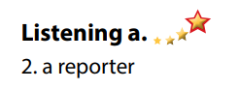  - Read.  - Listen and circle the correct answers.  - Exchange answers.  - Give answers.  Answer keys  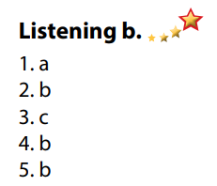
Activity 3: Reading
a. Objective: Students can develop their reading skill.
b. Content:
- Read Jane's email to Dan. Would Jane like to take part in future clean-ups?
- Now, read and write True or False.
c. Expected outcomes: Students can read an email about cleaning up the beach for gist and detail, and they can talk about their environmental clean-up activities.
d. Organization of the activity:
TEACHER’S ACTIVITIES | STUDENTS’ ACTIVITIES
Task a. Read Jane's email to Dan. Would Jane like to take part in future clean-ups?  - Have Ss read Task a.  - Ask Ss to read the email quickly and circle the correct answer.  - Call 1 S to give answer.  - Check answers as a whole class using DCR.  Task b. Now, read and write True or False.  - Have Ss read the content in Task b and underline the key words.  - Have Ss read the email again and write True or False.  - Have Ss check their answers with a partner.  - Call Ss to give answers.  - Check answers as a whole class using DCR.  Task c. Speaking: In pairs: Would you like to take part in a beach clean-up? Why (not)?  - Have Ss discuss the questions in pairs.  - Call some Ss to share their answers with the whole class.  - Give feedback and evaluation.  - For class with high level students: Give Ss an extra task: List some activities you can do in a beach clean-up project.  - Call Ss some Ss to share their answers with the whole class.  - Give feedback and evaluation. | - Read and guess.  - Scan the email for general idea.  - Give answer.  Answer keys  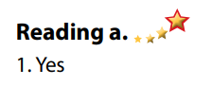  - Read and underline the key words.  - Read the text again for details.  - Exchange answers.  - Give answers.  Answer keys  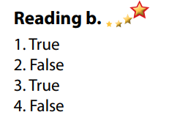  - Discuss in pairs.  - Present.  - Discuss in pairs.  - Present.
C. Consolidation and homework assignments (5’)
*Consolidation:
- Vocabulary: cleaner, volunteer, reporter, clean-up, environment, environmental, take part in, trash, pick up, organize.
*Homework
- Practice talking about your environmental clean-up.
- Do the exercises in WB: Listening and Reading (page 24).
- Do the vocabulary exercise in Tiếng Anh 7 i-Learn Smart World Notebook (page 26).
- Play consolation games in Tiếng Anh 7 i-Learn Smart World DHA App on www.eduhome.com.vn
- Prepare: Lesson 3 – Writing and Speaking (page 35 – SB).
*********************************************************************
Teaching date: 05/12/2022
Period 40 UNIT 4: COMMUNITY SERVICES
Lesson 3.2 Writing and Speaking (Page 35)
I. OBJECTIVES
By the end of the lesson, Ss will be able to:
1.1. Language knowledge and skills
- know format of writing an email to describe past experiences.
- talk about environmental problems.
- write an email to a friend describing their experience of an environmental clean-up.
1.2. Competences
- improve communication, collaboration, writing and critical thinking skills.
1.3. Attributes
- be active to take part in social activities.
- help other people.
- raise awareness of protecting the environment.
II. TEACHING AIDS AND LEARNING MATERIALS
1. Teacher’s aids: Student book and Teacher’s book, class CDs, Digital Book (DCR phần mềm tương tác SB, DHA (từ vựng/ cấu trúc) phần mềm trò chơi tương tác), projector/interactive whiteboard / TV (if any), PowerPoint slides.
2. Students’ aids: Student’s book, workbook, notebook.
III. ASSESSMENT EVIDENCE
Performance Tasks | Performance Products | Assessment Tools
- Speaking: Look at the pictures of places in Greenview City. Can you see similar problems near where you live? Where? Why is there so much trash? | - Ss’ answers / presentation. | - T’s feedback/Peers’ feedback.
- Choose a place in Greenview City. Use your own ideas to fill in the tables about a clean-up there. | - Ss’ answers. | - T’s feedback/Peers’ feedback.
- Writing: Read about writing emails to describe past experiences. Then, read Jane’s email again and circle the information, answering "what?," "when?," "where?," and "who?". | - Ss’ answers. | - T’s feedback/Peers’ feedback.
- Write full sentences using the prompts. Then, number the sentences (1–4) to match them with the order in the skill box. | - Ss’ answers. | - T’s feedback/Peers’ feedback.
- Now, write an email to a friend describing your experience of an environmental clean-up. Use the Feedback form to help you. Write 60 to 80 words. | - Ss’ answers. | - T’s observation and feedback.
IV. PROCEDURES
A. Warm up: (5’)
a. Objective: Introduce the new lesson and set the scene for Ss to acquire new language; get students' attention at the beginning of the class by enjoyable and short activities as well as to engage them in the follow-up steps.
b. Content: Jumbled sentences / talking about the environmental problems.
c. Expected outcomes: Ss know about the topic that they are going to talk and write about in new the lesson.
d. Organization of the activity:
TEACHER’S ACTIVITIES | STUDENTS’ ACTIVITIES
Option 1: Speaking part a.  - Use the Speaking part a (page 35) for warm up activity.  - Have Ss look the pictures of places in Greenview City using DCR, discuss and answer the questions:  1. Can you see similar problems near where you live? 2. Where?  3. Why is there so much trash?  - Have Ss give answers.  - Give feedback and evaluation.  - Lead to the new lesson.  Option 2: Jumbled sentences  - Have Ss close all books.  - Give Ss some sentences relating to cleaning-up the beach. These sentences are not correct in time order.  1. There were plastic bags and trash everywhere.  2. I arrived at the Pebble beach in Somerton on Tuesday morning.  3. We worked for eight hours and picked up over 5 tons of trash!  4. It was really dirty and the smell was horrible  - Have Ss rearrange the sentences in time order.  - Call Ss to read answers.  - Give feedback, show correct answers and lead to the new lesson: Writing an email about environmental clean-up. | - Work in pairs: Look and discuss.  - Give answers.  - Listen.  - Close all books.  - Read the sentences and rearrange them in time order.  - Work in pairs.  - Read answers.  - Listen.  Answer keys  2. I arrived at the Pebble beach in Somerton on Tuesday morning.  4. It was really dirty and the smell was horrible.  1. There were plastic bags and trash everywhere.  3. We worked for eight hours and picked up over 5 tons of trash!
B. New lesson
Activity 1: Pre-Writing (Speaking)
a. Objective: Ss prepare for what they are going to write about.
b. Content:
- Speaking: Look at the pictures of places in Greenview City. Can you see similar problems near where you live? Where? Why is there so much trash?
- Choose a place in Greenview City. Use your own ideas to fill in the tables about a clean-up there.
c. Expected outcomes: Ss have more ideas and language for their writing.
d. Organization of the activity:
TEACHER’S ACTIVITIES | STUDENTS’ ACTIVITIES
Task a. In pairs: Look at the pictures of places in Greenview City. Can you see similar problems near where you live? Where? Why is there so much trash?  - Divide the class into pairs.  - Have students ask and answer using the questions.  - Go round and support Ss if necessary.  - Have some students share their ideas with the class.  - Give feedback and evaluation.  Task b. Now, choose a place in Greenview City. Use your own ideas to fill in the tables about a clean-up there.  - Have students choose a place in Greenview City, then use their own ideas to fill in the tables about a clean-up there.  - Go round and give help if necessary.  - Have some pairs read their answers.  - Give feedback and evaluation. | - Work in pairs.  - Present.  - Fill in the tables.  - Present.
Activity 2: While - Writing
a. Objective: Students can develop their writing skill.
b. Content: - Read about writing emails to describe past experiences. Then, read Jane’s email again and circle the information, answering "what?," "when?," "where?," and "who?".
- Write full sentences using the prompts. Then, number the sentences (1–4) to match them with the order in the skill box.
- Now, write an email to a friend describing your experience of an environmental clean-up. Write 60 to 80 words.
c. Expected outcomes: Students can write an email to a friend describing their experience of an environmental clean-up, using right format and rich vocabularies.
d. Organization of the activity:
TEACHER’S ACTIVITIES | STUDENTS’ ACTIVITIES
Task a. Read about writing emails to describe past experiences. Then, read Jane’s email again (page 34) and circle the information, answering "what?," "when?," "where?," and "who?"  - Briefly explain the Writing skill box using DCR and have some Ss read it aloud.  - Have Ss read Jane’s email again (page 34) and circle the information, answering "what?," "when?," "where?," and "who?  - Have Ss check their answers with a partner.  - Call Ss to give answers.  - Check answer as a whole class using DCR.  Task b. Write full sentences using the prompts. Then, number the sentences (1–4) to match them with the order in the skill box.  - Have students read the prompts.  - Have students write full sentences using the prompts.  - Then, have students number the sentences (1–4) to match them with the order in the skill box.  - Have students check their answers with a partner.  - Check answer as a whole class using DCR.  *Let’s Write: Now, write an email to a friend describing your experience of an environmental clean-up. Write 60 to 80 words.  - Draw Ss’ attention to the feedback form using DCR.  - Have Ss use their notes in speaking part and the instruction in the Writing box to write an email to a friend describing their experience of an environmental clean-up.  - Go round, observe and give help if necessary.  - Have some Ss write their email on the board. | - Listen.  -Work in pairs.  - Exchange their answers with a partner.  - Give answers.  Answer keys  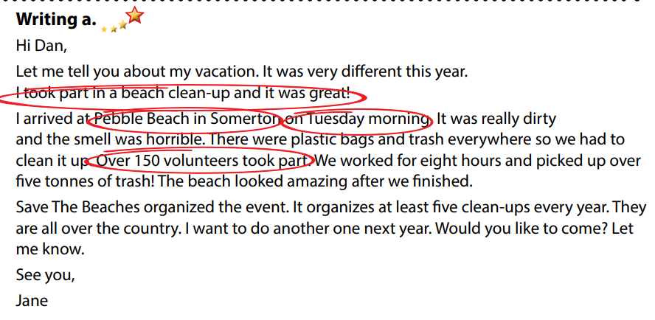  - Read the prompts and write full sentences.  - Number the sentences (1–4).  - Exchange answers.  - Read answers.  Answer keys  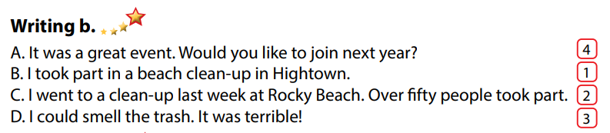  - Look and listen.  - Do the writing part.  - Write.  Suggested writing  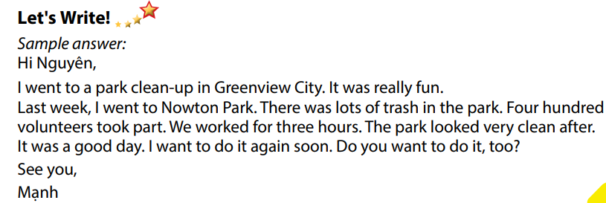
Activity 3: Post - Writing (5’)
a. Objective: Help Ss realize their mistakes in writing and correct them.
b. Content: Correcting Ss’ writings.
c. Expected outcomes: Students know whether their writings follow the model and use the correct structures and language, whether their writings are interesting and understandable or not.
d. Organization of the activity:
TEACHER’S ACTIVITIES | STUDENTS’ ACTIVITIES
- Give feedback, correct Ss’ mistakes.  - Use the feedback form to give evaluation. Focus on:  + the format, the structures  + the understandability  + the coherence and cohesion  + the spelling | - Look, listen and correct mistakes.
C. Consolidation and homework assignments (5’)
*Consolidation:
- Writing Skill:
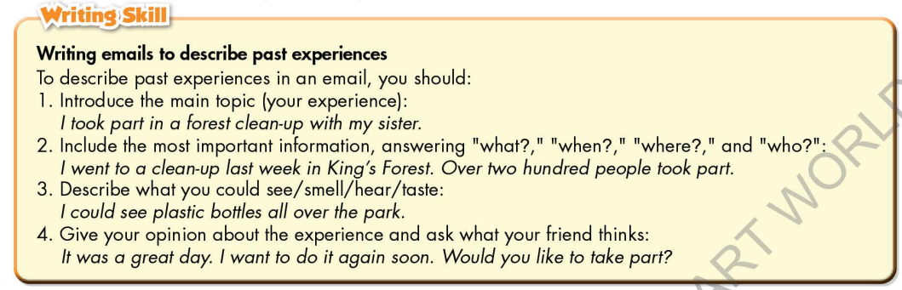
*Homework
- Remember how to write an email to describe past experiences.
- Finish the writing part.
- Do the exercises in WB: Lesson 3 – Writing (page 25).
- Complete the grammar notes in Tiếng Anh 7 i-Learn Smart World Notebook (page 27).
- Play consolation games in Tiếng Anh 7 i-Learn Smart World DHA App on www.eduhome.com.vn
- Prepare: Unit 4 – Review pages 92, 93.
********************************************************************
Teaching date: 07/12/2022
Period 41 UNIT 4: COMMUNITY SERVICES
Lesson 4 – Review (Pages 92, 93)
I. OBJECTIVES
By the end of the lesson, Ss will be able to:
1.1. Language knowledge and skills
- review words about charity and fund raising activities (donate clothes, bake sale, car wash, clean up parks, craft fair, raise money, plant trees, etc.) and talk about them.
- review grammar: Past simple form of regular verbs, making suggestions.
- review how to plan charity events.
- pronoun some sounds correctly: “ed” endings, /ʌ/, /ei/, /ɔ/, / ʊ /.
- put stress on words with two and three syllables.
1.2. Competences
- improve speaking, listening, reading and writing skills.
- improve the use of English.
1.3. Attributes
- have positive attitude in English language learning so that they actively participate in all classroom activities.
- review the old lesson and have good preparation for any assessment.
II. TEACHING AIDS AND LEARNING MATERIALS
1. Teacher’s aids: Student book and Teacher’s book, class CDs, Digital Book (DCR phần mềm tương tác SB, DHA (từ vựng/ cấu trúc) phần mềm trò chơi tương tác), projector/interactive whiteboard / TV (if any), PowerPoint slides, handouts
2. Students’ aids: Student’s book, workbook, notebook.
III. ASSESSMENT EVIDENCE
Performance Tasks | Performance Products | Assessment Tools
- Listening: You will hear a boy talking to his friend about different kinds of community service. Listen and complete questions 1– 5. You will hear the conversation twice. | - Ss’ answers. | - T’s feedback/Peers’ feedback.
- Reading: Look and read. Choose the correct answer (A, B, or C). | - Ss’ answers. | - T’s feedback/Peers’ feedback.
- Vocabulary: Fill in the blanks with the words from the box. | - Ss’ answers. | - T’s feedback/Peers’ feedback.
- Grammar: Fill in the blanks with the Past Simple form of the verbs in brackets.  + Underline the mistake in each sentence. Write the correct word on the line. | - Ss’ answers | - T’s feedback/Peers’ feedback.
- Pronunciation: Circle the word that has the underlined part pronounced differently from the others.  + Circle the word that differs from the other three in the position of primary stress in each of the following questions. | - Ss’ answers/ presentation. | - T’s observation, T’s feedback/Peers’ feedback.
IV. PROCEDURES
A. Warm up: (5’)
a. Objective: Introduce the new lesson and set the scene for Ss to acquire new language; get students' attention at the beginning of the class by enjoyable and short activities as well as to engage them in the follow-up steps.
b. Content: Slogan competition / Poster designing competition.
c. Expected outcomes: Ss are ready for the new lesson.
d. Organization of the activity:
TEACHER’S ACTIVITIES | STUDENTS’ ACTIVITIES
Option 1: Slogan competition  - Divide class into groups of 4 or 5.  - Have Ss close their books.  - Choose a charity activity (It can be: craft fair, tree planting day, car wash, soup kitchen, …).  - Have Ss work in groups to think and write a slogan for the activity.  - Have Ss in groups their share their answers with the whole class.  - Have Ss in the class vote for the best slogan.  - Give feedback and announce the winner.  - Give an applause or a present to the winner.  - Lead to the new lesson.  Option 2: Poster designing competition  - Divide class into groups of 4 or 5.  - Have Ss close their books.  - Choose a charity activity (It can be: craft fair, tree planting day, car wash, soup kitchen, …).  - Have Ss work in groups to design a poster for the activity.  - Have Ss in groups their share their products with the whole class.  - Have Ss in the class vote for the best poster.  - Give feedback and announce the winner.  - Give applause or a present to the winner.  - Lead to the new lesson.  *Note: In order for this activity to be carried out smoothly, T can have Ss prepare at home, then show their products in front of the class. | - Work in groups to write slogan.  - Give answers.  - Vote for the best slogan.  - Listen.  - Work in groups to design posters.  - Hang the poster on the board.  - Vote for the best posters.  - Listen.
B. New lesson (35’)
Activity 1: Listening (7’)
a. Objective: Help Ss improve their listening skill.
b. Content:
- You will hear a boy talking to his friend about different kinds of community service. Listen and complete questions 1– 5. You will hear the conversation twice.
c. Expected outcomes: Ss listen in details and get familiar with the listening test format.
d. Organization of the activity:
TEACHER’S ACTIVITIES | STUDENTS’ ACTIVITIES
You will hear a boy talking to his friend about different kinds of community service. Listen and complete questions 1– 5. You will hear the conversation twice.  - Have Ss read through the listening part.  - Demonstrate the activity on DCR by using the example.  - Play the audio (CD 2 – Track 37).  - Have Ss check answers with pairs and then give answers.  - Check answers as a whole class. | - Read in silence.  - Listen and then give answers.  Answer keys  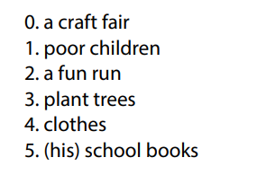
Activity 2: Reading (7’)
a. Objective: Students can improve their reading skill.
b. Content:
- Look and read. Choose the correct answer (A, B, or C).
c. Expected outcomes: Ss read for comprehension and get familiar with the reading test format.
d. Organization of the activity:
TEACHER’S ACTIVITIES | STUDENTS’ ACTIVITIES
Look and read. Choose the correct answer (A, B, or C).  - Demonstrate the activity using DCR by using the example.  - Have Ss look and read, then choose the correct answer, underline the supporting ideas for their answers.  - Call Ss to give answers, explain.  - Give feedback and evaluation. | - Observe and listen.  - Work individually.  - Give answers, explain.  Answer keys  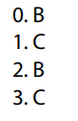
Activity 3: Vocabulary (7’)
a. Objective: Ss can review vocabulary about community services.
b. Content: Fill in the blanks with the words from the box.
c. Expected outcomes: Ss produce the new language successfully, and they can use these words in speaking and writing.
d) Organization of the activity:
TEACHER’S ACTIVITIES | STUDENTS’ ACTIVITIES
Fill in the blanks with the words from the box  - Have Ss read the phrases and observe the pictures.  - Ask Ss to work in pairs to fill in the blanks with the words from the box.  - Have Ss give answers, tell the meaning of the words /phrase again.  - Check answers as a whole class using DCR. | - Read the phrases and observe the pictures.  - Work in pairs.  - Give answers.  Answer keys  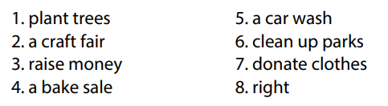
Activity 4: Grammar (10’)
a. Objective: Ss can review the use of English: Past simple form of regular verbs + making suggestions.
b. Content:
- Fill in the blanks with the Past Simple form of the verbs in brackets.
- Underline the mistake in each sentence. Write the correct word on the line.
c. Expected outcomes: Ss produce the new language successfully, and they can use the grammar points in speaking and writing.
d. Organization of the activity:
TEACHER’S ACTIVITIES | STUDENTS’ ACTIVITIES
Task a. Fill in the blanks with the Past Simple form of the verbs in brackets.  - Have Ss retell the way to use past simple form of regular verbs.  - Ask Ss to work individually to fill in the blanks with the Past Simple form of the verbs in brackets.  - Have Ss work in pairs to check each other’s work.  - Call Ss to give answers, explain for their choice.  - Check answers as a whole class using DCR.  Task b. Underline the mistake in each sentence. Write the correct word on the line.  - Have Ss read the sentences, underline the mistake in each sentence.  - Encourage Ss to correct the mistakes.  - Ask Ss to work in pairs to check each other’s work.  - Have Ss write answers on the board.  - Check Ss’ answers, give feedback. | - Review old knowledge.  - Work individually.  - Work in pairs.  - Give answers.  Answer keys  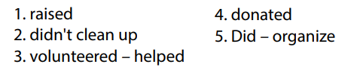  - Do the task.  - Exchange answers.  - Write answers on the board.  Answer keys  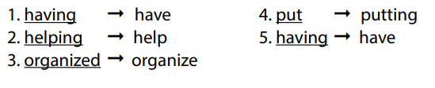
Activity 5: Pronunciation (4’)
a. Objective: Ss can review the word stress and vowels, last consonant of “ed” endings.
b. Content:
- Circle the word that has the underlined part pronounces differently from the others.
- Circle the word that differs from the other three in the position of primary stress in each of the following questions.
c. Expected outcomes: Ss produce the new language successfully.
d. Organization of the activity:
TEACHER’S ACTIVITIES | STUDENTS’ ACTIVITIES
Task a. Circle the word that has the underlined part pronounced differently from the others.  - Have Ss distinguish the sound: /“ed” endings, /ʌ/, /ei/, /ɔ/, / ʊ /.  - Ask Ss to work individually to circle the answer.  - Have Ss work in pairs to check each other’s work.  - Call Ss to give answers, pronounce the words again.  - Give feedback, correct Ss’ pronunciation if necessary.  Task b. Circle the word that differs from the other three in the position of primary stress in each of the following questions.  - Remind Ss some basic rules of putting stress on words with 2 or 3 syllables.  - Ask Ss to work individually.  - Have Ss work in pairs to check each other’s work.  - Call Ss to give answers, pronounce the words again.  - Give feedback, correct Ss’ pronunciation if necessary. | - Listen.  - Work individually.  - Work in pairs.  - Give answers.  Answer keys  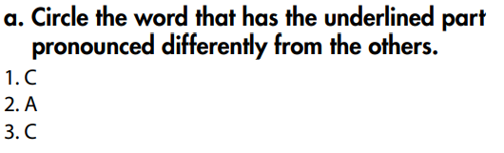  - Listen.  - Work individually.  - Work in pairs.  - Give answers.  Answer keys  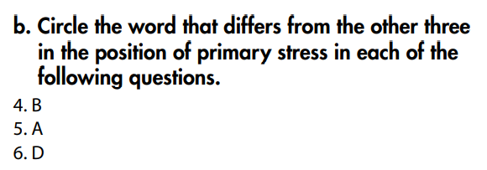
C. Consolidation and homework assignments (5’)
*Consolidation:
*Grammar of Unit 4: Past simple form of regular verbs, making suggestions.
*Vocabulary of Unit 4: Words about charity and fund raising activities (donate clothes, bake sale, car wash, clean up parks, craft fair, raise money, plant trees, …).
*Homework:
- Review vocabulary, grammar of unit 4.
- Do the exercises in WB: Review of Unit 4 (page 65).
- Prepare: Unit 5 – New words and Listening (page 36 – SB).
*********************************************************************
Teaching date: 08/12/2022
Period 42 UNIT 5: FOOD and DRINKS
Lesson 1.1 – New words and Listening (Page 36)
I. OBJECTIVES
By the end of the lesson, Ss will be able to:
1.1. Language knowledge and skills
- know more words about ingredients and measurements (spaghetti, lemon, tomato, onion, tablespoon, teaspoon, grams, milliliters, sugar, oil, flour, milk).
- talk about what food they need to buy.
- Listen to and understand a talk between a boy and his mom (for general and specific details).
- ask for repetition to check an amount or quantity.
1.2. Competences
- improve communication, collaboration, and critical thinking skills.
1.3. Attributes
- help family with the housework.
- eat healthily.
II. TEACHING AIDS AND LEARNING MATERIALS
1. Teacher’s aids: Student book and Teacher’s book, class CDs, Digital Book (DCR phần mềm tương tác SB, DHA (từ vựng/ cấu trúc) phần mềm trò chơi tương tác), projector/interactive whiteboard / TV (if any), PowerPoint slides.
2. Students’ aids: Student’s book, workbook, notebook.
III. ASSESSMENT EVIDENCE
Performance Tasks | Performance Products | Assessment Tools
- Number the picture. | - Ss’ answers. | - T’s feedback/Peers’ feedback
- Listen and repeat. | - Ss’ presentation. | - T’s feedback/Peers’ feedback
- Practice saying units of measurement with the ingredients using the numbers below. | - Ss’ presentation. | - T’s feedback/Peers’ feedback.
- Listen to Logan talking to his mom. Where are they? | - Ss’ answers. | - T’s feedback/Peers’ feedback.
- Listen and write the amounts or quantities they need. | - Ss’ answers. | - T’s feedback/Peers’ feedback.
- Speak: What do you usually buy at the supermarket? | - Ss’ answers/ presentation. | - T’s observation and feedback.
IV. PROCEDURES
A. Warm up: (5’)
a. Objective: Introduce the new lesson and set the scene for Ss to acquire new language; get students' attention at the beginning of the class by enjoyable and short activities as well as to engage them in the follow-up steps.
b. Content: Introduce words about ingredients and measurements / Make a shopping list.
c. Expected outcomes: Ss get to know some new words they are going to study in the lesson.
d. Organization of the activity:
TEACHER’S ACTIVITIES | STUDENTS’ ACTIVITIES
Option 1: Number the pictures. Listen and repeat.  - Use the “New words” part a.– page 36 for the warm-up activity.  - Show words and pictures using DCR, have Ss look and number the pictures (in pairs).  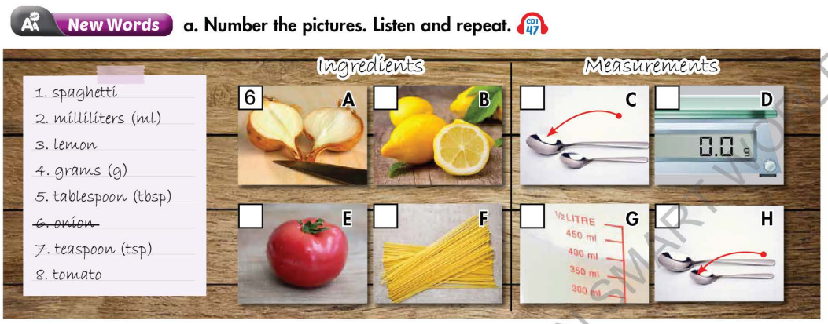  - Call Ss to give answers.  - Give feedback and show correct answers.  - Lead to the new lesson.  - Play the audio (CD1 – Track 47), have Ss listen and repeat.  - Correct Ss’ pronunciation if necessary.  Option 2: Make a shopping list.  - Let Ss imagine they are going to prepare dinner for a family of about 4-5 people.  - Have Ss work in groups of 4 to make a shopping list for things to buy to prepare dinner.  - Remind Ss to add quantity of the things they intend to buy.  - Have some groups share their answers with the whole class.  - Give feedback and evaluation.  - Lead to the new lesson. | - Work in pairs to number the pictures.  - Give answers.  - Listen.  - Listen and repeat.  Answer keys  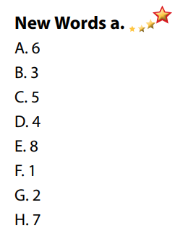  - Work in groups of 4.  - Give answers.  - Listen.
B. New lesson (35’)
Activity 1: Pre-Listening (Vocabulary) (12’)
a. Objective: Ss get to know words about ingredients and measurements.
b. Content:
- Vocabulary study (spaghetti, lemon, tomato, onion, tablespoon, teaspoon, grams, milliliters).
- Speaking: Say units of measurements with the ingredients using the given numbers.
c. Expected outcomes: Ss know how to pronounce the new words correctly and use them when talking about food and its quantities.
d. Organization of the activity:
TEACHER’S ACTIVITIES | STUDENTS’ ACTIVITIES
Task a. Number the pictures. Listen and repeat.  Option 1 (If the teacher hasn’t used this part for the Warm-up activity)  - Demonstrate the activity on DCR, using the example.  - Have Ss number the pictures.  - Divide class into pairs and have them check their answers with their partners.  - Call Ss to give answers (read or write).  - Check answers as a whole class using DCR.  - Play audio (CD1 – Track 47). Have Ss listen and repeat.  - Correct Ss’ pronunciation.  Option 2: Ingredients and Measurements (If the teacher has used part a. for the Warm-up activity)  - Give many words about ingredients and measurements (or pictures, if so, T uses different pictures from those in Task a).  - Have Ss work in pairs to divide the given words / pictures into 2 groups: ingredients and measurements.  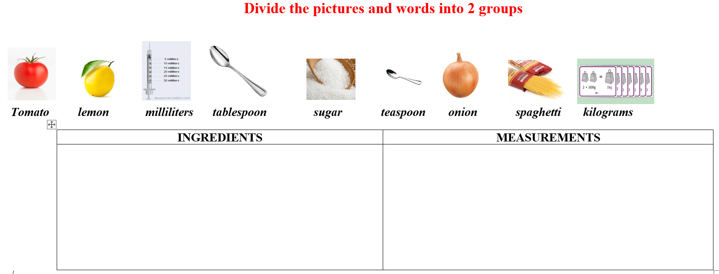  - Have Ss give answers and tell the meaning of words / phrases again.  - Check answers as a whole class.  - Call some Ss to read the words again.  - Correct Ss’ pronunciation if necessary.  Task b. In pairs: Practice saying units of measurement with the ingredients using the numbers below.  - Have Ss work in pairs to say units of measurement with the ingredients using the numbers in the table.  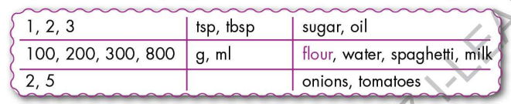  - Go round and give help if necessary.  - Have some pairs demonstrate the activity in front of the class.  - Give feedback and evaluation. | - Look and listen.  - Work individually.  - Work in pairs.  - Give answers.  - Listen and repeat.  Answer keys  - Work in pairs.  - Give answers, explain.  - Read.  Answer keys  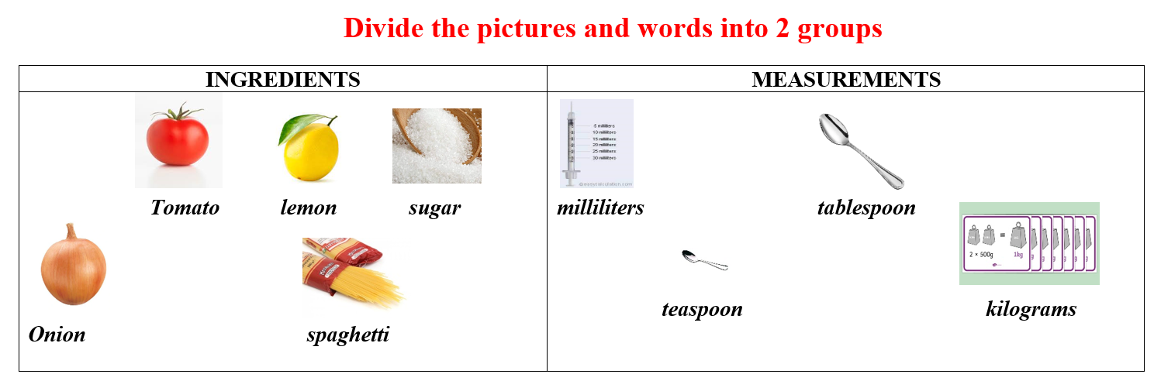  - Work in pairs.  - Present.  Sample answers  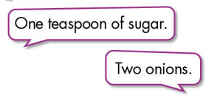
Activity 2: While - Listening (17’)
a. Objective: Students can develop their listening skill.
b. Content:
- Listen to Logan talking to his mom. Where are they?
- Listen and write the amounts or quantities they need.
c. Expected outcomes: Students can listen and understand general and specific information about making a shopping list.
d. Organization of the activity:
TEACHER’S ACTIVITIES | STUDENTS’ ACTIVITIES
Task a. Listen to Logan talking to his mom. Where are they?  - Have Ss read the phrases, guess the answer.  - Play audio (CD1 - Track 48).  - Have Ss listen and circle the correct answer.  - Check answers as a whole class using DCR.  Task b. Now, listen and write the amounts or quantities they need.  - Have Ss read the through the content of Task b.  - Play the audio again (CD1 - Track 48).  - Have Ss listen and write the amounts or quantities they need.  - Ask Ss to pay attention to the way to say numbers.  - Have Ss check answers with their partners.  - Call Ss to give answers.  - Give feedback and show correct answers using DCR. | - Work individually.  - Listen.  - Circle the correct answers.  Answer keys  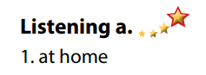  - Read.  - Do the task.  - Exchange answers.  Answer keys  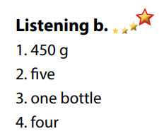
Activity 3: Post - Listening (6’)
a. Objective: Students can use the vocabulary and the content in listening part to develop their speaking skill.
b. Content: Speaking: What do you usually buy at the supermarket?
c. Expected outcomes: Students can think of their shopping list in the supermarket.
d. Organization of the activity:
TEACHER’S ACTIVITIES | STUDENTS’ ACTIVITIES
Conversation skill  - Have Ss look at the Conversation skill box and read.  - Play audio (CD 1 - Track 49), have Ss listen and repeat.  - Ask Ss to find more ways to ask for repetition.  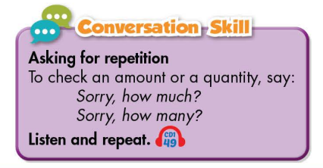  Task c. In pairs: What do you usually buy at the supermarket?  - Have Ss work in pairs to discuss.  - Observe and give help if necessary.  - Call some pairs to share their ideas with the class.  - Give feedback and evaluation. | - Look and read.  - Listen and repeat.  - Give answers.  - Work in pairs.  - Present.
C. Consolidation and homework assignments (5’)
*Consolidation:
- Words about ingredients and measurements: spaghetti, lemon, tomato, onion, tablespoon, teaspoon, grams, milliliters, sugar, oil, flour, milk.
- Language to ask for repetition to check an amount or quantity: Sorry, how much? / Sorry, how many?
*Homework
- Learn the new words by heart.
- Practice talking about what to buy at the supermarket.
- Do the exercises in WB: New words and Listening (pages 26, 27 – WB).
- Do the vocabulary exercise in Tiếng Anh 7 i-Learn Smart World Notebook (page 28).
- Play consolation games in Tiếng Anh 7 i-Learn Smart World DHA App on www.eduhome.com.vn
- Prepare: Lesson 1.2 – Grammar (page 37 – SB).
*********************************************************************
Teaching date: 12/12/2022

Period 43 UNIT 5: FOOD and DRINKS
Lesson 1.2 - Grammar (Page 37)
I. OBJECTIVES
By the end of the lesson, Ss will be able to:
1.1. Language knowledge and skills
- listen to 2 people asking and answering about food and quantities.
- use “How much” and “How many” to ask about food /drinks and quantities.
- talk about ingredients.
1.2. Competences
- improve speaking, listening skills.
- improve the use of English.
1.3. Attributes
- help family with the cooking.
- eat healthily.
II. TEACHING AIDS AND LEARNING MATERIALS
1. Teacher’s aids: Student book and Teacher’s book, class CDs, Digital Book (DCR phần mềm tương tác SB, DHA (từ vựng/ cấu trúc) phần mềm trò chơi tương tác), projector/interactive whiteboard / TV (if any), PowerPoint slides, handouts.
2. Students’ aids: Student’s book, workbook, notebook, handouts.
III. ASSESSMENT EVIDENCE
Performance Tasks | Performance Products | Assessment Tools
- Listen and repeat. | - Ss’ performance. | - T’s feedback.
- Circle the correct words. | - Ss’ answers. | - T’s feedback/Peers’ feedback.
- Look at the table of ingredients you need. Read the answers and write the questions. | - Ss’ answers. | - T’s feedback/Peers’ feedback.
- Speak: What ingredients are in your fridge? How much/many? | - Ss’ answers/ presentation. | - T’s observation, T’s feedback/Peers’ feedback.
IV. PROCEDURES
A. Warm up: (5’)
a) Objective: Introduce the new lesson and set the scene for Ss to acquire new language; get students' attention at the beginning of the class by enjoyable and short activities as well as to engage them in the follow-up steps.
b) Content: Review countable and uncountable nouns / Weight things.
c) Expected outcomes: Ss review old grammar points which are very useful for them in the new lesson.
d) Organization of the activity:
TEACHER’S ACTIVITIES | STUDENTS’ ACTIVITIES
Option 1: Countable and uncountable nouns.  - Give Ss some nouns of food and drinks.  - Have Ss work in pairs to divide them into 2 groups: Countable and uncountable nouns.  - Call Ss to give answers.  - Check Ss’ answers, give feedback.  *Suggested nouns: apple, sugar, lemon, tomato, juice, salt, egg, spaghetti, cake, lemonade, beef, …  - Have Ss make sentences, using the words given by the teacher.  - Lead to the new lesson.  Option 2: Heaviness  - Bring to class a small scale, prepare some real objects or food / drinks (apple, milk, lemon, sugar, …).  - Have Ss weigh each object, write its heaviness on the board and practice reading it.  - Observe and support if necessary.  - Check Ss’ answers, give feedback.  - If T can’t use a real scale and real objects / food / drinks, try pictures.  *Illustration  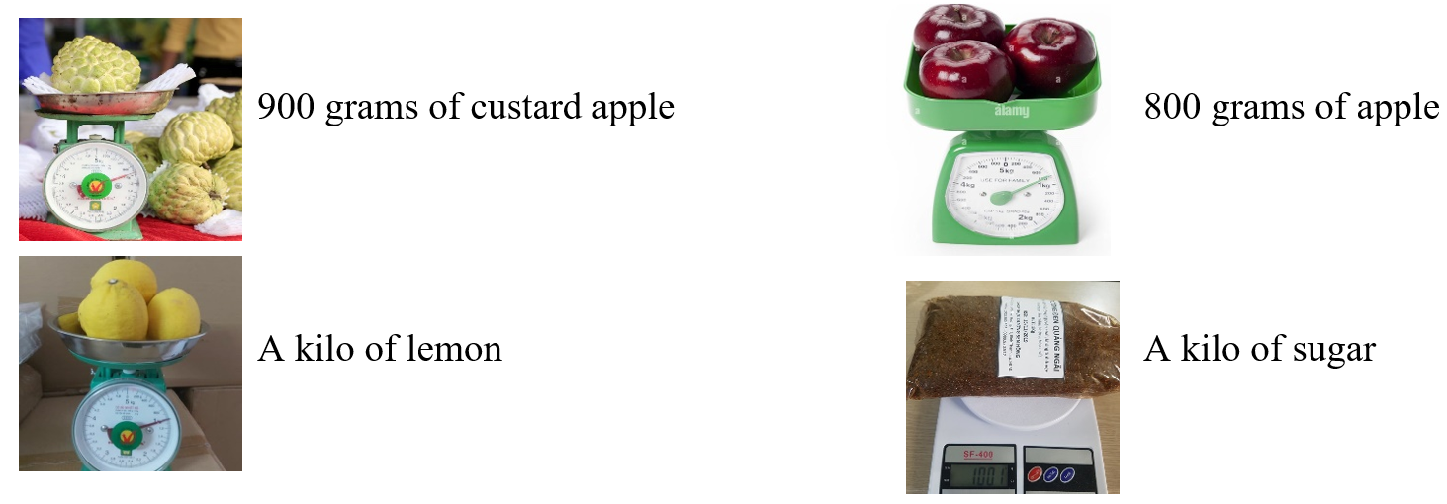  - Lead to the new lesson. | - Work in pairs.  - Give answers.  Answers keys  - Countable nouns: apple, lemon, tomato, egg, cake  - Uncountable nouns: sugar, juice, salt, spaghetti, lemonade, beef  - Make sentences.  - Weigh things, then write answers and read them.  - Listen and write the new lesson.
B. New lesson (35’)
Activity 1: Presentation (10’)
a) Objective: Introduce: “How much” and “How many”.
b) Content:
- Listen and repeat.
- Introduce the grammar points.
c) Expected outcomes: Ss know the new grammar points “How much” and “How many” and use them in some exercises that follow.
d) Organization of the activity:
TEACHER’S ACTIVITIES | STUDENTS’ ACTIVITIES
Task a. Listen and repeat.  - Have Ss look at the picture using DCR.  - Play audio (CD1 – Track 50) and have Ss listen and read the speech bubbles.  - Play the audio again and have Ss listen and repeat.  Grammar box  Option 1:  - Have Ss look at the grammar explanation and read “How much”, “How many”.  - Have Ss look at the box and read examples of different forms.  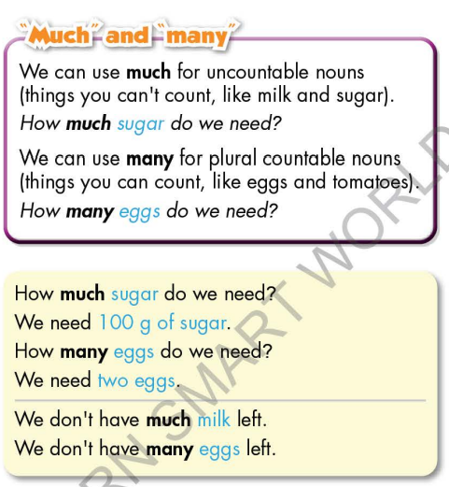  - Explain more about countable and uncountable nouns.  - Ask Ss to make more sentences using “How much”, “How many” to ask about amount and quantity of food.  - Give feedback and evaluation.  Option 2:  - Have Ss look at the sentences in the speech bubbles in Task a and read them again.  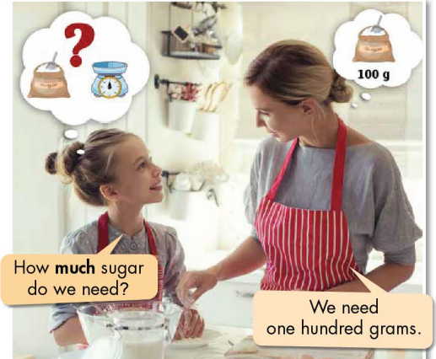  - Have Ss make comments on the types of noun (plural or singular) used after “How much” and “How many”.  - Give feedback.  - Then, lead to the grammar box, briefly explain the way to use “How much” and “How many”.  - Have Ss read the grammar box again.  - Ask Ss to make more sentences using “How much”, “How many” to ask about amount and quantity of food.  - Give feedback and evaluation. | - Look.  - Listen, then read.  - Listen and repeat.  - Look and read.  - Read examples of different forms.  - Listen.  - Give more examples.  - Look and read.  - Comment.  - Give more examples.  - Listen.
Activity 2: Practice (19’)
a) Objective: Students can use “How much”, “How many” to do the given exercises.
b) Content:
- Circle the correct words.
- Look at the table of ingredients you need. Read the answers and write the questions.
c) Expected outcomes: Students can get used to the form and usage of “How much”, “How many” and use them correctly.
d) Organization of the activity:
TEACHER’S ACTIVITIES | STUDENTS’ ACTIVITIES
Task b. Circle the correct words.  - Demonstrate the activity on DCR, using the example.  - Have Ss read the sentences and circle the correct words.  - Have Ss work in pairs to check each other’s work.  - Have some Ss share their answers with the whole class.  - Give feedback, correct Ss’ answers if necessary.  Task c. Look at the table of ingredients you need. Read the answers and write the questions.  - Demonstrate the activity on DCR using the example.  - Have students write the questions.  - Have pairs check each other's work.  - Have some students share their answers with the class. | - Look and listen.  - Work individually.  - Work in pairs.  - Read answers.  Answer keys  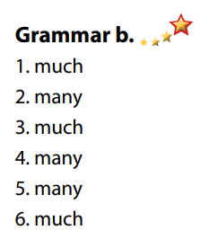  - Look and listen.  - Work individually.  - Work in pairs.  - Read answers.  Answer keys  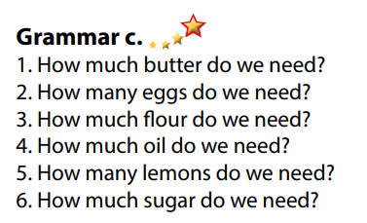
Activity 3: Production (6’)
a) Objective: Students master the grammar point they study in the lesson.
b) Content: Speaking: What ingredients are in your fridge? How much/many?
c) Expected outcomes: Ss produce the new language successfully, and they can use the grammar point in the lesson in everyday speaking and writing.
d) Organization of the activity:
TEACHER’S ACTIVITIES | STUDENTS’ ACTIVITIES
Task d. In pairs: What ingredients are in your fridge? How much/many?  - Divide class into pairs.  - Have Ss take turns asking their partner about what ingredients are in their fridge. How much/many?  - Have some pairs demonstrate the activity in front of the class.  - Give feedback and evaluation. | - Have conversation in pairs.  - Present.  - Listen.  Suggested answers  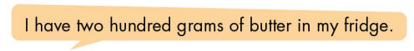
C. Consolidation and homework assignments (5’)
* Consolidation:

* Homework:
- Make 2 questions using How much/many.
- Do the exercises in WB: Grammar (page 27).
- Complete the grammar notes in Tiếng Anh 7 i-Learn Smart World Notebook (page 29).
- Play consolation games in Tiếng Anh 7 i-Learn Smart World DHA App on www.eduhome.com.vn
- Prepare: Lesson 1.3 – Pronunciation and Speaking (page 38 – SB).
****************************************************************
Teaching date: 14/12/2022
Period 44 UNIT 5: FOOD and DRINKS
Lesson 1.3 – Pronunciation and Speaking (Page 38)
I. OBJECTIVES
By the end of the lesson, Ss will be able to:
1.1. Language knowledge and skills
- pronounce the cluster /sp/ correctly.
- ask and answer about ingredients and recipes.
- ask for repetition.
- prepare ingredients to make lemon pancake, spaghetti and beans.
1.2. Competences
- improve listening and speaking skills.
1.3. Attributes
- help family with the cooking.
- eat healthily.
II. TEACHING AIDS AND LEARNING MATERIALS
1. Teacher’s aids: Student book and Teacher’s book, class CDs, Digital Book (DCR phần mềm tương tác SB, DHA (từ vựng/ cấu trúc) phần mềm trò chơi tương tác), projector/interactive whiteboard / TV (if any), PowerPoint slides, handouts.
2. Students’ aids: Student’s book, workbook, notebook.
III. ASSESSMENT EVIDENCE
Performance Tasks | Performance Products | Assessment Tools
- Listen to the words and focus on the underlined letters. | - Ss’ performance and answers. | - T’s observation.
- Listen to the /sp/ sound. Find and note down three more words with the same sound. | - Ss’ performance and answers. | - T’s feedback/Peers’ feedback.
- Read the words in Task c with the sound notes in Task a. | - Ss’ performance. | - T’s feedback/Peers’ feedback.
- Ask and answer using the recipes. | - Ss’ performance. | - T’s feedback/Peers’ feedback.
- Speak: Ask and answer about the ingredients to make lemon pancakes, spaghetti and beans. | - Ss’ performance /  Presentation. | - T’s observation, T’s feedback/Peers’ feedback.
IV. PROCEDURES
A. Warm up: (5’)
a) Objective: Introduce the new lesson and set the scene for Ss to acquire new language; get students' attention at the beginning of the class by enjoyable and short activities as well as to engage them in the follow-up steps.
b) Content: Introduce /sp/ cluster / guess food dish from the ingredients.
c) Expected outcomes: Ss have good preparation for the new lesson.
d) Organization of the activity:
TEACHER’S ACTIVITIES | STUDENTS’ ACTIVITIES
Option 1: /sp/ cluster  - Give class a sentence:  The special spaghetti for the sportsmen in Spanish is very spicy.  - T reads this sentence as a model, ask Ss to pay attention to the words with the letters “sp”.  - Have Ss practice reading this sentence, try to read it as fluently as possible.  - Call some Ss to read again.  - Give feedback, and give a small present for the best Ss that can read this sentence smoothly and correctly.  - Lead to the new lesson: the /sp/ sound.  Option 2: Ingredients and dishes  - Have Ss close all books.  - Give some groups of ingredients.  - Have Ss look at the ingredients and guess the name of the dish.  - Call Ss to read answers.  - Give feedback.  - Lead to the new lesson.  *Illustration:  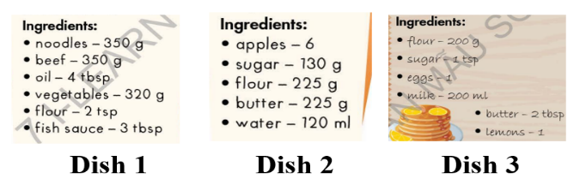  Option 3: Introduce /sp/ sound  - Play the video clip.  - Have Ss watch, listen and repeat, then listen again and sing together.  *Link: https://www.youtube.com/watch?v=  tHFNNAh4FII  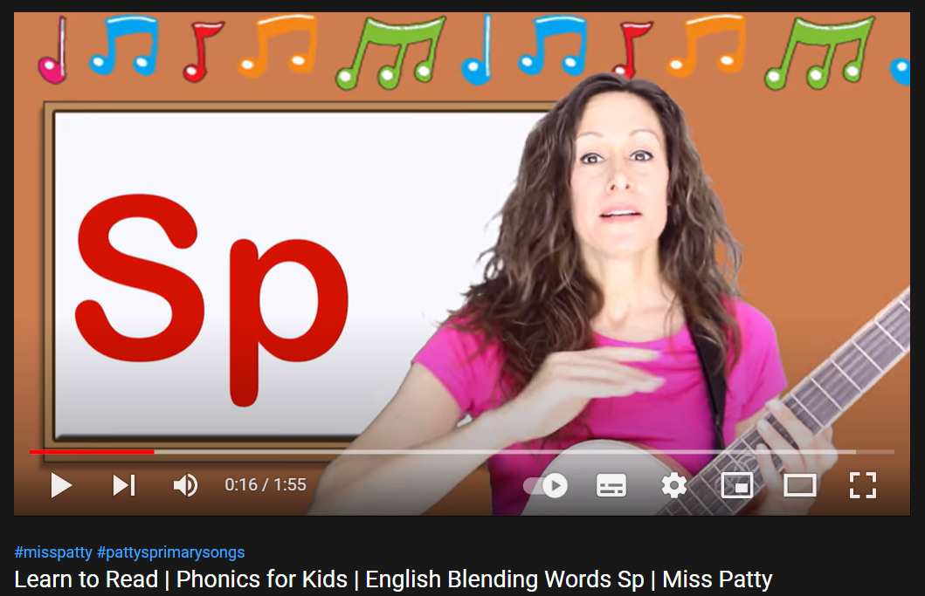  - Lead to the new lesson: the /sp/ sound. | - Listen.  - Read.  - Listen.  - Close books.  - Work in pairs, then give answers.  Answer keys  Dish 1:Beef Noodles  Dish 2:Apple Pie  Dish 3: Lemon Pancake  - Watch the video clip, listen and repeat, then sing together.
B. New lesson (35’)
Activity 1: Pre-Speaking: Pronunciation (10’)
a) Objective: Introduce: /sp/ sound.
b) Content:
- recognize /sp/ sound and know how to pronounce it.
- listen and check, find more words with the same sound.
- practice.
c) Expected outcomes: Ss distinguish /sp/ sound and know how to pronounce it correctly in their speaking.
d) Organization of the activity:
TEACHER’S ACTIVITIES | STUDENTS’ ACTIVITIES
Task a + b. Listen to the words and focus on the underlined letters.  - Briefly explain cluster /sp/ using DCR.  - Play the recording (CD1, track 51).  - Ask Ss to listen and focus on the underlined letters.  - Play the recording again, have Ss listen and repeat with a focus on the pronunciation feature.  Task c + d. Listen to the /sp sound. Find and note down three more words with the same sound.  - Play the recording (CD 1 – Track 52), have Ss listen to the /sp sound, then find and note down three more words with the same sound.  - Call Ss to give answers.  - Give feedback and evaluation.  - Then have Ss practice saying the words they have just added.  - Call some Ss to read the words in front of the class.  - Ask some Ss to make sentences with the words containing /sp / sound.  - Give feedback and evaluation. | - Listen, take notes.  - Listen again and repeat.  - Listen to the /sp sound, then find and note down three more words with the same sound.  - Give answers.  - Practice.  - Read.  - Make sentences.  Suggested answers  Some more words with /sp/ sound: space, sport, speak, Spanish, spam, spell, spin, spoil, splash, split, spider, special, …
Activity 2: While-speaking (20’)
a) Objective: Students can talk about ingredients of many different dishes.
b) Content:
- Ask and answer, using the recipes.
- Student B, turn to page 119, File 3. Student A, you’re helping your friend cook lemon pancakes. Look at the recipe for lemon pancakes and answer Student B's questions. Then, swap roles and talk about the ingredients and recipe of the dish: spaghetti and beans.
c) Expected outcomes: Ss produce the new language successfully.
d) Organization of the activity:
TEACHER’S ACTIVITIES | STUDENTS’ ACTIVITIES
*PRACTICE  Ask and answer using the recipes.  - Demonstrate the activity by asking and answering with a student.  - Have pairs take turns to ask and answer using the recipes.  - Remind Ss to pronounce words with /sp/ sound correctly.  - Have some pairs demonstrate the activity in front of the class.  - Give feedback and evaluation.  *SPEAKING: What Do We Need?  Task a. In pairs: Student B, turn to page 119, File 3. Student A, you’re helping your friend cook lemon pancakes. Look at the recipe for lemon pancakes and answer Student B's questions.  - Demonstrate the activity by practicing the role-play with a student.  - Divide the class into pairs.  - Have Student A stay on the page and Student B turn to page 119, File 3 and do the task.  - Remind Ss to use languages to ask for repetition.  - Observe, give help if necessary.  - Have students do the role-play.  - Give feedback and evaluation.  Task b. Swap roles. Student A, ask Student B what you need to make spaghetti and beans, then write the recipe in your notebook.  - Have pairs swap roles.  - Have pairs ask and answer about what they need to make spaghetti and beans, then write the recipe in their notebook.  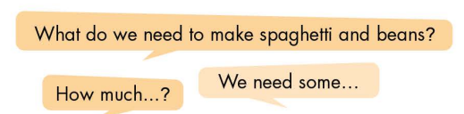  - Observe, give support.  - Have pairs do the role-play in front of the class.  - Make comment and evaluation. | - Observe, listen.  - Work in pairs.  - Present.  - Observe, listen.  - Work in pairs.  - Role play.  - Swap roles.  - Work in pairs.  - Role play.
Activity 3: Production (5’)
a) Objective: Check Ss’ writings.
b) Content: Share their recipes with the class.
c) Expected outcomes: Ss produce the new language successfully in everyday speaking and writing.
d) Organization of the activity:
TEACHER’S ACTIVITIES | STUDENTS’ ACTIVITIES
SPEAKING: What do we need?  Extra Task: Share the recipes with the class.  - Have some Ss write their recipes on the board.  (If time is not enough, T may capture the recipes Ss have written and show them on the screen.)  - Check Ss’ answers.  - Have other Ss in class make comment and vote for the best recipe.  - Give feedback and evaluation.  - Announce the winner. | - Write / present answers.  - Make comment and vote for the best recipe.
C. Consolidation and homework assignments (5’)
* Consolidation:
- How to make /sp/ sound: This cluster is a combination of the /s/ and /p/ sounds. Begin with the /s/ sound — it should be a voiceless stream of air from your mouth. Be careful not to include an “e” sound before the /s/ begins. As you produce /s/, the tip of your tongue should be close to, but not completely touching, the top of your mouth. To make the /p/, press your upper and lower lips together, briefly stopping the air. Then, release the air.
- Words with /sp / sound: space, sport, speak, Spanish, spam, spell, spin, spoil, splash, split, spider, special …
*Homework:
- Make 2 sentences with words containing the /sp/ sound.
- Complete the recipe for those who haven’t finished it in class.
- Prepare: Unit 5 - Lesson 2 – New words and Reading (page 39 – SB).
- Review the vocabulary and grammar notes in Tiếng Anh 7 i-Learn Smart World Notebook
(pages 28 & 29).
- Play consolation games in Tiếng Anh 7 i-Learn Smart World DHA App on www.eduhome.com.vn
************************************************************************
Teaching date: 15/12/2022
Period 45 UNIT 5: FOOD and DRINKS
Lesson 2.1 - Vocabulary and Reading (Page 39)
I. OBJECTIVES
By the end of the lesson, Ss will be able to:
1.1. Language knowledge and skills
- know some words about containers and quantities of food and drinks (a bunch of bananas, a bag of flour, a bottle of oil, a can of beans, a carton of eggs, a stick of butter, a carton of milk, a box of spaghetti).
- talk about containers and quantities of food and drinks in their kitchen.
- read a paragraph about Pete and his mom mentioning different containers and quantities of food and drinks to understand general and specific information.
1.2. Competences
- improve communication, collaboration, analytical and critical thinking skills.
1.3. Attributes
- help family with the cooking.
- eat healthily.
II. TEACHING AIDS AND LEARNING MATERIALS
1. Teacher’s aids: Student book and Teacher’s book, class CDs, Digital Book (DCR phần mềm tương tác SB, DHA (từ vựng/ cấu trúc) phần mềm trò chơi tương tác), projector/interactive whiteboard / TV (if any), PowerPoint slides.
2. Students’ aids: Student’s book, workbook, notebook.
III. ASSESSMENT EVIDENCE
Performance Tasks | Performance Products | Assessment Tools
- Fill in the blanks. | - Ss’ answers. | - T’s feedback/Peers’ feedback.
- Listen and repeat. | - Ss’ answers/ presentation. | - T’s observation / feedback.
- Say which of these you have in your kitchen. | - Ss’ answers. | - T’s feedback/Peers’ feedback.
- Read the paragraph about Pete. What did his mom want him to do? | - Ss’ answers. | - T’s feedback/Peers’ feedback.
- Read the paragraph and complete the table. | - Ss’ answers. | - T’s feedback/Peers’ feedback.
- What different containers do they mention in the reading? What other ones do you know? | - Ss’ answers. | - T’s feedback/Peers’ feedback.
IV. PROCEDURES
A. Warm up: (5’)
a) Objective: Introduce the new lesson and set the scene for Ss to acquire new language; get students' attention at the beginning of the class by enjoyable and short activities as well as to engage them in the follow-up steps.
b) Content: Introduce some words about containers and quantities of food and drinks (a bunch of bananas, a bag of flour, a bottle of oil, a can of beans, a carton of eggs, a stick of butter, a carton of milk, a box of spaghetti).
c) Expected outcomes: Ss have general ideas about the topic of the new lesson: containers and quantities of food and drinks.
d) Organization of the activity:
TEACHER’S ACTIVITIES | STUDENTS’ ACTIVITIES
Option 1:  - Use the “New words” part a.– page 39 for the warm-up activity.  - Show pictures and words using DCR, have Ss fill in the blanks (in pairs).  - Call Ss to give answers.  - Give feedback and show correct answers using DCR.  - Lead to the new lesson.  - Play the audio (CD1 – Track 53), have Ss listen and repeat.  - Correct Ss’ pronunciation if necessary.  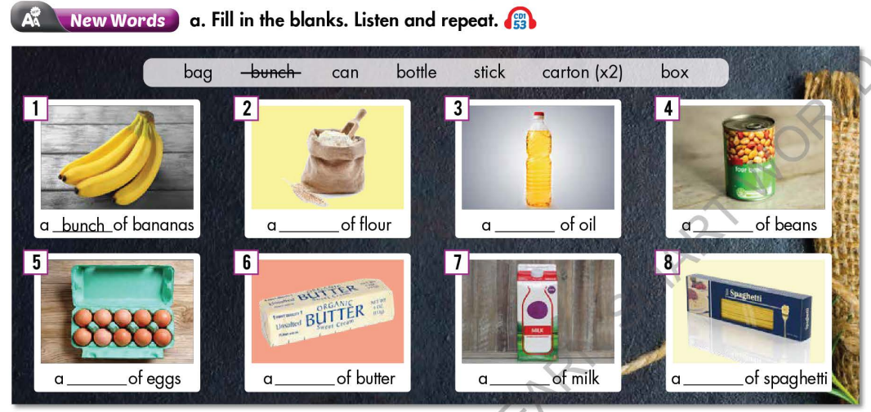  Option 2: Containers  - Show pictures, have Ss do the matching activity in pairs.  - Call Ss to give answers.  - Give feedback.  - Introduce the new lesson: containers and quantities of food and drinks.  *Illustration:  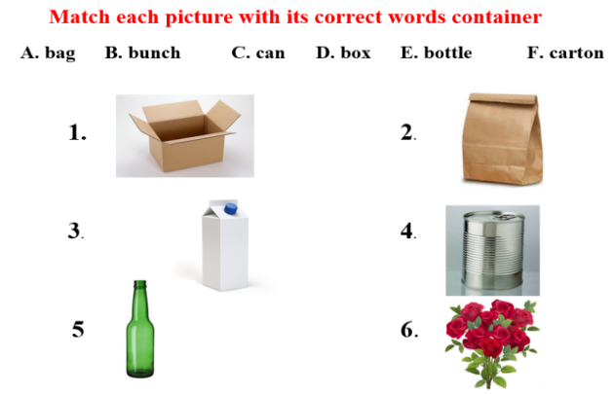 | - Work in pairs to fill in the blanks.  - Give answers.  - Listen.  Answer keys  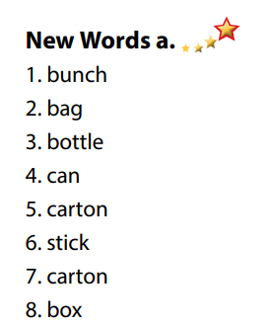  - Work in pairs.  - Give answers.  Suggested answers  1D  2A  3F  4C  5E  6B
B. New lesson (35’)
Activity 1: Pre-Reading (Vocabulary) (12’)
a) Objective: Ss know some words about containers and quantities of food and drinks.
b) Content:
- Vocabulary study: Fill in the blanks: Words about containers and quantities of food and drinks (a bunch of bananas, a bag of flour, a bottle of oil, a can of beans, a carton of eggs, a stick of butter, a carton of milk, a box of spaghetti).
- Listen and repeat.
- Speaking: Say which of these you have in your kitchen.
c) Expected outcomes: Ss know how to pronounce the new words correctly and use them in appropriate situations.
d) Organization of the activity:
TEACHER’S ACTIVITIES | STUDENTS’ ACTIVITIES
Task a. Fill in the blanks. Listen and repeat.  Option 1 (If the teacher hasn’t used this part for the Warm-up activity.)  - Demonstrate the activity on DCR, using the example.  - Have Ss look at the pictures and phrases, then fill in the blanks.  - Divide class into pairs and have them check their answers with their partners.  - Call Ss to give answers (read or write).  - Check answers as a whole class using DCR.  - Play audio (CD1 – Track 53). Have Ss listen and repeat.  - Correct Ss’ pronunciation.  Option 2: Brainstorming (If the teacher has used part a. for the Warm-up activity.)  - Have Ss review the words they have known in the warm-up activity by thinking of other food and drinks that can go with words of containers and quantities.  - Call Ss to give answers (read or write).  - Check answers as a whole class.  - Call some Ss to read the words again.  - Correct Ss’ pronunciation if necessary.  *Illustration:  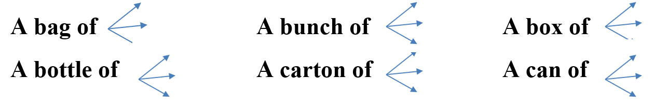  Task b. Say which of these you have in your kitchen.  - Have students say which foods they have in their kitchen.  - Have Ss share their answers in front of the class.  - Give feedback and evaluation. | - Look and listen.  - Work individually.  - Work in pairs.  - Give answers.  - Listen and repeat.  Answer keys  - Work in groups.  - Give answers.  - Read.  Expected answers  - A bag of: chocolate, candies, sugar, …  - A bunch of: banana, grapes, flowers, …  - A box of: chocolate, candies, pens, …  - A bottle of: cooking oil, water, soda, …  - A carton of: milk, yoghurt, juice, …  - A can of: fish, soda, candies, …  - Work in pairs.  - Present.  Sample answers  
Activity 2: While - Reading (17’)
a) Objective: Students can develop their reading skill.
b) Content:
- Read the paragraph about Pete. What did his mom want him to do?
- Read the paragraph and complete the table.
c) Expected outcomes: Students can read a paragraph and understand more about containers and quantities of food and drinks.
d) Organization of the activity:
TEACHER’S ACTIVITIES | STUDENTS’ ACTIVITIES
Task a. Read the paragraph about Pete. What did his mom want him to do?  - Have Ss read 3 options and guess the answer.  - Ask Ss to scan the paragraph, then choose the best answer.  - Remind Ss to underline or highlight the keywords or supporting ideas for their answers.  - Have some Ss share their answers with the class (read), explain for their answers.  - Give feedback.  - Give feedback and correct Ss’ answers if necessary.  Task b. Now, read the paragraph and complete the table.  - Have Ss look at the paragraph and the table.  - Have Ss work in pairs to compete the table.  - Elicit answers from different pairs.  - Give feedback and evaluation. | -Work individually.  - Read answers, explain.  - Check answers.  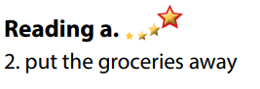  Answer keys  - Work in pairs to compete the table - Write answers.  - Read answers.  Answer keys  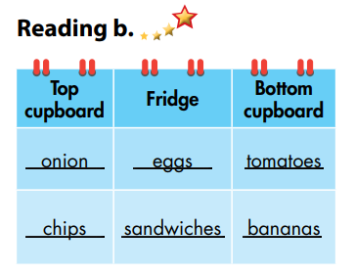
Activity 3: Post - Reading (6’)
a) Objective: Students can use the vocabulary and ideas from the reading text to develop their speaking skill.
b) Content: Speaking: What different containers do they mention in the reading? What other ones do you know?
c) Expected outcomes: Students can talk about other containers and quantities of food and drinks.
d) Organization of the activity:
TEACHER’S ACTIVITIES | STUDENTS’ ACTIVITIES
Task c. In pairs: What different containers do they mention in the reading? What other ones do you know?  - Have Students work in pairs to answer the questions.  - Go round and give help if necessary.  - Call some Ss to share their ideas with the whole class.  - Give feedback and evaluation. | - Discuss in pairs.  - Present.  - Listen.
C. Consolidation and homework assignments (5’)
* Consolidation:
- Words about containers and quantities of food and drinks (a bunch of bananas, a bag of flour, a bottle of oil, a can of beans, a carton of eggs, a stick of butter, a carton of milk, a box of spaghetti).
* Homework:
- Learn the new words by heart.
- Practice talking about containers and quantities of food and drinks.
- Do the exercises in WB: New words + Reading (Pages 28, 29).
- Do the vocabulary exercise in Tiếng Anh 7 i-Learn Smart World Notebook (page 30).
- Play consolation games in Tiếng Anh 7 i-Learn Smart World DHA App on www.eduhome.com.vn

